|  |  |
| --- | --- |
|  | **MINISTRY OF**  **EDUCATION AND TRAINING** |

|  |
| --- |
| **FPT UNIVERSITY** |
| Capstone Project Document |
| 4HealthyNutrium System |

|  |  |
| --- | --- |
| **SWP490-G31** | |
| **Group Members** | Nguyễn Hoàng Việt – HE140725  Lê Mạnh Cường – HE130386  Nguyễn Đức Sơn – HE140443  Nguyễn Viết Long – HE140051 |
| **Supervisors** | Bùi Ngọc Anh |
| **Capstone Project Code** | 4HTN |

– Hanoi, December 2022 –

# Table of Contents

Table of Contents 1

Acknowledgement 15

Acronyms & Definitions 16

I. Project Introduction 17

1. Overview 18

1.1. Project Introduction 18

1.2. Project Team 18

1.2.1. Supervisor 18

1.2.2. Team Members 18

2. Product Background 18

3. Existing Systems 24

3.1. Eat this much 25

3.2. Fatsecret 25

3.3. Myfitnesspal 25

4. Business Opportunity 25

5. Software Product Vision 27

6. Project Scope & Limitations 28

6.1 Major Features 28

6.2. Limitation & Exclusion 29

II. Project Management Plan 29

1. Overview 30

1.1. WBS & Estimation 30

1.2. Project Objectives 33

1.2.1. Project Objectives 34

1.2.2. Team Objectives 34

1.3. Project Risks 34

2. Management Approach 34

2.1. Project Process 35

2.2. Meeting Minutes 35

2.3. Quality Management 35

2.4. Training Plan 36

3. Master Schedule 37

4. Project Organization 38

4.1. Team & Structures 39

4.2. Roles & Responsibilities 39

5. Project Communication 40

5.1. Communication Plan 41

5.2. External Interface 41

6. Configuration Management 41

6.1. Tools & Infrastructures 42

6.2. Document Management 42

6.2.1. Convention 42

6.2.2. Management 42

6.3. Source Code Management 42

6.3.1. Convention 43

6.3.2. Management 43

III. Software Requirement Specification 43

1. Project Overview 44

2. User Requirement 44

2.1. Actors 44

2.2. Use Cases 44

2.2.1. Overview 45

2.2.2. Feature “Authenticate user” 45

2.2.2.1. Login 46

2.2.2.2. Register 47

2.2.2.3. Forgot password 49

2.2.3. Feature “Manage personal profile” 50

2.2.3.1. View personal profile 51

2.2.3.2. Edit personal profile 52

2.2.3.3. Change password 52

2.2.3.4. Change phone number 53

2.2.4. Feature “Manage system accounts” 54

2.2.4.1. View system account list 55

2.2.4.2. View account detail 55

2.2.4.3. Search system account 56

2.2.5. Feature “Search fishing location” 57

2.2.5.1. Search nearby fishing location 58

2.2.5.2. Filter nearby fishing location 59

2.2.5.3. Advanced search 60

2.2.5.4. View fishing location’s overview 61

2.2.5.5. View lake list 62

2.2.5.6. View lake details 63

2.2.5.7. Save fishing location 64

2.2.5.8. Report false fishing location information 64

2.2.6. Feature “Manage fishing location’s reviews” 65

2.2.6.1. View fishing location’s review 66

2.2.6.2. Post personal review 67

2.2.6.3. Vote/Downvote review 68

2.2.6.4. Delete personal review 69

2.2.6.5. Sort review list 70

2.2.6.6. Report inappropriate review 70

2.2.7. Feature “Manage check-in” 71

2.2.7.1. Verify check-in action 72

2.2.7.2. View personal check-in history 73

2.2.7.3. View fishing location’s check-in history 74

2.2.7.4. Filter fishing location’s check-in history 75

2.2.8. Feature “Manage catch reports” 75

2.2.8.1. Catch details reporting 76

2.2.8.2. View pending catch reports 78

2.2.8.3. Approve/Reject catch detail report 79

2.2.8.4. View personal catch history list 80

2.2.8.5. View fishing location's catch history 81

2.2.8.6. Filter fishing location's catch history 82

2.2.8.7. View catch history detail 83

2.2.8.8. Report inappropriate catch detail report 84

2.2.9. Feature “Manage fishing location’s profile” 85

2.2.9.1. Add a fishing location 86

2.2.9.2. Edit fishing location's overview 89

2.2.9.3. Edit pending fishing location 91

2.2.9.4. Add lake 94

2.2.9.5. Close lake 96

2.2.9.6. Edit lake's profile 98

2.2.9.7. Add fish in lake 100

2.2.9.8. Stock fish in lake 101

2.2.9.9. Delete fish in lake 102

2.2.9.10. Temporary close/reopen fishing location 103

2.2.9.11. Delete fishing location 104

2.2.10. Feature “Manage system fishing locations” 105

2.2.10.1. Verify/Unverify fishing location 106

2.2.10.2. Search system fishing location 107

2.2.10.3. View list of fishing locations 108

2.2.11. Feature “Receive notification” 108

2.2.11.1. View list of notifications 109

2.2.12. Feature “Manage fishing location’s posts” 109

2.2.12.1. View fishing location's posts 110

2.2.12.2. Publish fishing location's post 111

2.2.12.3. View public catch details as post 112

2.2.12.4. Edit fishing location's post 113

2.2.12.5. Delete fishing location's post 114

2.2.12.6. Report fishing location's post 115

2.2.12.7. Pin/Unpin fishing location's post 116

2.2.13. Feature “Manage fishing location’s staffs” 117

2.2.13.1. Add staff to fishing location 118

2.2.13.2. Remove staff from fishing location 119

2.2.13.3. View fishing location's staff list 120

2.2.14. Feature “Manage system reports” 120

2.2.14.1. View reports in the system 121

2.2.14.2. View report detail 122

2.2.14.3. Filter report list 122

2.2.14.4. Mark report as resolved 123

2.2.14.5. Remove reported review 124

2.2.14.6. Remove reported post 125

2.2.14.7. Remove reported catch report 125

2.2.14.8. Activate/Deactivate reported fishing location 126

2.2.15. Feature “Manage system fish species” 127

2.2.15.1. View system fish species list 128

2.2.15.2. Add new fish species 128

2.2.15.3. Edit fish species information 129

2.2.15.4. Activate/Deactivate fish species 130

2.2.16. Feature “Manage system fishing methods” 131

2.2.16.1. View system fishing method list 132

2.2.16.2. Add new fishing method 132

2.2.16.3. Edit fishing method information 133

2.2.16.4. Activate/Deactivate fishing method 134

2.2.17. Feature “Manage fishing location’s suggestion” 135

2.2.17.1. Suggest fishing location 136

2.2.17.2. View list of suggested location 137

2.2.17.3. Mark help suggestion form 138

2.2.17.4. Create suggested location 139

2.2.18. Feature “Manage banned phone number” 141

2.2.18.1. View banned phone number list 142

2.2.18.2. Search banned phone number 142

2.2.18.3. Ban a phone number 143

2.2.18.4. Unban a phone number 145

3. Functional Requirement 147

3.1. System Functional Overview 148

3.1.1. Screen Flow 148

3.1.1.1. Angler 148

3.1.1.2. Owner/Staff 148

3.1.1.3. Admin 149

3.1.2. Screen Descriptions 150

3.1.2.1. Angler 151

3.1.2.2. Owner/Staff 152

3.1.2.3. Admin 153

3.1.3. Screen Authorization 155

3.1.4. Entity Relationship Diagram 157

3.2. Feature “Authenticate user” 159

3.2.1. Welcome 160

3.2.2. Login 160

3.2.3. Register 161

3.2.4. Forgot password 162

3.2.5. OTP 163

3.2.6. Ban Notice 164

3.3. Feature “Manage personal profile” 165

3.3.1. Personal options 166

3.2.2. Edit personal profile 166

3.2.3. Change phone number 167

3.2.4. Change password 168

3.4. Feature “Manage system accounts” 169

3.4.1. System account management 170

3.4.2. Account details 170

3.5. Feature “Search fishing location” 171

3.5.1. Search nearby 172

3.5.2. Advanced search 172

3.5.3. Fishing location’s overview 173

3.5.4. View lake list 174

3.5.5. View lake details 175

3.5.6. Saved fishing location 176

3.6. Feature “Manage fishing location’s reviews” 177

3.6.1. View fishing location’s review 178

3.6.2. Post personal review 178

3.7. Feature “Manage check-in” 179

3.7.1. Show QR code 180

3.7.2. Scan QR 180

3.7.3. View personal check-in history 181

3.7.4. View fishing location’s check-in history 182

3.8. Feature “Manage catch reports” 183

3.8.1. Report catch form 184

3.8.2. View pending catch reports 184

3.8.3. View personal catch history 185

3.8.4. View fishing location’s catch history 186

3.9. Feature “Manage fishing location’s profile” 187

3.9.1. Add a fishing location form 188

3.9.2. Add lake form 188

3.9.3. Add fish in lake 189

3.10. Feature “Manage system fishing locations” 190

3.10.1. View and search system fishing location list 191

3.10.2. View fishing location details 191

3.11. Feature “Receive notification” 192

3.11.1. View list of notifications 193

3.12. Feature “Manage fishing location’s posts” 193

3.12.1. View fishing location’s post 194

3.12.2. Add a new post form 194

3.12.3. Pin/Unpin fishing location’s post 195

3.13. Feature “Manage fishing location’s staffs” 196

3.13.1. View fishing location’s staff list 197

3.13.2. Add staff to fishing location 197

3.14. Feature “Manage system reports” 198

3.14.1. Report form 199

3.14.2. View report in the system 199

3.14.3. View report details 200

3.15. Feature “Manage system fish species” 201

3.15.1. View fish species list 202

3.15.2. Fish species form 202

3.16. Feature “Manage system fishing methods” 203

3.16.1. View fishing method list 204

3.16.2. Fishing method form 204

3.17. Feature “Manage fishing location’s suggestion” 205

3.17.1. Suggest a location form 206

3.17.2. View list of suggested location 206

3.17.3. View suggested location detail 207

3.18. Feature “Manage banned phone number” 208

3.18.1. View banned phone list 209

3.18.2. Add banned phone form 209

4. Non-Functional Requirement 210

4.1. Usability 211

4.2. Security 211

4.3. Performance 211

4.4. Maintaining & Scalability 211

4.5. Compatibility 211

4.6. Localization 211

5. Requirement Appendix 211

5.1. Business Rules 212

5.2. Application Message List 212

IV. Software Design Description 215

1. System Architecture Design 216

1.1. Overall Architecture 216

1.2. System Architecture 216

1.2.1. Front-end Components 217

1.2.1.1. Expo 217

1.2.1.2. Easy Peasy 217

1.2.1.3. React Native Elements 217

1.2.1.4. React Navigation 218

1.2.1.5. NativeBase 218

1.2.2. Back-end Components 218

1.2.2.1. Spring Boot 219

1.2.2.2. Json Web Tokens 219

1.2.2.3. Swagger 219

1.2.2.4. Twilio 219

1.2.3. Database 220

1.2.4. Deployment & Hosting 220

1.2.4.1. VPS (Powered by Nhan Hoa Software Company) 220

1.2.4.2. Github Actions 220

1.3. Package Diagrams 221

1.3.1. Frontend 222

1.3.2. Backend 222

2. Database Design 223

2.1. Table “tbl_banned_phone” 224

2.2. Table “tbl_catches” 225

2.3. Table “tbl_catches_detail” 225

2.4. Table “tbl_check_in” 225

2.5. Table “tbl_district” 226

2.6. Table “tbl_employee_list” 226

2.7. Table “tbl_fish_species” 226

2.8. Table “tbl_fish_in_lake” 226

2.9. Table “tbl_fishing_location” 227

2.10. Table “tbl_fishing_method” 227

2.11. Table “tbl_lake” 228

2.12. Table “tbl_lake_fishing_method” 228

2.13. Table “tbl_notification” 228

2.14. Table “tbl_post” 228

2.15. Table “tbl_province” 229

2.16. Table “tbl_report” 229

2.17. Table “tbl_report_user” 229

2.18. Table “tbl_review” 230

2.19. Table “tbl_suggested_location” 230

2.20. Table “tbl_user” 230

2.21. Table “tbl_user_notification” 231

2.22. Table “tbl_user_saved_fishing_locations” 231

2.23. Table “tbl_vote” 231

2.24. Table “tbl_ward” 231

2.25. Table “user_roles” 232

3. Detail Design 232

3.1. Feature “Authenticate user” 233

3.1.1. Class Diagram 233

3.1.2. Sequence Diagram(s) 233

3.1.2.1. Login 234

3.1.2.2. Register 234

3.1.2.3. Forgot password 234

3.2. Feature “Manage personal profile” 235

3.2.1. Class Diagram 235

3.2.2. Sequence Diagram(s) 235

3.2.2.1. View personal profile 236

3.2.2.2. Edit personal profile 236

3.2.2.3. Change password 236

3.2.2.4. Change phone number 237

3.2.2.5. Send OTP 237

3.2.2.6. Validate OTP 238

3.3. Feature “Manage system accounts” 238

3.3.1. Class Diagram 239

3.3.2. Sequence Diagram(s) 239

3.3.2.1. View and search system account list 240

3.3.2.2. View account details 240

3.4. Feature “Search fishing location” 240

3.4.1. Class Diagram 241

3.4.2. Sequence Diagram(s) 241

3.4.2.1. Search and filter nearby fishing location 241

3.4.2.2. Advanced search 241

3.4.2.3. View fishing location’s overview 242

3.4.2.4. View lake list 242

3.4.2.5. View lake details 243

3.4.2.6. Save fishing location 243

3.4.2.7. Report false fishing location information 243

3.5. Feature “Manage fishing location’s reviews” 244

3.5.1. Class Diagram 245

3.5.2. Sequence Diagram(s) 245

3.5.2.1. View fishing location’s review 246

3.5.2.2. Post personal review 246

3.5.2.3. Vote/Downvote review 246

3.5.2.4. Delete personal review 247

3.5.2.5. Report inappropriate review 247

3.6. Feature “Manage check-in” 248

3.6.1. Class Diagram 248

3.6.2. Sequence Diagram(s) 248

3.6.2.1. Verify check-in action 249

3.6.2.2. View personal check-in history 249

3.6.2.3. View and filter fishing location’s check-in history 249

3.7. Feature “Manage catch reports” 250

3.7.1. Class Diagram 250

3.7.2. Sequence Diagram(s) 250

3.7.2.1. Catch details reporting 251

3.7.2.2. View pending catch reports 251

3.7.2.3. Approve/Reject catch detail report 251

3.7.2.4. View personal catch history list 252

3.7.2.5. View and filter fishing location’s catch history 252

3.7.2.6. View catch history detail 253

3.7.2.7. Report inappropriate catch detail report 253

3.7.2.8. Check-out 254

3.8. Feature “Manage fishing location’s profile” 254

3.8.1. Class Diagram 255

3.8.2. Sequence Diagram(s) 255

3.8.2.1. Add a fishing location 255

3.8.2.2. Edit fishing location’s overview 255

3.8.2.3. Add lake 256

3.8.2.4. Close lake 256

3.8.2.5. Edit lake’s profile 257

3.8.2.6. Add fish in lake 257

3.8.2.7. Stock fish in lake 258

3.8.2.8. Delete fish in lake 258

3.8.2.9. Temporary close/reopen fishing location 259

3.8.2.10. Delete fishing location 259

3.9. Feature “Manage system fishing locations” 260

3.9.1. Class Diagram 261

3.9.2. Sequence Diagram(s) 261

3.9.2.1.Verify/Unverify fishing location 262

3.9.2.2. Search and view system fishing location list 262

3.10. Feature “Receive notification” 262

3.10.1. Class Diagram 263

3.10.2. Sequence Diagram(s) 263

3.10.2.1. View list of notifications 263

3.11. Feature “Manage fishing location’s posts” 263

3.11.1. Class Diagram 264

3.11.2. Sequence Diagram(s) 264

3.11.2.1. View fishing location’s posts 265

3.11.2.2. View public catch details as post 265

3.11.2.3. Public fishing location’s post 265

3.11.2.4. Edit fishing location’s post 266

3.11.2.5. Delete fishing location’s post 266

3.11.2.6. Report fishing location’s post 267

3.11.2.7. Pin/Unpin fishing location’s post 267

3.12. Feature “Manage fishing location’s staffs” 268

3.12.1. Class Diagram 269

3.12.2. Sequence Diagram(s) 269

3.12.2.1. View fishing location’s staff list 270

3.12.2.2. Add staff to fishing location 270

3.12.2.3. Remove staf from fishing location 270

3.13. Feature “Manage system reports” 271

3.13.1. Class Diagram 271

3.13.2. Sequence Diagram(s) 271

3.13.2.1. View reports in the system 272

3.13.2.2. View report details 272

3.13.2.3. Mark report as resolved 273

3.13.2.4. Remove reported review 273

3.13.2.5. Remove reported post 274

3.13.2.6. Remove reported catch report 274

3.13.2.7. Activate/Deactive reported fishing location 275

3.14. Feature “Manage system fish species” 275

3.14.1. Class Diagram 275

3.14.2. Sequence Diagram(s) 276

3.14.2.1. View system fish species list 276

3.14.2.2. Add new fish species 276

3.14.2.3. Edit fish species information 277

3.14.2.4. Activate/Deactive fish species 277

3.15. Feature “Manage system fishing methods” 277

3.15.1. Class Diagram 278

3.15.2. Sequence Diagram(s) 278

3.15.2.1. View system fishing method list 278

3.15.2.2. Add new fishing method 278

3.15.2.3. Edit fishing method information 279

3.15.2.4. Activate/Deactive fishing method 279

3.16. Feature “Manage fishing location’s suggestion” 279

3.16.1. Class Diagram 280

3.16.2. Sequence Diagram(s) 280

3.16.2.1. Suggest fishing location 281

3.16.2.2. View list of suggested location 281

3.16.2.3. Mark helpful suggestion form 281

3.16.2.4. Create suggested location 281

3.17. Feature “Manage banned phone number” 282

3.17.1. Class Diagram 282

3.17.2. Sequence Diagram(s) 282

3.17.2.1. View and search banned phone number list 283

3.17.2.2. Ban a phone number 283

3.17.2.3. Unban a phone number 283

V. Software Testing Documentation 283

1. Scope of Testing 284

2. Test Strategy 284

2.1. Test Model 284

2.2. Testing Types 284

2.3. Test Levels 285

2.4. Supporting Tools 286

3. Test Plan 286

33.1. Human Resources 287

3.2. Test Milestones 287

4. Test Cases 287

4.1. Unit Test 288

4.2. Integration Test 289

4.3. System Test 290

4.4. Defect & Bug Log 290

4.5. Acceptance Test 291

5. Test Reports 293

5.1. Unit Test 293

5.2. Integration Test 295

5.3. System Test 296

VI. Release Package & User Guides 296

1. Deliverable Packages 297

2. Installation Guides 297

2.1. Backend Installation 297

2.1.1. Prerequisite 297

2.1.2. Install Java, Maven, & PostgreSQL 297

2.1.2.1. Java Development Kit version 8 297

2.1.2.2. Apache Maven 298

2.1.2.3. PostgreSQL 12.9 298

2.1.2. Configure Twilio 298

2.1.3. Start the build 299

2.1.4. Setup FSMIS service 299

2.2. Frontend Installation 299

2.2.1. Prerequisite 300

2.2.2. Preparation 300

2.2.2.1. Install Nodejs, npm, and Yarn 300

2.2.2.2. Install Expo CLI 300

2.2.2.3. Sign up for new Expo account 300

2.2.2.4. Get Google Maps API key 301

2.2.3. Setup project 303

2.2.4. Configure API URL and Google Maps API key 303

2.2.5. Start the build 304

2.2.6. Get the APK file 304

3. User Manual 304

3.1. Overview 305

3.2. Guest 305

3.2.1. Register 305

3.3. User 305

3.3.1. Login 306

3.3.2. Reset password 306

3.3.3. Search fishing location 307

3.3.3.1. View, search and filter nearby fishing locations 307

3.3.3.2. View, search, and filter all fishing locations 308

3.3.4. View fishing location detail 309

3.3.4.1. View overview information of the fishing location 310

3.3.4.2. View lake of the fishing location 311

3.3.4.3. View list of reviews and post a review 312

3.3.4.3.1. Post a review 313

3.3.4.4. View posts and catch reports of the fishing location 314

3.3.5. Save/Unsave a fishing location and view saved fishing location list 315

3.3.5.1. Save/Unsave a fishing location 315

3.3.5.2. View list of saved fishing locations 316

3.3.6. View notifications 316

3.3.7. Write report 317

3.3.8. View personal check-in history 318

3.3.9. View personal catch reports 319

3.3.10. Edit personal information 320

3.3.11. Change account phone number 321

3.3.12. Change account password 322

3.3.13. View, create a manageable fishing location 323

3.3.14. Manage a fishing location 324

3.3.14.1. Edit fishing location information 324

3.3.14.2. Lake management 324

3.3.14.2.1. Create new lake 324

3.3.14.2.2. Edit lake information 324

3.3.14.2.3. Edit fishes in lake 324

3.3.14.3. Staff management 324

3.3.14.3.1. Add new staff 324

3.3.14.3.2. Remove staff 324

3.3.14.4. Check-in an angler at the fishing location 324

3.3.14.5. View check-in history of anglers at the fishing location 324

3.3.14.6. View, verify catch reports 324

3.3.14.7. View verified catch reports 324

3.3.14.8. Post management 324

3.3.14.8.1. Create new post 324

3.3.14.8.2. Edit a post 324

3.3.14.8.3. Pin, delete a post 324

3.3.14.9. Change opening state of fishing location 324

3.3.14.10. Delete fishing location 324

3.3.15. Check-out, report catches in a check-in 324

3.3.16. Suggest a fishing location 324

3.3.17. Logout 324

3.4. Admin 324

3.4.1. Account management 324

3.4.1.1. Search accounts 324

3.4.1.2. Activate/Deactivate an account 324

3.4.1.2.1. Deactivate account 324

3.4.1.2.2. Activate account 324

3.4.2. Blacklist management 324

3.4.2.1. Remove a phone number from blacklist 324

3.4.2.2. Add a phone number to blacklist 324

3.4.3. Fishing locations management 324

3.4.3.1. Activate/Deactivate a fishing location 324

3.4.3.2. Verify/unverified a fishing location 324

3.4.4. Fish management 324

3.4.4.1. Add new fish 324

3.4.4.2. Edit a fish species 324

3.4.5. Fishing methods management 324

3.4.5.1. Add new fishing method 324

3.4.5.2. Edit fishing method 324

3.4.6. Suggested fishing locations management 324

3.4.6.1. Mark suggested location record as helpful 324

3.4.6.2. Create new pending fishing location from suggested information 324

3.4.7. Reports management 324

3.4.7.1. Resolve report 324

# Acknowledgement

FSMIS Project is reaching its final stage. Looking back to the very beginning, it has been a long journey for each member of the project and the team as a whole. We started at the zero point when we decided to do FSMIS. Fortunately, we have received tremendous support from many people during our journey. Therefore, we would like to let them know that we are very grateful.

First of all, we wish to offer our deepest gratitude to our team’s supervisor. Mr. Bui Ngoc Anh, without him, we probably would not be ale to be where we are today. Besides technological advices, he is also an excellent motivation for us not to give up and always yearn to achieve more for the project. Secondly, we would like to thank all of our teachers at FPT University. They have shown us great support this semester when we do our Capstone Project. Also, thanks to their lessons, we, the clueless students, can become the ones we want to be and do what we want to do. Moreover, we also want to show our gratitude to our friends and families, who always give us a helping hand during this challenging period.

Last but not least, we want to say thanks to the great source of knowledge, the internet, to the people we do not know but still share with us precious knowledge, which helps us a lot in this project. We are very thankful for that.

Because the project was carried out during the COVID-19 pandemic, we hope our friends, relatives, and teachers stay healthy. We look forward to seeing everyone when everything is back to normal as soon as possible.

*FSMIS Project, SWP490_G31*

*Hanoi, December 20th, 2021*

# Acronyms & Definitions

|  |  |  |
| --- | --- | --- |
| **#** | **Acronym** | **Definition** |
|  | WBS | Work Breakdown Structure |
|  | RFAMA | Recreational Fishing Area Management Application |
|  | FE | Feature |
|  | LI | Limitation |
|  | EX | Exclusion |
|  | VPS | Virtual Private Server |
|  |  |  |
|  |  |  |
|  |  |  |
|  |  |  |
|  |  |  |
|  |  |  |

Acronyms and Definitions Table

# I. Project Introduction

## 1. Overview

### 1.1. Project Introduction

* Project name: 4HealthyNutrium Website System
* Project code: 4HTN
* Group name: SWP493 – G5
* Software type: Web.

### 1.2. Project Team

#### 1.2.1. Supervisor

|  |  |  |  |
| --- | --- | --- | --- |
| **Full Name** | **Email** | **Phone Number** | **Title** |
| Bùi Ngọc Anh | [anhbn5@fe.edu.vn](mailto:anhbn5@fe.edu.vn) | 091 534 3020 | Supervisor |

Table 1.2.1. Supervisor’s Information

#### 1.2.2. Team Members

|  |  |  |  |
| --- | --- | --- | --- |
| **Full Name** | **Email** | **Mobile** | **Role** |
| Nguyễn Hoàng Việt | vietnhhe140789[@fpt.edu.vn](mailto:duchmhe140725@fpt.edu.vn) | 098 529 5760 | Leader |
| Nguyễn Viết Long | longnvhe140051[@fpt.edu.vn](mailto:anhlthe140428@fpt.edu.vn) | 096 337 2727 | Member |
| Nguyễn Đức Sơn | sonndhe140443[@fpt.edu.vn](mailto:datndhe140411@fpt.edu.vn) | 096 905 1715 | Member |
| Lê Mạnh Cường | cuonglmhe130386[@fpt.edu.vn](mailto:anhtdhe140447@fpt.edu.vn) | 096 374 3383 | Member |

Table 1.2.2. Team member’s information

## 2. Product Background

In recent years, along with strong socio-economic development, people's health care needs are increasing day by day. Therefore, how to take care of your own health is a big question in everyone's mind. We conducted a survey with 50 people of various professions, gender and ages for 1 week (September 17th - 24th, 2022).

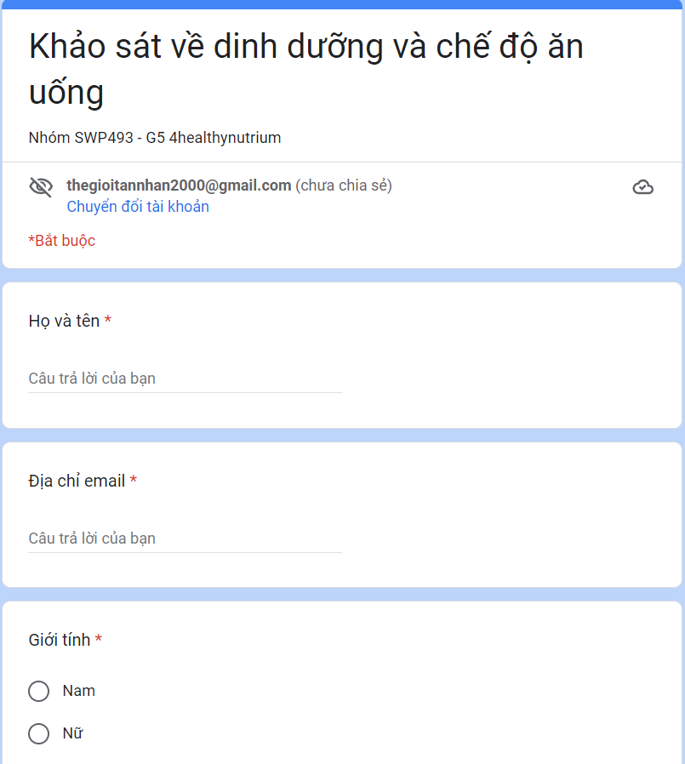

*Figure 2:1. Our survey form*

With 74 different responses from 74 people of different professions, gender and ages, we gathered a lot of information about each person's nutritional needs and habits:

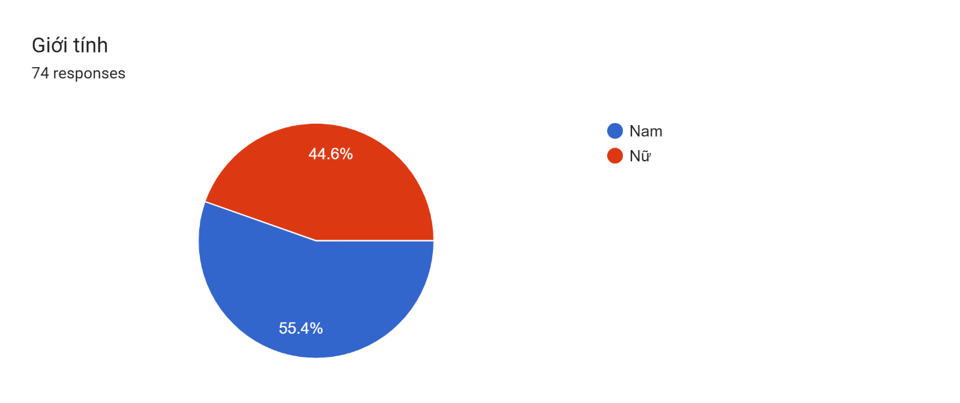  
*Figure 2:2. Statistics of survey participant's gender*

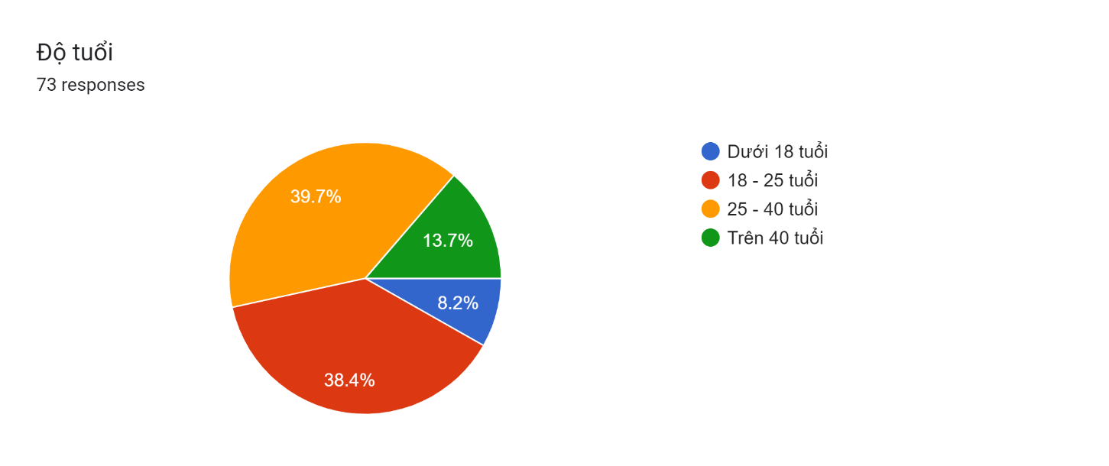

Figure 2:3. Statistics of survey participant's age

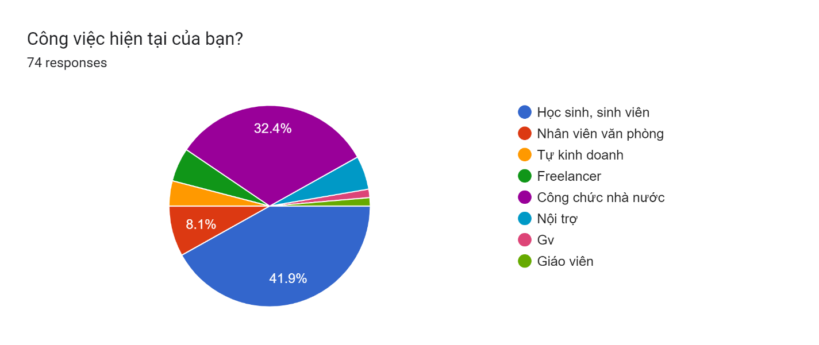

*Figure 2:4. Statistics of survey participant's profession*

First, we can see that most of the survey participants are extremely health conscious and are willing to invest money and effort for their health needs.

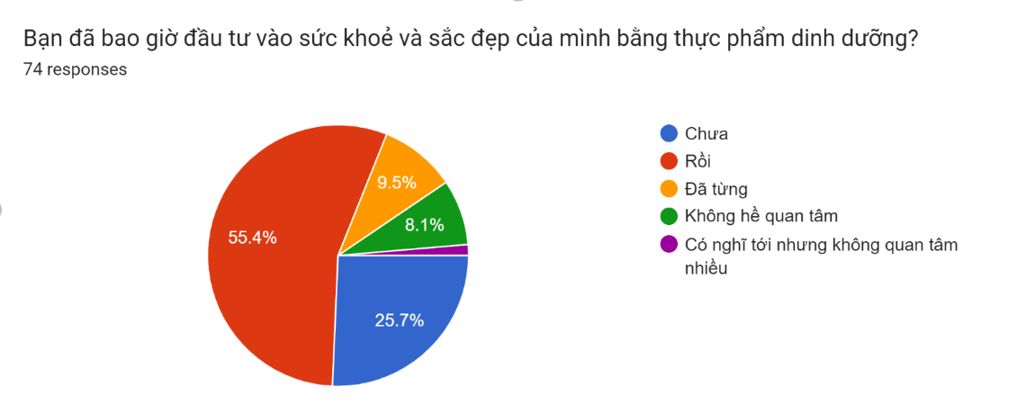

*Figure 2:5. Statistics of survey participant's the need to invest money and effort in health and beauty with nutritious food*

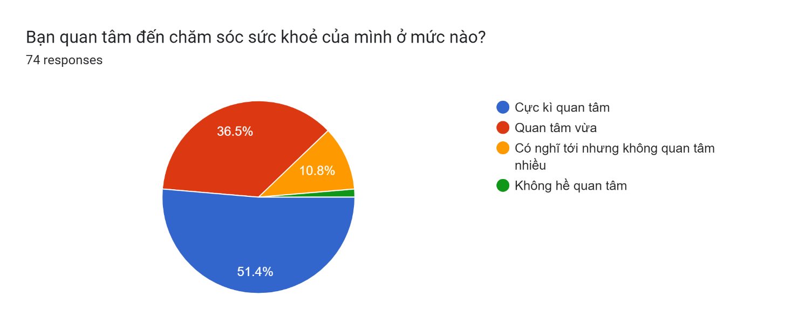

*Figure 2:6. Statistics of survey participant's level of concern for health*

Next, we conducted a survey on the difficulties that the interviewees encountered when learning about and building a healthy diet and exercise regimen. It can be seen that quite a few interviewees attributed the lack of nutrition knowledge to the lack of knowledge. Besides, the lack of a clear and specific plan also makes it difficult for many people to build a diet and exercise regimen.



*Figure 2:6. Statistics of survey participant's level of concern for health*

That's why our team decided to work together to build a website for nutrition and exercise advice to help satisfy everyone's needs.

In order to be able to create a website to help advise on diet, we have prepared the basic nutritional knowledge required, aimed at Vietnamese people who need to maintain and improve health. Our website will help users calculate the energy they need for the whole day based on the information provided by the user. From there, suggesting to user suitable menus to help them maintain and improve their personal health.

First, we learn about the basis for building energy recommendations for Vietnamese people. Based on the formula[[1]](https://drive.google.com/drive/folders/1EsUWzp1ufCXleiTTQSDOBzx7jxfK1--3):

**A = B x C**

A: Recommended all-day energy needs (kcal).

B: Basal metabolic energy for the day (kcal).

C: Physical activity coefficient (PAL).

From the above basis, we learned about the basic metabolic energy in a day and the physical activity coefficient of Vietnamese people.



*Figure 2:7.1. Statistics of basic metabolic energy of Vietnamese people* [[2]](https://drive.google.com/file/d/1WTg9GA-RXxcPPfJ1JojHX7fDRRZTa0GW/view?fbclid=IwAR0My0Ap6B-ZtjAJSDE5IYdCPgQ1eVPtqrp1oVNPHtRG03wNHaXeX7Bxu3g)



*Figure 2:7.2. Statistics of basic metabolic energy of Vietnamese people* [[1]](https://drive.google.com/drive/folders/1EsUWzp1ufCXleiTTQSDOBzx7jxfK1--3)



*Figure 2:8. Statistics of the physical activity coefficient* *of Vietnamese people* [[1]](https://drive.google.com/drive/folders/1EsUWzp1ufCXleiTTQSDOBzx7jxfK1--3)

We also learned more about the classification of physical activity levels by type of work so that it is easier to categorize the physical activity coefficients by different occupations.



*Figure 2:9 Statistics of classification of physical activity levels by type of work of Vietnamese people* [[1]](https://drive.google.com/drive/folders/1EsUWzp1ufCXleiTTQSDOBzx7jxfK1--3)

From the above parameters, we have continued to collect data on recommended energy needs for Vietnamese people.



*Figure 2:10 Statistics of recommended energy needs* *of Vietnamese people* [[1]](https://drive.google.com/drive/folders/1EsUWzp1ufCXleiTTQSDOBzx7jxfK1--3)



*Figure 2:11 Statistics of recommended energy needs* *of Vietnamese people* [[1]](https://drive.google.com/drive/folders/1EsUWzp1ufCXleiTTQSDOBzx7jxfK1--3)

In addition to ensuring energy needs, balancing the ratio of energy-producing substances (protein, glucide, lipid) [[1]](https://drive.google.com/drive/folders/1EsUWzp1ufCXleiTTQSDOBzx7jxfK1--3) is also very important:

* The energy provided by protein ranges from 13-20% of the total amount of dietary energy.
* The energy provided by lipids ranges from 20-25% of total amount of dietary energy. Should not exceed 25% of total energy.
* The energy provided by glucide ranges from 55-65% of the total amount of dietary energy.

Besides, our team has also studied documents on how to divide meals in a reasonable way during the day.



*Figure 2:12 Statistics of dividing the meals of the day of Vietnamese people* [[2]](https://drive.google.com/file/d/1WTg9GA-RXxcPPfJ1JojHX7fDRRZTa0GW/view?fbclid=IwAR0My0Ap6B-ZtjAJSDE5IYdCPgQ1eVPtqrp1oVNPHtRG03wNHaXeX7Bxu3g)

With the above knowledge, 4healthyNutrium wishes to be able to help advise Vietnamese users on how to maintain a healthy diet and exercise.

## 3. Existing Systems

### **3.1. Eat this much**

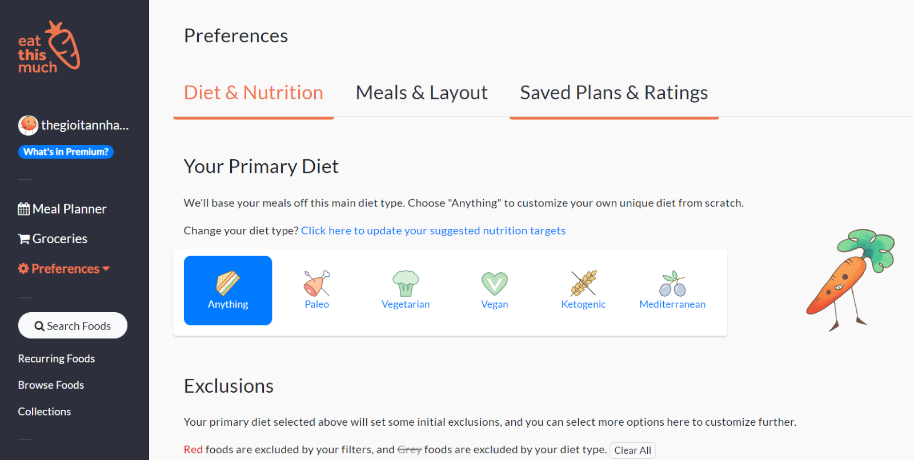

|  |  |
| --- | --- |
| **Advantages** | **Disadvantages** |
| * Easy to use, beginner-friendly. * Good classification about ingredient and food. * Automatically looking for diets. * Users can easily change their diets. | * Generated diets that are too high in fat. * Do not classify food and ingredients by season. |

*Table 3.1. Advantages and disadvantages of Eatthismuch*

### **3.2. Fatsecret**

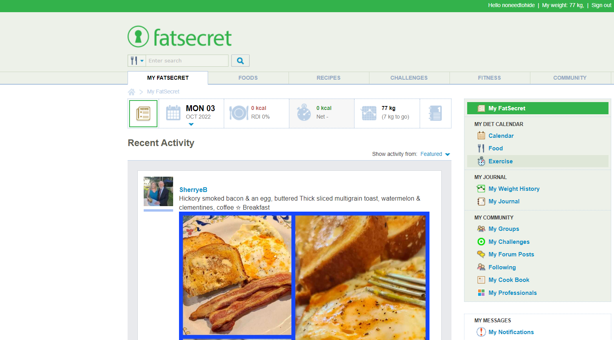

|  |  |
| --- | --- |
| **Advantages** | **Disadvantages** |
| * Easy to use. * Good calorie calculator. * Rich and varied nutritional information. * Having a social networking function that helps users easily connect with others. | * Significantly underestimates sodium and protein levels. * Do not classify food and ingredients by season. * Does not automatically generate dishes according to the calories entered. |

*Table 3.2. Advantages and disadvantages of fatsecret*

### **3.3. Myfitnesspal**

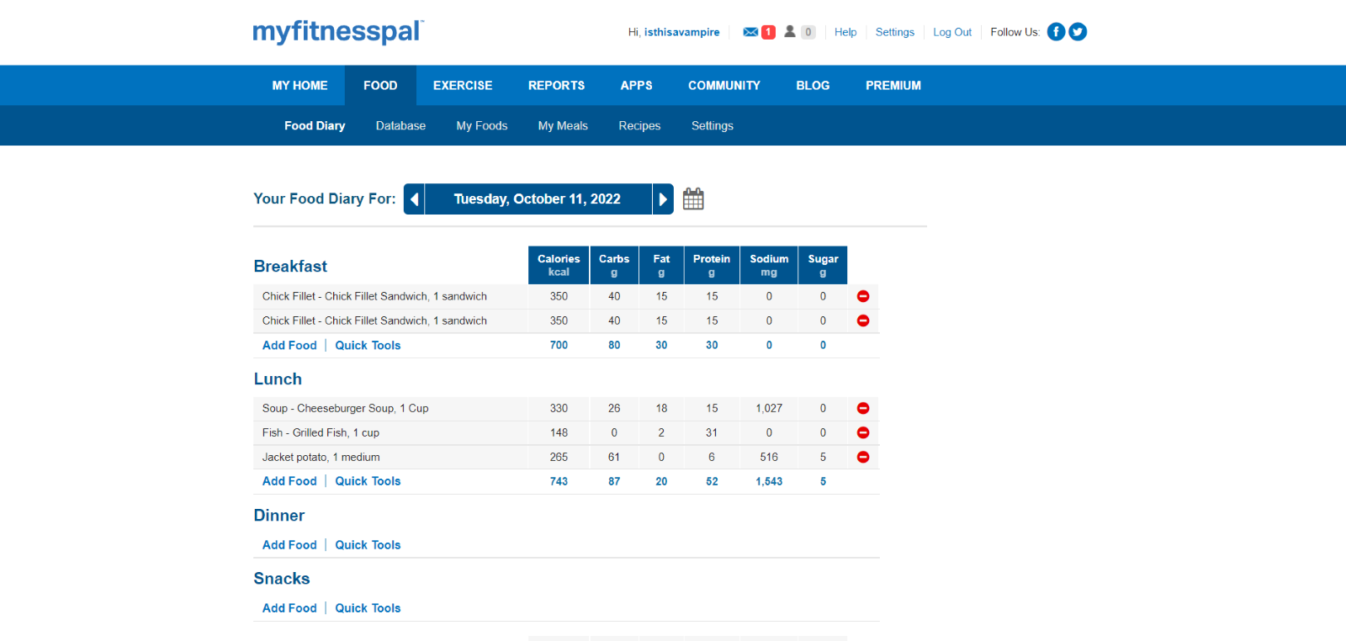

|  |  |
| --- | --- |
| **Advantages** | **Disadvantages** |
| * Users can track their water intake and macronutrients. * Extensive nutrient databases. * Recommended by dietitians. | * Underestimate micronutrients like calcium, iron, and vitamin C. * Quite complex to use. * Do not classify food and ingredients by season. |

*Table 3.3. Advantages and disadvantages of myfitnesspaypal*

## 4. Business Opportunity

Through the survey, we found that most anglers want an application to look up fishing information, find nearby fishing locations, read reviews to make the right decisions before they arrive, and save fishing history so they can track their skills for themselves.

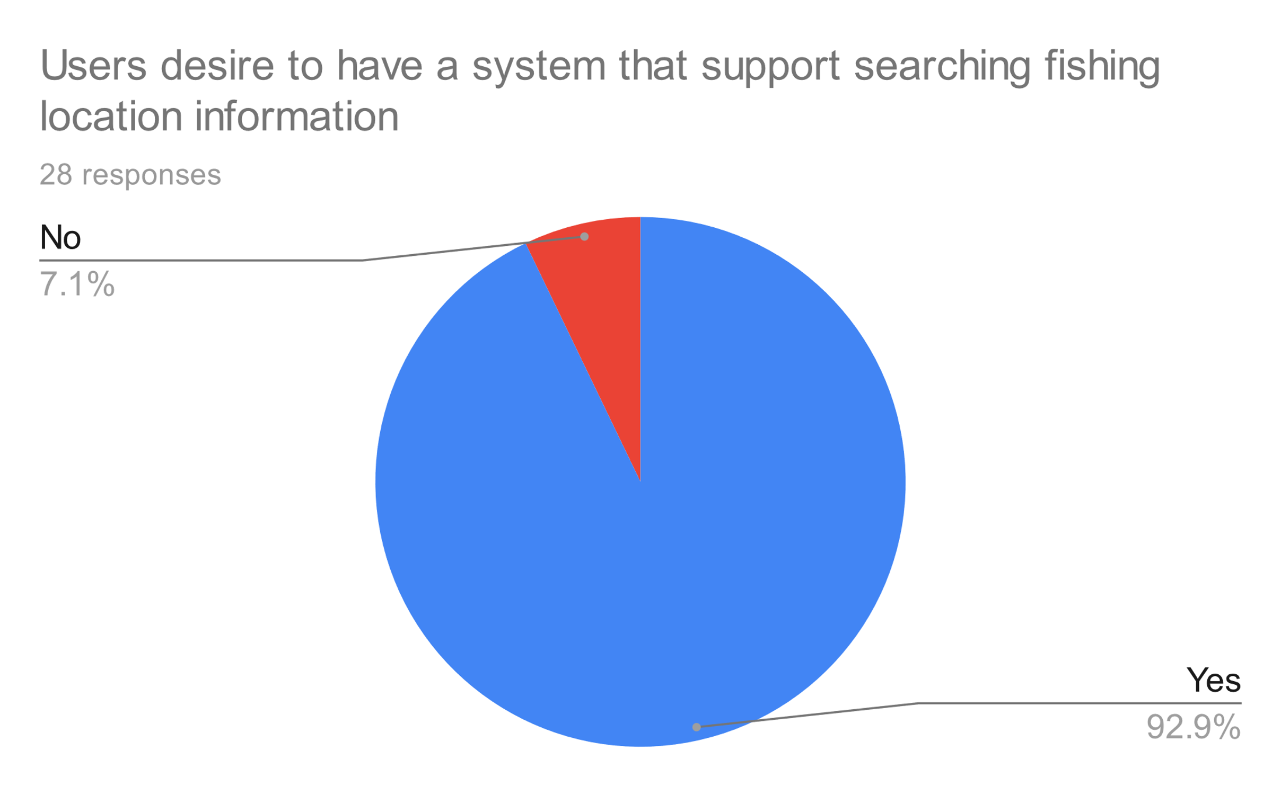

Figure 4:1. Statistics of anglers who want an application to look up fishing information

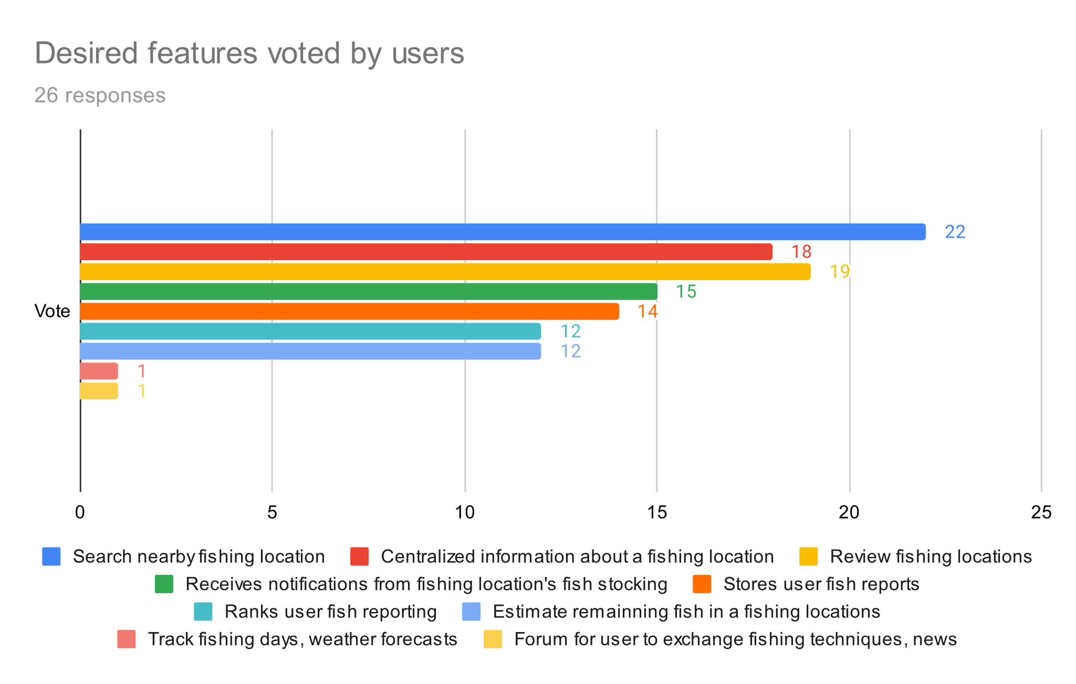

Figure 4:2. Statistics of the features anglers want in the application

As for lake owners, they also want an application to attract their location to anglers, manage fishing lake information (rules, services, types of fish, ticket prices), manage the indicators in the lake (remaining fish, depth of the lake), and manage staffs working at the fishing spots.

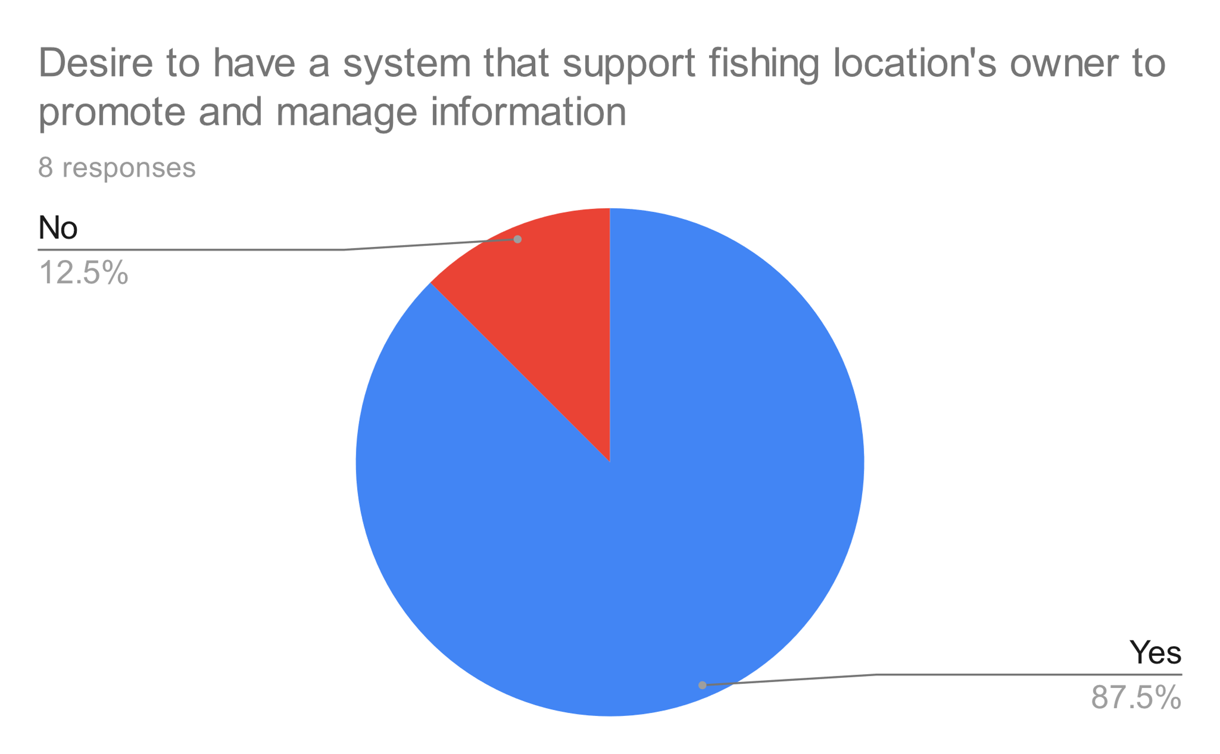

Figure 4:3. Statistics of owners who want an application to manage fishing location

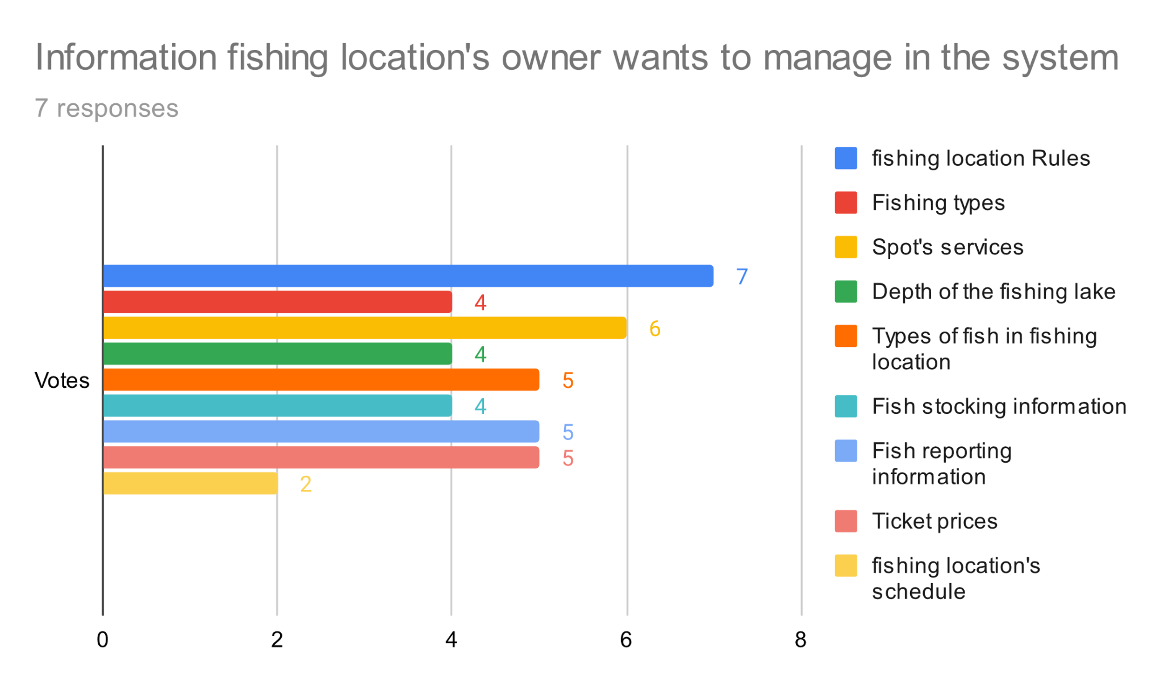

Figure 4:4. Statistics of information lake owners want to post publicity

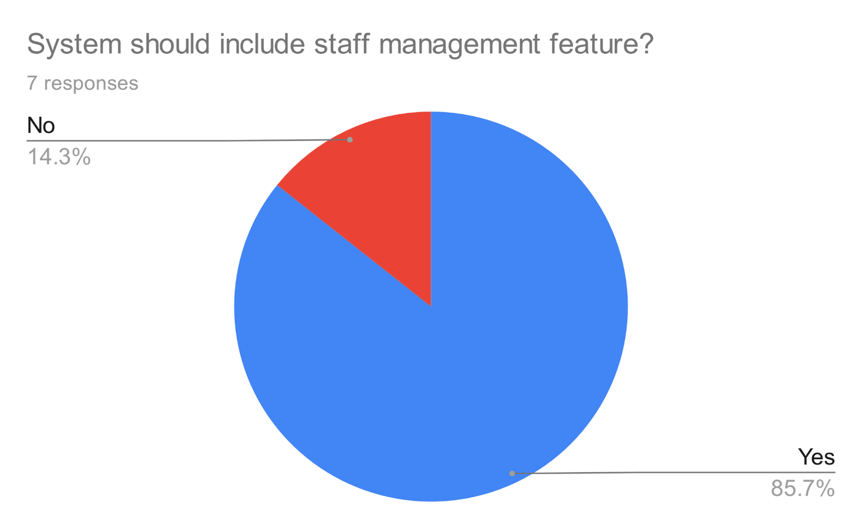

Figure 4:5. Statistics of owners want to manage staffs

## 5. Software Product Vision

For anglers who want to find information about fishing spots, and the owner who wants to promote more about their place, FSMIS is a mobile phone application that will support information’s transmission and bring two-way interaction between them. This application also allows anglers to access information more accurately, and up-to-date every time the lake owner posts any changes. At the same time, FSMIS supports the owner in managing information about his/her fishing spots and its staff.

## 6. Project Scope & Limitations

### 6.1 Major Features

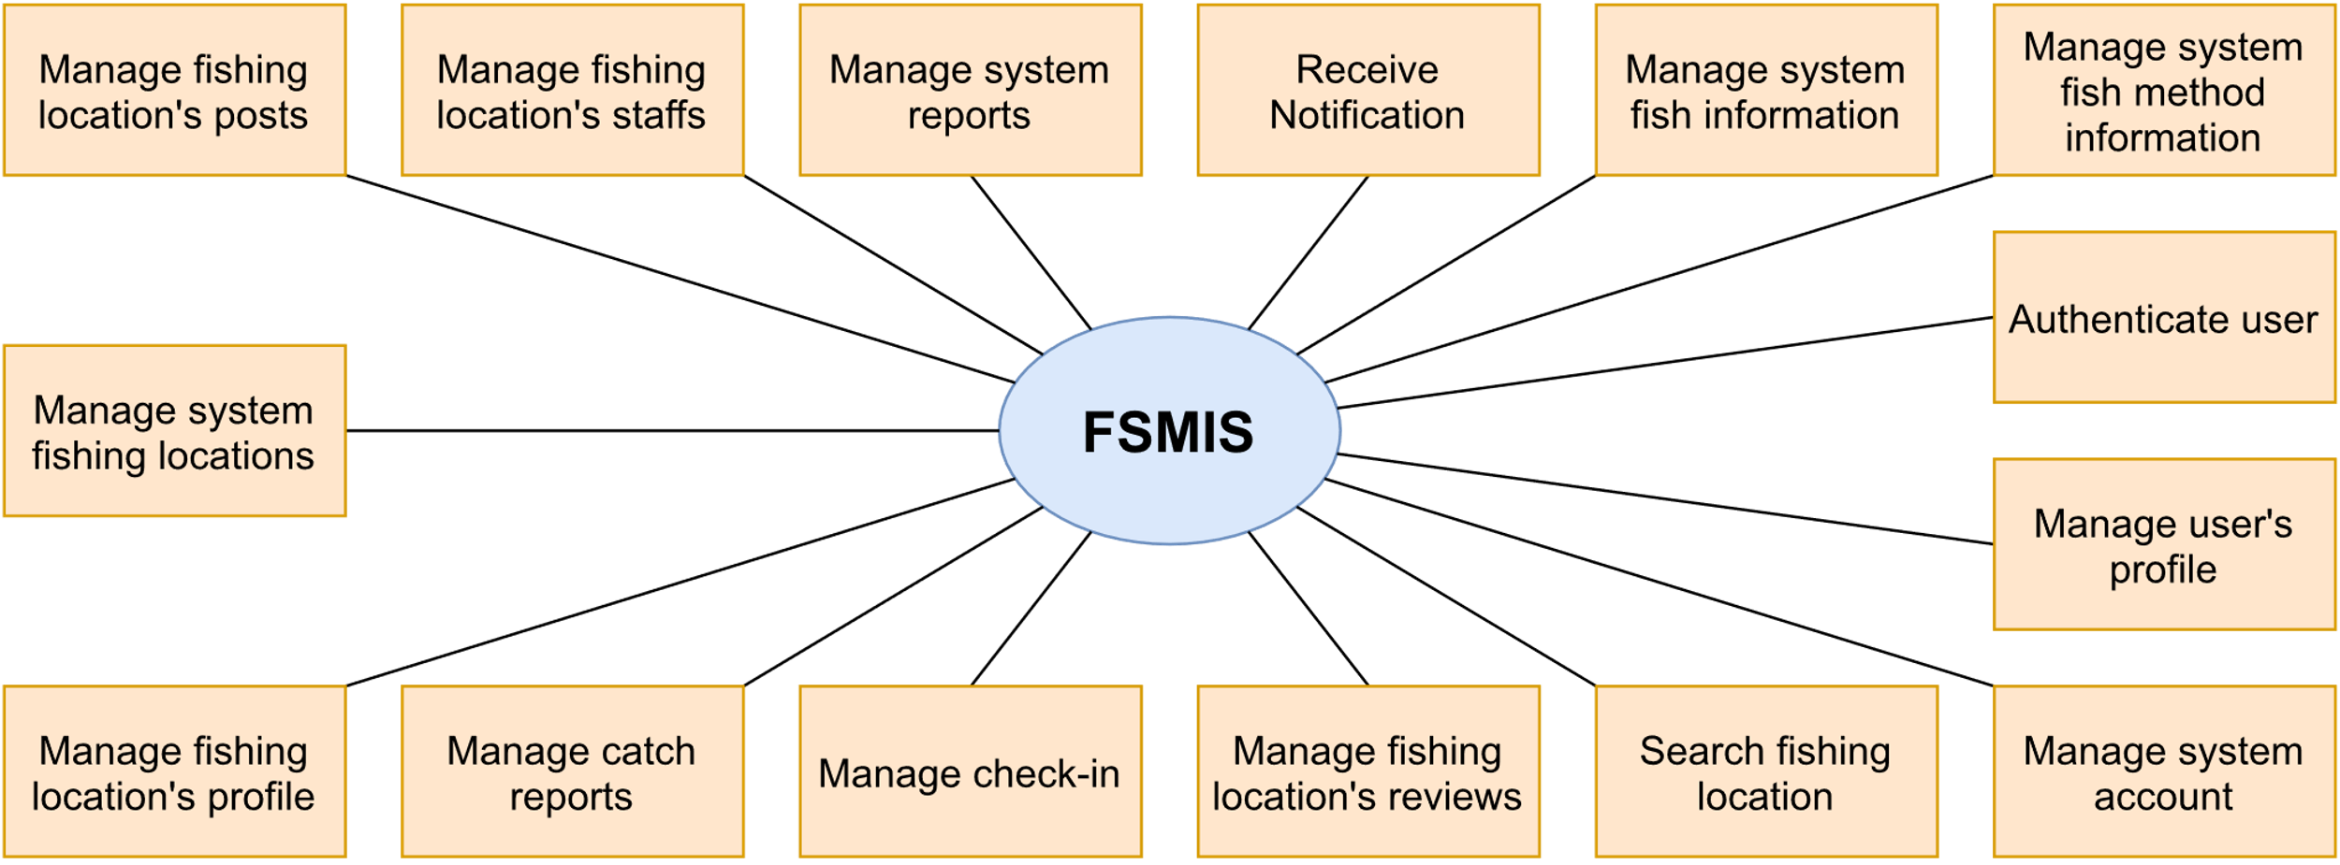

Figure 6.1. FSMIS’s major features

|  |  |
| --- | --- |
| **ID** | **Feature & Description** |
| FE-01 | Authenticate user: Anglers must have an account to access other features in the system. |
| FE-02 | Manage user’s profile: Anglers can manage their personal information. |
| FE-03 | Manage system account: Admin can manage accounts in the system to activate or deactivate a user. |
| FE-04 | Search fishing location: Anglers can search fishing locations nearby or by keywords, see all information, and save them. |
| FE-05 | Manage fishing location’s reviews: Anglers can leave a review followed by fishing location, rate other reviews. |
| FE-06 | Manage check-in: Anglers can check-in at the specific fishing location, view their check-in history. Owners can see check-in history followed by their fishing location. |
| FE-07 | Manage catch reports: Anglers can send catch report for checked-in fishing location, can see personal catch history. Owners can see catch history followed by their fishing location. |
| FE-08 | Manage fishing location’s profile: Owners can update their fishing location’s information such as schedule, services, rules, and fishes are available. |
| FE-09 | Manage system fishing locations: Admin can read fishing location in system to give verified icon. |
| FE-10 | Manage fishing location’s posts: Anglers can see other public catch reports in the specific fishing location and read the post of the fishing location (Fish stocking, fish reporting, announcement) created by the owner or staff. |
| FE-11 | Manage fishing location’s staff: Owners can manage staffs who work at their fishing location. |
| FE-12 | Manage system reports: Admin can manage all reports about false information that was sent by anglers. |
| FE-13 | Receive information: Users can know posts created by the saved fishing locations or when the admin processes report. |
| FE-14 | Manage system fish information: Admin can manage fish species in the system. |
| FE-15 | Manage system fishing method information: Admin can manage fishing methods in the system. |
| FE-16 | Manage fishing location’s suggestion: Admin create fishing locations from the user’s suggestions and transfer it to any owner having an account in the system. |
| FE-17 | Manage banned phone number: Ban any violated account by phone number, prevent them from further accessing the system. |

Table 6.1. List of major features.

### 6.2. Limitation & Exclusion

|  |  |
| --- | --- |
| **ID** | **Feature & Description** |
| LI-01 | Users cannot see other people's profiles. |
| LI-02 | Users cannot receive push notifications when not using the app. |
| LI-03 | The application only supports the Vietnamese language. |
| LI-04 | The application has not been developed on the iOS operating system. |
| LI-05 | The application does not support real-time |

Table 6.2:1. Limitations

|  |  |
| --- | --- |
| **ID** | **Feature & Description** |
| EX-01 | The application does not support weather forecasts. |
| EX-02 | The application does not support live streaming. |
| EX-03 | The application does not support leaderboards. |
| EX-04 | The application is not a social network or forum. |
| EX-05 | The application does not support the angler to pin individual fishing points |

Table 6.2:2. Exclusions

# II. Project Management Plan

## 1. Overview

### 1.1. WBS & Estimation

|  |  |  |  |
| --- | --- | --- | --- |
| **#** | **WBS Item** | **Complexity** | **Est. Effort (Man-days)** |
| ***1*** | ***Pre-Initiating Phase*** |  | ***25*** |
| 1.1 | Select project manager | Simple | 2 |
| 1.2 | Determine the role of team members | Simple | 2 |
| 1.3 | Choose topic | Complex | 20 |
| 1.4 | Register Capstone Project | Simple | 1 |
| ***2*** | ***Initiating Phase*** |  | ***40*** |
| 2.1 | Kick-off meeting | Simple | 5 |
| 2.2 | Develop project introduction document | Complex | 35 |
| ***3*** | ***Planning Phase*** |  | ***50*** |
| **3.1** | **Project Planning** |  | ***20*** |
| 3.1.1 | Define scope | Medium | 3 |
| 3.1.2 | Choose working model process | Simple | 1 |
| 3.1.3 | Choose software process model | Simple | 1 |
| 3.1.4 | Select tools and techniques | Simple | 1 |
| 3.1.5 | Develop WBS | Medium | 4 |
| 3.1.6 | Develop project schedule | Medium | 3 |
| 3.1.7 | Develop risk management plan | Medium | 1 |
| 3.1.8 | Develop project communication plan | Simple | 1 |
| 3.1.9 | Organize project resources | Simple | 1 |
| 3.1.10 | Develop software project management plan | Medium | 4 |
| **3.2** | **Project Preparing** |  | ***5*** |
| 3.2.1 | Create software mockup | Complex | 3 |
| 3.2.2 | Technical Training/Self study | Simple | 2 |
| **3.3** | **Analyzing & Requirement** |  | ***25*** |
| 3.3.1 | User Requirements | Medium | 3 |
| 3.3.2 | Functional Requirements | Medium | 3 |
| 3.3.3 | Create Entity Relationship Diagram | Complex | 5 |
| 3.3.4 | Non-Functional Requirements | Simple | 2 |
| 3.3.5 | Create test cases for system test | Medium | 3 |
| 3.3.6 | Develop Software Requirement Specification | Complex | 9 |
| ***4*** | ***Executing*** |  | ***260*** |
| **4.1** | **Designing** |  | ***40*** |
| 4.1.1 | Basic architecture design | Medium | 3 |
| 4.1.2 | Create test cases for integration test | Medium | 5 |
| 4.1.3 | Detail design | Medium | 6 |
| 4.1.4 | Data & Database Design | Medium | 6 |
| 4.1.5 | Create test cases for unit test | Medium | 5 |
| 4.1.6 | Develop Software Design Document | Medium | 15 |
| **4.2** | **Implementation - Iteration 1: Develop user features** |  | ***72*** |
| 4.2.1 | *Requirements* |  | **3** |
| 4.2.1.1 | Update Software Requirement Specification | Medium | 3 |
| 4.2.2 | *Design* |  | ***4*** |
| 4.2.2.1 | Update Software Design Document | Medium | 4 |
| 4.2.3 | *Coding* |  | **45** |
| 4.2.3.1 | Feature 1: Authentication user |  | 5 |
| 4.2.3.1.1 | Code front-end | Medium | 3 |
| 4.2.3.1.2 | Code backend | Complex | 2 |
| 4.2.3.2 | Feature 2: Manage personal profile |  | 5 |
| 4.2.3.2.1 | Code front-end | Medium | 3 |
| 4.2.3.2.2 | Code backend | Medium | 2 |
| 4.2.3.3 | Feature 4: Search fishing location |  | 5 |
| 4.2.3.3.1 | Code front-end | Medium | 3 |
| 4.2.3.3.2 | Code backend | Medium | 2 |
| 4.2.3.4 | Feature 5: Manage fishing location's reviews |  | 5 |
| 4.2.3.4.1 | Code front-end | Medium | 3 |
| 4.2.3.4.2 | Code backend | Medium | 2 |
| 4.2.3.5 | Feature 6: Manage check-in |  | 5 |
| 4.2.3.5.1 | Code front-end | Medium | 2 |
| 4.2.3.5.2 | Code backend | Complex | 3 |
| 4.2.3.6 | Feature 7: Manage catch reports |  | 5 |
| 4.2.3.6.1 | Code front-end | Medium | 3 |
| 4.2.3.6.2 | Code backend | Medium | 2 |
| 4.2.3.7 | Feature 8: Manage fishing location's profile |  | 5 |
| 4.2.3.7.1 | Code front-end | Complex | 3 |
| 4.2.3.7.2 | Code backend | Medium | 2 |
| 4.2.3.8 | Feature 11: Manage fishing locations' posts |  | 5 |
| 4.2.3.8.1 | Code front-end | Medium | 4 |
| 4.2.3.8.2 | Code backend | Complex | 1 |
| 4.2.3.9 | Feature 12: Manage fishing location's staffs |  | 5 |
| 4.2.3.9.1 | Code front-end | Medium | 3 |
| 4.2.3.9.2 | Code backend | Medium | 2 |
| 4.2.4 | *Testing* |  | **15** |
| 4.2.4.1 | Unit test | Medium | 10 |
| 4.2.4.2 | Integration test | Medium | 5 |
| 4.2.5 | *Evaluation* | Simple | **5** |
| **4.3** | **Implementation - Iteration 2: Develop admin features** |  | ***73*** |
| 4.3.1 | *Requirements* |  | **4** |
| 4.3.1.1 | Update Software Requirement Specification | Medium | 4 |
| 4.3.2 | *Design* |  | **4** |
| 4.3.2.1 | Update Software Design Document | Medium | 4 |
| 4.3.3 | *Coding* |  | **45** |
| 4.3.3.1 | Feature 3: Manage system account |  | 6 |
| 4.3.3.1.1 | Code front-end | Medium | 3 |
| 4.3.3.1.2 | Code backend | Medium | 3 |
| 4.3.3.2 | Feature 9: Manage system fishing location |  | 6 |
| 4.3.3.2.1 | Code front-end | Medium | 3 |
| 4.3.3.2.2 | Code backend | Medium | 3 |
| 4.3.3.3 | Feature 13: Manage system reports |  | 7 |
| 4.3.3.3.1 | Code front-end | Medium | 4 |
| 4.3.3.3.2 | Code backend | Medium | 3 |
| 4.3.3.4 | Feature 10: Receive notification |  | 4 |
| 4.3.3.4.1 | Code front-end | Simple | 1 |
| 4.3.3.4.2 | Code backend | Simple | 3 |
| 4.3.3.5 | Feature 14: Manage system fish species |  | 5 |
| 4.3.3.5.1 | Code front-end | Simple | 3 |
| 4.3.3.5.2 | Code backend | Simple | 2 |
| 4.3.3.6 | Feature 15: Manage system fishing method |  | 5 |
| 4.3.3.6.1 | Code front-end | Simple | 3 |
| 4.3.3.6.2 | Code backend | Simple | 2 |
| 4.3.3.7 | Feature 16: Manage fishing location's suggestion |  | 6 |
| 4.3.3.7.1 | Code front-end | Medium | 3 |
| 4.3.3.7.2 | Code backend | Medium | 3 |
| 4.3.3.8 | Feature 17: Manage banned phone number |  | 6 |
| 4.3.3.8.1 | Code front-end | Medium | 3 |
| 4.3.3.8.2 | Code backend | Medium | 3 |
| 4.3.4 | *Testing* |  | **15** |
| 4.3.4.1 | Unit test | Medium | 10 |
| 4.3.4.2 | Integration test | Medium | 5 |
| 4.3.5 | *Evaluation* | Simple | **5** |
| 4.4 | **Full System testing** |  | **30** |
| 4.4.1 | Execute Full System Test & Fix Bugs | Medium | 25 |
| 4.4.2 | Update Software Test Report Document | Medium | 5 |
| 4.5 | **Transitioning** |  | **45** |
| 4.5.1 | *Software Optimization* |  | *30* |
| 4.5.1.1 | Create LIVE Data | Medium | 10 |
| 4.5.1.2 | Optimize/Refactor Codes | Medium | 5 |
| 4.5.1.3 | Execute Full System Test Round 2 & Fix Bugs | Simple | 15 |
| 4.5.2 | *User Guides* |  | *5* |
| 4.5.2.1 | Develop Software User Guides | Medium | 5 |
| 4.5.3 | Develop Final Project Report | Medium | 10 |
| ***5*** | ***Monitoring and Controlling*** |  | ***5*** |
| 5.1 | Meet instructor | Medium | 2 |
| 5.2 | Progress Report | Complex | 3 |
| ***6*** | ***Closing*** |  | ***25*** |
| 6.1 | Prepare for final project presentation | Medium | 15 |
| 6.2 | Present final project | Medium | 5 |
| 6.3 | Project completed | Simple | 5 |
| **Total Estimated Effort (man-days)** | | | **405** |

Table 1.1. WBS & Estimation

### 1.2. Project Objectives

#### 1.2.1. Project Objectives

* This product is a mobile application, suitable for anglers and fishing spots owners who want to connect to each other’s.
* This product has main features:
  + Provide information about fishing spots.
  + Manage fishing spots information and staff.

#### 1.2.2. Team Objectives

* Team finishes the project before 20th December, 2021.
* Team members improve skill in working in group.
* Each member improves both technical skills and soft skills.
* Team successfully applied a software development process.

### 1.3. Project Risks

|  |  |  |  |  |
| --- | --- | --- | --- | --- |
| **#** | **Risk Description** | **Impact** | **Possibility** | **Response Plans** |
| 1 | Member illness | High | Medium | Other members should join forces to fulfill the work of the absent member. |
| 2 | Conflict among members | Medium | Medium | All members should discuss ways to resolve the conflict. |
| 3 | Lack of skill | High | Medium | Members should be given time to train their field before coding. |
| 4 | Ambiguous business requirement | High | High | Study about other existing systems.  Study about the needs of end-users.  State the requirements clearly in documents.  Analyze each requirement carefully. |
| 5 | Facing hard problems | High | High | All members should discuss the problems and find out the best solution.  Ask the supervisor and people who have experience and knowledge about the problems. |
| 6 | Requirement changes | High | Medium | All members should discuss carefully  at the beginning of each iteration to  define scope and requirement. |

Table 1.3. Project Risks

## 2. Management Approach

### 2.1. Project Process

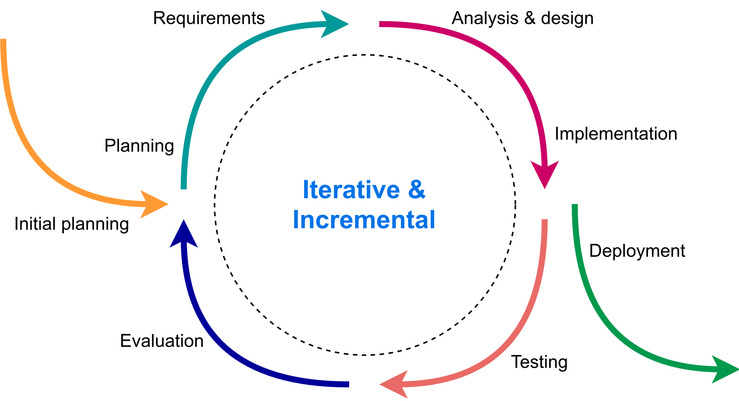

Figure 2.1. Iterative and Incremental software process model

We use the Iterative and Incremental software process model - a method in which the system is developed through repeated cycles and in smaller portions at a time. This model allows software developers to take advantage of what was learned during the development of earlier system parts. At each iteration, design modifications are made, and new functional capabilities are added.

This project will be divided into two iterations. In each iteration, we are going to finish and deliver a code package of essential features.

### 2.2. Meeting Minutes

All meeting minutes will follow this template:

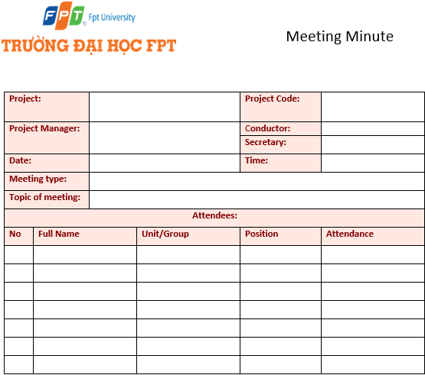

Figure 2.2. Meeting minute template

### 2.3. Quality Management

* In the frontend, we use EsLint[1] and Prettier[2] tools to control source code conventions and unify the coding convention between all members, a configuration like images below:

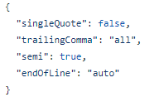

Figure 2.3:1. Prettier Configuration

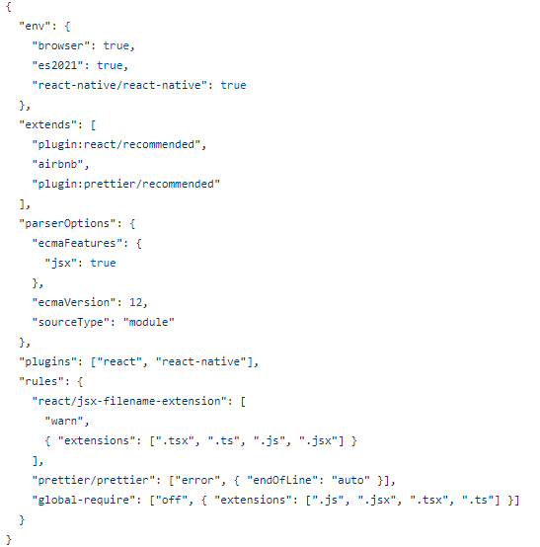

Figure 2.3:2. EsLint Configuration

* In the backend, we use Oracle’s Java Code Convention[3].
* In the database, identifiers such as names of databases, tables, and columns will use snake_case[4]. Tables start with “tbl_name” prefix.
* In each merge request, we always verify code on each other.

### 2.4. Training Plan

|  |  |  |  |
| --- | --- | --- | --- |
| **Training Area** | **Participants** | **When, Duration** | **Waiver Criteria** |
| Java Spring Boot | Le Tuan Anh  Tran Duc Anh | 20/9/2021, 1 week | Mandatory |
| React Native | Dao Quoc Toan  Nguyen Dinh Dat  Hoang Minh Duc | 20/9/2021, 1 week | Mandatory |
| ReactJS | Hoang Minh Duc | 20/9/2021, 1 week | Mandatory |
| Git, Github | Le Tuan Anh  Tran Duc Anh  Dao Quoc Toan  Nguyen Dinh Dat  Hoang Minh Duc | 20/9/2021, 1 week | Mandatory |
| Figma | Le Tuan Anh  Nguyen Dinh Dat | 20/09/2021, 1 week | Mandatory |

Table 2.4. Training Plan

## 3. Master Schedule

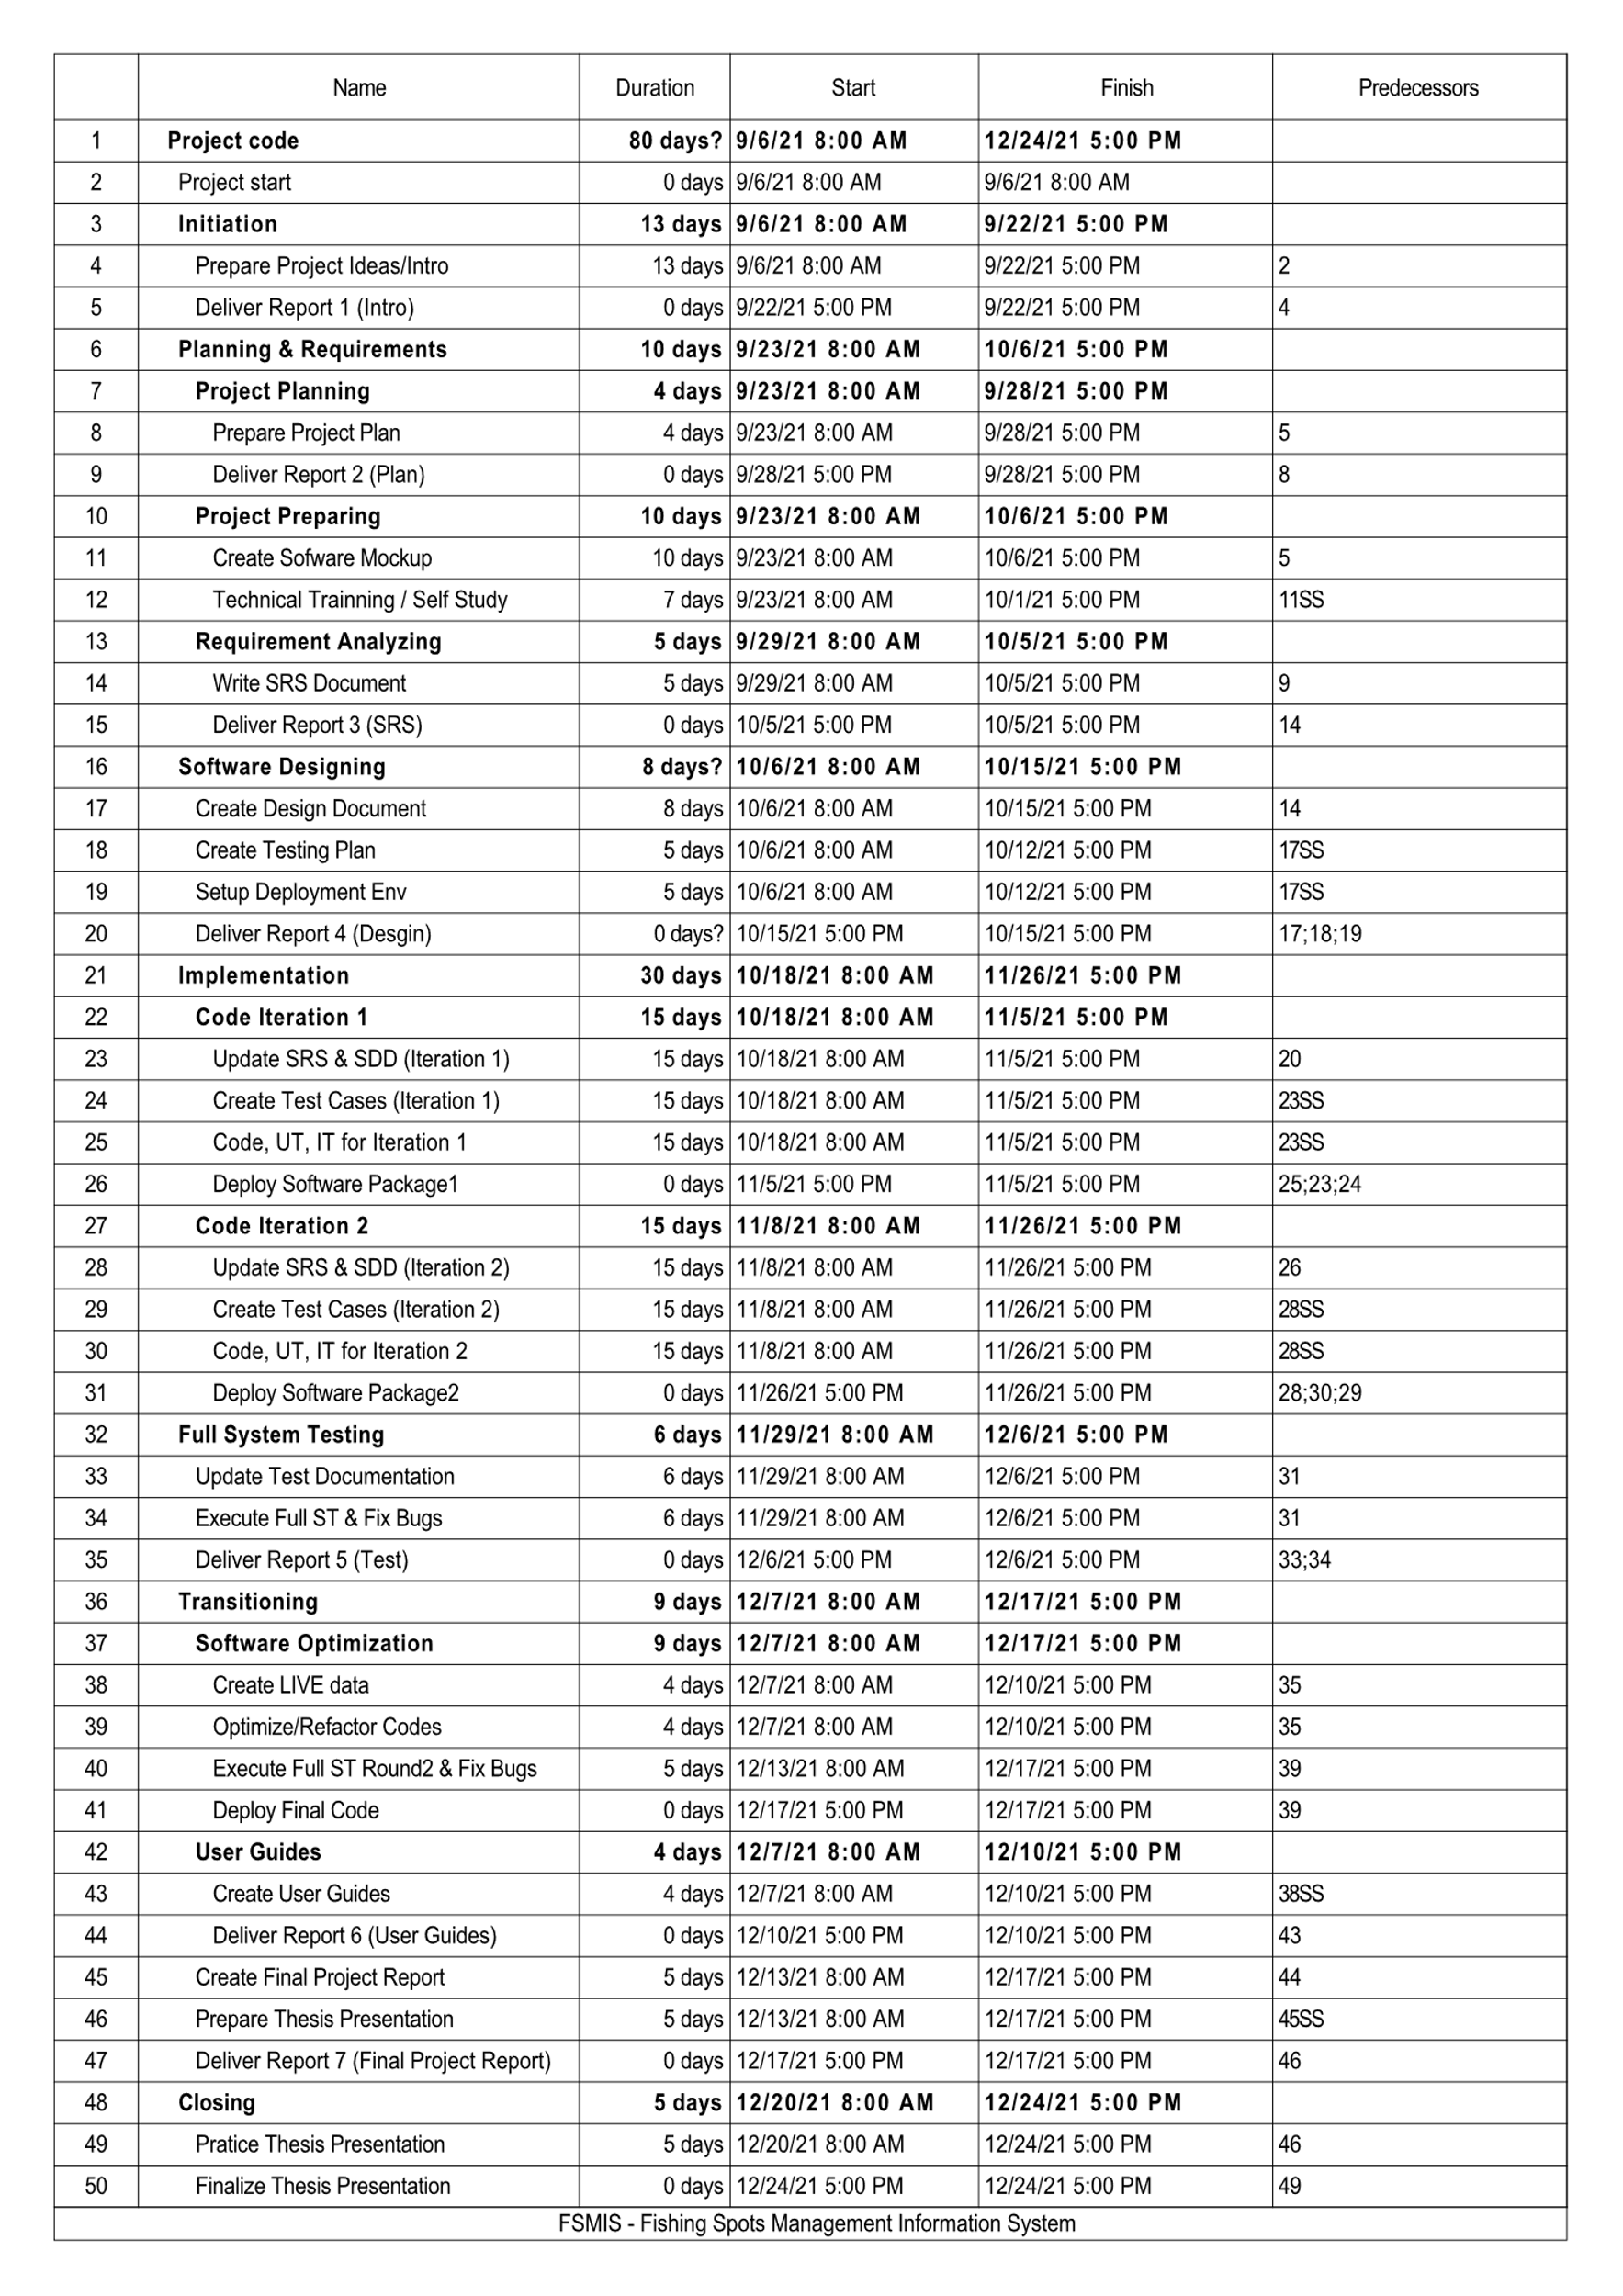

Figure 3. Master Schedule

## 4. Project Organization

### 4.1. Team & Structures

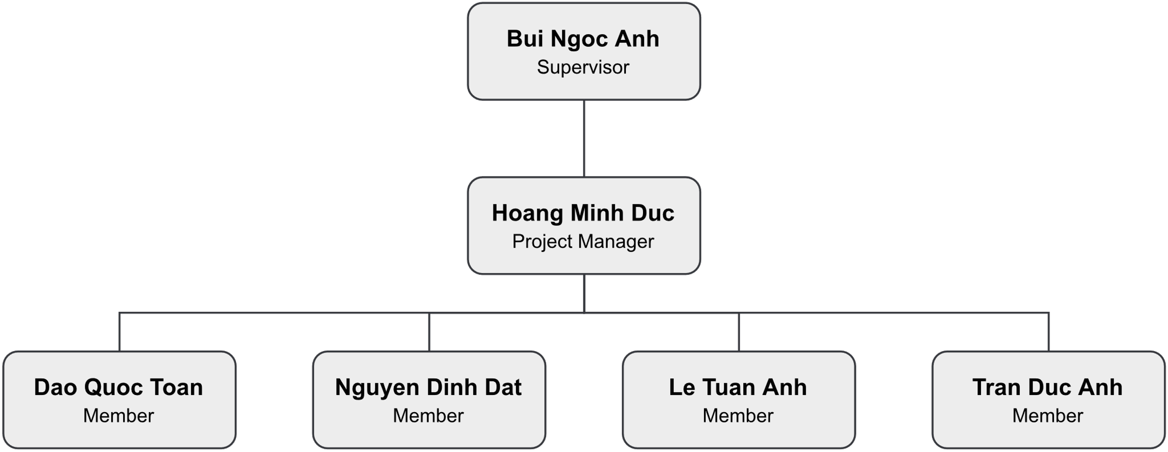

Figure 4.1. Team & Structures Diagram

### 4.2. Roles & Responsibilities

|  |  |  |
| --- | --- | --- |
| **Role** | **Member** | **Responsibility** |
| Project Manager | Hoang Minh Duc | Responsible for planning, creating schedules, coordinating communication  Keeping track of the progress of the project  Take responsibility with all requirement and schedule of school  Keep project in direct goals |
| Analysis Leader | Le Tuan Anh | Analyze project requirement  Define project scope, create SRS document  Review SRS created by analysis members  Study and research about fishing activity |
| Analysis Member | Hoang Minh Duc  Dao Quoc Toan  Tran Duc Anh  Nguyen Dinh Dat | Define requirements: functional and non-functional requirements  Keep track and contribute to SRS document  Define detail flow of features  Review other members and comment  Study and research about fishing activity |
| Designer | Nguyen Dinh Dat  Le Tuan Anh | Define screens, flow between screens  Design UI, UX for application |
| Technical Leader | Dao Quoc Toan | Responsible for choosing technologies for the whole system and overseeing the work done by other programmers |
| Frontend Developer | Dao Quoc Toan  Nguyen Dinh Dat  Hoang Minh Duc | Initial and develop frontend  Study technical requirement to apply into  project  Review code for each other  Fix bugs |
| Backend Developer | Tran Duc Anh  Le Tuan Anh | Design database  Study technical requirement to apply into  project  Initial and develop backend server  Review code for each other  Fix bugs  Deploy code to server |
| Test Leader | Le Tuan Anh | Define test plan  Assign tasks for other member  Study and research testing tools  Create test template, test cases  Implement tests follow test plan  Take responsibility about coverage of test  Create test reports and inform development teams about bugs |

Table 4.2. Roles & Responsibilities

## 5. Project Communication

### 5.1. Communication Plan

|  |  |  |  |  |
| --- | --- | --- | --- | --- |
| **Communication Item** | **Who/ Target** | **Purpose** | **When, Frequency** | **Type, Tool, Method(s)** |
| Weekly meeting | Team members, supervisor | Review member’s work achievements.  Report the project's progress and status of each member’s work. | Every Tuesday | Google Meet |
| Daily meeting | Team members | Report the project's progress and status of each member’s work each day. | From Monday to Friday | Google Meet |
| Unscheduled meeting | Team members | Resolve unpredicted problems | When any problems arise | Google Meet, Discord |
| Supervisor daily communication | Team member, supervisor | Report project status, Q&A | Every Tuesday | Messenger |
| Team daily communication | Team members | Discuss project, sharing files, sharing source code | From Monday to Friday | Discord, Messenger |

Table 5.1. Communication Plan

### 5.2. External Interface

|  |  |  |  |
| --- | --- | --- | --- |
| **Function** | **Contact Person**  **(name, position)** | **Contact address**  **(email, telephone)** | **Responsibility** |
| Supervisor | Bui Ngoc Anh | [anhbn5@fe.edu.vn](mailto:anhbn5@fe.edu.vn) | * Provide document template * Give instruction to project team * Review deliverables * Supervise project status |

Table 5.2. External Interface

## 6. Configuration Management

### 6.1. Tools & Infrastructures

|  |  |
| --- | --- |
| **Programming languages** | **Tools & Technical** |
| Framework | Java Spring Boot, React Native, Expo |
| Library | ReactJS |
| API | RESTful API |
| DBMS | PostgreSQL |
| IDEs/Editors | Visual Studio Code, IntelliJ |
| Testing tools & Framework | IntelliJ, Postman |
| Design | Figma |
| UML tools | Draw.io |
| Version Control | GitHub |
| Deployment Server | VPS |
| Project Management Tools | Project Libre |

Table 6.1. Tools & Infrastructures

### 6.2. Document Management

#### 6.2.1. Convention

* Font family: Times New Roman
* Heading 1: 18pt Bold
* Heading 2: 16pt Bold
* Heading 3: 14pt Bold
* Heading 4: 12pt Bold
* Heading 5: 12pt Bold Italic
* Heading 6: 12pt Bold Italic Underline
* Image & Table Title: 10pt Italic
* Normal: 12pt

#### 6.2.2. Management

* All documents will be stored on Google Drive and Microsoft OneDrive.
* All reports will be delivered to the supervisor through Gmail.

### 6.3. Source Code Management

#### 6.3.1. Convention

* All coding branches must be reviewed by team developers before merging to the default branch.
* All developers must implement unit tests and review code before creating a merge request.

#### 6.3.2. Management

* All source code will be stored on GitHub.
* Only team members can access the repository on GitHub.

# III. Software Requirement Specification

## 1. Project Overview

The FSMIS aims to connect anglers and fishing location owners. The system packs feature up into a single mobile application, where the users can use and carry with them wherever they go. The diagram below illustrates the external entities and system interfaces for first-time release.

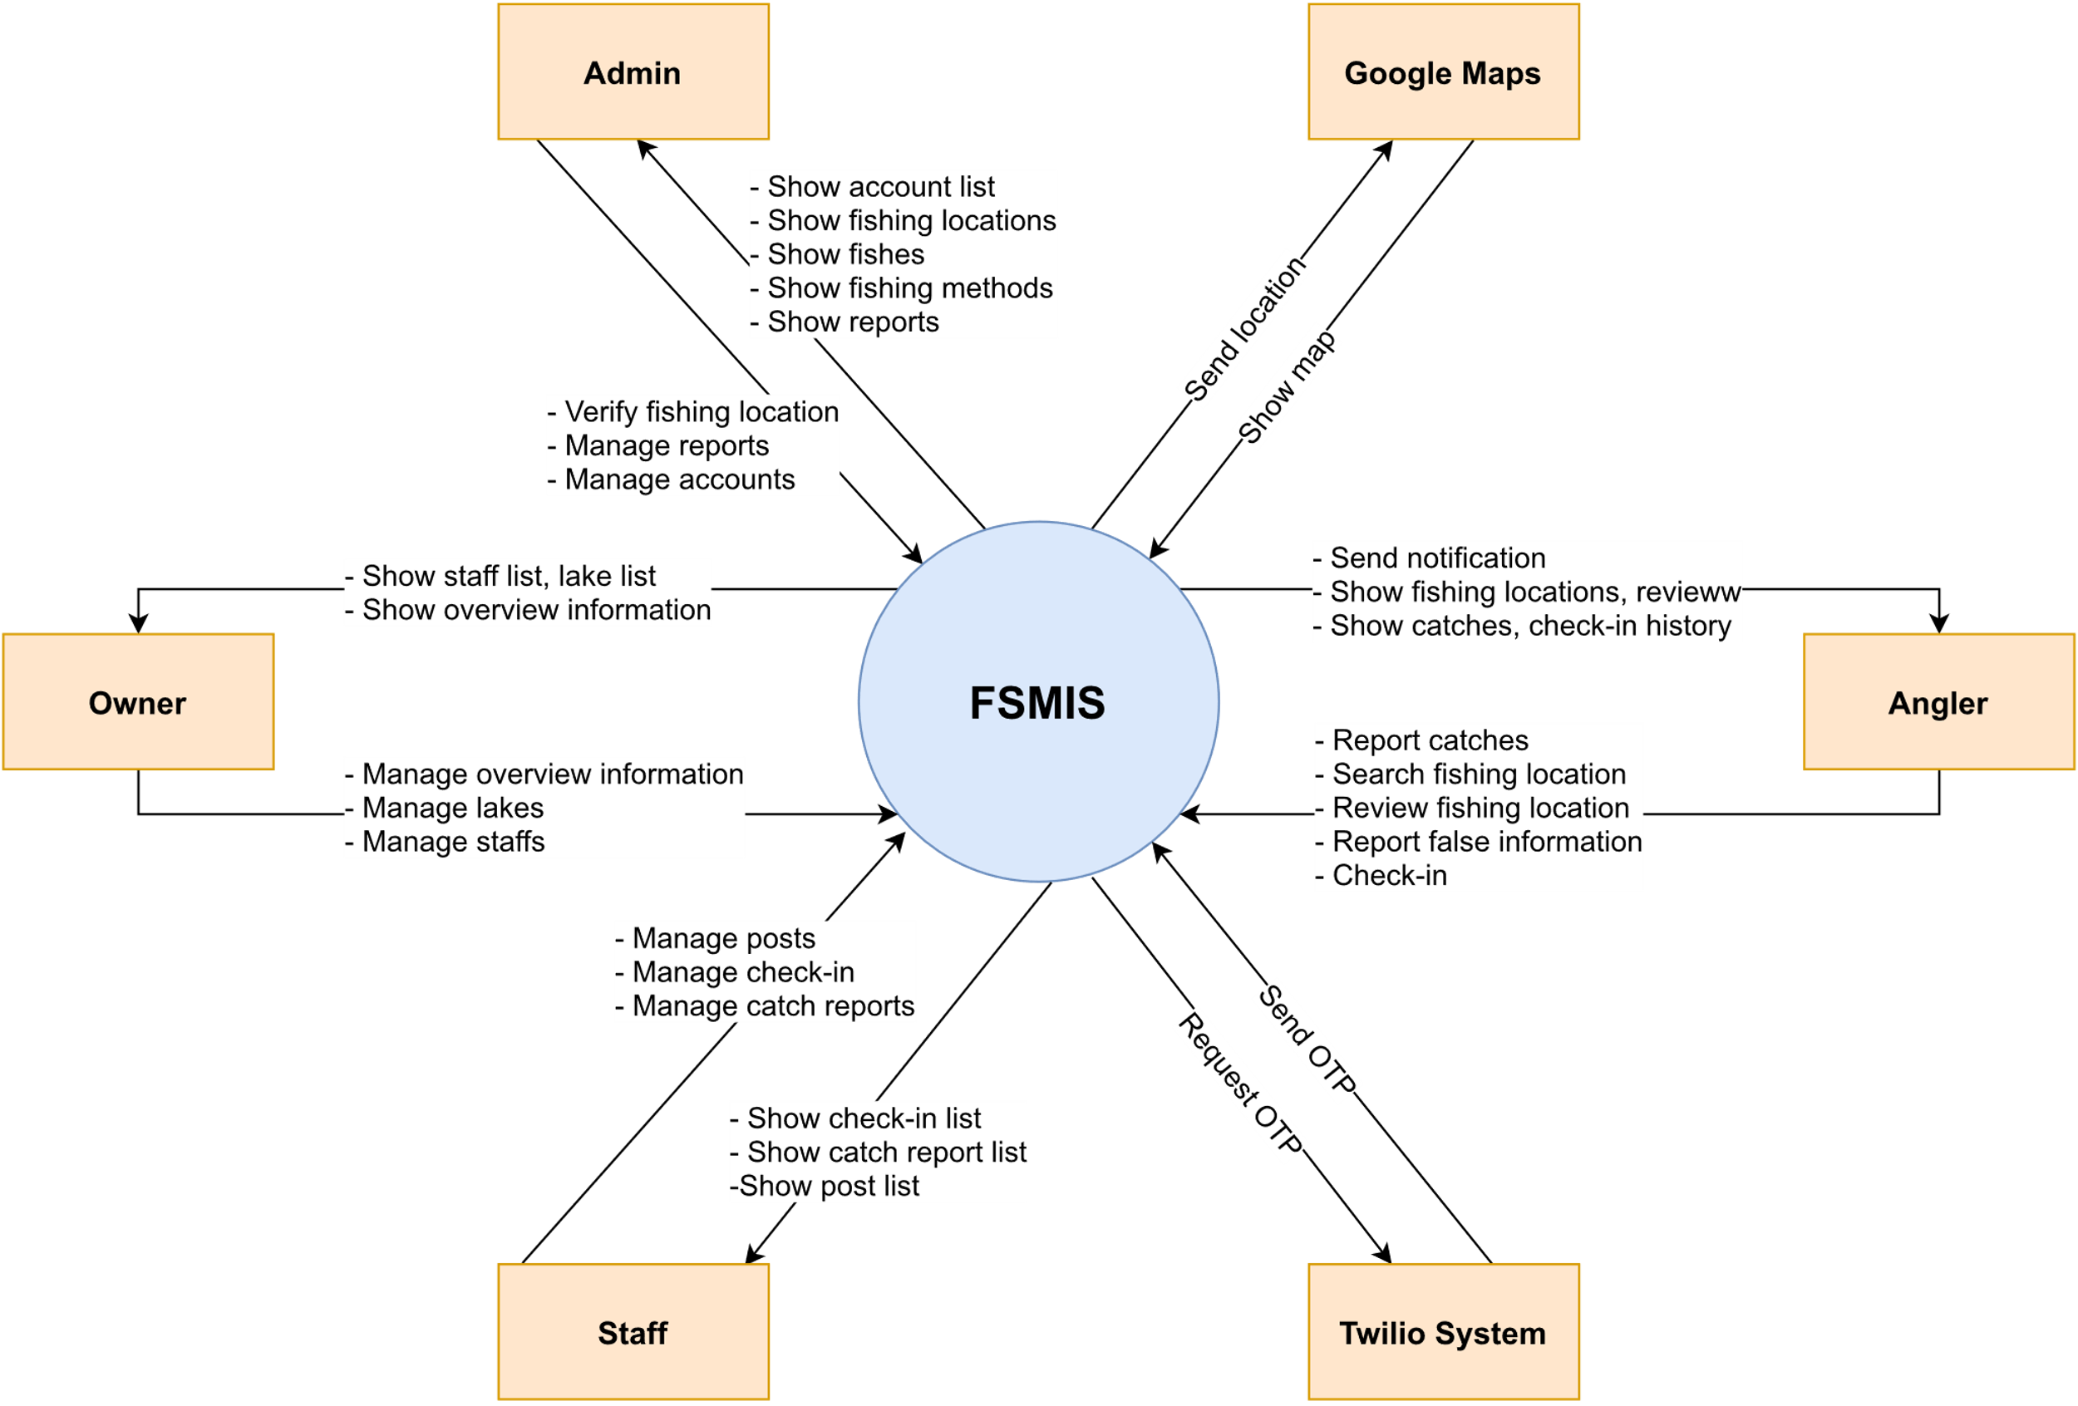

Figure 1. Context Diagram

## 2. User Requirement

### 2.1. Actors

|  |  |  |
| --- | --- | --- |
| **#** | **Actor** | **Description** |
| 1 | Angler | Angler is the person who can search for fishing locations, check-in, report fish catches publicity or privately, and rate fishing locations. |
| 2 | Owner | Owner is the person who owns of a certain number of fishing locations, able to edit fishing location information publicity, confirm angler’s report fish catches, create posts, and read check-in or catches history. |
| 3 | Staff | Staff is the person add to the fishing location’s management by owner but can perform certain functions of the fishing location’s owner. |
| 4 | Administrator | Admin is the person who has the permission to administer user accounts, fishing locations, fish species, fishing methods in the system and receive false information’s reports from users. |

Table 2.1. Actors

### 2.2. Use Cases

#### 2.2.1. Overview

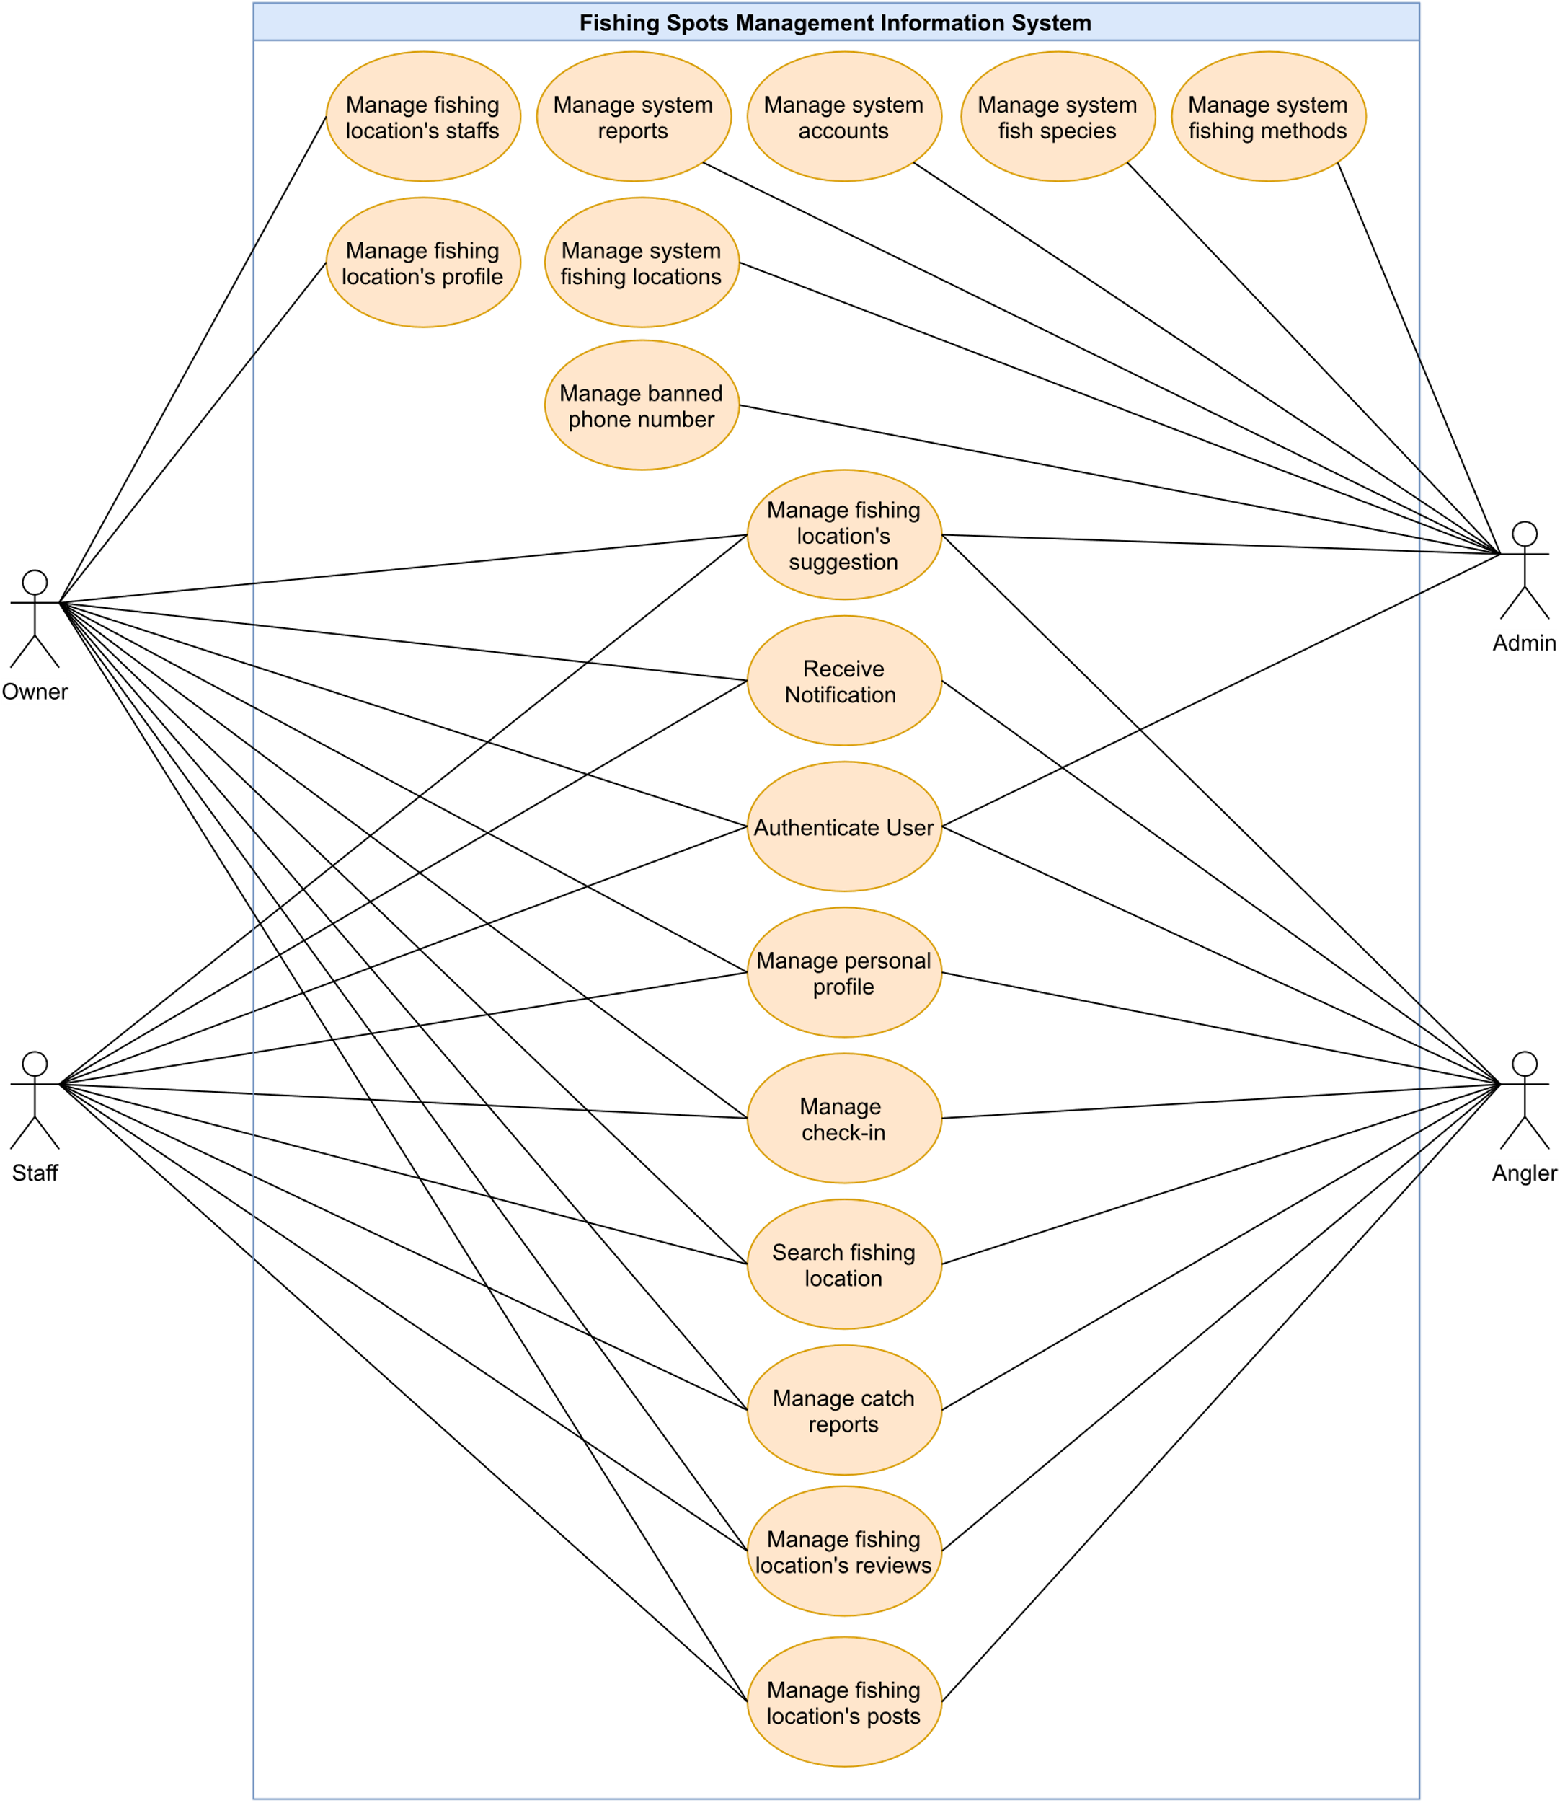

Figure 2.2.1. Overall use case diagram

#### 2.2.2. Feature “Authenticate user”

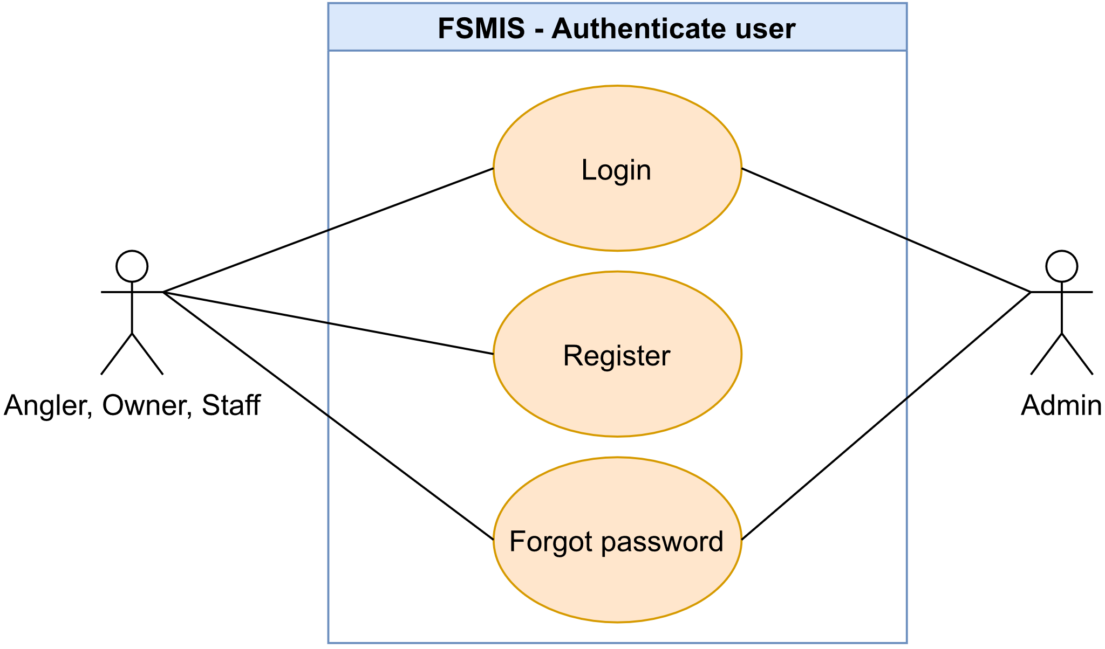

Figure 2.2.2. “Authenticate user” use cases

##### 2.2.2.1. Login

|  |  |  |  |
| --- | --- | --- | --- |
| **UC ID and Name:** | **UC-01. Login** | | |
| **Created By:** | DucHM | **Date Created:** | 10/02/2021 |
| **Primary Actor:** | Anglers, Owner, Staff, Admin | **Secondary Actors:** | N/A |
| **Trigger:** | **TRIG-01.** Press on the app icon on the user’s smart phone. | | |
| **Description:** | This use case allows the user to login into the system. | | |
| **Preconditions:** | **PRE-01.** The user has registered an account in the system.  **PRE-02.** The user’s phone number has not been banned in the system. | | |
| **Post-conditions:** | **POST-01.** The system saves the user’s login session token. | | |
| **Normal Flow:** | **1.0. Login to the system**   1. The user presses on the app icon to open the system. 2. The system displays the system’s logo and redirects the user to the Login screen.    1. A required number field to input the phone number.    2. A required text field to input the user’s password. 3. The user inputs his/her phone number and password, then presses on the “Đăng nhập” button to login (See 1.0.E1, 1.0.E2, 1.0.E3, 1.0.E4). 4. The system validates and user logged in successfully. | | |
| **Alternative Flows:** | N/A | | |
| **Exceptions:** | **1.0.E1. Wrong phone number or password**   1. In step 3, if the user inputs the wrong phone number or password. 2. The system rejects the user’s login attempt and displays an error message (MSG01).   **1.0.E2. Leave required fields blank**   1. In step 3, if the user login without providing a phone number or password. 2. The system rejects the user’s login attempt and displays error messages (MSG02).   **1.0.E3. Login with a banned phone number**   1. In step 3, the user logins with a phone number banned in the system. 2. The system rejects the user’s login, and redirects the user to the Ban Notice Screen, where he/she is explained why he/herself is being banned.   **1.0.E4.** **The user inputs the wrong password format**   1. The user inputs a password less than 8 characters. 2. 2. The system rejects the user’s attempt and displays an error message (MSG16). | | |
| **Priority:** | High | | |
| **Frequency of Use:** | High | | |
| **Business Rules:** | BR-01, BR-02, BR-06, BR-07 | | |
| **Other Information:** | 1. If the user logouts from the system, the system returns to the Login Screen as default. | | |
| **Assumptions:** | N/A | | |

Table 2.2.2.1. Login

##### 2.2.2.2. Register

|  |  |  |  |
| --- | --- | --- | --- |
| **UC ID and Name:** | **UC-02. Register** | | |
| **Created By:** | DucHM | **Date Created:** | 10/02/2021 |
| **Primary Actor:** | Anglers, Owner, Staff | **Secondary Actors:** | N/A |
| **Trigger:** | **TRIG-01.** The user presses on the “Đăng ký” underline text in the Login Screen. | | |
| **Description:** | This use case allows user to register a new account to login to the system. | | |
| **Preconditions:** | **PRE-01.** The user must have a phone number.  **PRE-01.** The user is in the Login Screen. | | |
| **Post-conditions:** | **POST-01.** The system creates an account for the user in the database. | | |
| **Normal Flow:** | **2.0. Register a new account**   1. The user presses on the “Đăng ký” underline text in the Login Screen. 2. The system redirects to the Register Screen and displays the following:    1. A required number field to input the phone number.    2. Two required text fields to input password and password confirmation. 3. The user inputs required fields, presses “Tiếp tục” to continue the process. (See 2.0.E1, 2.0.E2, 2.0.E3, 2.0.E4, 2.0.E5) 4. The system sends the OTP code to the user’s phone number and redirects the user the OTP Screen, displays the following (See other information 1):    1. 6 number cells to input OTP code.    2. A countdown timer indicates the next OTP send request availability.    3. The “Tiếp tục” button. 5. The user inputs the OTP code and presses the “Tiếp tục” button to continue the process (see 2.0.E6). 6. The system validates the OTP code successfully, registers the account and redirects the user to the Register Information Screen, displays the following field:    1. Required name text field.    2. Required birth date select field.    3. Non-required fields: gender, address, province, district, street. 7. The user inputs required fields, any non-required fields and presses the “Đăng ký” button (see 2.0.E1, 2.0.E2). 8. The system registers the user, displays a message (MSG46) and redirects the user back to the Login Screen. | | |
| **Alternative Flows:** | N/A | | |
| **Exceptions:** | **2.0.E1. Leave required fields blank**   1. In step 3, the user registers without filling the required fields 2. The system rejects the user’s register attempt and displays error messages (MSG02).   **2.0.E2. The user inputs invalid phone number**   1. The user inputs invalid phone number. 2. The system rejects the user’s register attempt and displays an error message (MSG04).   **2.0.E3. The user inputs wrong password format**   1. The user inputs a password less than 8 characters. 2. The system displays an error message (MSG16).   **2.0.E4. The user inputs unmatched password re-confirmation**   1. In step 3, the user inputs unmatched password re-confirmation, 2. The system displays an error message (MSG06).   **2.0.E5. Use existed phone number or banned phone number to register**   1. In step 3, the user inputs existed phone number or banned phone number 2. The system rejects the user’s register attempt and displays an error message (MSG05).   **2.0.E6. The user inputs invalid OTP**   1. In step 3, the user inputs invalid OTP code. 2. The system rejects the user’s attempt and displays an error message (MSG03). | | |
| **Priority:** | High | | |
| **Frequency of Use:** | High | | |
| **Business Rules:** | BR-03, BR-06, BR-07 | | |
| **Other Information:** | 1. When an OTP session is over, the system asks if the user wants to re-send an OTP code. The system repeats steps 4, 5 if the user chooses to resend. | | |
| **Assumptions:** | N/A | | |

Table 2.2.2.2. Register

##### 2.2.2.3. Forgot password

|  |  |  |  |
| --- | --- | --- | --- |
| **UC ID and Name:** | **UC-03. Forgot password** | | |
| **Created By:** | DucHM | **Date Created:** | 10/02/2021 |
| **Primary Actor:** | Anglers, Owner, Staff, Admin | **Secondary Actors:** | N/A |
| **Trigger:** | **TRIG-01.** The user presses on the “Quên mật khẩu?” underline text in the Login Screen. | | |
| **Description:** | The function allows the user to reset the password. | | |
| **Preconditions:** | **PRE-01.** The user is in the Login Screen. | | |
| **Post-conditions:** | **POST-01**. The new password is updated in the system. | | |
| **Normal Flow:** | **3.0. Reset the password in the Forgot Password Screen**   1. The user presses on the “Quên mật khẩu?” underline text in the Login Screen. 2. The system redirects the user to the Forgot Password Screen, displays a required number field for phone number. 3. The user inputs his/her phone number and presses the “Tiếp tục” button to continue the process. (See 3.0.E1, 3.0.E2) 4. The system sends the OTP code to the user’s phone number and redirects the user the OTP Screen, displays the following field (See other information 1):    1. 6 number cells to input OTP code.    2. A countdown timer indicates the next OTP send request availability.    3. The “Tiếp tục” button. 5. The user inputs the OTP code and presses on the “Tiếp tục” button to continue the process (see 3.0.E4). 6. The system validates the OTP code and successfully redirects the user to the Change Password Screen, displays two required password and password confirmation fields. 7. The user inputs required fields and press the “Tiếp tục” button (see 3.0.E1, 3.0.E3, 3.0.E4, 3.0.E5). 8. The system updates a new password, displays a message (MSG46) and navigates the user backs to the Login Screen. | | |
| **Alternative Flows:** | **3.0.E1. Leave required fields blank**   1. The user not filling required fields and press the “Tiếp tục” button. 2. The system rejects the user’s attempt and displays error messages (MSG01).   **3.0.E2. The user input invalid phone number**   1. In step 3, The user inputs invalid phone number. 2. The system rejects the user’s attempt and displays an error message (MSG04).   **3.0.E3. The user inputs wrong password format**   1. In step 7, the user inputs a password less than 8 characters. 2. The system rejects the user’s attempt and displays an error message (MSG16).   **3.0.E4. The user inputs incorrect OTP code**   1. In step 7, the user inputs incorrect OTP code. 2. The system rejects the user’s attempt and displays an error message (MSG03).   **3.0.E5. Password confirmation does not match**   1. In step 7, the user inputs a different password confirmation. 2. The system rejects the user’s attempt, display an error message (MSG06). | | |
| **Exceptions:** | N/A | | |
| **Priority:** | High | | |
| **Frequency of Use:** | Low | | |
| **Business Rules:** | BR-06 | | |
| **Other Information:** | 1. When an OTP session is over, the system asks if the user wants to re-send an OTP code. The system repeats steps 4, 5 if the user chooses to resend. | | |
| **Assumptions:** | N/A | | |

Table 2.2.2.3. Forgot password

#### 2.2.3. Feature “Manage personal profile”

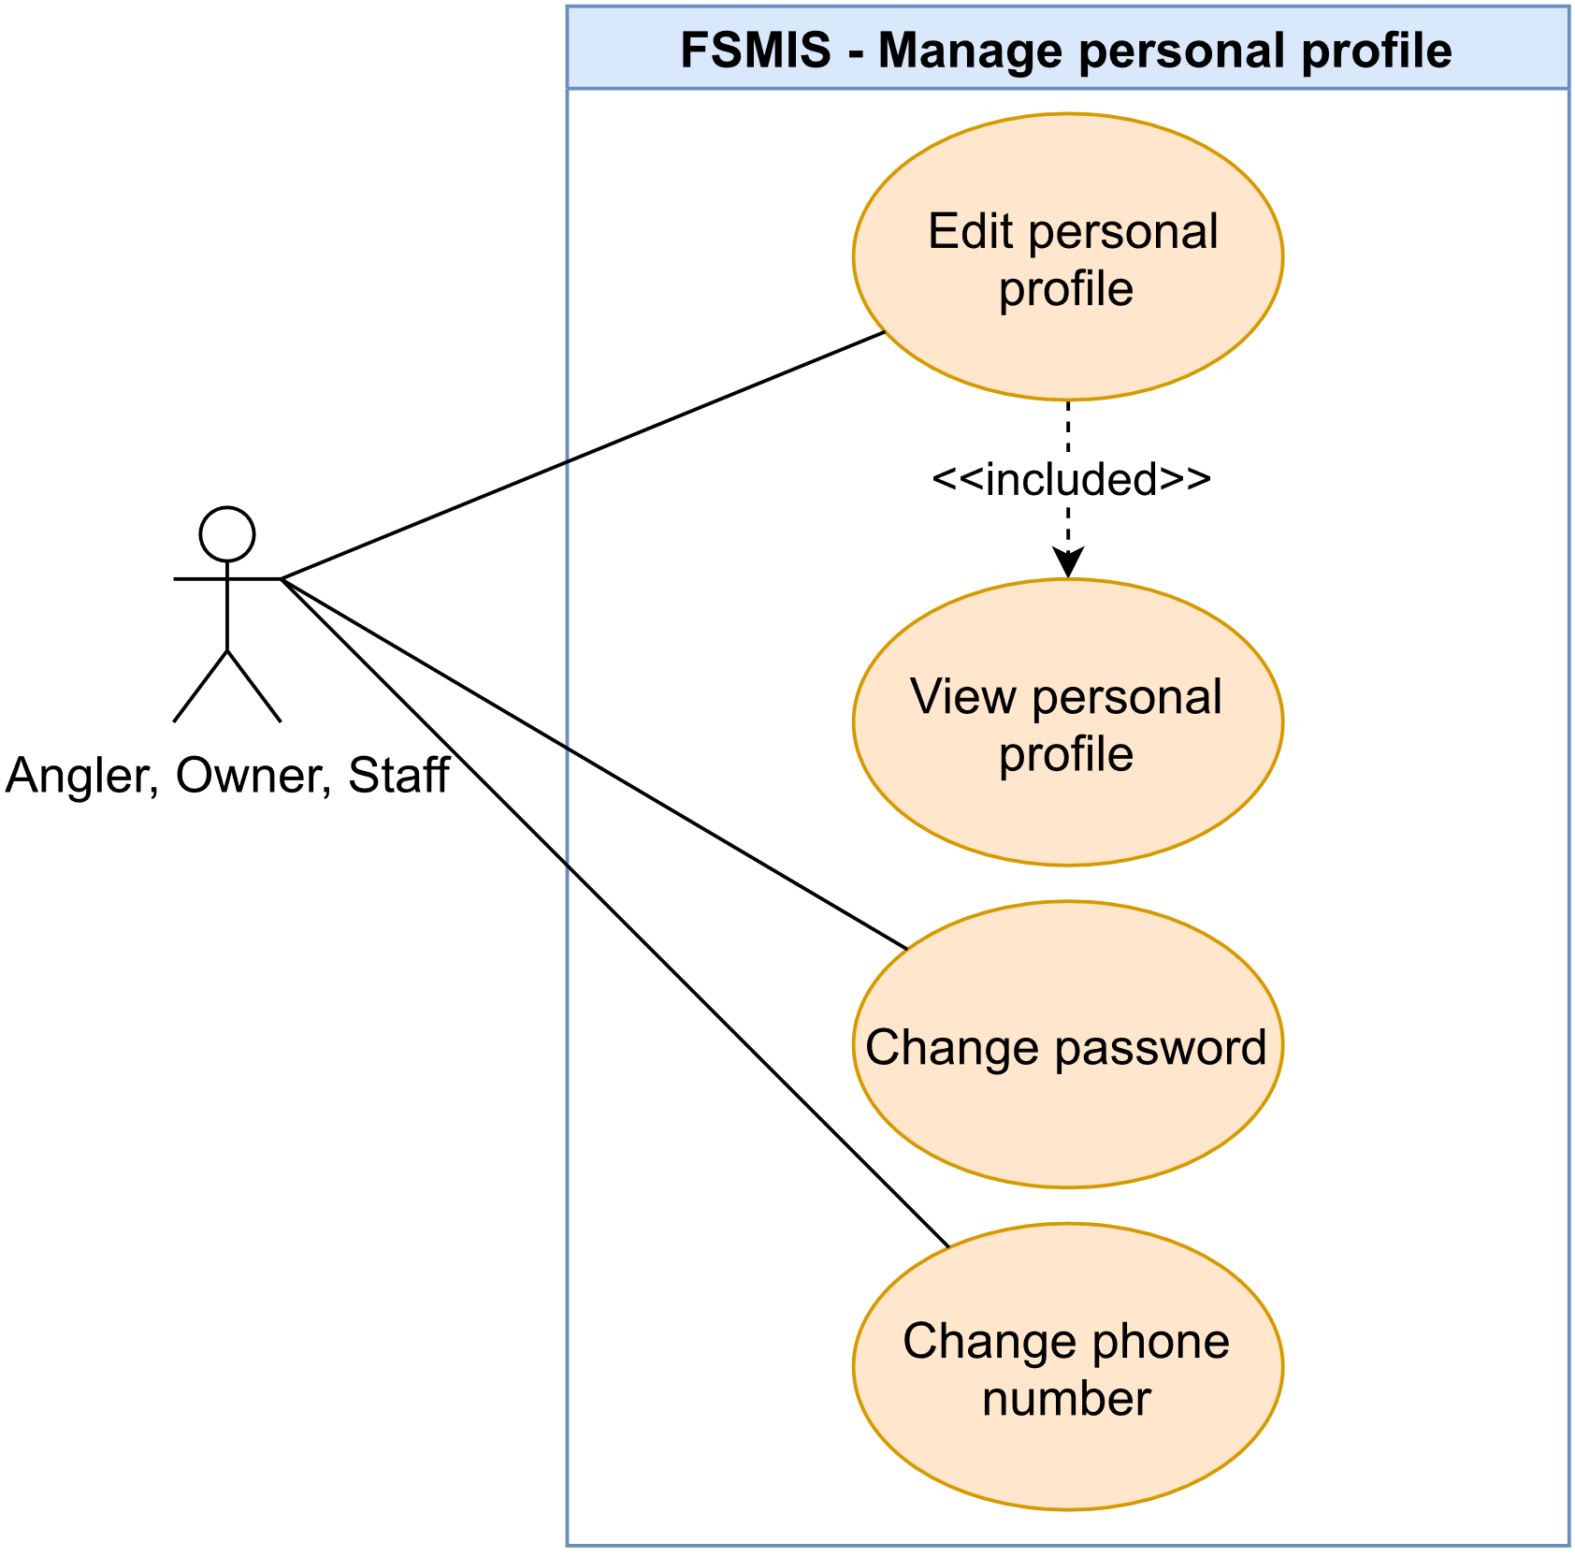

Figure 2.2.3. “Manage personal profile” use cases

##### 2.2.3.1. View personal profile

|  |  |  |  |
| --- | --- | --- | --- |
| **UC ID and Name:** | **UC-04. View personal profile** | | |
| **Created By:** | DucHM | **Date Created:** | 10/02/2021 |
| **Primary Actor:** | Anglers, Owner, Staff | **Secondary Actors:** | N/A |
| **Trigger:** | **TRIG-01.** The user presses on the “Chỉnh sửa thông tin cá nhân” option in the Personal Setting Screen. | | |
| **Description:** | This use case allows the user to view his/her profile information. | | |
| **Preconditions:** | **PRE-01.** The user has logged in.  **PRE-02.** The user is in the Personal Profile Setting Screen. | | |
| **Post-conditions:** | N/A | | |
| **Normal Flow:** | **4.0. View the user profile**   1. After PRE-01, PRE-02 are confirmed, the user presses on the “Chỉnh sửa thông tin cá nhân” option. 2. The system redirects to the Edit Personal Profile Screen, displays fields containing information of the user:    1. Required text field for name    2. Required date selector for birthdate    3. Non-required fields are: Gender, Address, Province, District, Ward. | | |
| **Alternative Flows:** | N/A | | |
| **Exceptions:** | N/A | | |
| **Priority:** | High | | |
| **Frequency of Use:** | High | | |
| **Business Rules:** | N/A | | |
| **Other Information:** | 1. If the user has not input any non-required field (Gender, Address, Province, District, Ward) when registering in the Register Information Screen, fields will display as empty. | | |
| **Assumptions:** | N/A | | |

Table 2.2.3.1. View personal profile

##### 2.2.3.2. Edit personal profile

|  |  |  |  |
| --- | --- | --- | --- |
| **UC ID and Name:** | **UC-05. Edit personal profile** | | |
| **Created By:** | DucHM | **Date Created:** | 10/02/2021 |
| **Primary Actor:** | Anglers, Owner, Staff | **Secondary Actors:** | N/A |
| **Trigger:** | **TRIG-01.** The user presses on the “Lưu thay đổi” button. | | |
| **Description:** | The function allows the user to edit his/her profile information | | |
| **Preconditions:** | **PRE-01.** The user has logged in.  **PRE-02.** The user is in the Edit Personal Profile Screen. | | |
| **Post-conditions:** | **POST-01**. The system updates the user’s profile changes. | | |
| **Normal Flow:** | **5.0. The user edits personal profile**   1. The user makes any changes to any field in the Edit Personal Profile Screen and presses the “Lưu thay đổi” button to save new changes (see 6.0.E1). 2. The system updates new changes. | | |
| **Alternative Flows:** | N/A | | |
| **Exceptions:** | **5.0.E1. The user leaves the required fields empty**   1. The user deletes data in required fields and presses the “Lưu thay đổi” button. 2. The system rejects the user’s attempt, and displays error messages (MSG02). | | |
| **Priority:** | High | | |
| **Frequency of Use:** | Low | | |
| **Business Rules:** | BR-03 | | |
| **Other Information:** | N/A | | |
| **Assumptions:** | N/A | | |

Table 2.2.3.2. Edit personal profile

##### 2.2.3.3. Change password

|  |  |  |  |
| --- | --- | --- | --- |
| **UC ID and Name:** | **UC-06. Change password** | | |
| **Created By:** | DucHM | **Date Created:** | 10/02/2021 |
| **Primary Actor:** | Anglers, Owner, Staff | **Secondary Actors:** | N/A |
| **Trigger:** | **TRIG-01.** The user presses on the “Thay đổi mật khẩu” option in the Personal Setting Screen. | | |
| **Description:** | This use case allows the user to change his/her password. | | |
| **Preconditions:** | **PRE-01.** The user has logged in.  **PRE-02.** The user is in the Personal Setting Screen. | | |
| **Post-conditions:** | **POST-01.** The system updates the user’s new password. | | |
| **Normal Flow:** | **6.0 The user changes the password**   1. The system redirects the user to the Change Password Screen, display the following fields:    1. Required text field to input old password.    2. Required text field to input new password.    3. Required text field to input new password confirmation. 2. The user inputs required fields and presses the “Lưu thay đổi” button (see 6.0.E1, 6.0.E2, 6.0.E3, 6.0.E4). 3. The system updates the new password, displays a message (MSG48) and logs out the user. | | |
| **Alternative Flows:** | N/A | | |
| **Exceptions:** | **6.0.E1. Leave required fields blank.**   1. In step 2, the user does not input the required fields before saving. 2. The system rejects the user’s attempt, display error messages (MSG02).   **6.0.E2. The user inputs wrong password format**   1. The user inputs password less than 8 characters and presses the “Đổi mật khẩu” button. 2. The system rejects the user’s attempt, and displays an error message (MSG16).   **6.0.E3. The user inputs the new password matched with the old password**   1. In step 2, the user inputs the new password matched with the old password and presses the “Đổi mật khẩu” button. 2. The system rejects the user’s attempt, displays an error message (MSG07).   **6.0.E4.** **Password confirmation does not match**   1. The user inputs a different password confirmation and the “Đổi mật khẩu” button. 2. 2. The system rejects the user’s attempt, displays an error message (MSG06). | | |
| **Priority:** | High | | |
| **Frequency of Use:** | Low | | |
| **Business Rules:** | BR-07 | | |
| **Other Information:** | N/A | | |
| **Assumptions:** | N/A | | |

Table 2.2.3.3. Change password

##### 2.2.3.4. Change phone number

|  |  |  |  |
| --- | --- | --- | --- |
| **UC ID and Name:** | **UC-07. Change user’s phone number** | | |
| **Created By:** | DucHM | **Date Created:** | 10/02/2021 |
| **Primary Actor:** | Anglers, Owner, Staff | **Secondary Actors:** | N/A |
| **Trigger:** | **TRIG-01:** The user presses on the “Thay đổi số điện thoại” option. | | |
| **Description:** | This use case allows the user to change his/her phone number | | |
| **Preconditions:** | **PRE-01.** The user has logged in.  **PRE-02.** The user is in the Personal Setting Screen. | | |
| **Post-conditions:** | **POST-01.** The system updates the user’s new phone number. | | |
| **Normal Flow:** | **7.0 Change phone number**   1. The system redirects the user the Change Phone Number Screen, displays the following:    1. A required number field to input a new phone number.    2. A required text field to input password. 2. The user inputs required fields and presses on the “Tiếp tục” button to continue the process (see 7.0.E1, 7.0.E2, 7.0.E3). 3. The system validates the inputs successfully, sends the OTP code through the user’s new phone number and redirects the user the OTP Screen, displays the following:    1. 6 number cells to input OTP code.    2. A countdown timer indicates the next OTP send request availability.    3. The “Tiếp tục” button. 4. The user inputs the OTP code and presses the “Tiếp tục” button to continue the process (see 7.0.E4). 5. The system updates the user’s new phone number successfully, displays a message (MSG562) and logs out the user. | | |
| **Alternative Flows:** | **7.0.E1. Leave required fields blank**   1. In step 2, the user registers without filling all the required fields 2. The system rejects the user’s register attempt, and displays error messages (MSG02).   **7.0.E2. The user inputs invalid phone number**   1. In step 2, the user inputs invalid phone number. 2. The system rejects the user’s attempt and displays an error message (MSG04).   **7.0.E3. The user inputs matched new phone number with old phone number**   1. In step 2, the user inputs a new phone number matched with the old phone number. 2. The system rejects the user’s attempt, displays error message (MSG05)   **7.0.E4** **The user inputs invalid OTP**   1. In step 3, the user inputs invalid OTP code. 2. The system rejects the user’s attempt, displays an error message (MSG03). | | |
| **Exceptions:** | N/A | | |
| **Priority:** | High | | |
| **Frequency of Use:** | Low | | |
| **Business Rules:** | BR-06, BR-07 | | |
| **Other Information:** | 1. When an OTP session is over, the system asks if the user wants to re-send an OTP code. The system repeats step 3, 4 if the user chooses to resend. | | |
| **Assumptions:** | N/A | | |

Table 2.3.3.4. Change phone number

#### 2.2.4. Feature “Manage system accounts”

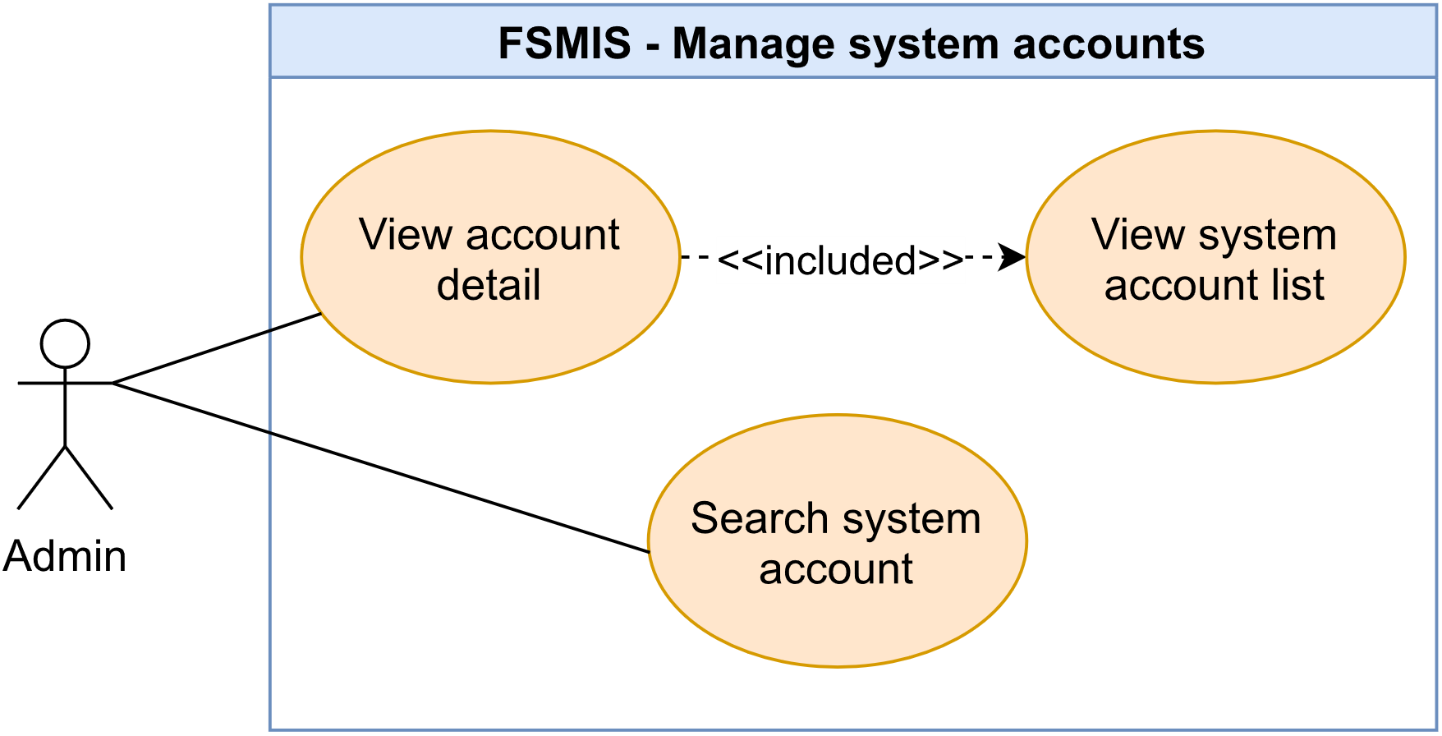

Figure 2.2.4. “Manage system accounts” use cases

##### 2.2.4.1. View system account list

|  |  |  |  |
| --- | --- | --- | --- |
| **UC ID and Name:** | **UC-08. View system account list** | | |
| **Created By:** | DucHM | **Date Created:** | 10/02/2021 |
| **Primary Actor:** | Admin | **Secondary Actors:** | N/A |
| **Trigger:** | **TRIG-01.** The admin presses on “Quản lý các tài khoản” option in the Admin Setting Screen. | | |
| **Description:** | The function allows the admin to view all user’s accounts registered in the system. | | |
| **Preconditions:** | **PRE-01.** The user must login with an admin account.  **PRE-02.** The admin is in the Admin Setting Screen. | | |
| **Post-conditions:** | N/A | | |
| **Normal Flow:** | **8.0. View list of accounts in the system**   1. The admin presses on the “Quản lý các tài khoản” option in the Admin Setting Screen. 2. The system redirects the admin to the System Account Management Screen, display the following:    1. A search bar to search by phone number.    2. List of all accounts in the system, each item in the list displays the summary of the account, includes avatar, name, phone number and account status. | | |
| **Alternative Flows:** | N/A | | |
| **Exceptions:** | N/A | | |
| **Priority:** | High | | |
| **Frequency of Use:** | High | | |
| **Business Rules:** | N/A | | |
| **Other Information:** | N/A | | |
| **Assumptions:** | N/A | | |

Table 2.2.4.1. View system account list

##### 2.2.4.2. View account detail

|  |  |  |  |
| --- | --- | --- | --- |
| **UC ID and Name:** | **UC-09. View account detail** | | |
| **Created By:** | DucHM | **Date Created:** | 02/10/21 |
| **Primary Actor:** | Admin | **Secondary Actors:** | N/A |
| **Trigger:** | **TRIG-01:** The admin presses on a list item in the System Account List Screen. | | |
| **Description:** | The function allows the admin to view all user’s account details. | | |
| **Preconditions:** | **PRE-01.** The user must login with an admin account.  **PRE-02.** The admin is in the System Account Management Screen. | | |
| **Post-conditions:** | N/A | | |
| **Normal Flow:** | **9.0 View details of the account**   1. The admin presses on a specific list item in the System Account List Screen. 2. The system redirects the admin to the Account Detail Screen, displays the following:    1. Account detail section, displays all information of the account includes: avatar, name, birthdate, phone number, gender, address and status to describe the locked or unlocked state of the account.    2. A button with changing label: “Vô hiệu hóa tài khoản” to deactivate or “Mở lại tài khoản” to activate account. | | |
| **Alternative Flows:** | N/A | | |
| **Exceptions:** | N/A | | |
| **Priority:** | High | | |
| **Frequency of Use:** | High | | |
| **Business Rules:** | N/A | | |
| **Other Information:** | N/A | | |
| **Assumptions:** | N/A | | |

Table 2.2.4.2. View account detail

##### 2.2.4.3. Search system account

|  |  |  |  |
| --- | --- | --- | --- |
| **UC ID and Name:** | **UC-10. Search system account** | | |
| **Created By:** | DucHM | **Date Created:** | 02/10/21 |
| **Primary Actor:** | Admin | **Secondary Actors:** | N/A |
| **Trigger:** | **TRIG-01.** The admin presses enter on the keyboard after filling in the search bar in the System Account List Screen. | | |
| **Description:** | The function allows the admin to search the system account by phone number or by username. | | |
| **Preconditions:** | **PRE-01.** The user must login with an admin account.  **PRE-02.** The admin is in the System Account List Screen. | | |
| **Post-conditions:** | N/A | | |
| **Normal Flow:** | **10.0.1 Search an account by username in the system**   1. The admin presses to focus on the search bar. 2. The system pops up a keyboard allowing the admin to type in. 3. The user inputs the account's username and presses enter on the keyboard. 4. The system finds matched accounts and displays them in the list of results (See other information 1).   **10.0.2 Search an account by phone number in the system**   1. The admin presses to focus on the search bar. 2. The system pops up a keyboard allowing the admin to type in. 3. The user inputs the account's phone number and presses enter on the keyboard. 4. The system finds matched accounts and displays them in the list of results (See other information 1). | | |
| **Alternative Flows:** | N/A | | |
| **Exceptions:** | N/A | | |
| **Priority:** | Medium | | |
| **Frequency of Use:** | High | | |
| **Business Rules:** | N/A | | |
| **Other Information:** | 1. The account list returns empty if no records match the username or phone number. | | |
| **Assumptions:** | N/A | | |

Table 2.2.4.3. Search system account

#### 2.2.5. Feature “Search fishing location”

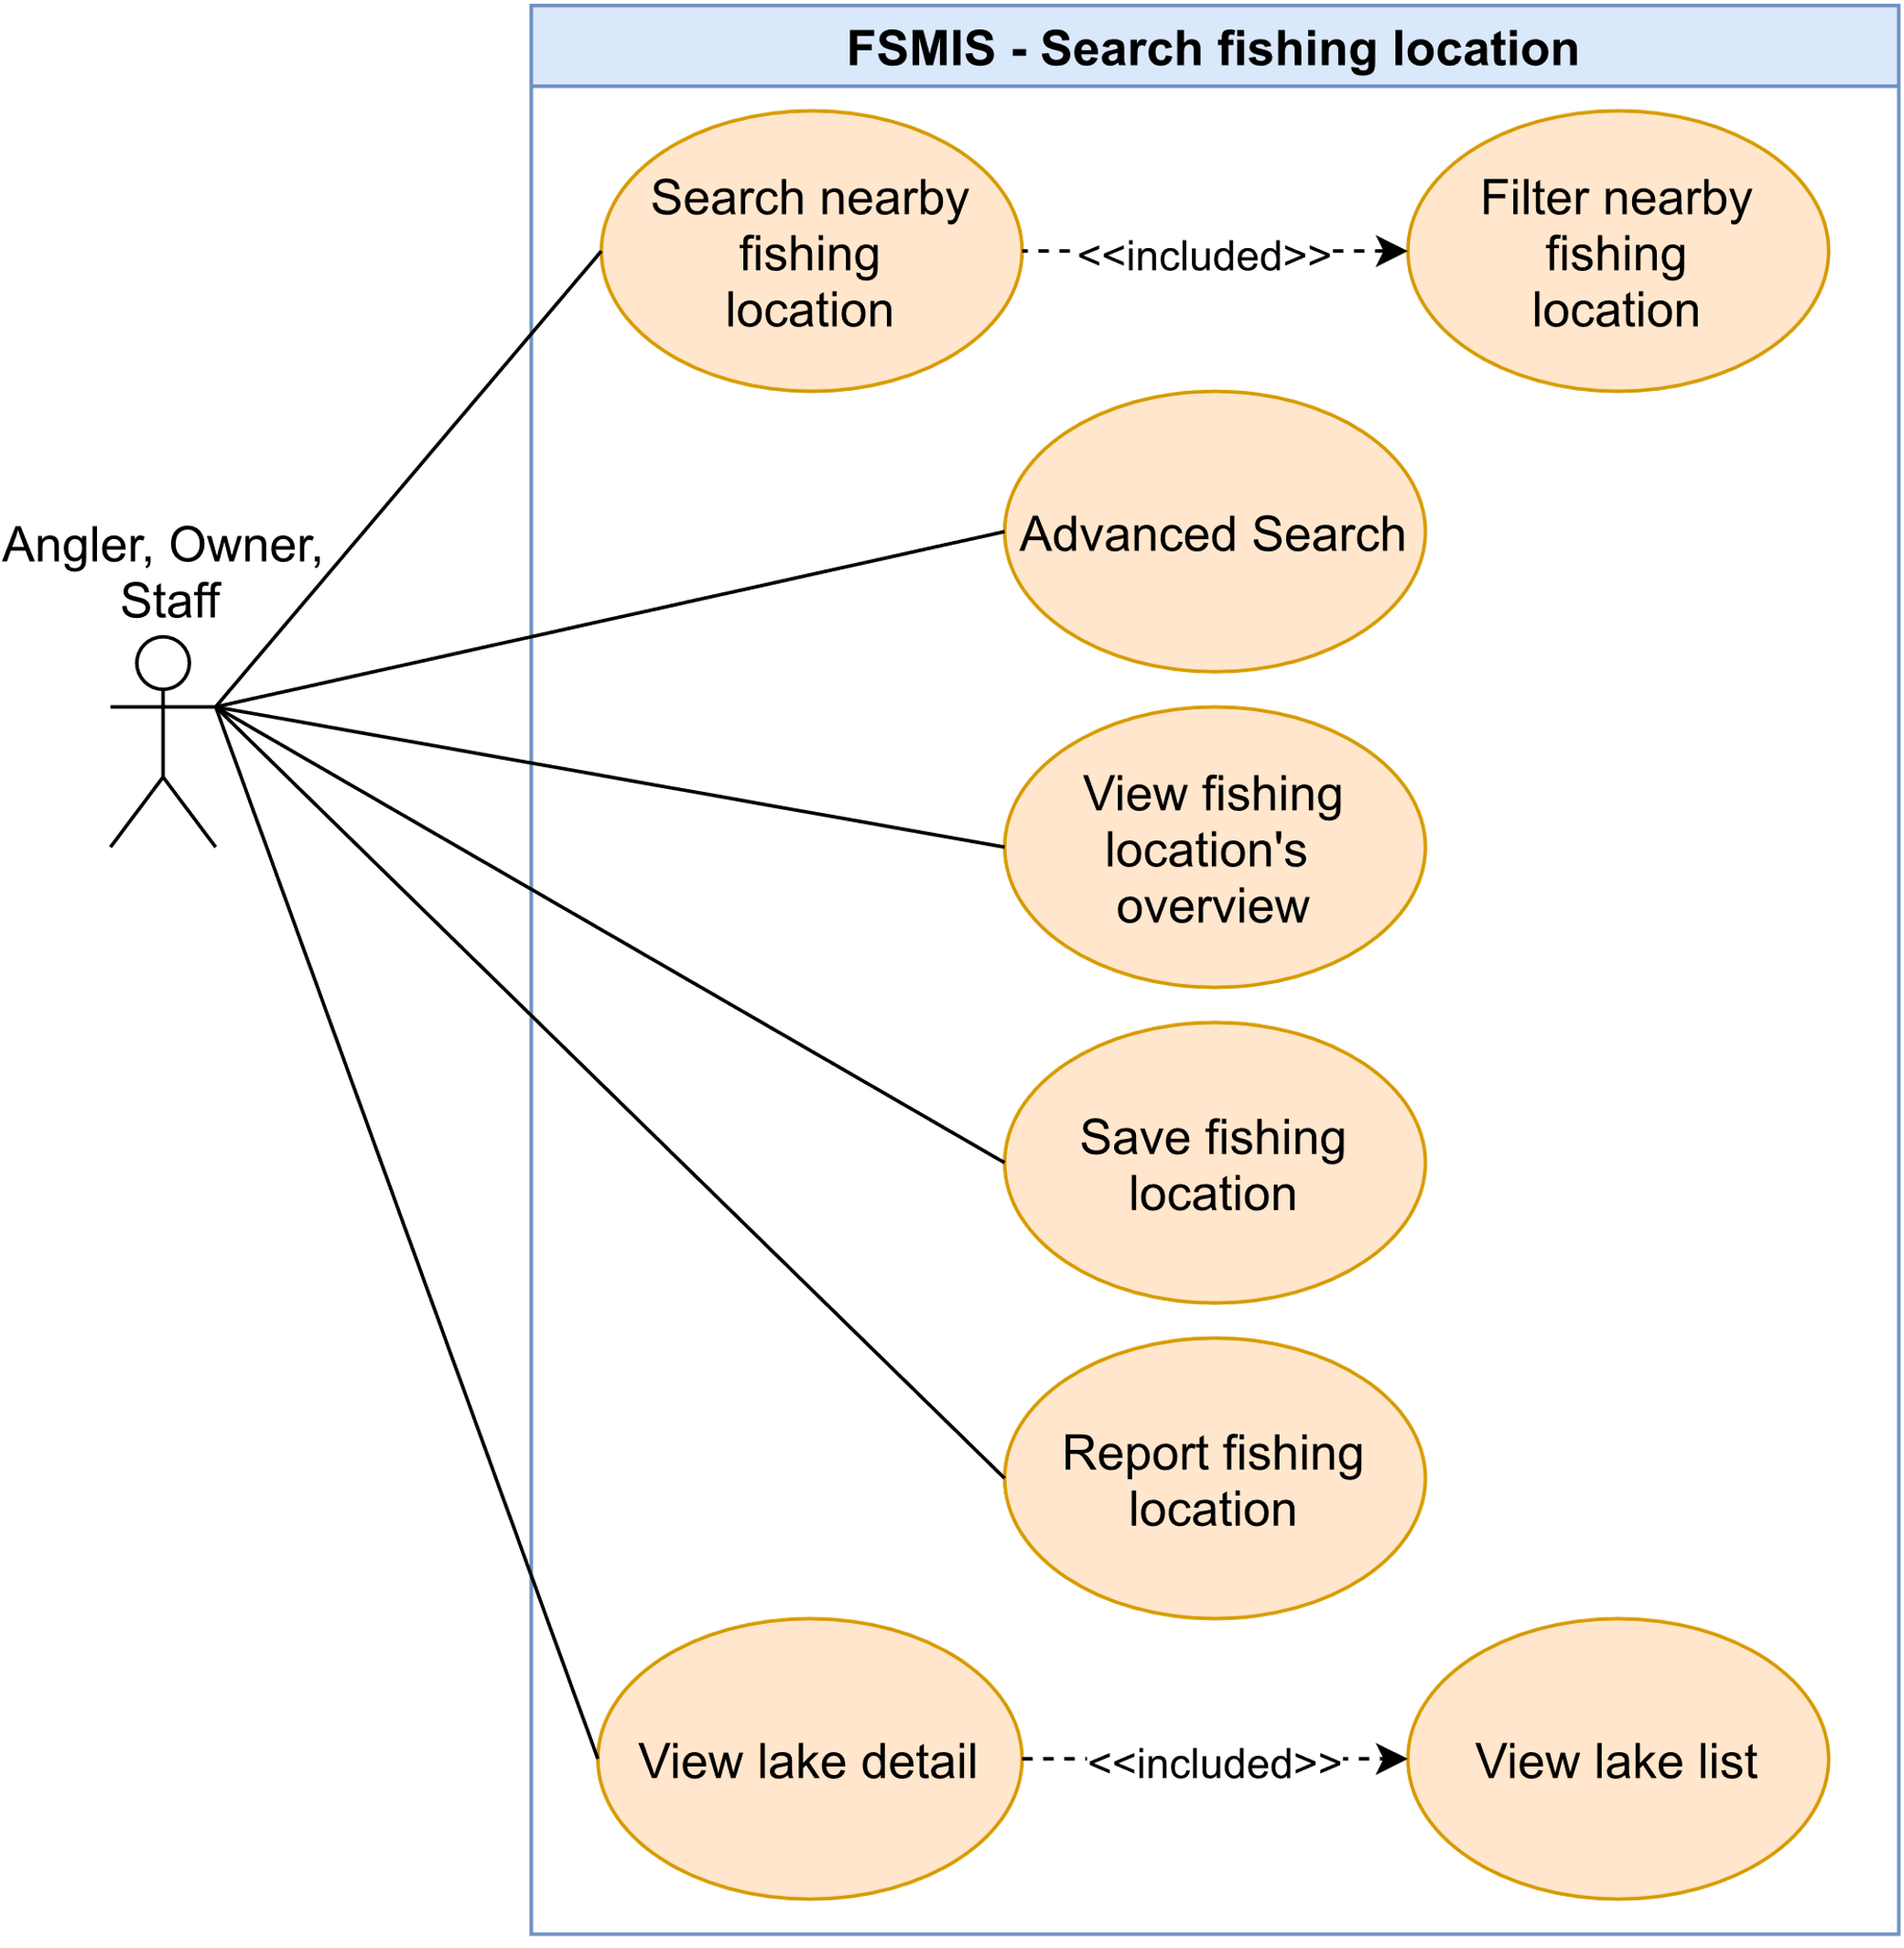

Figure 2.2.5. “Search fishing location” use cases

##### 2.2.5.1. Search nearby fishing location

|  |  |  |  |
| --- | --- | --- | --- |
| **UC ID and Name:** | **UC-11. Search fishing spot** | | |
| **Created By:** | DucHM | **Date Created:** | 10/02/2021 |
| **Primary Actor:** | Anglers, Owner, Staff | **Secondary Actors:** | N/A |
| **Trigger:** | **TRIG-01:** The user presses on the “Điểm câu” icon in the navigation bar.  **TRIG-02:** The user presses on the “Hồ câu gần đây in the Search Nearby Screen. | | |
| **Description:** | This use case allows the user to search nearby locations using the user’s current location. | | |
| **Preconditions:** | **PRE-01.** The user has logged in.  **PRE-02.** The user has allowed the system to access the user’s current location. | | |
| **Post-conditions:** | N/A | | |
| **Normal Flow:** | **11.0 Search fishing spots near me**   1. After PRE-01, PRE-02 is confirmed, the user presses on the “Điểm câu” icon in the navigation bar. 2. The system redirects the user to the Search Nearby Screen. (See other information 1, 2, 3). 3. The system displays list of nearby fishing location on the map with default radius of 5km estimated from the user’s current location, each fishing location on the map area display the following:    1. A red pin to pin point estimated the location.    2. Name of the fishing location.    3. The location’s rating score. | | |
| **Alternative Flows:** | N/A | | |
| **Exceptions:** | N/A | | |
| **Priority:** | High | | |
| **Frequency of Use:** | High | | |
| **Business Rules:** | N/A | | |
| **Other Information:** | 1. If the user does not allow the system to access the user’s location before, a pop up will rise from the bottom of the screen to ask the user’s permission. 2. If the user denies the system permission request, the map area on the Search Nearby Screen will not show any location. 3. 3. If the user allowed the system permission request but there was no location found nearby the user’s area, the map area on the Search Nearby Screen will not show any location. | | |
| **Assumptions:** | N/A | | |

Table 2.5.5.1. Search nearby fishing location

##### 2.2.5.2. Filter nearby fishing location

|  |  |  |  |
| --- | --- | --- | --- |
| **UC ID and Name:** | **UC-12. Filter nearby fishing location** | | |
| **Created By:** | DucHM | **Date Created:** | 10/02/2021 |
| **Primary Actor:** | Anglers, Owner, Staff | **Secondary Actors:** | N/A |
| **Trigger:** | **TRIG-01.** The user presses the “Bộ lọc” button in the Search Nearby Screen. | | |
| **Description:** | This use case allows the user to filter nearby fishing locations in the map area. | | |
| **Preconditions:** | **PRE-01.** The user has logged in.  **PRE-02.** The user is in the Search Nearby Screen.  **PRE-03.** The user has allowed the system to access the user’s current location. | | |
| **Post-conditions:** | N/A | | |
| **Normal Flow:** | **12.0 Filter fishing spot in the Search Nearby Screen**   1. The user presses on the “Bộ lọc” button in the Search Nearby Screen. 2. The system displays a modal, displays the following:    1. A select field to choose fishing methods (See other information 1).    2. A select field to choose average rating score.    3. A slider to setting radius (See other information 2). 3. The user adjusts the filter's criteria and presses on the “Tìm kiếm” button. 4. The system applies the user’s filter option to sort every fishing location in the map area, and displays fishing locations that match the filter criteria (See other information 3). | | |
| **Alternative Flows:** | N/A | | |
| **Exceptions:** | N/A | | |
| **Priority:** | High | | |
| **Frequency of Use:** | High | | |
| **Business Rules:** | N/A | | |
| **Other Information:** | 1. The user can only select one fishing method criteria for each filter. 2. The radius slider starts at minimum 5km to maximum setting at 50km. 3. If the filter option does not return any result, the system will display a message (MSG57). | | |
| **Assumptions:** | N/A | | |

Table 2.2.5.2. Filter nearby fishing location

##### 2.2.5.3. Advanced search

|  |  |  |  |
| --- | --- | --- | --- |
| **UC ID and Name:** | **UC-13. Advanced Search** | | |
| **Created By:** | DucHM | **Date Created:** | 10/02/2021 |
| **Primary Actor:** | Anglers, Owner, Staff | **Secondary Actors:** | N/A |
| **Trigger:** | **TRIG-01.** The user presses the “Tìm kiếm” button in the Advance Search Screen. | | |
| **Description:** | This use case allows the user to filter current fishing locations in the map area. | | |
| **Preconditions:** | **PRE-01.** The user has logged in.  **PRE-02.** The user is in the Search Result Screen. | | |
| **Post-conditions:** | N/A | | |
| **Normal Flow:** | **13.0. Advanced Search**   1. After PRE-01, PRE-02 are confirmed, the user presses the “Tìm kiếm” button in the Search Result Screen. 2. The system redirects the user to the Advance Search Screen, displays the following field:    1. A text field to search by fishing location contact phone number or by fishing location’s name.    2. A select field to filter location by province.    3. A select field to filter location by fishing method (See other information 1).    4. A select field to filter by fish available in one fishing location (See other information 2).    5. A select field to select location by rating score.    6. A “Xóa bộ lọc” button to clear all input and selections.    7. A “Tìm kiếm” button to perform the search. 3. The user inputs the search term, selects the filter option and presses the “Tìm kiếm” button to continue the process. 4. The system finds results based on the user’s option, redirects the user back to the Search Result Screen and displays the search result as list of location cards, each location card is the summary of a fishing location contains the location’s image, the location’s rating score, the location’s address. (See other information 3). | | |
| **Alternative Flows:** | N/A | | |
| **Exceptions:** | N/A | | |
| **Priority:** | High | | |
| **Frequency of Use:** | High | | |
| **Business Rules:** | N/A | | |
| **Other Information:** | 1. The user can select multiple fishing methods for each filter.  2. The user can select multiple fishes for each filter.  3. If the search result is empty, the Search Result Screen displays an empty list message (MSG55). | | |
| **Assumptions:** | N/A | | |

Table 2.2.5.3. Advanced search

##### 2.2.5.4. View fishing location’s overview

|  |  |  |  |
| --- | --- | --- | --- |
| **UC ID and Name:** | **UC-14. View fishing location overview** | | |
| **Created By:** | DucHM | **Date Created:** | 10/02/2021 |
| **Primary Actor:** | Anglers, Owner, Staff | **Secondary Actors:** | N/A |
| **Trigger:** | **TRIG-01.** The user presses on the fishing location red pin in the map area in the Search Nearby Screen.  **TRIG-02.** The user presses on the fishing location card in the Search Result Screen. | | |
| **Description:** | This use case allows the user to view the fishing location overview. | | |
| **Preconditions:** | **PRE-01.** The user has logged in.  **PRE-02.** If the user previously searched through Search Nearby Screen or Advance Search Screen, the search result from either one or two screens must not be empty (for the Search Nearby Screen, there must be a red pin available to press, for the Search Result Screen, there must be a location card returns from doing the Advanced Search function). | | |
| **Post-conditions:** | N/A | | |
| **Normal Flow:** | **14.0. View fishing location overview**   1. The user presses on a specific fishing location red pin on the map area or a location card in the Search Result Screen. 2. The system redirects the user to that locations’ Fishing Location Overview Screen, displays the following:    1. Image of the fishing location    2. A button to save the fishing location (See other information 1).    3. A contact section, having the following:       1. Address of the location.       2. The location contact phone number.       3. The location website (See other information 2).       4. Date and time indicate the last time the location overview was updated.    4. A small map view pin points the fishing location on the map.    5. A section to describe a brief information about the fishing location.    6. A section to describe the location’s working hours.    7. A section can be used to describe which services are provided in the location.    8. A section can be used to describe rules of the location. | | |
| **Alternative Flows:** | **14.1. Access fishing location overview via the Saved Fishing Location Screen**   1. The user presses on the “Đã lưu” icon at the navigation bar. 2. The system redirects to the Saved Fishing Location Screen, displays a list of saved fishing locations as a list of location cards. 3. 3. The user presses on the saved location card and begins step 2 of normal flow. | | |
| **Exceptions:** | N/A | | |
| **Priority:** | High | | |
| **Frequency of Use:** | High | | |
| **Business Rules:** | N/A | | |
| **Other Information:** | 1. By pressing this button, the current location the user is in will be saved and can be later viewed as a location card in the Saved Fishing Location Screen. 2. 2. If the owner of the fishing location does not provide information for the website, the field will appear empty in the Fishing Location Overview Screen. | | |
| **Assumptions:** | N/A | | |

Table 2.2.5.4. View fishing location’s overview

##### 2.2.5.5. View lake list

|  |  |  |  |
| --- | --- | --- | --- |
| **UC ID and Name:** | **UC-15. View lake list** | | |
| **Created By:** | DucHM | **Date Created:** | 10/02/2021 |
| **Primary Actor:** | Anglers, Owner, Staff | **Secondary Actors:** | N/A |
| **Trigger:** | **TRIG-01.** The user presses on the “Các loại hồ” option in the navigation bar inside the Fishing Location Overview Screen. | | |
| **Description:** | This use case allows the user to view a list of lakes of a fishing location. | | |
| **Preconditions:** | **PRE-01.** The user has logged in  **PRE-02.** The user is in the Fishing Location Overview Screen. | | |
| **Post-conditions:** | N/A | | |
| **Normal Flow:** | **15.0 View list of lakes in the fishing location**   1. The user presses on the “Các loại hồ” option at the navigation bar inside the Fishing Location Overview Screen. 2. The system redirects the user to the Lake List Screen, displays list of lakes available in the fishing location (See other information 1), each lake card is the summary of the lake contains lake’s image, lake’s name, fish species in the lake. | | |
| **Alternative Flows:** | N/A | | |
| **Exceptions:** | N/A | | |
| **Priority:** | High | | |
| **Frequency of Use:** | High | | |
| **Business Rules:** | N/A | | |
| **Other Information:** | 1. If the list in the Lake List Screen is empty, the system will display a message (MSG56). | | |
| **Assumptions:** | N/A | | |

Table 2.2.5.5. View lake list

##### 2.2.5.6. View lake details

|  |  |  |  |
| --- | --- | --- | --- |
| **UC ID and Name:** | **UC-16. View Lake detail** | | |
| **Created By:** | DucHM | **Date Created:** | 10/02/2021 |
| **Primary Actor:** | Anglers, Owner, Staff | **Secondary Actors:** | N/A |
| **Trigger:** | **TRIG-01:** The user presses on the lake card in the Lake List Screen. | | |
| **Description:** | This use case allows the user to view a lake detail of a fishing location. | | |
| **Preconditions:** | **PRE-01.** The user has logged in.  **PRE-02.** The user is in the Lake List Screen. | | |
| **Post-conditions:** | N/A | | |
| **Normal Flow:** | **16.0. View lake detail**   1. After PRE-01, PRE-02 are confirmed, the user presses on the lake card in the Lake List Screen. 2. The system redirects the user to the Lake Detail Screen, displays the following:    1. An image of the lake    2. Date and time field indicates the last time the information of the lake was updated.    3. A section describes a list of fishing methods used in this lake.    4. A section describes the entry fees.    5. A section describes the lake’s dimension, including: width, length and depth.    6. A section describes each species of fishes as fish cards in the lake, each fish card having the following:       1. Image of the fish.       2. Name of the fish       3. Minimum weight and maximum weight of the fish.       4. A field displays the estimated quantity of this fish in the lake. 3. A field displays estimated total weight of all fishes of this species in the lake. | | |
| **Alternative Flows:** | N/A | | |
| **Exceptions:** | N/A | | |
| **Priority:** | High | | |
| **Frequency of Use:** | High | | |
| **Business Rules:** | N/A | | |
| **Other Information:** | N/A | | |
| **Assumptions:** | N/A | | |

Table 2.2.5.6. View lake details

##### 2.2.5.7. Save fishing location

|  |  |  |  |
| --- | --- | --- | --- |
| **UC ID and Name:** | **UC-17. Save fishing location** | | |
| **Created By:** | DucHM | **Date Created:** | 10/02/2021 |
| **Primary Actor:** | Anglers | **Secondary Actors:** | N/A |
| **Trigger:** | **TRIG-01.** The user presses on the “Lưu điểm câu” button in a Fishing Location Overview Screen. | | |
| **Description:** | This use case allows the user to save the fishing location to receive future notification about the fishing location. The user can quick access the saved fishing location in the Saved Fishing Location Screen. | | |
| **Preconditions:** | **PRE-01.** The user has logged in.  **PRE-02.** The user is in the Fishing Location Overview Screen. | | |
| **Post-conditions:** | **POST-01.** The user is registered to receive any new notification about this fishing location in the Notification List Screen.  **POST-02.** The saved location appears as a location card and can be viewed in the Saved Fishing Location Screen. | | |
| **Normal Flow:** | **17.0. Save a fishing location**   1. The user presses on the “Lưu điểm câu” buttonin the Fishing Location Overview Screen (See other information 1). 2. The system saves the fishing location as a location card in the Saved Fishing Location Screen (See other information 2). | | |
| **Alternative Flows:** | N/A | | |
| **Exceptions:** | N/A | | |
| **Priority:** | High | | |
| **Frequency of Use:** | High | | |
| **Business Rules:** | N/A | | |
| **Other Information:** | 1. When the user presses the “Lưu điểm câu” button, the text in the button will changes to “Bỏ lưu” indicates that the location is saved. To unsaved the location, presses on the “Bỏ lưu” button, the text in the button will now changes back to “Lưu điểm câu” indicates that the location is unsaved. 2. 2. If the Saved Fishing Location Screen is empty, the system will display a message (MSG58). | | |
| **Assumptions:** | N/A | | |

Table 2.2.5.7. Save fishing location

##### 2.2.5.8. Report false fishing location information

|  |  |  |  |
| --- | --- | --- | --- |
| **UC ID and Name:** | **UC-18. Report false fishing location information** | | |
| **Created By:** | DucHM | **Date Created:** | 10/02/2021 |
| **Primary Actor:** | Anglers | **Secondary Actors:** | N/A |
| **Trigger:** | **TRIG-01:** The user presses on the Flag icon in the Fishing Location Overview Screen. | | |
| **Description:** | This use case allows the user to report the fishing location if he or she finds any information provided in the fishing location overview or lake detail to be false. | | |
| **Preconditions:** | **PRE-01.** The user has logged in.  **PRE-02.** The user is in the Fishing Location Overview Screen. | | |
| **Post-conditions:** | **POST-01.** The system sends a report described by the user to the admin. | | |
| **Normal Flow:** | **18.0 Report false review**   1. The user presses the Flag icon on the top right corner in the Fishing Location Overview Screen. 2. The system redirects the user to the Report Editor Screen, displays the following:    1. A required text area to input report description.    2. The “Báo cáo” button to submit the report. 3. The user inputs reason of report in the report description and presses on the “Báo cáo” button to submit the report (See 18.0.E1). 4. The system successfully sends the report form of the fishing location to the admin, displays a pop-up message (MSG60) (See 18.0.E2). | | |
| **Alternative Flows:** | N/A | | |
| **Exceptions:** | **18.0.E1. Leave required field blank**   1. In Step 3, the user leaves the field blank. 2. The system rejects the user’s submit attempt, displays error messages (MSG61).   **18.0.E2. Send request failed**   1. In step 4, if the send request fails, the system will display an error message (MSG59). | | |
| **Priority:** | High | | |
| **Frequency of Use:** | High | | |
| **Business Rules:** | N/A | | |
| **Other Information:** | N/A | | |
| **Assumptions:** | N/A | | |

Table 2.2.5.8. Report false fishing location information

#### 2.2.6. Feature “Manage fishing location’s reviews”

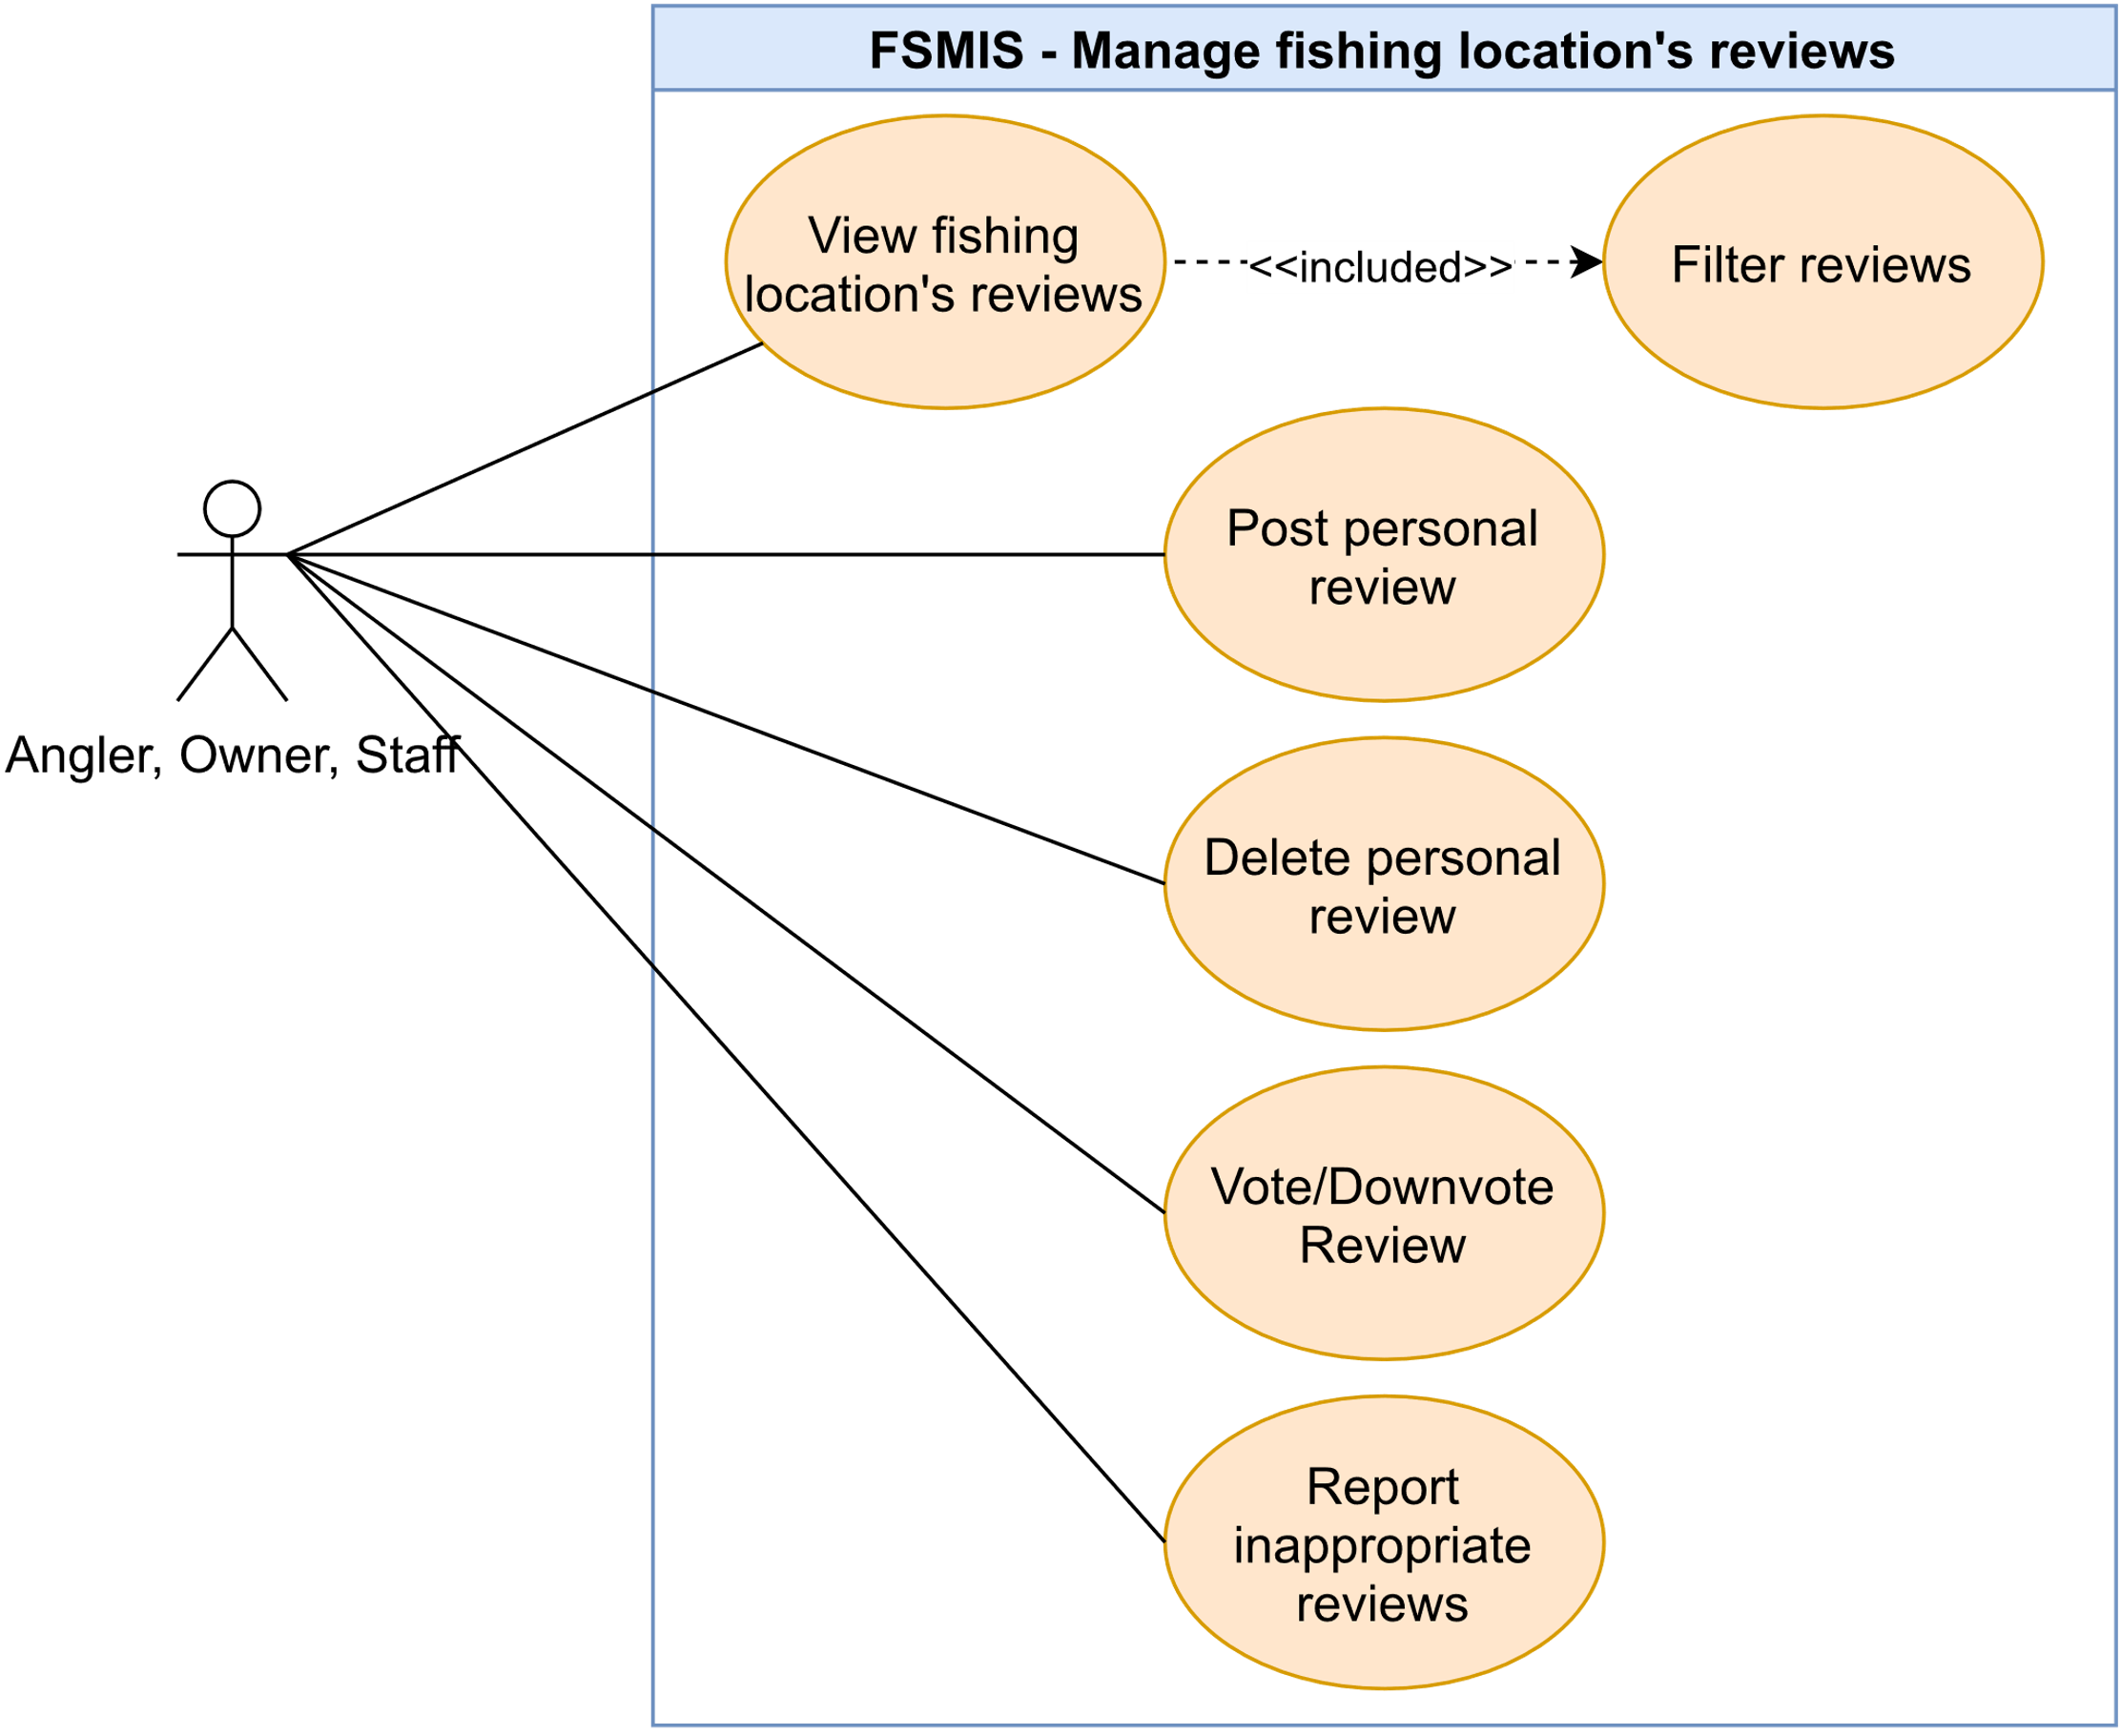

Figure 2.2.6. “Manage fishing location’s reviews” use cases

##### 2.2.6.1. View fishing location’s review

|  |  |  |  |
| --- | --- | --- | --- |
| **UC ID and Name:** | **UC-19. View fishing location review** | | |
| **Created By:** | DucHM | **Date Created:** | 10/02/2021 |
| **Primary Actor:** | Anglers, Owner, Staff | **Secondary Actors:** | N/A |
| **Trigger:** | **TRIG-01.** The user presses on the “Đánh giá” option at the navigation bar inside the Fishing Location Overview Screen. | | |
| **Description:** | This use case allows the user to view all reviews of a fishing location. | | |
| **Preconditions:** | **PRE-01.** The user has logged in  **PRE-02.** The user must have checked-in this fishing location before.  **PRE-03.** The user is in the Fishing Location Overview Screen. | | |
| **Post-conditions:** | N/A | | |
| **Normal Flow:** | **19.0. View fishing location review**   1. After PRE-01, PRE-02, PRE-03 are confirmed, the user presses on the “Đánh giá” option at the navigation bar inside the Fishing Location Overview Screen. 2. The system redirects user to the Review Screen, displays the following:    1. A section displays an average number rating of the fishing location.    2. A section labelled “Đánh giá của bạn”, the user will post personal review of the location here.    3. A section labelled “Đánh giá từ cộng đồng” having the following:       1. Three sorting buttons, they are: “Mới nhất” to sort the review list in newest order, “Cao nhất” to sort the review list by highest rating, “Thấp nhất” to sort the review list by lowest rating.       2. A review list displays other user’s reviews about the location (See other information 1, 2). | | |
| **Alternative Flows:** | N/A | | |
| **Exceptions:** | N/A | | |
| **Priority:** | High | | |
| **Frequency of Use:** | High | | |
| **Business Rules:** | N/A | | |
| **Other Information:** | 1. Each review item in the review list provides review information of other users, includes their name, their given rating score, their review date, their review description. The user can upvote or downvote them by pressing either of the two buttons “Hữu ích” and “Không hữu ích” in each review item. 2. If this fishing location does not have any review, the system will display message (MSG23). | | |
| **Assumptions:** | N/A | | |

Table 2.2.6.1. View fishing location’s review

##### 2.2.6.2. Post personal review

|  |  |  |  |
| --- | --- | --- | --- |
| **UC ID and Name:** | **UC-20. Post personal review** | | |
| **Created By:** | DucHM | **Date Created:** | 02/10/21 |
| **Primary Actor:** | Angler | **Secondary Actors:** | N/A |
| **Trigger:** | **TRIG-01.** The user presses on the button labelled “Đăng đánh giá” in the “Đánh giá của bạn” section in the Review Screen. | | |
| **Description:** | This use case allows the user to post his/her review of a fishing location. | | |
| **Preconditions:** | **PRE-01.** The user has logged in.  **PRE-02.** The user is in the Review Screen.  **PRE-03.** The user has checked-in this fishing location before. | | |
| **Post-conditions:** | **POST-01.** The system creates and adds the user’s review to the fishing location’s review list. | | |
| **Normal Flow:** | **20.0 Post a review**   1. The user presses on the button labelled “Đăng đánh giá” in the “Đánh giá của bạn” section in the Review Screen. 2. The system redirects the user to the Review Editor Screen, displays the following:    1. A required rating input field as star shape.    2. A required text field to input review description.    3. The “Đăng” button. 3. The user selects the number of stars as rating score for the location, input the required review description and presses on the “Đăng” button to submit the review (See 20.0.E1, 20.0.E2) (See other information 1). 4. The system accepts and creates the review, then redirects the user back to the Review Screen. 5. The system displays the review created as a review item in the “Đánh giá của bạn” section (See other information 2). | | |
| **Alternative Flows:** | N/A | | |
| **Exceptions:** | **20.0.E1. Leave required field blank**   1. In step 3, the user leaves the required fields blank. 2. The system rejects the user’s attempt, displays error messages (MSG02).   **20.0.E2. Owner or staff post review on their fishing location**   1. In step 3, the user is the owner or staff of this fishing location. 2. 2. The system rejects the user’s attempt, displays an error message (MSG62). | | |
| **Priority:** | High | | |
| **Frequency of Use:** | High | | |
| **Business Rules:** | BR-22, BR-23, BR-24 | | |
| **Other Information:** | 1. If the user is this fishing location’s owner or fishing location’s staff, the user cannot post review of the fishing location to remain the fairness of the review, therefore the system will hide the “Đăng đánh giá” button in the “Đánh giá của bạn” section to post his/her review. 2. The user cannot upvote or downvote his/her review. | | |
| **Assumptions:** | N/A | | |

Table 2.2.6.2. Post personal review

##### 2.2.6.3. Vote/Downvote review

|  |  |  |  |
| --- | --- | --- | --- |
| **UC ID and Name:** | **UC-21. Upvote/Downvote review** | | |
| **Created By:** | DucHM | **Date Created:** | 10/02/2021 |
| **Primary Actor:** | Anglers, Staff, Owner | **Secondary Actors:** | N/A |
| **Trigger:** | **TRIG-01.** The user presses on the “Hữu ích” or “Không hữu ích” button in the review item in the Review Screen. | | |
| **Description:** | This use case allows the user to upvote or downvote other user’s reviews. | | |
| **Preconditions:** | **PRE-01.** The user has logged in  **PRE-02.** The user is in the Review Screen. | | |
| **Post-conditions:** | **POST-01.** The system updates the one’s review upvote or downvote score in the fishing location’s review list. | | |
| **Normal Flow:** | **21.0. Vote review**   1. The user presses the “Hữu ích” or “Không hữu ích” button in a review item from the review list in the “Đánh giá từ cộng đồng” section (See other information 1, 2, 3). 2. The system increments either the number of votes or downvotes of a review by one, displays the number of votes in the “Hữu ích” button or the number of downvotes in the “Không hữu ích” button. | | |
| **Alternative Flows:** | N/A | | |
| **Exceptions:** | N/A | | |
| **Priority:** | High | | |
| **Frequency of Use:** | High | | |
| **Business Rules:** | N/A | | |
| **Other Information:** | 1. The user can only choose either vote or downvote a review at a time. 2. If the user presses the “Hữu ích” button a second time, the system will decrease the number of upvotes by one. 3. If the user presses the “Không hữu ích” button a second time, the system will decrease the number of downvotes by one. | | |
| **Assumptions:** | N/A | | |

Table 2.2.6.3. Vote/Downvote review

##### 2.2.6.4. Delete personal review

|  |  |  |  |
| --- | --- | --- | --- |
| **UC ID and Name:** | **UC-22. Delete review** | | |
| **Created By:** | DucHM | **Date Created:** | 10/02/2021 |
| **Primary Actor:** | Anglers, Staff, Owner | **Secondary Actors:** | N/A |
| **Trigger:** | **TRIG-01.** The user selects the “Xóa đánh giá” optionfrom the kebab menu in the “Đánh giá của bạn” section. | | |
| **Description:** | This use case allows the user to delete his/her review of the fishing location. | | |
| **Preconditions:** | **PRE-01.** The user has logged in.  **PRE-02.** The user is in the Review Screen.  **PRE-03.** The user has posted a review of the fishing location. | | |
| **Post-conditions:** | **POST-01.** The system removes the user’s current review of the fishing location. | | |
| **Normal Flow:** | **22.0 Delete Review**   1. After PRE-01, PRE-02, PRE-03 are confirmed, the system displays a pop-up message (MSG09) to ask the user for confirmation. 2. The user presses the “Xác nhận” button in the pop-up to confirm the process. 3. The system deletes the user’s review and reset “Đánh giá của bạn” section, ready for the user to post another review. | | |
| **Alternative Flows:** | N/A | | |
| **Exceptions:** | N/A | | |
| **Priority:** | High | | |
| **Frequency of Use:** | Low | | |
| **Business Rules:** | N/A | | |
| **Other Information:** | 1. If the user is added as an employee in the fishing location, in which he/she has previously posted a review before. The review item will still be displayed in the “Đánh giá của bạn” section. Any attempt to delete and post a new review to be rejects by the system due to the rule that a fishing location’s staff cannot review in the location they are working in. | | |
| **Assumptions:** | N/A | | |

Table 2.2.6.4. Delete personal review

##### 2.2.6.5. Sort review list

|  |  |  |  |
| --- | --- | --- | --- |
| **UC ID and Name:** | **UC-23. Sort review list** | | |
| **Created By:** | DucHM | **Date Created:** | 10/02/2021 |
| **Primary Actor:** | Anglers, Owner, Staff | **Secondary Actors:** | N/A |
| **Trigger:** | **TRIG-01.** The user presses on one of three sorting button “Mới nhất”, “Cao nhất”, “Thấp nhất” in the “Đánh giá từ cộng đồng” section. | | |
| **Description:** | This use case allows the user to sort a list of reviews of a fishing location. | | |
| **Preconditions:** | **PRE-01.** The user has logged in.  **PRE-02.** The user is in the Review Screen. | | |
| **Post-conditions:** | **POST-01.** The system displays the review list in sorted order. | | |
| **Normal Flow:** | **23.0.1. Sort review list in newest order**   1. The user presses on the “Mới nhất” button in the “Đánh giá từ cộng đồng” section. 2. The system sorts each review item by their date and time in ascending order and displays the review list in sorted order.   **23.0.2. Sort review list by highest rating score**   1. The user presses on the “Cao nhất” button in the “Đánh giá từ cộng đồng” section. 2. The system sorts each review item by their highest rating score in descending order and displays the review list in sorted order.   **23.0.3. Sort review list by lowest rating score**   1. The user presses on the “Thấp nhất” button in the “Đánh giá từ cộng đồng” section. 2. The system sorts each review item by their lowest rating score in descending order and displays the review list in sorted order. | | |
| **Alternative Flows:** | N/A | | |
| **Exceptions:** | N/A | | |
| **Priority:** | Medium | | |
| **Frequency of Use:** | High | | |
| **Business Rules:** | N/A | | |
| **Other Information:** | 1. The sort will not work if the fishing location’s review list is empty. | | |
| **Assumptions:** | N/A | | |

Table 2.2.6.5. Sort review list

##### 2.2.6.6. Report inappropriate review

|  |  |  |  |
| --- | --- | --- | --- |
| **UC ID and Name:** | **UC-24. Report inappropriate review** | | |
| **Created By:** | DucHM | **Date Created:** | 10/02/2021 |
| **Primary Actor:** | Angler | **Secondary Actors:** | N/A |
| **Trigger:** | **TRIG-01.** The user presses on the Flag iconin one of review item in the “Đánh giá từ cộng đồng” section. | | |
| **Description:** | This use case allows the user to report any inappropriate review of the fishing location. | | |
| **Preconditions:** | **PRE-01.** The user has logged in.  **PRE-02.** The user is in the Review Screen.  **PRE-03.** There is at least one review item in the review list in the “Đánh giá từ cộng đồng” section. | | |
| **Post-conditions:** | **POST-01.** The system sends a report of the review to the admin. | | |
| **Normal Flow:** | **24.0. Report inappropriate review**   1. After PRE-01, PRE-02, PRE-03 are confirmed, the user presses the Flag icon in a specific review item from the review list in the “Đánh giá từ cộng đồng” section. 2. The system redirects the user to the Report Editor Screen, display the following:    1. A required text area to input report description.    2. The “Báo cáo” button to submit the report. 3. The user inputs reason of report in the report description and presses on “Báo cáo” to submit the report (See 24.0.E1). 4. The system successfully sends the report form of the review to the admin, displays a pop-up message (MSG60) (See 24.0.E2). | | |
| **Alternative Flows:** | N/A | | |
| **Exceptions:** | **24.0.E1. Leave required field blank**   1. In step 3, the user leaves required fields blank. 2. The system rejects the user’s attempt, displays error messages (MSG02).   **24.0.E2.** **Send request failed**   1. In step 4, if the send request fails, the system will display an error message (MSG59). | | |
| **Priority:** | High | | |
| **Frequency of Use:** | High | | |
| **Business Rules:** | N/A | | |
| **Other Information:** | N/A | | |
| **Assumptions:** | N/A | | |

Table 2.2.6.6. Report inappropriate review

#### 2.2.7. Feature “Manage check-in”

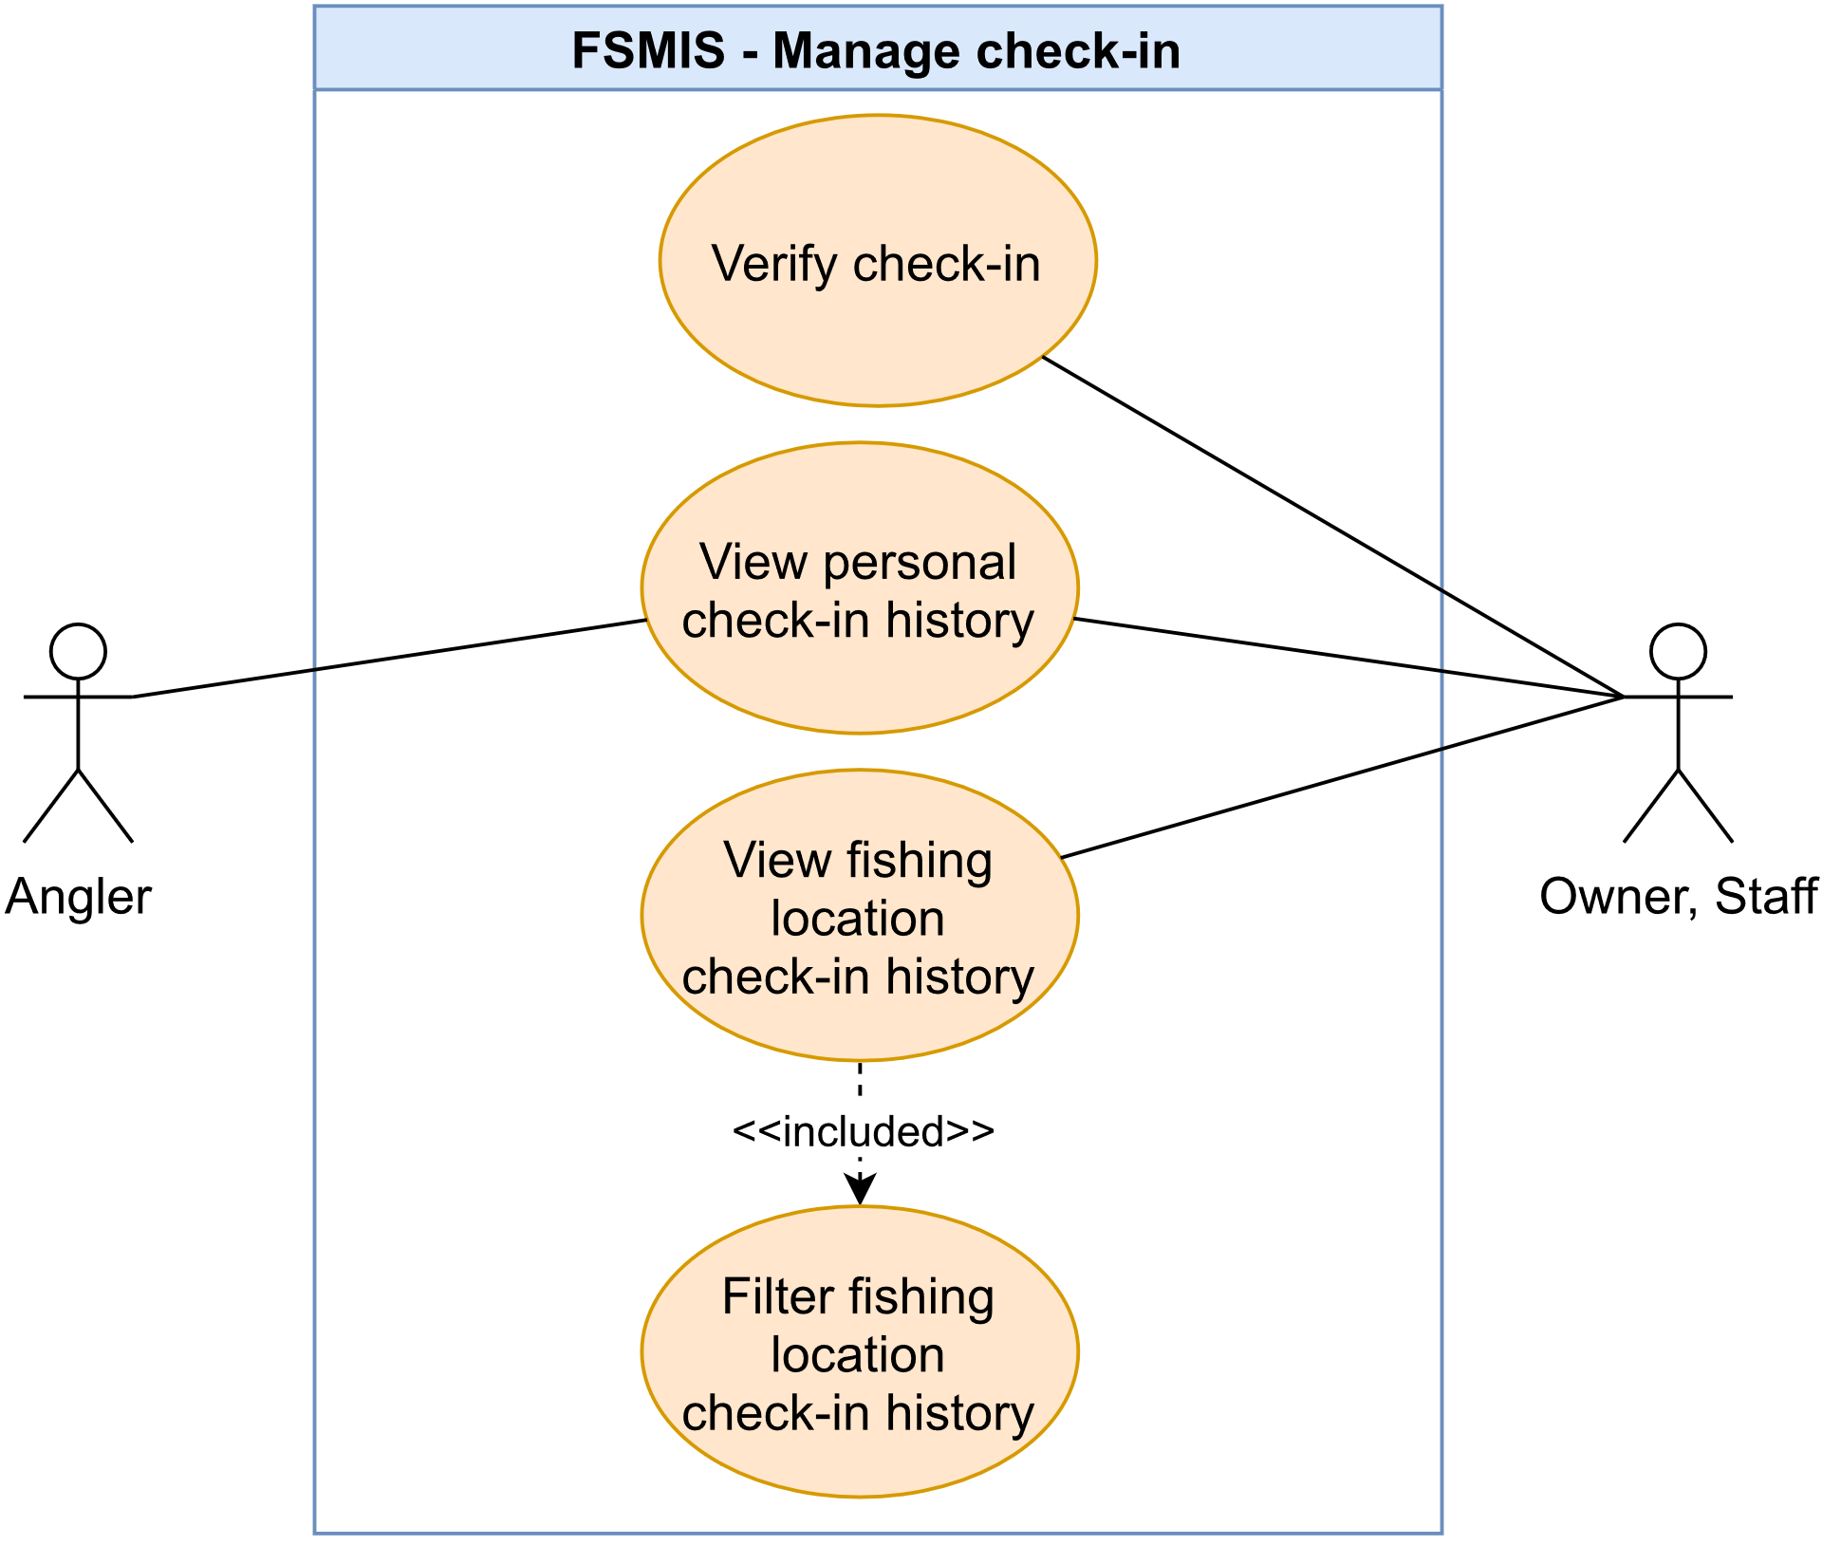

Figure 2.2.7. “Manage check-in” use cases

##### 2.2.7.1. Verify check-in action

|  |  |  |  |
| --- | --- | --- | --- |
| **UC ID and Name:** | **UC-25. Verify Check-in action** | | |
| **Created By:** | DucHM | **Date Created:** | 10/06/2021 |
| **Primary Actor:** | Owner, Staff | **Secondary Actors:** | Angler |
| **Description:** | This allows the owner (or staff) to use the phone’s camera to scan the angler check-in QR code. | | |
| **Trigger:** | **TRIG-01.** The owner (or staff) scans any angler’s QR code through the Camera Screen. | | |
| **Preconditions:** | **PRE-01.** The user is logged in.  **PRE-02.** The user must have a fishing location registered in the system to become owner or must be added as an employee in a fishing location to become staff.  **PRE-03.** The user is in the Fishing Location Management Screen. | | |
| **Post-conditions:** | **POST-01.** The angler’s check-in session is saved in the system and displays in the Fishing Location Check-in History Screen. | | |
| **Normal Flow:** | **25.0. Verify Check-in action**   1. After PRE-01, PRE-02 are confirmed, the user presses on the "Quét mã QR check-in” option in the Fishing Location Management Screen. 2. The system redirects the user to the Camera Screen, by default opens the phone camera to scan QR code. 3. The user points the camera at the angler's QR code to perform scanning (See 25.0.E1, 25.0.E2, 25.0.E3, 25.0.E4, 25.0.E5). 4. After the code is accepted, the system displays message (MSG68) and redirects the user to the Angler Check-in Detail Screen. While displaying the angler’s information: avatar, username, check-in time, there are two buttons “Tiếp tục” to perform next scan and “Màn hình quản lý” to redirect the user back to the Fishing Location Management Screen. | | |
| **Alternative Flows:** | N/A | | |
| **Exceptions:** | **25.0.E1. QR Scan did not found any user account related to the QR Code**   1. In step 3, if the system cannot find any user related to the QR Code. 2. The system rejects the scan attempt, and displays an error message (MSG63).   **25.0.E2.** **Owner account is being checked-in one’s fishing location**   1. In step 3, if the system detects that the owner account is being used to check-in his/her own fishing location. 2. The system rejects the scan attempt, displays an error message (MSG64).   **25.0.E3. Staff account is being checked-in one’s fishing location**   1. In step 3, if the system detects that the staff account is being used to check-in his/her currently working fishing location. 2. The system rejects the scan attempt, displays an error message (MSG65).   **25.0.E4. Owners or staffs checked-in themselves in their own fishing location**   1. In step 3, if the system detects that the owner or staff used their own account to check-in his/her own fishing location. 2. The system rejects scan attempt, displays error messages (MSG66).   **25.0.E5. Camera scans unknown type of code**   1. In step 3, if the camera picks up an unknown type of code other than QR Code. 2. The system rejects the scan attempt, displays error message (MSG71). | | |
| **Priority:** | High | | |
| **Frequency of Use:** | High | | |
| **Business Rules:** | BR-1, BR-2, BR-3, BR-4, BR-11, BR-12, BR-21, BR-22,BR-20 | | |
| **Other Information:** | N/A | | |
| **Assumptions:** | N/A | | |

Table 2.2.7.1. Verify check-in action

##### 2.2.7.2. View personal check-in history

|  |  |  |  |
| --- | --- | --- | --- |
| **UC ID and Name:** | **UC-26. View personal check-in history** | | |
| **Created By:** | DucHM | **Date Created:** | 10/02/2021 |
| **Primary Actor:** | Angler | **Secondary Actors:** | N/A |
| **Description:** | This allows an angler to access and view personal check-in history. | | |
| **Trigger:** | **TRIG-01.** Angler presses on the "Lịch sử check-in” option in the Personal Setting Screen. | | |
| **Preconditions:** | **PRE-01.** The user is logged in.  **PRE-02.** The user is in the Personal Setting Screen. | | |
| **Post-conditions:** | N/A | | |
| **Normal Flow:** | **26.0 View personal’s check-in history**   1. After PRE-01, PRE-02 are confirmed, the user presses on the “Lịch sử check-in” option. 2. The system redirects the angler to the Check-in history screen, displays the check-in list, each item contains name of checked-in fishing location, check-in date time and checkout date time (See other information 1). | | |
| **Alternative Flows:** | N/A | | |
| **Exceptions:** | N/A | | |
| **Priority:** | Medium | | |
| **Frequency of Use:** | High | | |
| **Business Rules:** | BR-03, BR-04 | | |
| **Other Information:** | 1. The system displays the angler’s check-in history by page (10 per page). | | |
| **Assumptions:** | N/A | | |

Table 2.2.7.2. View personal check-in history

##### 2.2.7.3. View fishing location’s check-in history

|  |  |  |  |
| --- | --- | --- | --- |
| **UC ID and Name:** | **UC-27. View fishing location’s check-in history** | | |
| **Created By:** | DucHM | **Date Created:** | 10/03/2021 |
| **Primary Actor:** | Owner, Staff | **Secondary Actors:** | N/A |
| **Description:** | The owner (or staff) can view a list of who has checked in his/her fishing location. | | |
| **Trigger:** | **TRIG-01.** A fishing location owner press on the "Lịch sử check-in” option in the Fishing Location Management Screen. | | |
| **Preconditions:** | **PRE-01.** The user is logged in.  **PRE-02.** The user must have a fishing location registered in the system to become owner role or must be added as an employee in a fishing location to become staff.  **PRE-03.** The user is in the Fishing Location Management Screen. | | |
| **Post-conditions:** | N/A | | |
| **Normal Flow:** | **27.0 View fishing location’s check-in history**   1. After PRE-01, PRE-02, PRE-03 are confirmed, the user presses on the “Lịch sử check-in” option. 2. The system redirects the user to the Fishing Location Check-in History, displays the following:    1. A select field allows the user to filter the check-in history by date.    2. The check-in history list, each item in the list represents an angler account who has checked-in this fishing location (See other information 1). | | |
| **Alternative Flows:** | N/A | | |
| **Exceptions:** | N/A | | |
| **Priority:** | High | | |
| **Frequency of Use:** | High | | |
| **Business Rules:** | BR-03, BR-04, BR-10 | | |
| **Other Information:** | 1. Each list item contains: angler’s avatar and name, angler’s check-in date time and angler’s checkout date time. 2. If the angler's check-in list is empty or the filter returns an empty list, the system will display a message (MSG13). | | |
| **Assumptions:** | N/A | | |

Table 2.2.7.3. View fishing location’s check-in history

##### 2.2.7.4. Filter fishing location’s check-in history

|  |  |  |  |
| --- | --- | --- | --- |
| **UC ID and Name:** | **UC-28. Filter fishing location’s check-in history** | | |
| **Created By:** | DucHM | **Date Created:** | 10/03/2021 |
| **Primary Actor:** | Owner, Staff | **Secondary Actors:** | N/A |
| **Description:** | This allows the owner (or staff) to sort the fishing location check-in history list by date range. | | |
| **Trigger:** | **TRIG-01.** The owner presses the OK button on the calendar picker. | | |
| **Preconditions:** | **PRE-01.** The user is logged in to the system.  **PRE-02.** The user must have a fishing location registered in the system to become an owner or must be added as an employee in a fishing location to become staff.  **PRE-03.** The user is in the Fishing Location Check-in History Screen. | | |
| **Post-conditions:** | N/A | | |
| **Normal Flow:** | **28.0. Filter fishing location check-in history**   1. After PRE-01, PRE-02, PRE-03 are confirmed, the user presses on the select dropdown, reveals a menu bar and then selects the “Theo ngày” option. 2. The system displays a calendar picker. 3. The user picks either a start date or an end date to form a date range and presses the OK button to finish selecting. 4. The system sorts the list by the selected date range, displays a new fishing location check-in history list with each item’s check-in date matches or is within the selected date range (See other information 1). | | |
| **Alternative Flows:** | N/A | | |
| **Exceptions:** | N/A | | |
| **Priority:** | High | | |
| **Frequency of Use:** | High | | |
| **Business Rules:** | BR-03, BR-04, BR-10 | | |
| **Other Information:** | 1. Each list item contains: angler’s avatar and name, angler’s check-in date time and angler’s checkout date time. | | |
| **Assumptions:** | N/A | | |

Table 2.2.7.4. Filter fishing location’s check-in history

#### 2.2.8. Feature “Manage catch reports”

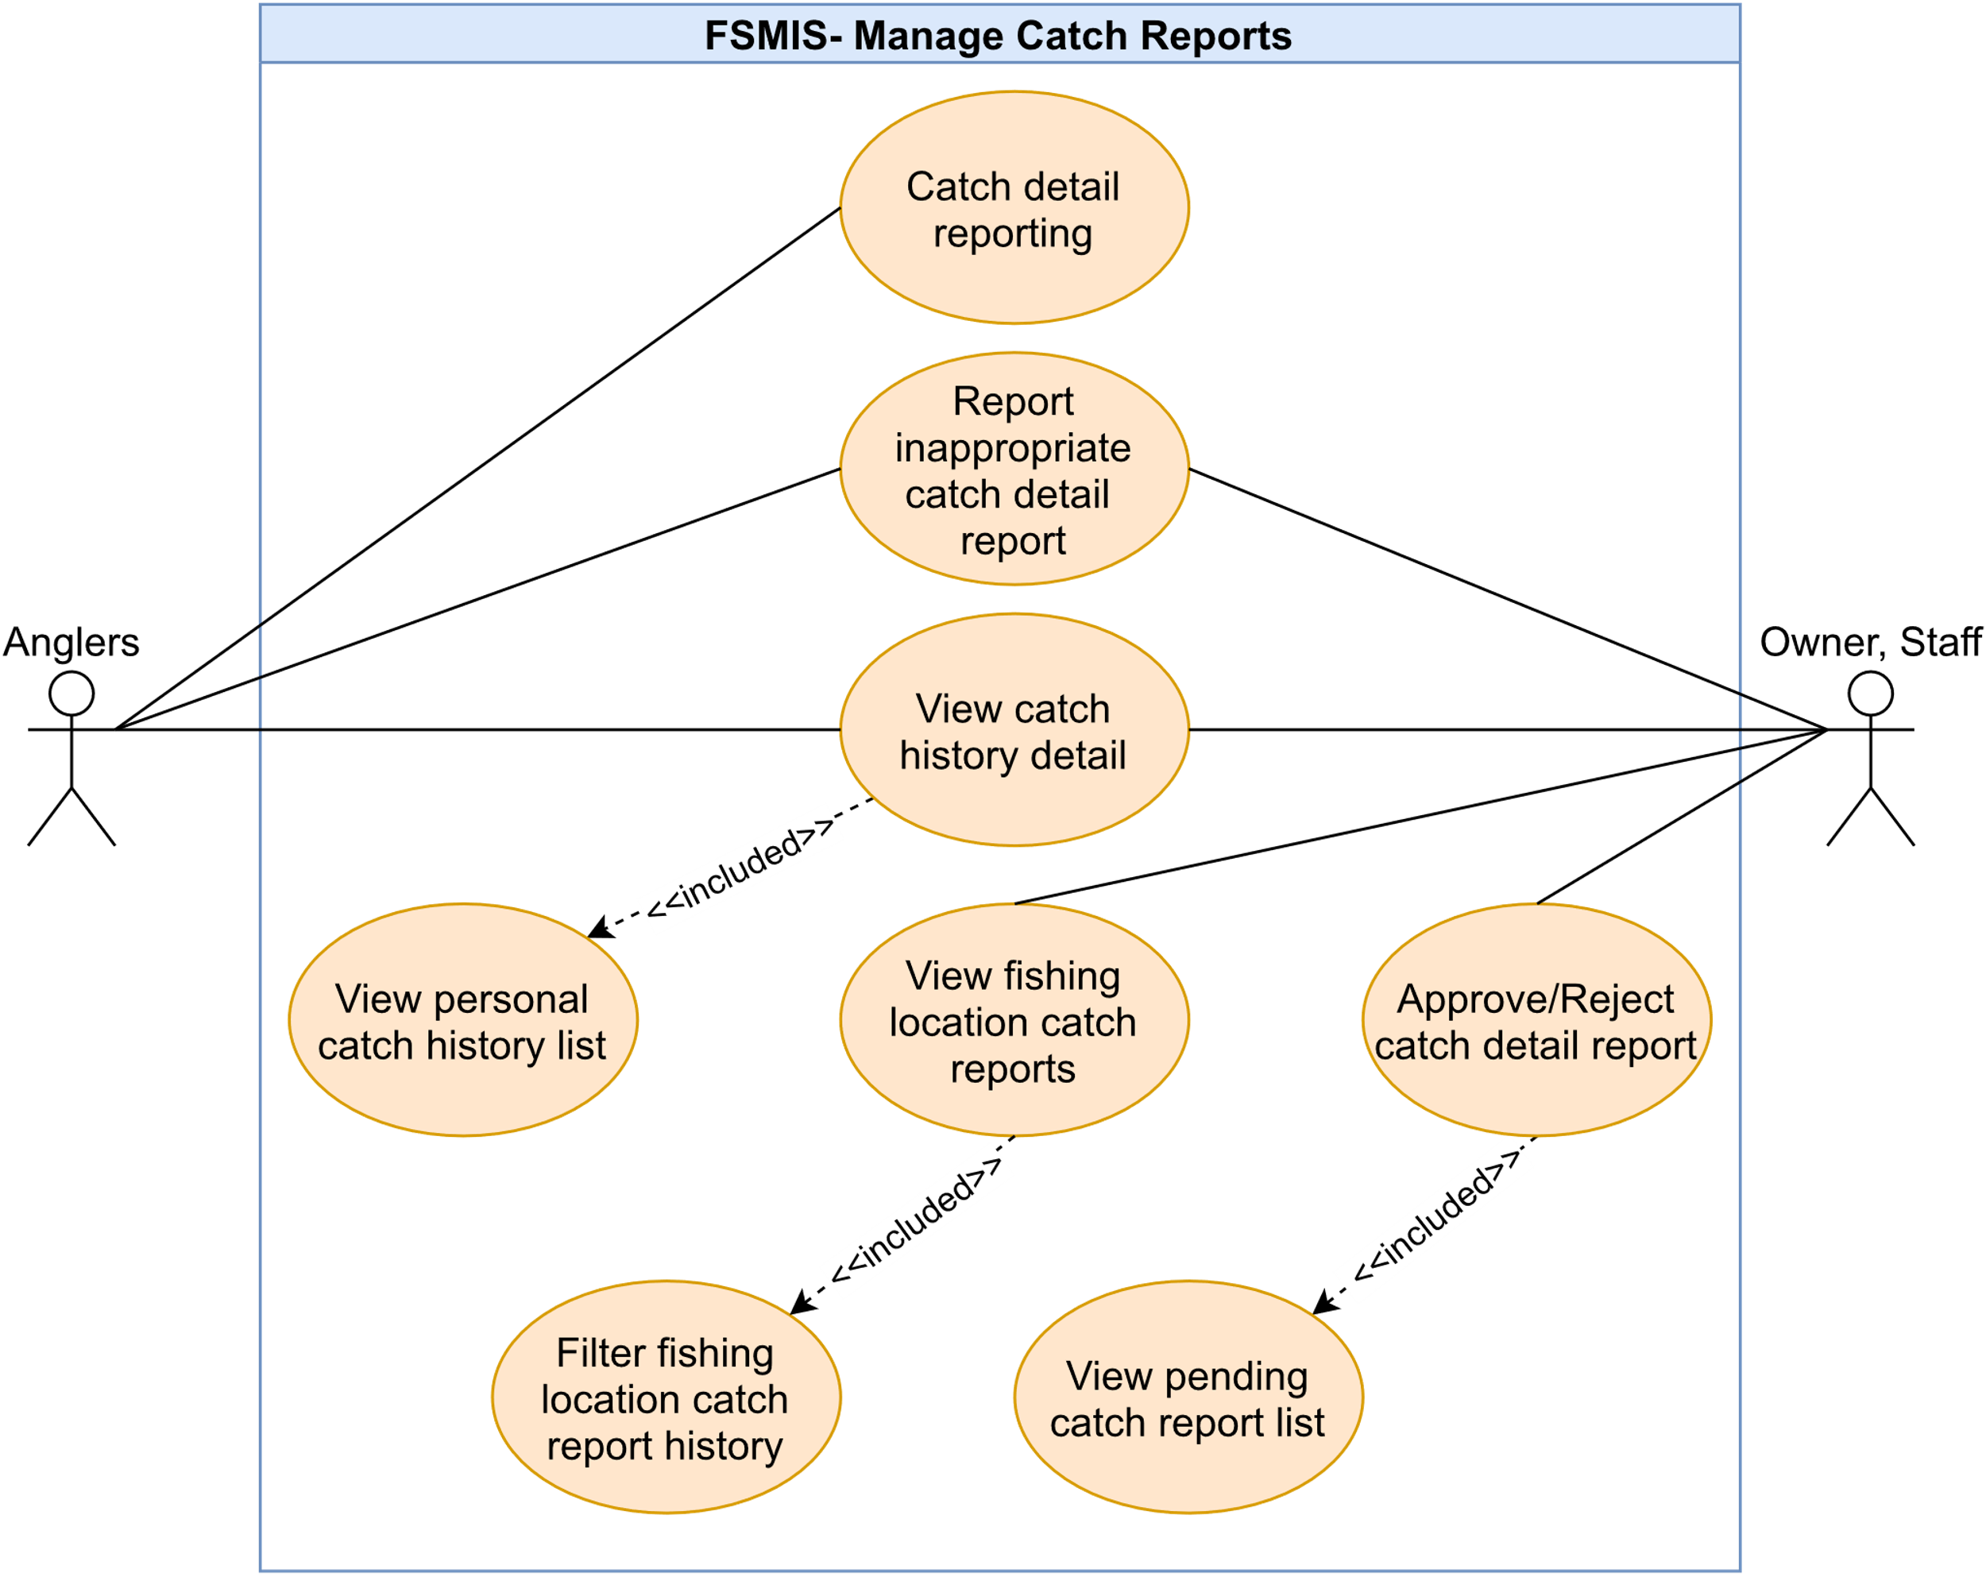

Figure 2.2.8. “Manage catch reports” use cases

##### 2.2.8.1. Catch details reporting

|  |  |  |  |
| --- | --- | --- | --- |
| **UC ID and Name:** | **UC-29. Catch detail reporting** | | |
| **Created By:** | DucHM | **Date Created:** | 10/03/2021 |
| **Primary Actor:** | Angler | **Secondary Actors:** | N/A |
| **Description:** | This use case allows the angler to submit a catch detail report in the fishing location, where the user has previously checked-in for fishing. | | |
| **Trigger:** | **TRIG-01.** Angler presses on the "Báo kết quả câu” button in the Check-in Successful Screen. | | |
| **Preconditions:** | **PRE-01.** The user has logged.  **PRE-02.** The angler is in the Check-in Successful Screen. | | |
| **Post-conditions:** | **POST-01.** The catch detail report of the angler is created with the status of pending in the system.  **POST-02.** The catch detail report is sent to the Pending Catch Report List Screen, allowing the owner (or staff) to approve or reject the report.  **POST-03.** The checkout time will be logged after the catch detail report is sent, displayed in the angler personal Check-in History Screen and the fishing location’s Fishing Location Check-in History Screen. | | |
| **Normal Flow:** | **29.0 Catch detail reporting**   1. After PRE-01, PRE-02 are confirmed, the user presses on the “Báo kết quả câu” in the Check-in Successful Screen. 2. The system redirects the user to the Catch Detail Editor Screen, displays the following:    1. A required image section allows the angler to upload his/her image from the media library (see other information 1).    2. A required select field to select which lake of the fishing location.    3. A required catch detail card list, having the following (See other information 2):       1. A required select field to select which fish species is caught by the user.       2. A required number field to input the number of catches of that species.       3. A required number field to input the total weight of all fishes of that species.       4. A non-required checkbox indicates the angler has released the fish after the catch,       5. A delete button to delete this card.    4. A “Thêm thẻ” button to add more catch detail cards.    5. A checkbox indicating that the angler if he/she wants to publicize this catch detail report to everyone.    6. A button “Gửi và checkout” to submit the catch detail report. 3. The angler fills in required fields in detail report form and presses the "Gửi và check out” button to submit the form (See 29.0.E1, 29.0.E2, 29.0.E3, 29.0.E4, 29.0.E5, 29.0.E6). 4. The system accepts the submitted form, displays a pop-up (MSG12), log the user checkout time and redirects the user back to QR Screen (See 29.0.E7). | | |
| **Alternative Flows:** | N/A | | |
| **Exceptions:** | **29.0.E1. Leave required fields blank**   1. In step 3, the user leaves required fields blank. 2. The system rejects the user’s submit attempt, displays error messages (MSG02).   **29.0.E2. The user inputs letters in number field**   1. In step 3, the user inputs letters in the number field. 2. The system rejects the user’s submit attempt, displays error messages (MSG70).   **29.0.E3. The user does not add any catch detail card**   1. In step 3, the user does not add any catch detail card. 2. The system rejects the user’s submit attempt, displays an error message (MSG73).   **29.0.E4. The user does add more than 10 catch detail cards**   1. In step 3, the user adds more than 10 catch detail cards. 2. The system rejects the user’s submit attempt, displays an error message (MSG74).   **29.0.E5. Number of catches and total weight larger than 9999**   1. In the catch detail card, the user inputs either number of catches or total weight more than 9999. 2. The system rejects the user’s submit attempt, displays error messages (MSG76, MSG79).   **29.0.E5. Number of catches and total weight smaller than 0**   1. In the catch detail card, the user inputs either number of catches or total weight smaller than 0. 2. The system rejects the user’s submit attempt, displays error messages (MSG75, MSG78).   **29.0.E6. Number of catches is not an integer**   1. In the catch detail card, the user inputs the number of catches not an integer. 2. The system rejects the user’s submit attempt, and displays error messages (MSG77).   **29.0.E7. Submission failed**   1. If they system has an error when submitting the user’s catch detail report form, the system displays error message (MSG81). | | |
| **Priority:** | High | | |
| **Frequency of Use:** | High | | |
| **Business Rules:** | BR-08, BR-15, BR-09 | | |
| **Other Information:** | 1. Total images the angler can upload in a catch report is 3 images. 2. Each catch detail card is used for one fish species. If the angler catches multiple species of fishes, he/she must add a new card for the new fish species. | | |
| **Assumptions:** | N/A | | |

Table 2.2.8.1. Catch details reporting

##### 2.2.8.2. View pending catch reports

|  |  |  |  |
| --- | --- | --- | --- |
| **UC ID and Name:** | **UC-30. View pending catch reports** | | |
| **Created By:** | DucHM | **Date Created:** | 10/03/2021 |
| **Primary Actor:** | Staff, Owner | **Secondary Actors:** | N/A |
| **Description:** | This allows the owner or staff to view a list of catch detail reports sent by anglers. | | |
| **Trigger:** | **TRIG-01.** The owner or staff presses the "Xác nhận báo cá” option in the Fishing Location Management Screen. | | |
| **Preconditions:** | **PRE-01.** The user is logged in.  **PRE-02.** The user must have a fishing location registered in the system to become an owner or must be added as an employee in a fishing location to become staff.  **PRE-03.** The user is in the Fishing Location Management Screen. | | |
| **Post-conditions:** | N/A | | |
| **Normal Flow:** | **30.0. View pending catch reports**   1. After PRE-01, PRE-02, PRE-03 are confirmed, the user presses on the "Xác nhận báo cá” option. 2. The system redirects the user to the Pending Catch Report List Screen, displays a list of anglers catch detail report in pending status, each list item having the following (See other information 1):    1. Angler’s avatar    2. Angler’s name    3. Date and time of when the catch detail is sent.    4. A text line describes description content submitted with the report (See other information 2).    5. A text line describes species of fishes caught in that report    6. A “Đồng ý” button to approve that catch report.    7. A “Chi tiết” button to view detailed information of that catch detail report. | | |
| **Alternative Flows:** | N/A | | |
| **Exceptions:** | N/A | | |
| **Priority:** | High | | |
| **Frequency of Use:** | High | | |
| **Business Rules:** | BR-03, BR-04 | | |
| **Other Information:** | 1. If the pending catch detail report list is empty, the system will display a message (MSG82). 2. The catch report’s description is shortened with “...” if the content is too long. | | |
| **Assumptions:** | N/A | | |

Table 2.2.8.2. View pending catch reports

##### 2.2.8.3. Approve/Reject catch detail report

|  |  |  |  |
| --- | --- | --- | --- |
| **UC ID and Name:** | **UC-31. Approve/Reject catch reports** | | |
| **Created By:** | DucHM | **Date Created:** | 03/10/21 |
| **Primary Actor:** | Staff, Owner | **Secondary Actors:** | N/A |
| **Description:** | This allows the owner (or staff) to verify any catch detail report is sent by anglers. | | |
| **Trigger:** | **TRIG-01.** The user presses on the "Đồng ý‘’ button placed next to the right of a list item in the Pending Catch Report Screen. | | |
| **Preconditions:** | **PRE-01.** The user is logged in.  **PRE-02.** The user must have a fishing location registered in the system to become an owner or must be added as an employee in a fishing location to become staff.  **PRE-03.** The user is in the Pending Catch Report List Screen. | | |
| **Post-conditions:** | **POST-01.** The status of the catch report’s record in the database changes from “Pending” to the "Approved” or the "Rejected”.  **POST-02.** The “Approved” catch detail report will be displayed in the Fishing Location Catch History List Screen.  **POST-03.** The “Approved” catch detail report which the submitter has allowed to publicize, will be displayed in the Public Catch Event Screen of that fishing location. | | |
| **Normal Flow:** | **31.0.1. Approve catch detail report in the Pending Catch Report List Screen**   1. After PRE-01, PRE-02, PRE-03 are confirmed, the user presses on the “Đồng ý” button placed next to the right of list item. 2. The system updates the status of that catch detail report from “Pending” to “Approved”, and removes the catch detail report from the Pending Catch Report List Screen.   **31.0.2. Reject catch detail report in the Pending Catch Report Detail Screen**   1. After PRE-01, PRE-02, PRE-03 are confirmed, the user presses on a list item. 2. The system redirects the user to the Pending Catch Report Detail Screen. While displaying all information contains in the catch detail report form submitted by the angler, the system also displays a “Từ chối” button to reject this catch detail report and a “Xác nhận” button to approve this catch detail report. 3. The user presses on the “Từ chối” button to reject the catch detail report. 4. The system updates the status of that catch detail report from “Pending” to “Rejected”, redirects the user back to the Pending Catch Report List Screen and removes the catch detail report from the list. | | |
| **Alternative Flows:** | **31.1 Approve catch detail report in the Pending Catch Report Detail Screen**   1. After PRE-01, PRE-02, PRE-03 are confirmed, the user presses on a list item. 2. The system redirects the user to the Pending Catch Report Detail Screen. While displaying all information contains in the catch detail report form submitted by the angler, the system also displays a “Từ chối” button to reject this catch detail report and a “Xác nhận” button to approve this catch detail report. 3. The user presses on the “Từ chối” button to reject the catch detail report. 4. The system updates the status of that catch detail report from “Pending” to “Approved”, redirects the user back to the Pending Catch Report List Screen and removes the catch detail report from the list. | | |
| **Exceptions:** | N/A | | |
| **Priority:** | High | | |
| **Frequency of Use:** | High | | |
| **Business Rules:** | BR-03, BR-04, BR-10 | | |
| **Other Information:** | N/A | | |
| **Assumptions:** | N/A | | |

Table 2.2.8.3. Approve/Reject catch detail report

##### 2.2.8.4. View personal catch history list

|  |  |  |  |
| --- | --- | --- | --- |
| **UC ID and Name:** | **UC-32. View personal catch history** | | |
| **Created By:** | DucHM | **Date Created:** | 10/03/2021 |
| **Primary Actor:** | Angler | **Secondary Actors:** | N/A |
| **Description:** | This allows an angler to view his/her all-time catch report history. | | |
| **Trigger:** | **TRIG-01.** The user presses on the "Lịch sử Báo cá” option in the Personal Setting Screen. | | |
| **Preconditions:** | **PRE-01.** The user is logged in.  **PRE-02.** The user is in the Personal Setting Screen. | | |
| **Post-conditions:** | N/A | | |
| **Normal Flow:** | **32.0. View personal catch history**   1. After PRE-01, PRE-02 are confirmed, the user presses on the "Lịch sử Báo cá” option. 2. The system redirects the user to the Personal Catch Report History Screen, each list item is a summary of a catch detail report, displays information contains user’s avatar, username, name of the visited fishing location, created date time, fish species caught. | | |
| **Alternative Flows:** | **32.1. View personal catch history detail**   1. After step 2 of normal flow, the user presses on a list item. 2. The system redirects to the Personal Catch Detail Screen, displaying all information contains in the catch detail report form submitted by the user. | | |
| **Exceptions:** | N/A | | |
| **Priority:** | Medium | | |
| **Frequency of Use:** | Low | | |
| **Business Rules:** | N/A | | |
| **Other Information:** | N/A | | |
| **Assumptions:** | N/A | | |

Table 2.2.8.4. View personal catch history list

##### 2.2.8.5. View fishing location's catch history

|  |  |  |  |
| --- | --- | --- | --- |
| **UC ID and Name:** | **UC-33. View fishing location's catch history** | | |
| **Created By:** | DucHM | **Date Created:** | 10/03/2021 |
| **Primary Actor:** | Owner, Staff | **Secondary Actors:** | N/A |
| **Description:** | This allows the owner (or staff) to view the history of catch detail reports of anglers, which previously were rejected or approved by the owner (or staff). | | |
| **Trigger:** | **TRIG-01.** The owner or staff presses on the "Báo cá đã duyệt” option in the Fishing Location Management Screen. | | |
| **Preconditions:** | **PRE-01.** The user is logged in.  **PRE-02.** The user must have a fishing location registered in the system to become owner or must be added as an employee in a fishing location to become staff.  **PRE-03.** The user is in the Fishing Location Management Screen. | | |
| **Post-conditions:** | N/A | | |
| **Normal Flow:** | **33.0 View fishing location's catch history**   1. After PRE-01, PRE-02, PRE-03 are confirmed, the user presses on the "Báo cá đã duyệt'' option. 2. The system redirects the user to the Fishing Location Catch History Screen, displays the following:    1. A select field allows the user to filter the check-in history by date.    2. The catch history list, each item in the list represents a catch detail report submitted by the angler who has gone fishing in this fishing location (See other information 1). | | |
| **Alternative Flows:** | N/A | | |
| **Exceptions:** | N/A | | |
| **Priority:** | High | | |
| **Frequency of Use:** | High | | |
| **Business Rules:** | BR-03, BR-04, BR-10 | | |
| **Other Information:** | 1. Each list item in the Fishing Location Catch History Screen is the summary of the angler’s catch detail report, the item displays information contains angler’s avatar, angler’s name, submitted date time, a truncated catch detail description content, fish species caught. | | |
| **Assumptions:** | N/A | | |

Table 2.2.8.5. View fishing location's catch history

##### 2.2.8.6. Filter fishing location's catch history

|  |  |  |  |
| --- | --- | --- | --- |
| **UC ID and Name:** | **UC-34. Filter fishing location’s catch history** | | |
| **Created By:** | DucHM | **Date Created:** | 10/03/2021 |
| **Primary Actor:** | Owner, Staff | **Secondary Actors:** | N/A |
| **Description:** | This allows the owner or staff to sort the fishing location catch history list with filter conditions. | | |
| **Trigger:** | **TRIG-01.** The user presses the OK button on the calendar picker. | | |
| **Preconditions:** | **PRE-01.** The user is logged in to the system.  **PRE-02.** The user must have a fishing location registered in the system to become an owner or must be added as an employee in a fishing location to become staff.  **PRE-03.** The user is in the Fishing Location Catch History Screen. | | |
| **Post-conditions:** | N/A | | |
| **Normal Flow:** | **34.0. Filter fishing location’s catch history**   1. After PRE-01, PRE-02, PRE-03 are confirmed, the user presses on the select dropdown, reveals a menu bar and then selects the “Theo ngày” option. 2. The system displays a calendar picker. 3. The user picks either a start date or an end date to form a date range and presses the OK button to finish selecting. 4. The system sorts the list by the selected date range, displays new fishing location catch history list with each item’s submitted date matches or is within the selected date range (See other information 1). | | |
| **Alternative Flows:** | N/A | | |
| **Exceptions:** | N/A | | |
| **Priority:** | Medium | | |
| **Frequency of Use:** | High | | |
| **Business Rules:** | BR-03, BR-04, BR-09, BR-10 | | |
| **Other Information:** | 1. Each list item in the Fishing Location Catch History Screen is the summary of the angler’s catch detail report, the item displays information contains angler’s avatar, angler’s name, submitted date time, a truncated catch detail description content, fish species caught. | | |
| **Assumptions:** | N/A | | |

Table 2.2.8.6. Filter fishing location's catch history

##### 2.2.8.7. View catch history detail

|  |  |  |  |
| --- | --- | --- | --- |
| **UC ID and Name:** | **UC-35. View catch history detail** | | |
| **Created By:** | DucHM | **Date Created:** | 10/03/2021 |
| **Primary Actor:** | Owner, Staff | **Secondary Actors:** | N/A |
| **Description:** | This allows the owner (or staff) to view a fishing location’s catch history detail. | | |
| **Trigger:** | **TRIG-01.** The user presses on a list item in the Fishing Location Catch History Screen. | | |
| **Preconditions:** | **PRE-01.** The user is logged in.  **PRE-02.** The user must have a fishing location registered in the system to become an owner role or must be added as an employee in a fishing location to become staff.  **PRE-03.** The user is in the Fishing Location Catch History Screen. | | |
| **Post-conditions:** | N/A | | |
| **Normal Flow:** | **35.0.** **View fishing location's catch history in detail**   1. After PRE-01, PRE-02, PRE-03 are confirmed, the user presses on a list item. 2. The system redirects to the Catch History Detail Screen, displays all information contains in the catch detail report form submitted by the angler, including:    1. A slider section to view the image attached to this catch detail report.    2. A section to describe information of the submitter: avatar, name, submitted date time.    3. A section describes which fishing location is visited and which lake the angler has gone fishing.    4. A text area describes description content submitted with this catch detail report.    5. A Catch Detail Card list, each catch detail card contains fish species image, name, number of catches, total weight of caught fish. | | |
| **Alternative Flows:** | N/A | | |
| **Exceptions:** | N/A | | |
| **Priority:** | Medium | | |
| **Frequency of Use:** | High | | |
| **Business Rules:** | BR-03 | | |
| **Other Information:** | N/A | | |
| **Assumptions:** | N/A | | |

Table 2.2.8.7. View catch history detail

##### 2.2.8.8. Report inappropriate catch detail report

|  |  |  |  |
| --- | --- | --- | --- |
| **UC ID and Name:** | **UC-36. Report inappropriate catch report** | | |
| **Created By:** | DucHM | **Date Created:** | 10/03/2021 |
| **Primary Actor:** | Angler, Owner, Staff | **Secondary Actors:** | N/A |
| **Description:** | This allows the user to report any inappropriate catch detail report which is public in the Public Catch Event Screen. | | |
| **Trigger:** | **TRIG-01.** The user presses on the Flag icon in a post in the Public Catch Event Screen. | | |
| **Preconditions:** | **PRE-01.** The user has logged in.  **PRE-02.** The user is in the Public Catch Event Screen.  **PRE-03.** There is at least one post in the Public Catch Event Screen. | | |
| **Post-conditions:** | N/A | | |
| **Normal Flow:** | **36.0.** **Report inappropriate catch report**   1. After PRE-01, PRE-02, PRE-03 are confirmed, the user presses on the Flag icon in a post from the list of posts. 2. The system reveals a menu with the “Báo cáo bài viết” option. 3. The user presses on the “Báo cáo bài viết” option. 4. The system redirects the user to the Report Editor Screen, display the following:    1. A required text area to input report description.    2. The “Báo cáo” button to submit the report. 5. The user inputs the reason of report in the report description and presses on “Báo cáo” to submit the report (See 36.0.E1). 6. The system successfully sends the report form of the review to the admin, displays a pop-up message (MSG60) (See 36.0.E2). | | |
| **Alternative Flows:** | N/A | | |
| **Exceptions:** | **36.0.E1. Leave required field blank**   1. In step 3, the user leaves required fields blank. 2. The system rejects the user’s attempt, displays error messages (MSG02).   **36.0.E2.** **Send request failed**   1. In step 4, if the send request fails, the system will display an error message (MSG59). | | |
| **Priority:** | Medium | | |
| **Frequency of Use:** | High | | |
| **Business Rules:** | BR-03 | | |
| **Other Information:** | 1. To access the Public Catch Event Screen of a fishing location, all users first need to access that fishing location overview through the Search Result Screen or the Saved Fishing Location Screen, then pressing on any of the location cards. This will redirect the users to the Fishing Location Overview Screen of that location. Next, navigate to the Public Catch Event Screen by pressing the “Sự kiện” option at the navigation bar inside the Fishing Location Overview Screen. 2. The owner (or staff) can also access the Public Catch Event Screen by accessing the Fishing Location Overview Screen in the Fishing Location Management Screen of a fishing location, then presses on the “Xem trang điểm câu của bạn” option. | | |
| **Assumptions:** | N/A | | |

Table 2.2.8.8. Report inappropriate catch detail report

#### 2.2.9. Feature “Manage fishing location’s profile”

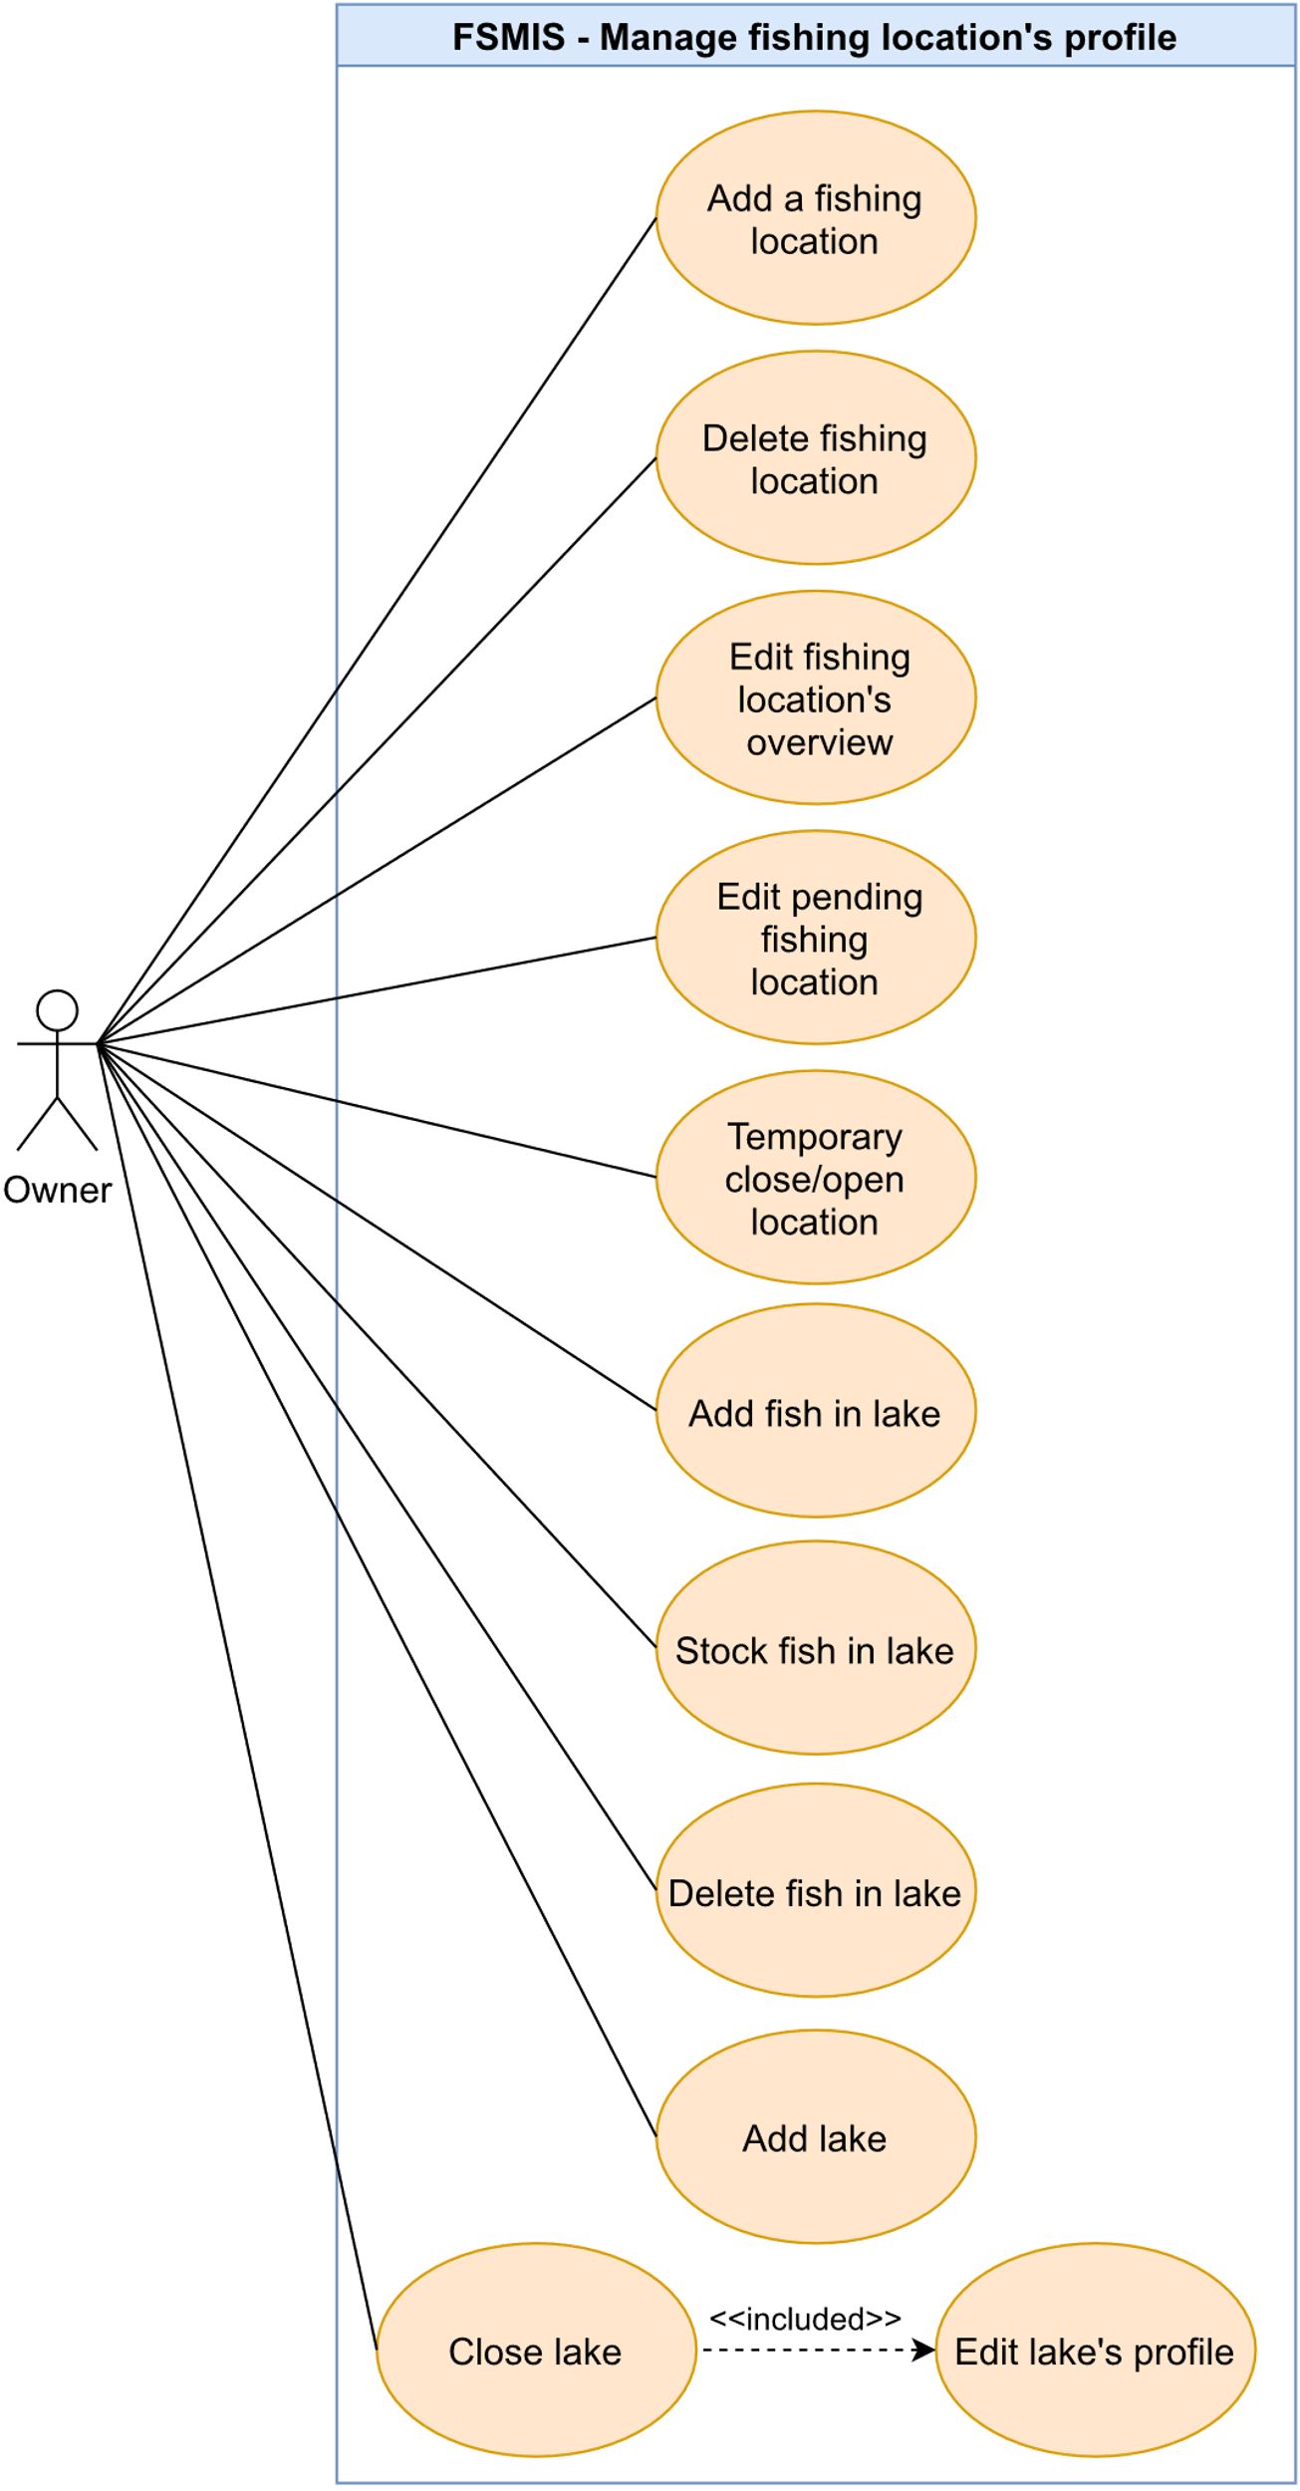

Figure 2.2.9. “Manage fishing location’s profile”

##### 2.2.9.1. Add a fishing location

|  |  |  |  |
| --- | --- | --- | --- |
| **UC ID and Name:** | **UC-37. Add a fishing location** | | |
| **Created By:** | DucHM | **Date Created:** | 10/03/2021 |
| **Primary Actor:** | Owner | **Secondary Actors:** | N/A |
| **Description:** | This allows the owner to add a new fishing location to the system or edit any pending fishing locations assigned to the owner by the admin to make it official fishing location. | | |
| **Trigger:** | **TRIG-01.** The user presses on the “Thêm điểm câu” box in the Fishing Location Select Screen. | | |
| **Preconditions:** | **PRE-01.** The user is logged in.  **PRE-02.** The user is in the Fishing Location Select Screen. | | |
| **Post-conditions:** | **POST-01**. The fishing location profile is created in a database with status of unverified.  **POST**-**02.** The fishing location profile created will be displayed as a location card in the Fishing Location Select Screen.  **POST-03.** The fishing location profile is sent to the System Location Management Screen for the admin to verify. | | |
| **Normal Flow:** | **37.0.1. Add new fishing location**   1. After PRE-01, PRE-02 are confirmed, the user presses on the “Thêm điểm câu” box on the screen. 2. The system redirects the user to the Fishing Location Editor Screen, displays the following:    1. A required section to upload images of the fishing location (See other information 2).    2. A required text field to input the fishing location name.    3. A contact section, having the following:       1. A required number field for the contact phone number,       2. A non-required text field to input website related to the fishing location.       3. A required text field to input location’s address       4. A required select field to select province       5. A required select field to select district       6. A required select field to select ward    4. A required map section allows the user to place the red pin on where the fishing location is in the google map layout.    5. A required text area labelled “Miêu tả khu hồ” to input fishing location description.    6. A required text area labelled “Thời gian hoạt động” to describe the opening and closing time of the location,    7. A required text area labelled “Dịch vụ” to describe list of services in this location.    8. A required text area labelled “Nội quy” to describe the rules of this fishing location.    9. A “Thêm điểm câu” button to save the location profile and submit the form. 3. The user fills in required fields and presses the “Lưu thông tin” button to save the information (see 37.0.E1, 37.0.E2, 37.0.E3, 37.0.E4, 37.0.E6). 4. The system sends the OTP code through the location contact phone number and redirects the user the OTP Screen, displays the following (See other information 3):    1. 6 number cells to input OTP code.    2. A countdown timer indicates the next OTP send request availability.    3. The “Tiếp tục” button. 5. The user inputs the OTP code and presses the “Tiếp tục” button to continue the process (see 37.0.E5). 6. The system redirects the user back to the Fishing Location Editor Screen, accepts new information in the form, creates a new fishing location profile, and displays pop-up message (MSG83) (See 37.0.E7). 7. The user presses on the “Xác nhận” button in the pop-up message to be redirected back to the Fishing Location Select Screen. | | |
| **Alternative Flows:** | N/A | | |
| **Exceptions:** | **37.0.E1. Leaving the required field blank**   1. In step 4, the user leaves required fields blank. 2. The system rejects the user’s attempt, displays error messages (MSG02).   **37.0.E2. Invalid phone number**   1. In step 4, the user enters an invalid phone number. 2. The system rejects the user’s attempt, displays an error message (MSG04).   **37.0.E3. Use existed phone number or banned phone number to register**   1. In step 4, the user inputs an existing phone number or banned phone number. 2. The system rejects the user’s register attempt, displays error message (MSG05).   **37.0.E4. The user does not select the fishing location position on the map**   1. The user does not select the location position through the map section before pressing the “Lưu thông tin” button. 2. The system rejects the user’s attempt, displays an error pop-up message (MSG84).   **37.0.E5.** **The user inputs invalid OTP**   1. In step 6, the user inputs invalid OTP code. 2. The system rejects the user’s attempt, and displays an error message (MSG03).   **37.0.E6.** **Using phone number of a staff account to create new location**   1. The user enters in the contact a phone number of a staff account. 2. The system rejects the user’s submission attempt, displays the error message (MSG106).   **37.0.E7. The system failed to create new fishing locationprofile**   1. The system displays an error pop-up message. (MSG81) | | |
| **Priority:** | High | | |
| **Frequency of Use:** | Low | | |
| **Business Rules:** | BR-11, BR-12, BR-13 | | |
| **Other Information:** | 1. If the Fishing Location Select Screen does not have any location card, the system shows the “Thêm điểm câu” button in the middle of the screen. 2. The maximum number of images the user can upload within the fishing location profile is 5 images. 3. When an OTP session is over, the system asks if the user wants to re-send an OTP code. The system repeats step 4, 5 if the user chooses resend. | | |
| **Assumptions:** | N/A | | |

Table 2.2.9.1. Add a fishing location

##### 2.2.9.2. Edit fishing location's overview

|  |  |  |  |
| --- | --- | --- | --- |
| **UC ID and Name:** | **UC-38. Edit fishing location's overview** | | |
| **Created By:** | DucHM | **Date Created:** | 10/03/2021 |
| **Primary Actor:** | Owner | **Secondary Actors:** | N/A |
| **Description:** | This allows the owner to edit his/her fishing location profile. | | |
| **Trigger:** | **TRIG-01.** The user presses on the "Chỉnh sửa thông tin hồ câu” in the Fishing Location Management Screen. | | |
| **Preconditions:** | **PRE-01.** The user is logged in.  **PRE-02.** The user has added at least a fishing location’s profile before.  **PRE-03.** The user is in the Fishing Location Management Screen. | | |
| **Post-conditions:** | **POST-01**. The fishing location profile is updated in the database.  **POST-01**. The status of the fishing location changes to unverified.  **POST-03.** The fishing location’s profile is sent to the admin for verification. | | |
| **Normal Flow:** | **38.0.1 Edit fishing location's overview without changing contact phone number**   1. After PRE-01, PRE-02, PRE-03 are confirmed, the user presses on the “Chỉnh sửa khu hồ” option in the Fishing Location Management Screen (See other information 1). 2. The system redirects the user to the Fishing Location Editor Screen, displays the following (See 38.0.2):    1. A required section to upload images of the fishing location (See other information 2).    2. A required text field to input the fishing location name.    3. A contact section, having the following:       1. A required number field for the contact phone number,       2. A non-required text field to input website related to the fishing location.       3. A required text field to input location’s address       4. A required select field to select province       5. A required select field to select district       6. A required select field to select ward    4. A required map section allows the user to place the red pin on where the fishing location is in the google map layout.    5. A required text area labelled “Miêu tả khu hồ” to input fishing location description.    6. A required text area labelled “Thời gian hoạt động” to describe the opening and closing time of the location,    7. A required text area labelled “Dịch vụ” to describe list of services in this location.    8. A required text area labelled “Nội quy” to describe the rules of this fishing location.    9. A “Lưu thông tin” button to save the location profile and submit the form. 3. The user makes changes in any field without changing the contact phone number and presses the “Lưu thông tin” button to submit the changes (see 38.0.E1, 38.0.E4). 4. The system accepts the changes, updates fishing location profile, displays pop-up messages (MSG85).   **38.0.2.** **Edit fishing location's profile includes changing contact phone number**   1. After step 2 in flow 38.0.1, the user makes changes to any field including changing the contact phone number and presses the “Lưu thông tin” button (see 38.0.E1, 38.0.E2, 38.0.E3, 38.0.E4, 38.0.E5). 2. The system sends an OTP code to the new contact phone number and redirects the user the OTP Screen, displays the following (See other information 3):    1. 6 number cells to input OTP code.    2. A countdown timer indicates the next OTP send request availability.    3. The “Tiếp tục” button. 3. The user inputs the OTP code and presses the “Tiếp tục” button to continue the process (see 38.0.E5). 4. The system redirects the user back to the Fishing Location Editor Screen, accepts the changes, updates fishing location profile, and displays a pop-up message (MSG85) (See 38.0.E7). | | |
| **Alternative Flows:** | N/A | | |
| **Exceptions:** | **38.0.E1. Leave required fields blank**   1. The user leaves required fields blank before pressing the “Lưu thông tin” button. 2. The system rejects the user’s submit attempt, and displays error messages (MSG02).   **38.0.E2. Invalid phone number**   1. If the user enters an invalid phone number. 2. The system rejects the user’s submit attempt, and displays an error message (MSG04).   **38.0.E3. Use existed phone number or banned phone number to register**   1. In step 4, the user inputs an existing phone number or banned phone number. 2. The system rejects the user’s register attempt, displays an error message (MSG05).   **38.0.E4. The user does not select the fishing location position on the map**   1. The user does not select the location position through the map section before pressing the “Lưu thông tin” button. 2. The system rejects the user’s attempt, displays an error pop-up message (MSG84).   **38.0.E5. The user inputs invalid OTP**   1. In step 6, the user inputs invalid OTP code. 2. The system rejects the user’s attempt, displays an error message (MSG03).   **38.0.E6. Using phone number of a staff account when editing fishing location**   1. The user enters in the contact a phone number of a staff account. 2. The system rejects the user’s submission attempt, displays the error message (MSG106).   **38.0.E7. The system failed to change information of the fishing location**   1. The system cancels any further action, displays an error pop-up message. (MSG81) | | |
| **Priority:** | High | | |
| **Frequency of Use:** | High | | |
| **Business Rules:** | BR-11, BR-12 | | |
| **Other Information:** | 1. The owner (or staff) must have a fishing location available in the Fishing Location Select Screen. To access that location’s Fishing Location Management Screen. The owner (or staff) presses on the location card in the Fishing Location Select Screen. 2. The maximum number of images the user can upload within the fishing location profile is 5 images. 3. When an OTP session is over, the system asks if the user wants to re-send an OTP code. The system repeats step 2, 3 if the user chooses to resend. | | |
| **Assumptions:** | N/A | | |

Table 2.2.9.2. Edit fishing location's overview

##### 2.2.9.3. Edit pending fishing location

|  |  |  |  |
| --- | --- | --- | --- |
| **UC ID and Name:** | **UC-39. Edit pending fishing location** | | |
| **Created By:** | DucHM | **Date Created:** | 10/03/2021 |
| **Primary Actor:** | Owner | **Secondary Actors:** | N/A |
| **Trigger:** | This allows the owner to add a new fishing location to the system or edit any pending fishing locations assigned to the owner by the admin to make it official fishing location. | | |
| **Description:** | **TRIG-01.** The user presses on the location card has the pending status box in the Fishing Location Select Screen. | | |
| **Preconditions:** | **PRE-01.** The user is logged in.  **PRE-02.** The user is in the Fishing Location Select Screen.  **PRE-03**. The user has a pending fishing location in the Fishing Location Screen. | | |
| **Post-conditions:** | **POST-01**. The fishing location profile is updated in a database with status of unverified.  **POST-02.** The angler can search this fishing location through the Search Nearby Screen or the Advance Search Screen. | | |
| **Normal Flow:** | **39.0.1. Add a pending fishing location and changing available contact phone number in its profile**   1. After PRE-01, PRE-02, PRE-03 are confirmed, the user presses on the location card which has a “Pending” status badge on the left corner of the card. 2. The system redirects the user to the Fishing Location Editor Screen to edit the pending fishing location, displays a form with following:    1. A required section to upload images of the fishing location (See other information 1) (See 39.0.2).    2. A required text field to input the fishing location name.    3. A contact section, having the following:       1. A required number field for the contact phone number       2. A non-required text field to input website related to the fishing location.       3. A required text field to input location’s address       4. A required select field to select province       5. A required select field to select district       6. A required select field to select ward    4. A required map section allows the user to place the red pin on where the fishing location is in the google map layout.    5. A required text area labelled “Miêu tả khu hồ” to input fishing location description.    6. A required text area labelled “Thời gian hoạt động” to describe the opening and closing time of the location,    7. A required text area labelled “Dịch vụ” to describe list of services in this location.    8. A required text area labelled “Nội quy” to describe the rules of this fishing location.    9. A “Lưu thông tin” button to save the location profile and submit the form. 3. The user fills in required fields, makes change to the available contact phone number in the form and presses the “Lưu thông tin” button to save the information (see 39.0.E1, 39.0.E2, 39.0.E3, 39.0.E4, 39.0.E6). 4. The system sends the OTP code through the new contact phone number and redirects the user the OTP Screen, displays the following (See other information 2):    1. 6 number cells to input OTP code.    2. A countdown timer indicates the next OTP send request availability.    3. The “Tiếp tục” button. 5. The user inputs the OTP code and presses the “Tiếp tục” button to continue the process (see 39.0.E5). 6. The system redirects the user back to the Fishing Location Editor Screen, accepts new information in the form, updates fishing location profile and change its status to official, and displays pop-up message (MSG85) (See 39.0.E7). 7. The user presses on the “Xác nhận” button in the pop-up message to be redirected back to the Fishing Location Select Screen.   **39.0.2. Add a pending fishing location without changing available contact phone number in its profile**   1. After step 2 in flow 39.0.2, the user fills in required fields, does not change the available contact phone number in the form and presses the “Lưu thông tin” button to save the information (see 39.0.E1, 39.0.E4). 2. The system accepts the submission, updates fishing location profile and change its status to official, displays pop-up messages (MSG85) (See 39.0.E7). 3. The user presses on the “Xác nhận” button in the pop-up message to be redirected back to the Fishing Location Select Screen. | | |
| **Alternative Flows:** | N/A | | |
| **Exceptions:** | **39.0.E1. Leaving the required field blank**   1. In step 4, the user leaves required fields blank. 2. The system rejects the user’s attempt, displays error messages (MSG02).   **39.0.E2. Invalid phone number**   1. In step 4, the user enters an invalid phone number. 2. The system rejects the user’s attempt, displays an error message (MSG04).   **39.0.E3. Use existed phone number or banned phone number to register**   1. In step 4, the user inputs an existing phone number or banned phone number. 2. The system rejects the user’s register attempt, displays error message (MSG05).   **39.0.E4. The user does not select the fishing location position on the map**   1. The user does not select the location position through the map section before pressing the “Lưu thông tin” button. 2. The system rejects the user’s attempt, displays an error pop-up message (MSG84).   **39.0.E5.** **The user inputs invalid OTP**   1. In step 6, the user inputs invalid OTP code. 2. The system rejects the user’s attempt, and displays an error message (MSG03).   **39.0.E6.** **Using phone number of a staff account to create new location**   1. The user enters in the contact a phone number of a staff account. 2. The system rejects the user’s submission attempt, displays the error message (MSG106).   **39.0.E7. The system failed to create new fishing locationprofile**   1. The system displays an error pop-up message. (MSG81) | | |
| **Priority:** | Medium | | |
| **Frequency of Use:** | Low | | |
| **Business Rules:** | BR-11, BR-12 | | |
| **Other Information:** | 1. The maximum number of images the user can upload within the fishing location profile is 5 images. 2. When an OTP session is over, the system asks if the user wants to re-send an OTP code. The system repeats step 4, 5 if the user chooses to resend. | | |
| **Assumptions:** | N/A | | |

Table 2.2.9.3. Edit pending fishing location

##### 2.2.9.4. Add lake

|  |  |  |  |
| --- | --- | --- | --- |
| **UC ID and Name:** | **UC-40. Add Lake** | | |
| **Created By:** | DucHM | **Date Created:** | 03/10/21 |
| **Primary Actor:** | Owner | **Secondary Actors:** | N/A |
| **Description:** | This allows the owner to add a lake profile to the fishing location. | | |
| **Trigger:** | **TRIG-01.** The owner pressed on the "Thêm hồ câu” button on the Lake Management Screen. | | |
| **Preconditions:** | **PRE-01.** The user is logged in.  **PRE-02.** The user must have a fishing location registered in the system to become an owner.  **PRE-03.** The user is in the Lake Management Screen. | | |
| **Post-conditions:** | **POST-01.** The lake’s profile is created in the database.  **POST-02**. The status of the fishing location changes to unverified due to the new lake’s profile creation. | | |
| **Normal Flow:** | **40.0. Add lake**   1. After PRE-01, PRE-02 are confirmed, the user presses on the "Thêm hồ câu” option. 2. The system redirects the owner to the Lake Editor Screen, displays the following:    1. A required image section to upload an image of the lake (See other information 2)    2. A required text field to input the name of the lake.    3. A required multiple select field to select fishing methods used in this lake.    4. A required text area to describe entry fee for this lake.    5. A required number field to input the lake’s length.    6. A required number field to input the lake's width.    7. A required number field to input the lake's depth.    8. A required fish card list, each fish card represents a fish species in the lake, fish card list displays the following:       1. A required select field to select which fish species in the lake.       2. A required number field to input the minimum weight of this fish.       3. A required number field to input maximum weight of this fish.       4. A required number field to input the amount of this species in the lake (See other information 1).       5. A required number field to input the total weight of that fish species in the lake (See other information 1).    9. A “Thêm thẻ” button to add a new fish card    10. A “Lưu thông tin” to save the lake’s profile 3. The user fills in all required fields and presses the "Lưu thông tin” button to submit the form (See 40.0.E1, 40.0.E2, 40.0.E3, 40.0.E4, 40.0.E5, 40.0.E6, 40.0.E7, 40.0.E8, 40.0.E9). 4. The system accepts new information, creates a new lake profile, and displays a pop-up message (MSG86) (See 40.0.E10). 5. The user presses on the “Xác nhận” button in the pop-up message to be redirected back to the Lake Management Screen. | | |
| **Alternative Flows:** | N/A | | |
| **Exceptions:** | **40.0.E1. Leaving the required field blank**   1. In step 3, the user leaves required fields blank. 2. The system rejects the user’s attempt, displays error messages (MSG02).   **40.0.E2. The user inputs letters in number field**   1. In step 3, the user inputs letters in the number field. 2. The system rejects the user’s submit attempt, displays error messages (MSG70).   **40.0.E3. The user does not add any fish card**   1. In step 3, the user does not add any catch detail card. 2. The system rejects the user’s submit attempt, displays an error message (MSG87).   **40.0.E4. The user does add more than 3 fish cards**   1. In step 3, the user adds more than 3 catch detail cards. 2. The system rejects the user’s submit attempt, displays an error message (MSG88).   **40.0.E5. Minimum weight, maximum weight, number of catches and total weight larger than 9999**   1. In the fish card, the user inputs either minimum weight, maximum weight, number of catches or total weight more than 9999. 2. The system rejects the user’s submit attempt, displays error messages (MSG76, MSG79).   **40.0.E6. Minimum weight, maximum weight, number of catches and total weight smaller than 0**   1. In the fish card, the user inputs either minimum weight, maximum weight, number of catches or total weight smaller than 0. 2. The system rejects the user’s submit attempt, displays error messages (MSG75, MSG78).   **40.0.E7. Number of catches is not an integer**   1. In the fish card, the user inputs the number of catches not an integer. 2. The system rejects the user’s submit attempt, displays error messages (MSG77).   **40.0.E8. The user inputs lake’s length, lake’s width, lake’s depth smaller than 0**   1. In step 3, if the user inputs either lake’s length, lake’s width or lake’s depth smaller than 0. 2. The system reject’s the user submit attempt, displays error messages (MSG90, MSG92, MSG94)   **40.0.E9. The user inputs lake’s length, lake’s width larger than 1000**   1. In step 3, if the user inputs either lake’s length or lake’s width larger than 1000. 2. The system reject’s the user submit attempt, displays error messages (MSG89, MSG91)   **40.0.E10. The user inputs lake’s depth larger than 50**   1. In step 3, if the user inputs a lake's depth larger than 50. 2. The system reject’s the user submit attempt, displays error messages (MSG93).   **40.0.E11. Create lake failed**   1. If they system has error when creating new lake profile, the system displays an error message (MSG81). | | |
| **Priority:** | High | | |
| **Frequency of Use:** | Low | | |
| **Business Rules:** | BR-11, BR-14 | | |
| **Other Information:** | 1. The owner can input either the amount of fishes in the lake field or total weight field but cannot leave both fields empty. 2. The owner can only upload one image in the lake’s profile. | | |
| **Assumptions:** | N/A | | |

Table 2.2.9.4. Add lake

##### 2.2.9.5. Close lake

|  |  |  |  |
| --- | --- | --- | --- |
| **UC ID and Name:** | **UC-41. Close lake** | | |
| **Created By:** | DucHM | **Date Created:** | 10/03/2021 |
| **Primary Actor:** | Owner | **Secondary Actors:** | N/A |
| **Trigger:** | This allows the owner to close a lake profile in the fishing location. | | |
| **Description:** | **TRIG-01.** The owner pressed on the "Xóa hồ câu” button in the Lake Editor Screen in editing mode (See other information 1). | | |
| **Preconditions:** | **PRE-01.** The user is logged in.  **PRE-02.** The user must have a fishing location registered in the system to become an owner.  **PRE-03.** The user is in the Lake Profile Screen. | | |
| **Post-conditions:** | **POST-01.** The lake’s profile is updated as deleted status in the database.  **POST-02**. The status of the fishing location changes to unverified due to the deletion of the lake profile. | | |
| **Normal Flow:** | **41.0. Close lake**   1. After PRE-01, PRE-02, PRE-03 are confirmed, the user presses on the “Thông tin hồ câu” button. 2. The system redirects the owner to the Lake Editor Screen to edit the current lake’s profile, displays the following (See other information 2):    1. A required image section to upload an image of the lake (See other information 3)    2. A required text field to input the name of the lake.    3. A required multiple select field to select fishing methods used in this lake.    4. A required text area to describe entry fee for this lake.    5. A required number field to input the lake’s length.    6. A required number field to input the lake's width.    7. A required number field to input the lake's depth.    8. A “Lưu thông tin” to save the lake’s profile.    9. A “Xóa hồ câu” to save the lake’s profile (See other information 4). 3. The user presses on the “Xóa hồ câu” inside the Lake Editor Screen to delete the current lake’s profile (See other information 2). 4. The system displays a pop-up message (MSG95). 5. The user presses on the “Xác nhận” button in the pop-up message to confirm the deletion process. 6. The system closes the lake successfully, displays a message (MSG96) and redirects back to the Lake Management Screen, the lake card representing the lake’s profile will be removed from the Lake Management Screen. (See 41.0.E1). | | |
| **Alternative Flows:** | N/A | | |
| **Exceptions:** | **41.0.E1. The system failed to delete the lake’s profile**   1. The system cancels any further action, displays an error pop-up message (MSG81). | | |
| **Priority:** | High | | |
| **Frequency of Use:** | Low | | |
| **Business Rules:** | BR-11, BR-28 | | |
| **Other Information:** | 1. To enter the Lake Profile Screen, the owner first needs to access the Lake Management Screen in the Fishing Location Management Screen by pressing on the “Quản lý hồ câu” option. In the Lake Management Screen, the system displays a list of created lakes as a list of lake cards. The owner presses on a lake card to be redirected to that lake’s Lake Profile Screen. 2. The Lake Editor in editing mode will not have the fish card list section and the “Thêm thẻ” button. 3. The owner can only upload one image in the lake’s profile. 4. The “Xóa hồ câu” button will only be displayed if the Lake Editor Screen is in editing mode, which can be triggered by pressing the “Thông tin hồ câu” in the Lake Profile Screen. | | |
| **Assumptions:** | N/A | | |

Table 2.2.9.5. Close lake

##### 2.2.9.6. Edit lake's profile

|  |  |  |  |
| --- | --- | --- | --- |
| **UC ID and Name:** | **UC-42 Edit lake’s profile** | | |
| **Created By:** | DucHM | **Date Created:** | 10/03/2021 |
| **Primary Actor:** | Owner | **Secondary Actors:** | N/A |
| **Description:** | This allows the owner to edit an existing lake profile in the fishing location. | | |
| **Trigger:** | **TRIG-01.** The owner pressed on the "Lưu thông tin hồ câu” button in the Lake Editor Screen in editing mode (See other information 1). | | |
| **Preconditions:** | **PRE-01.** The user is logged in.  **PRE-02.** The user must have a fishing location registered in the system to become an owner.  **PRE-03.** The user is in the Lake Profile Screen. | | |
| **Post-conditions:** | **POST-01.** The lake’s profile is updated in the database.  **POST-02**. The status of the fishing location changes to unverified due to the updated lake’s profile. | | |
| **Normal Flow:** | **42.0. Edit lake’s profile**   1. After PRE-01, PRE-02 are confirmed, the user presses on the "Thông tin hồ câu” option. 2. The system redirects the owner to the Lake Editor Screen to edit the current lake’s profile, displays the following (See other information 2):    1. A required image section to upload an image of the lake (See other information 3)    2. A required text field to input the name of the lake.    3. A required multiple select field to select fishing methods used in this lake.    4. A required text area to describe entry fee for this lake.    5. A required number field to input the lake’s length.    6. A required number field to input the lake's width.    7. A required number field to input the lake's depth.    8. A “Lưu thông tin” to save the lake’s profile.    9. A “Xóa hồ câu” to save the lake’s profile (See other information 4). 3. The user makes changes to any field and presses the "Lưu thông tin” button to submit the changes (See 42.0.E1, 42.0.E2, 42.0.E3, 42.0.E4, 42.0.E5). 4. The system accepts the changes, updates the current lake’s profile, displays a pop-up message (MSG97) (See 39.0.E6). | | |
| **Alternative Flows:** | N/A | | |
| **Exceptions:** | **42.0.E1. Leaving the required field blank**   1. In step 3, the user leaves required fields blank. 2. The system rejects the user’s attempt, displays error messages (MSG02).   **42.0.E2. The user inputs letters in number field**   1. In step 3, the user inputs letters in the number field. 2. The system rejects the user’s submit attempt, displays error messages (MSG70).   **42.0.E3. The user inputs lake’s length, lake’s width, lake’s depth smaller than 0**   1. In step 3, if the user inputs either lake’s length, lake’s width or lake’s depth smaller than 0. 2. The system reject’s the user submit attempt, displays error messages (MSG90, MSG92, MSG94)   **42.0.E4. The user inputs lake’s length, lake’s width larger than 1000**   1. In step 3, if the user inputs either lake’s length or lake’s width larger than 1000. 2. The system reject’s the user submit attempt, displays error messages (MSG89, MSG91)   **42.0.E5. The user inputs lake’s depth larger than 50**   1. In step 3, if the user inputs a lake's depth larger than 50. 2. The system reject’s the user submit attempt, displays error messages (MSG93).   **42.0.E6. The system failed to update current lake’s profile**   1. If the system has an error when updating current lake profile, the system displays an error message (MSG81). | | |
| **Priority:** | High | | |
| **Frequency of Use:** | High | | |
| **Business Rules:** | BR-11 | | |
| **Other Information:** | 1. To enter the Lake Profile Screen, the owner first needs to access the Lake Management Screen in the Fishing Location Management Screen by pressing on the “Quản lý hồ câu” option. In the Lake Management Screen, the system displays a list of created lakes as a list of lake cards. The owner presses on a lake card to be redirected to that lake’s Lake Profile Screen. 2. The Lake Editor in editing mode will not have the fish card list section and the “Thêm thẻ” button. 3. The owner can only upload one image in the lake’s profile. 4. The “Xóa hồ câu” button will only be displayed if the Lake Editor Screen is in editing mode, which can be triggered by pressing the “Thông tin hồ câu” in the Lake Profile Screen. | | |
| **Assumptions:** | N/A | | |

Table 2.2.9.6. Edit lake's profile

##### 2.2.9.7. Add fish in lake

|  |  |  |  |
| --- | --- | --- | --- |
| **UC ID and Name:** | **UC-43. Add fish to the lake** | | |
| **Created By:** | DatND | **Date Created:** | 10/03/2021 |
| **Primary Actor:** | Owner, Staff | **Secondary Actors:** | N/A |
| **Trigger:** | **TRIG-01.** The user presses on the “Thêm loại cá” option in the Add Fish Screen. | | |
| **Description:** | This use case allows users to add information about a new type of fish that was released in the lake. | | |
| **Preconditions:** | **PRE-01.** The user is logged in.  **PRE-02.** The user is in the Lake Profile Screen. | | |
| **Post-conditions:** | **POST-01.** A new record of fish species is saved to the database. | | |
| **Normal Flow:** | **43.0. Create fish**   1. The user presses on “Thêm loại cá” button. 2. The system redirects the user to the Add Fish Screen, displays form for input data of new fish species. The form includes required fields: fish species name, min fish weight, max fish weight, total weight of fish and quantity of fish (See other information 1). 3. The user inputs data on all required fields and presses the “Thêm loại cá” button inside the screen. (See 43.0.E1, 43.0.E2, 43.0.E3, 43.0.E4, 43.0.E5, 43.0.E6) 4. The system alerts fish added successfully and redirects the user back to the Lake Profile Screen. | | |
| **Alternative Flows:** | N/A | | |
| **Exceptions:** | **43.0.E1. User leaves input field blank**   1. In step 3, if use leaves important input field blank in add new fish type form 2. The system will display an error message code (MSG02).   **43.0.E2. Unbalance between mix/max fish weight with total fish weight and quantity.**   1. In step 3, if the user enters the fish quantity (or total weight) too high. 2. The system will display the error message (MSG44).   **43.0.E5. Minimum weight, maximum weight, number of catches and total weight larger than 9999**   1. In step 3, if user inputs either minimum weight, maximum weight, number of catches or total weight more than 9999. 2. The system rejects the user’s submit attempt, displays error messages (MSG75, MSG78).   **43.0.E5. Minimum weight, maximum weight, number of catches and total weight smaller than 0**   1. In step 3, the user inputs either minimum weight, maximum weight, number of catches or total weight smaller than 0. 2. The system rejects the user’s submit attempt, displays error messages (MSG74, MSG77).   **43.0.E6. Number of catches is not an integer**   1. In step 3, the user inputs the number of catches not an integer. 2. The system rejects the user’s submit attempt, displays error messages (MSG76). | | |
| **Priority:** | High | | |
| **Frequency of Use:** | Medium | | |
| **Business Rules:** | N/A | | |
| **Other Information:** | 1. User can enter either total weight of fish or quantity of fish. The system calculates a total weight (or quantity) through data of min/max weight and quantity (or total weight). 2. With the fish of the same species but different in minimum and maximum weight, the user should create a new fish card to manage them. | | |
| **Assumptions:** | N/A | | |

Table 2.2.9.7. Add fish in lake

##### 2.2.9.8. Stock fish in lake

|  |  |  |  |
| --- | --- | --- | --- |
| **UC ID and Name:** | **UC-44. Stockfish in the lake** | | |
| **Created By:** | DatND | **Date Created:** | 10/03/2021 |
| **Primary Actor:** | Owner, Staff | **Secondary Actors:** | N/A |
| **Trigger:** | **TRIG-01.** The user presses on the “Bồi cá” option in the fish card on the Lake Editor Screen. | | |
| **Description:** | This use case allows users to restock the total weight and quantity of fish that exist in the lake. To restock fish, the user enters data in one of two fields: total weight of fish or quantity of fish. | | |
| **Preconditions:** | **PRE-01.** The user is logged in.  **PRE-02.** The user must have a fishing location registered in the system to become an owner or must be added as an employee in a fishing location to become staff.  **PRE-03.** Users are accessed to the Lake Editor Screen. | | |
| **Post-conditions:** | **POST-01.** An edit record of fish species is saved to the database. | | |
| **Normal Flow:** | **44.0. Restock fish**   1. The user presses on the “Bồi cá” button. 2. The system displays a modal with two required field: total weight number field and quantity number field. (See 44 3. The user input on either on all fields and press the submit button. (See 44.0.E1, 44.0.E2, 44.0.E3, 44.0.E4, 44.0.E5) 4. System announcement success state and redirect to the Lake Editor Screen. | | |
| **Alternative Flows:** | N/A | | |
| **Exceptions:** | **44.0.E1. User leaves input field blank**   1. In step 3, if use leaves both required fields blank. 2. The system will display an error message (MSG43)   **44.0.E2. Unbalance between current mix/max fish weight with total fish weight and quantity.**   1. In step 3, if the user enters the fish quantity (or total weight) too high, 2. The system will display the error message (MSG44).   **44.0.E3. Minimum weight, maximum weight, number of catches and total weight larger than 9999**   1. In step 3, if user inputs either minimum weight, maximum weight, number of catches or total weight more than 9999. 2. The system rejects the user’s submit attempt, displays error messages (MSG76, MSG79).   **44.0.E4. Minimum weight, maximum weight, number of catches and total weight smaller than 0**   1. In step 3, the user inputs either minimum weight, maximum weight, number of catches or total weight smaller than 0, then proceeds to step 2. The system rejects the user’s submit attempt, displays error messages (MSG75, MSG78).   **44.0.E5. Number of catches is not an integer**   1. In step 3, the user inputs the number of catches not an integer, then proceeds to step 4. 2. The system rejects the user’s submit attempt, displays error messages (MSG77). | | |
| **Priority:** | High | | |
| **Frequency of Use:** | High | | |
| **Business Rules:** | N/A | | |
| **Other Information:** | 1. This use case doesn’t allow the user to edit the fish species minimum and maximum weight. With the fish of the same species but different in minimum and maximum weight, the user should create a new fish card to manage them. 2. The system calculates total weight (or quantity) through data of current minimum, maximum weight and quantity (or total weight). | | |
| **Assumptions:** | N/A | | |

Table 2.2.9.8. Stock fish in lake

##### 2.2.9.9. Delete fish in lake

|  |  |  |  |
| --- | --- | --- | --- |
| **UC ID and Name:** | **UC-45. Delete fish in the lake** | | |
| **Created By:** | DatND | **Date Created:** | 10/03/2021 |
| **Primary Actor:** | Owner, Staff | **Secondary Actors:** | N/A |
| **Trigger:** | **TRIG-01.** The user presses on the “Xóa” option in the fish card on the Lake Editor Screen. | | |
| **Description:** | This use case allows users to delete the type of fish that exists in the lake. The user chooses to delete one type of fish and confirm the delete process. After that, the type of fish been deleted will not display in the lake profile. | | |
| **Preconditions:** | **PRE-01.** The user is logged in.  **PRE-02.** The user must have a fishing location registered in the system to become an owner  **PRE-02.** The user is in the Lake Profile Screen. | | |
| **Post-conditions:** | **POST-01.** An edit record of fish species is saved to the database. | | |
| **Normal Flow:** | **45.0. Delete fish in the lake**   1. User presses on the “Xóa” button. 2. System display alert confirm. 3. User press “Xác nhận” to confirm delete fish type. 4. System announcement success state and redirect to the Lake Editor Screen. | | |
| **Alternative Flows:** | N/A | | |
| **Exceptions:** | N/A | | |
| **Priority:** | High | | |
| **Frequency of Use:** | Medium | | |
| **Business Rules:** | N/A | | |
| **Other Information:** | **1. Cancel delete fish**  In step 3, if users choose “Huỷ”, the system will cancel the delete type of fish process. | | |
| **Assumptions:** | N/A | | |

Table 2.2.9.9. Delete fish in lake

##### 2.2.9.10. Temporary close/reopen fishing location

|  |  |  |  |
| --- | --- | --- | --- |
| **UC ID and Name:** | **UC-46. Temporary close/reopen the fishing location** | | |
| **Created By:** | DatND | **Date Created:** | 10/03/2021 |
| **Primary Actor:** | Owner | **Secondary Actors:** | N/A |
| **Trigger:** | **TRIG-01.** The user presses on the “Đóng cửa tạm thời” option in Fishing Location Management Screen. | | |
| **Description:** | This use case allows users to change fishing location opening status to temporarily close or reopen. | | |
| **Preconditions:** | **PRE-01.** The user is logged in.  **PRE-02.** The user must have a fishing location registered in the system to become owner.  **PRE-03.** The user is in the Fishing Location Management Screen. | | |
| **Post-conditions:** | **POST-01.** Change fishing location opening status in the search result and overview location information.  **POST-02.** Sending notification about fishing location status to follower angler. | | |
| **Normal Flow:** | **46.0.1. Temporary close fishing location**   1. User presses on the “Đóng hồ tạm thời” option in Fishing Location Management Screen. 2. System display alert confirm. 3. User press “Xác nhận” to confirm temporary close fishing location. 4. System announcement successfully temporary closed the fishing location.   **46.0.2. Reopen fishing location**   1. User presses on the “Mở lại khu hồ” option in Fishing Location Management Screen. 2. System display alert confirm. 3. User press “Xác nhận” to confirm reopen fishing location. 4. System announcement successfully reopened the fishing locaiton. | | |
| **Alternative Flows:** | N/A | | |
| **Exceptions:** | N/A | | |
| **Priority:** | High | | |
| **Frequency of Use:** | Medium | | |
| **Business Rules:** | N/A | | |
| **Other Information:** | **1. Cancel temporary close fishing location**  In step 3, if users choose “Huỷ”, the system will cancel the temporary close fishing location process.  **2. Cancel reopen fishing location.**  In step 3, if users choose “Huỷ”, the system will cancel the reopened fishing location process. | | |
| **Assumptions:** | N/A | | |

Table 2.2.9.10. Temporary close/reopen fishing location

##### 2.2.9.11. Delete fishing location

|  |  |  |  |
| --- | --- | --- | --- |
| **UC ID and Name:** | **UC-47. Delete the fishing location** | | |
| **Created By:** | DatND | **Date Created:** | 10/03/21 |
| **Primary Actor:** | Owner | **Secondary Actors:** | N/A |
| **Trigger:** | **TRIG-01.** The user presses on the “Xóa khu hồ” option in Fishing Location Management Screen | | |
| **Description:** | This use case allows users to disable fishing locations information. After this action, information about fishing locations will no longer display when the angler serach result. | | |
| **Preconditions:** | **PRE-01.** The use is logged in.  **PRE-02.** The user must have a fishing location registered in the system to become an owner.  **PRE-03.** The user is in the Fishing Location Management Screen.  **PRE-04.** All location staffs must be removed before (see UC-60). | | |
| **Post-conditions:** | **POST-01.** The fishing location has been disabled in the database.  **POST-02.** Sending notification about fishing location status to any angler following the fishing locaiton. | | |
| **Normal Flow:** | **47.0. Close fishing location**   1. User presses on the “Xóa khu hồ” option in Fishing Location Management Screen. 2. System display alert confirm. 3. User presses “Xác nhận” to confirm close the fishing location. 4. System announces fishing location deletion successful. | | |
| **Alternative Flows:** | N/A | | |
| **Exceptions:** | **47.0.E1. Close fishing location without removing staff.**   1. If the user does not delete all staff information in the fishing location profile before close fishing location. 2. System displays alert message (MSG98) and cancel the delete fishing location process. | | |
| **Priority:** | High | | |
| **Frequency of Use:** | Medium | | |
| **Business Rules:** | BR-28 | | |
| **Other Information:** | 1**.** Because fishing location information is only disabled, not been deleted, in the database. Owner can contact Admin to get support to recover fishing location information.  **2. Cancel close fishing location**  In step 3, if users choose “Huỷ”, the system will cancel the close fishing location process. | | |
| **Assumptions:** | N/A | | |

Table 2.2.9.11. Delete fishing location

#### 2.2.10. Feature “Manage system fishing locations”

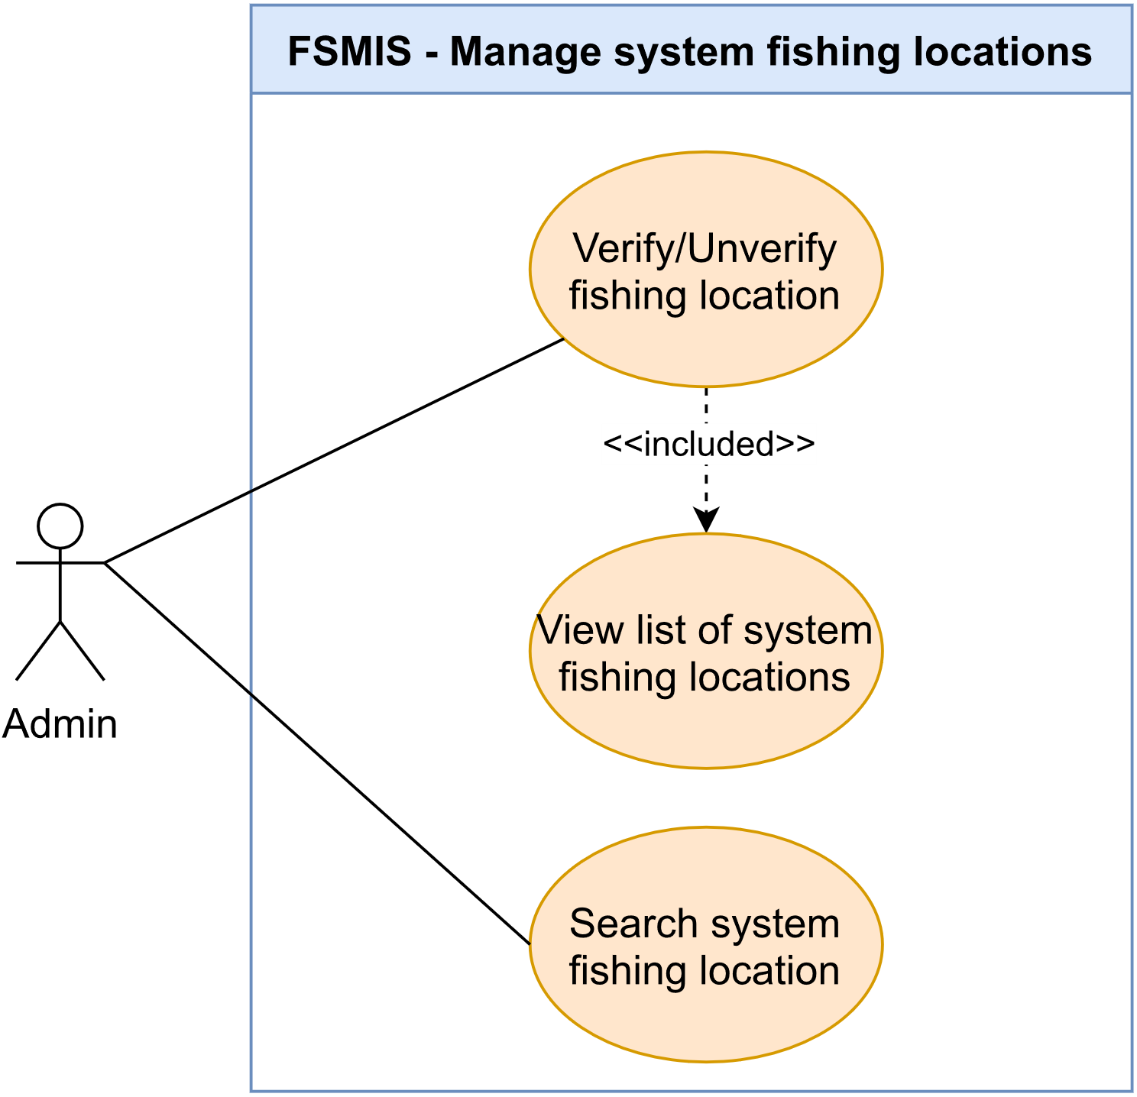

Figure 2.2.10. “Manage system fishing locations” use cases

##### 2.2.10.1. Verify/Unverify fishing location

|  |  |  |  |
| --- | --- | --- | --- |
| **UC ID and Name:** | **UC-48. Verify/Unverified fishing location** | | |
| **Created By:** | DatND | **Date Created:** | 10/03/2021 |
| **Primary Actor:** | Admin | **Secondary Actors:** | N/A |
| **Description:** | This use case allows user to change the verification status of the fishing location. User accesses the fishing locations management screen, chooses one fishing location, views all information, and verifies the information. | | |
| **Trigger:** | **TRIG-01.** User press on the kebab menu icon in the top right of Fishing Location Overview Screen and choose to verify/unverified. | | |
| **Preconditions:** | **PRE-01.** User logged in using an admin account.  **PRE-02.** User is in the System Location Management Screen. | | |
| **Post-conditions:** | **POST-01.** Status of information of the fishing location in the database is changed based on the action of the user  **POST-02.** The fishing location with information verified to be true will have a signature icon | | |
| **Normal Flow:** | **48.0.1. Verify fishing location information**   1. User presses on a fishing location from the list. 2. System displays detailed information of the fishing location. 3. User presses on kebab menu icon. 4. System display menu with “Xác thực” option to verify the fishing location. 5. User presses on “Xác thực” option. 6. System display alerts to confirm the process. 7. User chooses to confirm. 8. System announcement success.   **48.0.2.** **Unverified fishing location**   1. User presses on a fishing location from the list. 2. System displays detailed information of the fishing location. 3. User presses on kebab menu icon. 4. System display menu with “Hủy Xác thực” option to unverified the fishing location. 5. User presses on “Hủy xác thực” option. 6. System display alerts to confirm the process. 7. User chooses to confirm. 8. System announcement success. | | |
| **Alternative Flows:** | N/A | | |
| **Exceptions:** | N/A | | |
| **Priority:** | High | | |
| **Frequency of Use:** | Medium | | |
| **Business Rules:** | BR-11, BR-12 | | |
| **Other Information:** | N/A | | |
| **Assumptions:** | N/A | | |

Table 2.2.10.1. Verify/Unverify fishing location

##### 2.2.10.2. Search system fishing location

|  |  |  |  |
| --- | --- | --- | --- |
| **UC ID and Name:** | **UC-49: Search system fishing location.** | | |
| **Created By:** | DatND | **Date Created:** | 10/04/2021 |
| **Primary Actor:** | Admin | **Secondary Actors:** | N/A |
| **Description:** | This use case allows the user to search fishing locations in the system by name. User enters name fishing location in the search box and submit, system return result exactly or close with input data. | | |
| **Trigger:** | **TRIG-01.** User presses the search box to start to enter fishing location name. | | |
| **Preconditions:** | **PRE-01.** User logged in using an admin account.  **PRE-02.** User is in the System Location Management Screen. | | |
| **Post-conditions:** | **POST-1.** System returns result exactly or close with input data. | | |
| **Normal Flow:** | **49.0. Search system fishing location.**   1. User presses on the search box in the list of fishing locations screen. 2. System display keyboard and typing cursor. 3. User enters fishing location name and submit. 4. System display list results. | | |
| **Alternative Flows:** | N/A | | |
| **Exceptions:** | N/A | | |
| **Priority:** | High | | |
| **Frequency of Use:** | High | | |
| **Business Rules:** | N/A | | |
| **Other Information:** | If the admin enters a location name not existing in the database in the search box. The system will return an empty list. | | |
| **Assumptions:** | N/A | | |

Table 2.2.10.2. Search system fishing location

##### 2.2.10.3. View list of fishing locations

|  |  |  |  |
| --- | --- | --- | --- |
| **UC ID and Name:** | **UC-50. View list of fishing locations** | | |
| **Created By:** | DatND | **Date Created:** | 10/04/2021 |
| **Primary Actor:** | Admin | **Secondary Actors:** | N/A |
| **Description:** | This use case allows the user to overview a list of fishing locations in the system. User can choose one in five types of filter that system provides help classify the list of fishing locations: all list, locations are opening, locations are closing, location is verified, location is unverified. | | |
| **Trigger:** | **TRIG-01.** User presses the “Quản lý điểm câu” option in manage menu. | | |
| **Preconditions:** | **PRE-01.** User logged into system as admin. | | |
| **Post-conditions:** | **POST-1.** System display list of the fishing locations. | | |
| **Normal Flow:** | **50.0.1. View the list of the fishing locations.**   1. User presses on “Quản lý điểm câu” option in manage menu. 2. The system redirects to the System Location Management Screen, displays the list of fishing locations screen with default filter get all list. (See 50.0.2)   **50.0.2.View the list of the fishing locations by the filter.**   1. After step 2 in flow 50.0.2, user presses on filter select box. 2. System display select filter list. 3. User presses on one in five option filters. 4. System display list filter by admin option. | | |
| **Alternative Flows:** | N/A | | |
| **Exceptions:** | N/A | | |
| **Priority:** | High | | |
| **Frequency of Use:** | High | | |
| **Business Rules:** | N/A | | |
| **Other Information:** | N/A | | |
| **Assumptions:** | N/A | | |

Table 2.2.10.3. View list of fishing locations

#### 2.2.11. Feature “Receive notification”

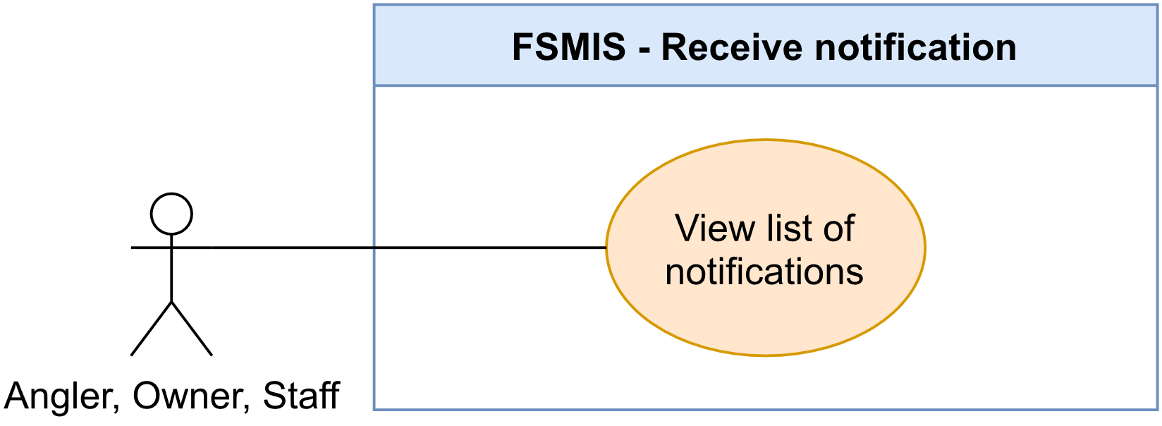

Figure 2.2.11. “Receive notification” use case

##### 2.2.11.1. View list of notifications

|  |  |  |  |
| --- | --- | --- | --- |
| **UC ID and Name:** | **UC-51. View list of notifications** | | |
| **Created By:** | AnhLT | **Date Created:** | 10/03/2021 |
| **Primary Actor:** | Angler | **Secondary Actors:** | N/A |
| **Trigger:** | **TRIG-01.** User press on “Thông báo” icon in navbar. | | |
| **Description:** | This use case allows the user to receive notifications sent by the system. | | |
| **Preconditions:** | **PRE-01.** Users is logged in. | | |
| **Post-conditions:** | N/A | | |
| **Normal Flow:** | **51.0. View list of notifications**   1. User login to the system and press the “Thông tin” option shaped as a bell icon in the navbar. 2. System redirect the user to the Notification List Screen, displays, each notification as a list item contains notification content, date time notified. | | |
| **Alternative Flows:** | N/A | | |
| **Exceptions:** | N/A | | |
| **Priority:** | High | | |
| **Frequency of Use:** | Medium | | |
| **Business Rules:** | N/A | | |
| **Other Information:** | N/A | | |
| **Assumptions:** | N/A | | |

Table 2.2.11.1. View list of notifications

#### 2.2.12. Feature “Manage fishing location’s posts”

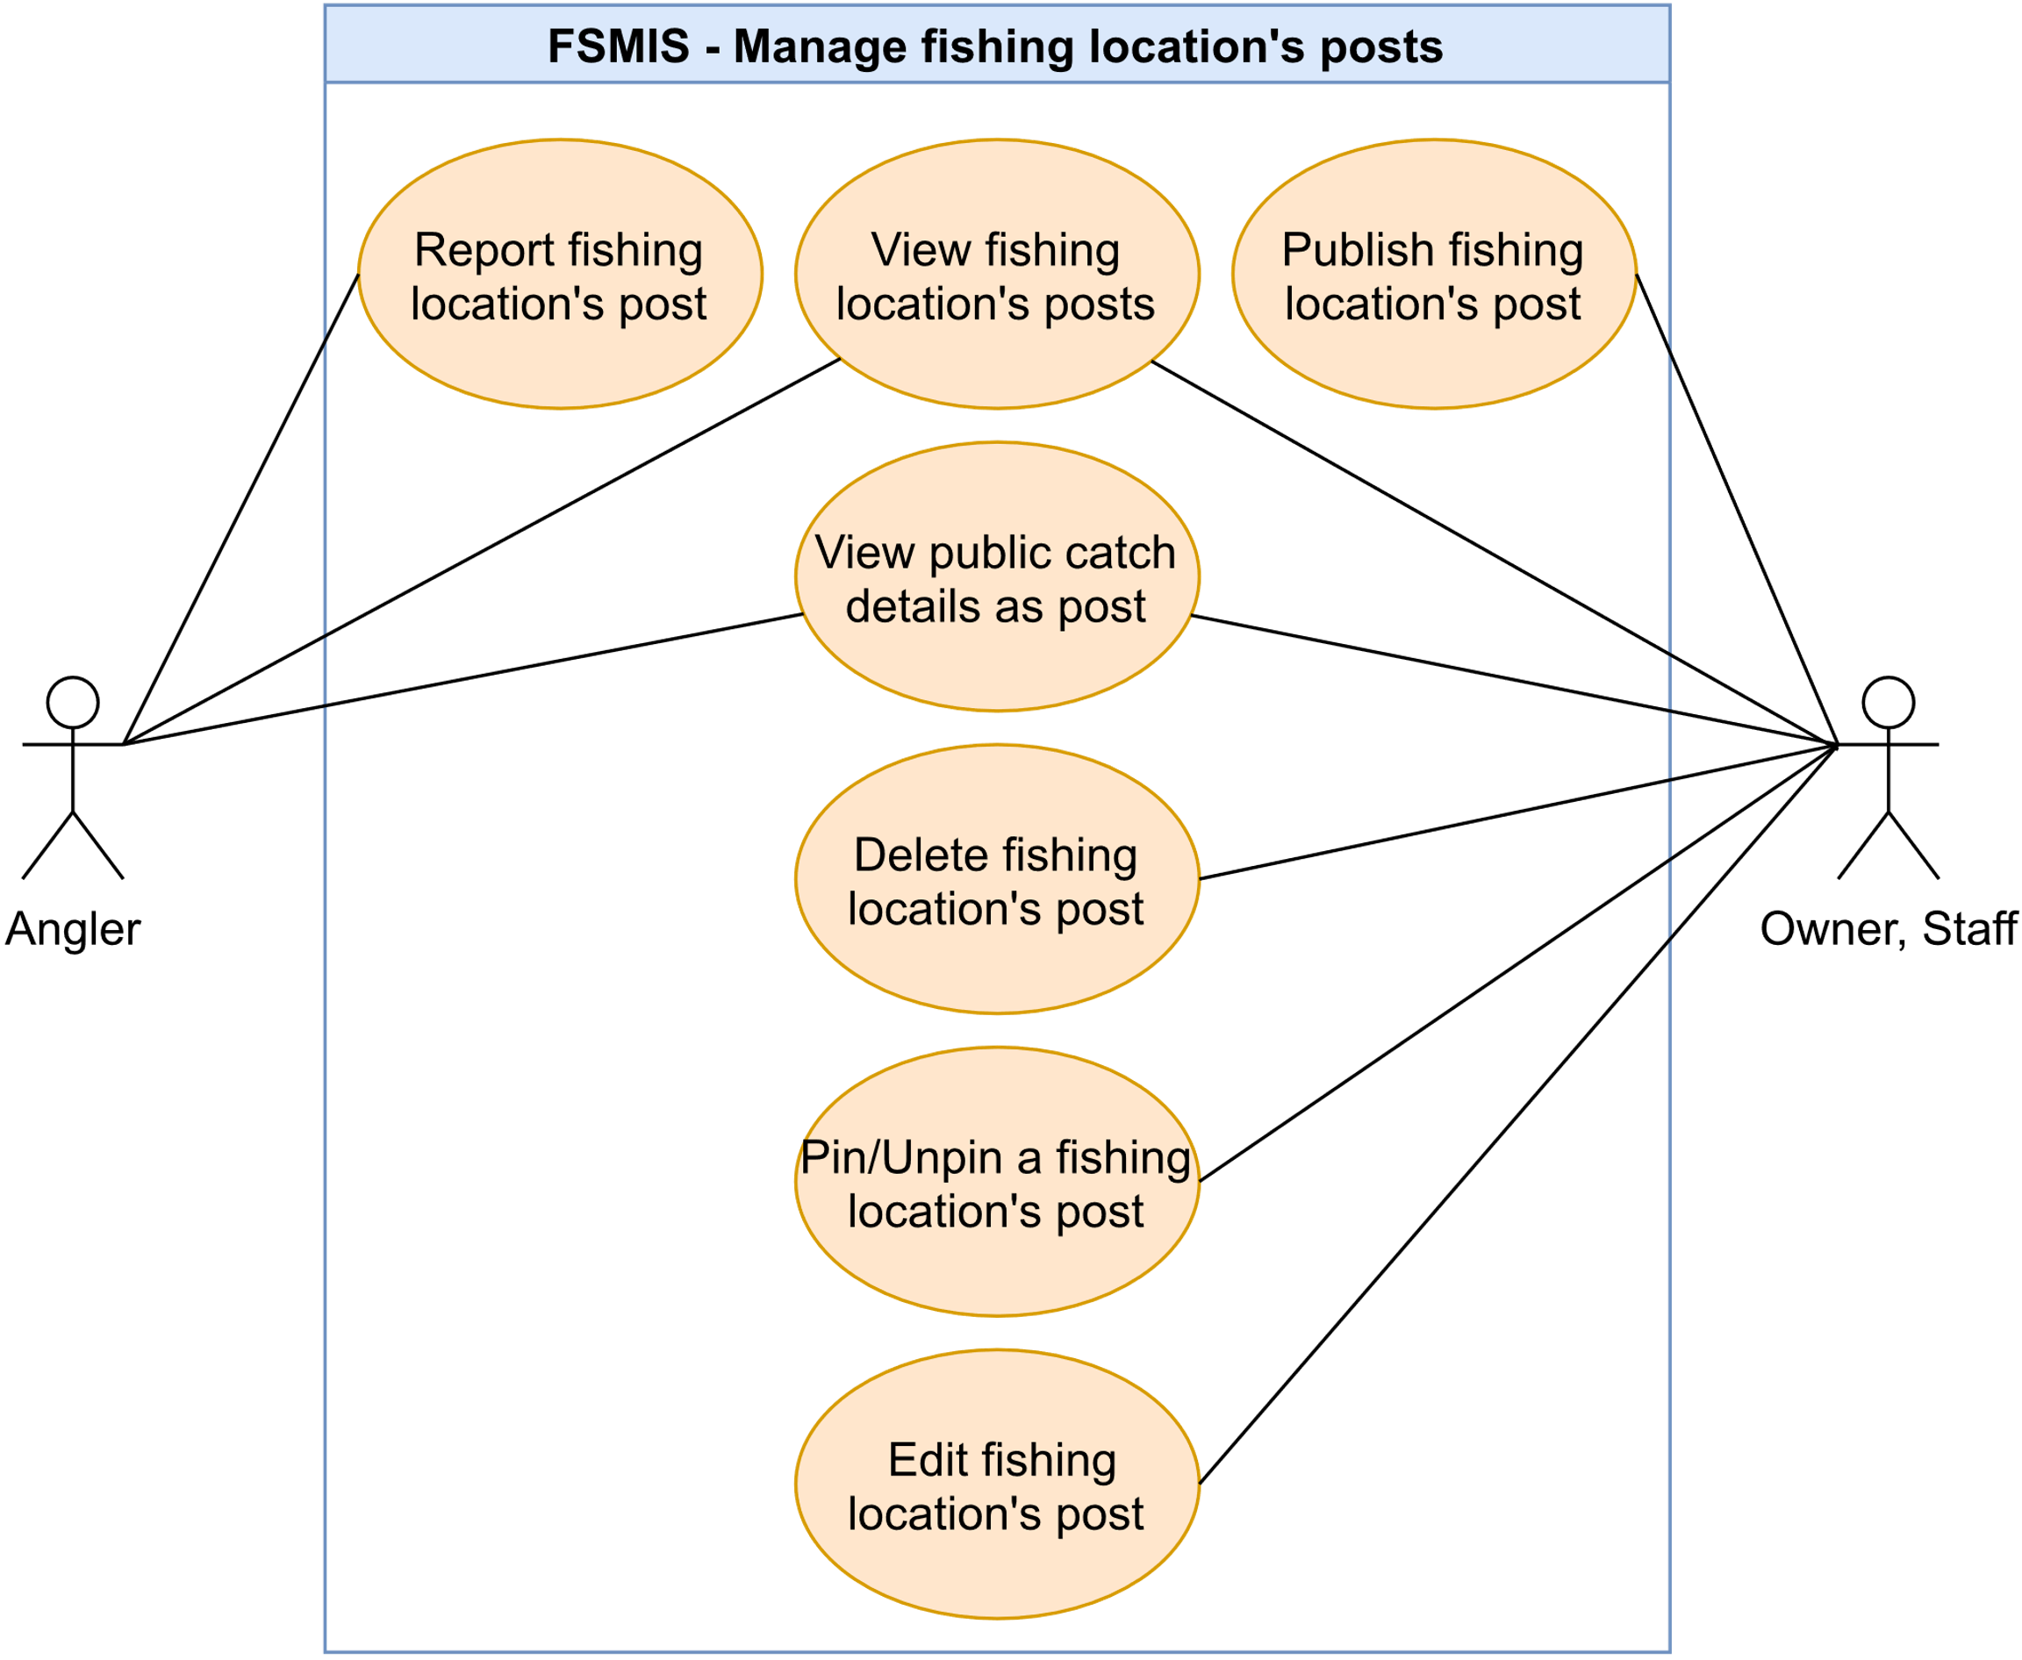

Figure 2.2.12. “Manage fishing location’s posts” use cases

##### 2.2.12.1. View fishing location's posts

|  |  |  |  |
| --- | --- | --- | --- |
| **UC ID and Name:** | **UC-52. View fishing location's posts** | | |
| **Created By:** | DatND | **Date Created:** | 10/03/2021 |
| **Primary Actor:** | Angler, Staff, Owner | **Secondary Actors:** | N/A |
| **Description:** | This use case allows users to view all fishing locations’ published posts created by the Owner and staff. | | |
| **Trigger:** | **TRIG-01.** The user presses on the "Sự kiện” option in the navbar. | | |
| **Preconditions:** | **PRE-01.** The user logged into the system.  **PRE-02.** The user is in the Fishing Location Overview Screen. | | |
| **Post-conditions:** | N/A | | |
| **Normal Flow:** | **52.0. View fishing location's posts**   1. The user presses on the “Sự kiện” option in the navbar. 2. The system redirects the user to the Events Screen. 3. In the Events Screen, on top there are two options “Bài viết” and “Lịch sử báo cá”. By default, the user stays in the Post Event Screen. The screen displays the following:    1. A list of post events of three types “Bồi cá”, “Báo cá” and “Thông báo” (see other information 1)    2. Each item in the list of posts contains post content text, a badge displaying what type of post is it, the date-time the post was uploaded, the video or picture attached, the poster's name, and a flag icon at the top right for trigger reporting (see UC-55). | | |
| **Alternative Flows:** | N/A | | |
| **Exceptions:** | N/A | | |
| **Priority:** | High | | |
| **Frequency of Use:** | High | | |
| **Business Rules:** | BR-03, BR-04 | | |
| **Other Information:** | 1. “Bồi cá” is for stocking post, “Báo cá” for reporting post and “Thông báo” for announcing post. | | |
| **Assumptions:** | N/A | | |

Table 2.2.12.1. View fishing location's posts

##### 2.2.12.2. Publish fishing location's post

|  |  |  |  |
| --- | --- | --- | --- |
| **UC ID and Name:** | **UC-53. Publish fishing location's post** | | |
| **Created By:** | DatND | **Date Created:** | 03/10/21 |
| **Primary Actor:** | Staff, Owner | **Secondary Actors:** | N/A |
| **Description:** | This use case allows users to create and publish posts about fishing location activity. | | |
| **Trigger:** | **TRIG-01.** The user presses on the "Tạo bài đăng mới” button. | | |
| **Preconditions:** | **PRE-01.** The user is logged in to the system.  **PRE-02.** The user must have a fishing location registered in the system to become an owner or must be added as an employee in a fishing location to become staff.  **PRE-03.** The owner (orhas chosen their fishing location to enter that fishing location’s Fishing Location Management Screen. | | |
| **Post-conditions:** | **POST-01.** The post is created in the database. | | |
| **Normal Flow:** | **53.0. Publish fishing location's post**   1. The user presses the "Quản lý bài đăng” option in the Fishing Location Management Screen. 2. The system redirects the owner, staff, to the Fishing Location Post Management Screen, having the following section:    1. A pressable field “Tạo bài đăng mới” to create new post.    2. List of posts, each item contains post content text, a badge displaying what type of post is it, date-time the post was uploaded, video or picture attached, and a menu resembling kebab menu icon at the top right. 3. The user presses the "Tạo bài đăng mới” button. 4. The system redirects the owner or staff to the Post Editor Screen, having the following fields:    1. A required select dropdown to select types of the post (see other information 1)    2. A required text area for the post content text    3. A required drop down to select attachment types of the post (see other information 2)    4. A dynamic field to select image or input link video (see other information 3) 5. The owner or staff fills in required fields in the form and presses the submit button (See 53.0.E1) 6. The system displays a pop-up (MSG37) to inform the owner or staff that a new post is published. | | |
| **Alternative Flows:** | N/A | | |
| **Exceptions:** | **53.0.E1. The required fields are left blank**   1. In step 5, if use leaves an important input field blank in add new fish type form 2. The system will display an error message followed by:    1. Empty the post content text - MSG49    2. Empty image - MSG51 (or Empty video link - MSG50) | | |
| **Priority:** | High | | |
| **Frequency of Use:** | High | | |
| **Business Rules:** | N/A | | |
| **Other Information:** | 1. Three types can be selected from the dropdown: “Bồi cá” is for stocking post, “Báo cá” for reporting post and “Thông báo” for announcing post. 2. Three types can be selected from the dropdown: “Không đính kèm” for no attachment option, “Ảnh” for picture attachment and “Link Video” for video attachment link. 3. If the owner or staff selects “Ảnh”, the field will show a plus box to select an image. If the owner or staff selects “Link Video”, the field will show the input to type in the link of that video. Selecting “Không đính kèm” will not show this field. 4. In the current app version, video links can get from Facebook video share link, Facebook video embed link, Youtube shares link, Youtube embeds link. | | |
| **Assumptions:** | N/A | | |

Table 2.2.12.2. Publish fishing location's post

##### 2.2.12.3. View public catch details as post

|  |  |  |  |
| --- | --- | --- | --- |
| **UC ID and Name:** | **UC-54 View public catch details as post** | | |
| **Created By:** | DatND | **Date Created:** | 10/03/21 |
| **Primary Actor:** | Angler, Staff, Owner. | **Secondary Actors:** | N/A |
| **Description:** | This use case allows users to view other anglers' public catch reporting of that fishing location has been verified by the owner or staff. An angler accesses the Fishing Location Overview screen and views other angler catch reporting of that fishing location. | | |
| **Trigger:** | **TRIG-01.** User choose the "Lịch sử báo cá” tab in the Event screen. | | |
| **Preconditions:** | **PRE-01.** The user is logged into system.  **PRE-02.** The user accesss to the Fishing Location Overview screen through finding that fishing location in search function. | | |
| **Post-conditions:** | N/A | | |
| **Normal Flow:** | **54.0. View user’s catch reporting**   1. System displays a fishing location with general information and navigation with 4 options: general information option labelled “Thông tin”, lake list option labelled “Loại hồ”, activities option lablled “Sự kiện”, review option labelled “Đánh giá”. 2. User presses the activities tab labelled “Sự kiện”. 3. System redirects the user to the Events Screen. On top there are two options “Bài viết” and “Lịch sử báo cá”. 4. User presses the “Lịch sử báo cá” tab. 5. System redirects the user to the Public Catch Event Screen, displays a list of the anglers' catch reporting of that fishing location. | | |
| **Alternative Flows:** | **54.1. Staff/Owner view angler catch reporting in manage mode.**   1. User presses on the “Chuyển sang chế độ quản lý” in the Personal Setting Screen. 2. System redirects the user to the Fishing Location Select Screen. 3. User chooses one fishing location in the list. 4. System rediects the user to that fishing locaiton’s Fishing Location Management Screen. 5. User presses on the "Lịch sử báo cá” option. 6. System redirects the user to the Fishing Location Catch History Screen, displays a list of the anglers' catch reporting of that fishing location. | | |
| **Exceptions:** | N/A | | |
| **Priority:** | High | | |
| **Frequency of Use:** | High | | |
| **Business Rules:** | BR-03, BR-04 | | |
| **Other Information:** | N/A | | |
| **Assumptions:** | N/A | | |

Table 2.2.12.3. View public catch details as post

##### 2.2.12.4. Edit fishing location's post

|  |  |  |  |
| --- | --- | --- | --- |
| **UC ID and Name:** | **UC-55. Edit fishing location's posts** | | |
| **Created By:** | DatND | **Date Created:** | 10/03/2021 |
| **Primary Actor:** | Staff, Owner | **Secondary Actors:** | N/A |
| **Description:** | This use case allows users to edit the post of fishing location that has been published. | | |
| **Trigger:** | **TRIG-01.** In the Fishing Location Post Management Screen, the user presses on the kebab menu icon in the left corner of any post and choose the "Chỉnh sửa bài đăng”. | | |
| **Preconditions:** | **PRE-01**. The user is logged into system.  **PRE-02.** The user is on manage mode and access Fishing Location Management Screen.  **PRE-03.** The user has created at least one post. | | |
| **Post-conditions:** | **POST-01**. Post record in the database is updated.  **POST-02.** The post will mark has been edited when displaying on the Events Screen of the fishing location. | | |
| **Normal Flow:** | **55.0. Edit fishing location's posts**   1. User opens List of posts screen. 2. System displays a list of posts of the fishing location. 3. User presses on a kebab menu icon in the right corner of the post. 4. System display menu with “Chỉnh sửa bài viết” option to edit post. 5. User chooses “Chỉnh sửa bài viết” option. 6. The system displays information of the post in a form type. 7. User edits information in the form and presses the submit button. (See 55.0.E1).    1. Change attached type to image.       1. User press on the “Đính kèm” selector.       2. System display list with “Ảnh” option to create image attached.       3. User presses on the “Ảnh” option.       4. System displays a touch-able box with a plus icon in the center.       5. User presses on the touch-able box.       6. System display user image gallery.       7. User chooses one image and presses “Chọn ảnh”.    2. Change attached type to Video.       1. User press on the “Đính kèm” selector.       2. System display list with “Video” option.       3. User presses on the “Video” option.       4. System displays an input field to enter video link.       5. Users can press on the clipboard icon to paste the video link. 8. The system informs the user that the post is edited. | | |
| **Alternative Flows:** | N/A | | |
| **Exceptions:** | **55.0.E1. The form is left blank**   1. In step 7, if use leaves important input field blank in add new fish type form 2. The system will display an error message followed by:    1. Empty the post content text - MSG49    2. Empty image - MSG51 (or Empty video link - MSG50) | | |
| **Priority:** | Medium | | |
| **Frequency of Use:** | Medium | | |
| **Business Rules:** | N/A | | |
| **Other Information:** | N/A | | |
| **Assumptions:** | N/A | | |

Table 2.2.12.4. Edit fishing location's post

##### 2.2.12.5. Delete fishing location's post

|  |  |  |  |
| --- | --- | --- | --- |
| **UC ID and Name:** | **UC-56. Delete fishing location's post** | | |
| **Created By:** | DatND | **Date Created:** | 10/03/21 |
| **Primary Actor:** | Staff, Owner | **Secondary Actors:** | N/A |
| **Description:** | This use case allows the user to delete fishing location post that has been published. User accesses the fishing location s Management Information System, views the fishing location management screen, views activities management screen, and deletes an activity. | | |
| **Trigger:** | **TRIG-01.** In the List of posts screen, the user presses on the kebab menu icon in the left corner of the post and chooses the "Xóa bài đăng” option. | | |
| **Preconditions:** | **PRE-01.** User is logged into the system.  **PRE-02.** User has already published at least one post. | | |
| **Post-conditions:** | **POST-01.** The posting record in the database is deleted. | | |
| **Normal Flow:** | **56.0. Delete fishing location's post**   1. User chooses “Quản lý bài đăng” option in manage menu. 2. System displays the Fishing Location Post Management Screen. 3. User presses on the kebab menu icon in the right corner of the post. 4. System displays the function list to edit post content. 5. User presses the delete button. 6. System displays a popup to confirm user actions. 7. User press “Xác nhận” to confirm delete a post. 8. System informs user that the post is deleted. | | |
| **Alternative Flows:** | N/A | | |
| **Exceptions:** | N/A | | |
| **Priority:** | Medium | | |
| **Frequency of Use:** | Low | | |
| **Business Rules:** | N/A | | |
| **Other Information:** | **1. Cancel delete the post.**  In step 7, if users choose “Huỷ”, the system will cancel the delete post process. | | |
| **Assumptions:** | N/A | | |

Table 2.2.12.5. Delete fishing location's post

##### 2.2.12.6. Report fishing location's post

|  |  |  |  |
| --- | --- | --- | --- |
| **UC ID and Name:** | **UC-57. Report fishing location's post** | | |
| **Created By:** | DatND | **Date Created:** | 10/02/2021 |
| **Primary Actor:** | Anglers | **Secondary Actors:** | N/A |
| **Trigger:** | **TRIG-01.** The user presses on the Flag icon at the top right of the post. | | |
| **Description:** | This use case allows the user to report the post that published by the fishing location when the user thinks the post content is unsuitable for the system subject or posting news that adversely affects the user community. | | |
| **Preconditions:** | **PRE-01.** The user has logged in  **PRE-02.** The user is in the Events Screen of the fishing location. | | |
| **Post-conditions:** | **POST-01.** The system sends a report of type post to the admin | | |
| **Normal Flow:** | **57.0. Report fishing location's post**   1. The user presses the Flag icon on the top right corner of the post. 2. The system redirects the user to the Report Editor Screen with a text area to input the reason for the report. 3. The user inputs the reason and presses on the "Báo cáo” button to finish the process. (See 57.0.E1) 4. The system sends a report of the fishing location to the admin. | | |
| **Alternative Flows:** | N/A | | |
| **Exceptions:** | **57.0.E1. Empty report content.**  In step 3, if users leave input report content empty, then proceeds to step 4. The system will display an error message (MSG53). | | |
| **Priority:** | High | | |
| **Frequency of Use:** | Low | | |
| **Business Rules:** | N/A | | |
| **Other Information:** | N/A | | |
| **Assumptions:** | N/A | | |

Table 2.2.12.6. Report fishing location's post

##### 2.2.12.7. Pin/Unpin fishing location's post

|  |  |  |  |
| --- | --- | --- | --- |
| **UC ID and Name:** | **UC-58. Pin/Unpin fishing location's post** | | |
| **Created By:** | DatND | **Date Created:** | 10/03/2021 |
| **Primary Actor:** | Staff/Owner | **Secondary Actors:** | N/A |
| **Description:** | This use case allows the user to attach one post to the first place of the Events Screen of the fishing location. | | |
| **Trigger:** | **TRIG-01.** In the List of posts screen, the user presses on the kebab menu icon in the left corner of the post and chooses the "Ghim bài viết” option. | | |
| **Preconditions:** | **PRE-01.** User is logged into the system.  **PRE-02.** User has already published at least one post. | | |
| **Post-conditions:** | **POST-01.** The posting record in the database is marked as a pin-post.  **POST-02.** The pin-post has been displayed in the first place in the Events Screen. | | |
| **Normal Flow:** | **58.0.1 Pin fishing location's post**   1. User chooses “Quản lý bài đăng” option in manage menu. 2. System displays the Fishing Location Post Management Screen. 3. User presses on the kebab menu icon in the right corner of the post. 4. System displays the function list to edit post content. 5. User presses the “Ghim bài đăng” option. 6. System informs the user that the post is pin success.   **58.0.2 Unpin fishing location's post**   1. User chooses “Quản lý bài đăng” option in manage menu. 2. System displays the Fishing Location Post Management Screen. 3. User presses on the kebab menu icon in the left corner of the post that has been pinned. 4. System displays the function list to edit post content. 5. User presses the “Bỏ ghim bài đăng” option. 6. System informs the user that unpins post is success. | | |
| **Alternative Flows:** | N/A | | |
| **Exceptions:** | N/A | | |
| **Priority:** | Medium | | |
| **Frequency of Use:** | Medium | | |
| **Business Rules:** | N/A | | |
| **Other Information:** | N/A | | |
| **Assumptions:** | N/A | | |

Table 2.2.12.7. Pin/Unpin fishing location's post

#### 2.2.13. Feature “Manage fishing location’s staffs”

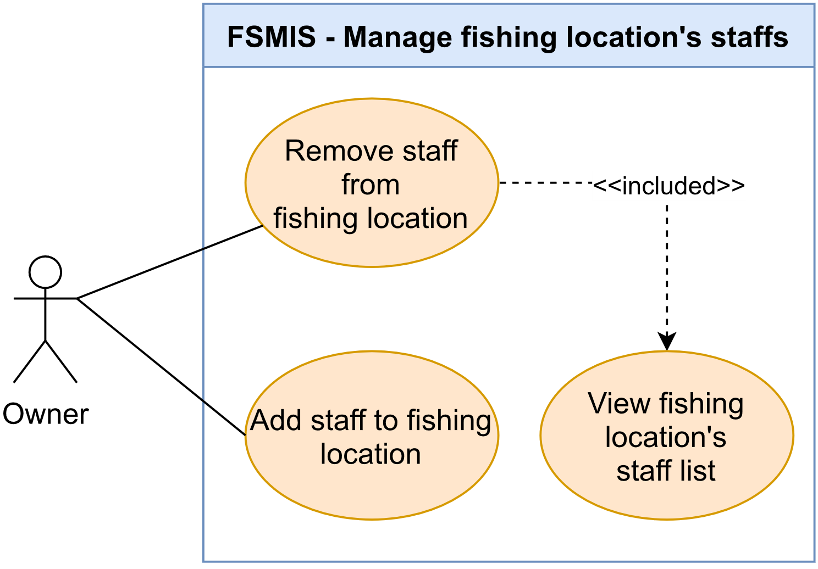

Figure 2.2.13. “Manage fishing location’s staffs” use cases

##### 2.2.13.1. Add staff to fishing location

|  |  |  |  |
| --- | --- | --- | --- |
| **UC ID and Name:** | **UC-59. Add staff to the fishing location** | | |
| **Created By:** | DatND | **Date Created:** | 10/06/2021 |
| **Primary Actor:** | Owner | **Secondary Actors:** | N/A |
| **Trigger:** | **TRIG-01:** Users press the “Thêm nhân viên” button in the Staff Management Screen. | | |
| **Description:** | This use case allows users to add a staff account to the fishing location profile. By adding a staff account, staff can use the system to manage fishing locations in staff authorization. | | |
| **Preconditions:** | **PRE-01.** The user is logged in.  **PRE-02.** The user must have a fishing location registered in the system to become an owner**.**  **PRE-03.** Staff already has an account in the system. | | |
| **Post-conditions:** | **POST-01.** Staff information added to the fishing location profile. | | |
| **Normal Flow:** | **59.0. Add staff to the fishing location**   1. The system displays the List of owner/staff fishing locations Screen. 2. Users choose one in a list of fishing locations. 3. The system displays the Management Screen. 4. Users press on the “Quản lý nhân viên” option in menu. 5. The system displays the List of staffs Screen. 6. Users presses on the “Thêm nhân viên” button. 7. System displays Add Staff Screen. 8. Users input phone number to find employee account. (See 59.0.E1, 59.0.E2, 59.0.E3) 9. System displays result. 10. Users press on “Thêm nhân viên” button. 11. System informs the user that the staff account is added success. | | |
| **Alternative Flows:** | N/A | | |
| **Exceptions:** | **59.0.E1.** At step 8, if the user input the phone number does not exist in the system. Then step 9, the system displays the error message (MSG15)  **59.0.E2.** At step 8, if the user inputs an invalid phone number. Then step 9, the system sends an error message (see MGS04)  **59.0.E3.** At step 8, if the user inputs a phone number of the account are already is Owner or staff of different fishing location. Then step 9, the system sends an error message (see MGS54) | | |
| **Priority:** | High | | |
| **Frequency of Use:** | Medium | | |
| **Business Rules:** | BR-06, BR16, BR-19, BR-18, BR-17 | | |
| **Other Information:** | N/A | | |
| **Assumptions:** | N/A | | |

Table 2.2.13.1. Add staff to fishing location

##### 2.2.13.2. Remove staff from fishing location

|  |  |  |  |
| --- | --- | --- | --- |
| **UC ID and Name:** | **UC-60. Remove staff from fishing location** | | |
| **Created By:** | DatND | **Date Created:** | 6/10/21 |
| **Primary Actor:** | Owner | **Secondary Actors:** | N/A |
| **Trigger:** | **TRIG-01.** Users press on the “Xóa nhân viên” button on Staff Detail Screen. | | |
| **Description:** | This use case allows user to remove staff account from fishing location profile. User access to Staff Management Screen, view detailed information of staff, and choose to remove the account. | | |
| **Preconditions:** | **PRE-01.** The user is logged in.  **PRE-02.** The user must have a fishing location registered in the system to become an owner.  **PRE-03.** The user is in the Staff Management Screen. | | |
| **Post-conditions:** | **POST-01.** Staff permission to manage fishing location is removed and staff is deleted from the fishing location profile. | | |
| **Normal Flow:** | **60.0. Remove staff from fishing location**   1. The system displays Staff Management Screen. 2. Users press the “Chi tiết” button on the staff info card. 3. The system displays the Staff detail screen with detailed staff information and the “Xóa nhân viên” button at the screen bottom for removing staff from the fishing location profile. 4. Users press the “Xóa nhân viên” button to remove staff. 5. System displays a popup to confirm user actions. 6. User press “Xác nhận” to confirm remove staff. 7. System informs user that staff account has been removed. | | |
| **Alternative Flows:** | N/A | | |
| **Exceptions:** | N/A | | |
| **Priority:** | High | | |
| **Frequency of Use:** | Low | | |
| **Business Rules:** | BR-28 | | |
| **Other Information:** | **1. Cancel remove the staff.**  In step 7, if users choose “Huỷ”, the system will cancel the remove staff process. | | |
| **Assumptions:** | N/A | | |

Table 2.2.13.2. Remove staff from fishing location

##### 2.2.13.3. View fishing location's staff list

|  |  |  |  |
| --- | --- | --- | --- |
| **UC ID and Name:** | **UC-61. View fishing location's staff list.** | | |
| **Created By:** | DatND | **Date Created:** | 6/10/21 |
| **Primary Actor:** | Owner | **Secondary Actors:** | N/A |
| **Trigger:** | **TRIG-01.** User press on “Quản lý nhân viên” option in manage menu. | | |
| **Description:** | This use case allows users to overview staff in fishing location profiles. | | |
| **Preconditions:** | **PRE-01.** Theuser is logged in.  **PRE-02.** The user must have a fishing location registered in the system to become an owner.  **PRE-03.** Users access the Location Management Screen of the fishing location. | | |
| **Post-conditions:** | N/A | | |
| **Normal Flow:** | **61.0 View fishing location's staff list.**   1. The system displays the Fishing Location Management Screen. 2. Users press on the “Quản lý nhân viên” option in menu. 3. The system redirects the user to the Staff Management Screen, displays list of staffs added in the fishing location. | | |
| **Alternative Flows:** | N/A | | |
| **Exceptions:** | N/A | | |
| **Priority:** | High | | |
| **Frequency of Use:** | Medium | | |
| **Business Rules:** | BR-28 | | |
| **Other Information:** | N/A | | |
| **Assumptions:** | N/A | | |

Table 2.2.13.3. View fishing location's staff list

#### 2.2.14. Feature “Manage system reports”

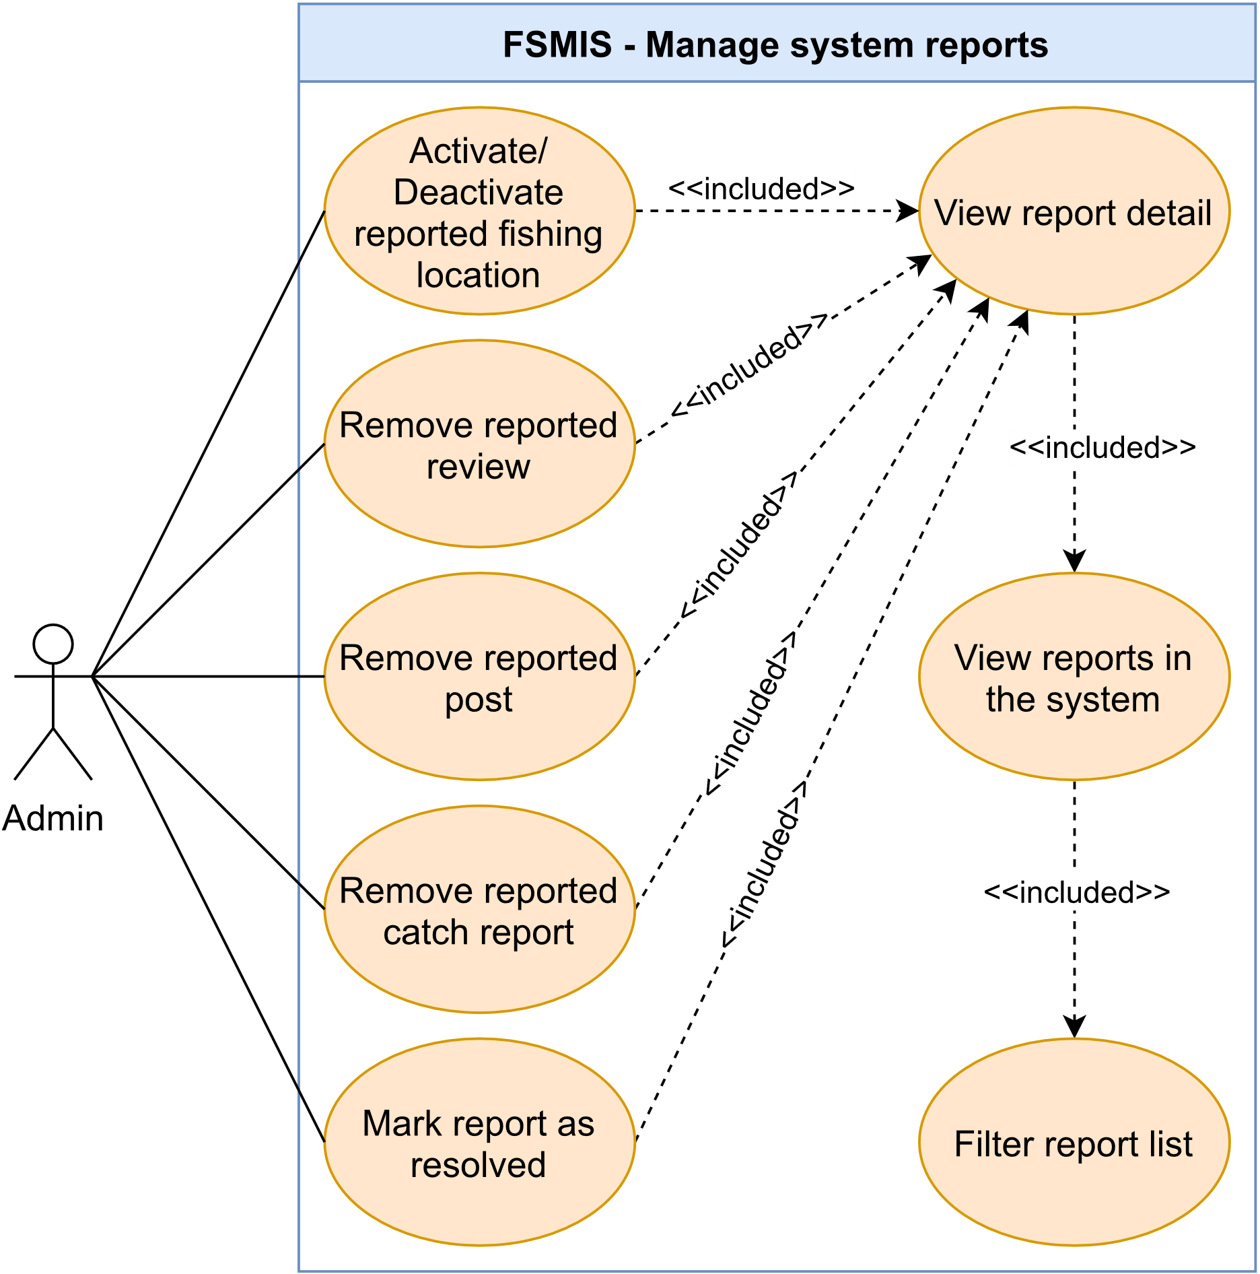

Figure 2.2.14. “Manage system reports” use cases

##### 2.2.14.1. View reports in the system

|  |  |  |  |
| --- | --- | --- | --- |
| **UC ID and Name:** | **UC-62. View reports in the system** | | |
| **Created By:** | DatND | **Date Created:** | 10/06/2021 |
| **Primary Actor:** | Admin | **Secondary Actors:** | N/A |
| **Trigger:** | **TRIG-01.** User press on the “Quản lý Báo cáo” option in Admin Management Screen. | | |
| **Description:** | This use case allows users to overview reports sent to the system. There will be four categories of the report: fishing location report, review report, post report, angler catch report. User changes overview report category by using the navbar has marked by type report name. | | |
| **Preconditions:** | **PRE-01.** Users logged in using an admin account. | | |
| **Post-conditions:** | N/A | | |
| **Normal Flow:** | **62.0. View system report list**   1. The system redirects to the Admin Management Screen. 2. The user presses on “Quản lý báo cáo” option on manage menu. 3. The system displays the Report management screen with the default report category is the fishing location report. 4. The user uses navbar to navigate between report types:    1. The “Điểm câu” tab for the fishing location report category (Fishing Location Report List Screen).    2. The “Bài đăng” for the post report category (Inappropriate Post Report List Screen).    3. The “Đánh giá” for review report category (Inappropriate Review Report List Screen).    4. The “Báo cá” for angler catch report category (Inappropriate Catch Report List Screen). | | |
| **Alternative Flows:** | N/A | | |
| **Exceptions:** | N/A | | |
| **Priority:** | High | | |
| **Frequency of Use:** | High | | |
| **Business Rules:** | N/A | | |
| **Other Information:** | N/A | | |
| **Assumptions:** | N/A | | |

Table 2.2.14.1. View reports in the system

##### 2.2.14.2. View report detail

|  |  |  |  |
| --- | --- | --- | --- |
| **UC ID and Name:** | **UC-63. View report details.** | | |
| **Created By:** | DatND | **Date Created:** | 10/06/2021 |
| **Primary Actor:** | Admin | **Secondary Actors:** | N/A |
| **Trigger:** | **TRIG-01.** Users press on a specific report in the System Report Management screen | | |
| **Description:** | This use case allows the user to view the report details of any report category. | | |
| **Preconditions:** | **PRE-01.** The user can access the system by admin account.  **PRE-02.** The user is accessing the Report management screen. (see UC-62) | | |
| **Post-conditions:** | N/A | | |
| **Normal Flow:** | **64.0. View report details**   1. System display System Report Management screen. 2. Users presses on in three options: fishing location report, review report, or fishing location post report to navigation to the report category user wants to view. 3. Users presses on a specific report on the list. 4. System display detail report. | | |
| **Alternative Flows:** | N/A | | |
| **Exceptions:** | N/A | | |
| **Priority:** | High | | |
| **Frequency of Use:** | High | | |
| **Business Rules:** | N/A | | |
| **Other Information:** | N/A | | |
| **Assumptions:** | N/A | | |

Table 2.2.14.2. View report detail

##### 2.2.14.3. Filter report list

|  |  |  |  |
| --- | --- | --- | --- |
| **UC ID and Name:** | **UC-64. Filter report list** | | |
| **Created By:** | DatND | **Date Created:** | 10/06/2021 |
| **Primary Actor:** | Admin | **Secondary Actors:** | N/A |
| **Trigger:** | **TRIG-01.** The user presses on a filter tab at the top of the System Report Management screen and selects the type of filter. | | |
| **Description:** | This use case allows users to filter solved and unsolved reports within a report category. | | |
| **Preconditions:** | **PRE-01.** The user is logged in using an admin account.  **PRE-02.** The user is in the System Report Management Screen. | | |
| **Post-conditions:** | **POST-01.** System change report list content based on user option. | | |
| **Normal Flow:** | **63.0. Filter report list**   1. System display Report management screen. 2. Users press on the select box a choice between 2 filter types: solved and unsolved. 3. The system show report list has been filtered by the option of the user. | | |
| **Alternative Flows:** | N/A | | |
| **Exceptions:** | N/A | | |
| **Priority:** | High | | |
| **Frequency of Use:** | High | | |
| **Business Rules:** | N/A | | |
| **Other Information:** | All report category has the same filter option. | | |
| **Assumptions:** | N/A | | |

Table 2.2.14.3. Filter report list

##### 2.2.14.4. Mark report as resolved

|  |  |  |  |
| --- | --- | --- | --- |
| **UC ID and Name:** | **UC-65. Mark report as solved.** | | |
| **Created By:** | DatND | **Date Created:** | 10/06/2021 |
| **Primary Actor:** | Admin | **Secondary Actors:** | N/A |
| **Trigger:** | **TRIG-01.** Users press on a specific report in the System Report Management screen | | |
| **Description:** | This use case allows the user to mark the report as solved. After performing report processing operations, including deactivating fishing location with the fishing location report (see UC-69), removing the review with review report (see UC-66), removing post with post report (see UC-67), or removing catch with catch report (see UC-68). Admin closes the report and marks it done. | | |
| **Preconditions:** | **PRE-01.** Users can access the system by admin account.  **PRE-02.** Users are on the System Report Management screen. | | |
| **Post-conditions:** | **POST-01.** Report marks as solved are updated in the database.  **POST-02.** Report is displayed on the resolved list. (see UC-62) | | |
| **Normal Flow:** | **65.0. View report details**   1. System display System Report Management Screen. 2. Users press on in four options: fishing location report labelled “Điểm câu”, review report labelled “Đánh giá”, post report “Bài đăng”, catch report labelled “Báo cá” to navigation to the report category user wants to view. 3. Users press on a specific report on the list. 4. System display detail report. 5. User press on “Đánh dấu xử lý” button to mark the report as solved. 6. System displays a popup to confirm user actions. 7. User press “Xác nhận” to confirm. 8. System informs the user that solved report is success. | | |
| **Alternative Flows:** | N/A | | |
| **Exceptions:** | N/A | | |
| **Priority:** | High | | |
| **Frequency of Use:** | High | | |
| **Business Rules:** | N/A | | |
| **Other Information:** | 1. Performing report processing operations is not compulsory. If the report is incorrect or spam, Admin can just press the “Đánh dấu đã xử lý” button to close the report.  **2. Cancel delete the post**.  In step 7, if users choose “Huỷ”, the system will cancel the mark solved report process. | | |
| **Assumptions:** | N/A | | |

Table 2.2.14.4. Mark report as resolved

##### 2.2.14.5. Remove reported review

|  |  |  |  |
| --- | --- | --- | --- |
| **UC ID and Name:** | **UC-66. Removes reported review.** | | |
| **Created By:** | DatND | **Date Created:** | 10/06/2021 |
| **Primary Actor:** | Admin | **Secondary Actors:** | N/A |
| **Trigger:** | **TRIG-01.** Users press on a specific report review in the Inappropriate Review Report List Screen. | | |
| **Description:** | This use case allows the user to remove an inappropriate review attached to the report review. After removal, the review will not display on the Review Screen of the fishing location. | | |
| **Preconditions:** | **PRE-01.** The is logged in using an admin account.  **PRE-02.** Users view report review details (see UC-64). | | |
| **Post-conditions:** | **POST-1:** Review no longer displays on the Review Screen of the fishing location. | | |
| **Normal Flow:** | **66.0. Removes reported review.**   1. The system displays Inappropriate Review Report Detail Screen. 2. The user presses on the “Gỡ review” button. 3. The system displays a popup to confirm user actions. 4. The user presses “Xác nhận” to confirm. 5. System informs the user that removing review is success. | | |
| **Alternative Flows:** | N/A | | |
| **Exceptions:** | N/A | | |
| **Priority:** | High | | |
| **Frequency of Use:** | Medium | | |
| **Business Rules:** | N/A | | |
| **Other Information:** | **1. Cancel delete the post.**  In step 4, if users choose “Huỷ”, the system will cancel the remove review process. | | |
| **Assumptions:** | N/A | | |

Table 2.2.14.5. Remove reported review

##### 2.2.14.6. Remove reported post

|  |  |  |  |
| --- | --- | --- | --- |
| **UC ID and Name:** | **UC-67. Removes reported post.** | | |
| **Created By:** | DatND | **Date Created:** | 10/06/2021 |
| **Primary Actor:** | Admin | **Secondary Actors:** | N/A |
| **Trigger:** | **TRIG-01:** Users press on a specific report review in the Inappropriate Post Report List Screen. | | |
| **Description:** | This use case allows the user to remove an inappropriate post attached to the report review. After removal, the review will not display on the Post Screen of the fishing location. | | |
| **Preconditions:** | **PRE-01:** Users can access the system by admin account.  **PRE-02:** Users view report post details (see UC-64). | | |
| **Post-conditions:** | **POST-01:** Post no longer displays on the Post Screen of the fishing location**.** | | |
| **Normal Flow:** | **67.0. Removes reported review.**   1. System display Inappropriate Review Report Detail Screen. 2. User presses on the kebab menu icon in the left corner of the post. 3. System displays function menu. 4. User presses on the “Gỡ” option. 5. System displays a popup to confirm user actions. 6. User press “Xác nhận” to confirm. 7. System informs the user that removing posts is a success. | | |
| **Alternative Flows:** | N/A | | |
| **Exceptions:** | N/A | | |
| **Priority:** | High | | |
| **Frequency of Use:** | Medium | | |
| **Business Rules:** | N/A | | |
| **Other Information:** | **1. Cancel delete the post.**  In step 4, if users choose “Huỷ”, the system will cancel the remove post process. | | |
| **Assumptions:** | N/A | | |

Table 2.2.14.6. Remove reported post

##### 2.2.14.7. Remove reported catch report

|  |  |  |  |
| --- | --- | --- | --- |
| **UC ID and Name:** | **UC-68. Removes reported catch report.** | | |
| **Created By:** | DatND | **Date Created:** | 10/06/2021 |
| **Primary Actor:** | Admin | **Secondary Actors:** | N/A |
| **Trigger:** | **TRIG-01.** Users press on a specific report catch in the Inappropriate Catch Report List Screen. | | |
| **Description:** | This use case allows the user to remove an inappropriate catch post attached to the report catch. After removal, the catch post will not display on the Public Catch Event Screen of the fishing location. | | |
| **Preconditions:** | **PRE-01.** Users can access the system by admin account.  **PRE-02.** Users view report post details (see UC-64). | | |
| **Post-conditions:** | **POST-01.** Post no longer displays on the Post Screen of the fishing location**.** | | |
| **Normal Flow:** | **68.0. Removes reported catch report.**   1. System display Inappropriate Catch Report Detail Screen. 2. User presses on the kebab menu icon in the left corner of the catch post 3. System displays function menu. 4. User press on “Gỡ” option. 5. System displays a popup to confirm user actions. 6. User press “Xác nhận” to confirm. 7. System informs the user that remove catch post is success. | | |
| **Alternative Flows:** | N/A | | |
| **Exceptions:** | N/A | | |
| **Priority:** | High | | |
| **Frequency of Use:** | Medium | | |
| **Business Rules:** | N/A | | |
| **Other Information:** | **1. Cancel delete the post.**  In step 4, if users choose “Huỷ”, the system will cancel the remove catch post process. | | |
| **Assumptions:** | N/A | | |

Table 2.2.14.7. Remove reported catch report

##### 2.2.14.8. Activate/Deactivate reported fishing location

|  |  |  |  |
| --- | --- | --- | --- |
| **UC ID and Name:** | **UC-69. Activate/Deactivate reported fishing location** | | |
| **Created By:** | DatND | **Date Created:** | 10/06/2021 |
| **Primary Actor:** | Admin | **Secondary Actors:** | N/A |
| **Trigger:** | **TRIG-01.** User press on the kebab menu icon in the top right of Fishing Location Overview Screen and choose to Activate/Deactivate reported fishing location. | | |
| **Description:** | This use case allows the user to activate/deactivate an inappropriate fishing location report by the system user. If the fishing location has been deactivated, information about fishing locations will no longer display on the advanced search result (see UC-14), a map search result (see UC-12), a save location list of fishing location followers (see UC-18), and a list of fishing locations user accounts possess. | | |
| **Preconditions:** | **PRE-01.** Users can access the system by admin account.  **PRE-02.** Users view Inappropriate Fishing Location Report Detail Screen (see UC-64). | | |
| **Post-conditions:** | **POST-01.** If the user chooses to deactivate, the fishing location information will no longer display on the system**.**  **POST-02.** If the user chooses to activate, the fishing location information will display on the system**.** | | |
| **Normal Flow:** | **69.0. Activate/Deactivate reported fishing location.**   1. System display Inappropriate Fishing Location Report Detail Screen. 2. User presses on the “Đi tới trang” button. 3. System display Fishing Location Overview Screen. 4. User presses on the kebab menu icon in the right top corner of the screen 5. System displays function menu depending on fishing location status: 6. The “Kích hoạt” option to activate fishing locations has been deactivated. 7. The “Vô hiệu hóa” option to deactivate fishing locations has been activated. 8. User press on option. 9. System displays a popup to confirm user actions. 10. User press “Xác nhận” to confirm. 11. System informs the user that the activate/deactivate fishing location is success. | | |
| **Alternative Flows:** | N/A | | |
| **Exceptions:** | N/A | | |
| **Priority:** | High | | |
| **Frequency of Use:** | Medium | | |
| **Business Rules:** | N/A | | |
| **Other Information:** | 1. Cancel delete the post.  In step 8, if users choose “Huỷ”, the system will cancel the activate/deactivate fishing location process.  2. The Activate/Deactivate fishing location function is also integrated into UC-50:   1. User presses on “Quản lý điểm câu” option in manage menu. 2. The system displays the list of fishing locations screen with default filter get all list. 3. User presses one item in the list.   Back to step 3 in UC-69 | | |
| **Assumptions:** | N/A | | |

Table 2.2.14.8. Activate/Deactivate reported fishing location

#### 2.2.15. Feature “Manage system fish species”

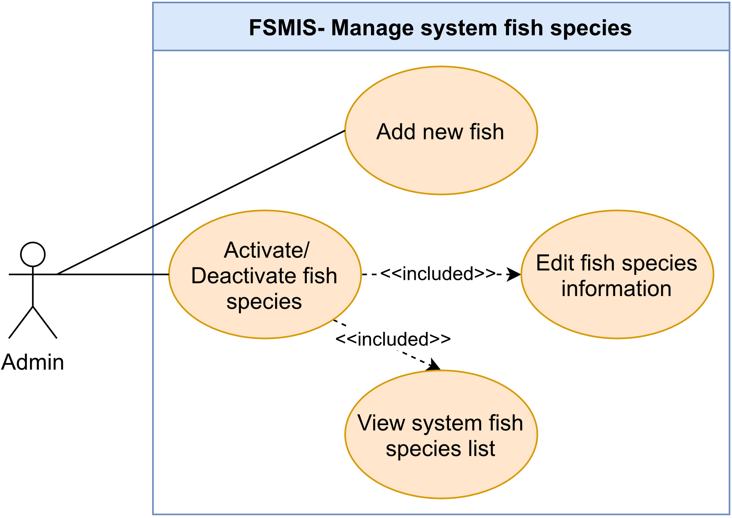

Figure 2.2.15. “Manage system fish species” use cases

##### 2.2.15.1. View system fish species list

|  |  |  |  |
| --- | --- | --- | --- |
| **UC ID and Name:** | **UC-70. View system fish species list** | | |
| **Created By:** | DucHM | **Date Created:** | 10/03/2021 |
| **Primary Actor:** | Admin | **Secondary Actors:** | N/A |
| **Trigger:** | **TRIG-01.** The user presses on “Quản lý loại cá” option in Admin Setting Screen. | | |
| **Description:** | This use case allows the user to view list of fish species in the system. | | |
| **Preconditions:** | **PRE-01.** The user is logged in using an admin account. | | |
| **Post-conditions:** | N/A | | |
| **Normal Flow:** | **70.0. View system fish species list**   1. After PRE-01, the system redirects the user to the Admin Setting Screen. 2. The user presses on the “Quản lý các loại cá” option. 3. The system redirects the user to the System Fish Management Screen, displays list of fish species, each item in the list contains image, name and status of the fish species. | | |
| **Alternative Flows:** | N/A | | |
| **Exceptions:** | N/A | | |
| **Priority:** | High | | |
| **Frequency of Use:** | Low | | |
| **Business Rules:** | N/A | | |
| **Other Information:** | N/A | | |
| **Assumptions:** | N/A | | |

Table 2.2.15.1. View system fish species list

##### 2.2.15.2. Add new fish species

|  |  |  |  |
| --- | --- | --- | --- |
| **UC ID and Name:** | **UC-71. Add new fish species** | | |
| **Created By:** | DucHM | **Date Created:** | 10/03/2021 |
| **Primary Actor:** | Admin | **Secondary Actors:** | N/A |
| **Trigger:** | **TRIG-01.** The user presses on the “Thêm loại cá” button in the System Fish Management Screen. | | |
| **Description:** | This use case allows users to create and add new fish species to the system. | | |
| **Preconditions:** | **PRE-01.** The user is logged in using an admin account.  **PRE-02.** The user is in the System Fish Management Screen. | | |
| **Post-conditions:** | **POST-01.** A new fish species is created in the system. | | |
| **Normal Flow:** | **71.0. Add new fish species**   1. After PRE-01, PRE-02 are confirmed, the user presses on the “Thêm loại cá” button. 2. The system redirects the user to the Add Fish Screen, displays a form the following:    1. A required image section to upload fish species image.    2. A required text field to input fish species name.    3. A “Thêm loại cá” button to save new information. 3. The user inputs new name, uploads image and presses on the “Thêm loại cá” button to submit the form (See 71.0.E1, 71.0.E2). 4. The system accepts the submission, creates new fish species, displays the message (MSG101) and redirect to the System Fish Management Screen. | | |
| **Alternative Flows:** | N/A | | |
| **Exceptions:** | **71.0.E1. Fish species name field empty**   1. In step 3, if the user leaves the fish species name field empty. 2. The system rejects the user’s submit attempt, displays the error message (MSG02)   **71.0.E2. Add an existing fish species**   1. In step 3, the user enters existing fish species name. 2. 2. The system rejects the user’s submit attempt, displays the error message (MSG80). | | |
| **Priority:** | High | | |
| **Frequency of Use:** | Low | | |
| **Business Rules:** | N/A | | |
| **Other Information:** | N/A | | |
| **Assumptions:** | N/A | | |

Table 2.2.15.2. Add new fish species

##### 2.2.15.3. Edit fish species information

|  |  |  |  |
| --- | --- | --- | --- |
| **UC ID and Name:** | **UC-72. Edit Fish species information** | | |
| **Created By:** | DucHM | **Date Created:** | 10/03/2021 |
| **Primary Actor:** | Admin | **Secondary Actors:** | N/A |
| **Trigger:** | **TRIG-01**. The user presses on an item from the list of fish species in the System Fish Management Screen. | | |
| **Description:** | This use case allows the admin to edit existing fish species. | | |
| **Preconditions:** | **PRE-01.** The user is logged in using admin account.  **PRE-02.** The user is in the System Fish Management Screen.  **PRE-03.** There must be at least a fish species in the System Fish Management Screen. | | |
| **Post-conditions:** | **POST-01:** The fish species information is updated in the system. | | |
| **Normal Flow:** | **72.0. Edit fish species information**   1. After PRE-01, PRE-02, PRE-03 are confirmed, the user presses on the list item from represents the fish species he/she want to edit. 2. The system redirects the user to the Fish Editor Screen to edit the current fish species, displays the following:    1. A required image section to upload fish species image.    2. A required text field to input fish species name.    3. A text field describes the status of the fish species in the system.    4. A “Lưu thay đổi” button to save new information.    5. A button with label changes to “Ẩn loại cá này” or “Hiện loại cá này” depends the fish species current status. 3. The user makes changes to the fish species image or name and presses on the “Lưu thay đổi” button to save changes (See 72.0.E1, 72.0.E2). 4. The system accepts new changes, updates the fish species and displays a message (MSG100). | | |
| **Alternative Flows:** | N/A | | |
| **Exceptions:** | **72.0.E1. Leave required fields blank**   1. In step 3, if the user leaves required fields empty. 2. The system rejects the user’s submit attempt, displays error messages (MSG02).   **72.0.E2. Enter an existing fish species**   1. In step 3, the user enters existing fish species name. 2. 2. The system rejects the user’s submit attempt, displays the error message (MSG80). | | |
| **Priority:** | High | | |
| **Frequency of Use:** | Low | | |
| **Business Rules:** | N/A | | |
| **Other Information:** | N/A | | |
| **Assumptions:** | N/A | | |

Table 2.2.15.3. Edit fish species information

##### 2.2.15.4. Activate/Deactivate fish species

|  |  |  |  |
| --- | --- | --- | --- |
| **UC ID and Name:** | **UC-73. Activate/Deactivate fish species** | | |
| **Created By:** | DucHM | **Date Created:** | 10/03/2021 |
| **Primary Actor:** | Admin | **Secondary Actors:** | N/A |
| **Trigger:** | **TRIG-01.** The user presses the “Hiện loại cá này” or “Ẩn loại cá này” button in the Fish Editor Screen. | | |
| **Description:** | This use case allows the user to activate or deactivate existing fish species. If fish species is deactivated, the fish species information cannot be accessed by the angler, owner and staff when they are using the application. | | |
| **Preconditions:** | **PRE-01.** The user is logged in using an admin account.  **PRE-02.** The user is in the System Fish Management Screen. | | |
| **Post-conditions:** | **POST-1.** The fish species status is updated in the system**.**  **POST-2.** The angler, owner and staff cannot access the deactivated fish species. | | |
| **Normal Flow:** | **73.0. Activate/Deactivate fish species**   1. After PRE-01, PRE-02 are confirmed, the user presses on a item represents the fish species he/she wants to activate/deactivate. 2. The system redirects the user to the Fish Editor Screen to edit the current fish species, displays the following:    1. A required image section to upload fish species image.    2. A required text field to input fish species name.    3. A text field describes the status of the fish species in the system.    4. A “Lưu thay đổi” button to save new information.    5. A button with label changes to “Ẩn loại cá này” or “Hiện loại cá này” depends the fish species current status (See other information 1). 3. The user press on the “Ẩn loại cá này” to deactivate or the “Hiện loại cá này” to activate the fish species. 4. The system updates the fish species status, display the message (MSG102). | | |
| **Alternative Flows:** | N/A | | |
| **Exceptions:** | N/A | | |
| **Priority:** | Medium | | |
| **Frequency of Use:** | Low | | |
| **Business Rules:** | N/A | | |
| **Other Information:** | 1. If the fish species is currently activated, the button label will display “Ẩn loại cá này”, else if the fish species is currently deactivated, the button label will be “Hiện loại cá này”. | | |
| **Assumptions:** | N/A | | |

Table 2.2.15.4. Activate/Deactivate fish species

#### 2.2.16. Feature “Manage system fishing methods”

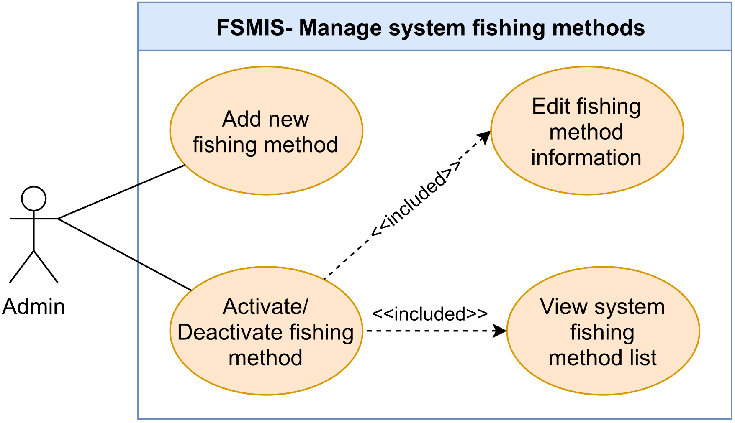

Figure 2.2.16. “Manage system fishing methods use cases

##### 2.2.16.1. View system fishing method list

|  |  |  |  |
| --- | --- | --- | --- |
| **UC ID and Name:** | **UC-74. View system fishing method list** | | |
| **Created By:** | DucHM | **Date Created:** | 10/03/2021 |
| **Primary Actor:** | Admin | **Secondary Actors:** | N/A |
| **Trigger:** | **TRIG-01.** Admin press on “Quản lý loại hình câu” option in Admin Setting Screen. | | |
| **Description:** | This use case allows the user to view list of fishing methods in the system. | | |
| **Preconditions:** | **PRE-01.** The user is logged in using an admin account. | | |
| **Post-conditions:** | N/A | | |
| **Normal Flow:** | **74.0. View system fishing methods list**   1. After PRE-01, the system redirects the user to the Admin Setting Screen. 2. The user presses on the “Quản lý loại hình câu” option. 3. The system redirects the user to the System Fishing Method Management Screen, displays list of fishing methods, each item in the list contains name and status of a fishing method. | | |
| **Alternative Flows:** | N/A | | |
| **Exceptions:** | N/A | | |
| **Priority:** | High | | |
| **Frequency of Use:** | Low | | |
| **Business Rules:** | N/A | | |
| **Other Information:** | N/A | | |
| **Assumptions:** | N/A | | |

Table 2.2.16.1. View system fishing method list

##### 2.2.16.2. Add new fishing method

|  |  |  |  |
| --- | --- | --- | --- |
| **UC ID and Name:** | **UC-75. Add new fishing method** | | |
| **Created By:** | DucHM | **Date Created:** | 10/03/2021 |
| **Primary Actor:** | Admin | **Secondary Actors:** | N/A |
| **Trigger:** | **TRIG-01.** The user presses on the “Thêm loại hình câu'' button in the Fishing Method Editor Screen. | | |
| **Description:** | This use case allows the user to create and add new fishing method to the system. | | |
| **Preconditions:** | **PRE-01.** The user is logged in using an admin account.  **PRE-02.** The user is in the System Fishing Method Management Screen. | | |
| **Post-conditions:** | **POST-01.** A new fishing method is created in the system. | | |
| **Normal Flow:** | **75.0. Add new fishing method**   1. After PRE-01, PRE-02 are confirmed, the user presses on “Thêm loại hình câu” button. 2. The system redirects the user to the Add Fishing Method Screen, display a form with the following:    1. A required text field to input name of the fishing method.    2. A “Thêm loại hình câu” button to submit the form. 3. The user input name of the new fishing method and presses the “Thêm loại câu” button to submit form (see 75.0.E1, 75.0.E2). 4. The system accepts the submission, creates new fishing method, displays the message (MSG101) and redirect to the System Fish Management Screen. | | |
| **Alternative Flows:** | N/A | | |
| **Exceptions:** | **75.0.E1. Leave required field empty**   1. In step 3, the user leaves required field empty. 2. The system rejects the user’s submit attempt, displays an error message (MSG02).   **75.0.E2. Add an existing fishing method**   1. In step 3, the user enters existing fishing methods. 2. 2. The system rejects the user’s submit attempt, displays the error message (MSG80). | | |
| **Priority:** | High | | |
| **Frequency of Use:** | Low | | |
| **Business Rules:** | N/A | | |
| **Other Information:** | N/A | | |
| **Assumptions:** | N/A | | |

Table 2.2.16.2. Add new fishing method

##### 2.2.16.3. Edit fishing method information

|  |  |  |  |
| --- | --- | --- | --- |
| **UC ID and Name:** | **UC-76. Edit fishing method information** | | |
| **Created By:** | AnhLT | **Date Created:** | 10/03/2021 |
| **Primary Actor:** | Admin | **Secondary Actors:** | N/A |
| **Trigger:** | **TRIG-01.** The user presses the “Lưu thay đổi” button on the Fishing Method Editor Screen. | | |
| **Description:** | This use case allows users to edit existing fishing methods. | | |
| **Preconditions:** | **PRE-01.** The user is logged in using an admin account.  **PRE-02.** The user is in the System Fishing Method Management Screen. | | |
| **Post-conditions:** | **POST-01.** The fishing method information is updated in the system. | | |
| **Normal Flow:** | **76.0.** **Edit fishing methods information**   1. After PRE-01, PRE-02 are confirmed, the user presses on the list item represents the fishing method he/she want to edit. 2. The system redirects the user to the Fishing Method Editor Screen to edit the current fishing method, display a form with the following:    1. A required text field to input name of the fishing method.    2. A text field describes the status of the fishing method in the system.    3. A “Lưu thay đổi” button to submit the form.    4. A button with label changes to “Ẩn loại hình câu này” or “Hiện loại hình câu này” depends the fishing method current status. 3. The user makes change to the fishing method name and presses the “Lưu thay đổi” button to save the changes (See 76.0.E1, 76.0.E2). 4. The system accepts new changes, updates the fishing method name and displays the message (MSG104). | | |
| **Alternative Flows:** | N/A | | |
| **Exceptions:** | **76.0.E1. Leave required field empty**   1. In step 3, the user leaves required field empty, 2. The system rejects the user’s submission, displays the message (MSG02)   **76.0.E2. Enter an existing fishing method**   1. In step 3, the user enters existing fishing methods name 2. 2. The system rejects the user’s submission, displays the message (MSG79). | | |
| **Priority:** | High | | |
| **Frequency of Use:** | Low | | |
| **Business Rules:** | N/A | | |
| **Other Information:** | N/A | | |
| **Assumptions:** | N/A | | |

Table 2.2.16.3. Edit fishing method information

##### 2.2.16.4. Activate/Deactivate fishing method

|  |  |  |  |
| --- | --- | --- | --- |
| **UC ID and Name:** | **UC-77. Activate/Deactivate fishing method** | | |
| **Created By:** | DucHM | **Date Created:** | 10/03/2021 |
| **Primary Actor:** | Admin | **Secondary Actors:** | N/A |
| **Trigger:** | **TRIG-01.** The user presses the “Hiện loại hình câu này” or “Ẩn loại hình câu này” button in the Fishing Method Editor Screen. | | |
| **Description:** | This function allows the user to activate or deactivate existing fishing methods. If fishing method is deactivated, the fishing method information cannot be accessed by the angler, owner and staff when they are using the application. | | |
| **Preconditions:** | **PRE-01.** The user is logged into using the admin account.  **PRE-02.** The user is in the System Fishing Method Management Screen. | | |
| **Post-conditions:** | **POST-1.** The fishing method status is updated in the system**.**  **POST-2.** The angler, owner and staff cannot access the deactivated fishing method. | | |
| **Normal Flow:** | **77.0. Activate/Deactivate fishing method**   1. After PRE-01, PRE-02 are confirmed, the user presses on the list item represents the fishing method he/she want to activate/deactivate. 2. The system redirects the user to the Fishing Method Editor Screen to edit the current fishing method, display a form with the following:    1. A required text field to input name of the fishing method.    2. A text field describes the status of the fishing method in the system.    3. A “Lưu thay đổi” button to submit the form.    4. A button with label changes to “Ẩn loại hình câu này” or “Hiện loại hình câu này” depends the fishing method current status. 3. The user press on the “Ẩn loại hình câu này” to deactivate or the “Hiện loại hình câu này” to activate the fishing method. 4. The system updates the fishing method status and displays the message (MSG105). | | |
| **Alternative Flows:** | N/A | | |
| **Exceptions:** | N/A | | |
| **Priority:** | Medium | | |
| **Frequency of Use:** | Low | | |
| **Business Rules:** | BR-05 | | |
| **Other Information:** | 1. If the fishing method is currently activated, the button label will display “Ẩn loại hình câu này”, else if the fishing method is currently deactivated, the button label will be “Hiện loại hình câu này”. | | |
| **Assumptions:** | N/A | | |

Table 2.2.16.4. Activate/Deactivate fishing method

#### 2.2.17. Feature “Manage fishing location’s suggestion”

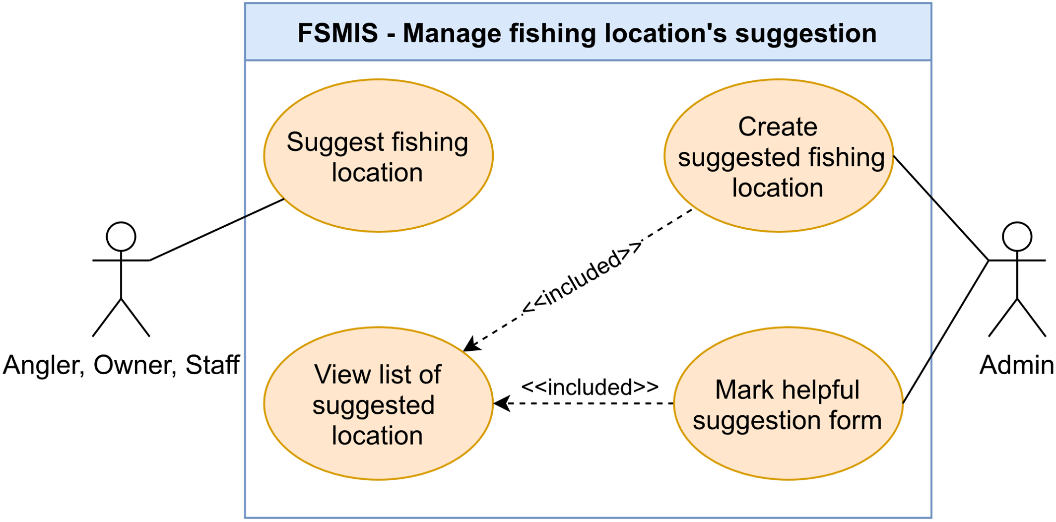

Figure 2.2.17. “Manage fishing location’s suggestion” use cases

##### 2.2.17.1. Suggest fishing location

|  |  |  |  |
| --- | --- | --- | --- |
| **UC ID and Name:** | **UC-78 Suggest fishing location** | | |
| **Created By:** | DucHM | **Date Created:** | 10/06/2021 |
| **Primary Actor:** | Angler | **Secondary Actors:** | N/A |
| **Trigger:** | **TRIG-01.** The user presses on the info icon in the top right of the Advanced Search Screen.  **TRIG-02.** The user presses on the info icon in the top right of the Fishing Location Select Screen. | | |
| **Description:** | This use case allows the user to send suggested information about fishing locations that do not exist in the system. | | |
| **Preconditions:** | **PRE-01.** The user is logged in.  **PRE-02.** The user is either in the Advanced Search Screen or the Fishing Location Select Screen. | | |
| **Post-conditions:** | **POST-01**. The new suggested fishing location form is sent to the admin and displays in the Suggested Location Management Screen. | | |
| **Normal Flow:** | **78.0. Suggest fishing location**   1. After PRE-01, PRE-02 are confirmed, the user presses on the info icon in the top right corner of the screen. 2. The system redirects the user to the Fishing Location Suggestion Form Screen, display a form with following field:    1. A required text field to input suggested location’s name.    2. A required number field to input the location’s owner phone number.    3. A non-required text filed to input suggested location’s address.    4. A non-required text field to input location related website.    5. A non-required map section to select location position.    6. A non-required text area to input addition information the admin should know.    7. A “Gửi” button to submit suggestion form. 3. The user inputs required fields, enters optional information in non-required fields and presses on the “Gửi” button to submit the form. (See 78.0.E1, 78.0.E2) 4. The system accepts the submission, displays a pop-up message (MSG107) (See 78.0.E3). 5. The user presses on the “Xác nhận” button on the pop-up message to be redirected back to the previous screen. | | |
| **Alternative Flows:** | N/A | | |
| **Exceptions:** | **78.0.E1. Leave required fields empty**   1. In step 3, if the user leaves the important field empty, 2. The system rejects the user’s submission, displays error messages (MSG02).   **78.0.E2. The user inputs invalid phone number**   1. In step 3, the user inputs invalid phone number. 2. The system rejects the user’s register attempt, and displays an error message (MSG04).   **78.0.E3. The system fails to send to the form**   1. If the system fails to send the form due to connection problem, the system will display error pop-up message (MSG32). | | |
| **Priority:** | Low | | |
| **Frequency of Use:** | Low | | |
| **Business Rules:** | N/A | | |
| **Other Information:** | N/A | | |
| **Assumptions:** | N/A | | |

Table 2.2.17.1. Suggest fishing location

##### 2.2.17.2. View list of suggested location

|  |  |  |  |
| --- | --- | --- | --- |
| **UC ID and Name:** | **UC-79. View list of suggested location** | | |
| **Created By:** | DucHM | **Date Created:** | 10/03/2021 |
| **Primary Actor:** | Admin | **Secondary Actors:** | N/A |
| **Trigger:** | **TRIG-01.** Admin press on “Hồ câu gợi ý từ cần thủ” option in Admin Management Screen. | | |
| **Description:** | This function allows users to overview suggested fishing location send to the system. | | |
| **Preconditions:** | **PRE-01.** The user is logged in using an admin account. | | |
| **Post-conditions:** | N/A | | |
| **Normal Flow:** | **79.0. View list of suggested location**   1. After PRE-01 is confirmed, the system redirects the user to the Admin Setting Screen. 2. The user presses on the “Hồ câu gợi ý từ cần thủ” option. 3. The system redirects the user to the Suggested Location Management Screen, display list of suggested locations. Inside each list item contains the summary of the suggested location, they are the fishing location name and the fishing location’s owner phone number. | | |
| **Alternative Flows:** | N/A | | |
| **Exceptions:** | N/A | | |
| **Priority:** | Low | | |
| **Frequency of Use:** | Low | | |
| **Business Rules:** | N/A | | |
| **Other Information:** | N/A | | |
| **Assumptions:** | N/A | | |

Table 2.2.17.2. View list of suggested location

##### 2.2.17.3. Mark help suggestion form

|  |  |  |  |
| --- | --- | --- | --- |
| **UC ID and Name:** | **UC-80 Mark helpful suggestion form** | | |
| **Created By:** | DucHM | **Date Created:** | 10/03/2021 |
| **Primary Actor:** | Admin | **Secondary Actors:** |  |
| **Trigger:** | **TRIG-01.** Admin press on “Đánh dấu hữu ích” button in Location Suggestion Detail Screen. | | |
| **Description:** | This use case allows admin to mark a suggestion form is useful, an useful suggestion form can be used to create new fishing location for the system and send a thanks message to the contributor. | | |
| **Preconditions:** | **PRE-01.** The users is logged in using an admin account.  **PRE-02.** The user is in the Suggested Location Management. | | |
| **Post-conditions:** | **POST-01.**The item represents the helpful suggestion form in the Suggested Location Management Screen will have a checked icon, meaning that the form has been marked as helpful.  **POST-02.** A thank you message will be sent to the suggestion form submitter. | | |
| **Normal Flow:** | **80.0. Resolve suggested record.**   1. After PRE-01, PRE-02 are confirmed, the user presses on the list item represents the suggestion form he/she wants to resolve. 2. The system redirects the user to the Location Suggestion Detail Screen, displays information from the submitted suggestion form, including:    1. Location name.    2. Location’s owner phone number.    3. Option information fields: Location’s address, location’s website, location position on the map and additional note from the submitter (See other information 1).    4. A ”Tạo điểm câu với thông tin” button.    5. A “Đánh dấu hữu ích” button. 3. The user presses on the “Đánh dấu hữu ích” button if the information in the form can be used to create a new fishing location. 4. The system displays a pop-up message (MSG109) to confirm the user’s action. 5. The user presses on the “Xác nhận” button on the pop-up message to confirm. 6. The system marks the suggestion form as helpful, displays the message (MSG109). | | |
| **Alternative Flows:** | N/A | | |
| **Exceptions:** | N/A | | |
| **Priority:** | Low | | |
| **Frequency of Use:** | Low | | |
| **Business Rules:** | N/A | | |
| **Other Information:** | 1. The optional field which was not entered by the submitter will not display in the Location Suggestion Detail Screen. | | |
| **Assumptions:** | N/A | | |

Table 2.2.17.3. Mark help suggestion form

##### 2.2.17.4. Create suggested location

|  |  |  |  |
| --- | --- | --- | --- |
| **UC ID and Name:** | **UC-81. Create suggested fishing location** | | |
| **Created By:** | DucHM | **Date Created:** | 10/03/21 |
| **Primary Actor:** | Admin | **Secondary Actors:** | N/A |
| **Trigger:** | **TRIG-01.** The user presses on “Tạo điểm câu với thông tin” button in Location Suggestion Detail Screen. | | |
| **Description:** | This use case allow user to create fishing location record from suggest sent to system. | | |
| **Preconditions:** | **PRE-01.** The user is logged in using an admin account.  **PRE-02.** Theuser is in the Suggested Location Management Screen. | | |
| **Post-conditions:** | **POST-01**. A fishing location profile is created in the system with pending status.  **POST-02.** If an owner account has the phone number matches with the phone number which is created with this fishing location, this fishing location will display as a location card in that owner’s Fishing Location Select Screen. The owner can edit this pending fishing location to make it official.  **POST-03.** The created fishing location in pending status is hide from the angler in any search function. | | |
| **Normal Flow:** | **81.0. Create suggested fishing location**   1. After PRE-01, PRE-02 are confirmed, the user presses on the list item represents the suggestion form he/she wants to create fishing location using information it provided. 2. The system redirects the user to the Location Suggestion Detail Screen, displays information from the submitted suggestion form, including:    1. Location name.    2. Location’s owner phone number.    3. Option information fields: Location’s address, location’s website, location position on the map and additional note from the submitter (See other information 1).    4. A ”Tạo điểm câu với thông tin” button.    5. A “Đánh dấu hữu ích” button. 3. The user presses on the “Tạo điểm câu với thông tin” button to continue the process. 4. The system redirects the user to the Fishing Location Editor Screen. Name, owner’s phone number or any additional information provided in the suggestion form will be use as inputs in the Fishing Location Editor Screen. The editor screen displays a form with the following:    1. A non-required section to upload images of the fishing location (See other information 2).    2. A required text field to input the fishing location name.    3. A contact section, having the following:       1. A required number field for the contact phone number,       2. A non-required text field to input website related to the fishing location.       3. A non-required text field to input location’s address       4. A non-required select field to select province       5. A non-required select field to select district       6. A non-required select field to select ward    4. A non-required map section allows the user to place the red pin on where the fishing location is in the google map layout.    5. A non-required text area labelled “Miêu tả khu hồ” to input fishing location description.    6. A non-required text area labelled “Thời gian hoạt động” to describe the opening and closing time of the location,    7. A non-required text area labelled “Dịch vụ” to describe list of services in this location.    8. A non-required text area labelled “Nội quy” to describe the rules of this fishing location.    9. A “Thêm điểm câu” button to save the location profile and submit the form. 5. The user fills in required fields, any optional non-required fields and presses the “Thêm điểm câu” button to create new location (See 81.0.E1, 81.0.E2, 81.0.E3). 6. The system accepts the form, creates new fishing location in pending status, displays a pop-up message (MSG83) (See 81.0.E4). | | |
| **Alternative Flows:** | N/A | | |
| **Exceptions:** | **81.0.E1. Leaving the required field blank**   1. In step 4, the user leaves required fields blank. 2. The system rejects the user’s attempt, displays error messages (MSG02).   **81.0.E2. Invalid phone number**  1. In step 4, the user enters an invalid phone number.  2. The system rejects the user’s attempt, displays an error message (MSG04).  **81.0.E3. Using phone number of a staff account to create new location**   1. The user enters in the contact a phone number of a staff account. 2. The system rejects the user’s submission attempt, displays the error message (MSG106).   **81.0.E4. The system failed to create new fishing locationprofile**   1. The system displays an error pop-up message. (MSG81) | | |
| **Priority:** | Low | | |
| **Frequency of Use:** | Low | | |
| **Business Rules:** | N/A | | |
| **Other Information:** | 1. The optional field which was not entered by the submitter will not display in the Location Suggestion Detail Screen. 2. The maximum number of images the user can upload within the fishing location profile is 5 images. 3. 3. Pending fishing locations cannot be searched through the Search Nearby Screen or through the Advanced Search Screen. | | |
| **Assumptions:** | N/A | | |

Table 2.2.17.4. Create suggested location

#### 2.2.18. Feature “Manage banned phone number”

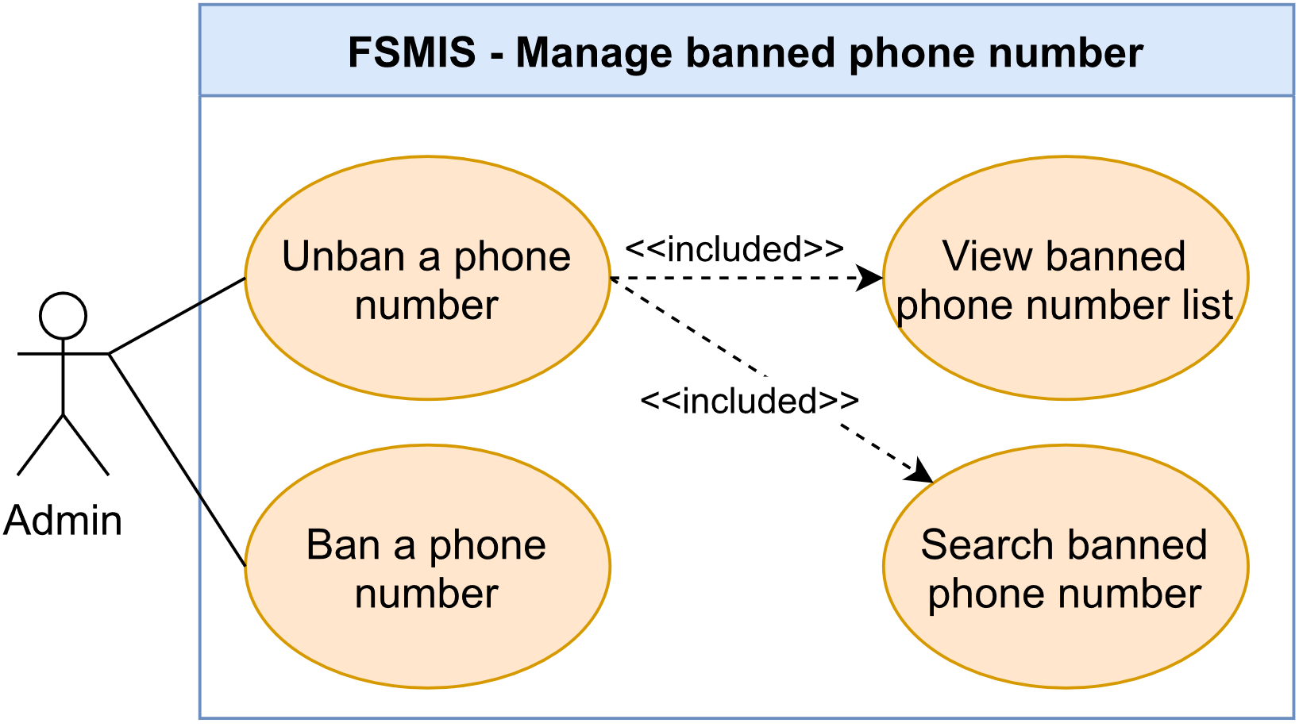

Figure 2.2.18. “Manage banned phone number” use cases

##### 2.2.18.1. View banned phone number list

|  |  |  |  |
| --- | --- | --- | --- |
| **UC ID and Name:** | **UC-82. View banned phone number list** | | |
| **Created By:** | DucHM | **Date Created:** | 10/06/2021 |
| **Primary Actor:** | Admin | **Secondary Actors:** | N/A |
| **Trigger:** | **TRIG-01:** User press on the “Danh sách đen” option in Admin Management Screen. | | |
| **Description:** | This use case allows user overview ban phone number in the system. | | |
| **Preconditions:** | **PRE-01.** The user is logged in using an admin account. | | |
| **Post-conditions:** | N/A | | |
| **Normal Flow:** | **82.0. View banned phone number list**   1. After PRE-01 is confirmed, the system redirects the user to the Admin Setting Screen. 2. The user presses on the “Danh sách đen” option. 3. The system redirects the user to the System Blacklist Phone Management Screen, displays list of banned phone numbers and a “Chặn số điện thoại” button to add another phone number to the blacklist. | | |
| **Alternative Flows:** | N/A | | |
| **Exceptions:** | N/A | | |
| **Priority:** | Low | | |
| **Frequency of Use:** | Low | | |
| **Business Rules:** | N/A | | |
| **Other Information:** | N/A | | |
| **Assumptions:** | N/A | | |

Table 2.2.18.1. View banned phone number list

##### 2.2.18.2. Search banned phone number

|  |  |  |  |
| --- | --- | --- | --- |
| **UC ID and Name:** | **UC-83. Search banned phone number** | | |
| **Created By:** | DucHM | **Date Created:** | 10/06/2021 |
| **Primary Actor:** | Admin | **Secondary Actors:** | N/A |
| **Trigger:** | **TRIG-01:** User press on the search box on top of the System Blacklist Phone Management Screen. | | |
| **Description:** | This use case allows the user to search for a phone number on a list of banned phone numbers | | |
| **Preconditions:** | **PRE-01.** The user is logged in using an admin account.  **PRE-02.** The user is in the System Blacklist Phone Management Screen. | | |
| **Post-conditions:** | N/A | | |
| **Normal Flow:** | **83.0. Search banned phone number**   1. After PRE-01 is confirmed, the user presses on the search bar. 2. The system displays a keyboard to enter phone number. 3. The user enters a phone number existed in the blacklist 4. The system displays phone number that matches the search number (See other information 1). | | |
| **Alternative Flows:** | N/A | | |
| **Exceptions:** | N/A | | |
| **Priority:** | Low | | |
| **Frequency of Use:** | Low | | |
| **Business Rules:** | N/A | | |
| **Other Information:** | If the search result is empty, the system displays the message (MSG116). | | |
| **Assumptions:** | N/A | | |

Table 2.2.18.2. Search banned phone number

##### 2.2.18.3. Ban a phone number

|  |  |  |  |
| --- | --- | --- | --- |
| **UC ID and Name:** | **UC-84 Ban a phone number** | | |
| **Created By:** | DucHM | **Date Created:** | 10/06/2021 |
| **Primary Actor:** | Admin | **Secondary Actors:** | N/A |
| **Trigger:** | **TRIG-01:** The user press on “Chặn số điện thoại” button in System Blacklist Phone Management Screen.  **TRIG-02:** The user presses on the “Vô hiệu hóa tài khoản” button in the Account Detail Screen. | | |
| **Description:** | This use case allows admin to block account have consistently transgress or been reported by other system user by ban phone number use to register that account. | | |
| **Preconditions:** | **PRE-01.** The user is logged in using an admin account. | | |
| **Post-conditions:** | **POST-01**. The system remembers and displays the banned phone number in the System Blacklist Phone Management Screen.  **POST-02.** The system redirects whose account’s phone number are being banned to the Ban Notice Screen when they are logged in or when using the application. | | |
| **Normal Flow:** | **84.0. Ban a phone number**   1. After PRE-01 is confirmed, the system redirects the user to the Admin Setting Screen (See 84.1). 2. The user presses on the “Danh sách đen” option. 3. The system redirects the user to the System Blacklist Phone Management Screen, displays list of banned phone numbers and a “Chặn số điện thoại” button. 4. The user press on “Chặn số điện thoại” button. 5. The system redirects the user to the Ban Phone Number Screen, displays a form with the following:    1. A required number field to enter phone number.    2. A non-required text area to enter ban reason.    3. A non-required image upload section to upload evidence of the violation.    4. A “Chặn” button to add this phone number to the blacklist. 6. The user enters required phone number and optional reason and image to describe the violation caused by the account related to this phone number, and presses on the “Chặn” button to finish banning process. 7. The system adds entered phone number to blacklist, display the pop-up message (MSG110). 8. The user presses on the “Xác nhận” button in the pop-up message to finish the process. 9. The system redirects the user back to the System Blacklist Phone Management Screen. | | |
| **Alternative Flows:** | **84.1. Deactivate an account**   1. After step 1 in normal flow, the user presses on the “Quản lý tài khoản” option in the Admin Setting Screen. 2. The system redirects the admin to the System Account Management Screen, display the following:    1. A search bar to search by phone number.    2. List of all accounts in the system, each item in the list displays the summary of the account, includes avatar, name, phone number and account status. 3. The user presses on a list item represents the account he/she want to deactivate in the list of accounts. 4. The system redirects the admin to the Account Detail Screen, displays the following:    1. Account detail section, displays all information of the account includes: avatar, name, birthdate, phone number, gender, address and status to describe the locked or unlocked state of the account.    2. A button with changing label: “Vô hiệu hóa tài khoản” to deactivate or “Mở lại tài khoản” to activate account. 5. The user presses on the “Vô hiệu hóa tài khoản” button. 6. The system redirects the user to the Ban Phone Number Screen to process the current account, displays a form with the following:    1. A non-required text area to enter ban reason.    2. A non-required image upload section to upload evidence of the violation.    3. A “Vô hiệu hóa tài khoản” button to add this phone number to the blacklist. 7. The user enters optional reason and upload image as evidence to the violation caused by the user’s using this account, and presses on the “Vô hiệu hóa tài khoản” button to finish deactivating process. 8. The system displays a pop-up message (MSG111) to ask for user confirmation. 9. The system presses on the “Xác nhận” button in the pop-up message to confirm the process. 10. The system adds this account’s phone number to blacklist, display the pop-up message (MSG110). 11. The user presses on the “Xác nhận” button on the pop-up message to finish the process. 12. The system redirects the user back to the Account Detail Screen, the account status displays locked state and the button label is changed to “Mở lại tài khoản”. | | |
| **Exceptions:** | **84.0.E1. Leave required field empty**   1. In step 3, if the user leaves required field empty, 2. The system rejects the user’s submit attempt, displays error message (MSG02). | | |
| **Priority:** | Low | | |
| **Frequency of Use:** | Low | | |
| **Business Rules:** | N/A | | |
| **Other Information:** | 1. If login using the account having its phone number banned in the blacklist, the system redirects the user to the Ban Notice Screen. The Ban Notice Screen displays what the admin has entered in the Ban Phone Number Screen, includes ban reason, image describes evidence of the violation and the admin’s phone number if the user wishes to contact to get the account back. | | |
| **Assumptions:** | N/A | | |

Table 2.2.18.3. Ban a phone number

##### 2.2.18.4. Unban a phone number

|  |  |  |  |
| --- | --- | --- | --- |
| **UC ID and Name:** | **UC-85. Ban a phone number** | | |
| **Created By:** | DucHM | **Date Created:** | 10/06/2021 |
| **Primary Actor:** | Admin | **Secondary Actors:** | N/A |
| **Trigger:** | **TRIG-01:** User press on “Xóa” button to remove a banned phone number from the System Blacklist Phone Management Screen.  **TRIG-02:** The user presses on the “Mở lại tài khoản” in the Account Detail Screen. | | |
| **Description:** | This use case allows the user to unban the phone number, allowing an account connected to that phone number to continue access to the system. | | |
| **Preconditions:** | **PRE-01.** The user is logged in using admin account. | | |
| **Post-conditions:** | **POST-01.** The banned phone number is removed from the System Blacklist Phone Management Screen.  **POST-02.** The user whose account related the banned phone number can access the system. | | |
| **Normal Flow:** | **85.0. Unban a phone number**   1. After PRE-01 is confirmed, the system redirects the user to the Admin Setting Screen (See 85.1). 2. The user presses on the “Danh sách đen” option. 3. The system redirects the user to the System Blacklist Phone Management Screen, displays list of banned phone numbers and a “Chặn số điện thoại” button. 4. The user presses the “Xóa” button in next to the banned phone number he/she want to remove from the blacklist. 5. The system displays a pop-up message (MSG115) to confirm the’s user action. 6. The user presses on the “Xác nhận” button in the pop-up message to finish the process. 7. The system removes the phone number from the blacklist. | | |
| **Alternative Flows:** | **85.1. Activate an account**   1. After step 1 in normal flow, the user presses on the “Quản lý tài khoản” option in the Admin Setting Screen. 2. The system redirects the admin to the System Account Management Screen, display the following:    1. A search bar to search by phone number.    2. List of all accounts in the system, each item in the list displays the summary of the account, includes avatar, name, phone number and account status. 3. The user presses on a list item which has been deactivated in the list of accounts. 4. The system redirects the admin to the Account Detail Screen, displays the following:    1. Account detail section, displays all information of the account includes: avatar, name, birthdate, phone number, gender, address and status to describe the locked or unlocked state of the account.    2. A button with changing label: “Vô hiệu hóa tài khoản” to deactivate or “Mở lại tài khoản” to activate account. 5. The user presses on the “Mở lại tài khoản” button to activate the account. 6. The system displays the pop-up message (MSG113) to confirm the user’s action. 7. The user presses on the “Xác nhận” button to finish the process. 8. The system activates the account, removes its related phone number form the blacklist and displays the message (MSG114). | | |
| **Exceptions:** | N/A | | |
| **Priority:** | Low | | |
| **Frequency of Use:** | Low | | |
| **Business Rules:** | N/A | | |
| **Other Information:** | N/A | | |
| **Assumptions:** | N/A | | |

Table 2.2.18.4. Unban a phone number

## 3. Functional Requirement

### 3.1. System Functional Overview

#### 3.1.1. Screen Flow

##### 3.1.1.1. Angler

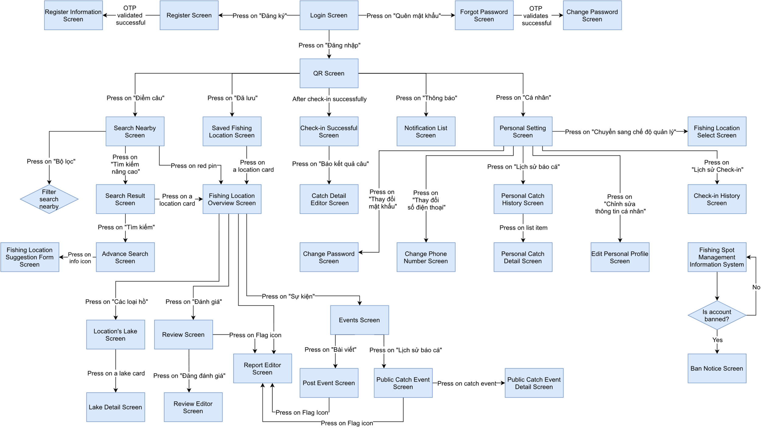

Figure 3.1.1.1. Angler Screen Flow

##### 3.1.1.2. Owner/Staff

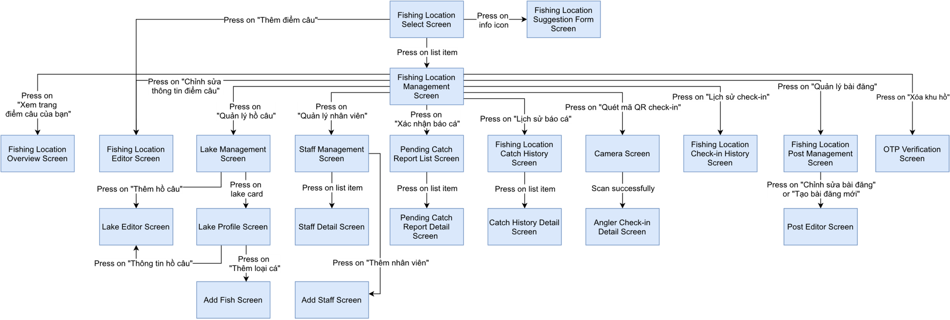

Figure 3.1.1.2. Owner/Staff Screen Flow

##### 3.1.1.3. Admin

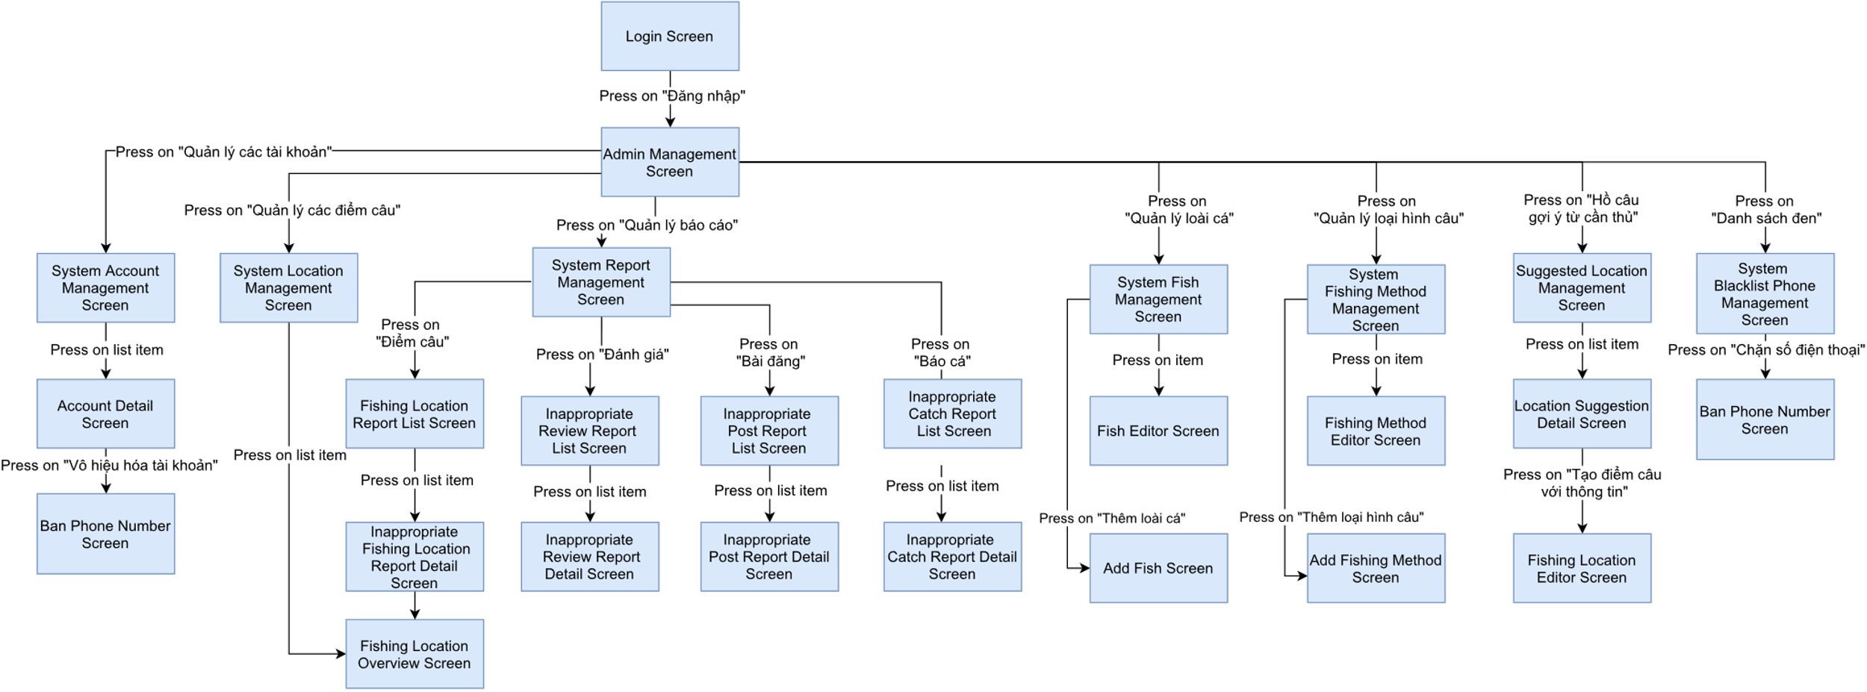

Figure 3.1.1.3. Admin Screen Flow

#### 3.1.2. Screen Descriptions

##### 3.1.2.1. Angler

|  |  |  |  |
| --- | --- | --- | --- |
| **#** | **Feature** | **Screen** | **Description** |
|  | Authenticate user | Login | Log in to the system. |
|  | Forgot password | Request change password. |
|  | Register | Register a new account. |
|  | Register information | Register personal information for a new account. |
|  | Manage personal profile | Personal setting | View profile management menu. |
|  | Edit personal profile | View and edit personal profile. |
|  | Change phone number | Change old phone number to new phone number. |
|  | Change password | Change old password to new password. |
|  | Search fishing location | Search Nearby | Searches for all fishing locations on the map within a specified radius starting from the user's location. |
|  | Filter search nearby | Filter fishing location display on the map by fishing type, review, and radius starting from the user location. |
|  | Advanced search | Searching fishing locations by name, fishing locations phone number, city, fishing type, review. |
|  | Fishing location overview | Show overview information of fishing spots (location, phone number, website, services, rules, etc.) |
|  | Location's lake | Show all lakes inside the fishing location. |
|  | Lake detail | Show lake detail information (fishing type, check-in price, specifications of the lake, etc.) |
|  | Saved fishing  location | Show all fishing locations saved by the user. |
|  | Manage fishing location's reviews | Review screen | Show all reviews about the fishing location, up-vote/down-vote review, delete the personal reviews. |
|  | Review editor | Post a new review about the fishing location. |
|  | Manage check-in | QR screen | Show personal QR code for check-in to the fishing location. |
|  | Check-in successful screen | Show check-in location information and two options checkout and catch report. |
|  | Check-in history | View history of check-in to the fishing location. |
|  | Manage catch reports | Catch detail editor | Create a catch report, sending catch report then check-out. |
|  | Personal catch history | View all personal catches history. |
|  | Personal catch detail | View personal catch detail (location, fishes, fish quantity and total weight, etc.) |
|  | Receive Notification | Notification list | View notification sends by the system. |
|  | Manage fishing location's posts | Events screen | Display event in fishing location. |
|  | Post event screen | View post published by fishing location. |
|  | Public catch event | Show other angler catch report in fishing location. |
|  | Public catch event detail | Show detail of other angler catch reports (location, fishes, fish quantity and total weight, etc.). |
|  | Manage fishing location's suggestion | Fishing location suggestion form | Sending information suggesting fishing location to the system. |
|  | Manage system report | Report editor | Sending report about fishing location overview, fishing location event, or review that user assumes is inappropriate for system content. |
|  | Ban Notice Screen | Show ban account notification. |

Table 3.1.2.1. Angler’s screen descriptions

##### 3.1.2.2. Owner/Staff

|  |  |  |  |
| --- | --- | --- | --- |
| **#** | **Feature** | **Screen** | **Description** |
|  | Manage check-in | Camera Screen | Scanning angler check-in QR code. |
|  | Angler check-in detail | After scanning QR success, show angler check-in information. |
|  | Fishing location check-in history | Show all check-in history. |
|  | Manage catch reports | Pending catch report list | Show list of unverified catch reports. |
|  | Pending catch report detail | Show unverified catch reports detail. |
|  | Fishing location catch history | Show all catch report history. |
|  | Catch history detail | Show catch report detail. |
|  | Manage fishing location's profile | Fishing location select | Show list of fishing locations created by owner or list of fishing locations which staff working. |
|  | Fishing location  management screen | Show management option menu. |
|  | Fishing location overview | Show detail fishing location information, lake, review, post. |
|  | Fishing location editor | View and edit information of current fishing location or create a new fishing location. |
|  | Lake management | Show a list of lakes inside the fishing location. |
|  | Lake profile | Show and edit list fish species that exist in the lake. |
|  | Lake editor | Show and edit lake information or create new lake. |
|  | Add fish screen | Create new fish species in lake. |
|  | OTP verification | Enter OTP verification to delete fishing location. |
|  | Manage fishing location's posts | Fishing location post management | Show all post has been published by the owner and staff, comes with management functions. |
|  | Post editor | Editing post content or create new post. |
|  | Manage fishing location's staffs | Staff management | Show list of staff working in fishing location, comes with management functions. |
|  | Staff detail | Show staff detailed information. (name, phone number, address, etc.) |
|  | Add staff | Adding new staff working in fishing location. |

Table 3.1.2.2. Owner/Staff’s screen descriptions

##### 3.1.2.3. Admin

|  |  |  |  |
| --- | --- | --- | --- |
| **#** | **Feature** | **Screen** | **Description** |
|  |  | Admin management screen | Show admin management option menu. |
|  | Manage system accounts | System account management | Show list of user account in the system, comes with management functions. |
|  | Account detail screen | Show detail of user account. |
|  | Manage system fishing locations | System location management | Show list of fishing location in the system. |
|  | Fishing location overview | Show detail fishing location information, lake, review, post. |
|  | Manage system reports | System report management | Display report send to system by user. |
|  | Fishing location report list | Show list of reports related to fishing location information. |
|  | Inappropriate fishing location report detail | Show detail of report related to fishing location information. |
|  | Inappropriate review report list | Show list of reports related to review. |
|  | Inappropriate review report detail | Show detail of report related to review. |
|  | Inappropriate post report list | Show list of reports related to post |
|  | Inappropriate  post report detail | Show detail of report related to post. |
|  | Inappropriate catch report list | Show list of reports related to catch report. |
|  | Inappropriate catch report detail | Show detail of report related to catch report. |
|  | Manage system fish species | System fish management | Show list of fish species in the system, comes with comes with management functions. |
|  | Add fish | Add new fish species. |
|  | Fish editor | Show and edit fish species information. |
|  | Manage system fishing methods | System fishing method management | Show list of fish species in the system, comes with comes with management functions. |
|  | Add fishing method | Adding new fishing method. |
|  | Fishing method editor | Show and edit fishing method information. |
|  | Manage fishing location's suggestion | Suggested location management | Show list of fishing location suggest by user. |
|  | Location suggestion detail | Show detailed information of suggested fishing locations. |
|  | Fishing location editor | Create fishing location by user suggest. |
|  | Manage banned phone number | System blacklist phone management | Show list of ban phone account. |
|  | Ban phone number | Add phone number to ban list. |

Table 3.1.2.3. Admin’s screen descriptions

#### 3.1.3. Screen Authorization

|  |  |  |  |  |
| --- | --- | --- | --- | --- |
| **Screen** | **Angler** | **Owner** | **Staff** | **Admin** |
| Login | X | X | X | X |
| Forgot password | X | X | X | X |
| Register | X | X | X |  |
| Register information | X | X | X |  |
| Personal setting | X | X | X |  |
| Edit personal profile | X |  |  |  |
| Change phone number | X |  |  |  |
| Change password | X |  |  |  |
| Search Nearby | X |  |  |  |
| Filter search nearby | X |  |  |  |
| Advanced search | X |  |  |  |
| Fishing location overview | X |  |  |  |
| Location's lake | X |  |  |  |
| Lake detail | X |  |  |  |
| Saved fishing location | X |  |  |  |
| Review screen | X |  |  |  |
| Review editor | X |  |  |  |
| QR screen | X |  |  |  |
| Check-in successful screen | X |  |  |  |
| Check-in history | X |  |  |  |
| Catch detail editor | X |  |  |  |
| Personal catch history | X |  |  |  |
| Personal catch detail | X |  |  |  |
| Notification list | X |  |  |  |
| Events screen | X |  |  |  |
| Post event screen | X |  |  |  |
| Public catch event | X |  |  |  |
| Fishing location suggestion form | X |  |  |  |
| Report editor | X |  |  |  |
| Ban Notice Screen | X |  |  |  |
| Camera Screen |  | X | X |  |
| Angler check-in detail |  | X | X |  |
| Fishing location check-in history |  | X | X |  |
| Pending catch report list |  | X | X |  |
| Pending catch report detail |  | X | X |  |
| Fishing location catch history |  | X | X |  |
| Catch history detail |  | X | X |  |
| Fishing location select |  | X | X |  |
| Fishing location management screen |  | X | X |  |
| Fishing location overview |  | X | X |  |
| Fishing location editor |  | X |  |  |
| Lake management |  | X |  |  |
| Lake profile |  | X |  |  |
| Lake editor |  | X |  |  |
| Add fish screen |  | X |  |  |
| OTP verification |  | X |  |  |
| Fishing location post management |  | X | X |  |
| Post editor |  | X | X |  |
| Staff management |  | X |  |  |
| Staff detail |  | X |  |  |
| Add staff |  | X |  | X |
| Admin management screen |  |  |  | X |
| System account management |  |  |  | X |
| Account detail screen |  |  |  | X |
| System location management |  |  |  | X |
| Fishing location overview |  |  |  | X |
| System report management |  |  |  | X |
| Fishing location report list |  |  |  | X |
| Inappropriate fishing location report detail |  |  |  | X |
| Inappropriate review report list |  |  |  | X |
| Inappropriate review report detail |  |  |  | X |
| Inappropriate post report list |  |  |  | X |
| Inappropriate post report detail |  |  |  | X |
| Inappropriate catch report list |  |  |  | X |
| Inappropriate catch report detail |  |  |  | X |
| System fish management |  |  |  | X |
| Fish editor |  |  |  | X |
| System fishing method management |  |  |  | X |
| Fishing method editor |  |  |  | X |
| Suggested location management |  |  |  | X |
| Location suggestion detail |  |  |  | X |
| Fishing location editor |  |  |  | X |
| System blacklist phone management |  |  |  | X |
| Ban phone number |  |  |  | X |

Table 3.1.3. Screen authorization

#### 3.1.4. Entity Relationship Diagram

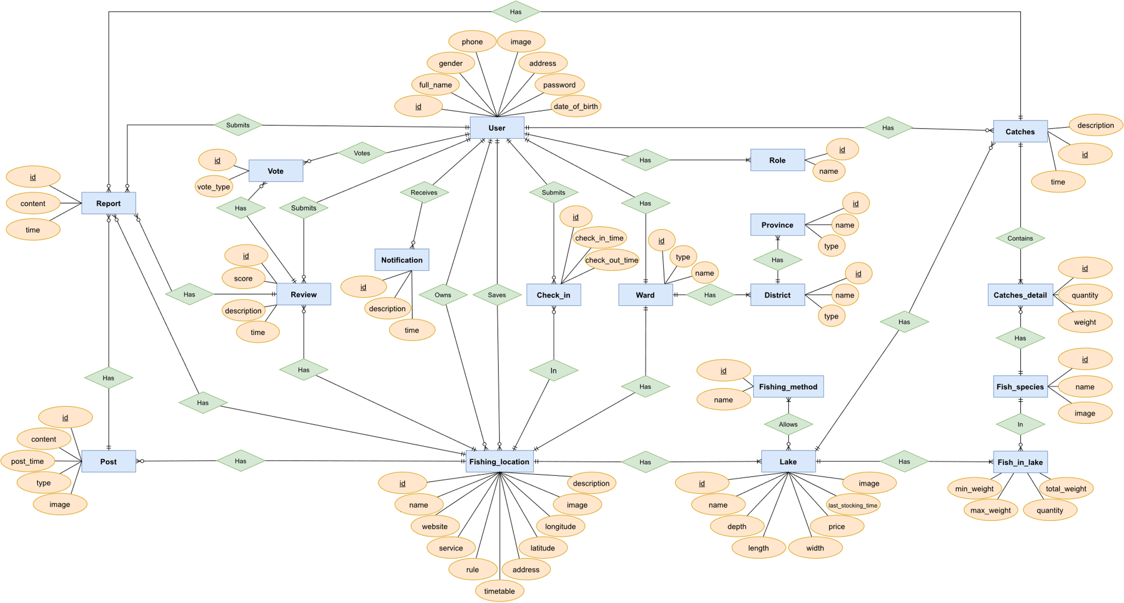

Figure 3.1.4. FSMIS Entity Relationship Diagram

|  |  |  |
| --- | --- | --- |
| **ID** | **Entity** | **Description** |
| 1 | User | An actor who uses the system. |
| 2 | Role | A user can have one role only, either normal user or admin. |
| 3 | Notification | Notifications are generated by the system. |
| 4 | Fishing_location | Created by a user or admin, contain fishing location information and lakes. |
| 5 | Lake | Contain lake information and list of fishes in lake. |
| 6 | Fishing_method | Editable by admin only. |
| 7 | Fish_species | Editable by admin only. |
| 8 | Fish_in_lake | Dictate a record of a species in a lake. |
| 9 | Catches | Contain information about the result of a fishing session, which include multiple catches detail. |
| 10 | Catches_detail | Contain information about fish caught in a fishing session. |
| 11 | Check_in | Contain information about check-in and check-out time of an angler in a fishing location. |
| 12 | Province | Contains all provinces in Vietnam. |
| 13 | District | Contains all districts of a every provinces in Vietnam. |
| 14 | Ward | Contains all wards of every districts in Vietnam. |
| 15 | Review | Uploaded by an angler, shown on fishing location page. The angler must have checked-in to upload a review. |
| 16 | Vote | Used to upvote or downvote a review. |
| 17 | Post | Uploaded by an owner or a staff, shown on fishing location page. |
| 18 | Report | Sent by a user to report inappropriate information in the system. |

Table 3.1.4. Entities Description

### 3.2. Feature “Authenticate user”

#### 3.2.1. Welcome



Figure 3.2.1. “Welcome” Mockup

|  |  |
| --- | --- |
| **Description** | This screen will appear when starting the application. |
| **Functional requirement** | * The app's logo will be in the center of the screen. * Logo appears for a maximum of 2 seconds. |

#### 3.2.2. Login

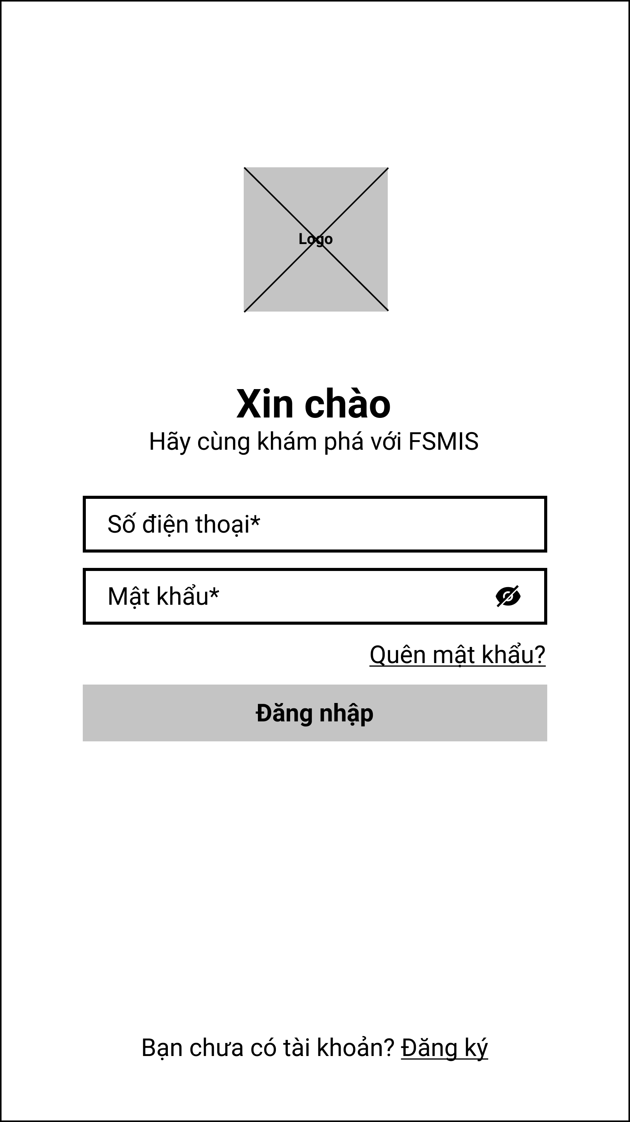

Figure 3.2.2. “Login” Mockup

|  |  |
| --- | --- |
| **Description** | The screen will appear if the user has not logged in for the first time or has logged out. |
| **Functional requirement** | * Phone numbers are limited to Vietnam region. * Password must be at least 8 characters. * The logo is small in size, appearing at the top of the form. * Forgot password and Register navigation buttons must be underlined. |

#### 3.2.3. Register

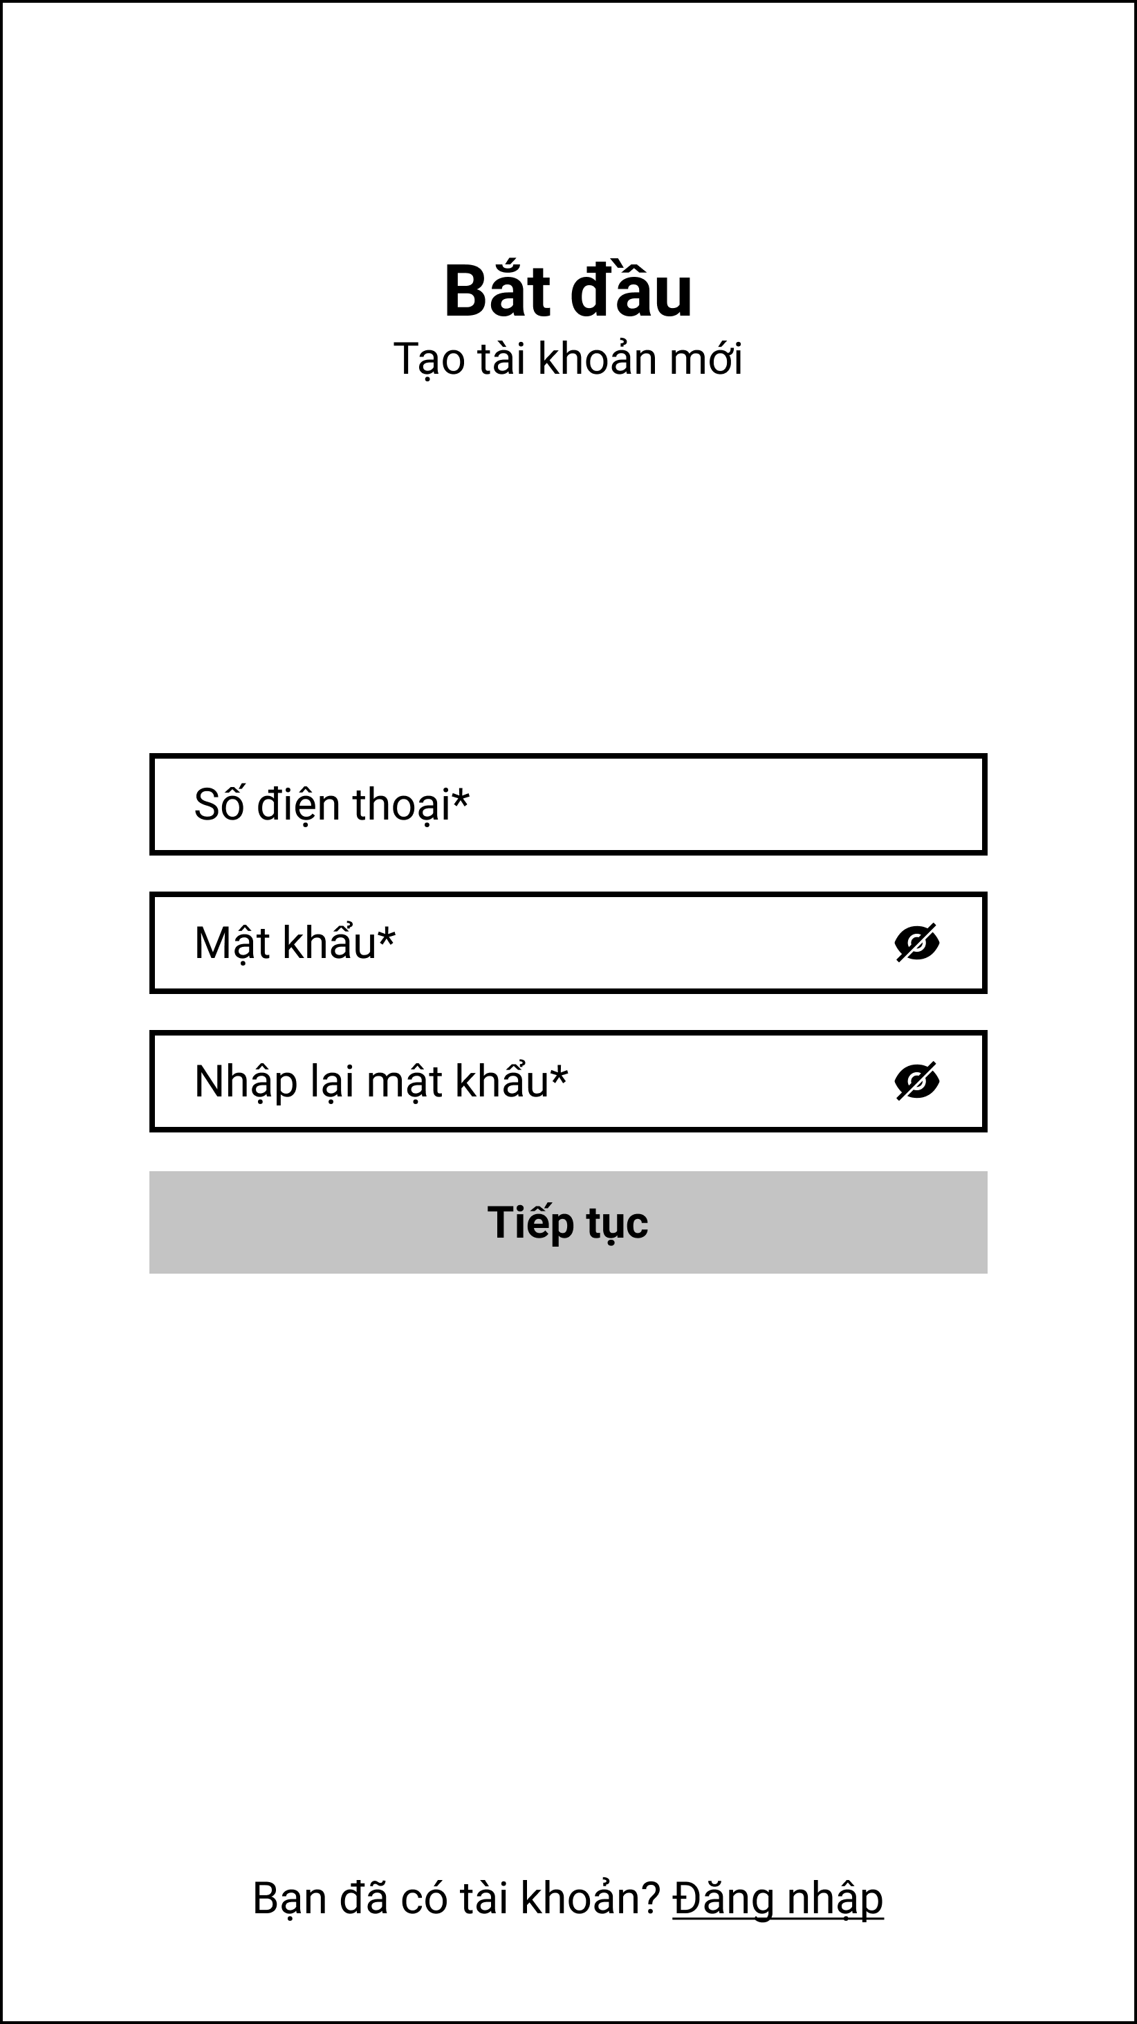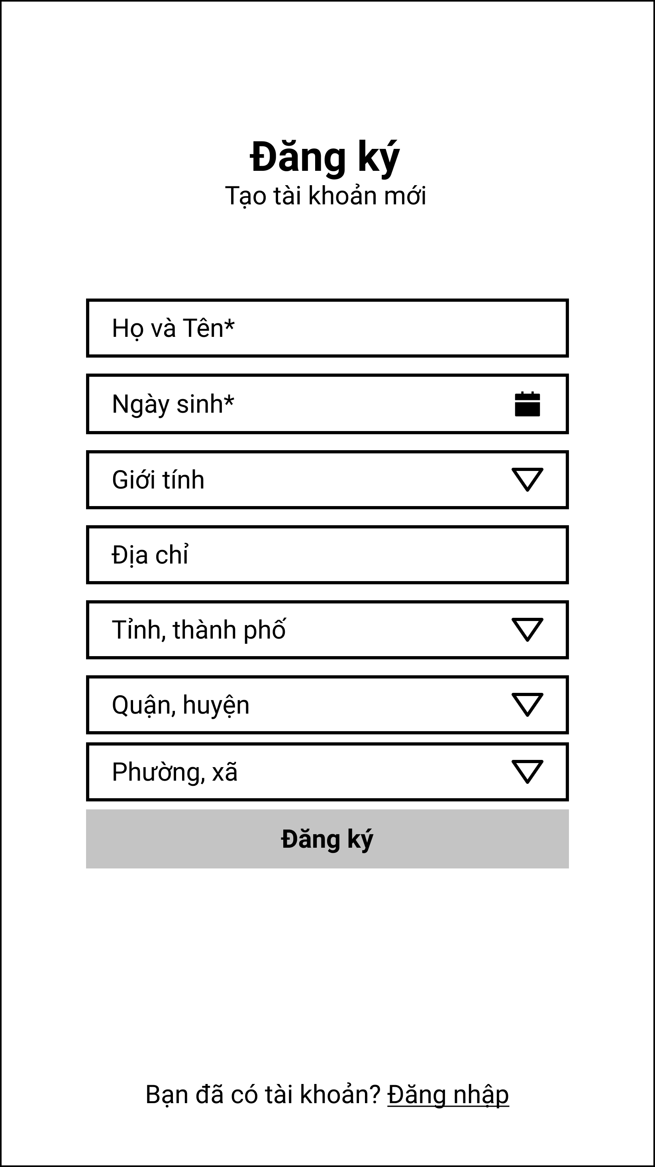

Figure 3.2.3. “Register” Mockup

|  |  |
| --- | --- |
| **Description** | This screen allows users to register with a new phone number to gain access to the system. |
| **Functional requirement** | * Phone numbers are limited to Vietnam region. * Password, re-enter password must be 8 characters long. * Provinces, districts and wards are limited to the Vietnam region. |

#### 3.2.4. Forgot password

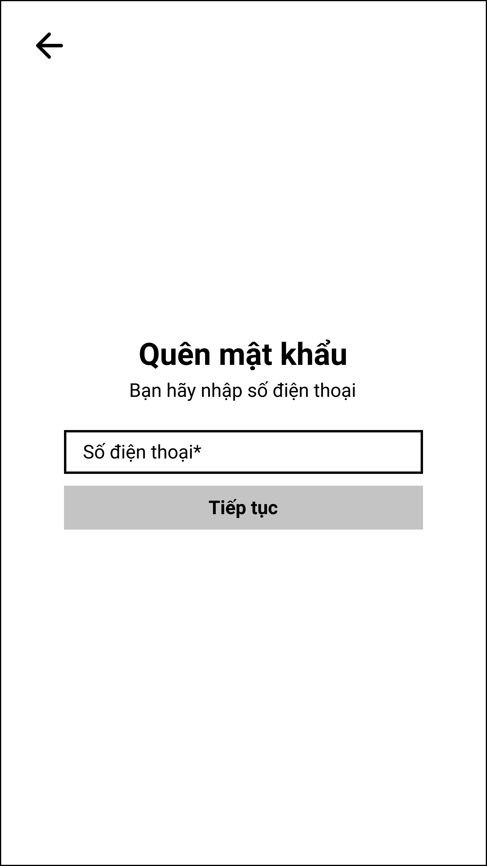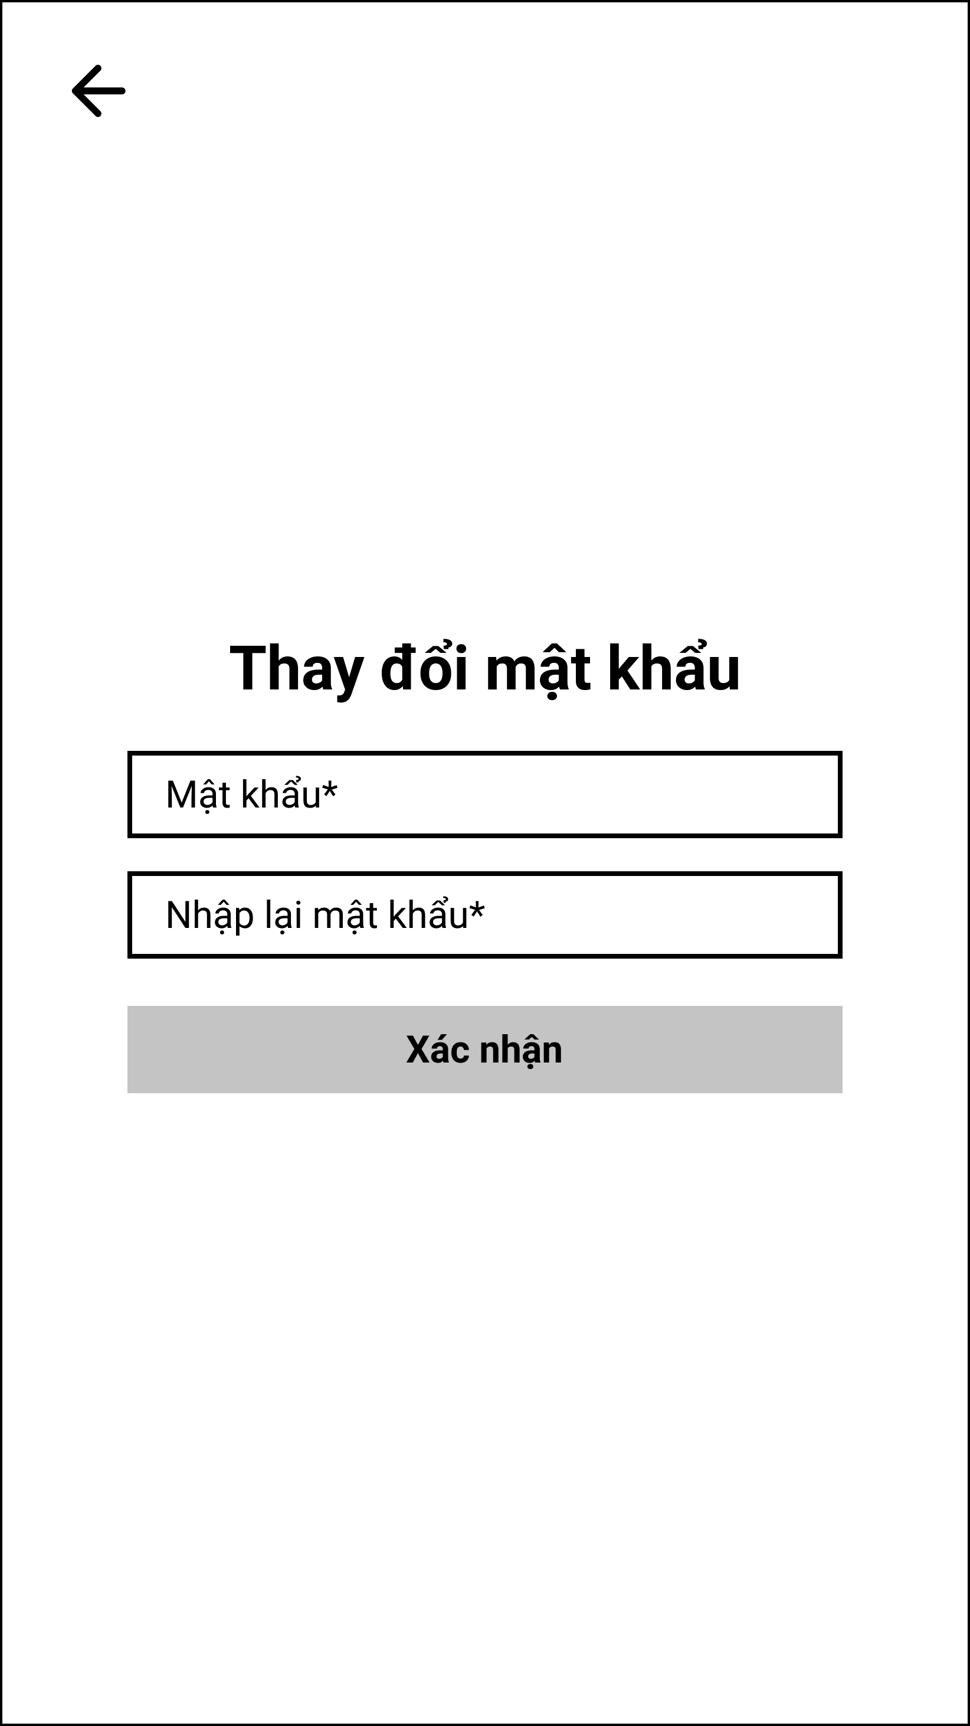

Figure 3.2.4. “Forgot password” Mockup

|  |  |
| --- | --- |
| **Description** | This screen allows users to reset their password when they forget the original password. |
| **Functional requirement** | * Phone numbers are limited to Vietnam region. * Password, re-enter password must be 8 characters long. |

#### 3.2.5. OTP

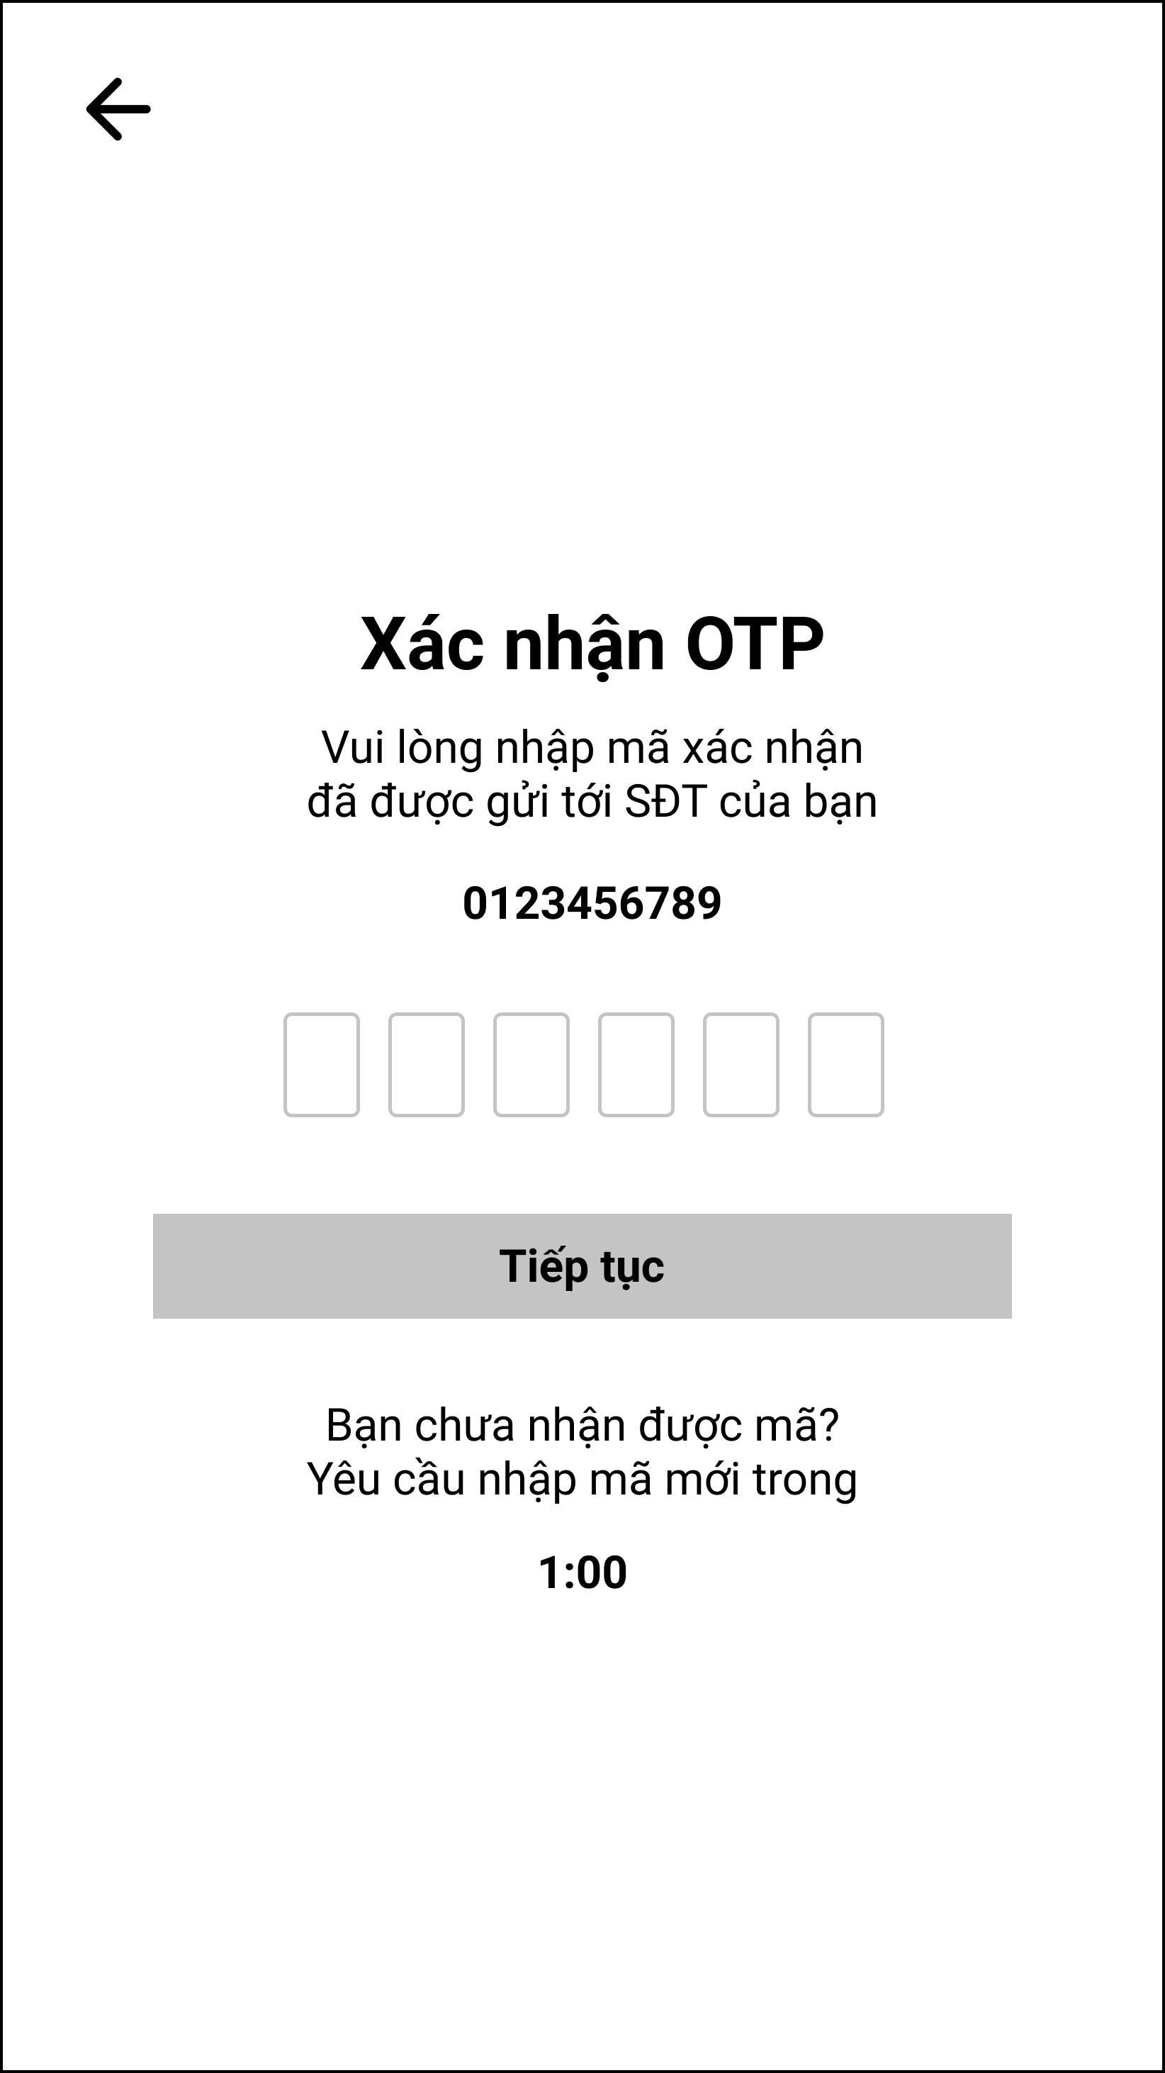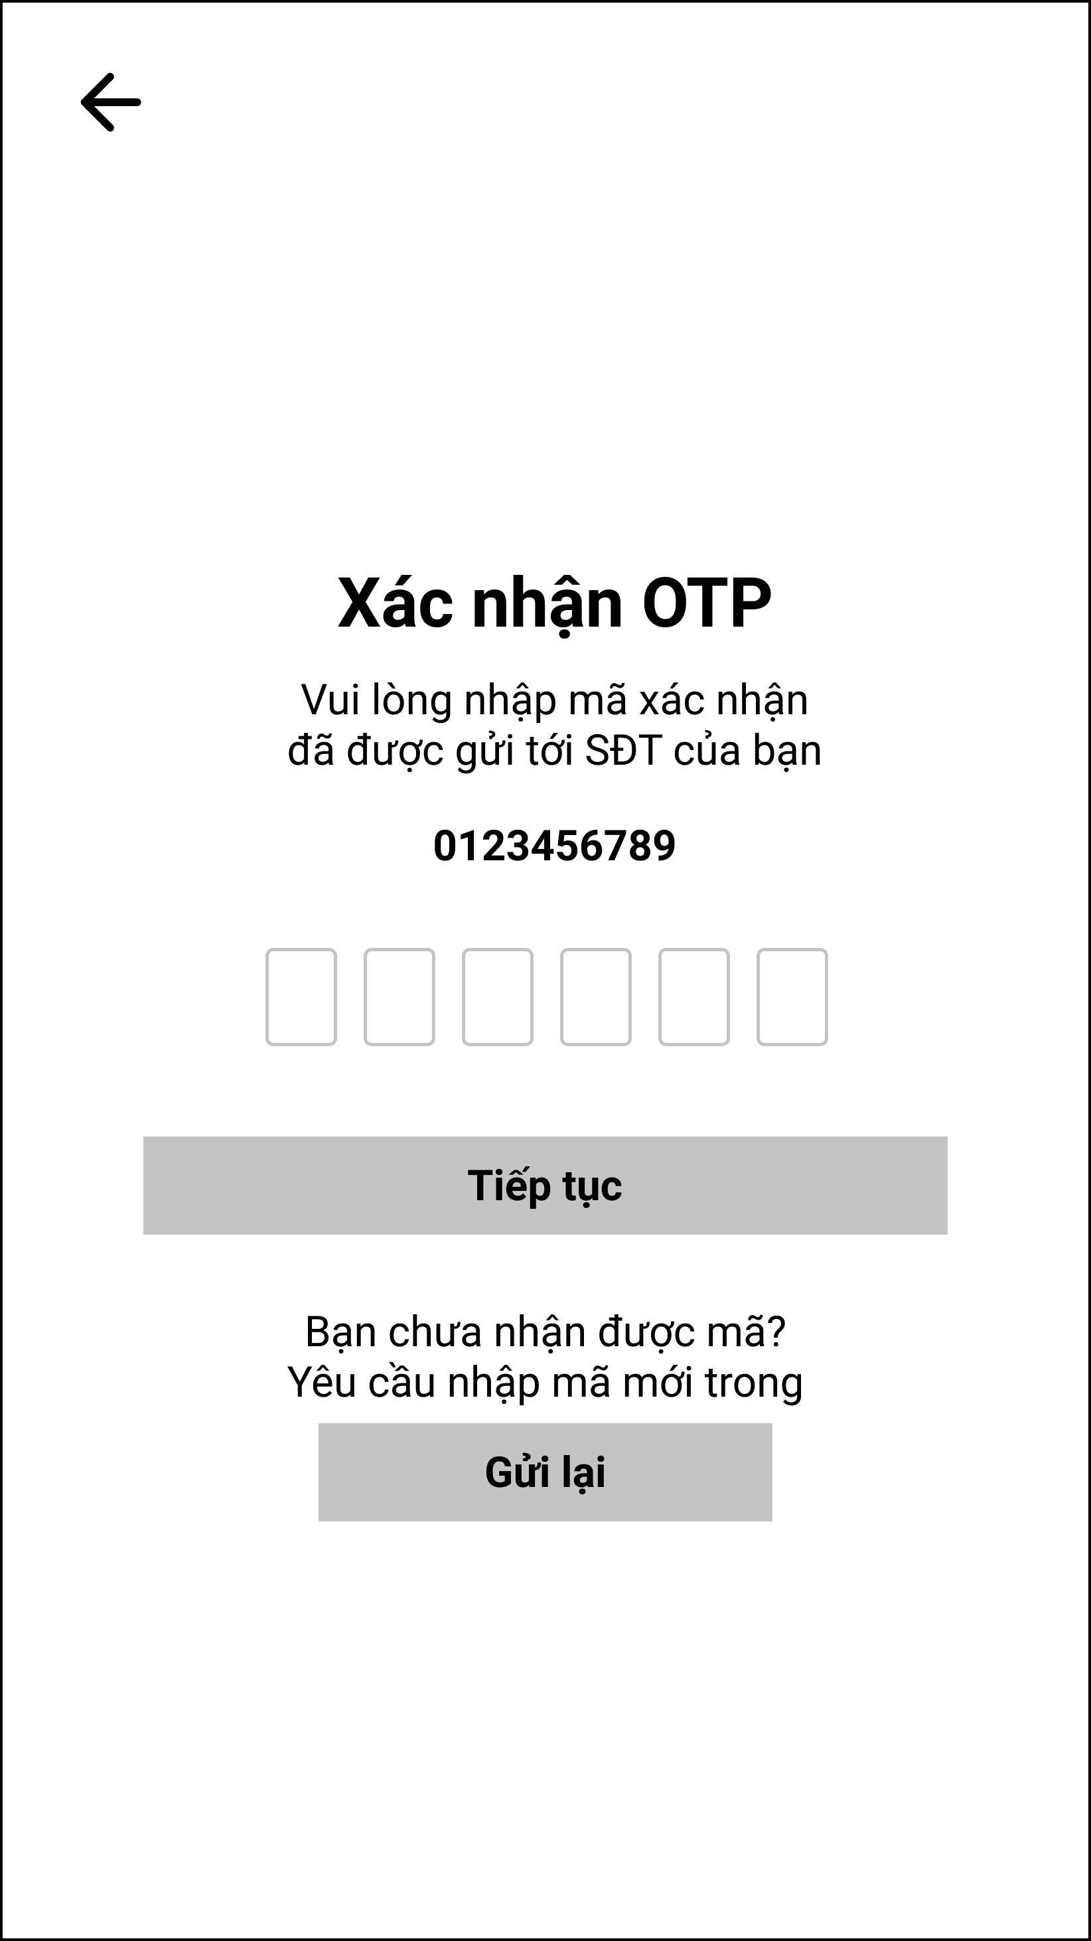

Figure 3.2.5. “OTP” Mockup

|  |  |
| --- | --- |
| **Description** | This screen is displayed in cases such as registration, forgetting password, changing phone number to be authenticated via OTP message. |
| **Functional requirement** | * Displays the phone number sending the OTP code. * The timeout for the resend button to show up is 1 minute. * The continue button will enable when the user enters all 6 numeric characters. |

#### 3.2.6. Ban Notice

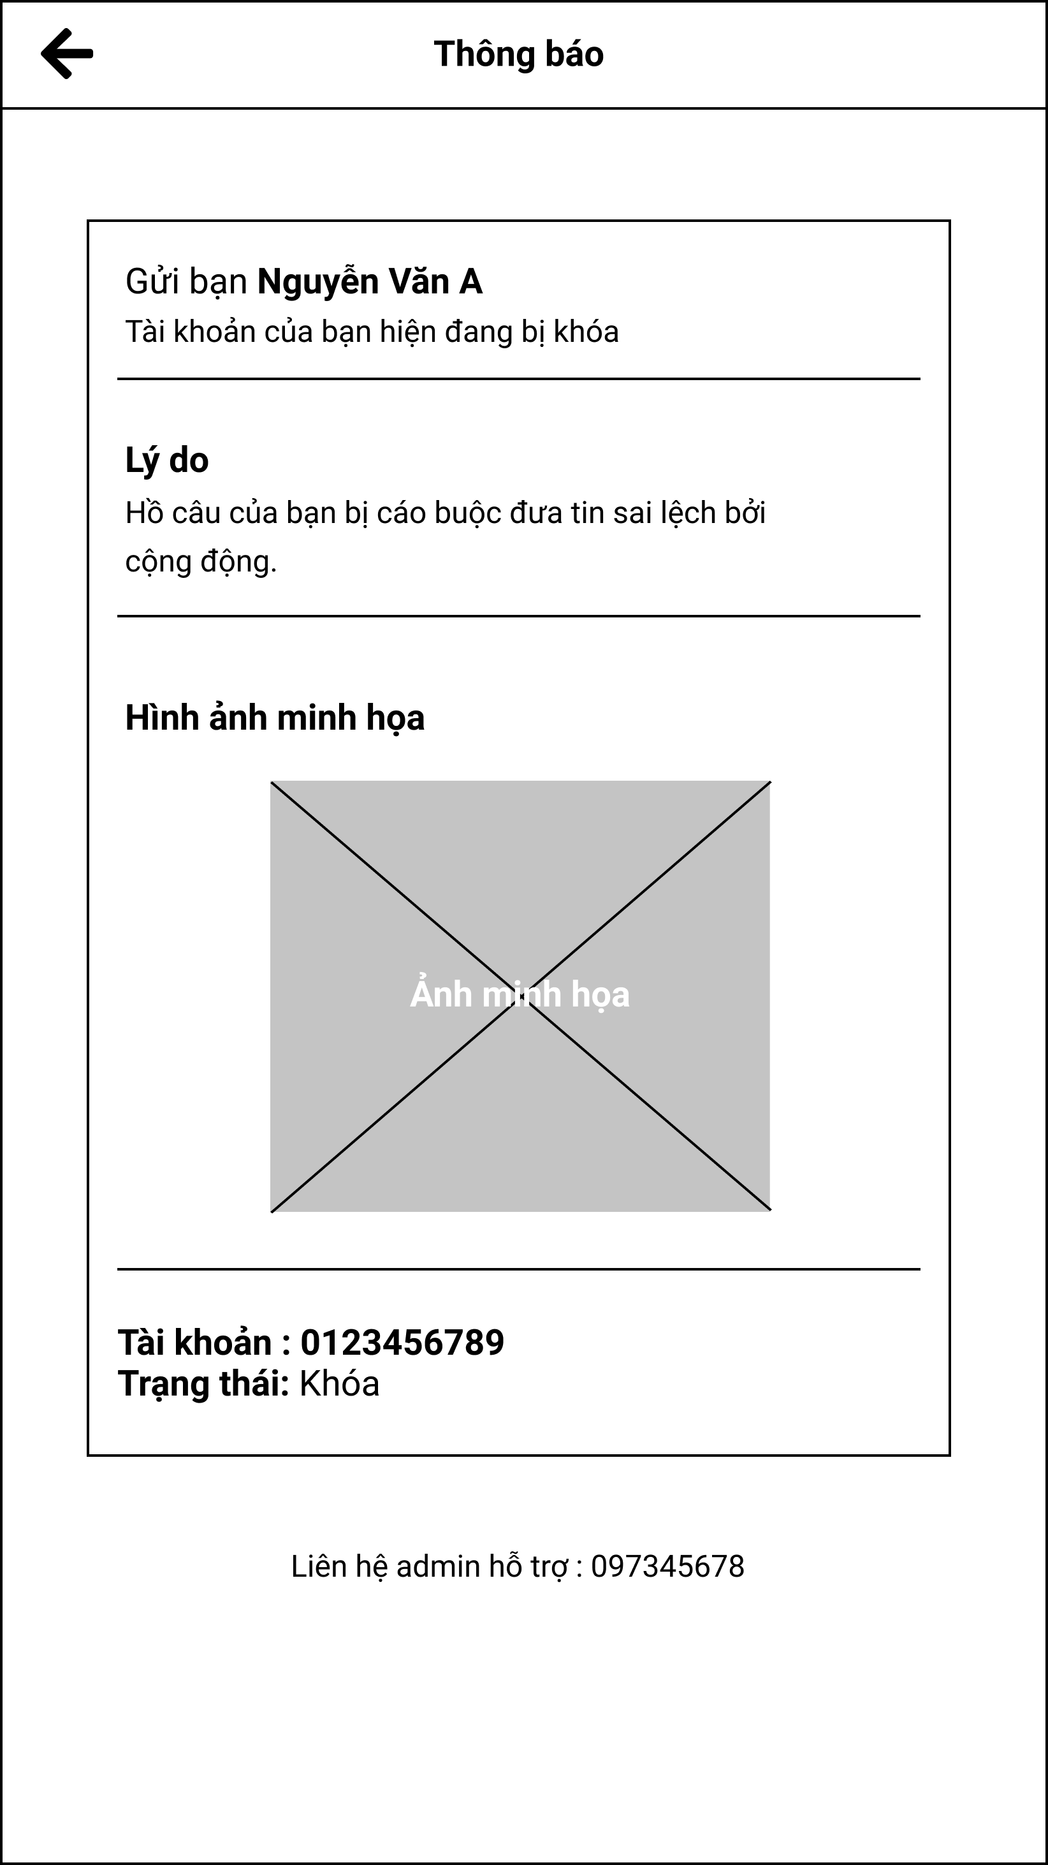

Figure 3.2.6. “Ban Notice” Mockup

|  |  |
| --- | --- |
| **Description** | This screen is displayed when a user is blocked from the system by an administrator. |
| **Functional requirement** | * Show full name, reason for ban, illustration and phone number. * The administrator's phone number, when clicked, will redirect to the user phone app. |

### 3.3. Feature “Manage personal profile”

#### 3.3.1. Personal options

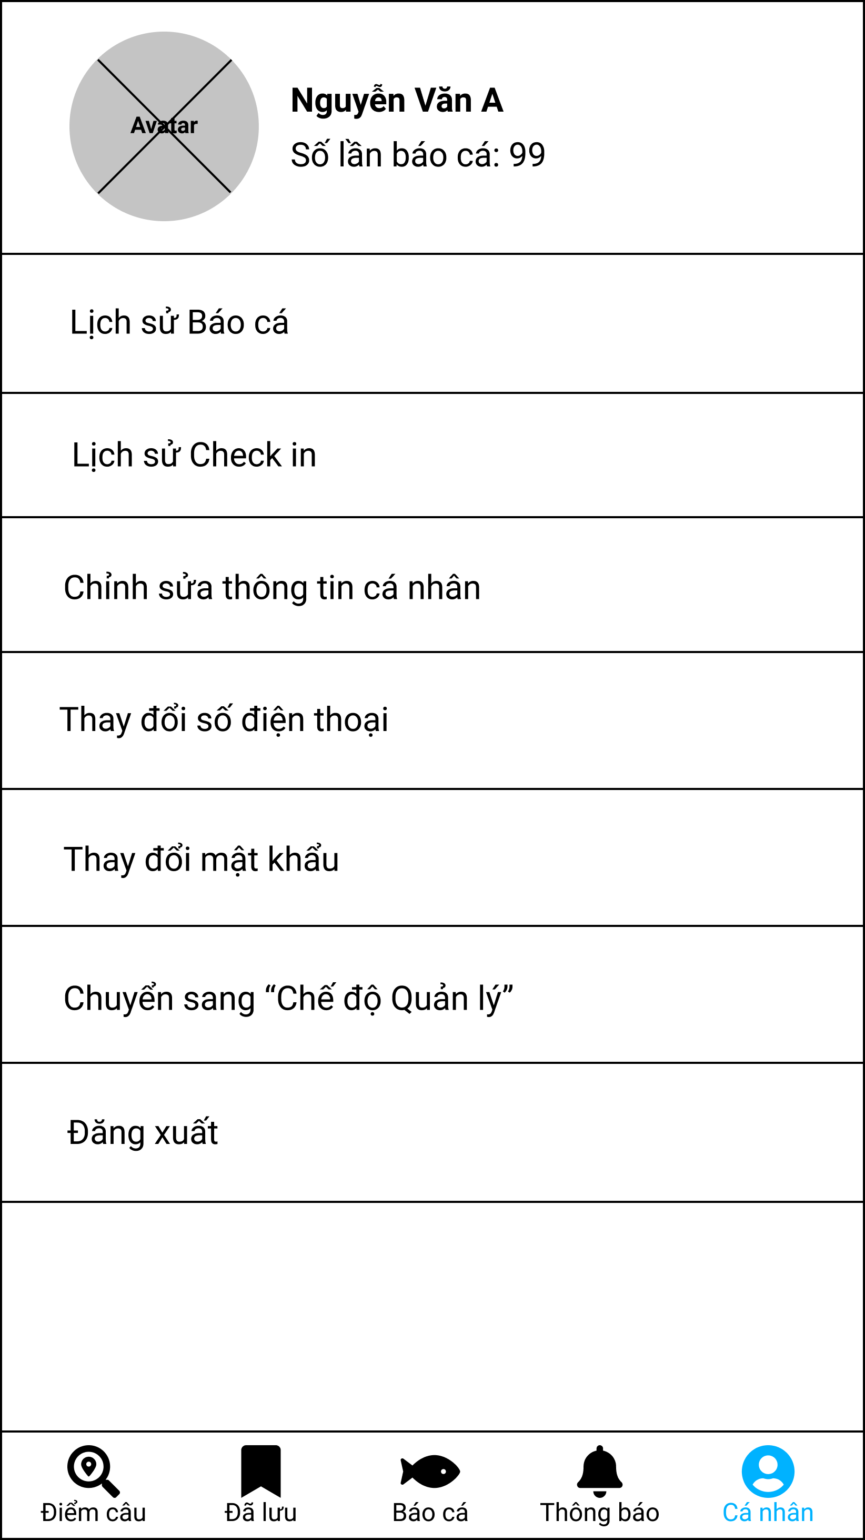

Figure 3.3.1. “Personal options” Mockup

|  |  |
| --- | --- |
| **Description** | This screen is displayed when the user clicks to view personal information on the navigation bar. |
| **Functional requirement** | * Show avatar, full name, number of catches. * The logout button should be colored red. |

#### 3.2.2. Edit personal profile

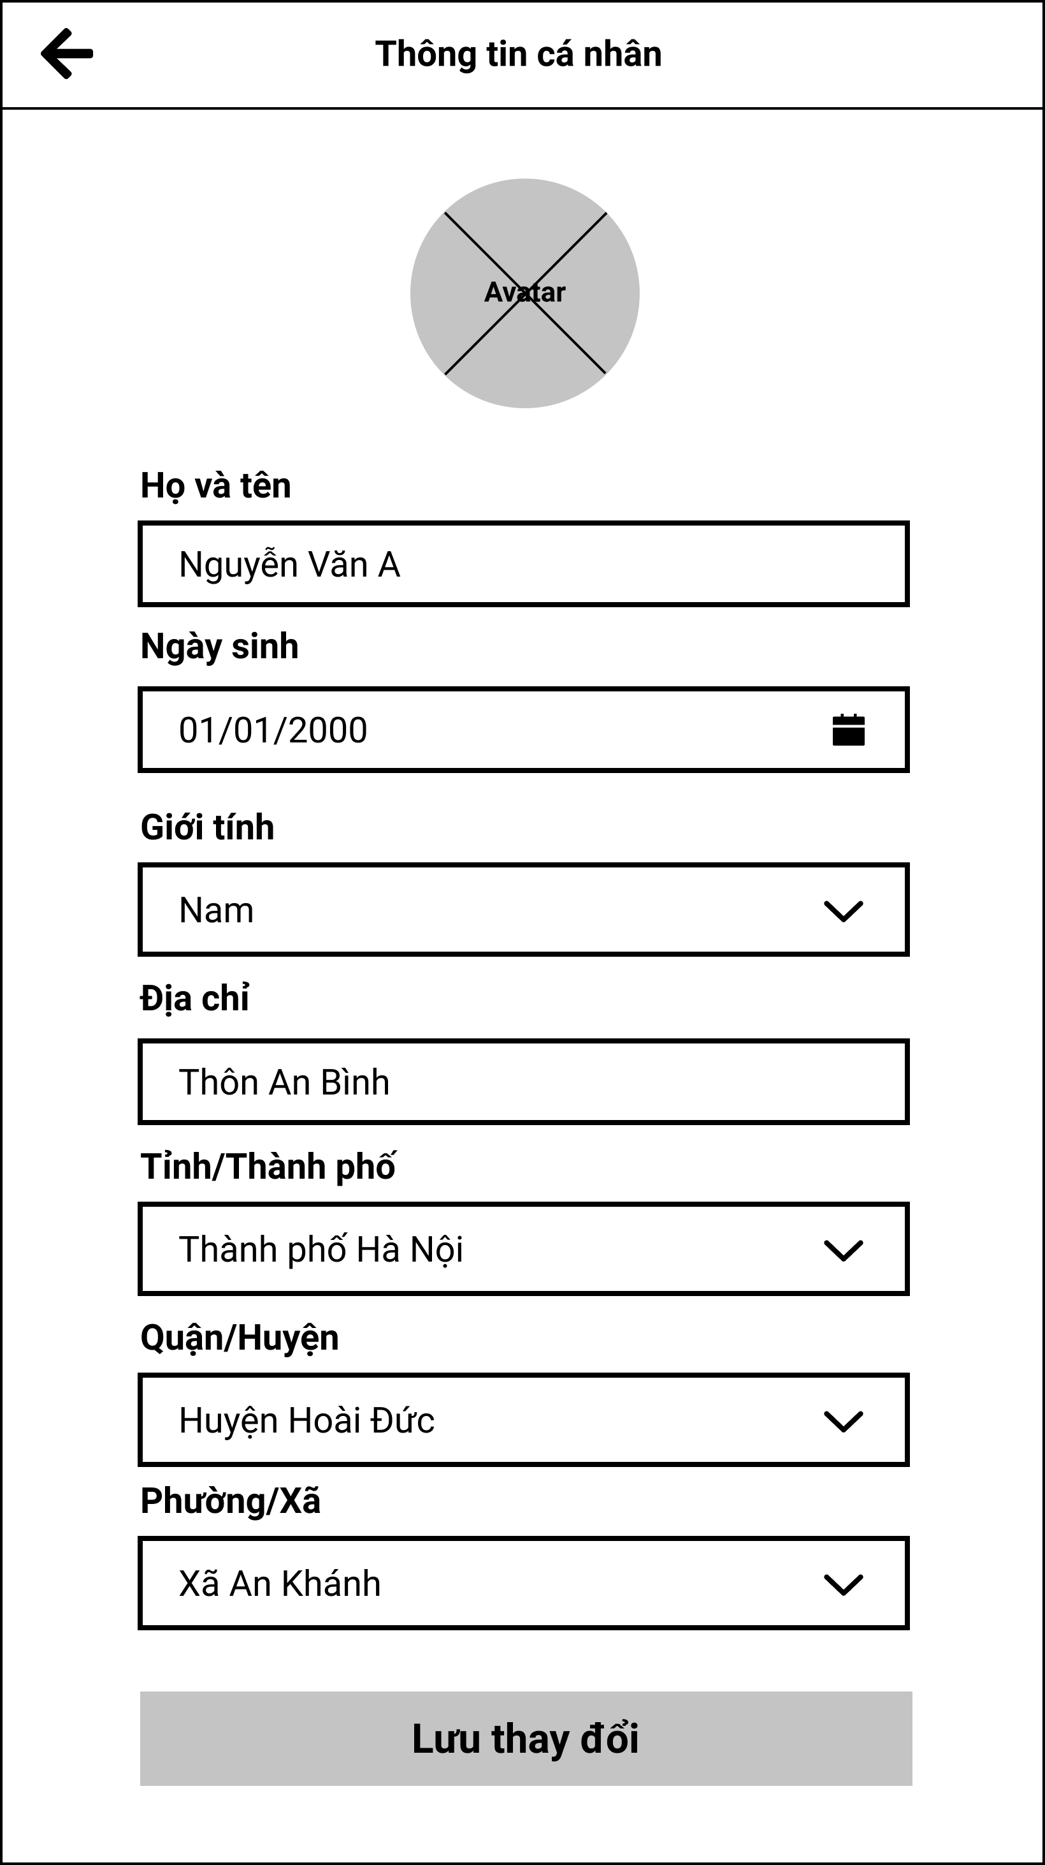

Figure 3.2.2. “Edit personal profile” Mockup

|  |  |
| --- | --- |
| **Description** | The screen displays full personal information of the user, and can be edited and updated. |
| **Functional requirement** | * Provinces, districts and wards are limited to the Vietnam region. |

#### 3.2.3. Change phone number

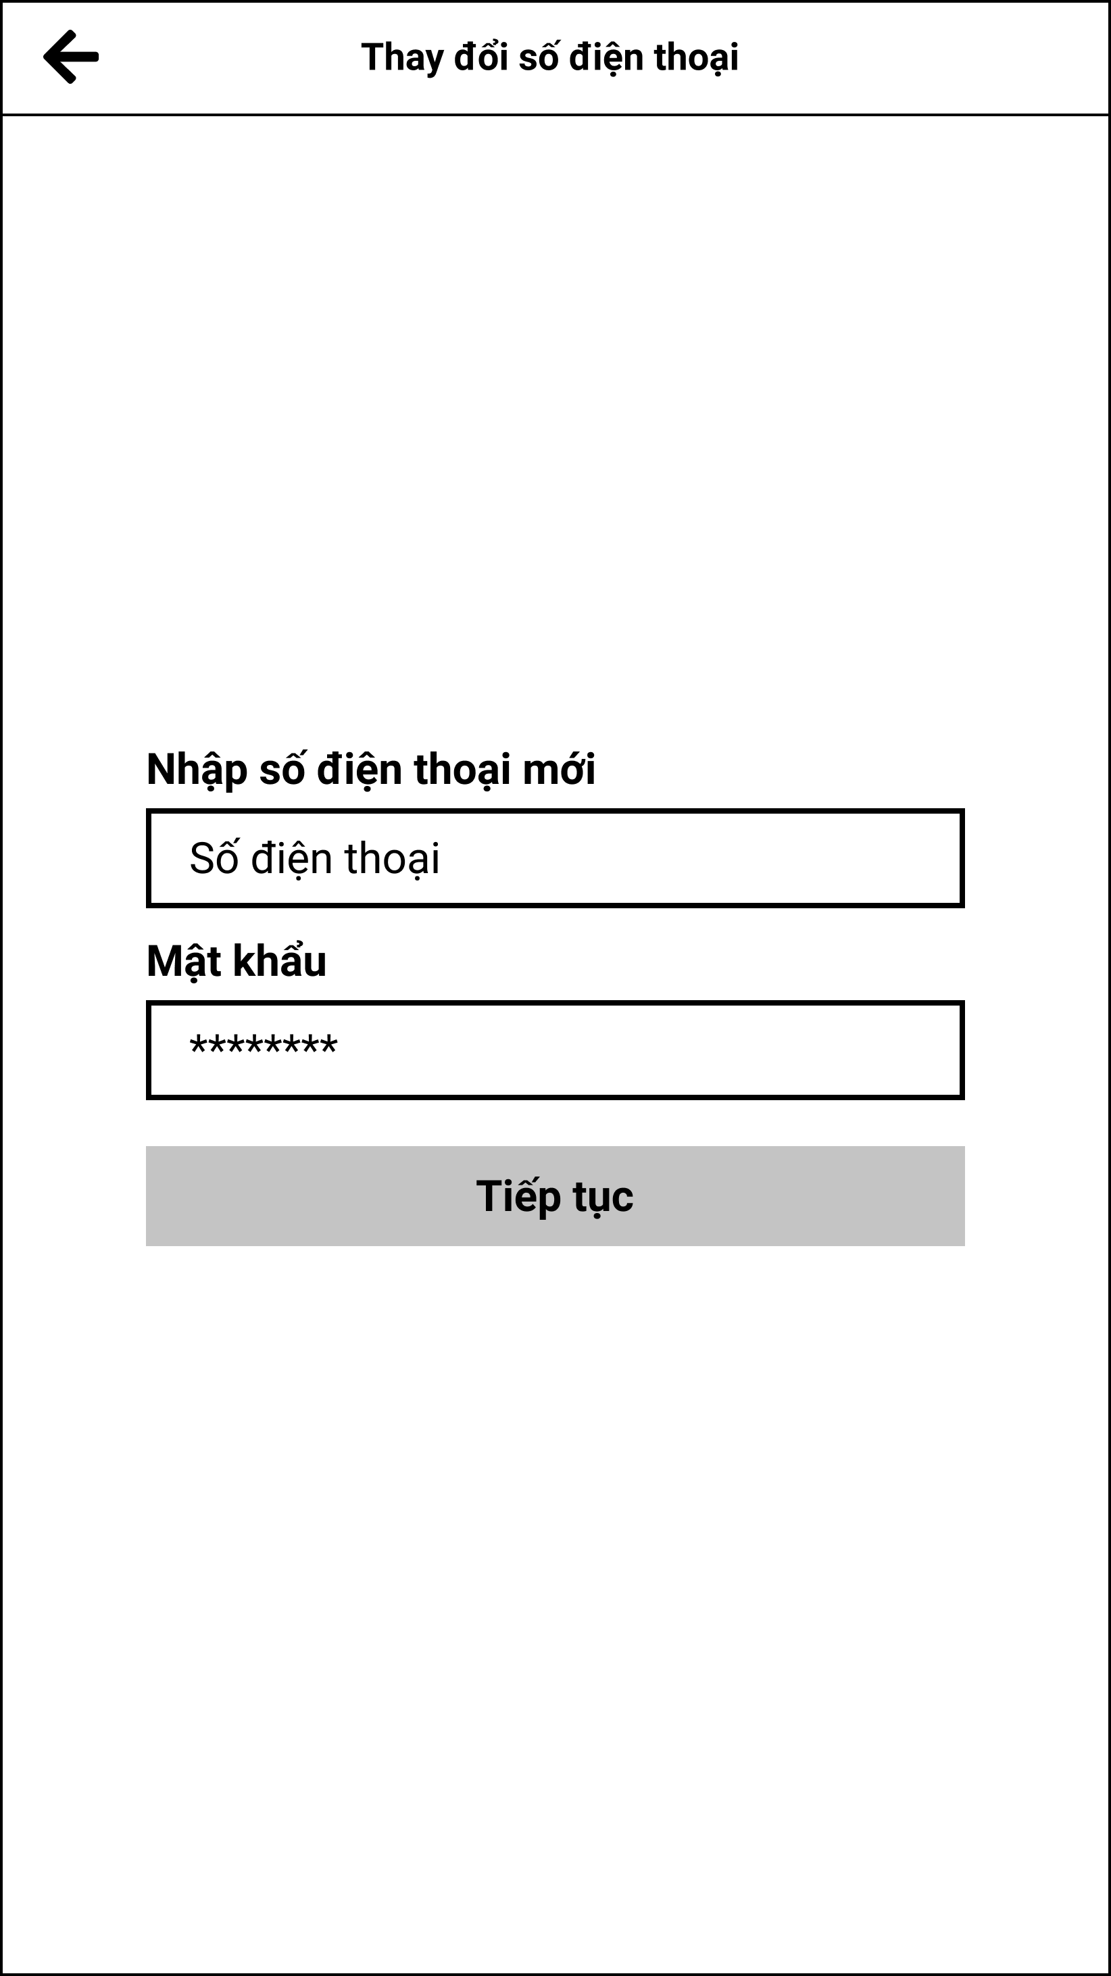

Figure 3.2.3. “Change phone number” Mockup

|  |  |
| --- | --- |
| **Description** | This screen allows users to change other phone numbers that are not in the system. |
| **Functional requirement** | * Phone numbers are limited to Vietnam region. * Password must be 8 characters long. |

#### 3.2.4. Change password

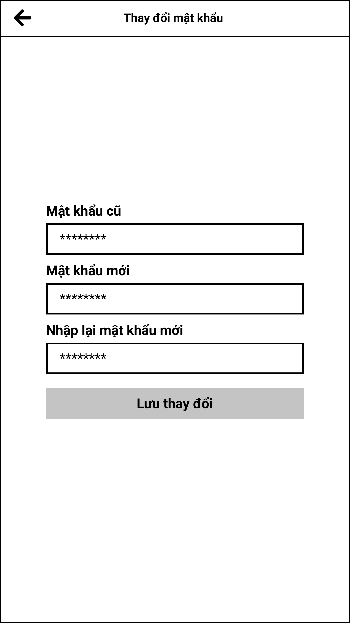

Figure 3.2.4. “Change password” Mockup

|  |  |
| --- | --- |
| **Description** | This screen allows the user to change to a new password. |
| **Functional requirement** | * Old password, new password, and re-enter new password must be 8 characters long. |

### 3.4. Feature “Manage system accounts”

#### 3.4.1. System account management

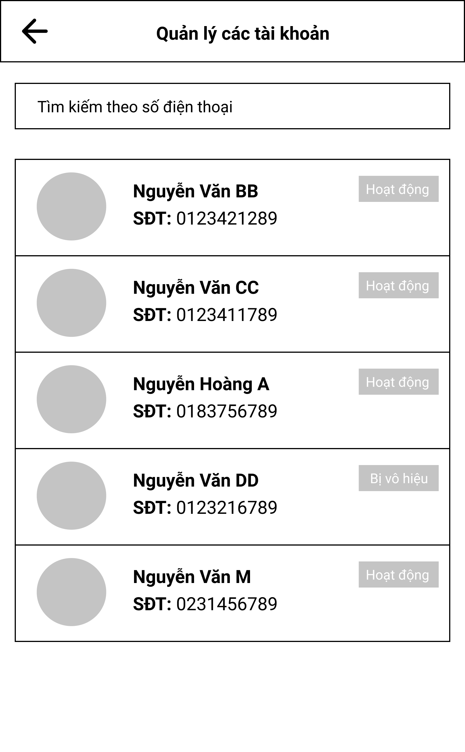

Figure 3.4.1. “System account management” Mockup

|  |  |
| --- | --- |
| **Description** | This screen allows the user to change to a new password. |
| **Functional requirement** | * Each card has an avatar, full name, phone number and status. * Administrators can search by name or by phone number. * Phone number search is limited to Vietnam region. |

#### 3.4.2. Account details

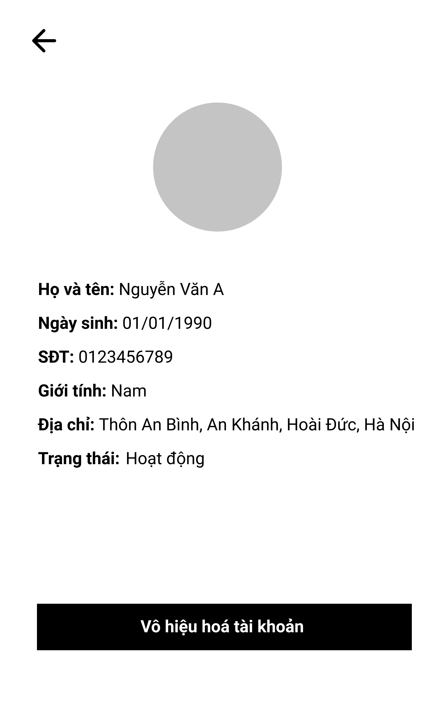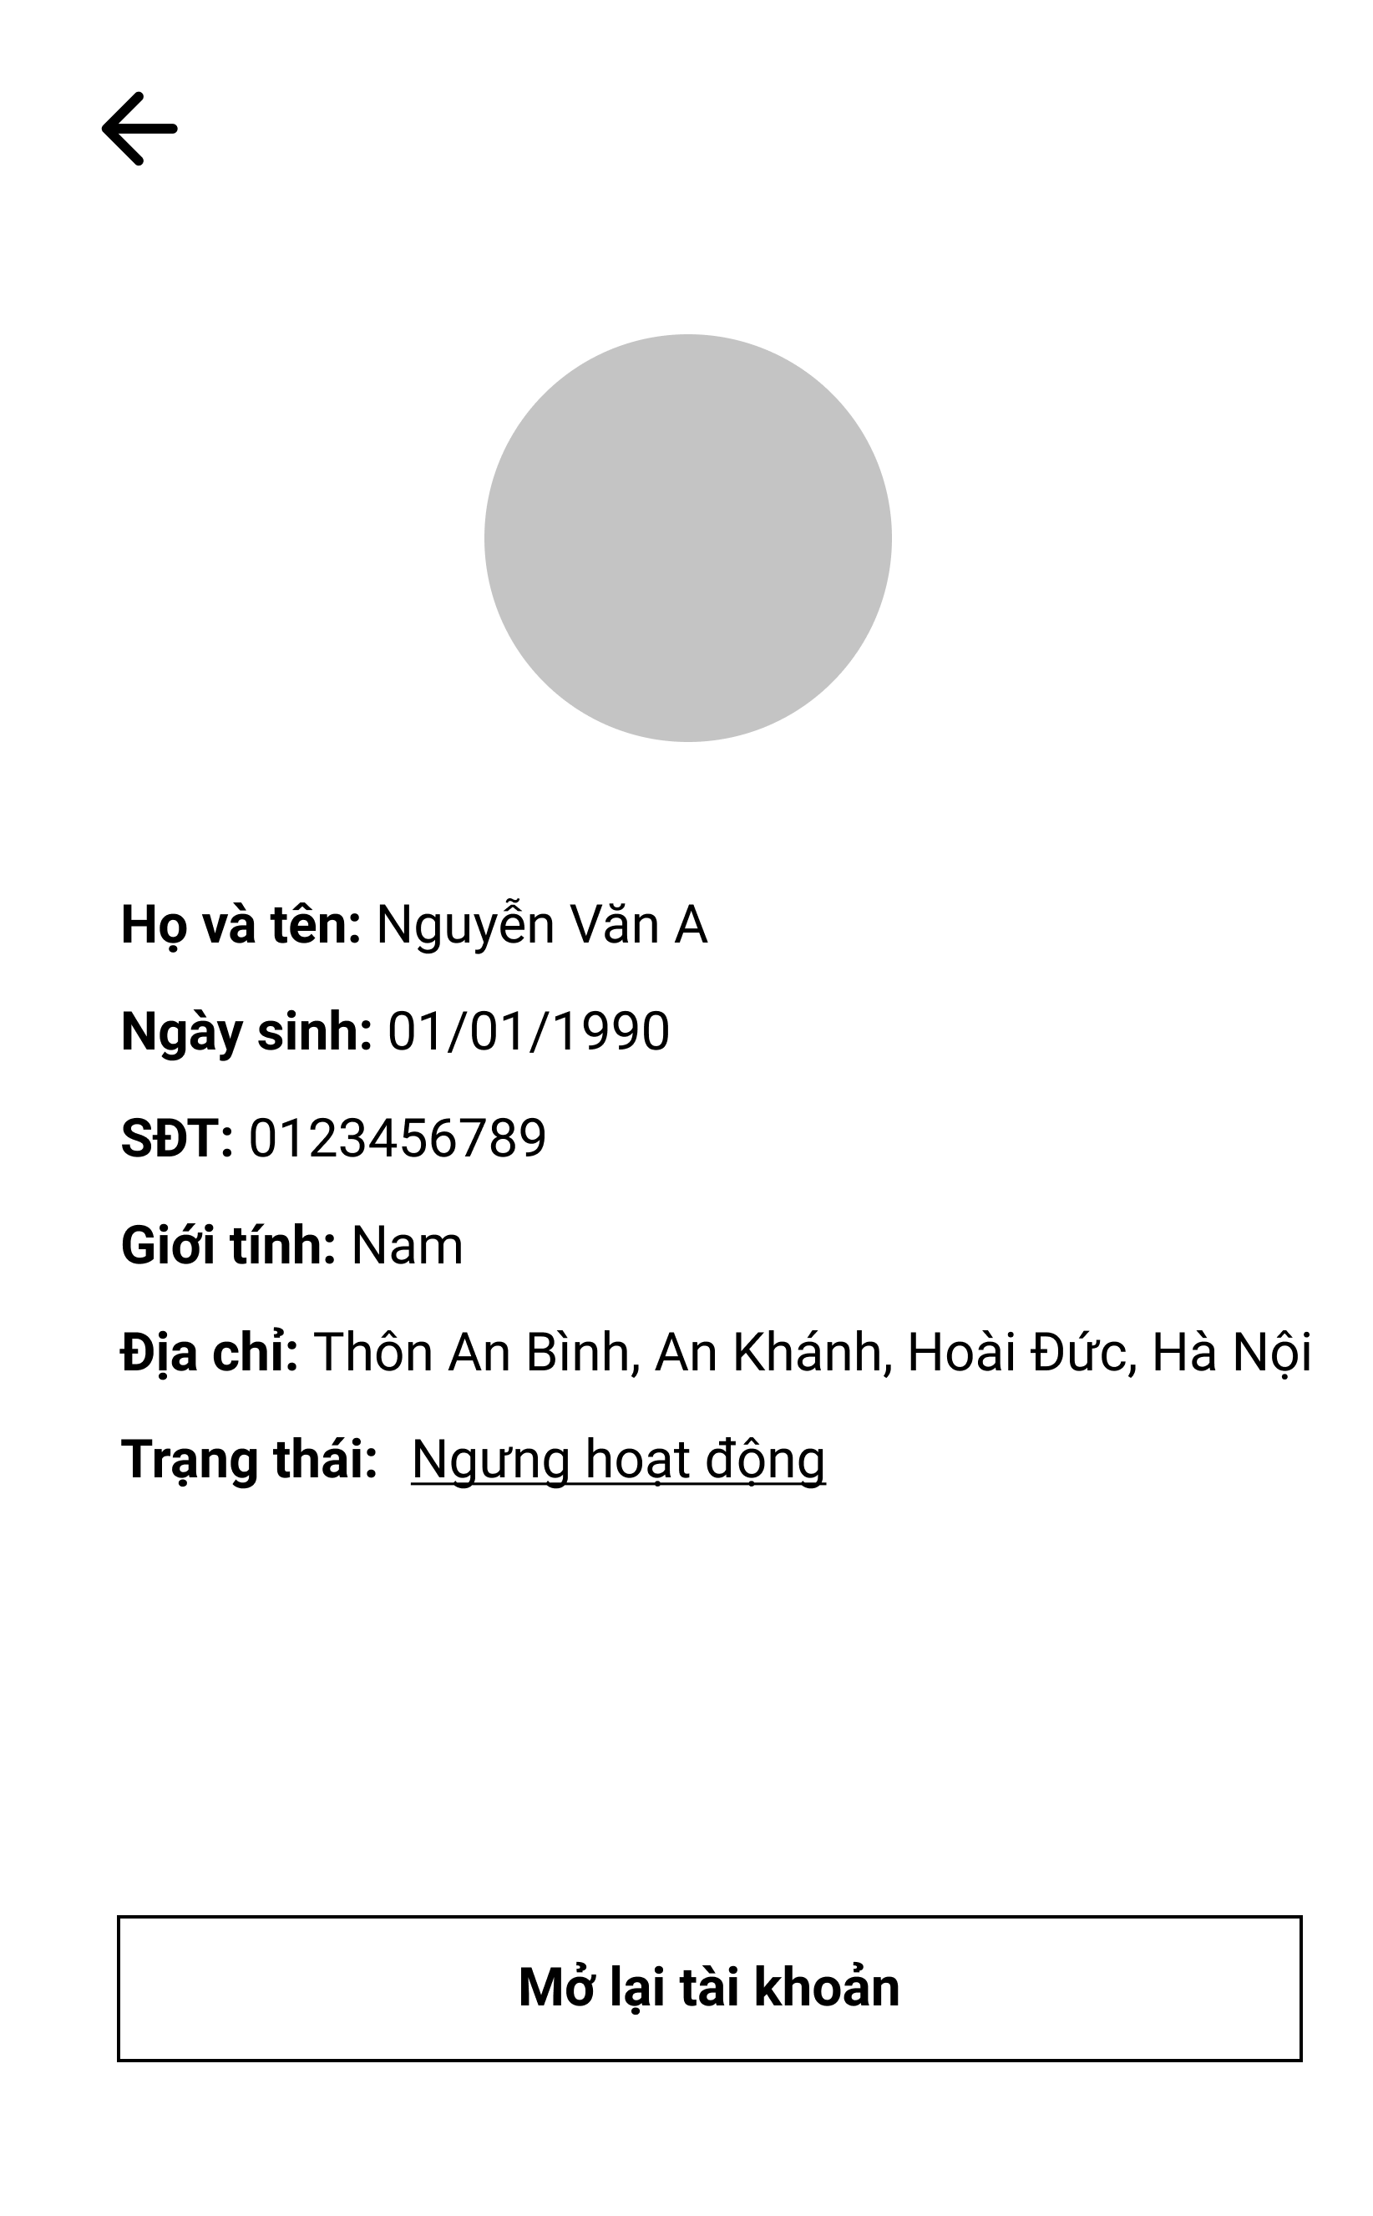

Figure 3.4.2. “Account details” Mockup

|  |  |
| --- | --- |
| **Description** | The screen displays full user information that only admins can access. |
| **Functional requirement** | * Show full avatar, full name, phone number, gender, date of birth, address and status. * When you deactivate an account, there must be a reason for the ban. |

### 3.5. Feature “Search fishing location”

#### 3.5.1. Search nearby

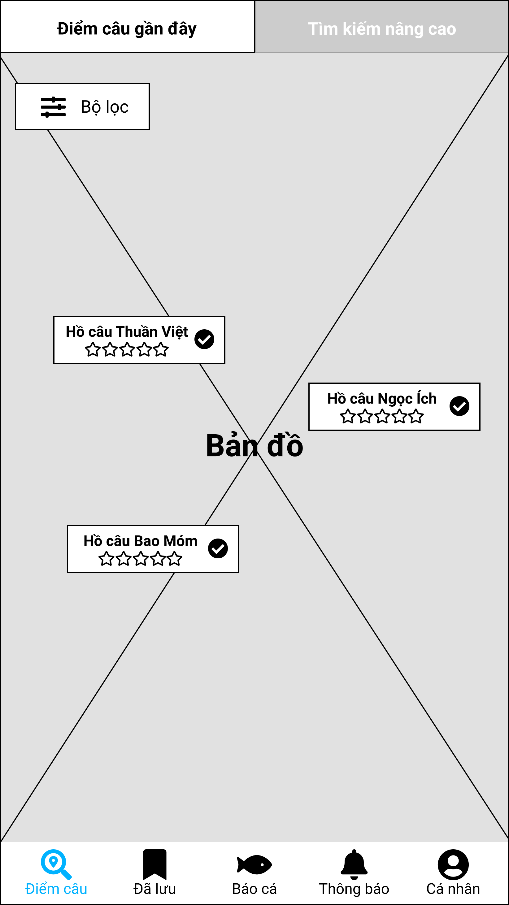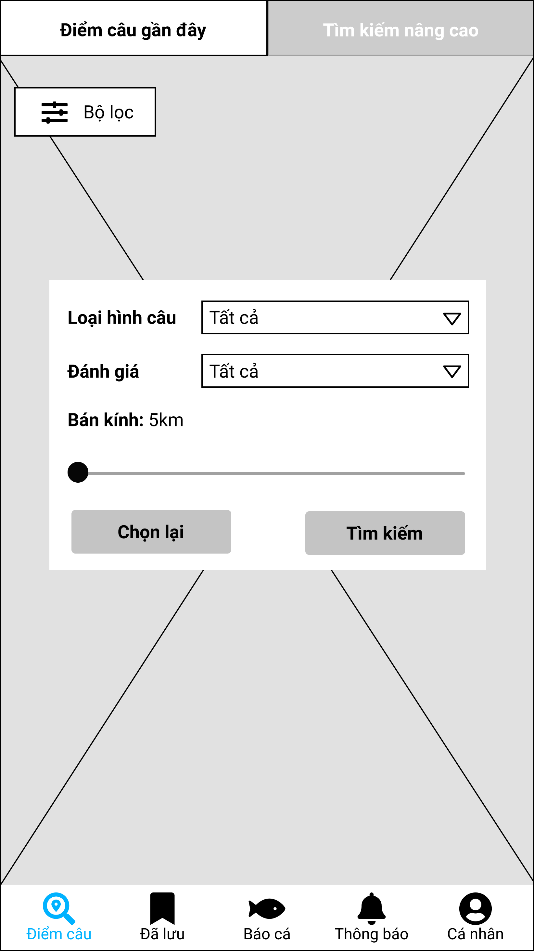

Figure 3.5.1. “Search nearby” Mockup

|  |  |
| --- | --- |
| **Description** | The screen shows the fishing locations around the user. |
| **Functional requirement** | * Each fishing location tag must show name, score and verified icon. * Search radius is limited from 5 to 50km. |

#### 3.5.2. Advanced search

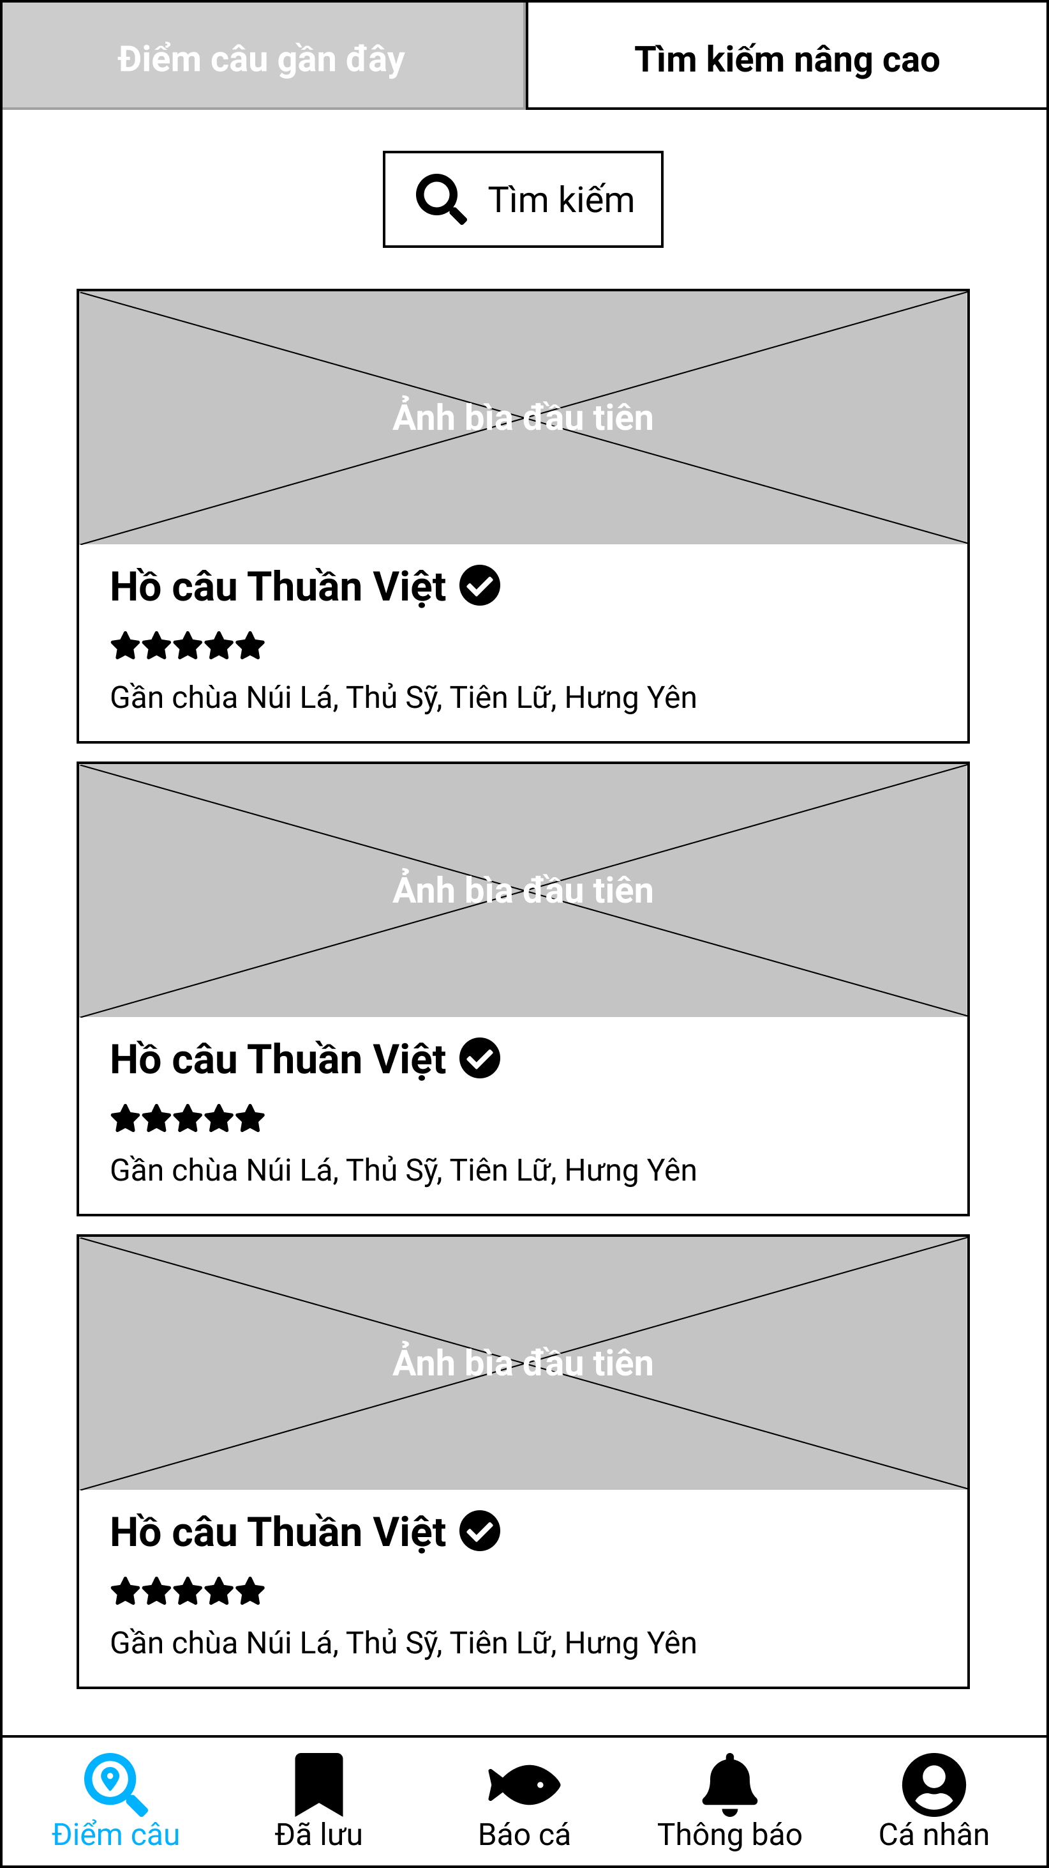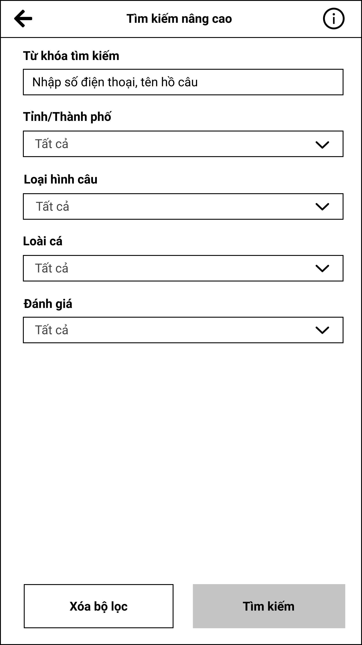

Figure 3.5.2. “Advanced search” Mockup

|  |  |
| --- | --- |
| **Description** | The screen allows users to find all types of lakes in the system. |
| **Functional requirement** | * The search input can be a phone number, an unsigned or accented word. * Provinces is limited to the Vietnam region only. * Fish species and fishing methods are only visible when the state is active. |

#### 3.5.3. Fishing location’s overview

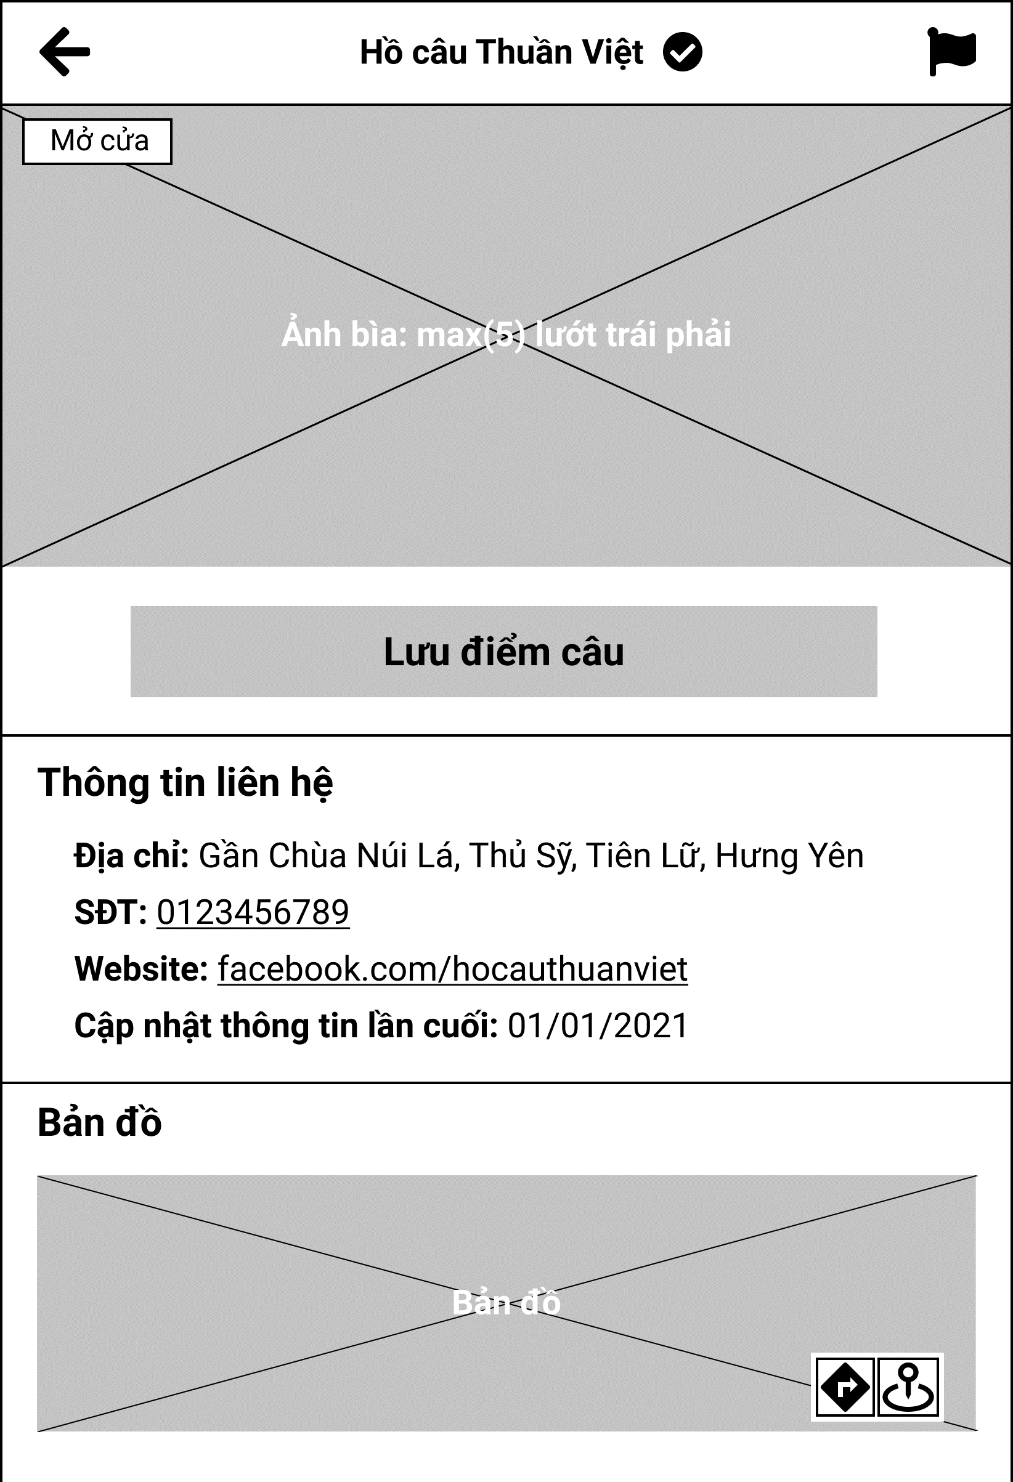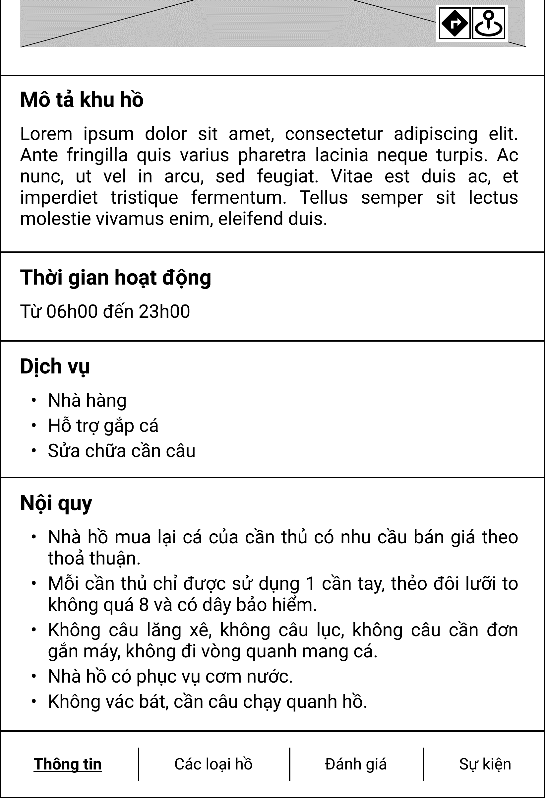

Figure 3.5.3. “Fishing location’s overview” Mockup

|  |  |
| --- | --- |
| **Description** | The screen shows preliminary information about the fishing location that the user wants to see. |
| **Functional requirement** | * The phone number can be clicked and redirected to the user's phone app. * Websites can be clicked and redirected to the user's browser. * Services, rules are bullet list. |

#### 3.5.4. View lake list

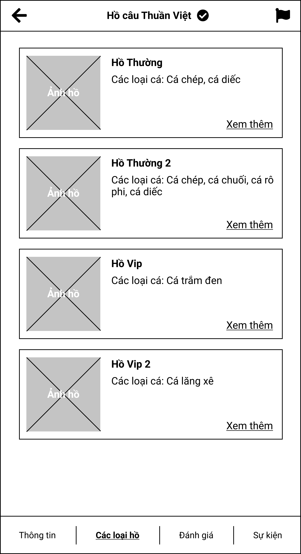

Figure 3.5.4. “View lake list” Mockup

|  |  |
| --- | --- |
| **Description** | The screen shows all active lakes of a fishing location. |
| **Functional requirement** | Show active fish species in the lake. |

#### 3.5.5. View lake details

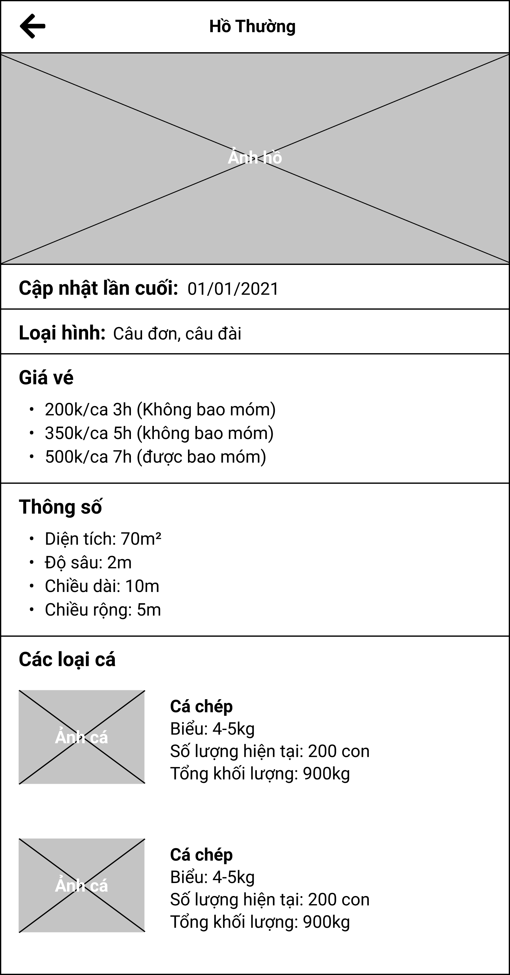

Figure 3.5.5. “View lake details” Mockup

|  |  |
| --- | --- |
| **Description** | The screen displays the full information of the lake in a fishing location. |
| **Functional requirement** | * Tickets and statistics are bullet lists. * The fish species tags must show quantity and total weights. |

#### 3.5.6. Saved fishing location

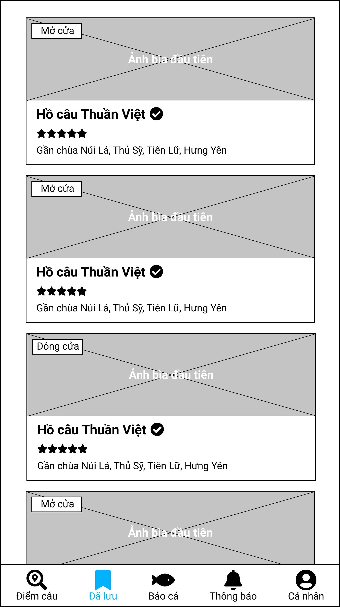

Figure 3.5.6. “Saved fishing location” Mockup

|  |  |
| --- | --- |
| **Description** | The screen displays all the fishing locations that the user wants to save. |
| **Functional requirement** | * Swipe down the screen to update active pools or newly saved fishing locations |

### 3.6. Feature “Manage fishing location’s reviews”

#### 3.6.1. View fishing location’s review

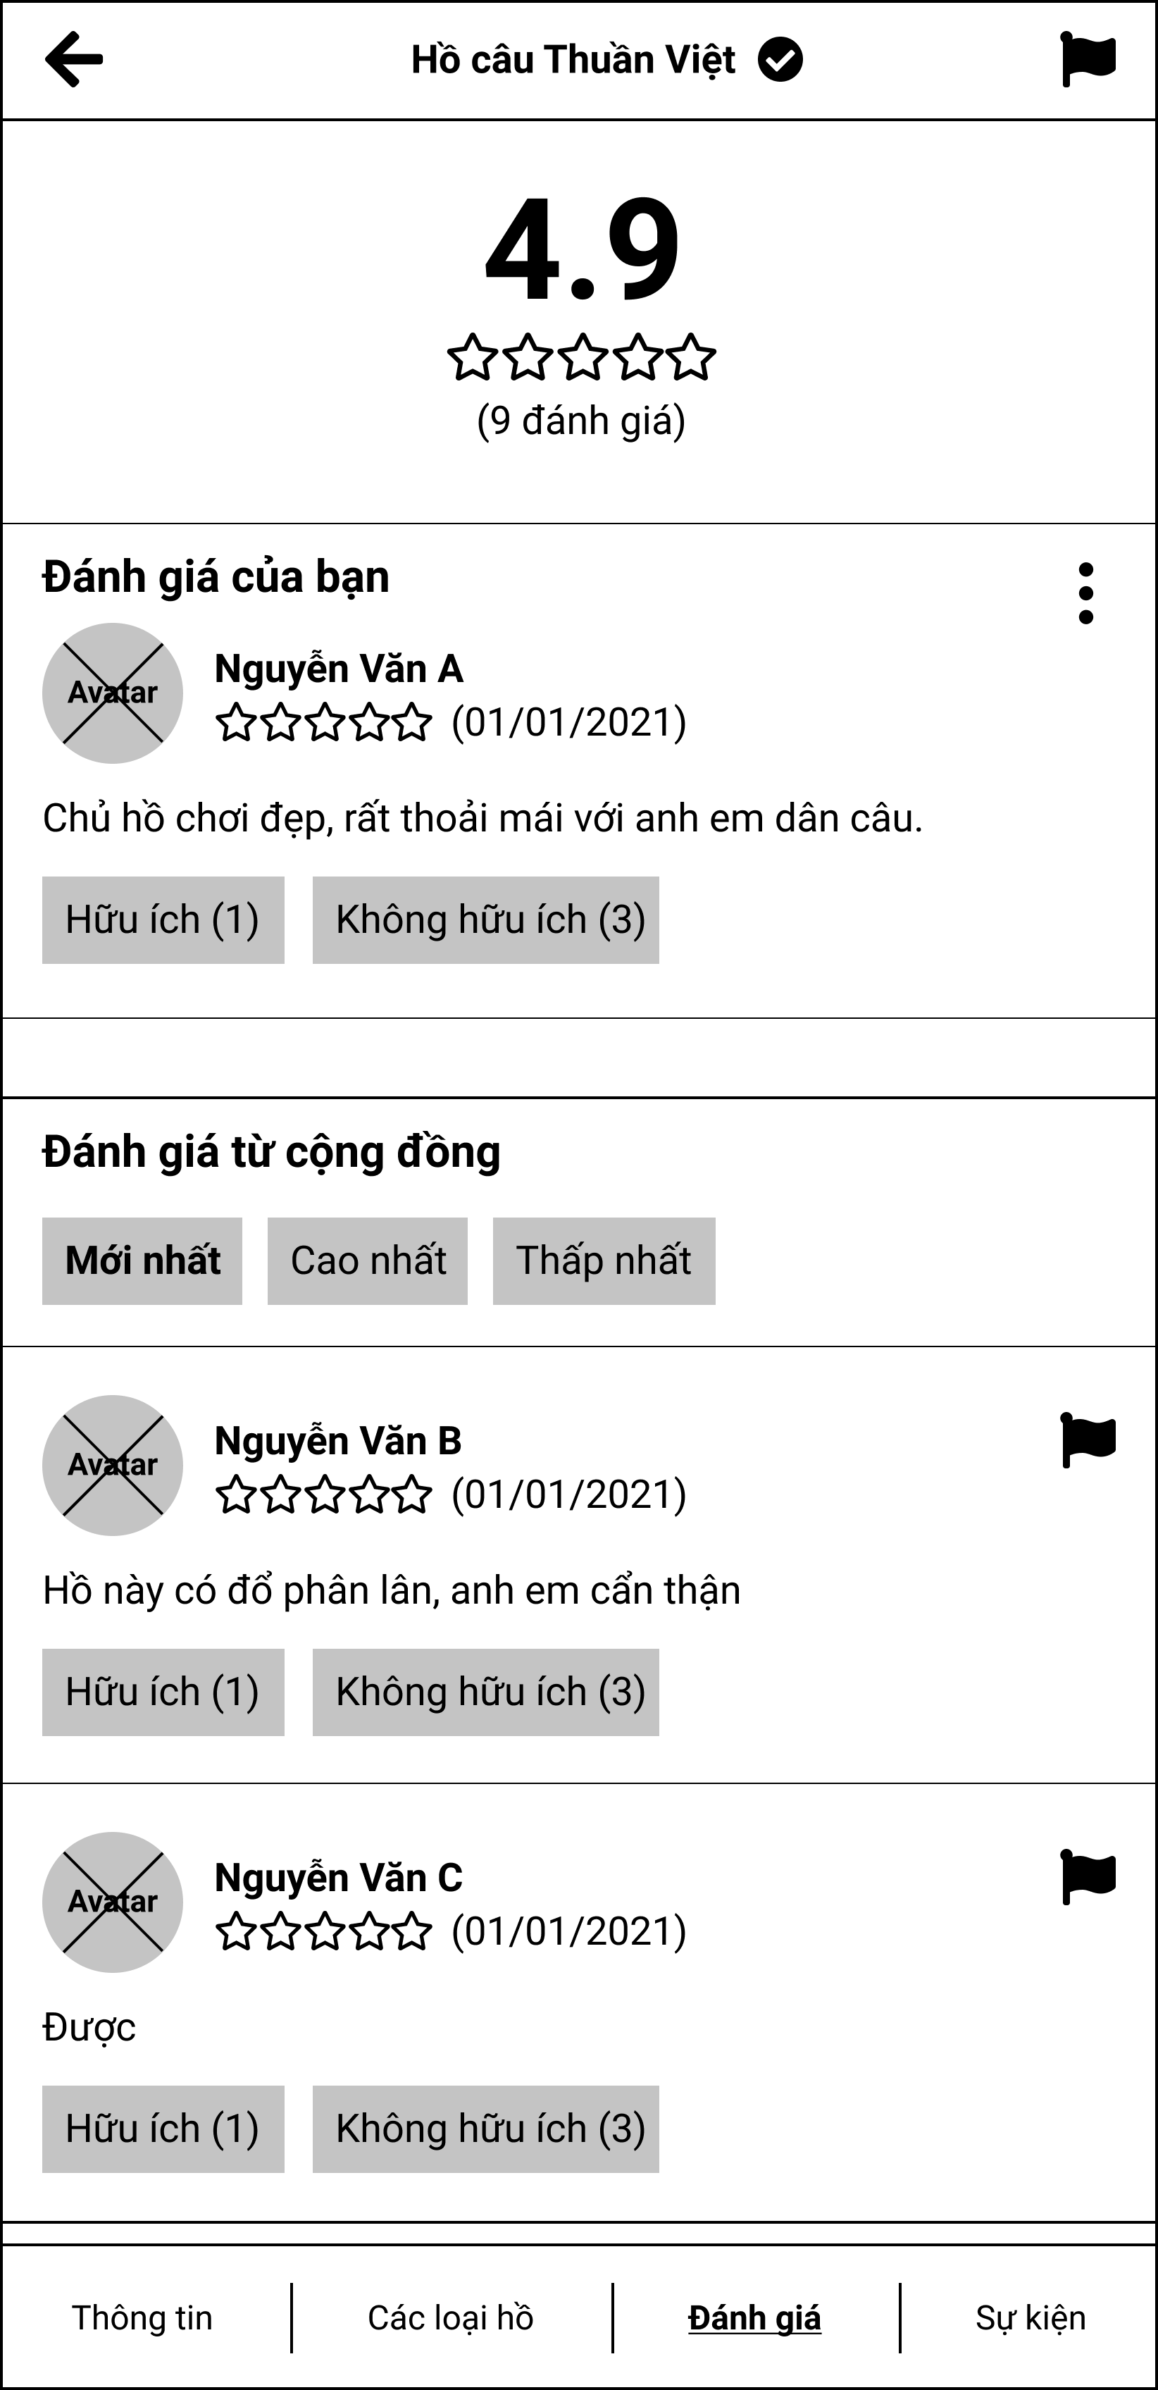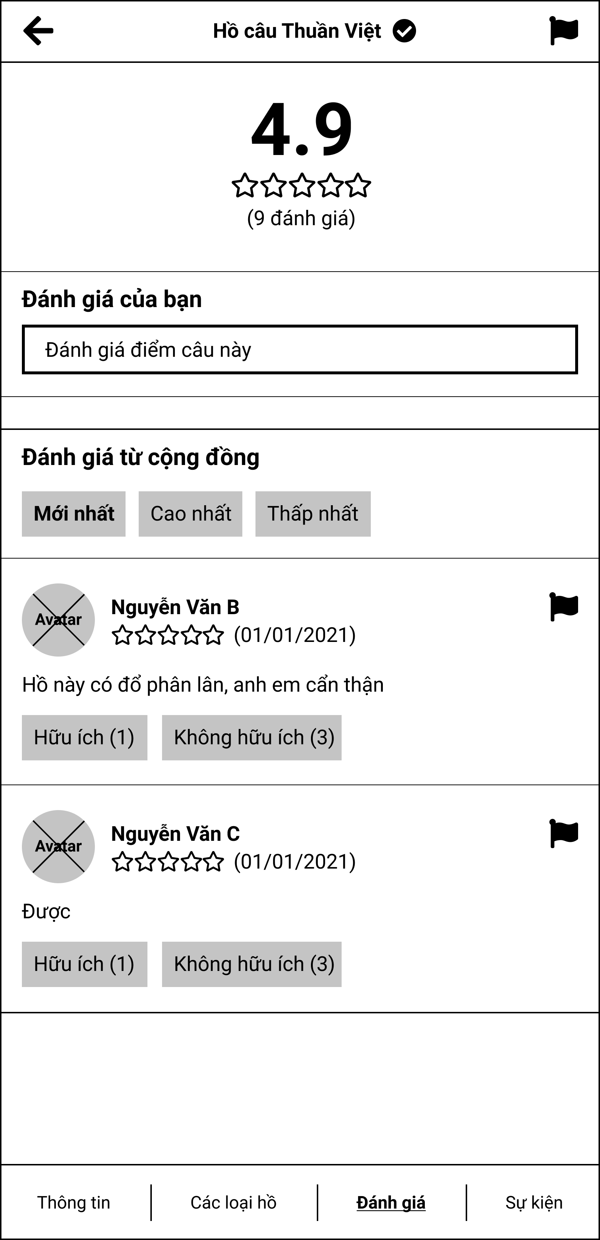

Figure 3.6.1. “View fishing location’s review” Mockup

|  |  |
| --- | --- |
| **Description** | The screen shows the full rating of a fishing location. |
| **Functional requirement** | * Filter has only 3 modes: newest, highest, lowest. With newest as default. * The review card must show full avatar, full name, score, description, and number of votes. * Personal reviews will not be allowed if the user has not been here before. |

#### 3.6.2. Post personal review

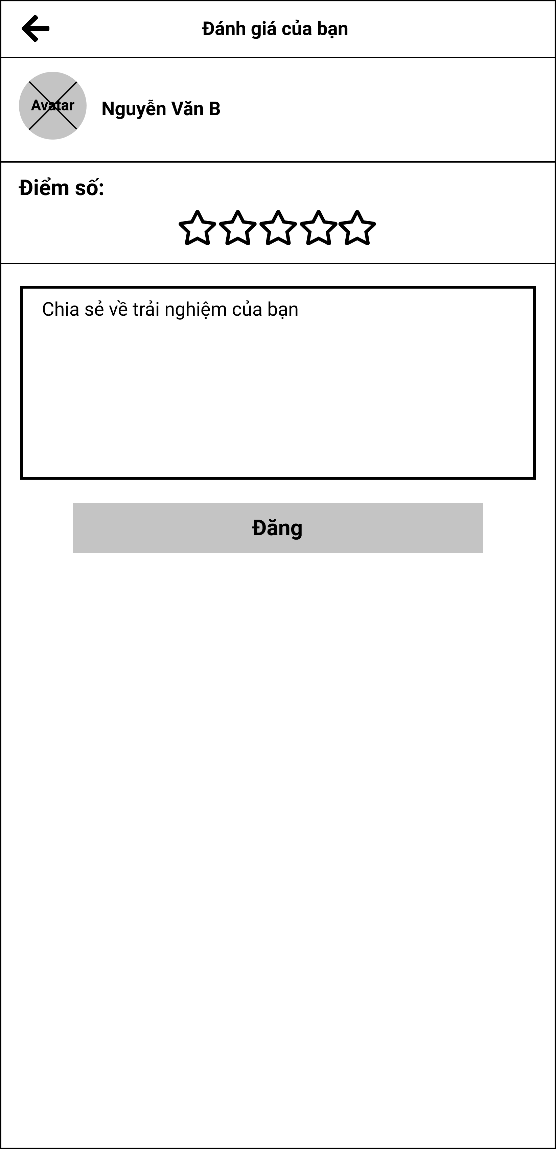

Figure 3.6.2. “Post personal review” Mockup

|  |  |
| --- | --- |
| **Description** | The screen allows the user to post a review for a fishing location. |
| **Functional requirement** | * Only rated when you've been to the fishing location. * The score must be an integer greater than 0. |

### 3.7. Feature “Manage check-in”

#### 3.7.1. Show QR code

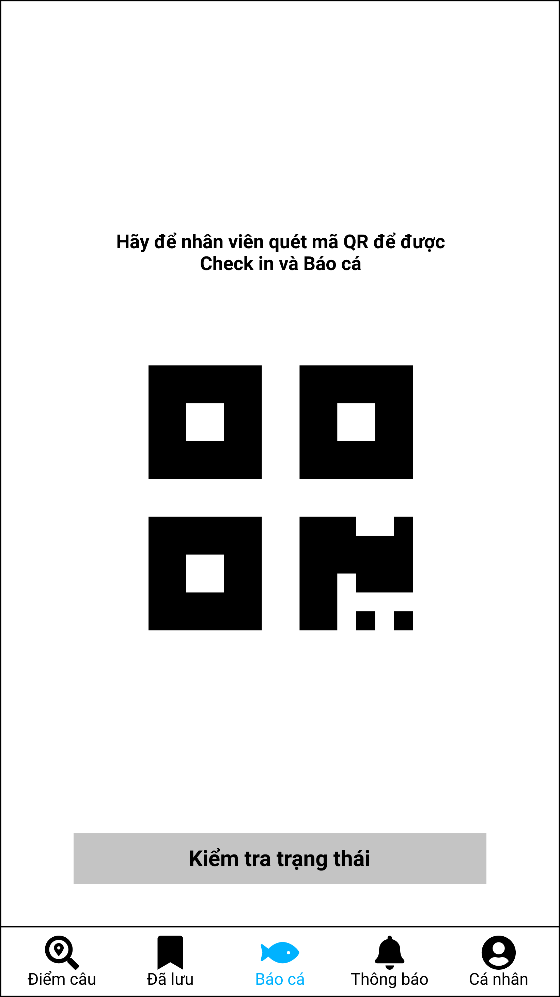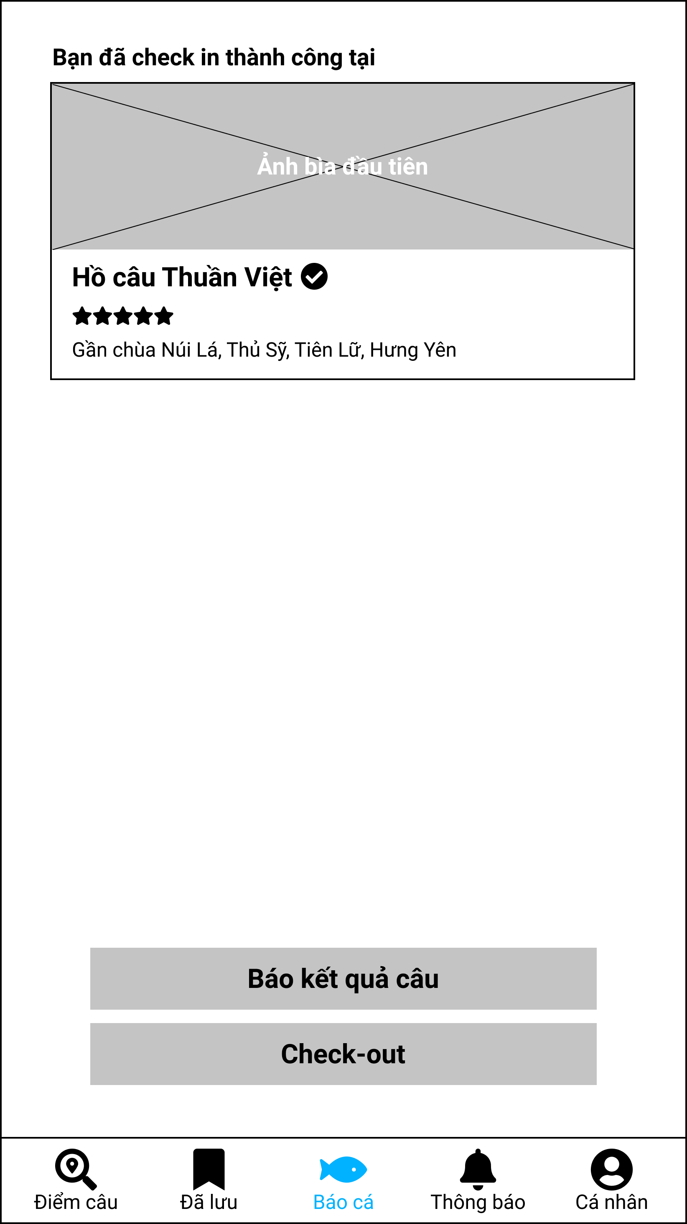

Figure 3.7.1. “Show QR code” Mockup

|  |  |
| --- | --- |
| **Description** | The screen displays the user's QR code, and checks whether the user has checked-in at the fishing location or not. |
| **Functional requirement** | * The QR code must have a logo in the middle. * When check-in is successful, the fishing location tab must be displayed at the top of the screen. |

#### 3.7.2. Scan QR

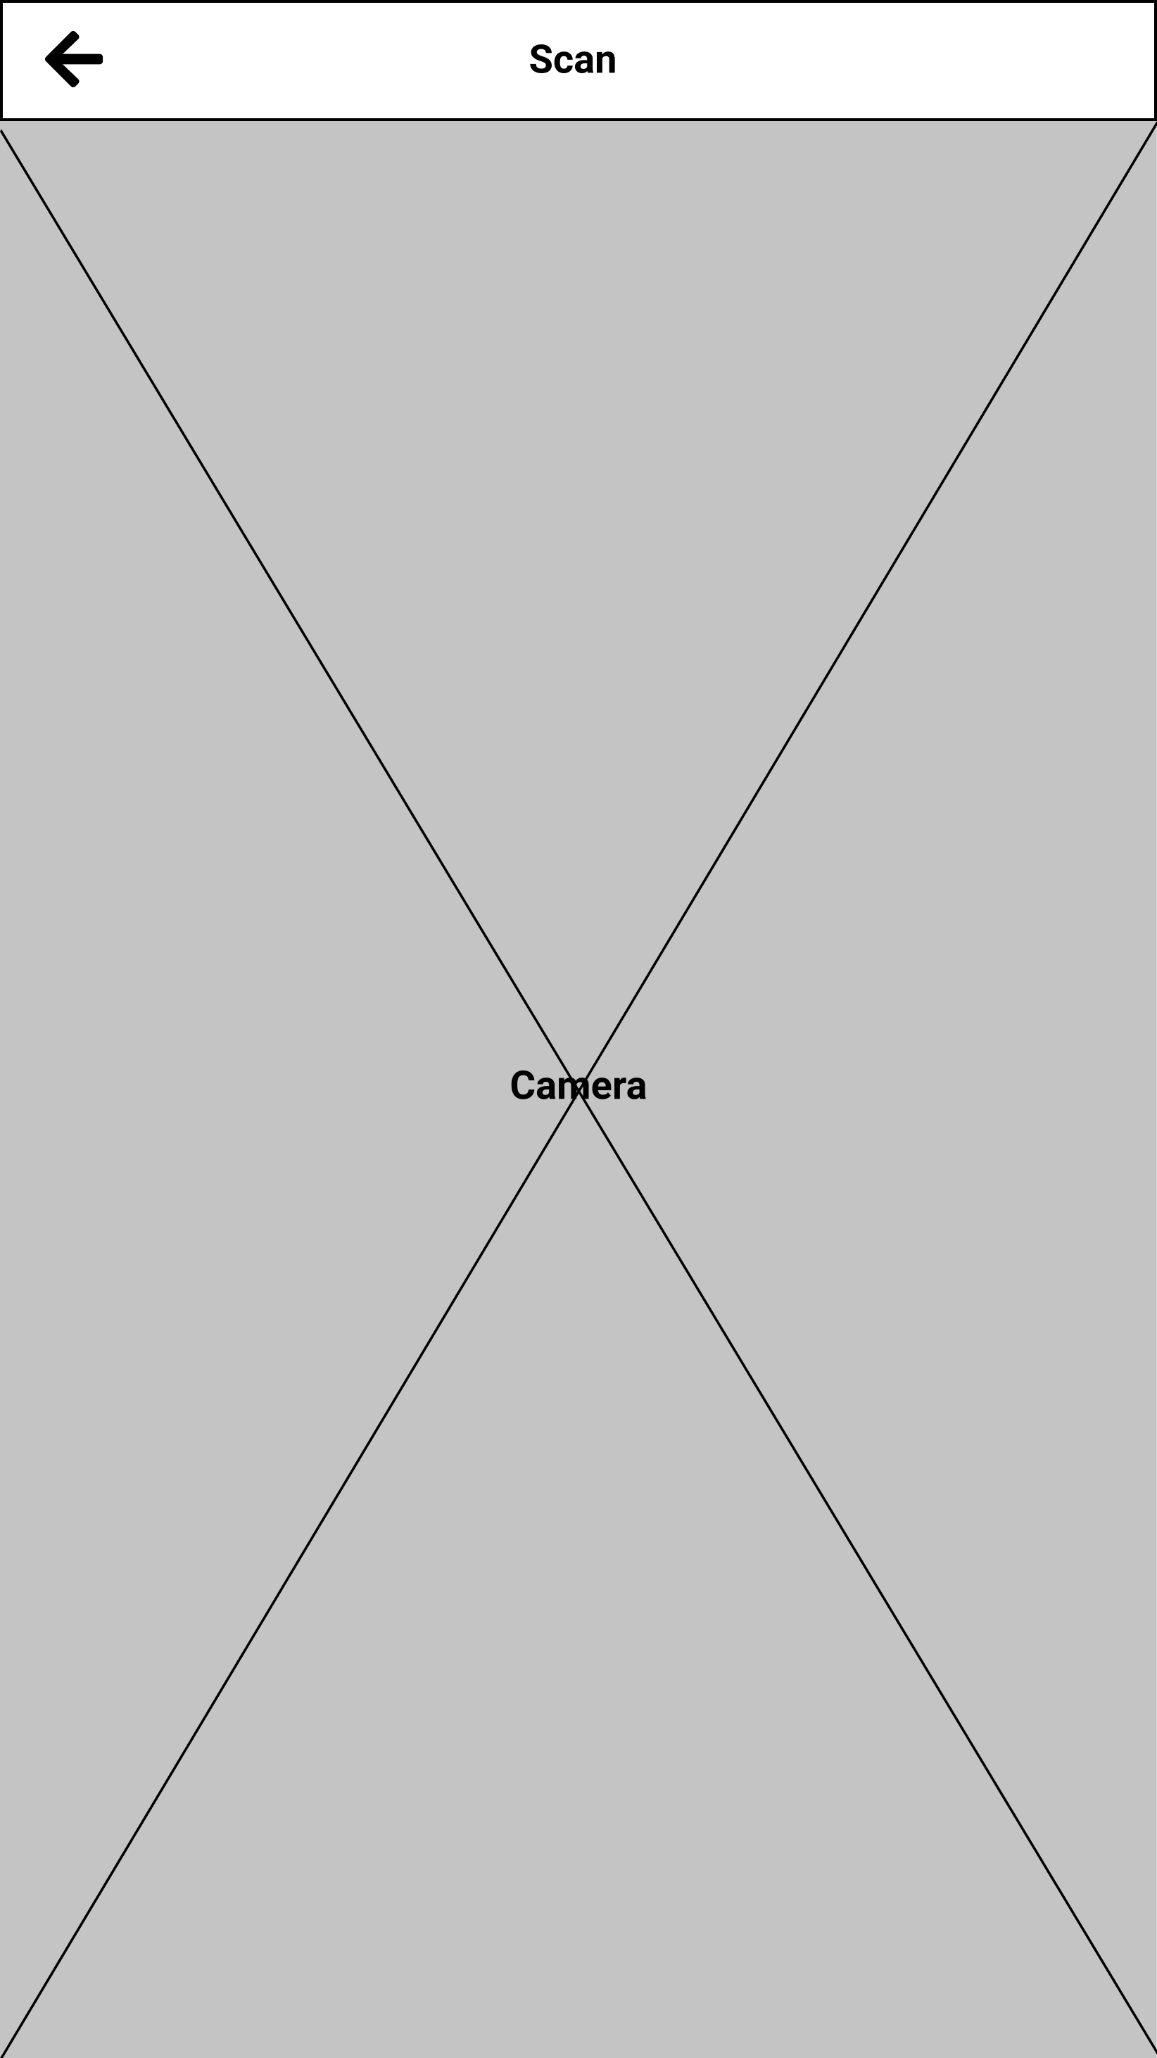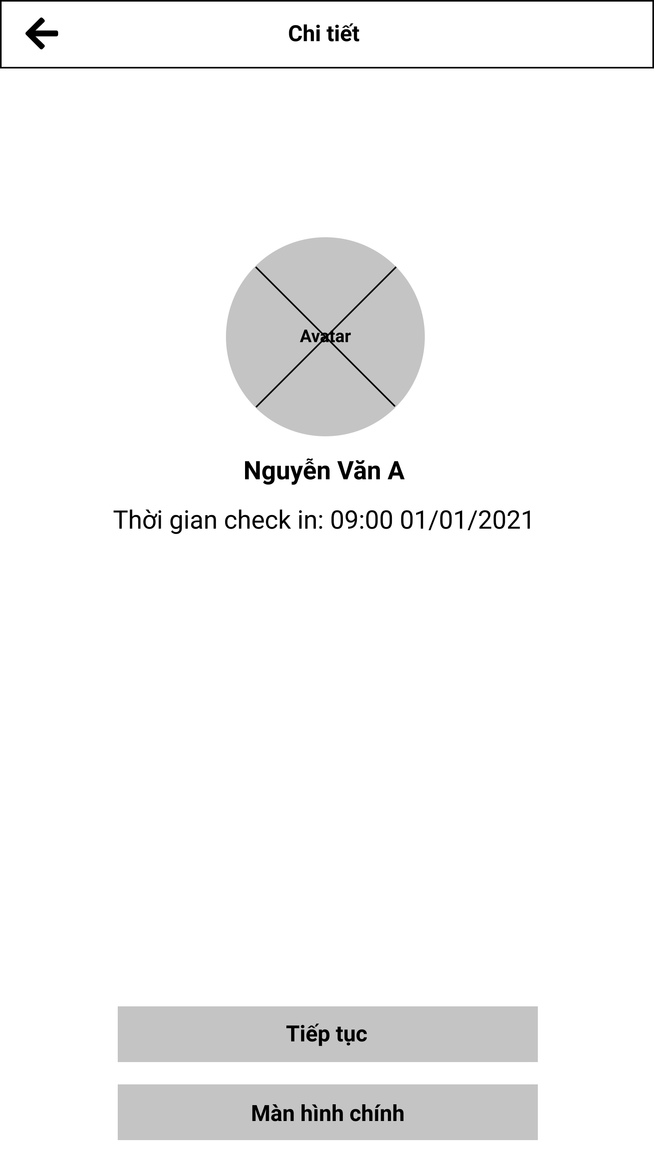

Figure 3.7.2. “Scan QR” Mockup

|  |  |
| --- | --- |
| **Description** | This screen allows the management of fishing location to scan QR codes of users in the system. |
| **Functional requirement** | * When scanning is successful, only the user's name, avatar and check-in time are displayed. |

#### 3.7.3. View personal check-in history

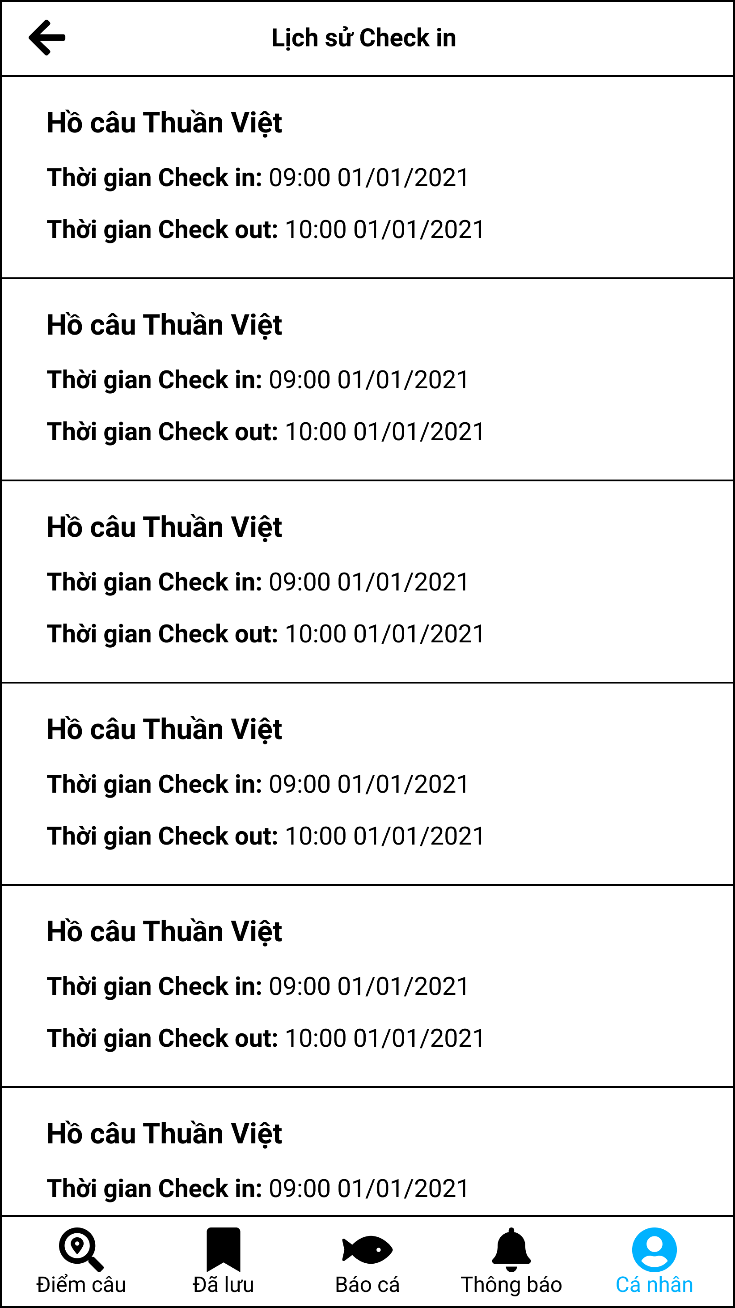

Figure 3.7.3. “View personal check-in history” Mockup

|  |  |
| --- | --- |
| **Description** | The screen allows users to review the check-in history at fishing locations in the system. |
| **Functional requirement** | * Each card is not clickable. * Show full check-in and check-out time. If user is not checked out yet, it must be displayed correctly. |

#### 3.7.4. View fishing location’s check-in history

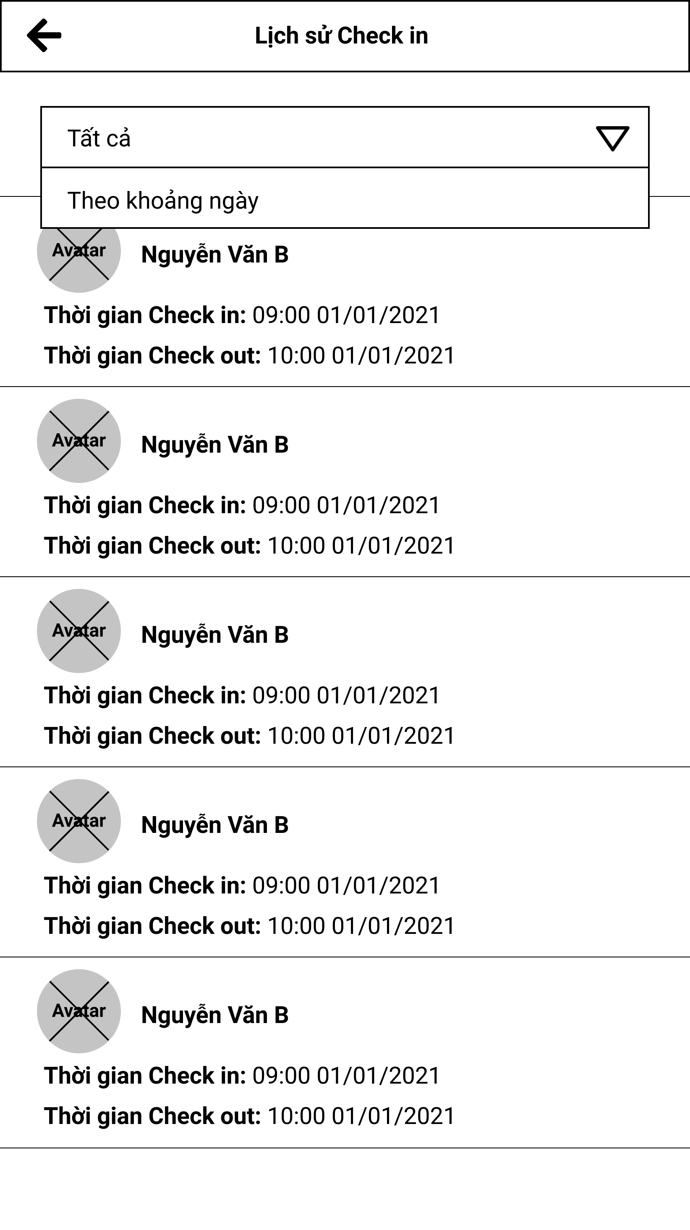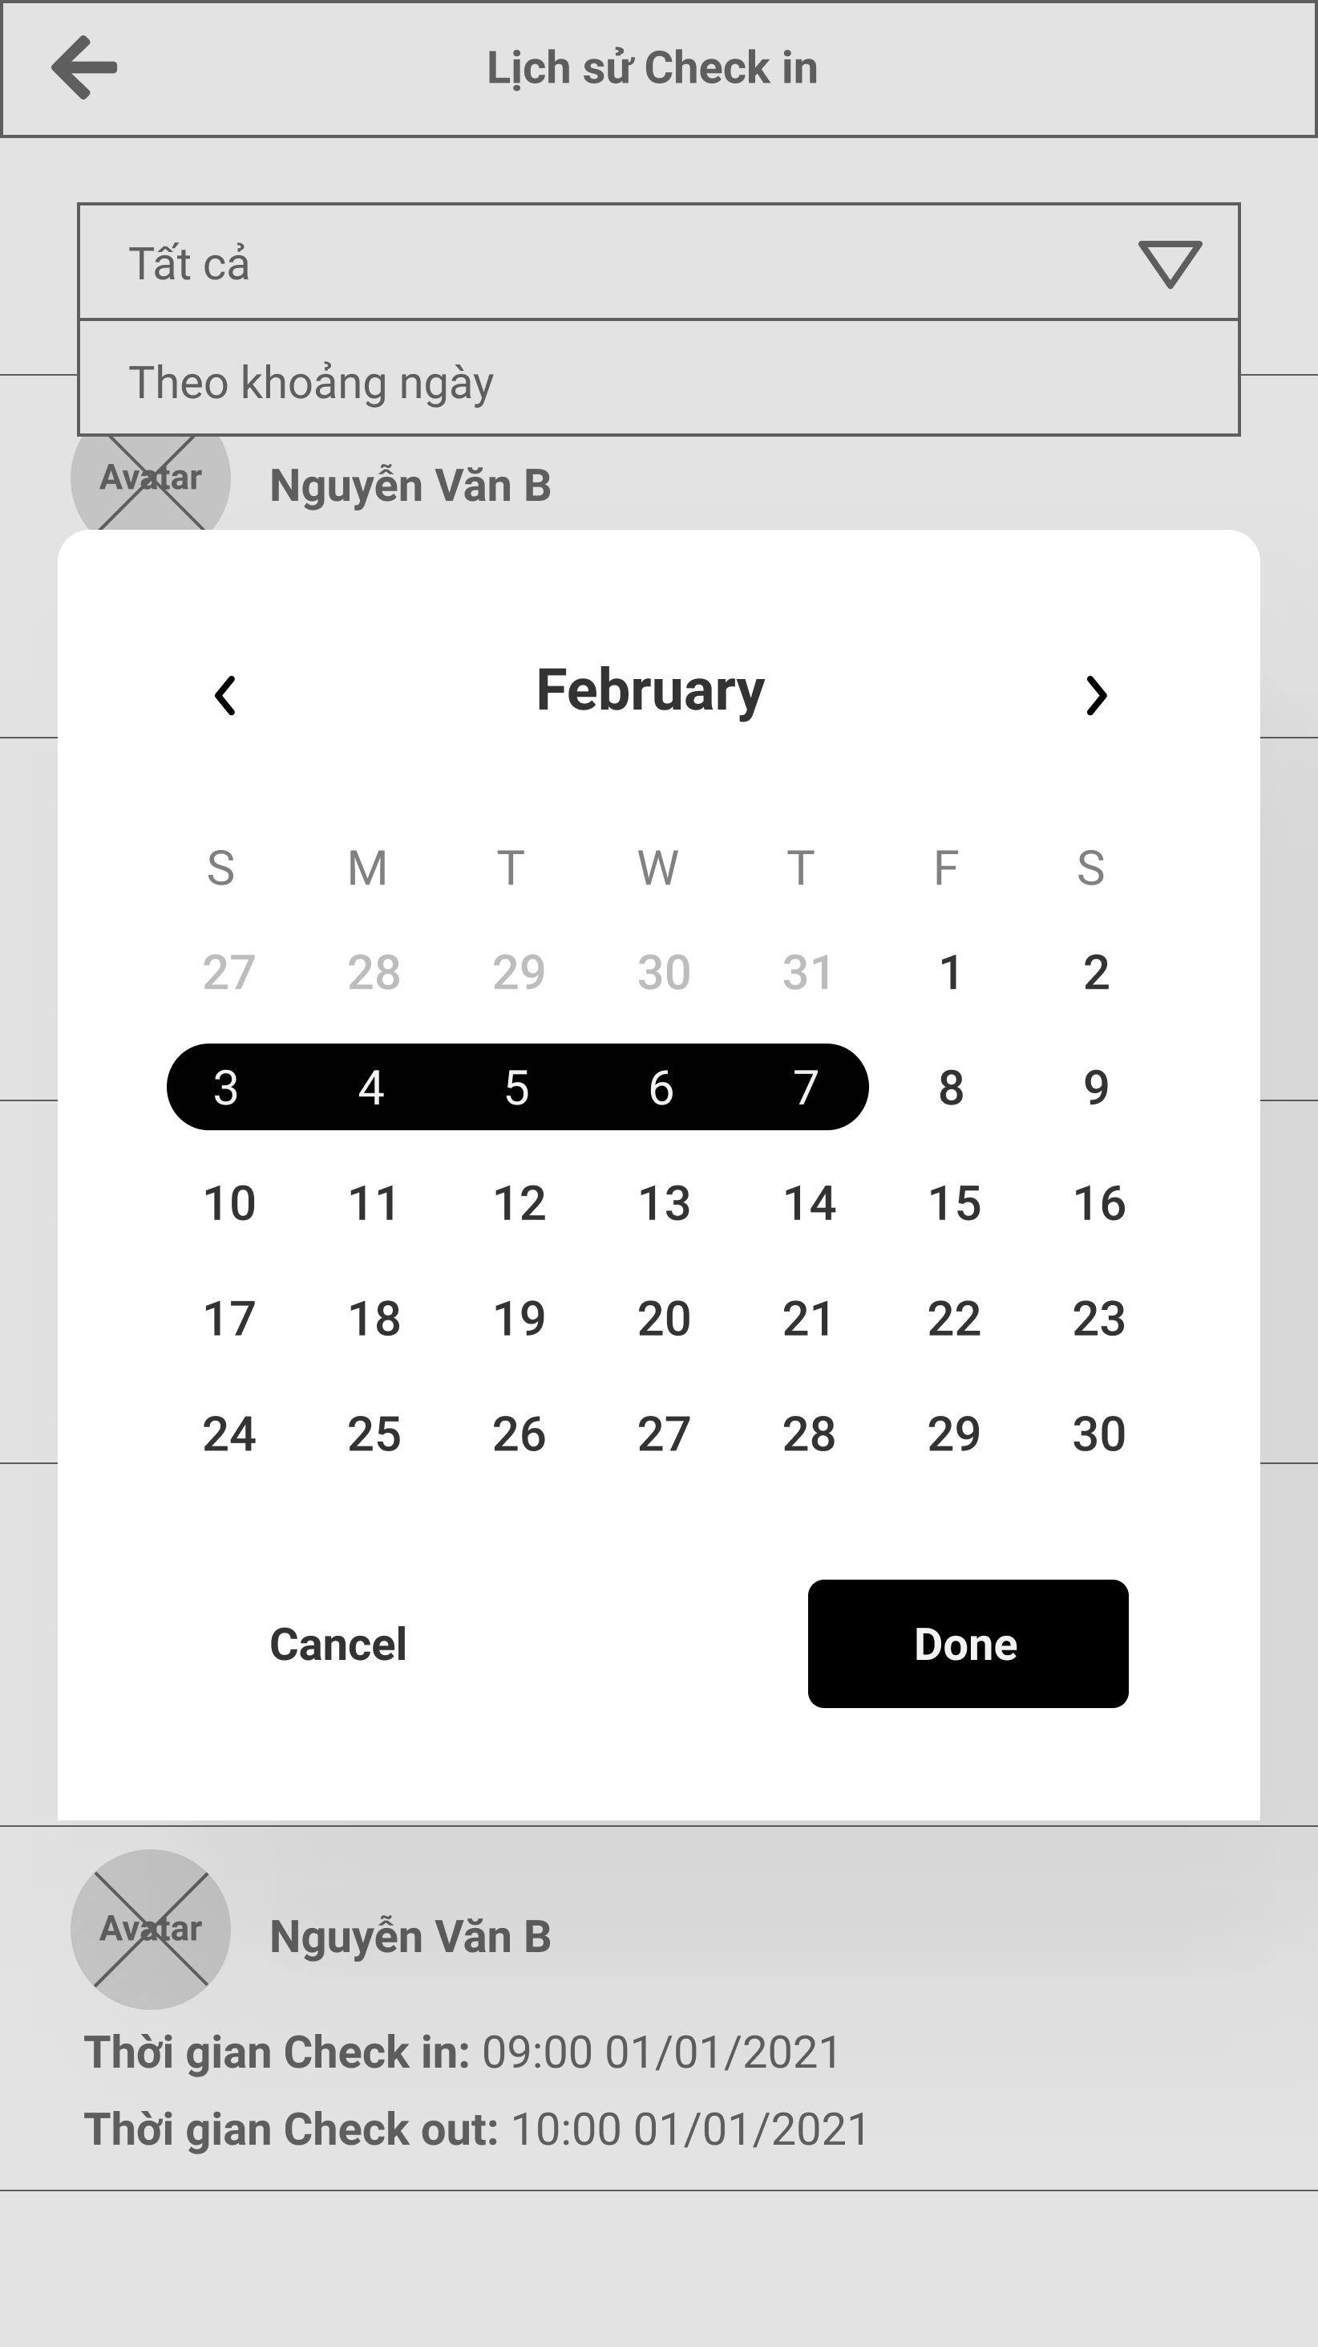

Figure 3.7.4. “View fishing location’s check-in history” Mockup

|  |  |
| --- | --- |
| **Description** | This screen allows management to monitor the user's check-in history in the system. |
| **Functional requirement** | * Choose a date must have these options: between two dates, within a day. |

### 3.8. Feature “Manage catch reports”

#### 3.8.1. Report catch form

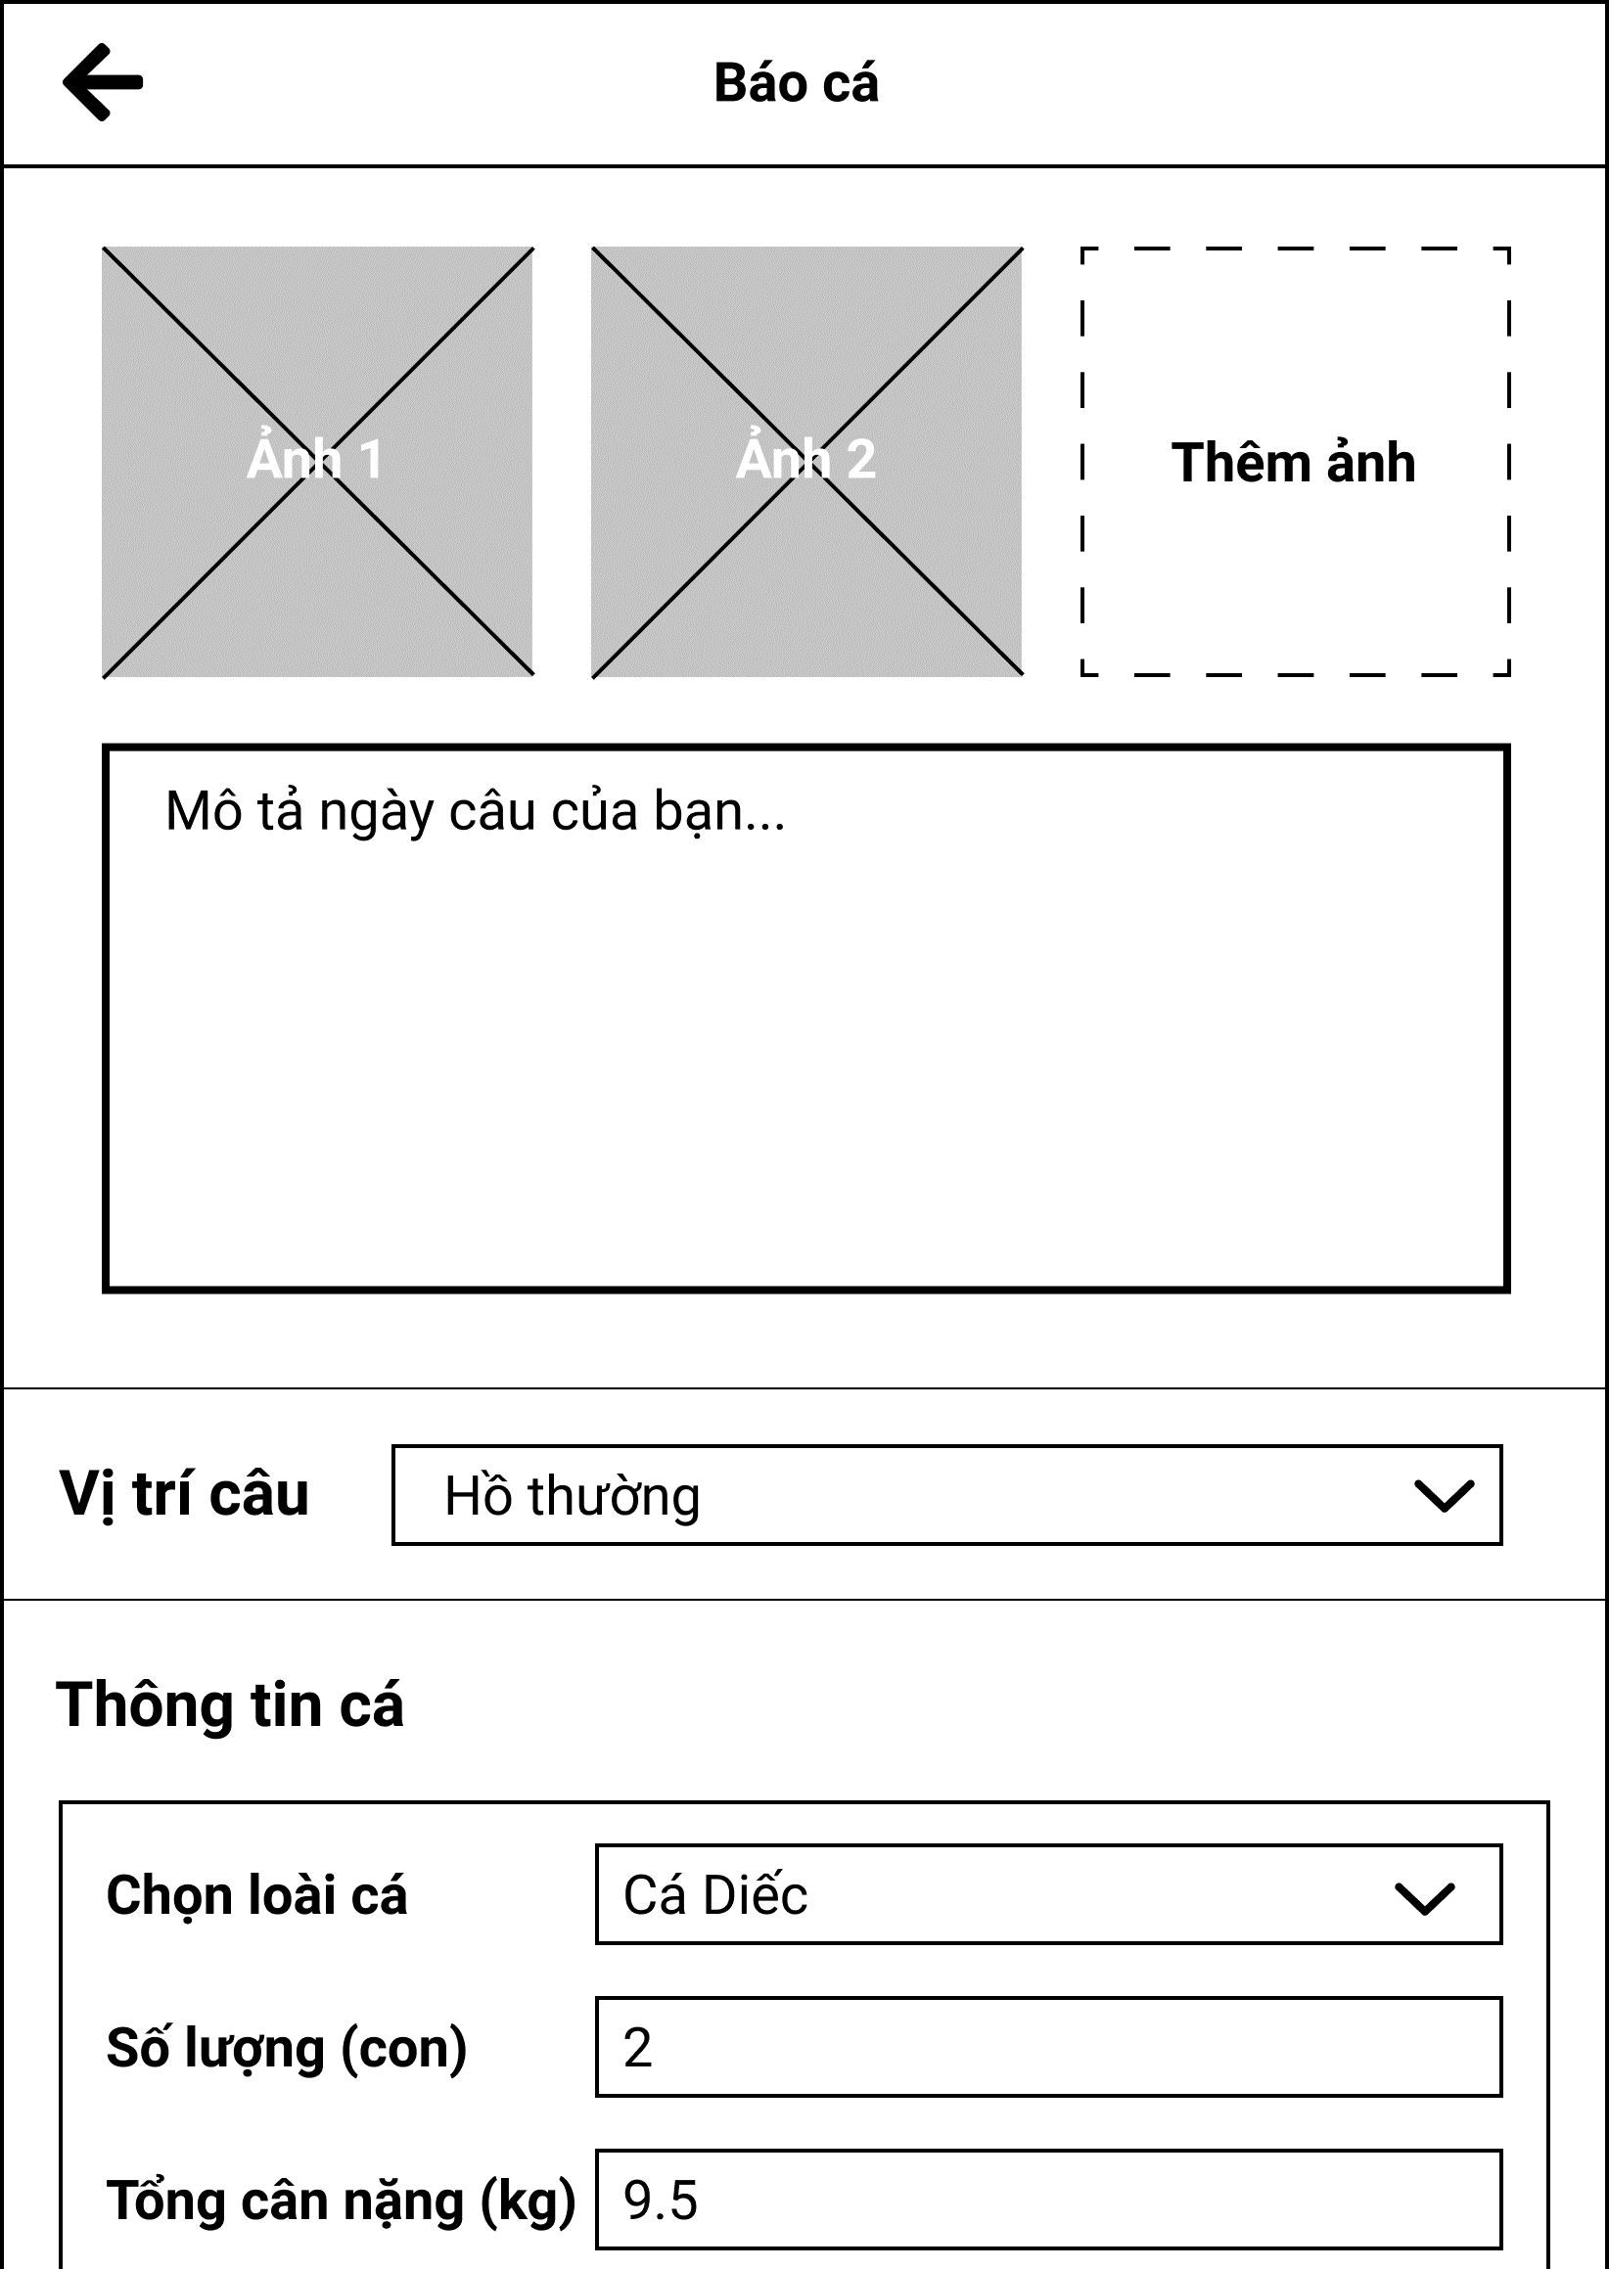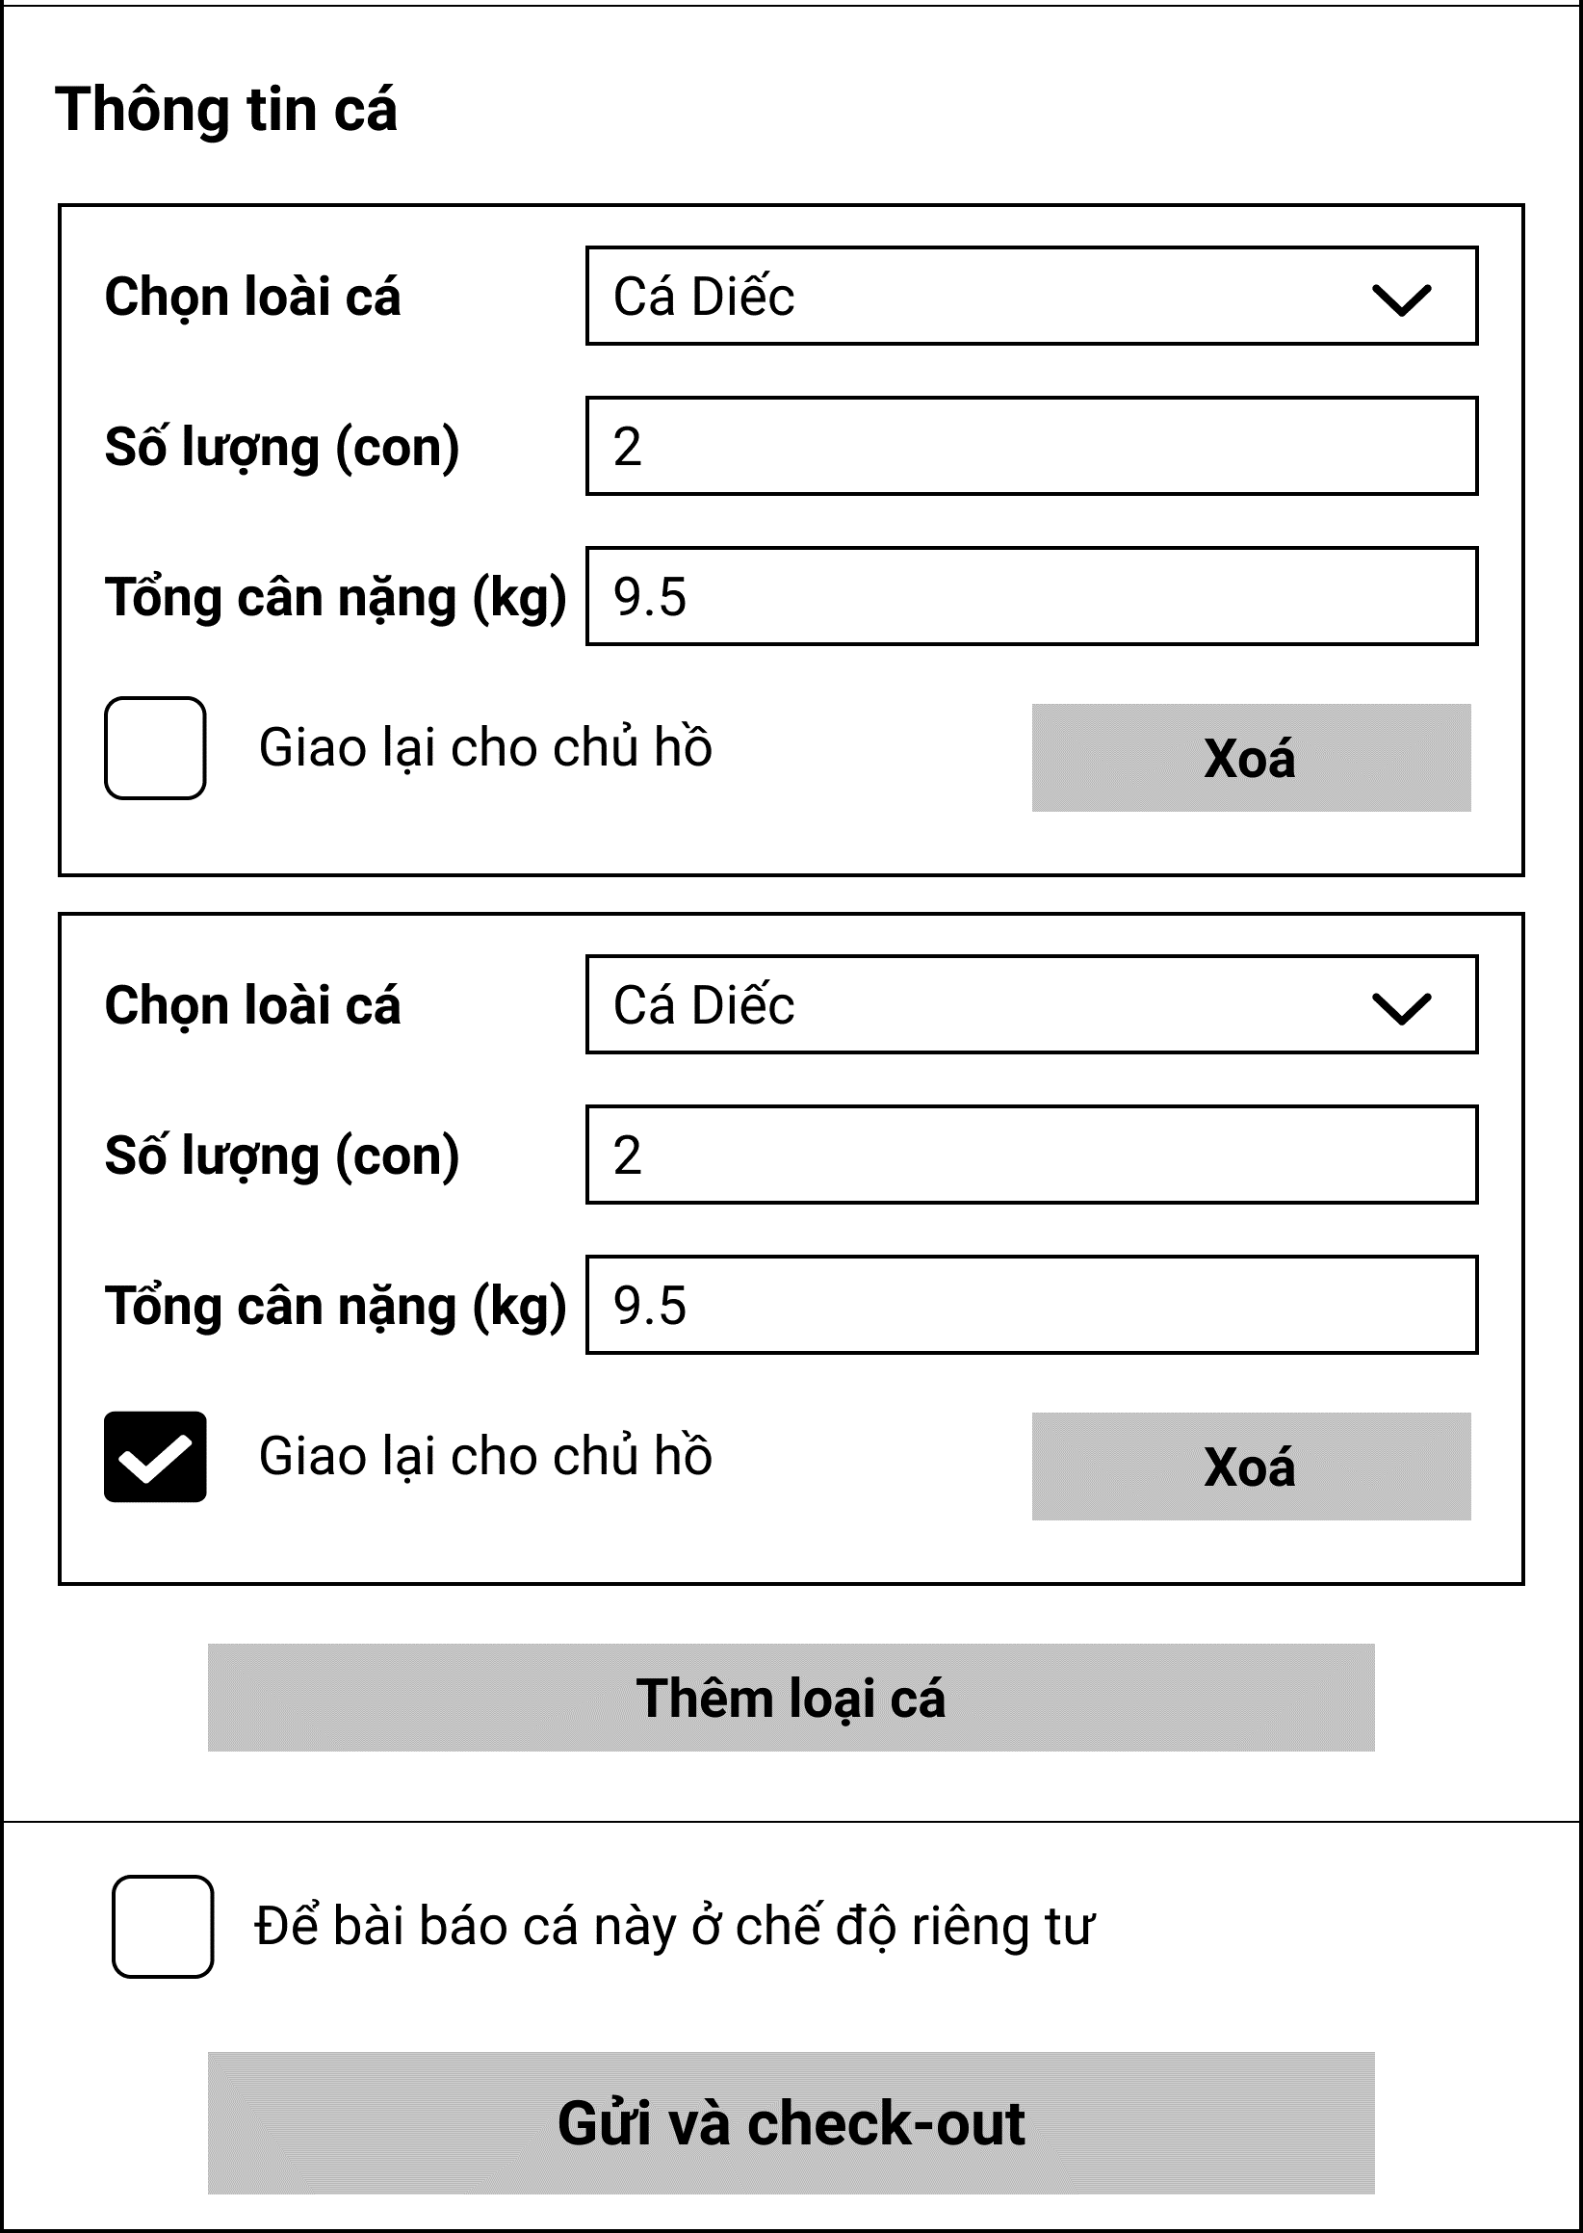

Figure 3.8.1. “Report catch form” Mockup

|  |  |
| --- | --- |
| **Description** | The screen allows users to report their fishing results at a fishing location. |
| **Functional requirement** | * The number of fish selection cards should be limited to 10. |

#### 3.8.2. View pending catch reports

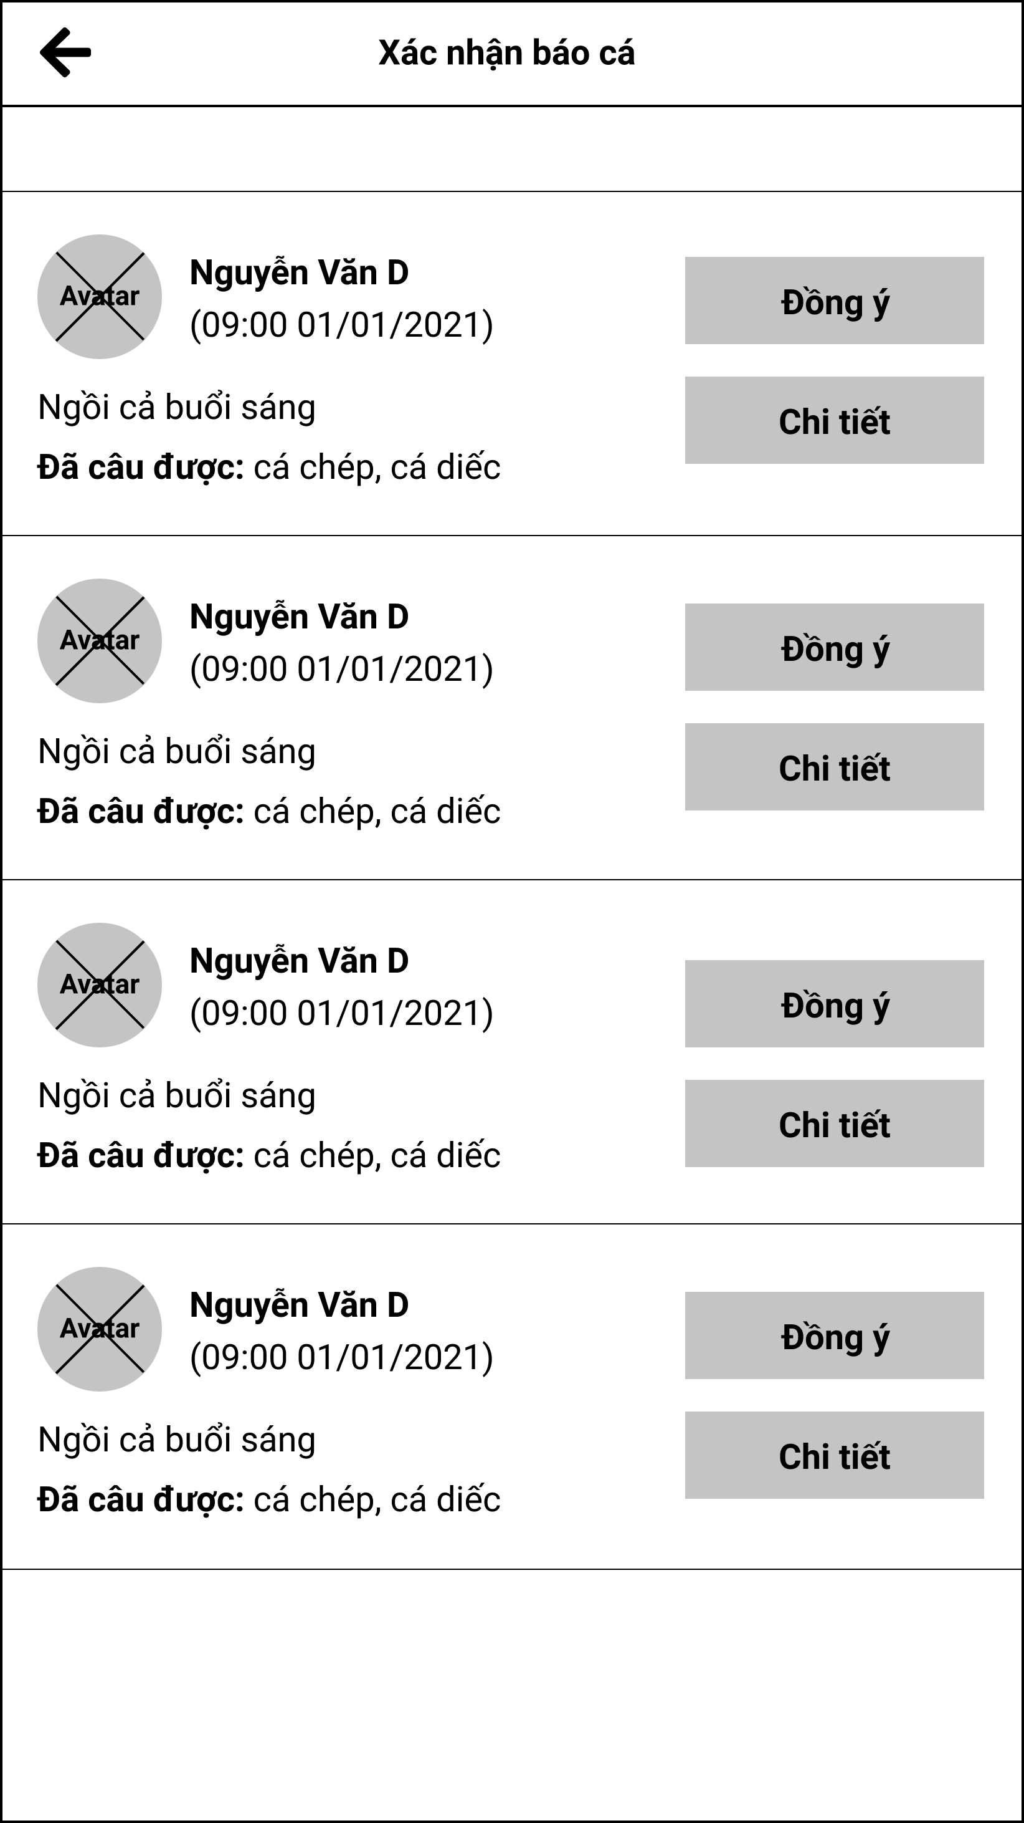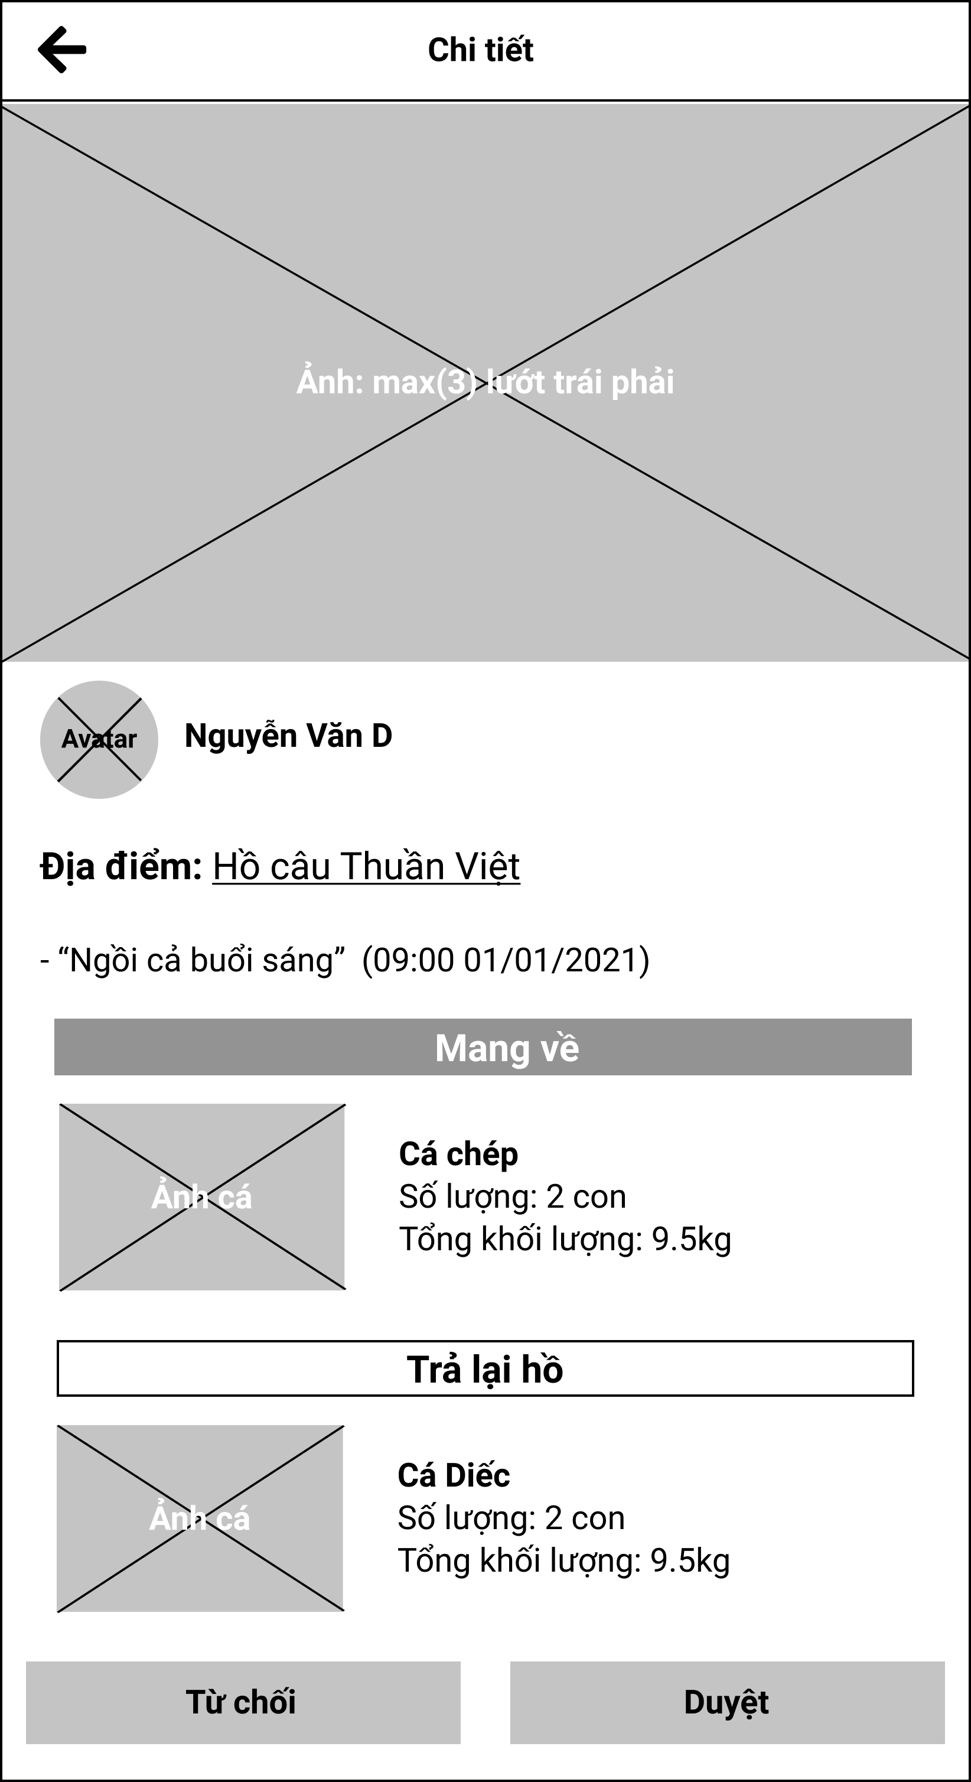

Figure 3.8.2. “View pending catch reports” Mockup

|  |  |
| --- | --- |
| **Description** | The screen displays the fishing results reports that need to be approved by the fishing location manager. |
| **Functional requirement** | * Fish species should be clearly divided into what user can bring in and what user want to return. |

#### 3.8.3. View personal catch history

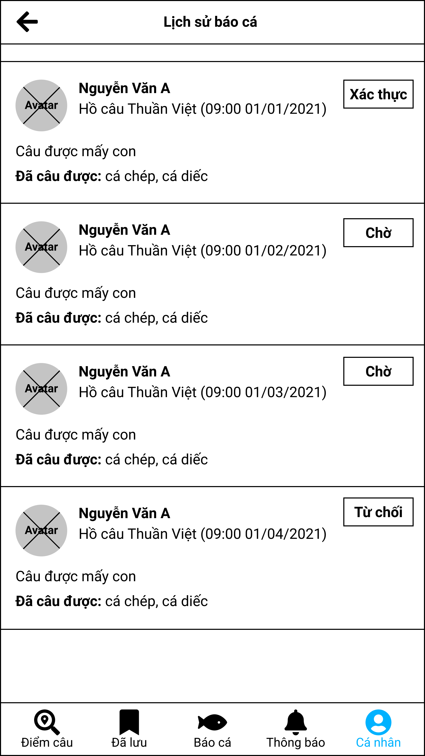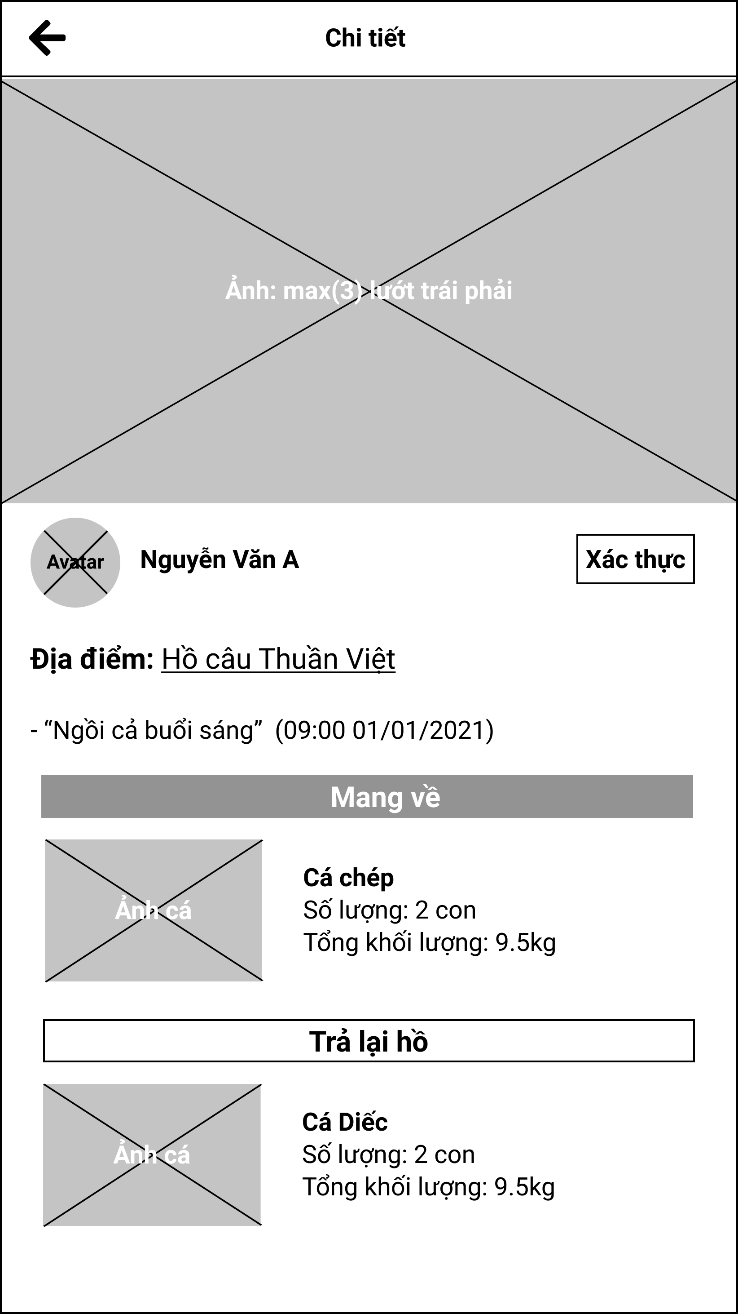

Figure 3.8.3. “View personal catch history” Mockup

|  |  |
| --- | --- |
| **Description** | The screen displays the entire history of the user's catch report in the system of all fishing locations. |
| **Functional requirement** | * Fish species should be clearly divided into what user can bring in and what user want to return. |

#### 3.8.4. View fishing location’s catch history

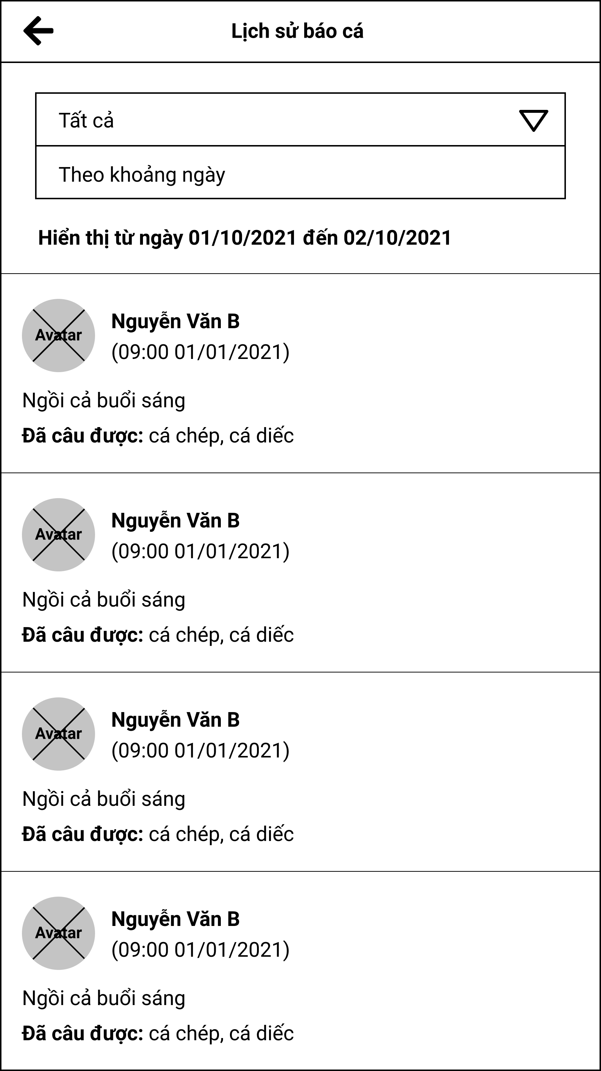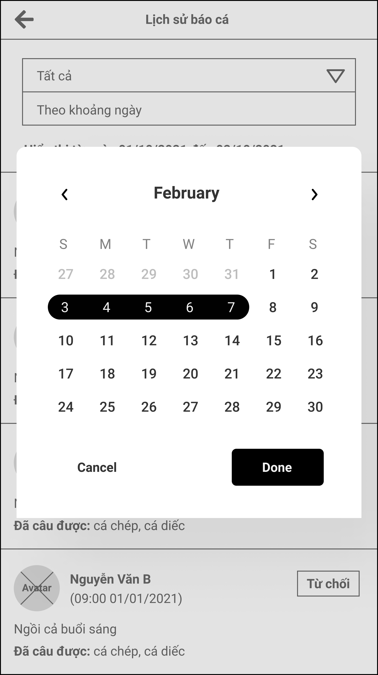

Figure 3.8.4. “View fishing location’s catch history” Mockup

|  |  |
| --- | --- |
| **Description** | The screen allows managers to view the history of catch reports in their fishing location. |
| **Functional requirement** | * Choose a date must have these options: between two dates, within a day. |

### 3.9. Feature “Manage fishing location’s profile”

#### 3.9.1. Add a fishing location form

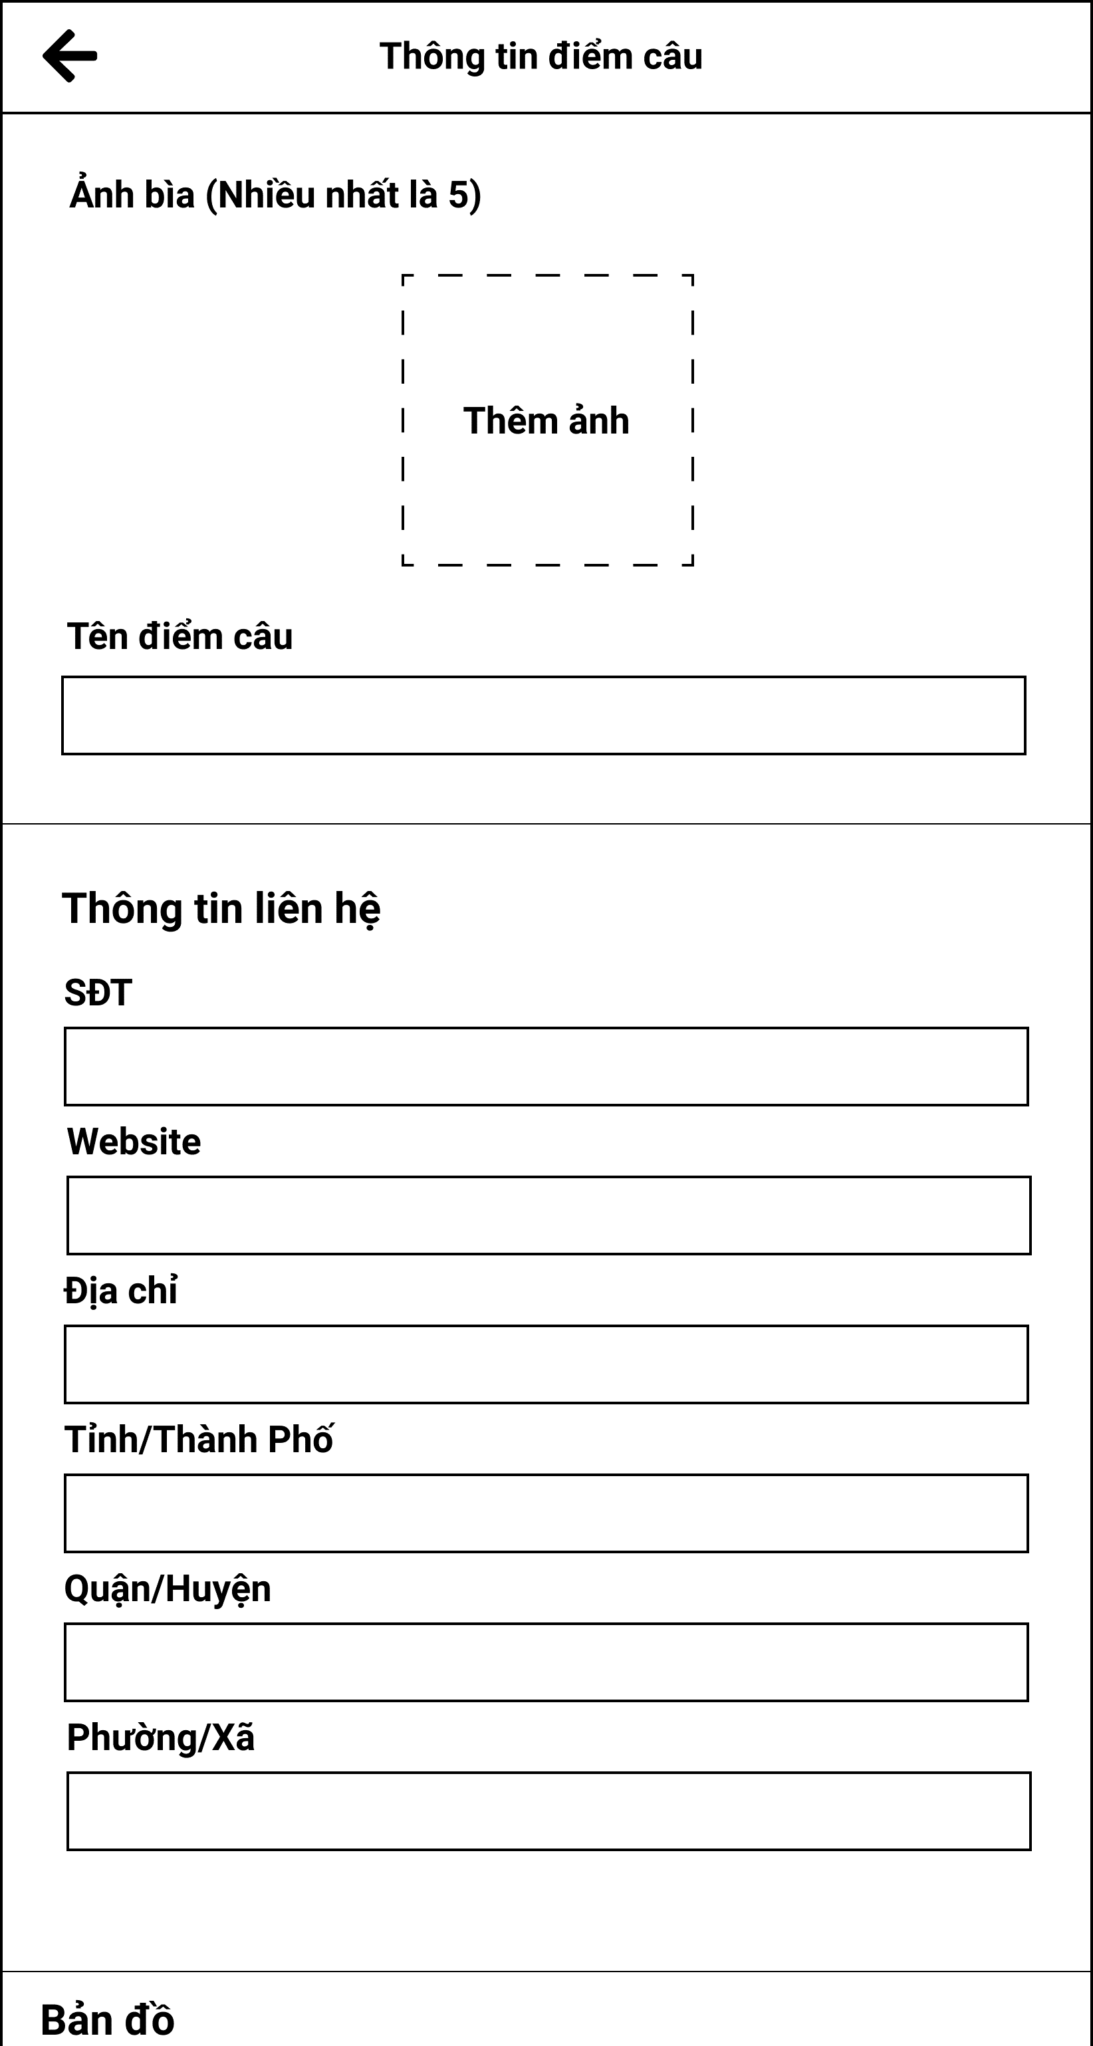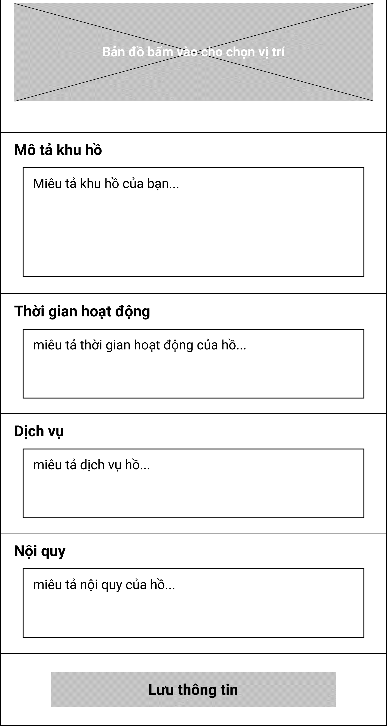

Figure 3.9.1. “Add a fishing location form” Mockup

|  |  |
| --- | --- |
| **Description** | The screen allows the user to create a self-managed fishing location. |
| **Functional requirement** | * Provinces, districts, and wards are limited to the Vietnam region only. * All information must be completely entered by the user and cannot be left blank except for the website. |

#### 3.9.2. Add lake form

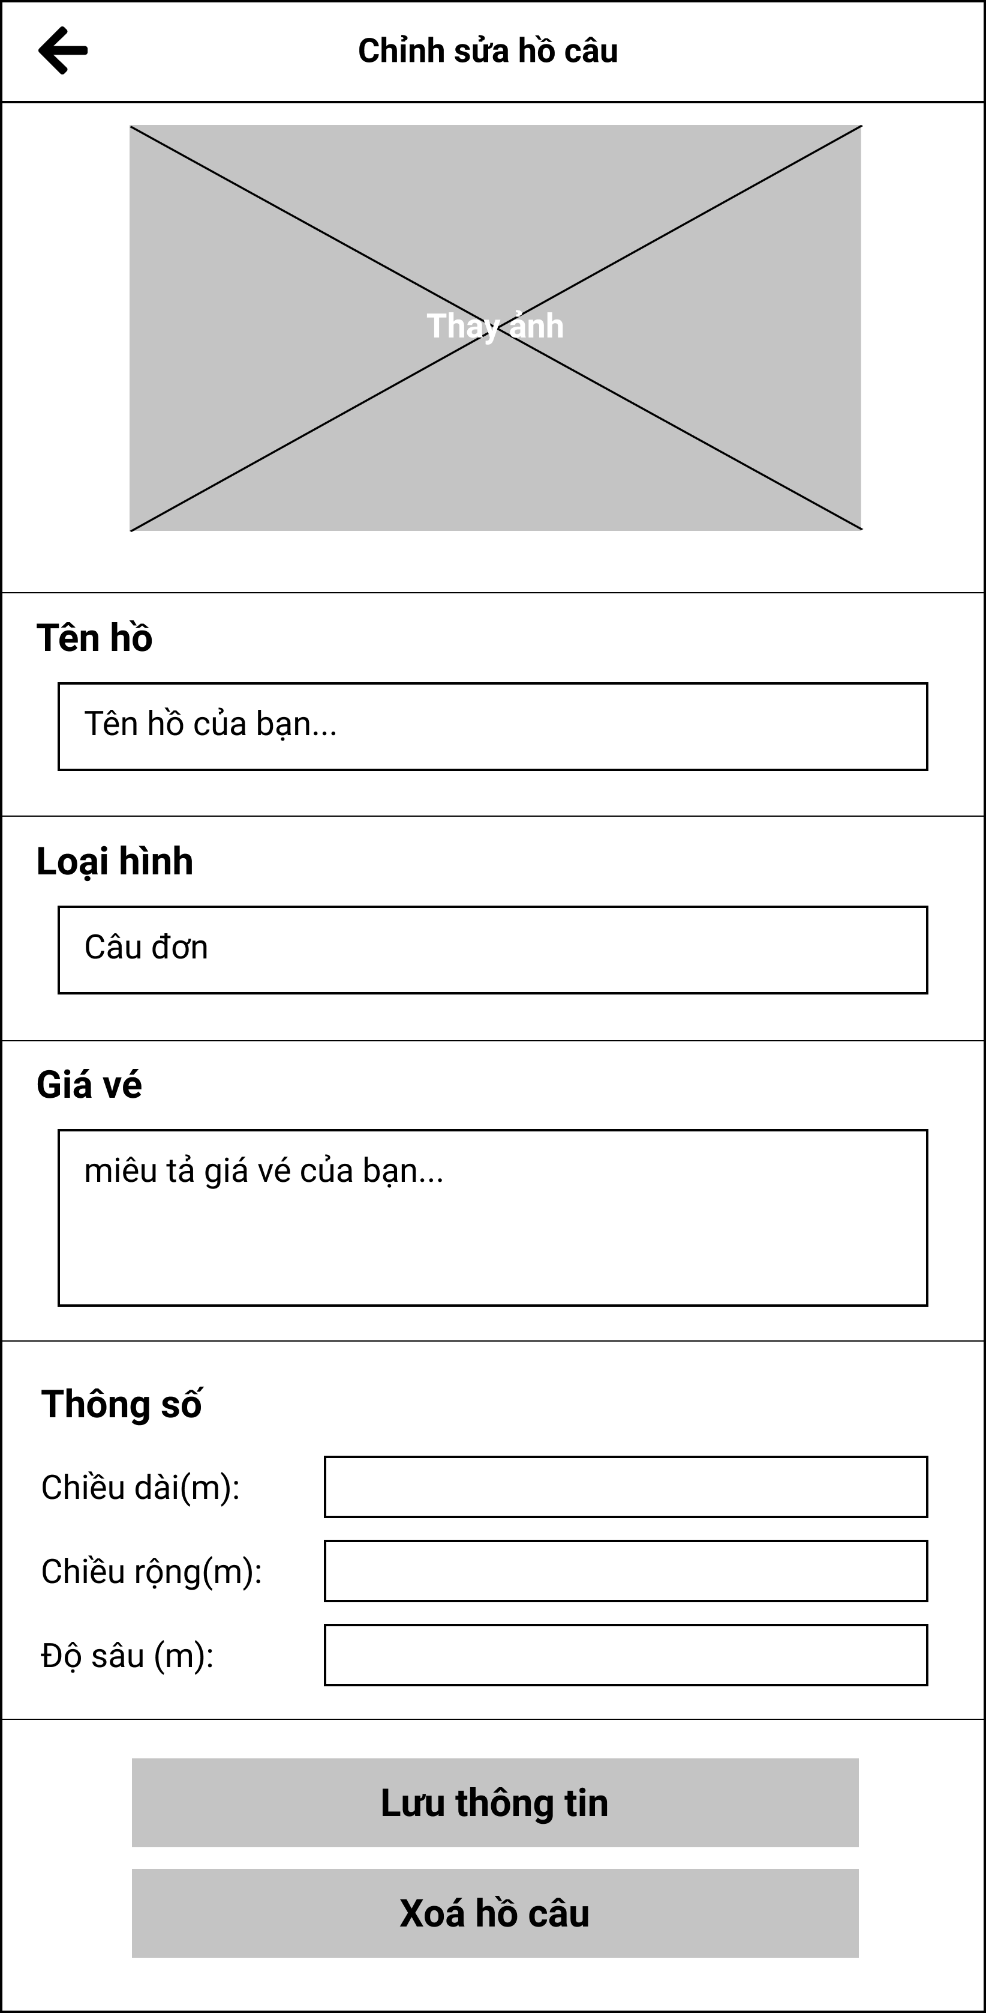

Figure 3.9.2. “Add lake form” Mockup

|  |  |
| --- | --- |
| **Description** | The screen allows managers to add a new lake to their fishing location. |
| **Functional requirement** | * Tickets and statistics when displayed later will be a bullet list. * Statistics is limited to floats greater than zero. |

#### 3.9.3. Add fish in lake

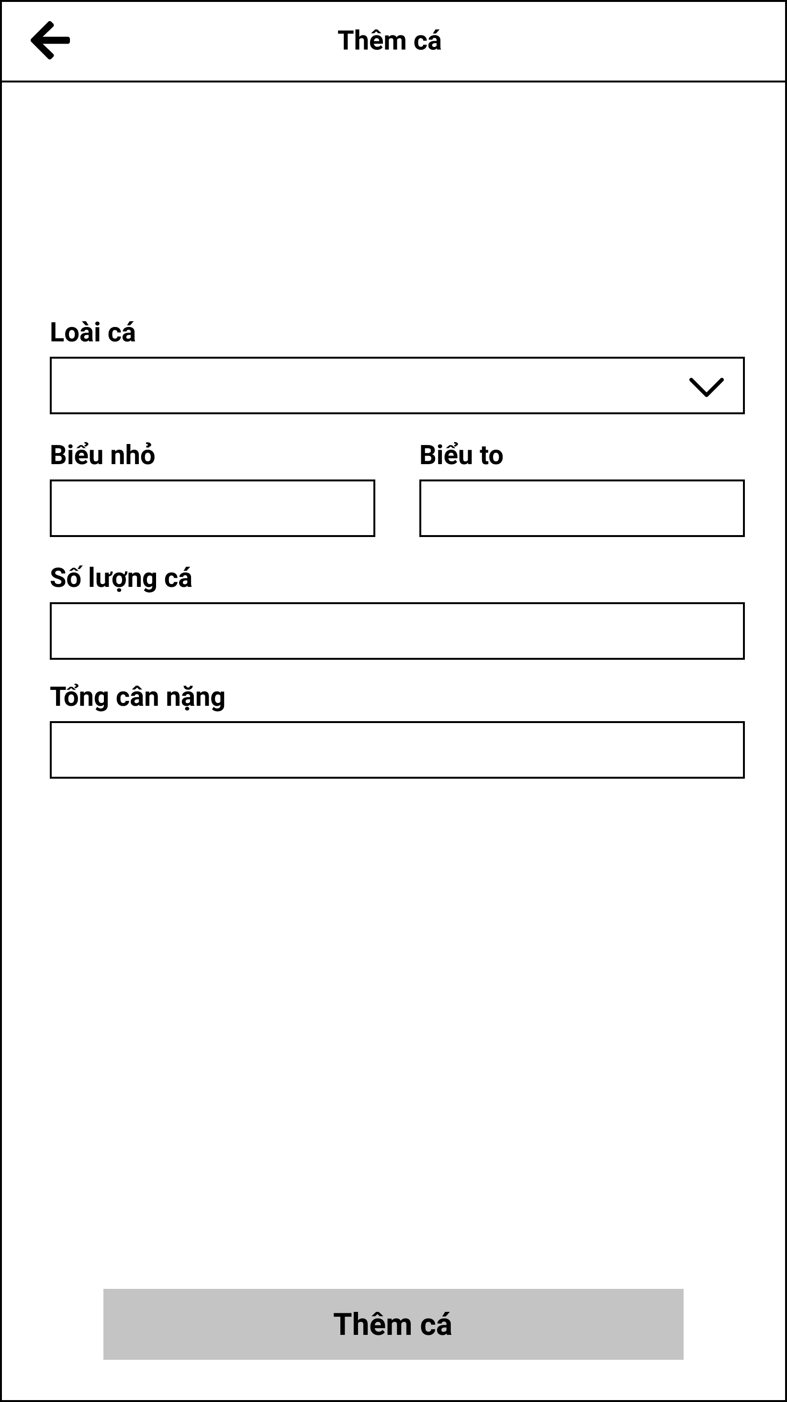

Figure 3.9.3. “Add fish in lake” Mockup

|  |  |
| --- | --- |
| **Description** | The screen allows the manager to add a fish to his lake. |
| **Functional requirement** | * Statistics is limited to floats greater than zero. |

### 3.10. Feature “Manage system fishing locations”

#### 3.10.1. View and search system fishing location list

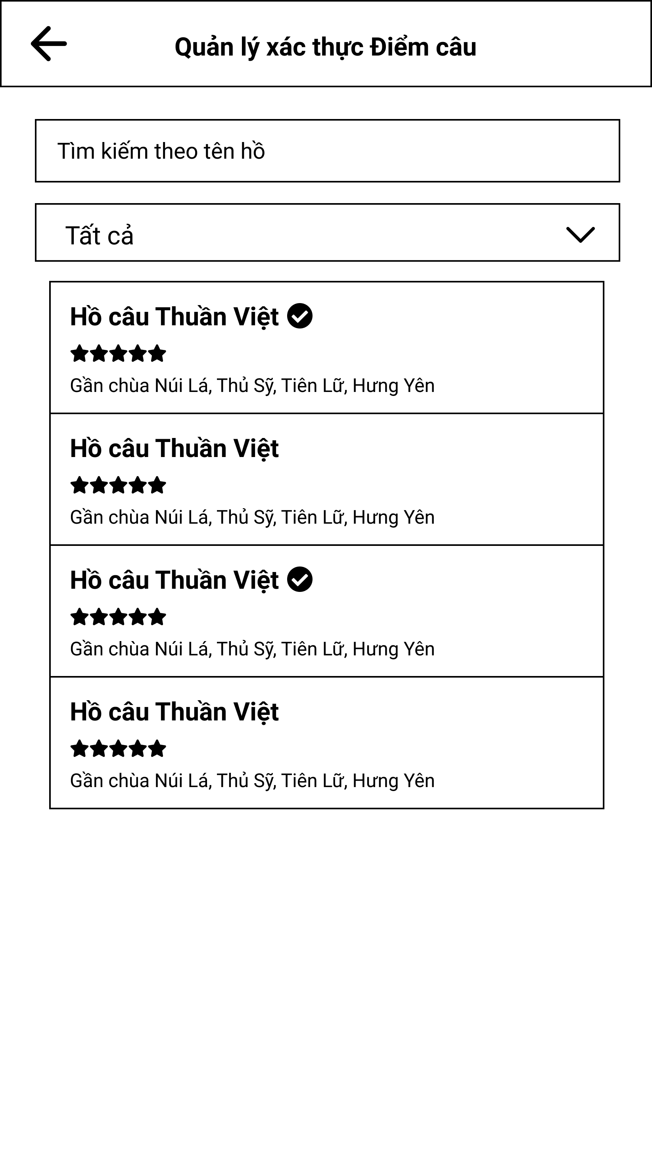

Figure 3.10.1. “View and search system fishing location list” Mockup

|  |  |
| --- | --- |
| **Description** | The screen shows all existing fishing locations in the system. |
| **Functional requirement** | * Filter has 3 items: all, verified, unverified. * The fishing location tag does not display the image. |

#### 3.10.2. View fishing location details

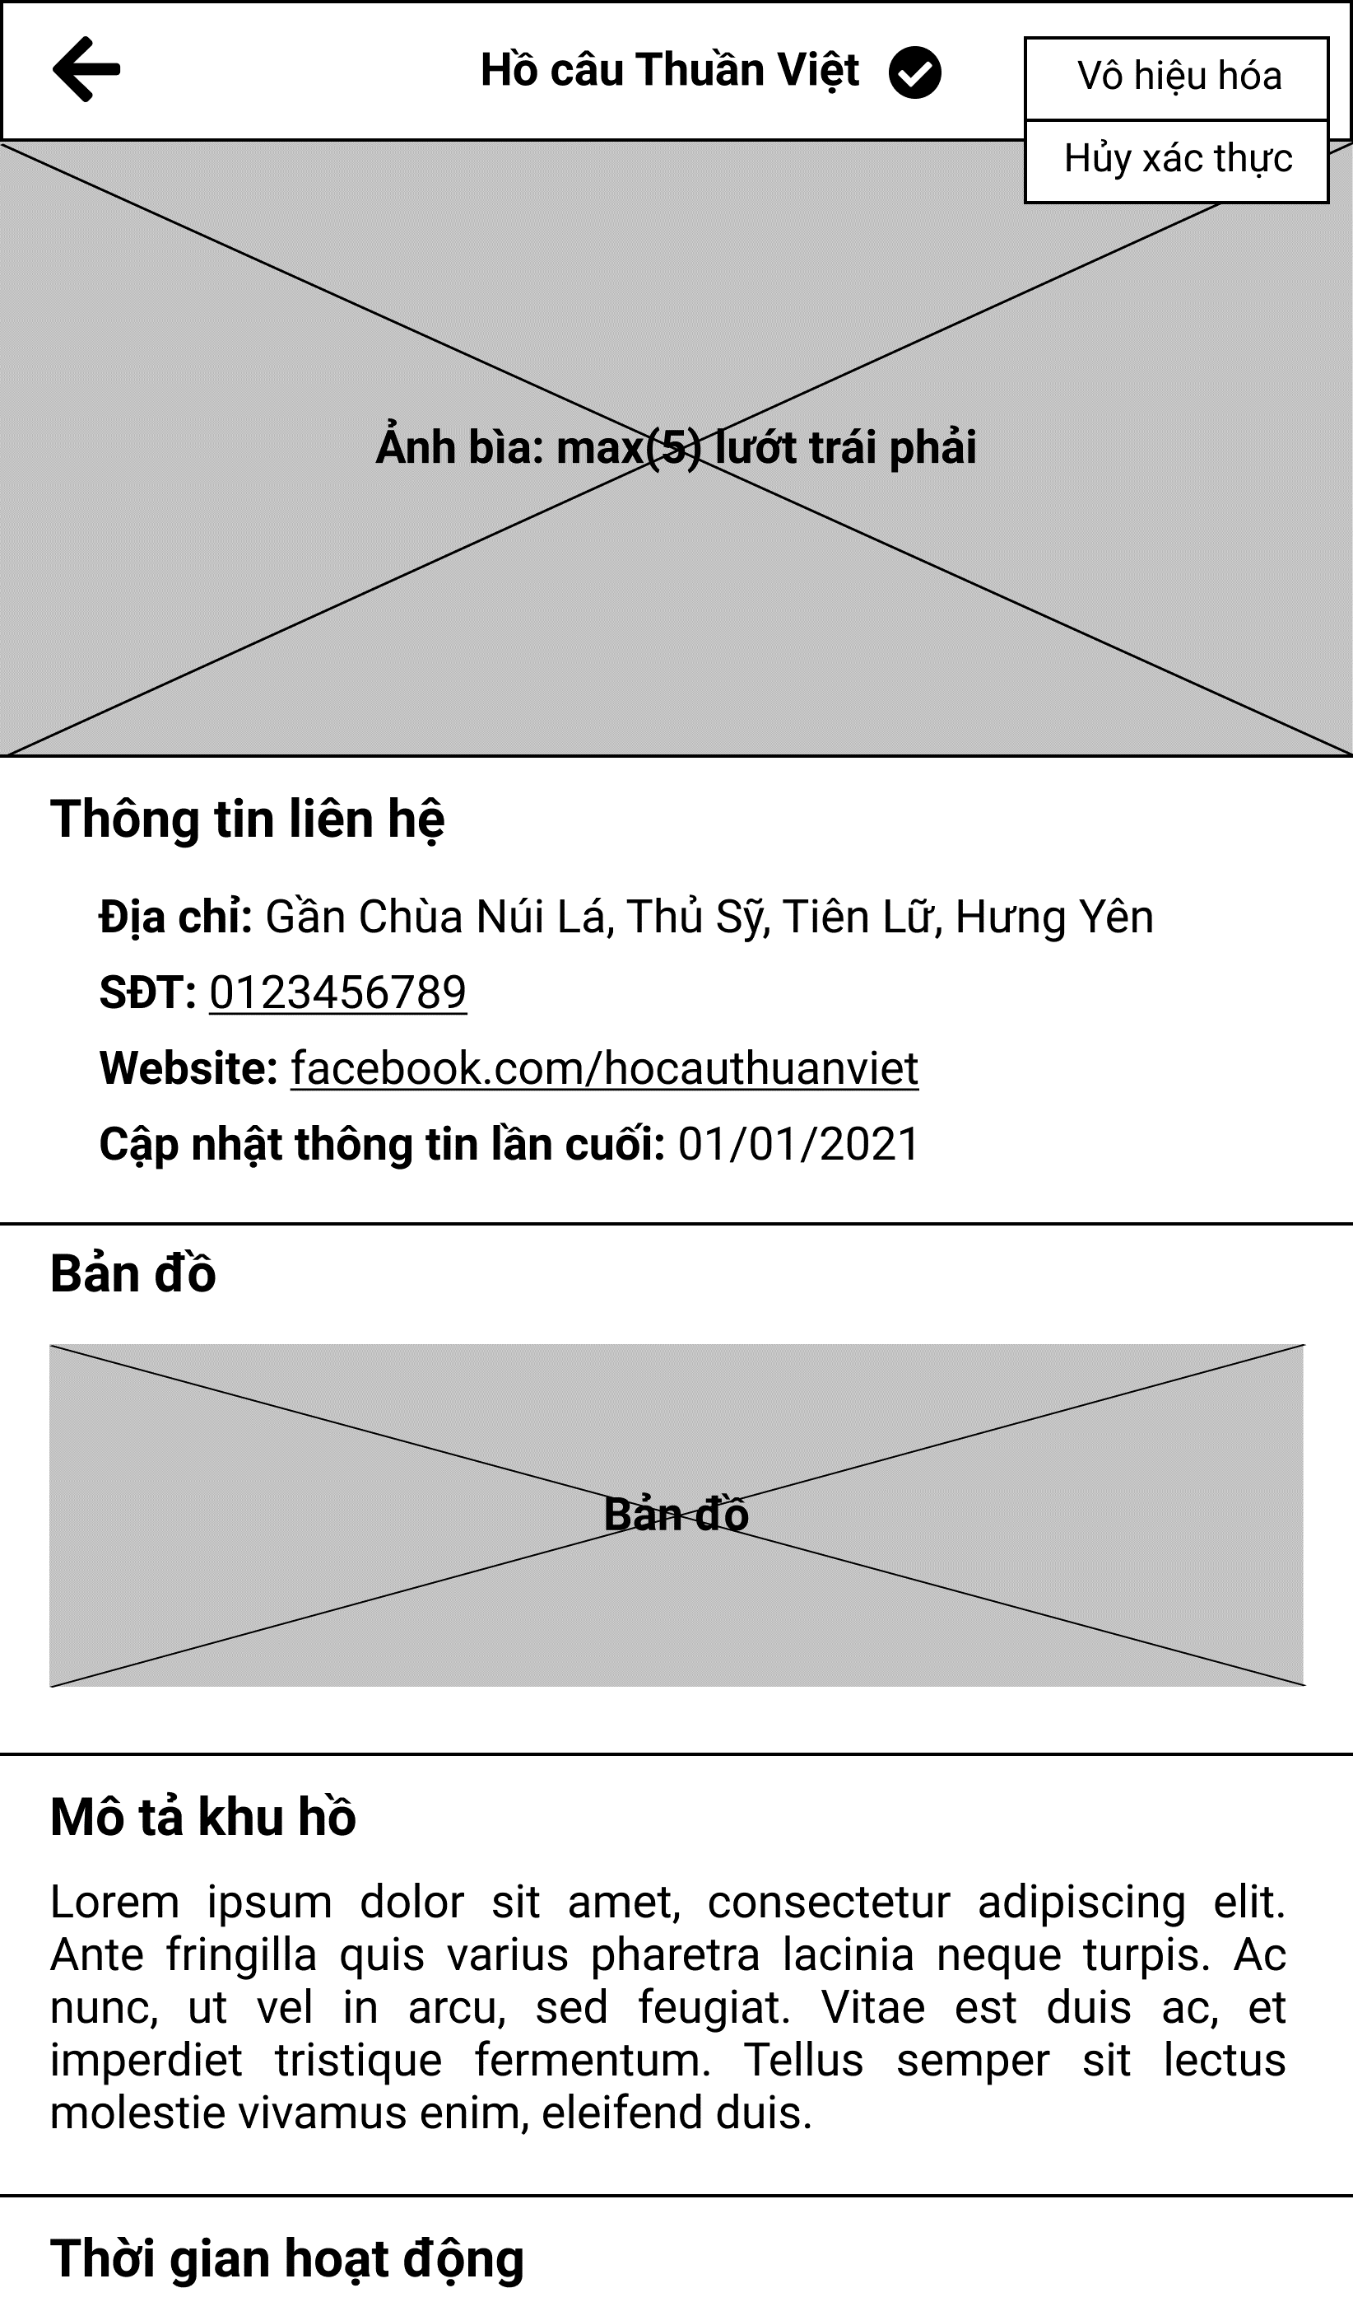

Figure 3.10.2. “View fishing location details” Mockup

|  |  |
| --- | --- |
| **Description** | The screen displays complete information of a fishing location, allowing the administrator to grant verified or disabled. |
| **Functional requirement** | * When verified, there must be a blue checked icon. |

### 3.11. Feature “Receive notification”

#### 3.11.1. View list of notifications

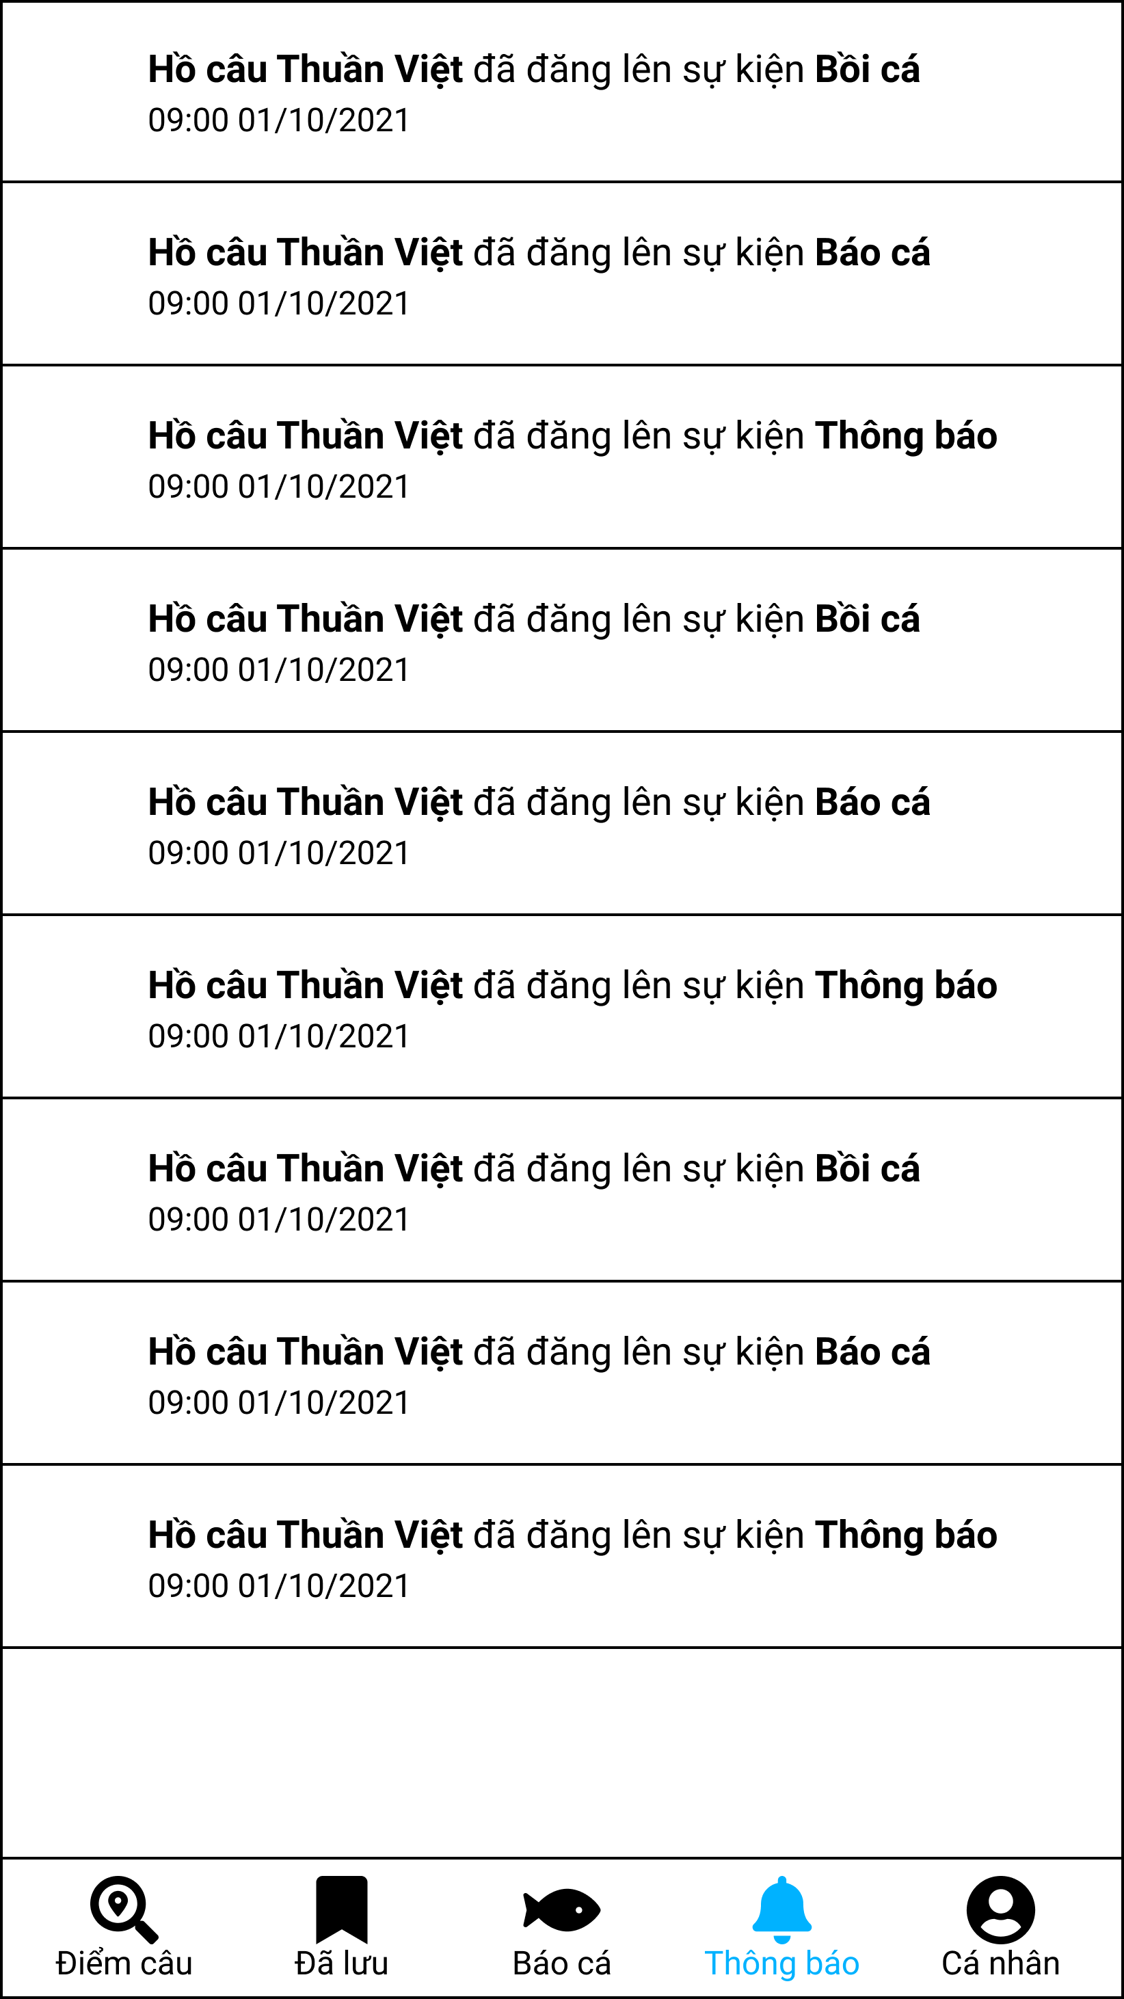

Figure 3.11.1. “View list of notifications” Mockup

|  |  |
| --- | --- |
| **Description** | The screen shows all notifications that the user can receive. |
| **Functional requirement** | * The notification card is not clickable. * The notification card shows the time the notification was created. |

### 3.12. Feature “Manage fishing location’s posts”

#### 3.12.1. View fishing location’s post

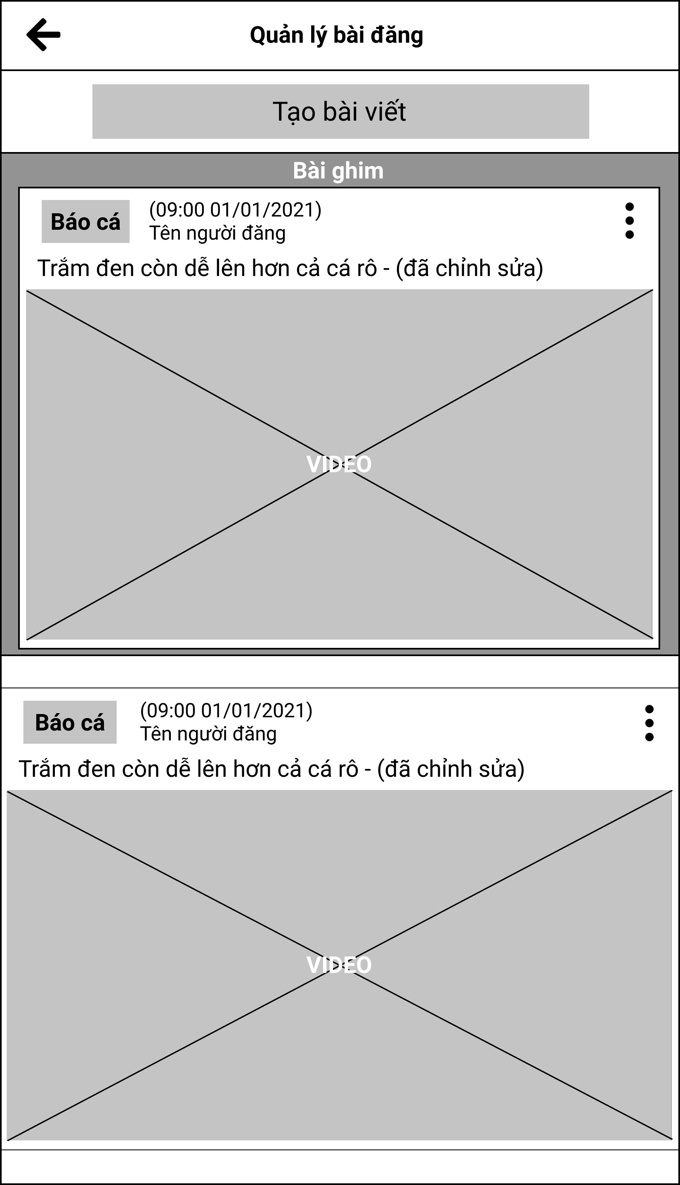

Figure 3.12.1. “View fishing location’s post” Mockup

|  |  |
| --- | --- |
| **Description** | The screen shows all posts that have been created by managers. |
| **Functional requirement** | * Pinned posts must appear at the top. * Each post must clearly state the action and who the post owner is. |

#### 3.12.2. Add a new post form

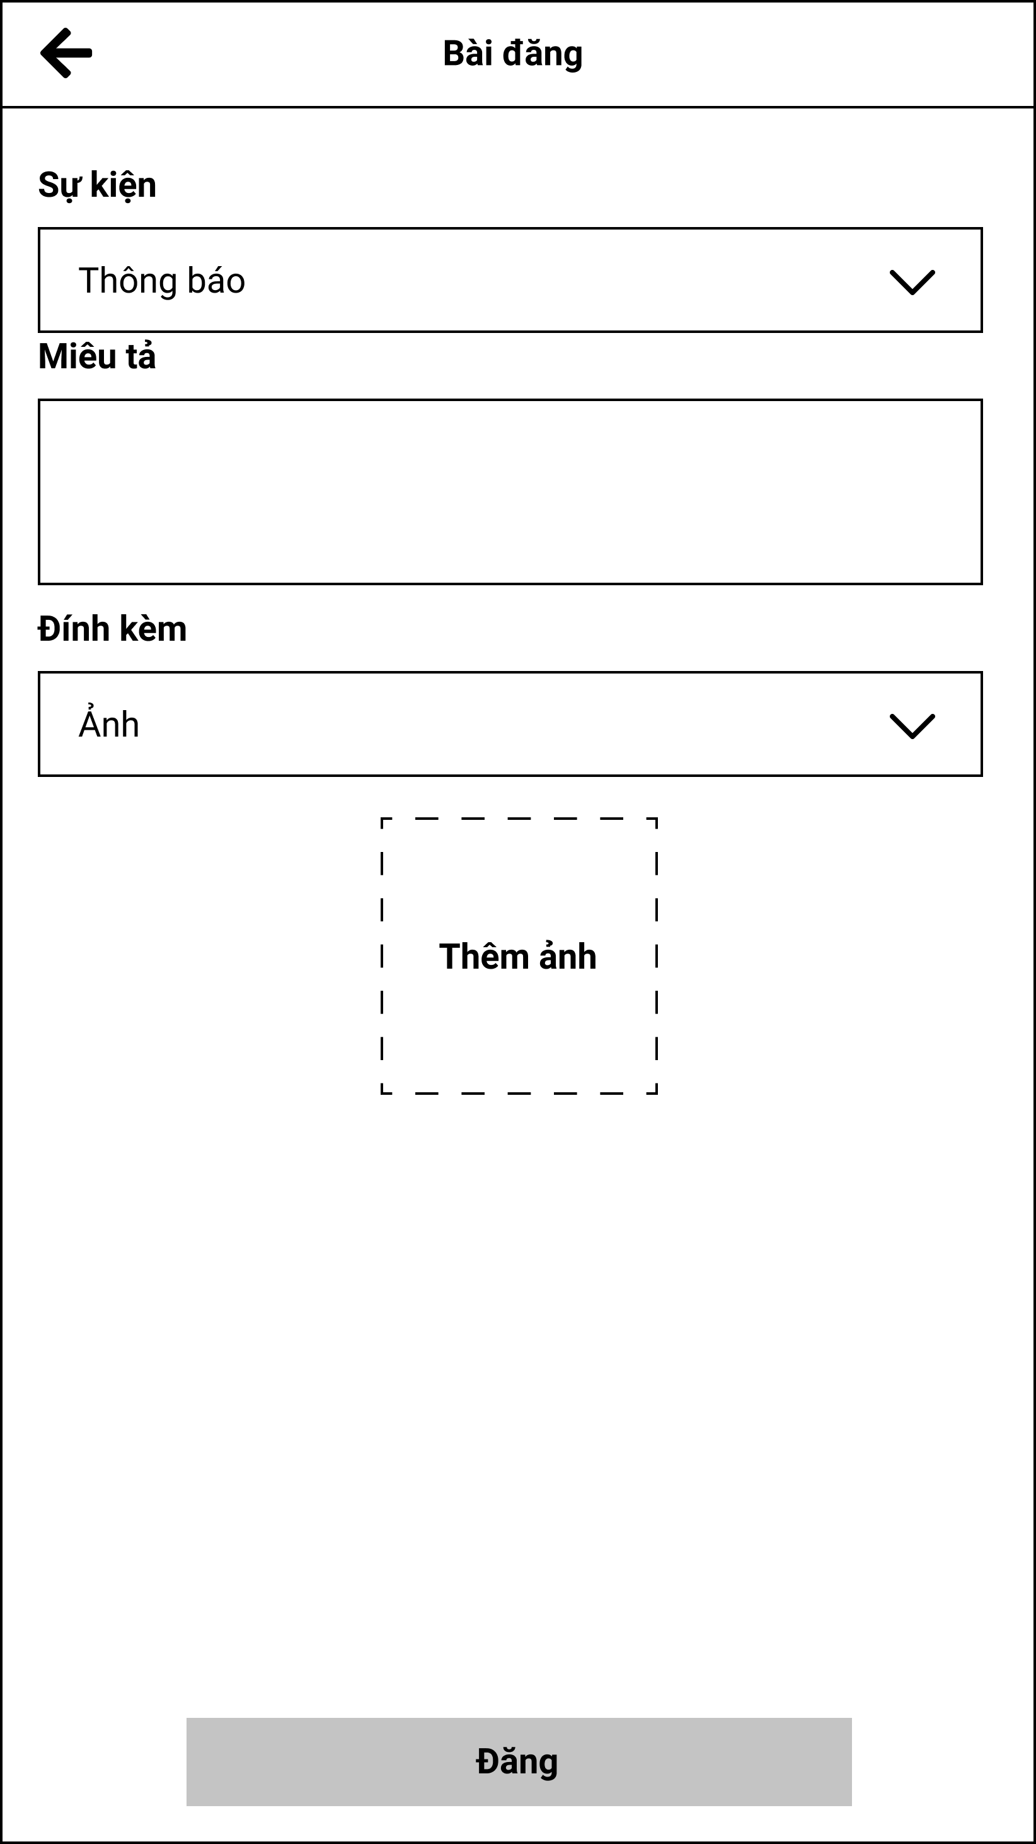

Figure 3.12.2. “Add a new post form” Mockup

|  |  |
| --- | --- |
| **Description** | The screen allows management to create a pos in the fishing location. |
| **Functional requirement** | * Users can attach Facebook video, Youtube and photos. |

#### 3.12.3. Pin/Unpin fishing location’s post

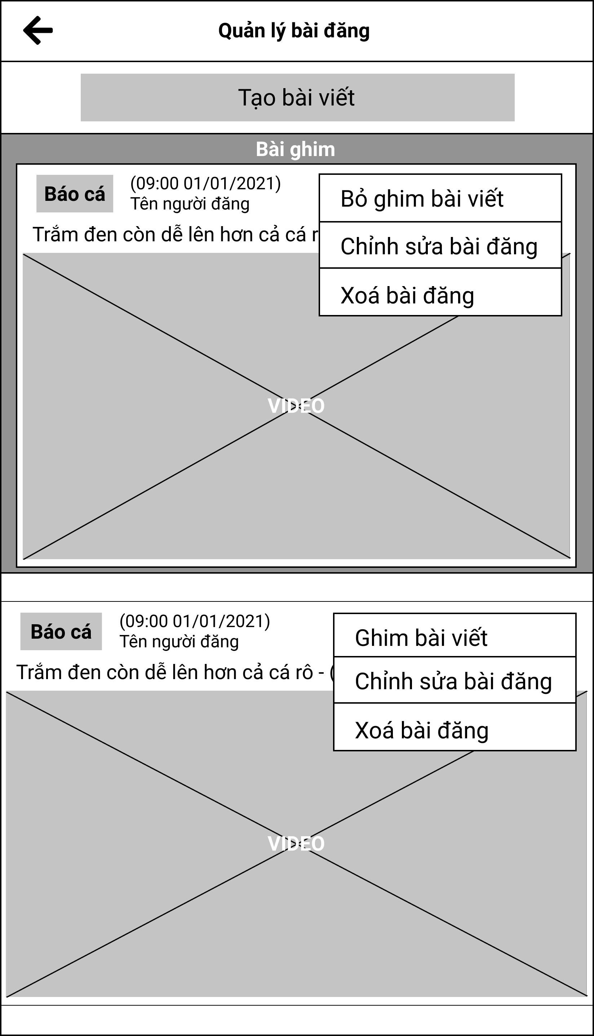

Figure 3.12.3. “Pin/Unpin fishing location’s post” Mockup

|  |  |
| --- | --- |
| **Description** | Users can pin posts to the top of the fishing location’s event. |
| **Functional requirement** | * Pinned post must be highlighted. |

### 3.13. Feature “Manage fishing location’s staffs”

#### 3.13.1. View fishing location’s staff list

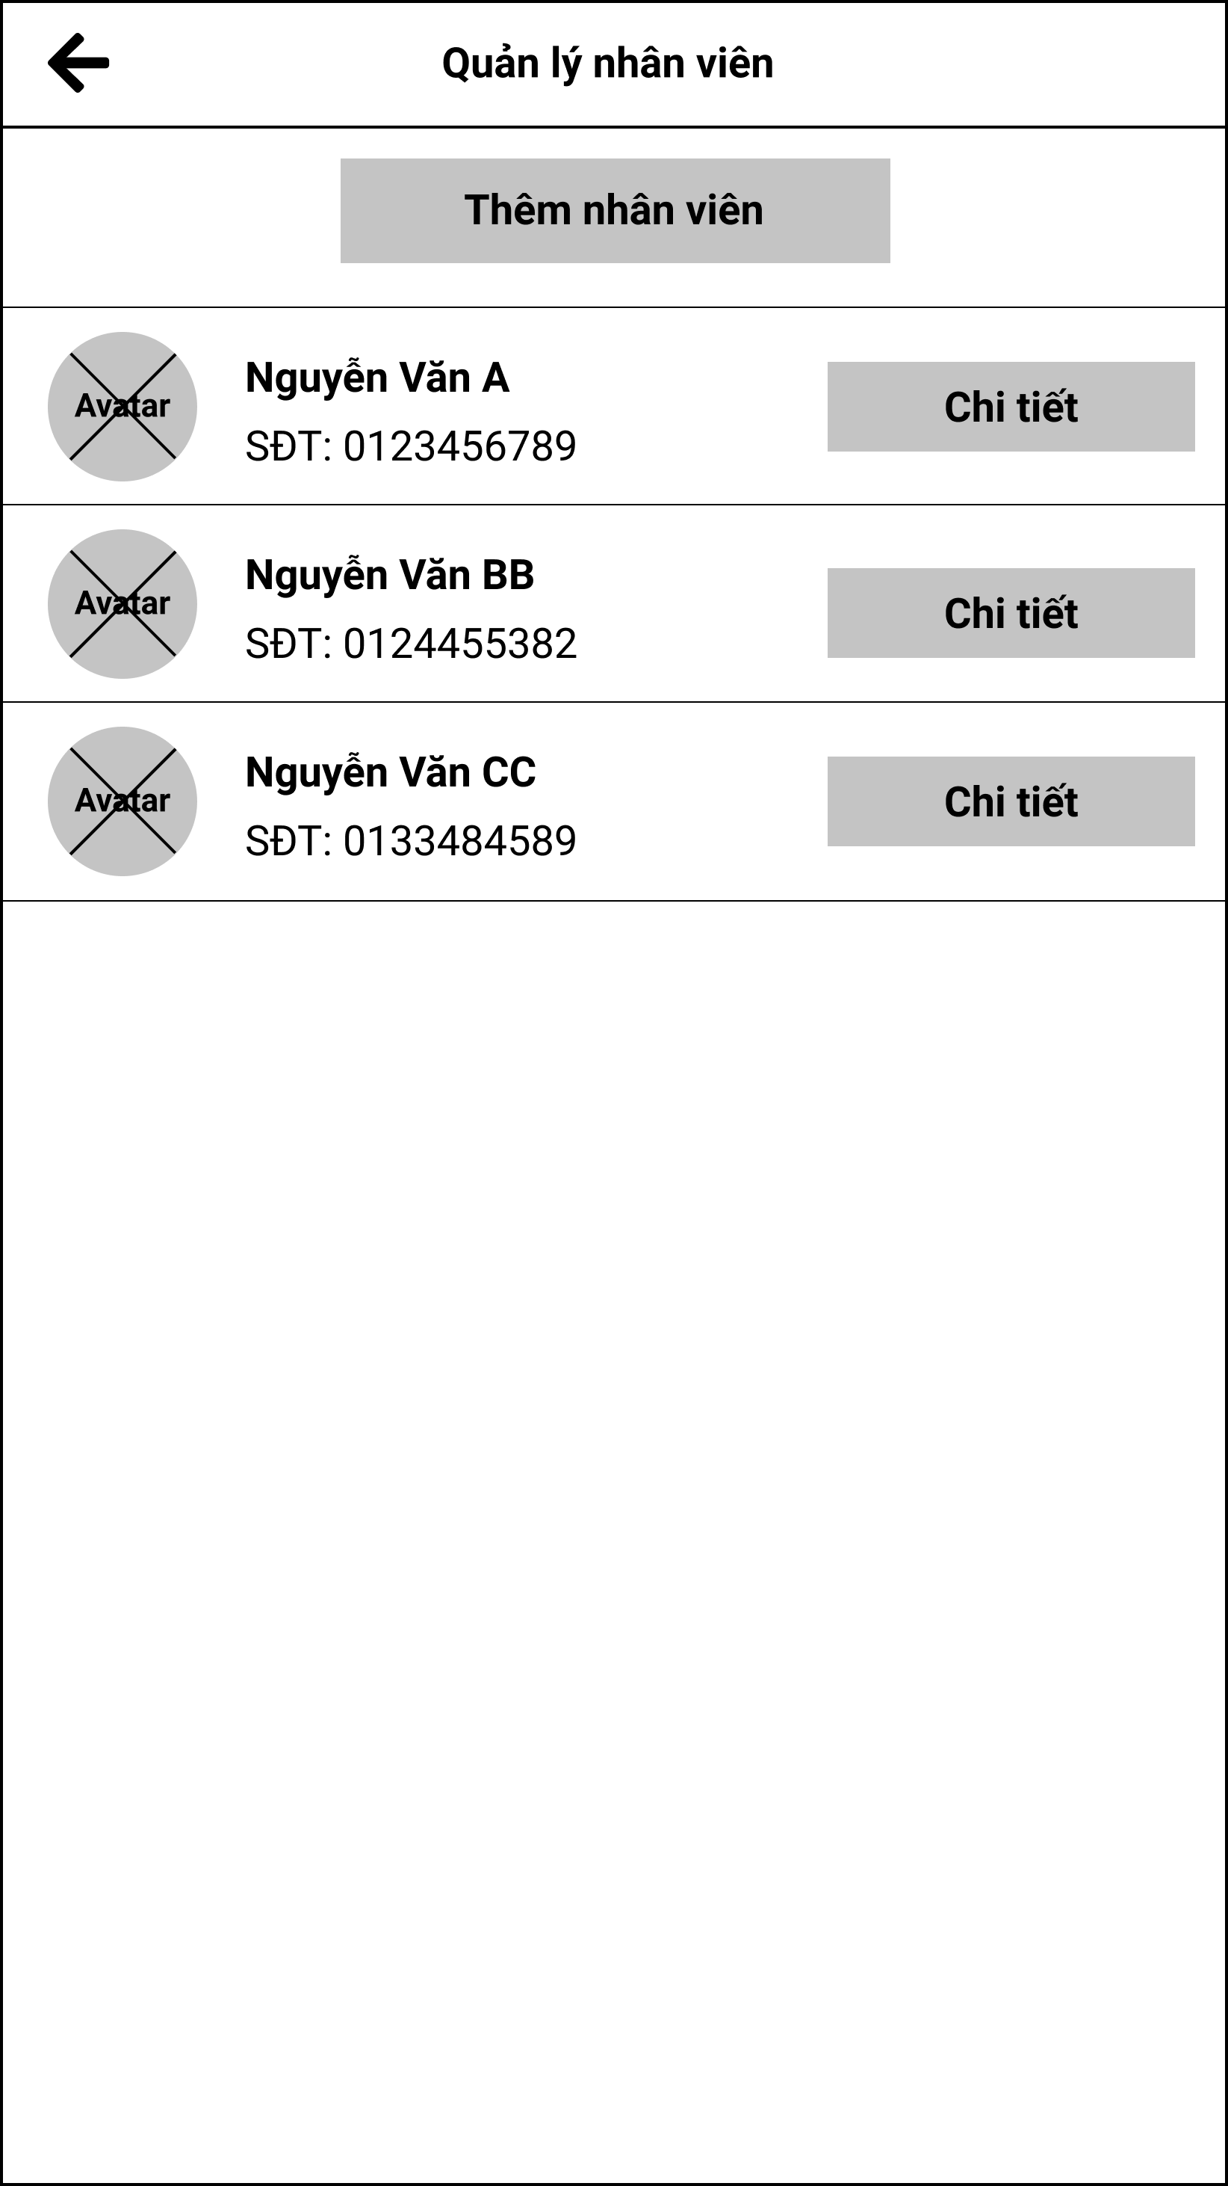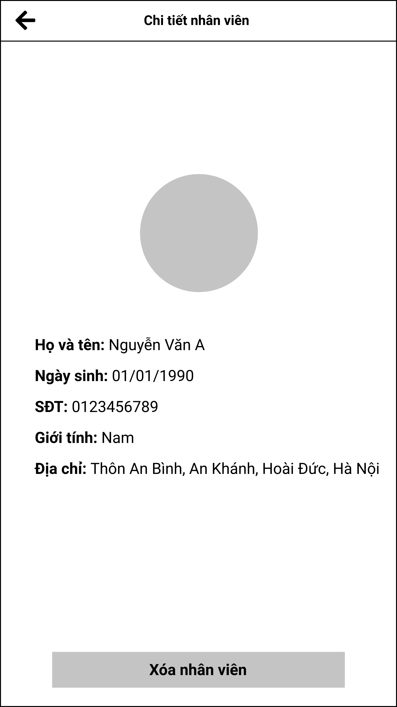

Figure 3.13.1. “View fishing location’s staff list” Mockup

|  |  |
| --- | --- |
| **Description** | The screen allows the owner of the fishing location to manage his staffs in the system. |
| **Functional requirement** | * Staffs must display complete information. |

#### 3.13.2. Add staff to fishing location

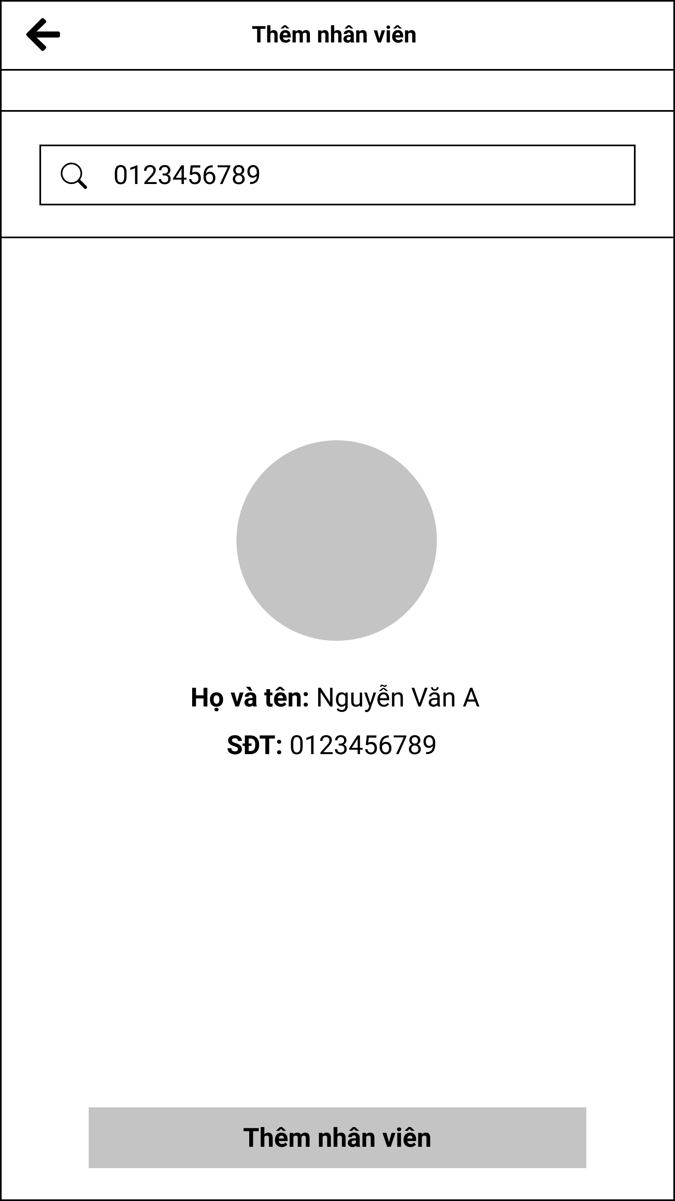

Figure 3.13.2. “Add staff to fishing location” Mockup

|  |  |
| --- | --- |
| **Description** | The screen that allows the owner of the fishing location to add any staffs present in the system. |
| **Functional requirement** | * Show only the avatar, phone number and full name of the staff. |

### 3.14. Feature “Manage system reports”

#### 3.14.1. Report form

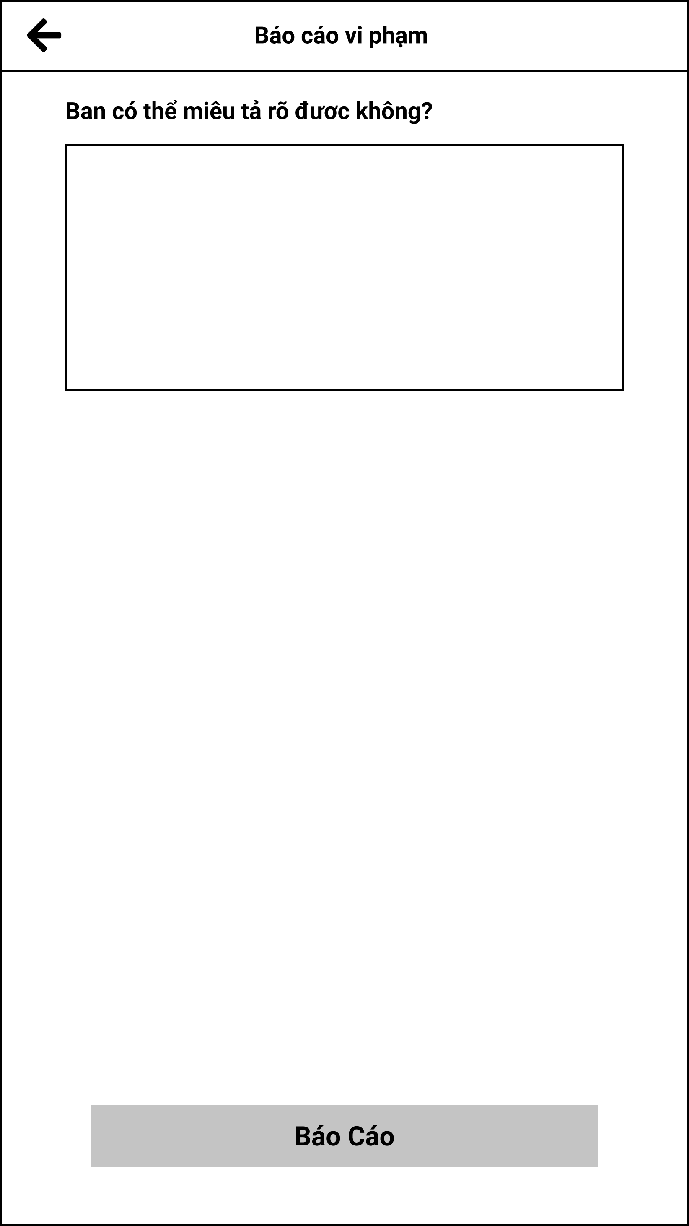

Figure 3.14.1. “Report form” Mockup

|  |  |
| --- | --- |
| **Description** | The screen allows users to report violations such as fishing location, review, post and catch report. |
| **Functional requirement** | * Users cannot send empty report. |

#### 3.14.2. View report in the system

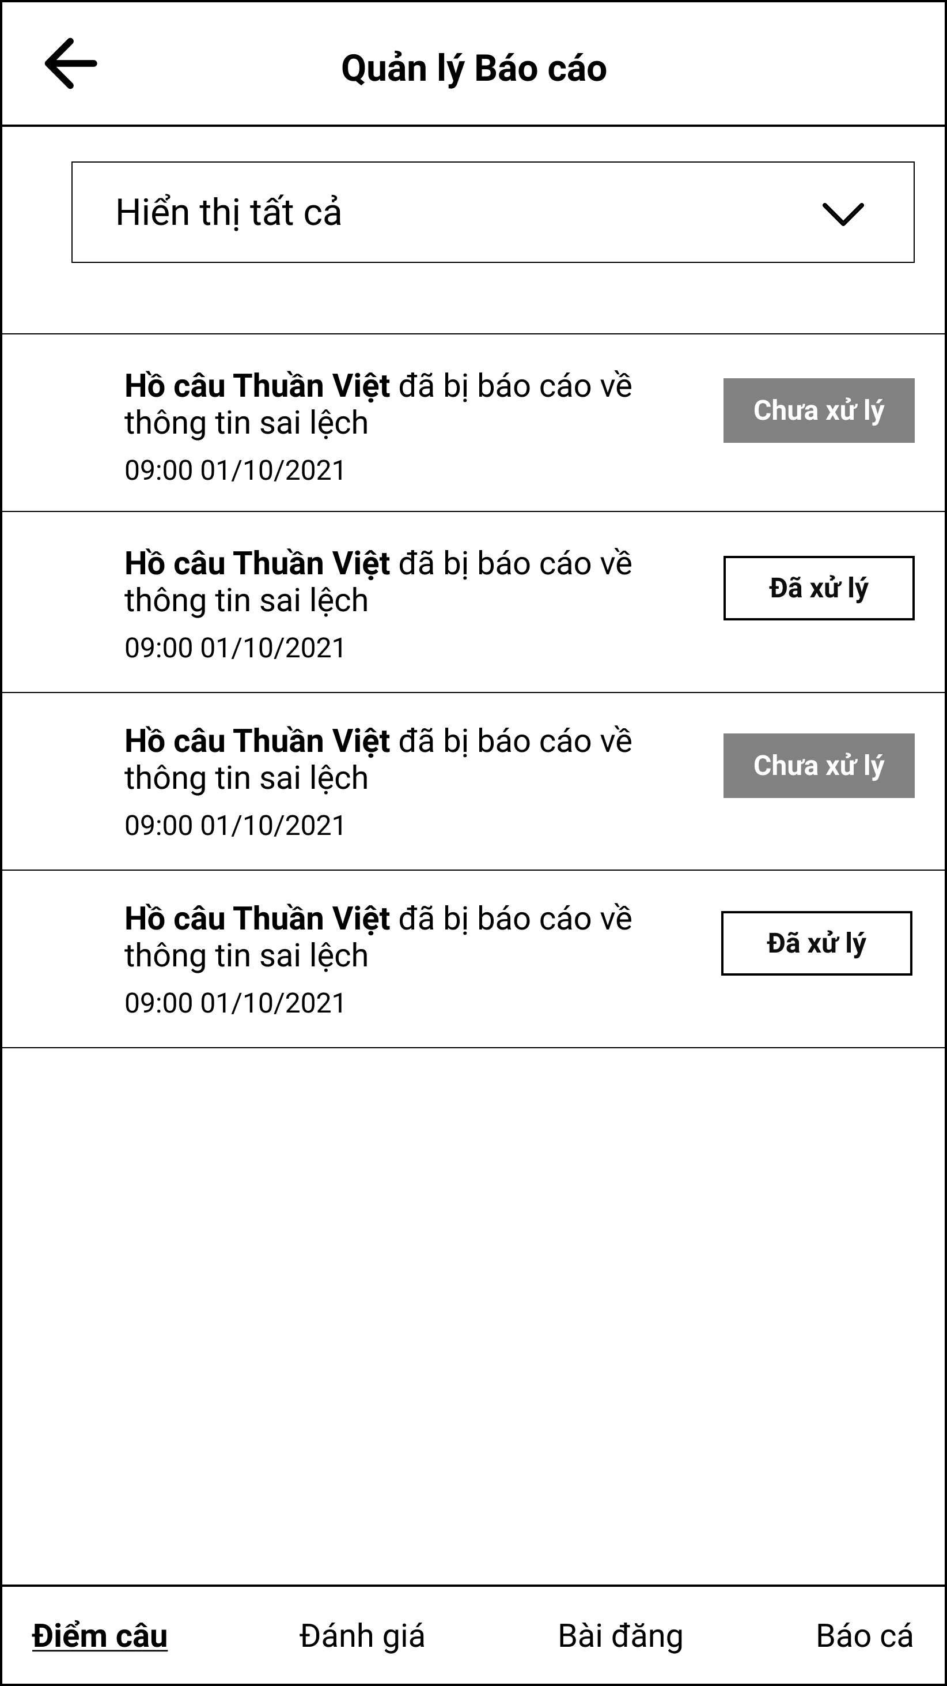

Figure 3.14.2. “View report in the system” Mockup

|  |  |
| --- | --- |
| **Description** | The screen allows administrators to see all reports that users send. |
| **Functional requirement** | * Filter has 3 modes: all, sovled, unsolved. |

#### 3.14.3. View report details

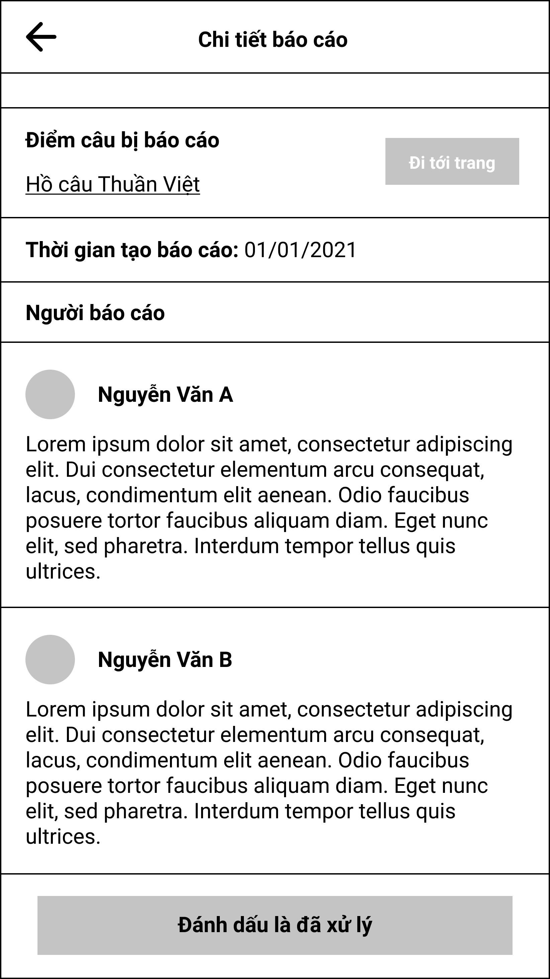

Figure 3.14.3. “View report details” Mockup

|  |  |
| --- | --- |
| **Description** | The screen displays report details of the users sent to. |
| **Functional requirement** | * If the report has been processed, the button will be disabled. |

### 3.15. Feature “Manage system fish species”

#### 3.15.1. View fish species list

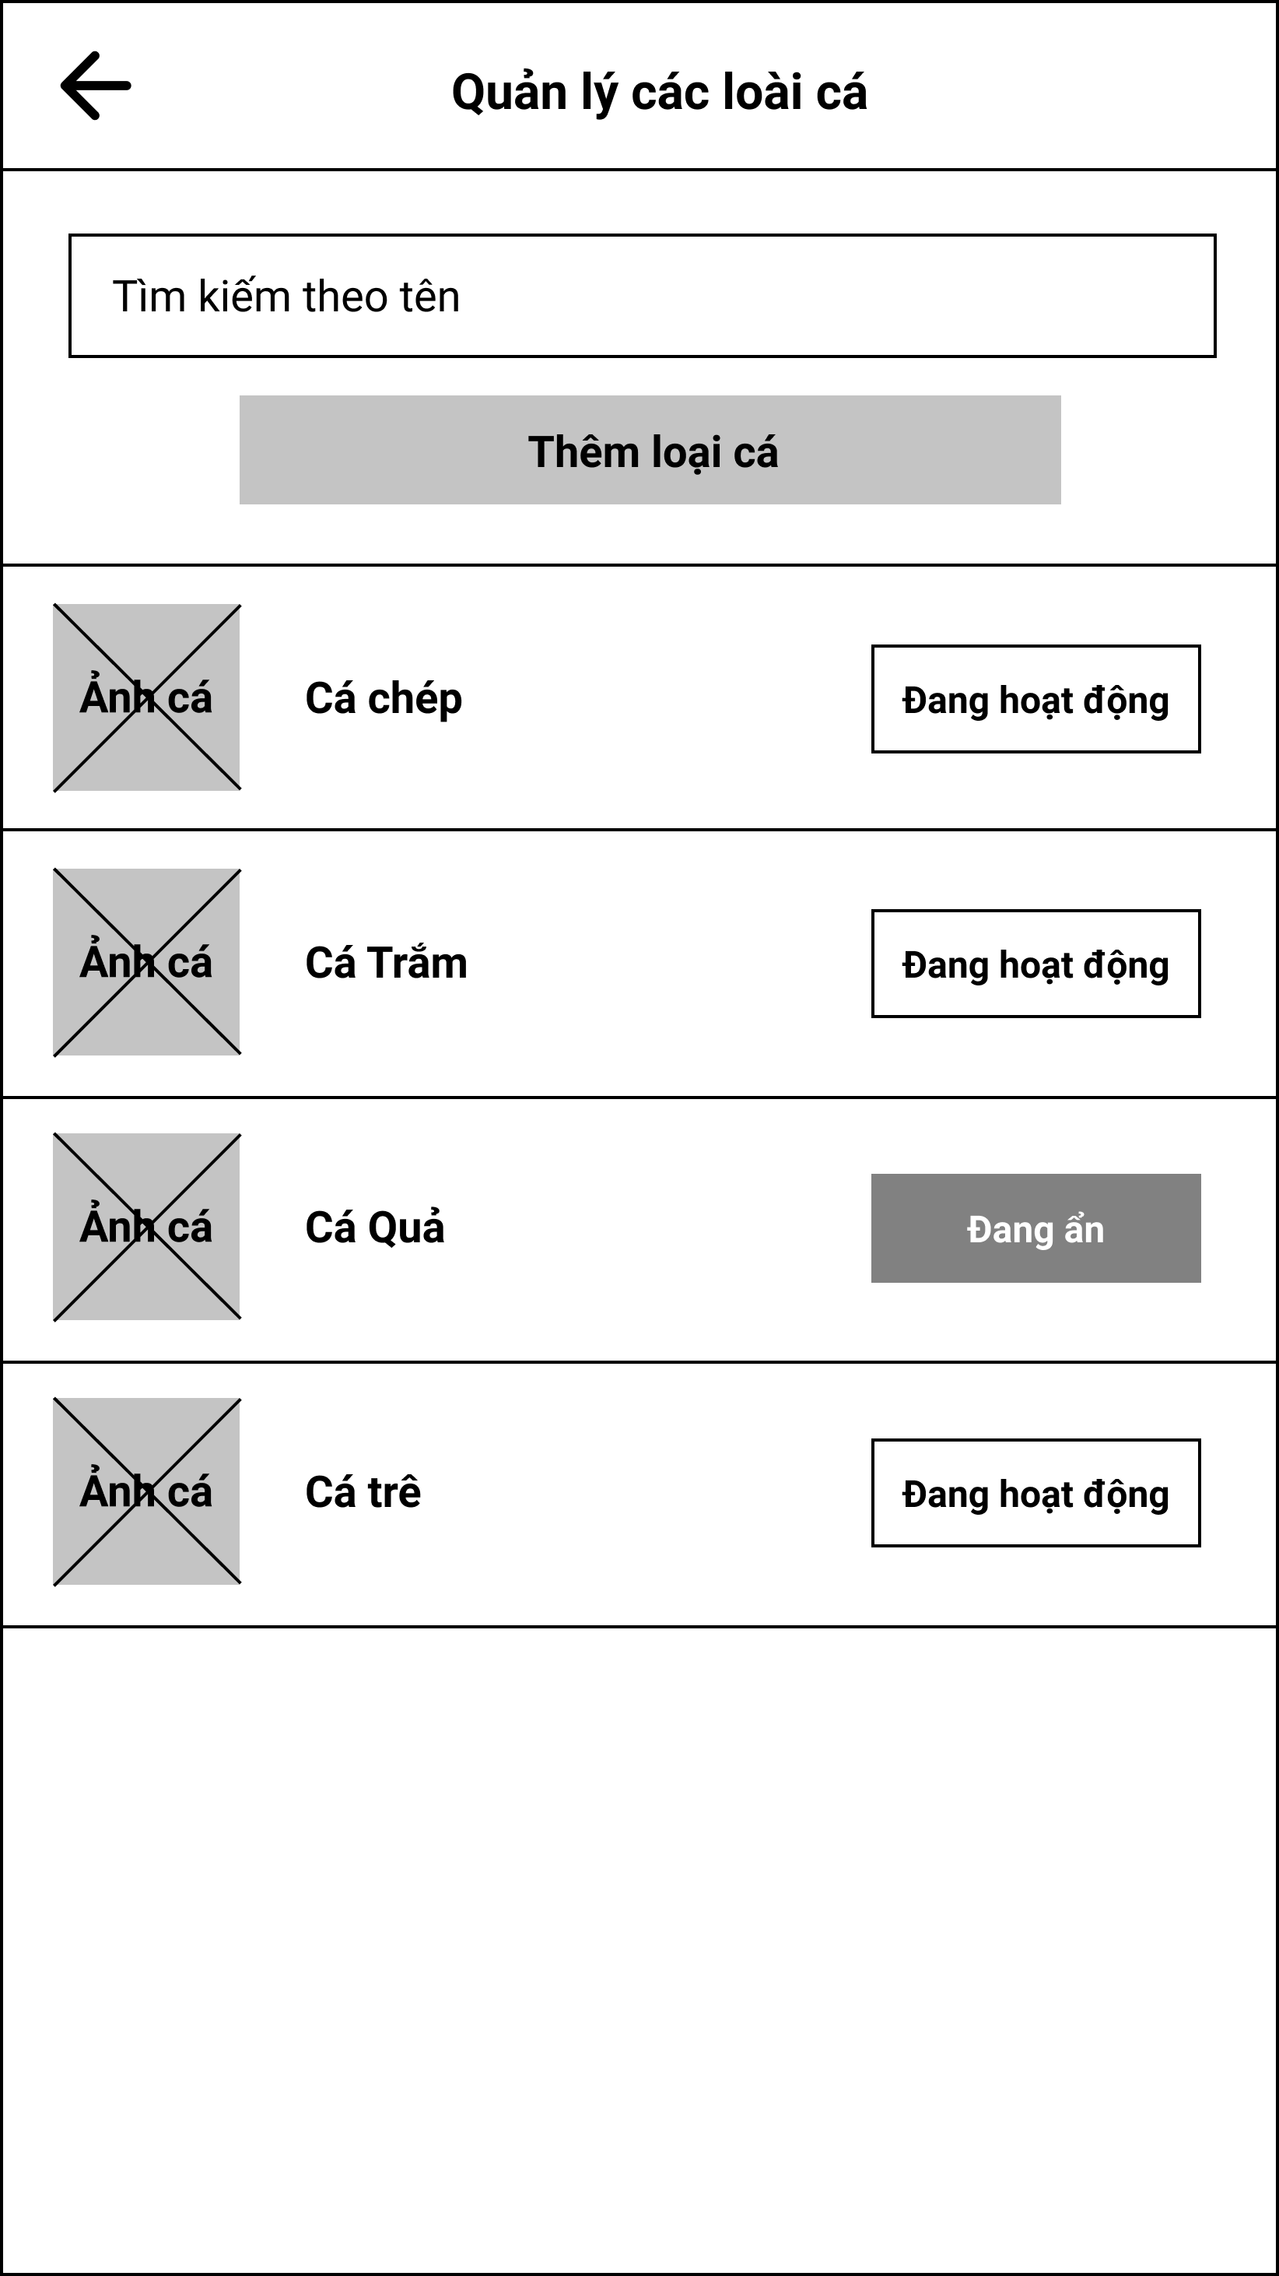

Figure 3.15.1. “View fish species list” Mockup

|  |  |
| --- | --- |
| **Description** | The screen shows all the fish species that exist in the system. |
| **Functional requirement** | * The search bar can search by letter |

#### 3.15.2. Fish species form

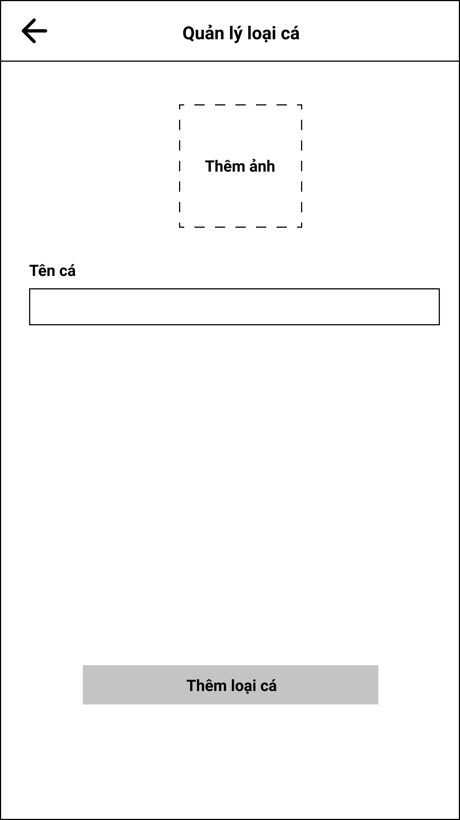

Figure 3.15.2. “Fish species form” Mockup

|  |  |
| --- | --- |
| **Description** | The screen allows the administrator to add fish species to the system. |
| **Functional requirement** | * The image must be resized to the most reasonable size. |

### 3.16. Feature “Manage system fishing methods”

#### 3.16.1. View fishing method list

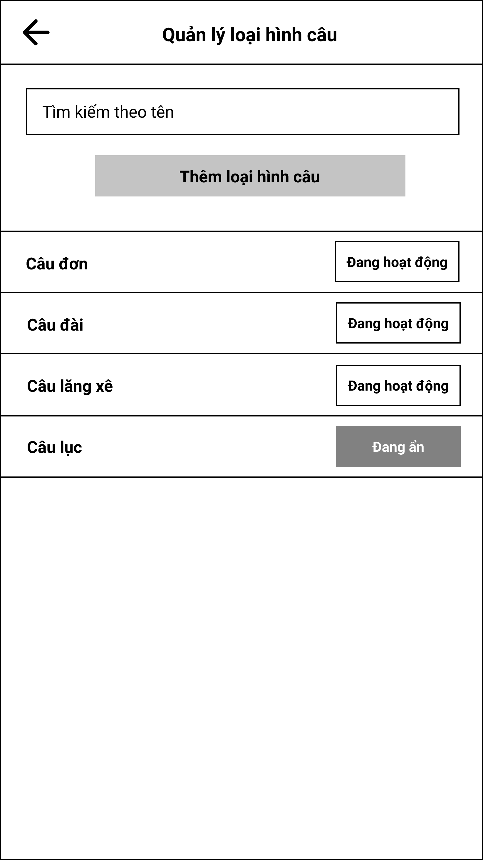

Figure 3.16.1. “View fishing method list” Mockup

|  |  |
| --- | --- |
| **Description** | The screen shows all the fishing methods that exist in the system. |
| **Functional requirement** | The search bar can search by letter |

#### 3.16.2. Fishing method form

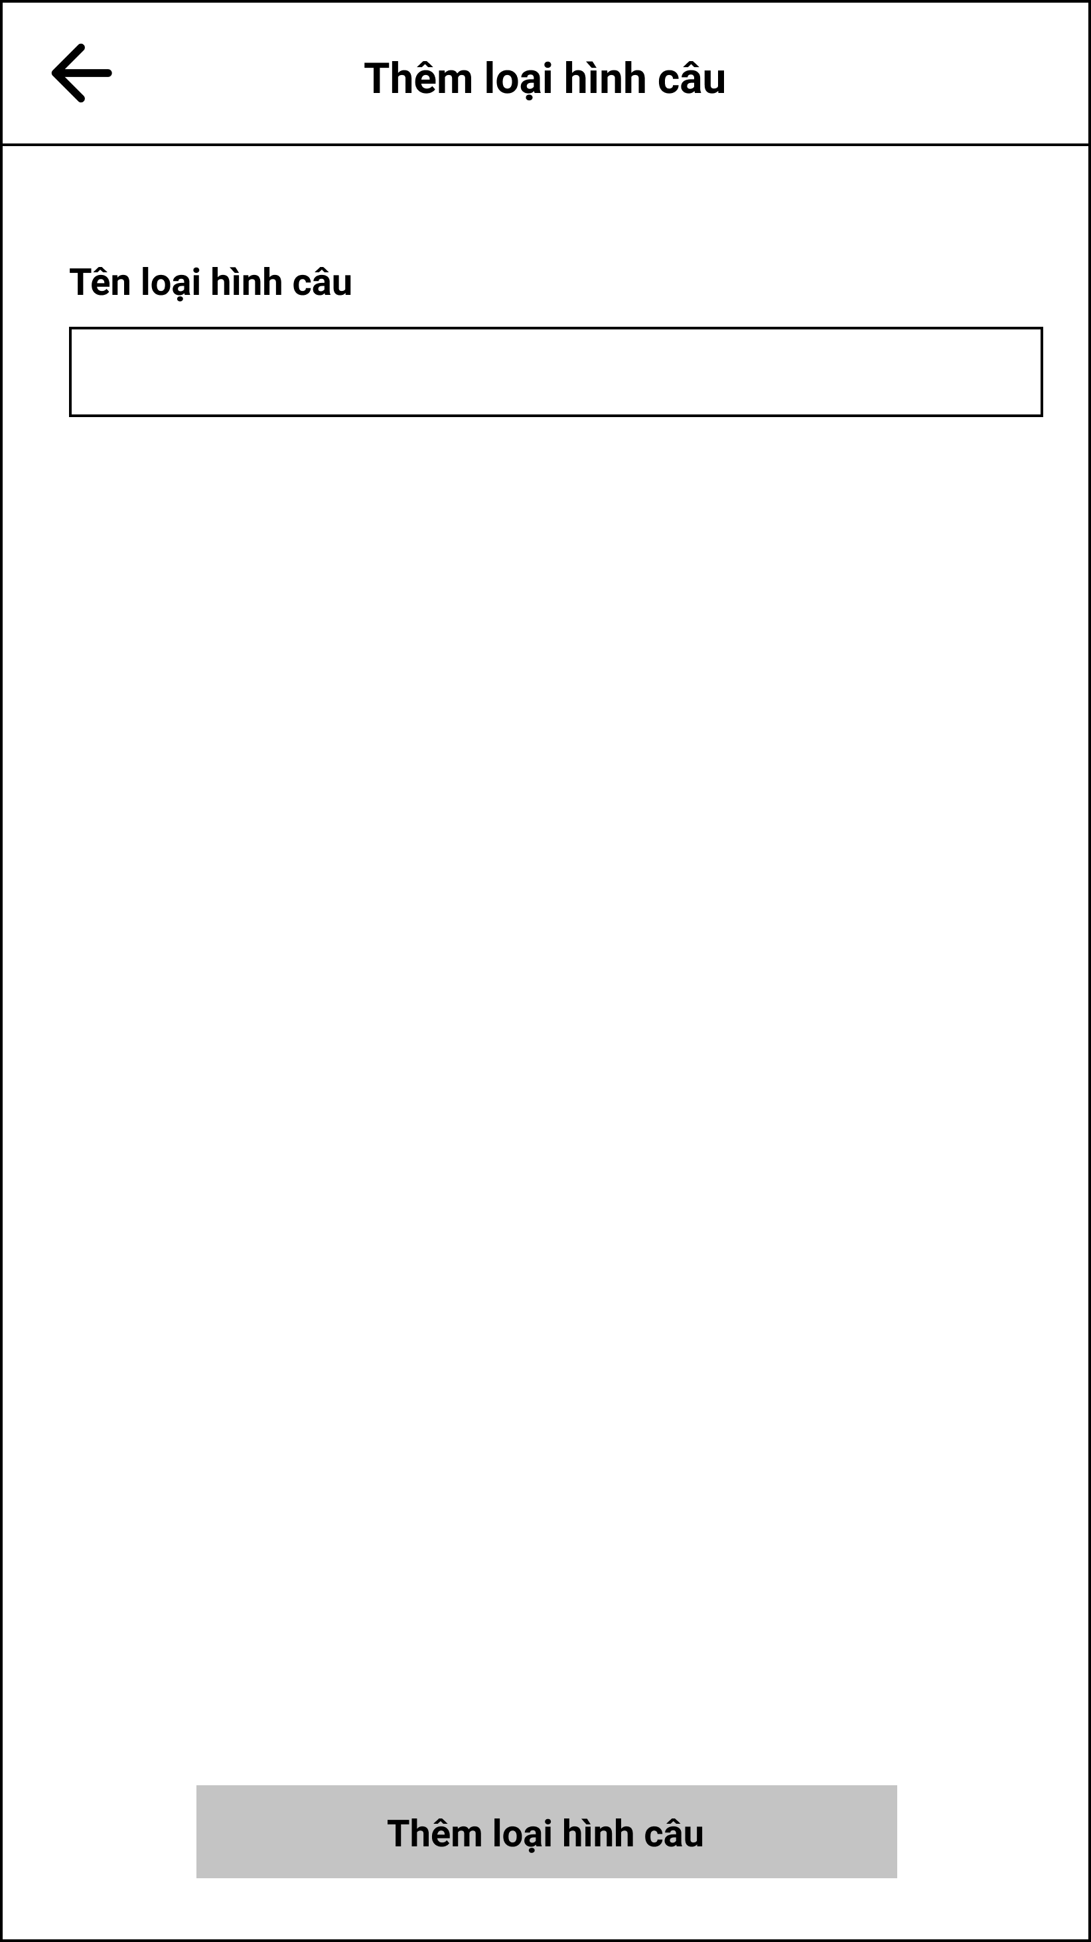

Figure 3.16.2. “Fishing method form” Mockup

|  |  |
| --- | --- |
| **Description** | The screen allows the administrator to add a fishing method to the system. |
| **Functional requirement** | * The fishing method name cannot be empty. |

### 3.17. Feature “Manage fishing location’s suggestion”

#### 3.17.1. Suggest a location form

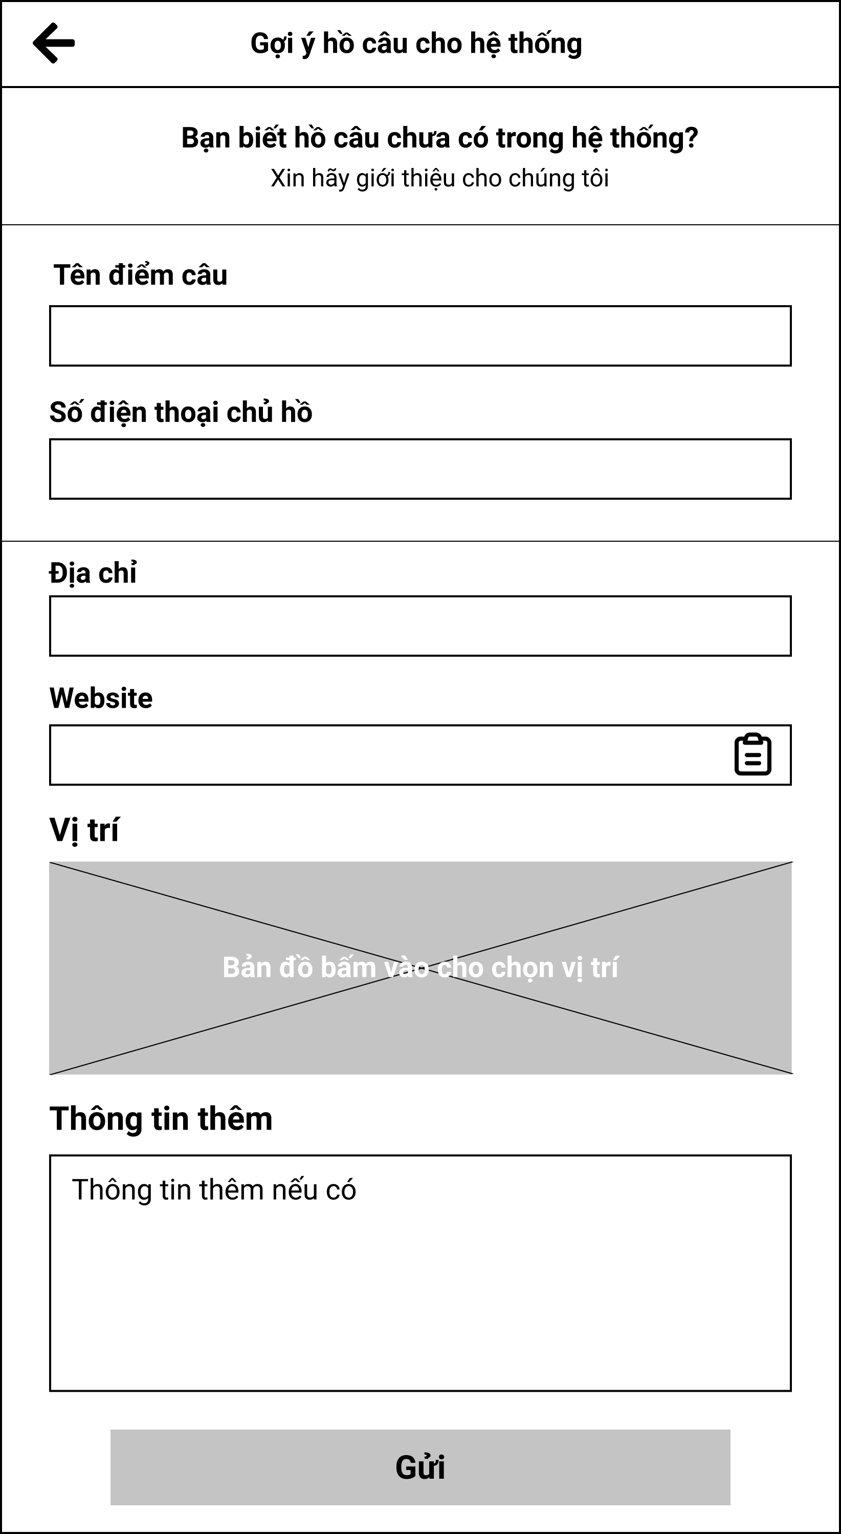

Figure 3.17.1. “Suggest a location form” Mockup

|  |  |
| --- | --- |
| **Description** | The screen allows users to send fishing location suggestions to the administrator. |
| **Functional requirement** | * Users are required to enter the fishing location name, owner's phone number. |

#### 3.17.2. View list of suggested location

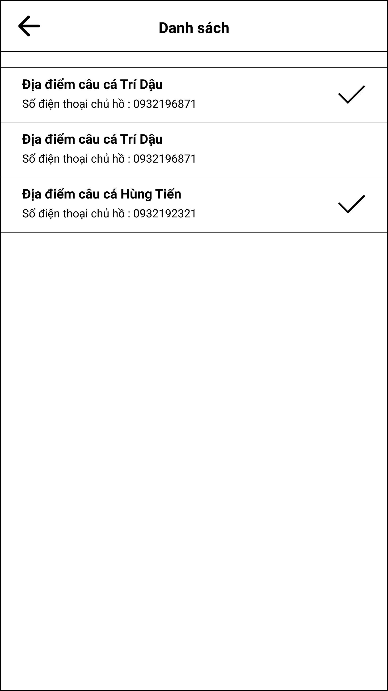

Figure 3.17.2. “View list of suggested location” Mockup

|  |  |
| --- | --- |
| **Description** | The screen allows administrators to see suggested fishing locations sent by users. |
| **Functional requirement** | * Checked records are useful. |

#### 3.17.3. View suggested location detail

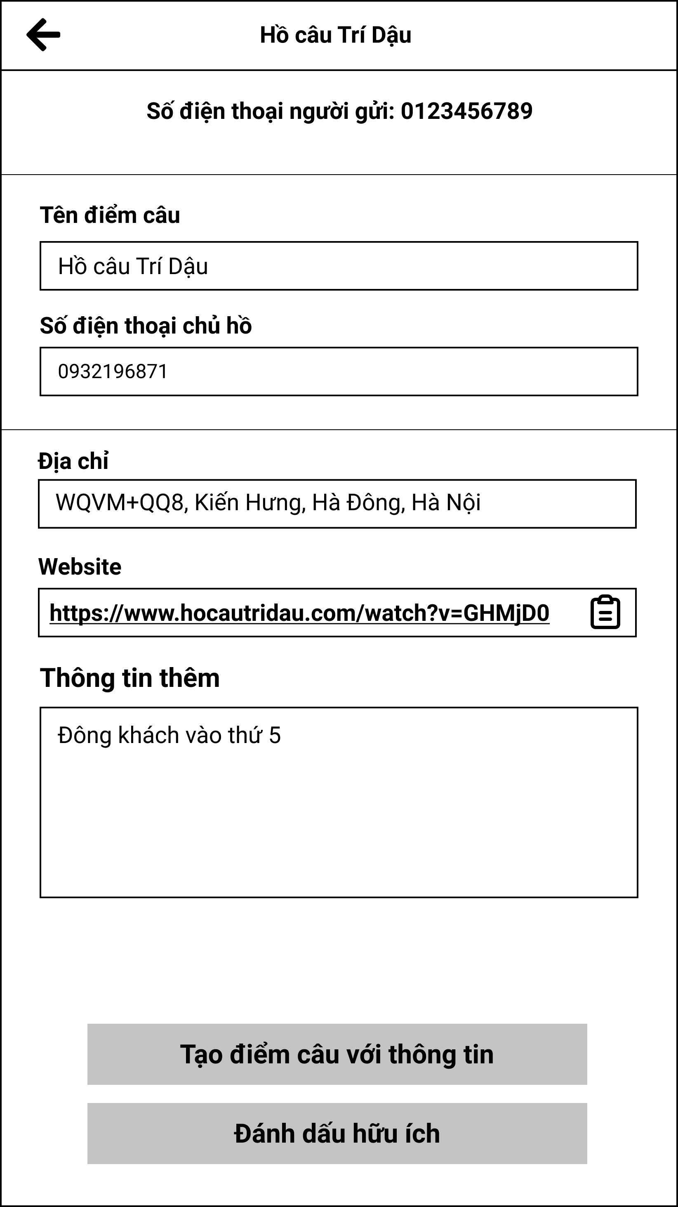

Figure 3.17.3. “View suggested location detail” Mockup

|  |  |
| --- | --- |
| **Description** | The screen allows the administrator to view the details of the information sent by the user. |
| **Functional requirement** | * Admin cannot edit the above information. * Admin is allowed to create new fishing location. |

### 3.18. Feature “Manage banned phone number”

#### 3.18.1. View banned phone list

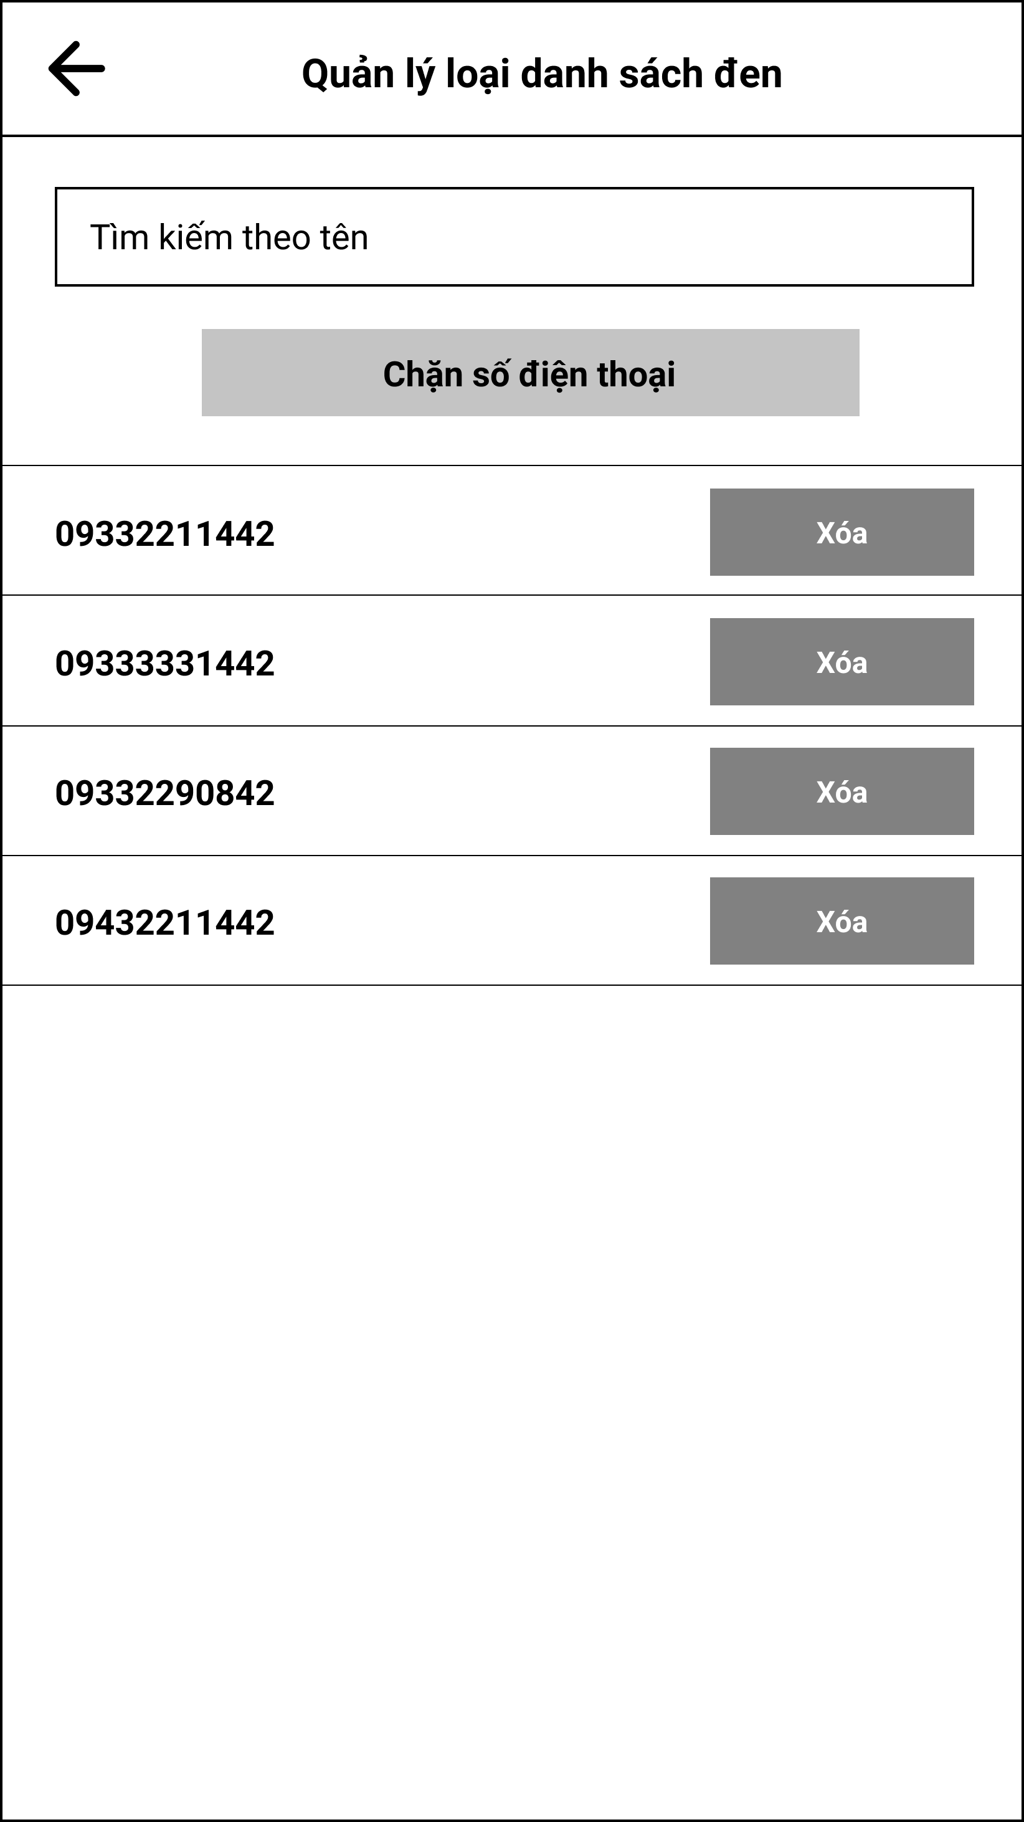

Figure 3.18.1. “View banned phone list” Mockup

|  |  |
| --- | --- |
| **Description** | The screen shows the administrator a list of users banned from the system. |
| **Functional requirement** | * The search bar must enter the phone number. |

#### 3.18.2. Add banned phone form

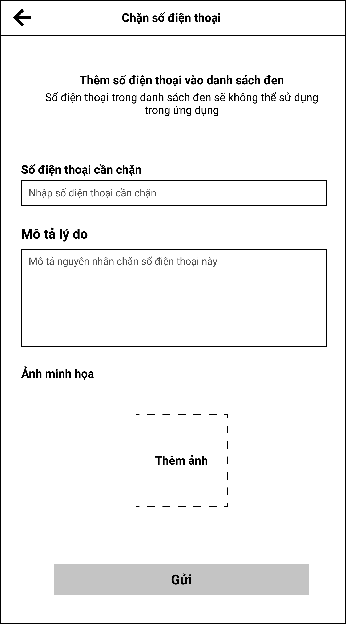

Figure 3.18.2. “Add banned phone form” Mockup

|  |  |
| --- | --- |
| **Description** | The screen allows administrators to add banned numbers to the system. |
| **Functional requirement** | * There should be a description of the reason and a picture attached so that the evidence can be shown. |

## 4. Non-Functional Requirement

### 4.1. Usability

* Links, buttons, and checkboxes are easily clickable.
* User interface should be clear and easy to use.
* The system must be designed so that users can easily familiarize themselves with and use competently functions in a short time.
* Main functions are organized into navigator for easier access.
* The maximum steps to complete 1 activity from seeing the screen is 3.

### 4.2. Security

* Using authentication and authorization to access protected resources.
* JWT token is used to authenticate user.
* Password must be protected and encrypt before store in database.
* User's password must be hashed with Bcrypt[5].
* Only send the latest OTP to the user's phone number.

### 4.3. Performance

* In the best condition, the slowest response is not exceed 5 seconds.
* The loading pages time must not exceed 5 seconds.

### 4.4. Maintaining & Scalability

* System logs error reporting to track errors whenever the application happens to crash.
* Source code must follow the coding convention to help developers to read, understand, and find it easy to maintain or modify the code.

### 4.5. Compatibility

* The device must be Android 9 or higher.

### 4.6. Localization

* The language is Vietnamese.
* The application only accept Vietnamese phone numer.
* The date format in the application must be: dd/MM/yyyy or dd/MM/yyyy HH:mm:ss.

## 5. Requirement Appendix

### 5.1. Business Rules

|  |  |
| --- | --- |
| **ID** | **Rule definition** |
| BR-02 | The user must provide phone number and password to login. |
| BR-03 | The date will be display in the format: DD/MM/YYYY. |
| BR-04 | The time will be display in 24-hour time. |
| BR-06 | The phone number must follow Vietnamese standard. |
| BR-07 | The password must have at least 8 characters and alphanumeric. |
| BR-08 | The list of fishes in catch report form only has fishes of the corresponding fishing location. |
| BR-09 | The list of fishes in the filter of anglers' catch reports list only contains fishes of the corresponding fishing location. |
| BR-10 | Information of the staff who does check-in for user or verify catch reports will be stored in the check-in record and catch reports. |
| BR-11 | All changes of information of a fishing locations will need to be verify again. |
| BR-12 | Fishing locations that had been verified will have a signature to distinct with location which had not yet been verified. |
| BR-13 | One owner can have multiple fishing locations. |
| BR-14 | One fishing location contains multiple lakes. |
| BR-15 | The number of fish in the catch report should not exceed the current number of fish in the lake. |
| BR-16 | The owner cannot add an existing staff to the fishing location. |
| BR-17 | Owners cannot work as staff at other fishing locations. |
| BR-18 | A fishing location will have many staff. |
| BR-19 | Staff will only be allowed to work at one lake. |
| BR-20 | Staff cannot check in at the fishing location they work at. |
| BR-21 | The owner cannot check in at the fishing location he/she is owning. |
| BR-22 | Staff cannot rate at the fishing location they are working in. |
| BR-23 | The owner can't review at the location he owns. |
| BR-24 | The highest number of stars a player can choose for a review is 5 stars. |
| BR-25 | Each user will have a unique QR code. |
| BR-26 | Registering an account requires a phone, password. |
| BR-27 | If you do not choose an address when registering, the default will be Phuc Xa, Ba Dinh, Hanoi. |

Table 5.1. Business rules

### 5.2. Application Message List

|  |  |  |  |  |
| --- | --- | --- | --- | --- |
| **#** | **ID** | **Message Type** | **Context** | **Content** |
|  | MSG01 | In red, under text field | Login with wrong phone number or password | Số điện thoại hoặc mật khẩu không hợp lệ |
|  | MSG02 | In red, under text field | Input required fields are empty | ${Tên_trường} không được bỏ trống |
|  | MSG03 | In red, under text field | Invalid OTP Code | Mã OTP không hợp lệ |
|  | MSG04 | In red, under text field | Wrong phone number format | Số điện thoại không hợp lệ |
|  | MSG05 | Toast message | Phone number is existed in the system | Số điện thoại này đã tồn tại trong hệ thống |
|  | MSG06 | Toast message | Unmatched password | Mật khẩu không khớp |
|  | MSG07 | In red, under text field | New password must differ than old password | Mật khẩu mới không được trùng với mật khẩu cũ |
|  | MSG09 | In red, under text field | Confirm to the user if he/she wants to delete the review | Bài đánh giá sẽ bị xóa vĩnh viễn. bạn không thể hoàn tác hành động này. |
|  | MSG10 | Alert pop-up | Choose to unlock an account that is not being locked | Hiện không thể mở khóa tài khoản này |
|  | MSG11 | Alert pop-up | Choose to lock an account that is not being unlocked | Hiện không thể khóa tài khoản này |
|  | MSG12 | Toast message | Confirm that verify information success | Xác nhận thông tin thành công |
|  | MSG13 | Toast message | The angler's checkin list is empty | Danh sách check-in trống |
|  | MSG14 | Popup | Fishing location owner choose close fishing location | Thông tin hồ câu này sẽ bị xóa khỏi hồ sơ của bạn, nhấn "Không" để ngừng xóa, "Đồng ý" để tiếp tục |
|  | MSG15 | In grey, center of the screen | When the angler does not enter the search information, or there are no results returned | Không tìm thấy kết quả |
|  | MSG16 | In red, under text field | The user inputs wrong password format | Mật khẩu phải chứa ít nhất 8 ký tự |
|  | MSG18 | Alert pop-up | Admin deactivate the user’s account | Tài khoản này sẽ bị vô hiệu hóa |
|  | MSG19 | Alert pop-up | Admin reactivate the user’s account | Tài khoản này sẽ được kích hoạt trở lại |
|  | MSG22 | In grey, center of the screen | When user save fishing location list is empty | Bạn chưa lưu điểm câu nào |
|  | MSG23 | In grey, center of the screen | When fishing location review is empty | Hồ chưa có bài đánh giá |
|  | MSG24 | In red, under text field | When the quantity of fish in the catch report is higher than the current fish quantity in the lake | Số lượng vượt quá số cá trong hồ |
|  | MSG25 | Alert pop-up | When removing staff out of fishing location profile | Bạn muốn xóa nhân viên này khỏi hồ ? |
|  | MSG26 | Popup | Send data successfully | Gửi thông tin thành công |
|  | MSG27 | Alert pop-up | QR code scan failed | Quét mã QR thất bại. Vui lòng thử lại sau |
|  | MSG28 | Alert pop-up | Delete lake in fishing location | Bạn muốn xóa hồ câu này? |
|  | MSG29 | Alert pop-up | When the start date cannot be greater than the end date | Ngày bắt đầu không được lớn hơn ngày kết thúc |
|  | MSG30 | Alert pop-up | When the end date must not be less than the start date | Ngày kết thúc không được nhỏ hơn ngày bắt đầu |
|  | MSG32 | Alert pop-up | When get or send data error | Đã có lỗi xảy ra. Vui lòng thử lại sau. |
|  | MSG33 | In grey, center of the screen | When list of lake is empty | Bạn chưa có hồ câu nào |
|  | MSG37 | Alert pop-up | Post publish success | Đăng bài thành công. |
|  | MSG38 | Alert pop-up | Post edit success | Bài đăng đã được cập nhật. |
|  | MSG39 | Alert pop-up | When chooses delete post | Bạn chắc chắn muốn xóa bài đăng này? |
|  | MSG40 | Alert pop-up | Post delete success | Bài đăng đã được xóa. |
|  | MSG44 | Toast message | When the correlation between the quantity of fish and the total weight of the fish is too great | Tương quan số lượng không phù hợp |
|  | MSG46 | Toast message | Register successfully | Đăng ký thành công |
|  | MSG48 | Toast message | Change password successfully | Đổi mật khẩu thành công |
|  | MSG49 | In red, under text field | Context post field is empty | Nội dung bài đăng không được để trống |
|  | MSG50 | In red, under text field | Link input field is empty | Link video không được để trống |
|  | MSG51 | In red, under image pick field | Image pick is empty | Hãy chọn ảnh bài đăng |
|  | MSG52 | Toast message | Change phone number successfully | Thay đổi số điện thoại thành công |
|  | MSG53 | Toast message | Report context field is empty | Nội dung báo cáo không được để trống |
|  | MSG54 | Toast message | When adding staff account is a staff of different fishing locations or fishing location owner | Không thể thêm tài khoản này làm tài khoản nhân viên |
|  | MSG55 | In Grey, center of the screen | When search return empty | Kết quả tìm kiếm đang trống |
|  | MSG56 | Center of the scren | List of lakes inside a fishing location overview is empty | Không có dữ liệu |
|  | MSG57 | Toast message | Searching nearby return empty result |  |
|  | MSG58 | In Grey, center of the screen | Save fishing location list is empty | Bạn chưa lưu điểm câu nào |
|  | MSG59 | Toast message | Report form send status failed | Gửi thành công |
|  | MSG60 | Alert pop-up | Report form send status status | Gửi thất bại |
|  | MSG61 | Toast message | Report description can not leave empty | Nội dung báo cáo không thể bỏ trống |
|  | MSG62 | Toast message | Owner or staff cannot post review on their fishing location | Bạn không có quyền đăng đánh giá ở địa điểm này |
|  | MSG63 | Toast message | QR Scanning cannot find any user matched QR Code | Không tìm thấy tài khoản |
|  | MSG64 | Toast message | Owners can not check-in in their own fishing location | Chủ hồ không được check in tại hồ của mình! |
|  | MSG65 | Toast message | Staff cannot check-in their currently working fishing location | Nhân viên không được check in tại nơi làm việc của mình! |
|  | MSG66 | Toast message | Staffs or owners cannot check-in themselves in their fishing location | Không có quyền thực hiện check in |
|  | MSG67 | Toast message | Anglers cannot check-in other fishing location if they are currently in one. | Không được check-in tại điểm khác khi đang câu! |
|  | MSG68 | Toast message | The owner or staff checked-in the angler successfully | Checkin cần thủ thành công |
|  | MSG69 | Alert pop-up | Camera picks up unknown type of code other than QR Code. | Ứng dụng không hỗ trợ loại mã này |
|  | MSG70 | In red, under text field | Input letter in number only field | Trường này chỉ được nhập số |
|  | MSG73 | In red, under text field | Catch report detail form or add new lake form must have at least one fish card | Phải có ít nhất một thẻ cá |
|  | MSG74 | In Red, under text field | Catch report detail form exceed maximum 10 fish cards | Chỉ được tạo tối đa 10 thẻ cá |
|  | MSG75 | In Red, under text field | Input quantity of fish below 0 | Số lượng phải lớn hơn 0 |
|  | MSG76 | In Red, under text field | Input quantity of fish greater than 9999 | Số lượng tối đa là 9999 |
|  | MSG77 | In Red, under text field | Input quantity is not an integer | Số lượng phải là số nguyên |
|  | MSG78 | In Red, under text field | Input total weight of fish smaller 0 | Cân nặng phải lớn hơn 0 |
|  | MSG79 | In Red, under text field | Input total weight of fish greater than 9999 | Cân nặng tối đa là 9999kg |
|  | MSG80 | In Red, under text field | There already a name like this exists in the system | Đã tồn tại ${STRING} với tên này |
|  | MSG81 | Alert pop-up | Error occur when preforming task | Đã xảy ra lỗi! Vui lòng thử lại sau. |
|  | MSG82 | In Grey, center of the screen | List of pending cacth report is empty | Chưa có báo cá nào cần duyệt |
|  | MSG83 | Alert pop-up | Add new fishing location successfully | Thêm điểm câu thành công |
|  | MSG84 | Alert pop-up | The owner does not select fishing location position on the map when adding new location | Vị trí hồ câu trên bản đồ không thể bỏ trống |
|  | MSG85 | Alert pop-up | Edit existing fishing location successfully | Cập nhật điểm câu thành công |
|  | MSG86 | Alert pop-up | Add new lake profile successfully | Thêm hồ bé thành công! |
|  | MSG87 | In Red, under text field | List of fish empty when create lake | Phải có ít nhất một loại cá trong hồ |
|  | MSG88 | In Red, under text field | List of fish more than 3 item | Tối đa thẻ cá được tạo là 3 |
|  | MSG89 | In Red, under text field | Input lenght greater than 1000 | Độ dài tối đa là 1000m |
|  | MSG90 | In Red, under text field | Input lenght smaller than 0 | Độ dài phải lớn hơn 0 |
|  | MSG91 | In Red, under text field | Input width greater than 1000 | Độ rộng tối đa là 1000m |
|  | MSG92 | In Red, under text field | Input width smaller than 0 | Độ rộng phải lớn hơn 0 |
|  | MSG93 | In Red, under text field | Input deep greater than 1000 | Độ sâu tối đa là 50m |
|  | MSG94 | In Red, under text field | Input deep smaller than 0 | Độ sâu phải lớn hơn 0 |
|  | MSG95 | Alert pop-up | When delete fishing location | ${Tên_hồ} sẽ bị xóa vĩnh viễn. Bạn không thể hoàn tác hành động này. |
|  | MSG96 | Toast message | Delete lake successully | Xóa hồ bé thành công |
|  | MSG97 | Alert pop-up | Update existing lake successfully | Chỉnh sửa hồ bé thành công |
|  | MSG98 | Toast message | Delete fishing location but not remove staff. | Vẫn còn nhân viên đang làm việc trong khu vực của bạn |
|  | MSG100 | Toast message | Edit fish species information successful | Cập nhật cá thành công |
|  | MSG101 | Toast message | Add new fish species successful | Thêm cá thành công |
|  | MSG102 | Toast message | Fish Species status updated successful | Trạng thái của cá đã được thay đổi |
|  | MSG103 | Toast message | Edit fishing method information successful | Thêm loại hình câu thành công |
|  | MSG104 | Toast message | Add new fishing method successful | Cập nhật loại hình câu thành công |
|  | MSG105 | Toast message | Fishing method status updated successful | Trạng thái của loại hình câu đã được thay đổi |
|  | MSG106 | Toast message | Admin creates suggestion location with an employee account | Tài khoản này đang là nhân viên, không thể dùng làm chủ hồ |
|  | MSG107 | Alert pop-up | The user submits suggested location form successful | Chúng tôi sẽ liên lạc với chủ hồ sớm nhất có thể |
|  | MSG108 | Alert pop-up | Ask if the admin want to send a thank you message to the user who submitted the suggestion form | Cần thủ sẽ nhận được thông báo cảm ơn vì đóng góp của họ |
|  | MSG109 | Toast message | Mark suggestion data can be used to create fishing location | Đánh dấu là hữu ích thành công |
|  | MSG110 | Alert pop-up | Ban phone number successful | Số điện thoại ${STRING} đã bị thêm vào danh sách đen |
|  | MSG111 | Alert pop-up | When choose deactivate account | Tài khoản bị vô hiệu hóa sẽ bị thêm vào danh sách đen và không thể tham gia vào ứng dụng |
|  | MSG113 | Alert pop-up | When choose reactivated a account | Tài khoản sẽ được kích hoạt và có thể tham gia vào ứng dụng như bình thường |
|  | MSG114 | Alert pop-up | Reactivated phone account successful | Kích hoạt tài khoản thành công |
|  | MSG115 | Alert pop-up | Remove phone number form ban list | Bạn có muốn xóa ${STRING} ra khỏi danh sách đen không?  Số điện thoại này sẽ được tham gia vào các hoạt động trên ứng dụng bình thường trở lại |
|  | MSG116 | In Grey, center of the screen | Search result is empty in the Blacklist Phone Managemnet Screen | Danh sách đang trống |

Table 5.2. Application Message List

# IV. Software Design Description

## 1. System Architecture Design

### 1.1. Overall Architecture

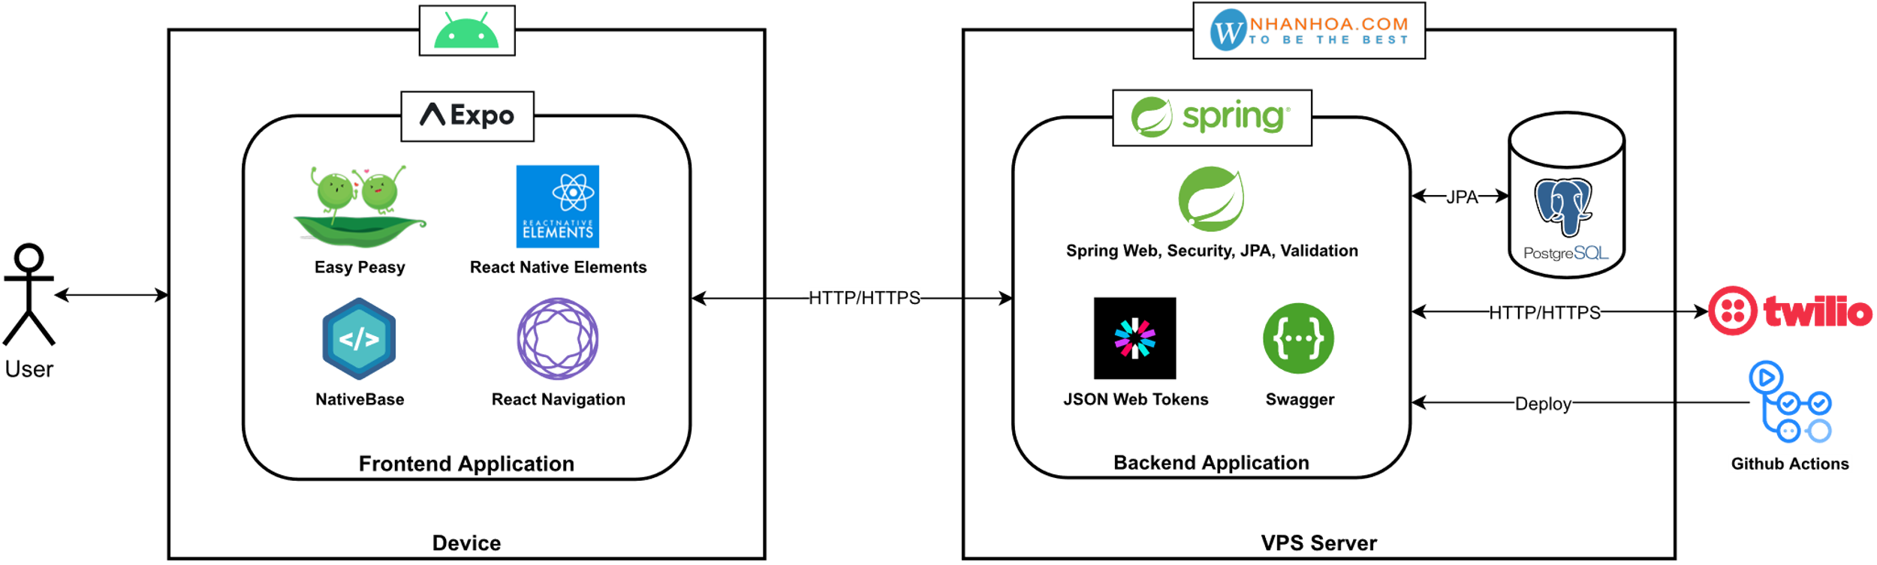

Figure 1.1. FSMIS Overall Architecture

### 1.2. System Architecture

#### 1.2.1. Front-end Components

##### 1.2.1.1. Expo[6]



Figure 1.2.1.1. “Expo” Logo

Expo is a framework and a platform for universal React applications. It is a set of tools and services built around React Native and native platforms, that help the developers develop, build, deploy, and quickly iterate on iOS, Android, and web apps from the same JavaScript/TypeScript codebase.

With its strong points are fast iterations and swift developing/testing capabilities, Expo has over 15k stars on GitHub and is used by more than 387,000 developers around the world.

##### 1.2.1.2. Easy Peasy[7]



Figure 1.2.1.2. “Easy Peasy” Logo

Easy Peasy is an abstraction of Redux, providing a reimagined API that focuses on developer experience. It allows you to quickly and easily manage your state, leveraging the strong architecture guarantees and extensive eco-system that Redux has to offer. Easy Peasy was nominated under the “Productivity Booster” category at the React Summit 2020 conference.

##### 1.2.1.3. React Native Elements[8]



Figure 1.2.1.3. React Native Elements

React Native Elements provide an all-in-one UI kit for creating apps in react native. Standing out among the many great open-source UI components in the market, React Native Elements takes the hassle of assembling these packages together by giving you a ready-made kit with consistent API and look and feel.

The project currently having 21.7k stars on GitHub and many contributors and backers around the globe, some of the application using React Native Element UI kits are from Icon88, dltx, TargetedWebTraffic.

##### 1.2.1.4. React Navigation[9]



Figure 1.2.1.4. “React Navigation” Logo

A routing and navigation API for all your React Native apps. Stands out as number one choice for mobile app navigation, some of the app using React Navigation are Expo Go, Codecademy Go, COVID Symptom Study, and many more.

React Navigation is an open-source project, having 20.6k stars on GitHub. The project source is consistently being improved upon by the large community base of enthusiastic contributors and backers from around the world.

##### 1.2.1.5. NativeBase[10]



Figure 1.2.1.5. “NativeBase” Logo

NativeBase is a component library that enables developers to build universal design systems. It is built on top of React Native, allowing you to develop apps for Android, iOS and the Web.

This open-source project has achieved over 16k stars on GitHub. NativeBase provides developers with features includes: Out of the Box Accessibility, Supporting Utility Props, Rich Component Library, Highly Themeable and Available in both Mobile and Web. NativeBase is competing with many other component libraries with the motivation of bringing the developers the experience of building and shipping accessible, high-quality apps quickly.

#### 1.2.2. Back-end Components

##### 1.2.2.1. Spring Boot[11]



Figure 1.2.2.1. “Spring Boot” Logo

Spring Boot is an open-source Java-based framework used to create a micro-service. It is developed by Pivotal Team and is used to build stand-alone and production ready spring applications.

##### 1.2.2.2. Json Web Tokens[12]



Figure 1.2.2.2. “JWT” Logo

JSON Web Token is a proposed Internet standard for creating data with optional signature and/or optional encryption whose payload holds JSON that asserts some number of claims. The tokens are signed either using a private secret or a public/private key.

##### 1.2.2.3. Swagger[13]



Figure 1.2.2.3. “Swagger” Logo

Swagger is an open source and professional toolset which simplify API development for users, teams and enterprises.

##### 1.2.2.4. Twilio[14]



Figure 1.2.2.4. “Twilio” Logo

Twilio allows software developers to programmatically make and receive phone calls, send and receive text messages, and perform other communication functions using its web service APIs.

#### 1.2.3. Database



Figure 1.2.3. “PostgreSQL” Logo

PostgreSQL is a flexible open-source object relational database management system with features meant to meet changes in workloads, from single machines to data warehouses to web services with many concurrent users. PostgreSQL uses and extends SQL (hence the name), and is broadly extensible to a range of use cases beyond mere transactional data.

#### 1.2.4. Deployment & Hosting

##### 1.2.4.1. VPS (Powered by Nhan Hoa Software Company[15])



Figure 1.2.4.1. “Nhan Hoa Ltd” Logo

A virtual private server (VPS) is a virtual machine sold as a service by an Internet hosting service. For many purposes it is functionally equivalent to a dedicated physical server and, being software-defined, can be created and configured much more easily.

##### 1.2.4.2. Github Actions[16]



Figure 1.2.4.2. “Github Actions” Logo

GitHub Actions is a continuous integration and continuous delivery (CI/CD) platform that allows you to automate your build, test, and deployment pipeline. You can create workflows that build and test every pull request to your repository, or deploy merged pull requests to production.

### 1.3. Package Diagrams

#### 1.3.1. Frontend

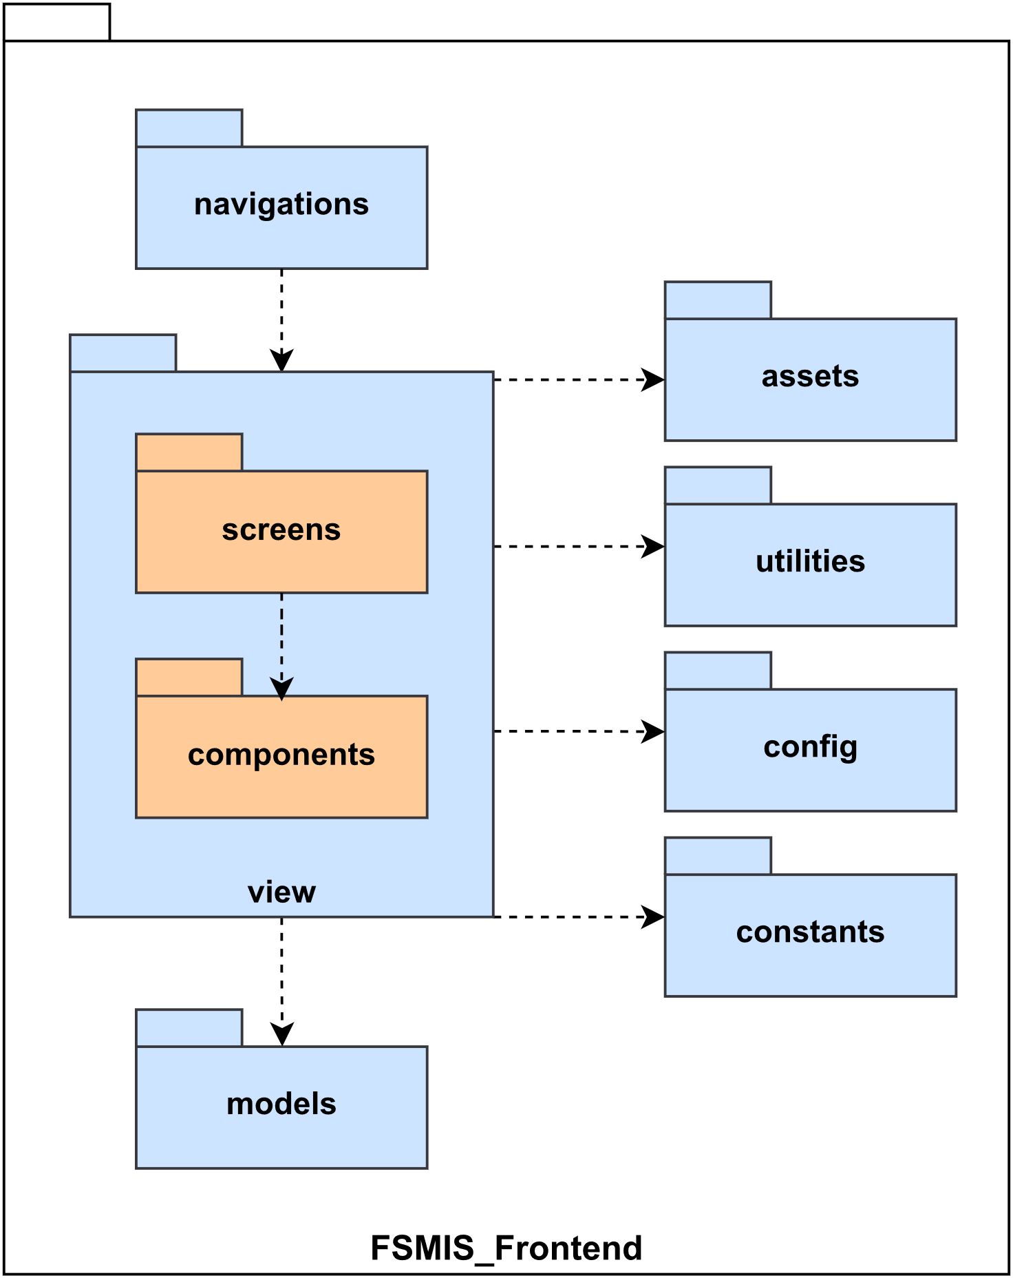

Figure 1.3.1. Frontend Package Diagram

|  |  |  |
| --- | --- | --- |
| **No** | **Package** | **Description** |
| 1 | navigations | House navigation stacks and navigation functions to move between multiple screens. |
| 2 | view - screens | House screens of the application |
| 3 | view - components | House reusable components for the screens. |
| 4 | assets | House images and logos of the application. |
| 5 | utilities | House helper functions for lightweight logic and creates HTTP requests and stores. |
| 6 | config | House theme configuration. |
| 7 | constants | House constant variables (strings, numbers, default values) are used across the application. |
| 8 | models | House models of the store. Contains all states and actions to communicate with API. |

Table 1.3.1. Frontend package details

#### 1.3.2. Backend

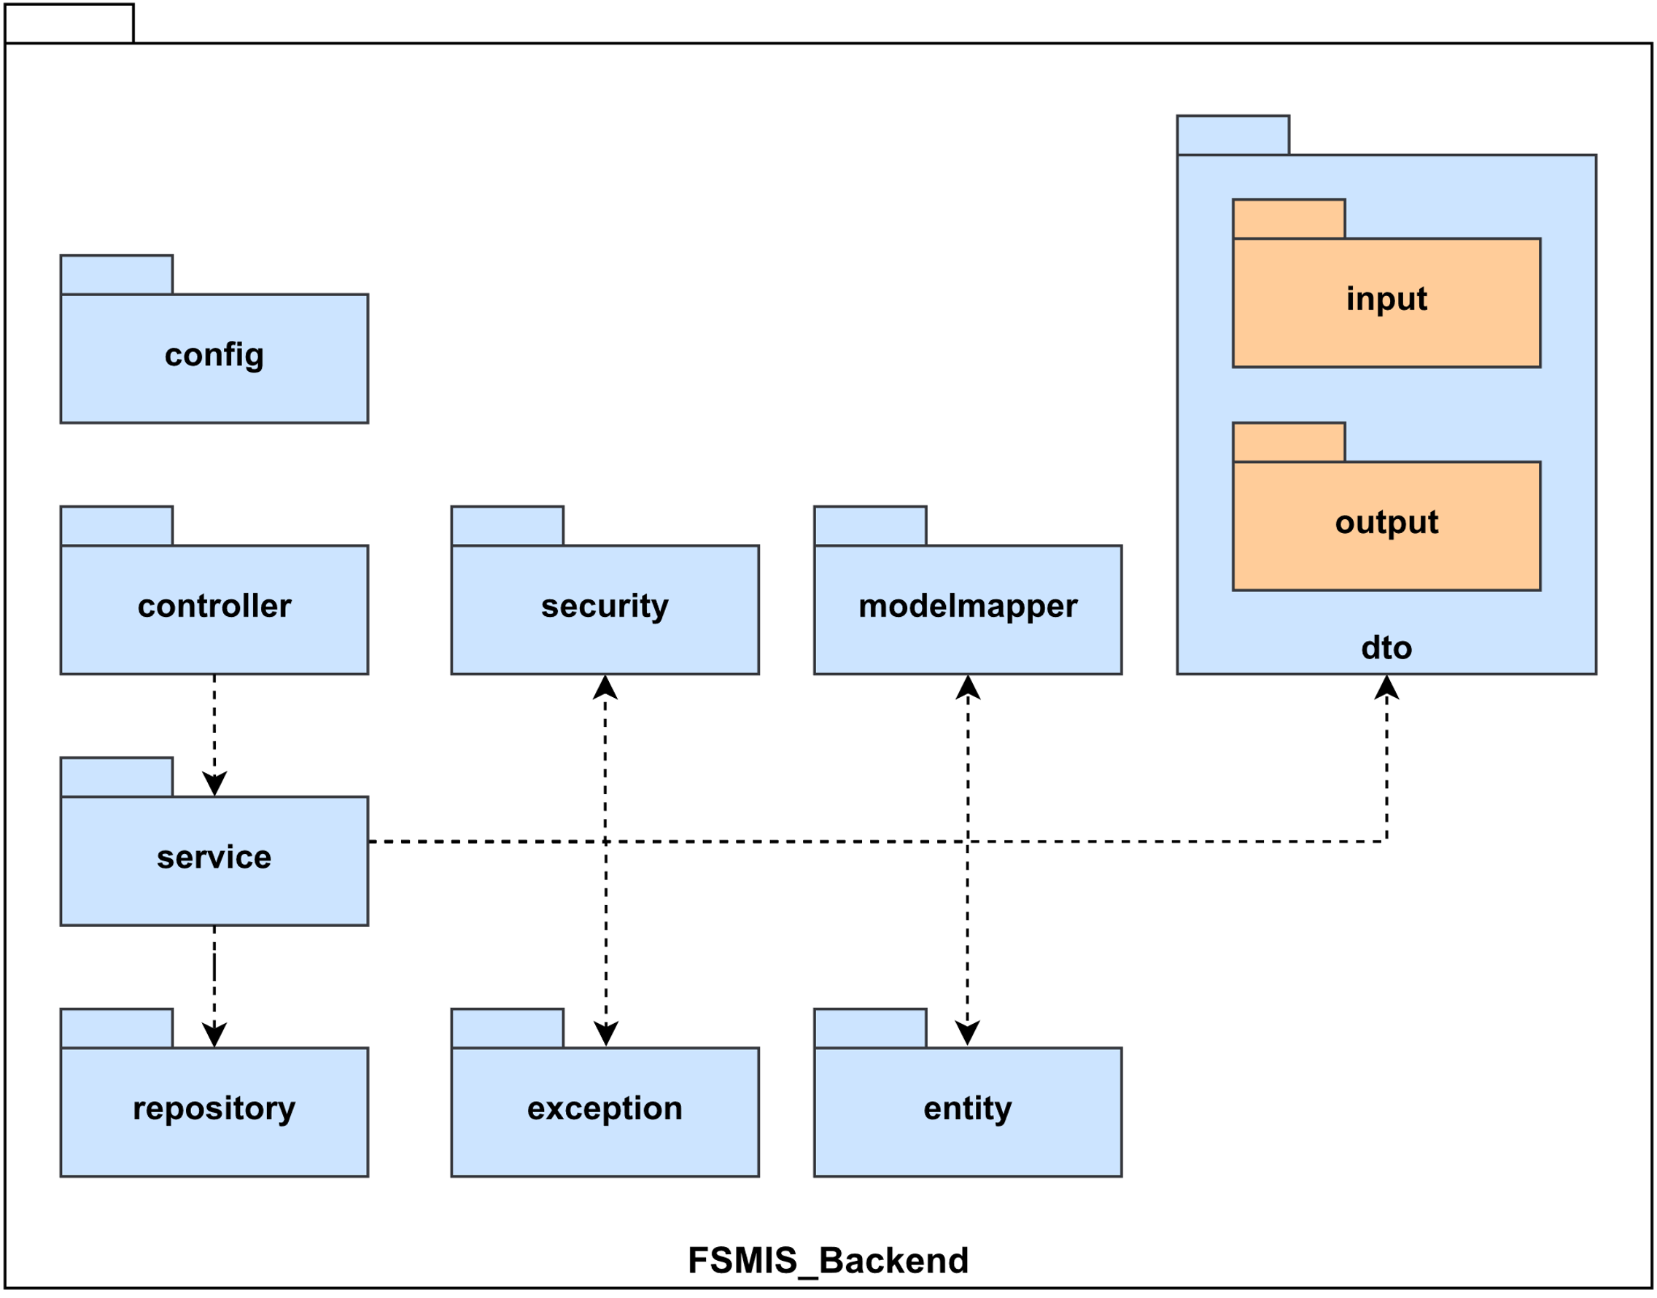

Figure 1.3.2. Backend Package Diagram

|  |  |  |
| --- | --- | --- |
| **No** | **Package** | **Description** |
| 1 | config | Contains classes used for configuration |
| 2 | controller | Contains classes which handle incoming requests and send them to service classes |
| 3 | service | Contains classes which are used to perform business logic. These classes communicate with repository classes, process data then return to controller classes |
| 4 | repository | Contains interfaces which communicate with the database and return them to service classes |
| 5 | security | Used for authentication and authorization |
| 6 | modelmapper | Used to map an entity to a DTO |
| 7 | exception | Contains custom exceptions and exceptions handler |
| 8 | entity | Contains classes represent real entities which can be persisted in database and some additional helper classes |
| 9 | dto - input | Contains objects used to transfer data from controller to service |
| 10 | dto - output | Contains objects used to transfer data from service to controller |

Table 1.3.2. Backend package details

## 2. Database Design

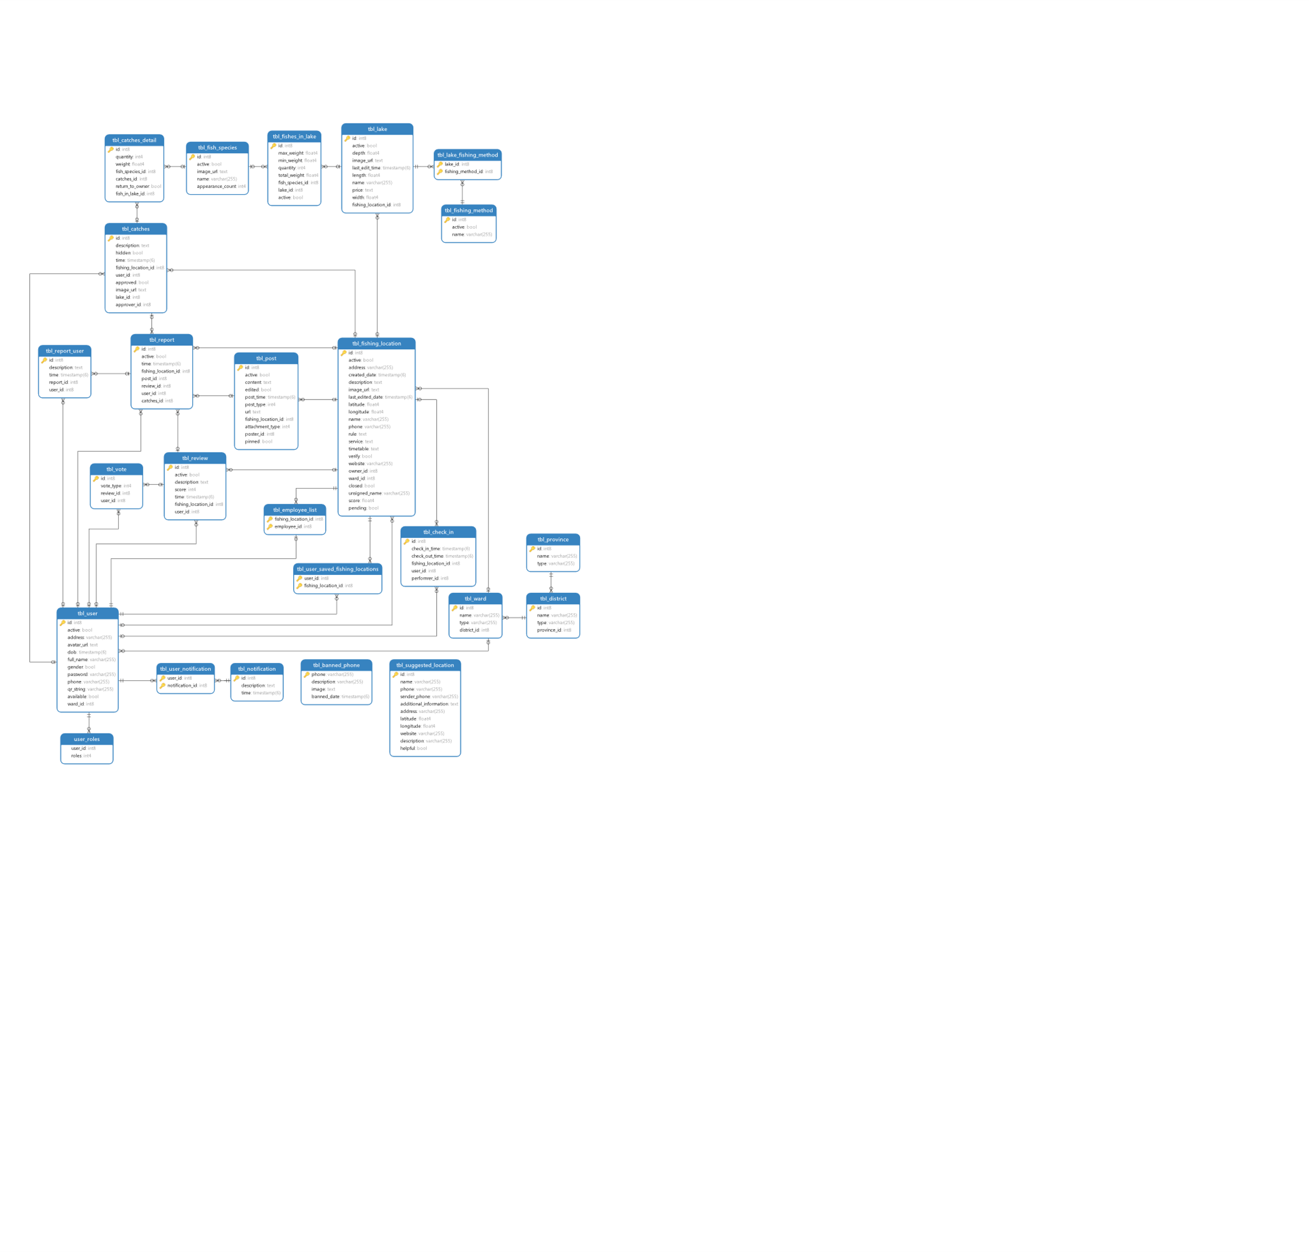

Figure 2. FSMIS Database design

### 2.1. Table “tbl_banned_phone”

|  |  |  |  |  |  |  |  |
| --- | --- | --- | --- | --- | --- | --- | --- |
| **#** | **Field name** | **Type** | **Size** | **Unique** | **Not Null** | **PK/FK** | **Notes** |
| 1 | phone | varchar | 255 | x | x | PK |  |
| 2 | description | varchar | 255 |  | x |  |  |
| 3 | image | text |  |  |  |  |  |
| 4 | banned_date | timestamp | 6 |  | x |  |  |

Table 2.1. tbl_banned_phone

### 2.2. Table “tbl_catches”

|  |  |  |  |  |  |  |  |
| --- | --- | --- | --- | --- | --- | --- | --- |
| **#** | **Field name** | **Type** | **Size** | **Unique** | **Not Null** | **PK/FK** | **Notes** |
| 1 | id | int | 8 | x | x | PK |  |
| 2 | description | text |  |  | x |  |  |
| 3 | hidden | bool | 1 |  | x |  |  |
| 4 | time | timestamp | 6 |  | x |  |  |
| 5 | fishing_location_id | int | 8 |  | x | FK |  |
| 6 | user_id | int | 8 |  | x | FK |  |
| 7 | approved | bool | 1 |  | x |  |  |
| 8 | image_url | text |  |  | x |  |  |
| 9 | lake_id | int | 8 |  | x |  |  |
| 10 | approver_id | int | 8 |  | x |  |  |

Table 2.2. tbl_catches

### 2.3. Table “tbl_catches_detail”

|  |  |  |  |  |  |  |  |
| --- | --- | --- | --- | --- | --- | --- | --- |
| **#** | **Field name** | **Type** | **Size** | **Unique** | **Not Null** | **PK/FK** | **Notes** |
| 1 | id | bigserial |  | x | x | PK |  |
| 2 | quantity | int | 4 |  | x |  |  |
| 3 | weight | float | 4 |  | x |  |  |
| 4 | fish_species_id | int | 8 |  | x |  |  |
| 5 | catches_id | int | 8 |  | x |  |  |
| 6 | return_to_owner | bool | 1 |  | x |  |  |
| 7 | fish_in_lake_id | int | 8 |  | x |  |  |

Table 2.3. tbl_catches_detail

### 2.4. Table “tbl_check_in”

|  |  |  |  |  |  |  |  |
| --- | --- | --- | --- | --- | --- | --- | --- |
| **#** | **Field name** | **Type** | **Size** | **Unique** | **Not Null** | **PK/FK** | **Notes** |
| 1 | id | int | 8 | x | x | PK |  |
| 2 | check_in_time | timestamp | 6 |  | x |  |  |
| 3 | check_out_time | timestamp | 6 |  |  |  |  |
| 4 | fishing_location_id | int | 8 |  | x | FK |  |
| 5 | user_id | int | 8 |  | x | FK |  |
| 6 | performer_id | int | 8 |  | x |  |  |

Table 2.4. tbl_check_in

### 2.5. Table “tbl_district”

|  |  |  |  |  |  |  |  |
| --- | --- | --- | --- | --- | --- | --- | --- |
| **#** | **Field name** | **Type** | **Size** | **Unique** | **Not Null** | **PK/FK** | **Notes** |
| 1 | id | int | 8 | x | x | PK |  |
| 2 | name | varchar | 255 |  | x |  |  |
| 3 | type | varchar | 255 |  | x |  |  |
| 4 | province_id | int | 8 |  | x | FK |  |

Table 2.5. tbl_district

### 2.6. Table “tbl_employee_list”

|  |  |  |  |  |  |  |  |
| --- | --- | --- | --- | --- | --- | --- | --- |
| **#** | **Field name** | **Type** | **Size** | **Unique** | **Not Null** | **PK/FK** | **Notes** |
| 1 | fishing_location_id | int | 8 |  | x | PK, FK |  |
| 2 | employee_id | int | 8 | x | x | PK, FK |  |

Table 2.6. tbl_employee_list

### 2.7. Table “tbl_fish_species”

|  |  |  |  |  |  |  |  |
| --- | --- | --- | --- | --- | --- | --- | --- |
| **#** | **Field name** | **Type** | **Size** | **Unique** | **Not Null** | **PK/FK** | **Notes** |
| 1 | id | bigserial |  | x | x | PK |  |
| 2 | active | bool | 1 |  | x |  |  |
| 3 | image_url | text |  |  | x |  |  |
| 4 | name | varchar | 255 |  | x |  |  |
| 5 | appearance_count | int | 4 |  | x |  |  |

Table 2.7. tbl_fish_species

### 2.8. Table “tbl_fish_in_lake”

|  |  |  |  |  |  |  |  |
| --- | --- | --- | --- | --- | --- | --- | --- |
| **#** | **Field name** | **Type** | **Size** | **Unique** | **Not Null** | **PK/FK** | **Notes** |
| 1 | id | bigserial |  | x | x | PK |  |
| 2 | max_weight | float | 4 |  | x |  |  |
| 3 | min_weight | float | 4 |  | x |  |  |
| 4 | quantity | int | 4 |  | x |  |  |
| 5 | total_weight | float | 4 |  | x |  |  |
| 6 | fish_species_id | int | 8 |  | x | FK |  |
| 7 | lake_id | int | 8 |  | x |  |  |
| 8 | active | bool | 1 |  | x |  |  |

Table 2.8. tbl_fish_in_lake

### 2.9. Table “tbl_fishing_location”

|  |  |  |  |  |  |  |  |
| --- | --- | --- | --- | --- | --- | --- | --- |
| **#** | **Field name** | **Type** | **Size** | **Unique** | **Not Null** | **PK/FK** | **Notes** |
| 1 | id | bigserial |  | x | x | PK |  |
| 2 | active | bool | 1 |  | x |  |  |
| 3 | address | varchar | 255 |  | x |  |  |
| 4 | created_date | timestamp | 6 |  | x |  |  |
| 5 | description | text |  |  | x |  |  |
| 6 | image_url | text |  |  | x |  |  |
| 7 | last_edited_date | timestamp | 6 |  | x |  |  |
| 8 | latitude | float | 4 |  | x |  |  |
| 9 | longitude | float | 4 |  | x |  |  |
| 10 | name | varchar | 255 |  | x |  |  |
| 11 | phone | varchar | 255 |  | x |  |  |
| 12 | rule | text |  |  | x |  |  |
| 13 | service | text |  |  | x |  |  |
| 14 | timetable | text |  |  | x |  |  |
| 15 | verify | bool | 1 |  | x |  |  |
| 16 | website | varchar | 255 |  |  |  |  |
| 17 | owner_id | int | 8 |  | x | FK |  |
| 18 | ward_id | int | 8 |  | x | FK |  |
| 19 | closed | bool | 1 |  | x |  |  |
| 20 | unsigned_name | varchar | 255 |  | x |  |  |
| 21 | score | floar | 4 |  | x |  |  |
| 22 | pending | bool | 1 |  |  |  |  |

Table 2.9. tbl_fishing_location

### 2.10. Table “tbl_fishing_method”

|  |  |  |  |  |  |  |  |
| --- | --- | --- | --- | --- | --- | --- | --- |
| **#** | **Field name** | **Type** | **Size** | **Unique** | **Not Null** | **PK/FK** | **Notes** |
| 1 | id | bigserial |  | x | x | PK |  |
| 2 | active | bool | 1 |  | x |  |  |
| 3 | name | varchar | 255 |  | x |  |  |

Table 2.10. tbl_fishing_method

### 2.11. Table “tbl_lake”

|  |  |  |  |  |  |  |  |
| --- | --- | --- | --- | --- | --- | --- | --- |
| **#** | **Field name** | **Type** | **Size** | **Unique** | **Not Null** | **PK/FK** | **Notes** |
| 1 | id | bigserial |  | x | x | PK |  |
| 2 | active | bool | 1 |  | x |  |  |
| 3 | depth | float | 4 |  | x |  |  |
| 4 | image_url | text |  |  | x |  |  |
| 5 | last_edit_time | timestamp | 6 |  | x |  |  |
| 6 | length | float | 4 |  | x |  |  |
| 7 | name | varchar | 255 |  | x |  |  |
| 8 | price | text |  |  | x |  |  |
| 9 | width | float | 4 |  | x |  |  |
| 10 | fishing_location_id | int | 8 |  | x | FK |  |

Table 2.11. tbl_lake

### 2.12. Table “tbl_lake_fishing_method”

|  |  |  |  |  |  |  |  |
| --- | --- | --- | --- | --- | --- | --- | --- |
| **#** | **Field name** | **Type** | **Size** | **Unique** | **Not Null** | **PK/FK** | **Notes** |
| 1 | lake_id | int | 8 |  | x | PK, FK |  |
| 2 | fishing_method_id | int | 8 |  | x | PK, FK |  |

Table 2.12. tbl_lake_fishing_method

### 2.13. Table “tbl_notification”

|  |  |  |  |  |  |  |  |
| --- | --- | --- | --- | --- | --- | --- | --- |
| **#** | **Field name** | **Type** | **Size** | **Unique** | **Not Null** | **PK/FK** | **Notes** |
| 1 | id | int | 8 | x | x | PK |  |
| 2 | description | text |  |  | x |  |  |
| 3 | time | timestamp | 6 |  | x |  |  |

Table 2.13. tbl_notification

### 2.14. Table “tbl_post”

|  |  |  |  |  |  |  |  |
| --- | --- | --- | --- | --- | --- | --- | --- |
| **#** | **Field name** | **Type** | **Size** | **Unique** | **Not Null** | **PK/FK** | **Notes** |
| 1 | id | bigserial |  | x | x | PK |  |
| 2 | active | bool | 1 |  | x |  |  |
| 3 | content | text |  |  | x |  |  |
| 4 | edited | bool | 1 |  | x |  |  |
| 5 | post_time | timestamp | 6 |  | x |  |  |
| 6 | post_type | int | 4 |  | x |  |  |
| 7 | url | text |  |  |  |  |  |
| 8 | fishing_location_id | int | 8 |  | x | FK |  |
| 9 | attachment_type | int | 4 |  | x |  |  |
| 10 | poster_id | int | 8 |  | x |  |  |
| 11 | pinned | bool | 1 |  |  |  |  |

Table 2.14. tbl_post

### 2.15. Table “tbl_province”

|  |  |  |  |  |  |  |  |
| --- | --- | --- | --- | --- | --- | --- | --- |
| **#** | **Field name** | **Type** | **Size** | **Unique** | **Not Null** | **PK/FK** | **Notes** |
| 1 | id | int | 8 | x | x | PK |  |
| 2 | name | varchar | 255 |  | x |  |  |
| 3 | type | varchar | 255 |  | x |  |  |

Table 2.15. tbl_province

### 2.16. Table “tbl_report”

|  |  |  |  |  |  |  |  |
| --- | --- | --- | --- | --- | --- | --- | --- |
| **#** | **Field name** | **Type** | **Size** | **Unique** | **Not Null** | **PK/FK** | **Notes** |
| 1 | id | bigserial |  | x | x | PK |  |
| 2 | active | bool | 1 |  | x |  |  |
| 3 | time | timestamp | 6 |  | x |  |  |
| 4 | fishing_location_id | int | 8 |  |  | FK |  |
| 5 | post_id | int | 8 |  |  | FK |  |
| 6 | review_id | int | 8 |  |  | FK |  |
| 7 | user_id | int | 8 |  | x | FK |  |
| 8 | catches_id | int | 8 |  |  | FK |  |

Table 2.16. tbl_report

### 2.17. Table “tbl_report_user”

|  |  |  |  |  |  |  |  |
| --- | --- | --- | --- | --- | --- | --- | --- |
| **#** | **Field name** | **Type** | **Size** | **Unique** | **Not Null** | **PK/FK** | **Notes** |
| 1 | id | int | 8 | x | x | PK |  |
| 2 | description | text |  |  | x |  |  |
| 3 | time | timestamp |  |  | x |  |  |
| 4 | report_id | int | 8 |  | x | FK |  |
| 5 | user_id | int | 8 |  | x | FK |  |

Table 2.17. tbl_report_user

### 2.18. Table “tbl_review”

|  |  |  |  |  |  |  |  |
| --- | --- | --- | --- | --- | --- | --- | --- |
| **#** | **Field name** | **Type** | **Size** | **Unique** | **Not Null** | **PK/FK** | **Notes** |
| 1 | id | bigserial |  | x | x | PK |  |
| 2 | active | bool |  |  | x |  |  |
| 3 | description | text |  |  |  |  |  |
| 4 | score | int | 4 |  |  |  |  |
| 5 | time | timestamp |  |  | x |  |  |
| 6 | fishing_location_id | int | 8 |  |  | FK |  |
| 7 | user_id | int | 8 |  |  | FK |  |

Table 2.18. tbl_review

### 2.19. Table “tbl_suggested_location”

|  |  |  |  |  |  |  |  |
| --- | --- | --- | --- | --- | --- | --- | --- |
| **#** | **Field name** | **Type** | **Size** | **Unique** | **Not Null** | **PK/FK** | **Notes** |
| 1 | id | int | 8 | x | x | PK |  |
| 2 | name | varchar | 255 |  | x |  |  |
| 3 | phone | varchar | 255 |  | x |  |  |
| 4 | sender_phone | varchar | 255 |  | x |  |  |
| 5 | additional_information | text |  |  |  |  |  |
| 6 | address | varchar | 255 |  |  |  |  |
| 7 | latitude | float | 4 |  |  |  |  |
| 8 | longitude | float | 4 |  |  |  |  |
| 9 | website | varchar | 255 |  |  |  |  |
| 10 | description | varchar | 255 |  |  |  |  |
| 11 | helpful | bool | 1 |  |  |  |  |

Table 2.19. tbl_suggested_location

### 2.20. Table “tbl_user”

|  |  |  |  |  |  |  |  |
| --- | --- | --- | --- | --- | --- | --- | --- |
| **#** | **Field name** | **Type** | **Size** | **Unique** | **Not Null** | **PK/FK** | **Notes** |
| 1 | id | bigserial |  | x | x | PK |  |
| 2 | active | bool |  |  | x |  |  |
| 3 | address | varchar | 255 |  |  |  |  |
| 4 | avatar_url | text |  |  |  |  |  |
| 5 | dob | timestamp | 6 |  |  |  |  |
| 6 | full_name | varchar | 255 |  | x |  |  |
| 7 | gender | bool | 1 |  |  |  |  |
| 8 | password | varchar | 255 |  | x |  |  |
| 9 | phone | varchar | 255 |  |  |  |  |
| 10 | qr_string | varchar | 255 | x | x |  |  |
| 11 | available | bool | 1 |  |  |  |  |
| 12 | ward_id | int | 8 |  |  | FK |  |

Table 2.20. tbl_user

### 2.21. Table “tbl_user_notification”

|  |  |  |  |  |  |  |  |
| --- | --- | --- | --- | --- | --- | --- | --- |
| **#** | **Field name** | **Type** | **Size** | **Unique** | **Not Null** | **PK/FK** | **Notes** |
| 1 | user_id | int | 8 |  | x | PK, FK |  |
| 2 | notification_id | int | 8 |  | x | PK, FK |  |

Table 2.21. tbl_user_notification

### 2.22. Table “tbl_user_saved_fishing_locations”

|  |  |  |  |  |  |  |  |
| --- | --- | --- | --- | --- | --- | --- | --- |
| **#** | **Field name** | **Type** | **Size** | **Unique** | **Not Null** | **PK/FK** | **Notes** |
| 1 | user_id | int | 8 |  | x | PK, FK |  |
| 2 | fishing_location_id | int | 8 |  | x | PK, FK |  |

Table 2.22. tbl_user_saved_fishing_location

### 2.23. Table “tbl_vote”

|  |  |  |  |  |  |  |  |
| --- | --- | --- | --- | --- | --- | --- | --- |
| **#** | **Field name** | **Type** | **Size** | **Unique** | **Not Null** | **PK/FK** | **Notes** |
| 1 | id | bigserial |  | x | x | PK |  |
| 2 | vote_type | int | 4 |  |  |  |  |
| 3 | review_id | int | 8 |  |  | FK |  |
| 4 | user_id | int | 8 |  |  | FK |  |

Table 2.23. tbl_vote

### 2.24. Table “tbl_ward”

|  |  |  |  |  |  |  |  |
| --- | --- | --- | --- | --- | --- | --- | --- |
| **#** | **Field name** | **Type** | **Size** | **Unique** | **Not Null** | **PK/FK** | **Notes** |
| 1 | id | int | 8 | x | x | PK |  |
| 2 | name | varchar | 255 |  | x |  |  |
| 3 | type | varchar | 255 |  | x |  |  |
| 4 | district_id | int | 8 |  | x | FK |  |

Table 2.24. tbl_ward

### 2.25. Table “user_roles”

|  |  |  |  |  |  |  |  |
| --- | --- | --- | --- | --- | --- | --- | --- |
| **#** | **Field name** | **Type** | **Size** | **Unique** | **Not Null** | **PK/FK** | **Notes** |
| 1 | user_id | int | 8 |  | x | PK, FK |  |
| 2 | roles | int | 4 |  | x |  |  |

Table 2.25. user_role

## 3. Detail Design

### 3.1. Feature “Authenticate user”

#### 3.1.1. Class Diagram

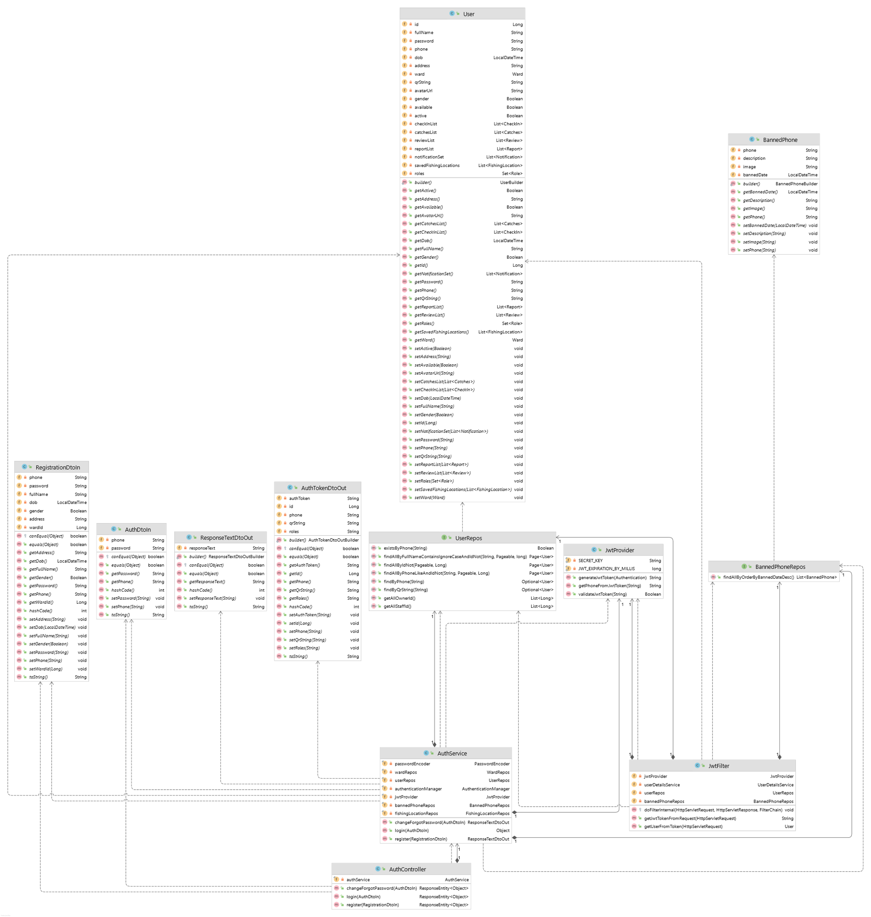

Figure 3.1. “Authenticate user” Class Digram

#### 3.1.2. Sequence Diagram(s)

##### 3.1.2.1. Login

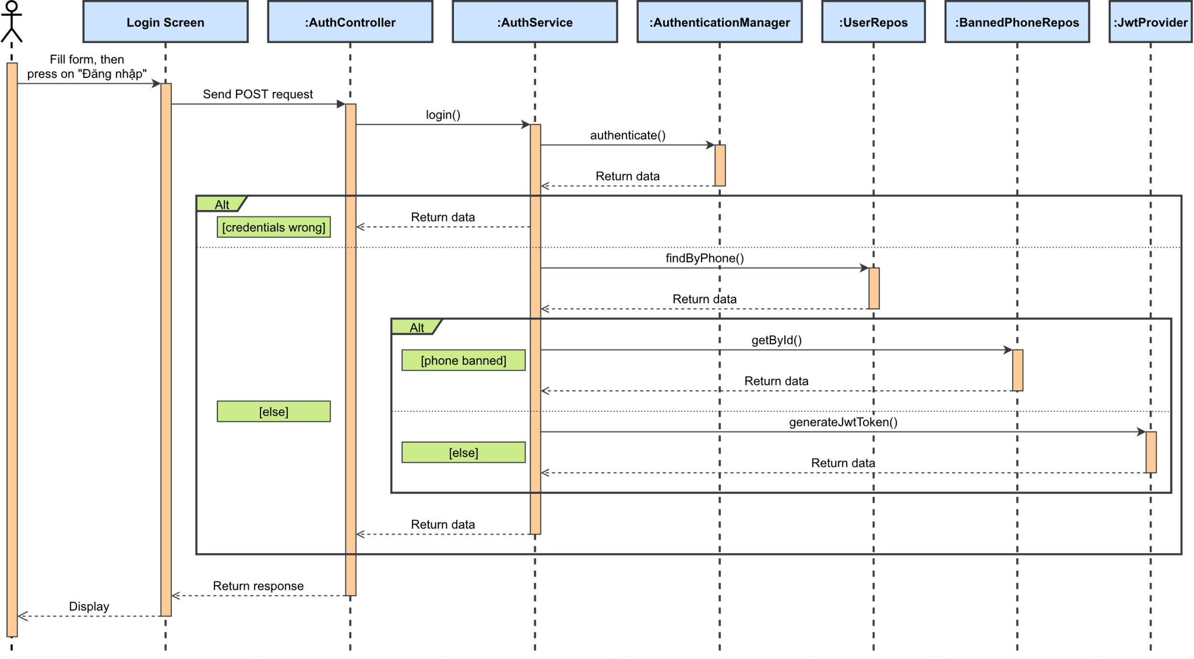

Figure 3.1.2.1. “Login” Sequence Diagram

##### 3.1.2.2. Register

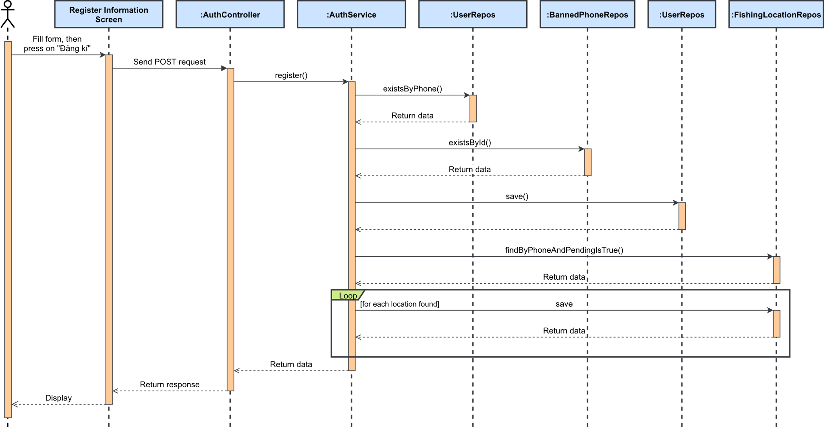

Figure 3.1.2.2. “Register” Sequence Diagram

##### 3.1.2.3. Forgot password

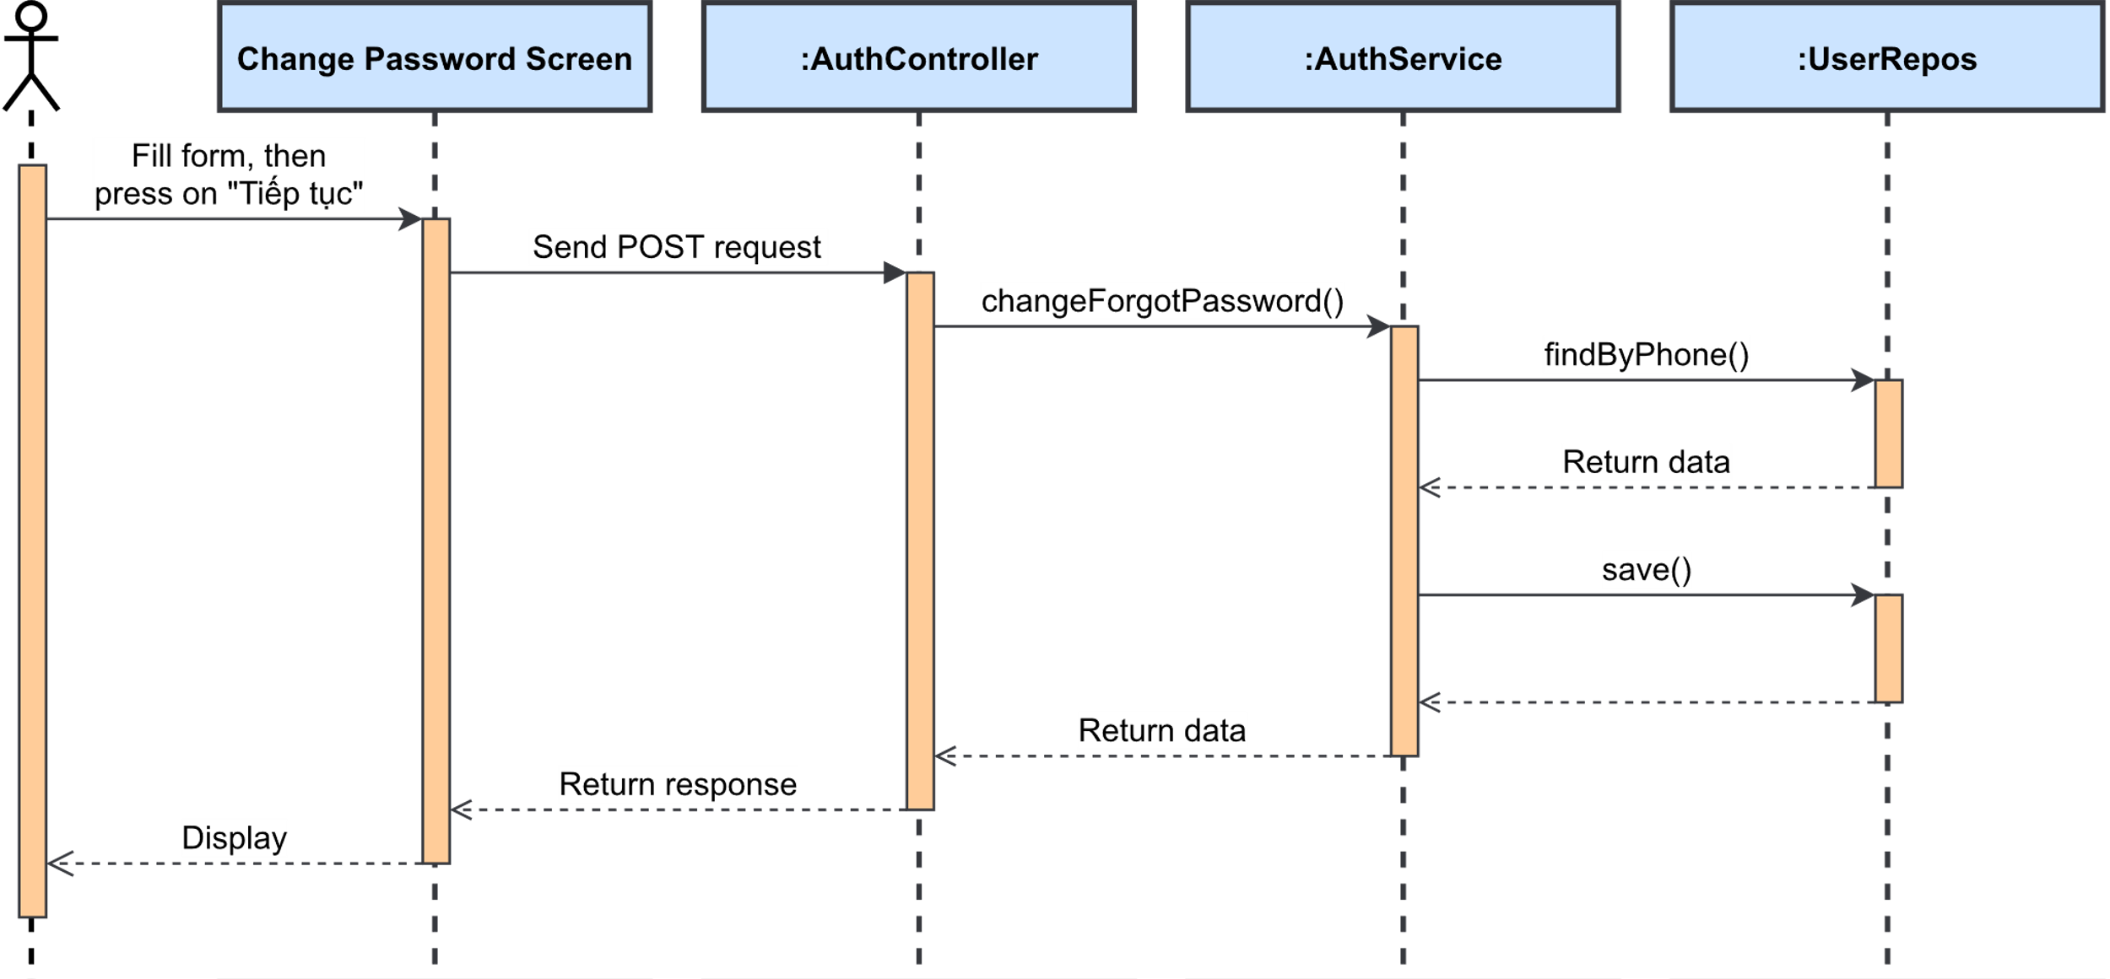

Figure 3.1.2.3. “Forgot password” Sequence Diagram

### 3.2. Feature “Manage personal profile”

#### 3.2.1. Class Diagram

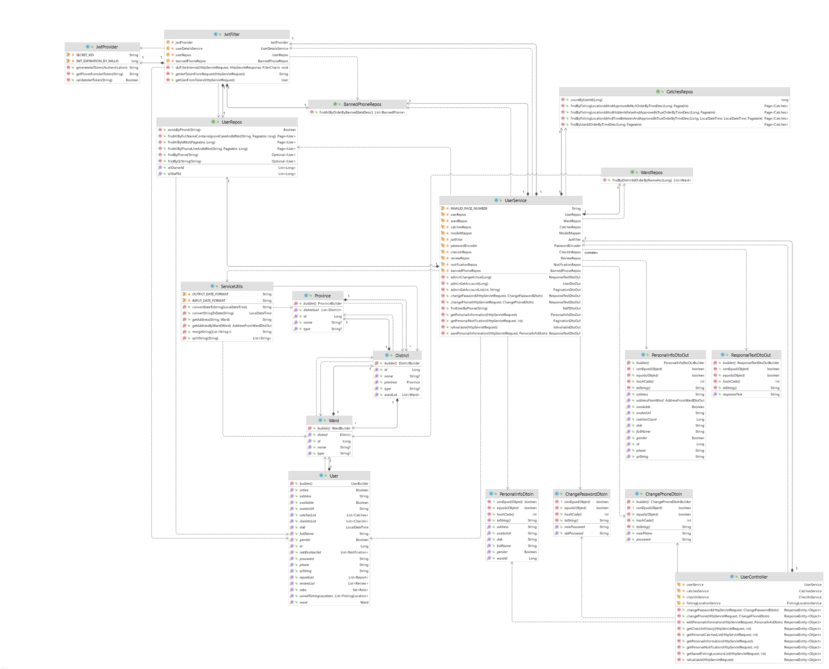

Figure 3.2. “Manage personal profile” Class Diagram

#### 3.2.2. Sequence Diagram(s)

##### 3.2.2.1. View personal profile

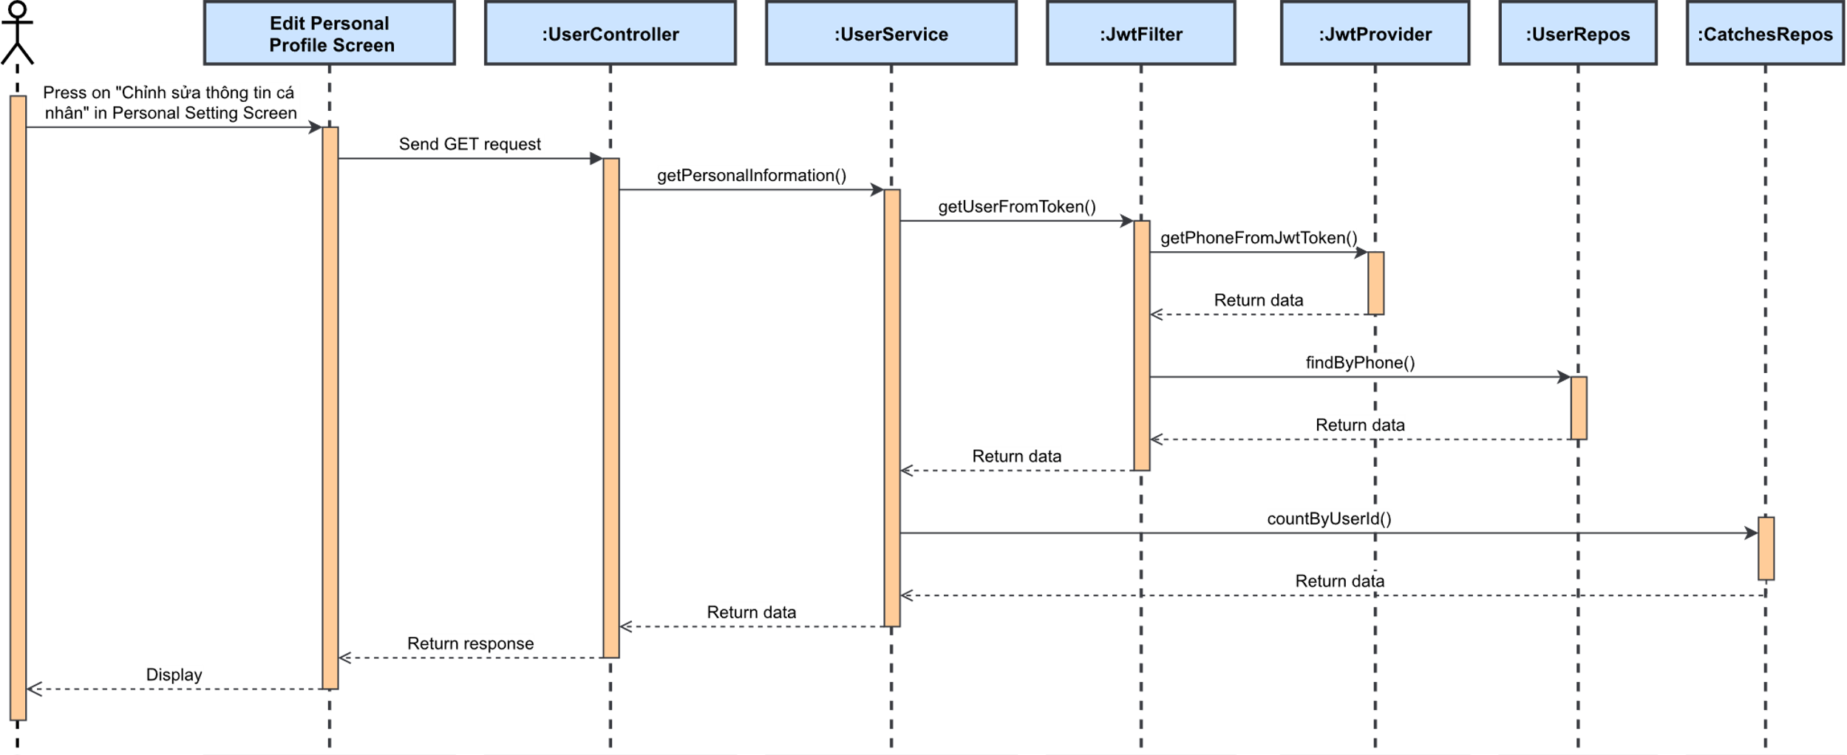

Figure 3.2.2.1. “View personal profile” Sequence Diagram

##### 3.2.2.2. Edit personal profile

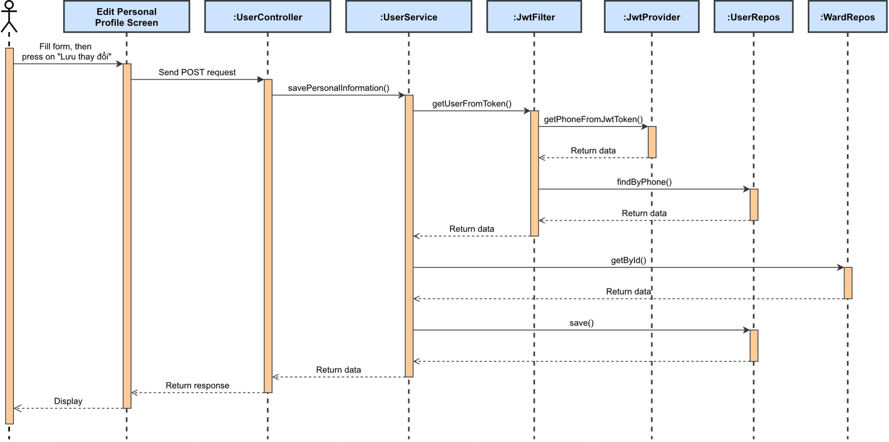

Figure 3.2.2.2. “Edit personal profile” Sequence Diagram

##### 3.2.2.3. Change password

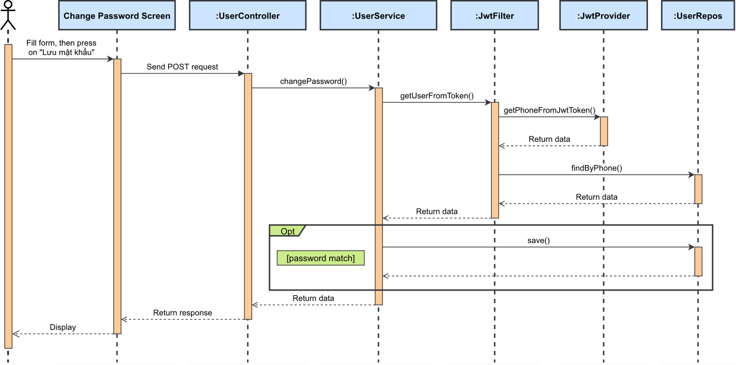

Figure 3.2.2.3. “Change password” Sequence Diagram

##### 3.2.2.4. Change phone number

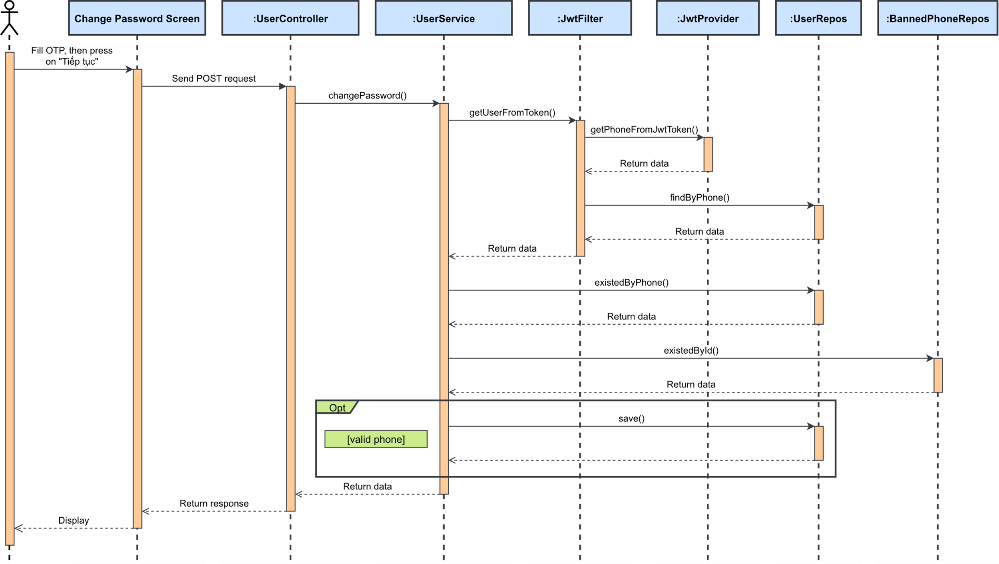

Figure 3.2.2.4. “Change password” Sequence Diagram

##### 3.2.2.5. Send OTP

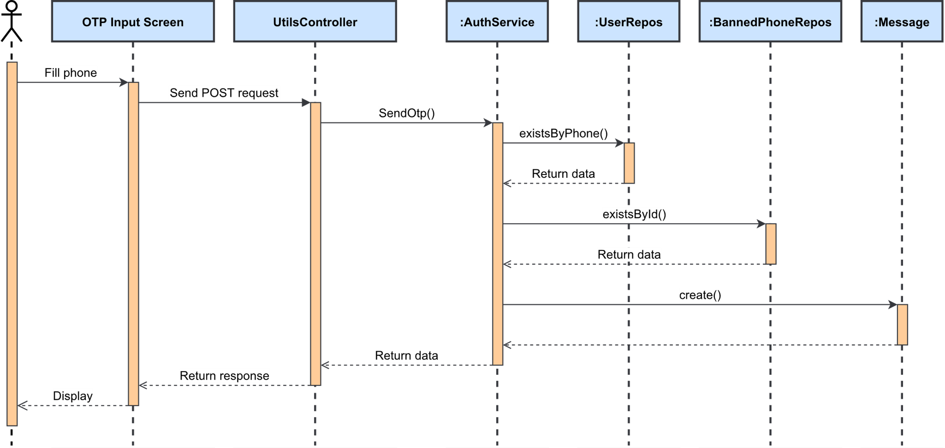

Figure 3.2.2.5. “Send OTP” Sequence Diagram

##### 3.2.2.6. Validate OTP

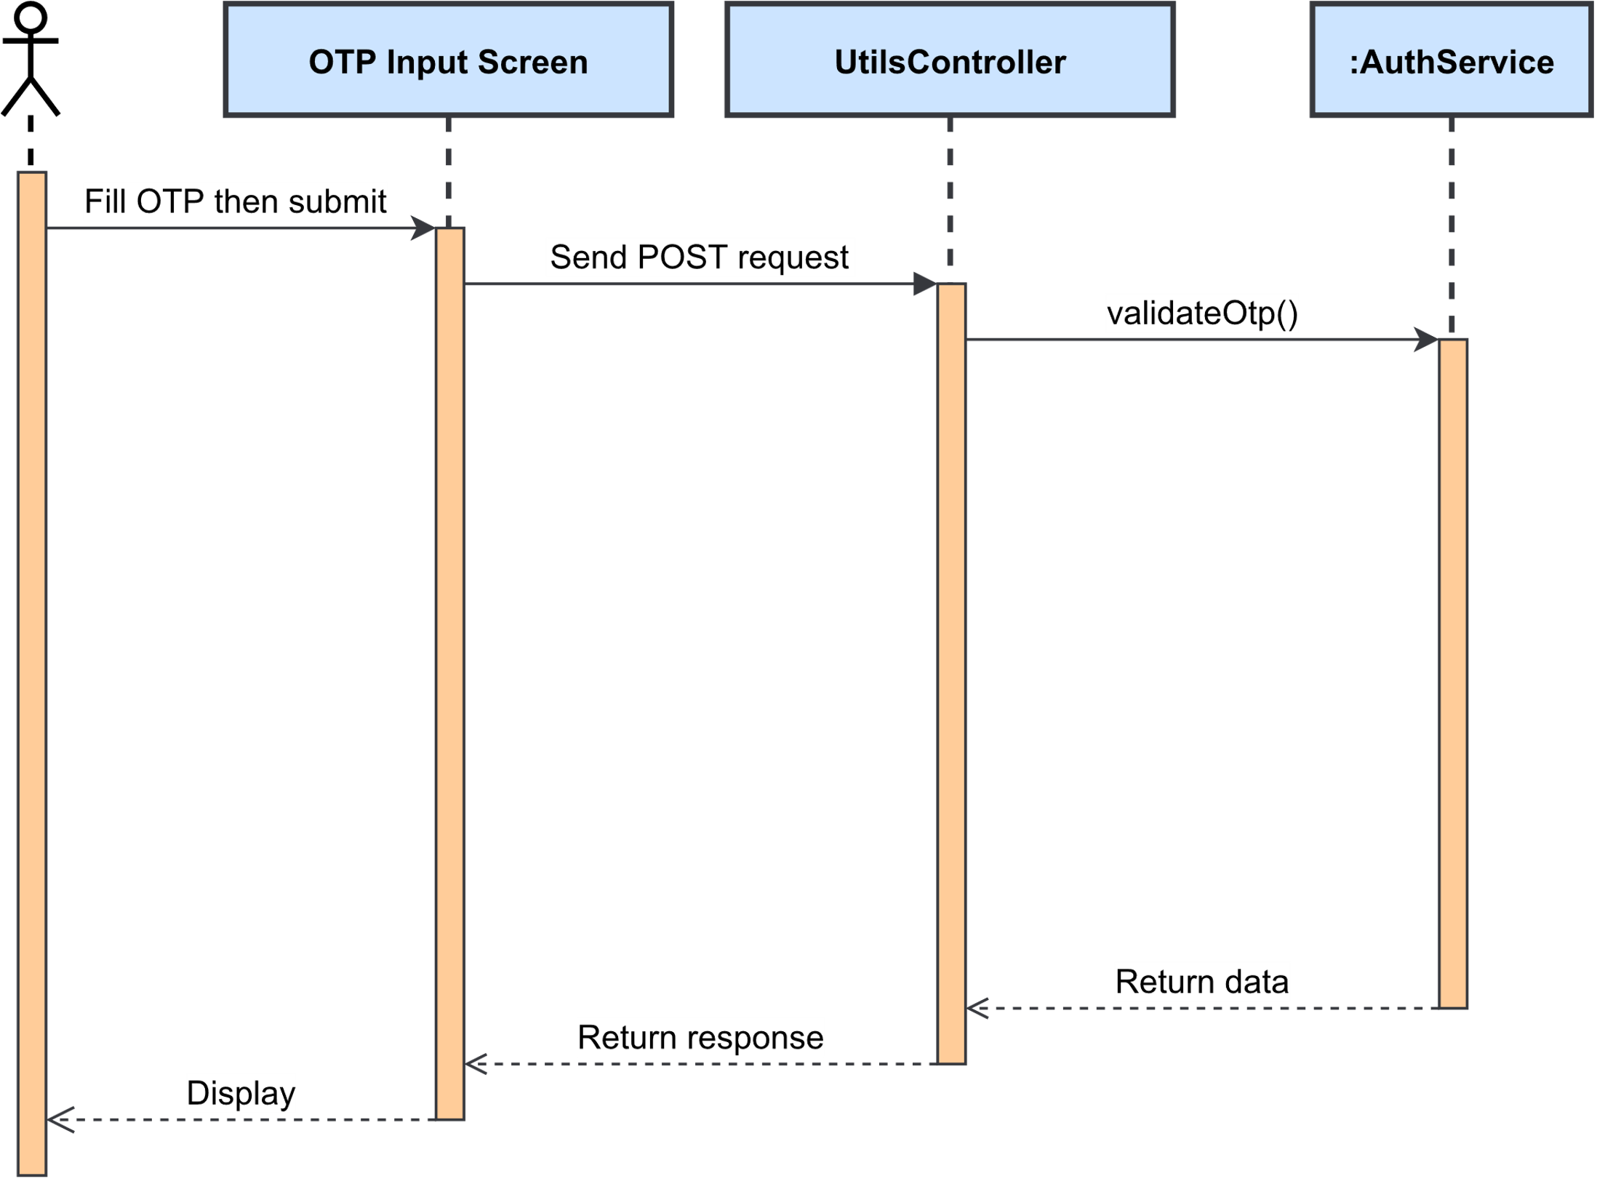

Figure 3.2.2.5. “Validate OTP” Sequence Diagram

### 3.3. Feature “Manage system accounts”

#### 3.3.1. Class Diagram

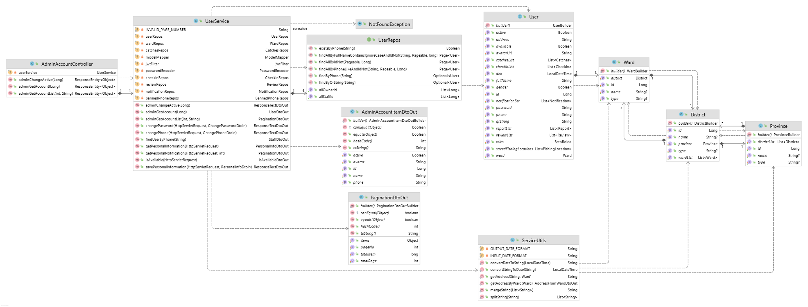

Figure 3.3.1. “Manage system accounts” Class Diagram

#### 3.3.2. Sequence Diagram(s)

##### 3.3.2.1. View and search system account list

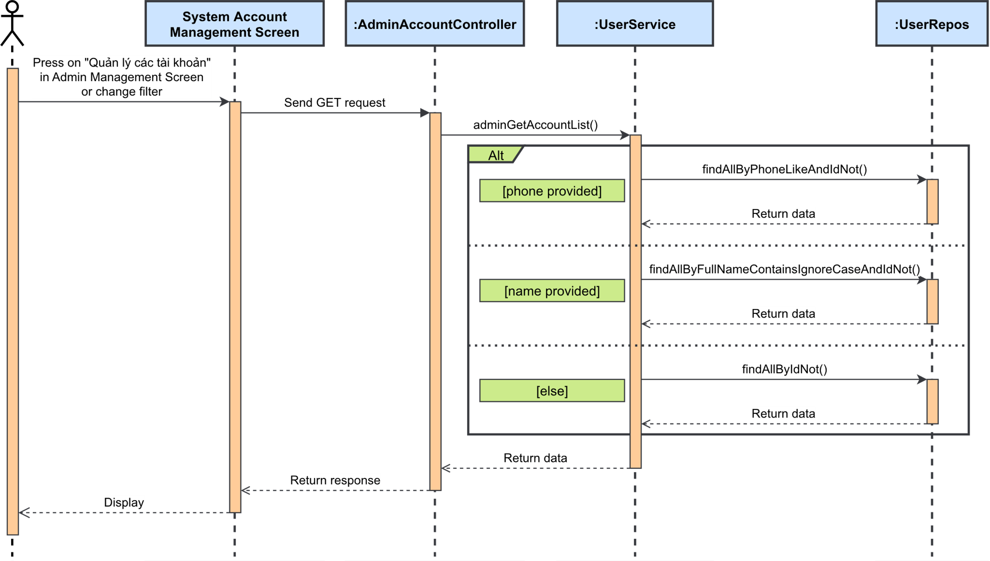

Figure 3.3.2.1. “View and search system account list” Sequence Diagram

##### 3.3.2.2. View account details

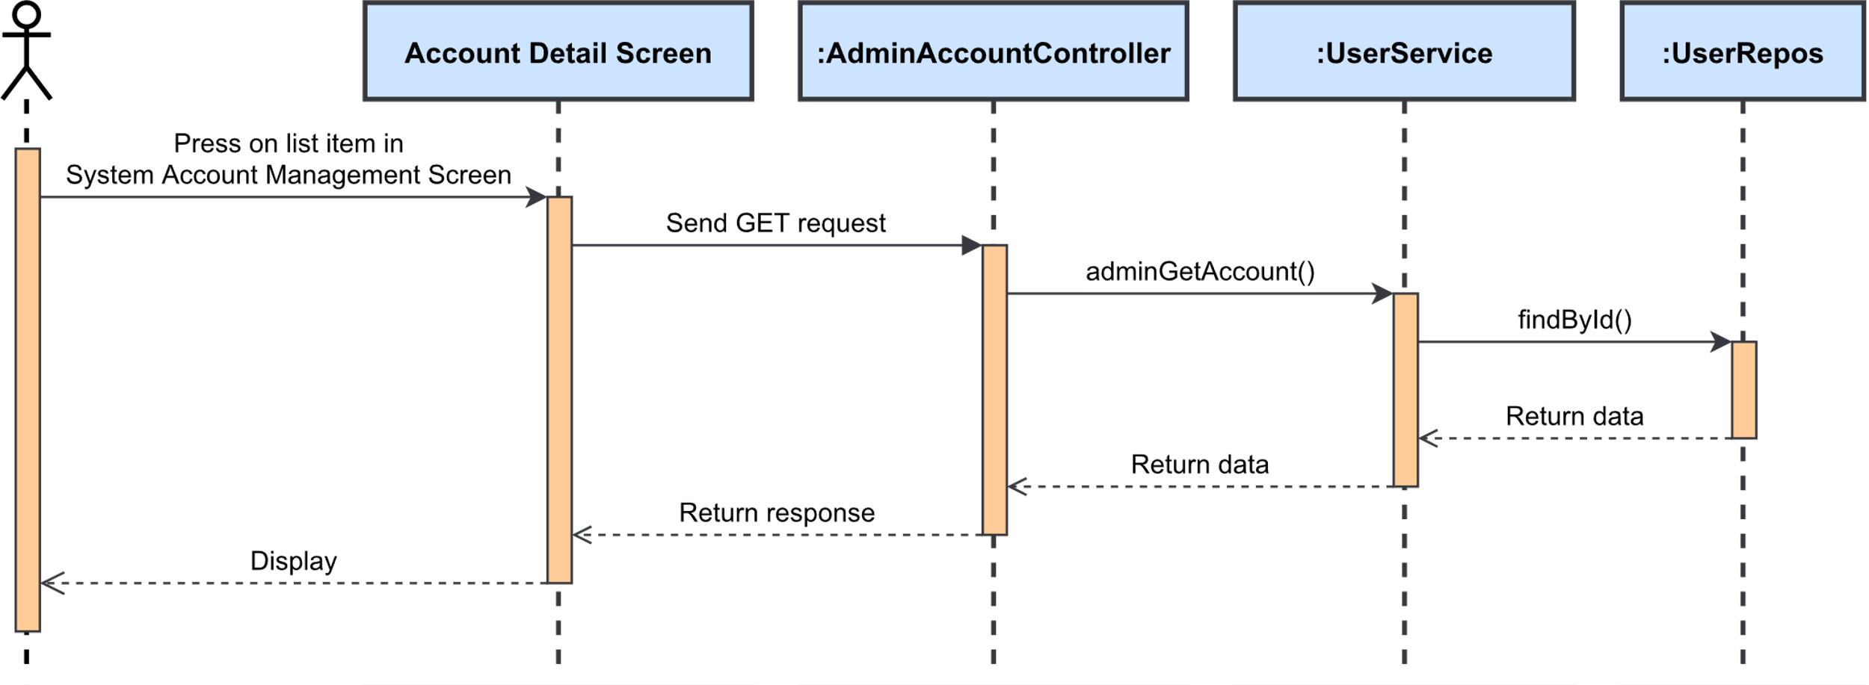

Figure 3.3.2.2. “View account details” Sequence Diagram

### 3.4. Feature “Search fishing location”

#### 3.4.1. Class Diagram

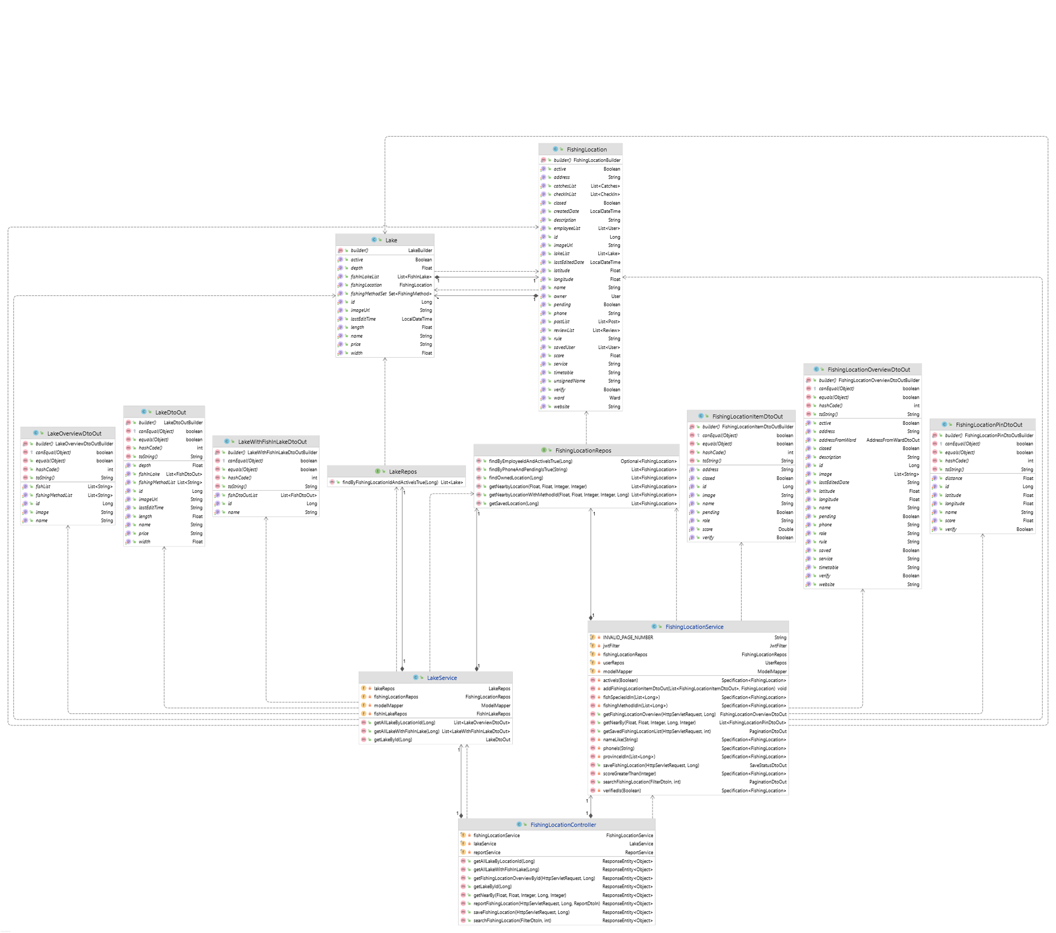

Figure 3.4.1. “Search fishing location” Class Diagram

#### 3.4.2. Sequence Diagram(s)

##### 3.4.2.1. Search and filter nearby fishing location

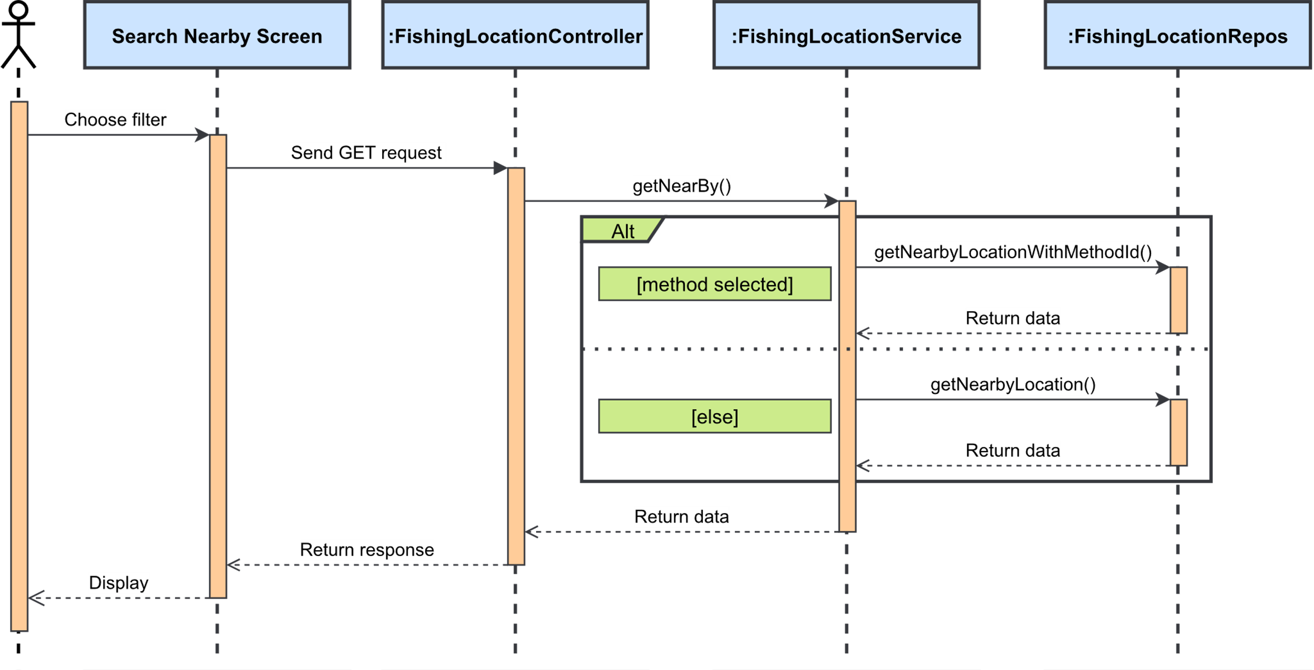

Figure 3.4.2.1. “Search and filter nearby fishing location” Sequence Diagram

##### 3.4.2.2. Advanced search

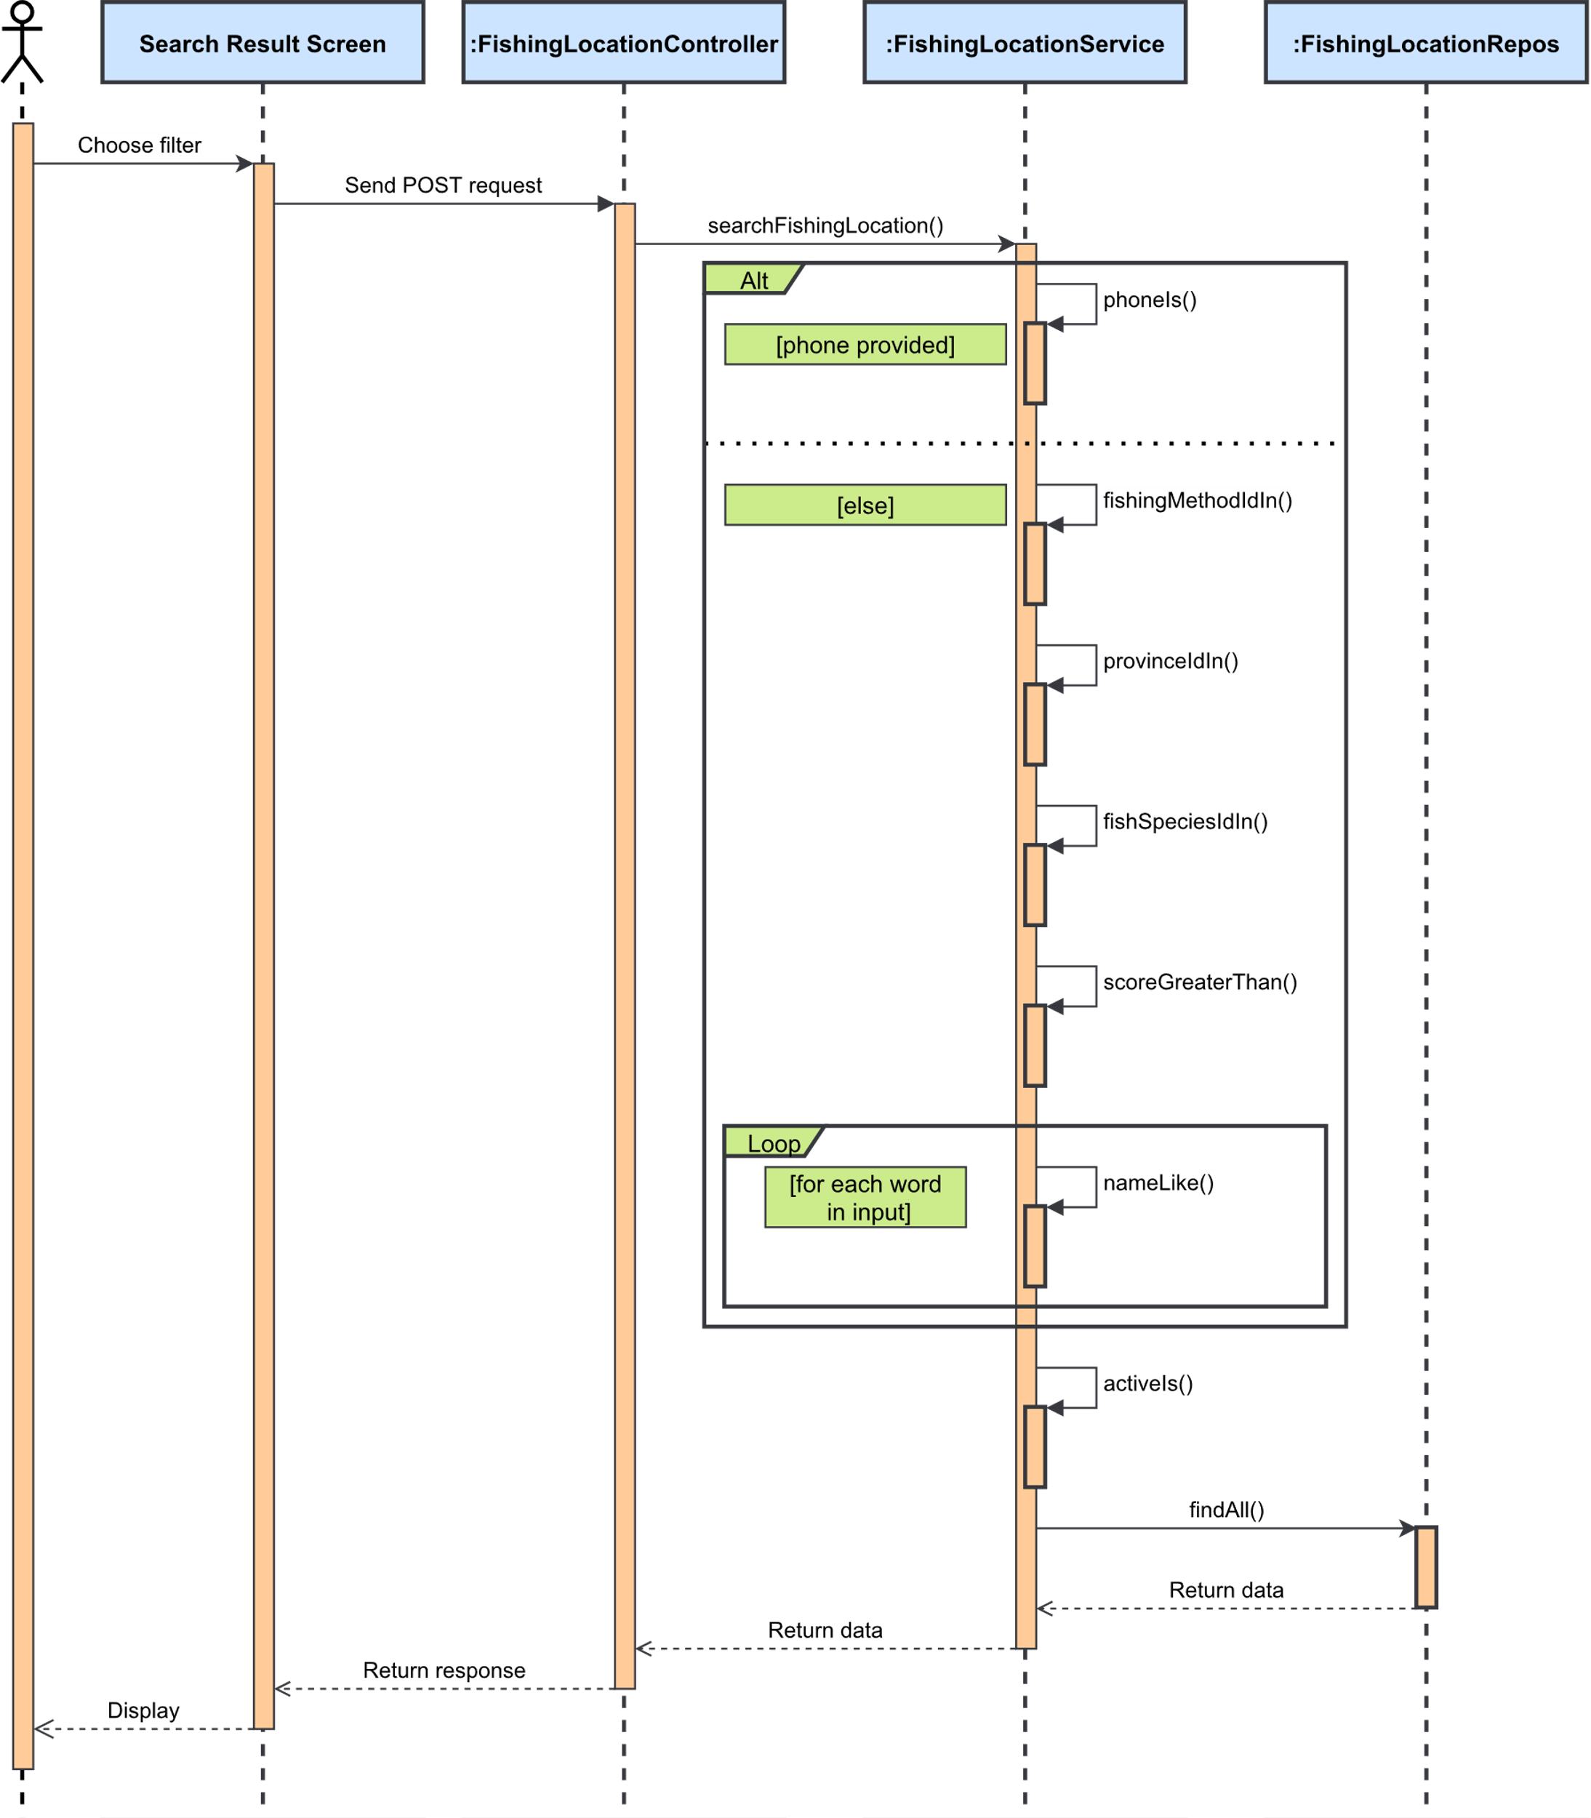

Figure 3.4.2.2. “Advanced search” Sequence Diagram

##### 3.4.2.3. View fishing location’s overview

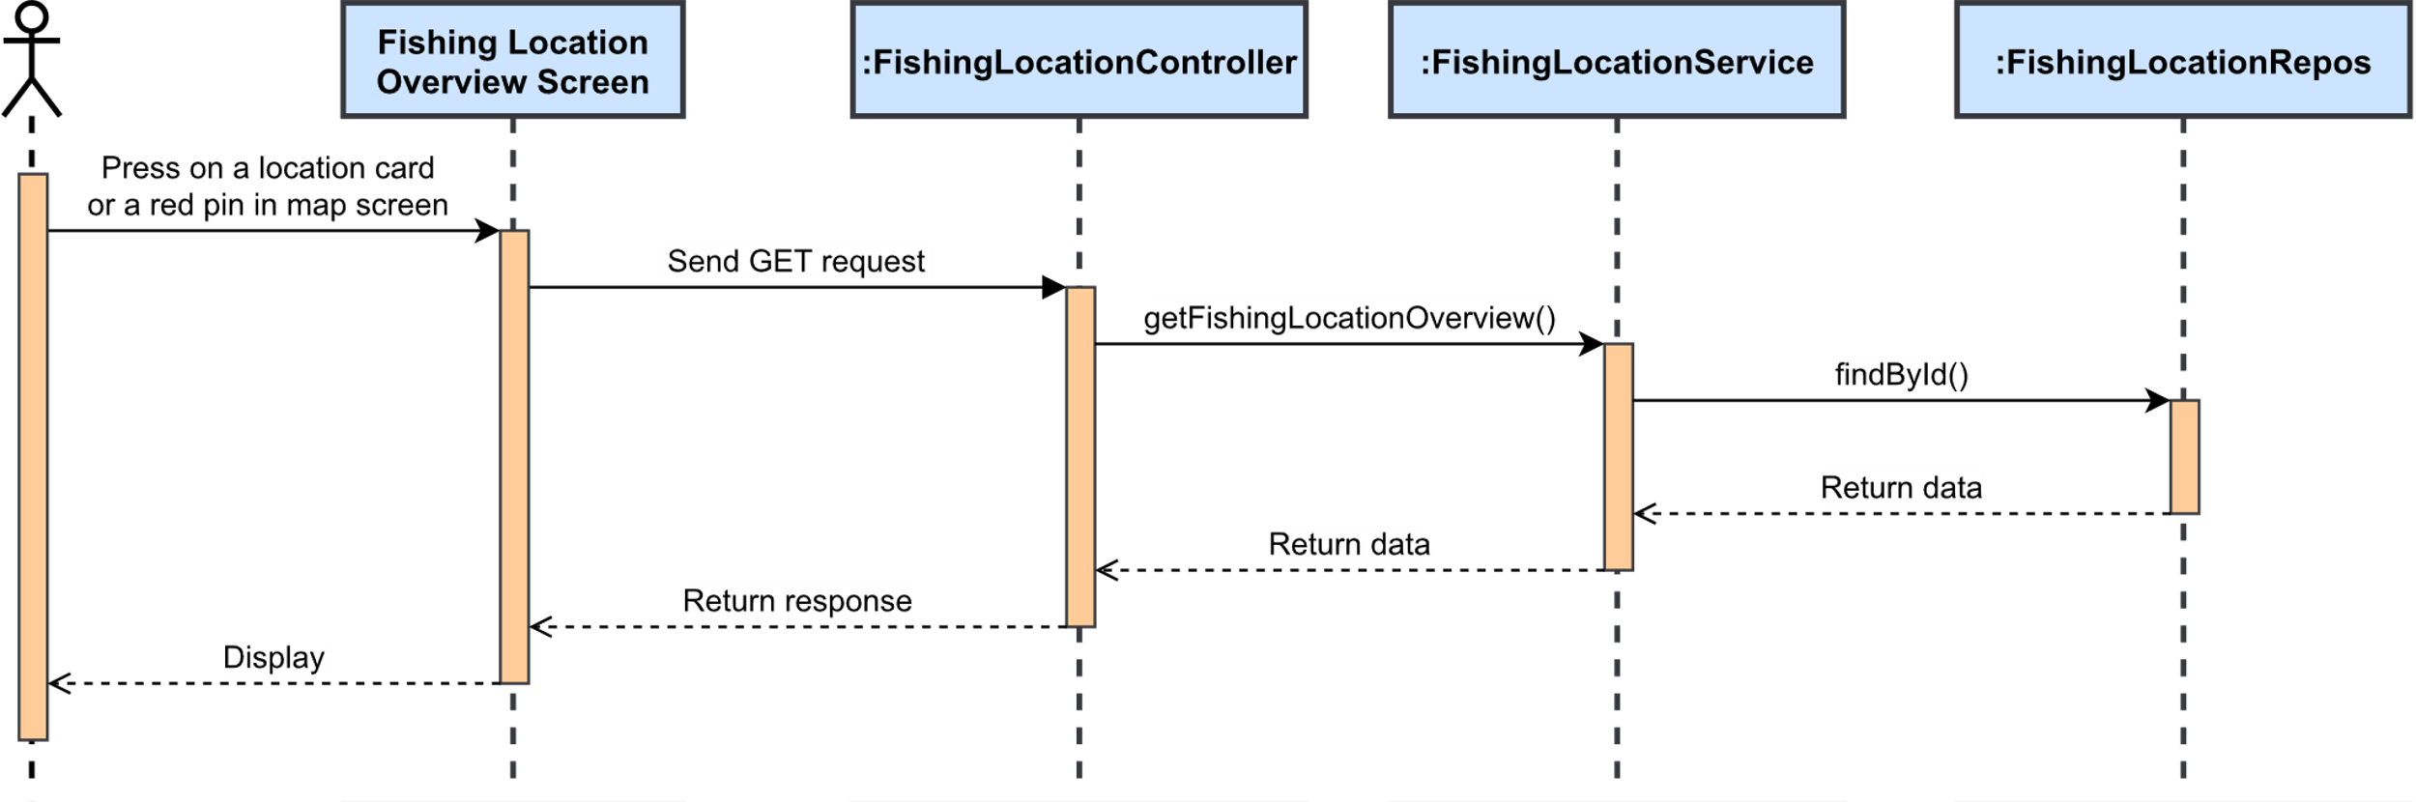

Figure 3.4.2.3. “View fishing location’s overview” Sequence Diagram

##### 3.4.2.4. View lake list

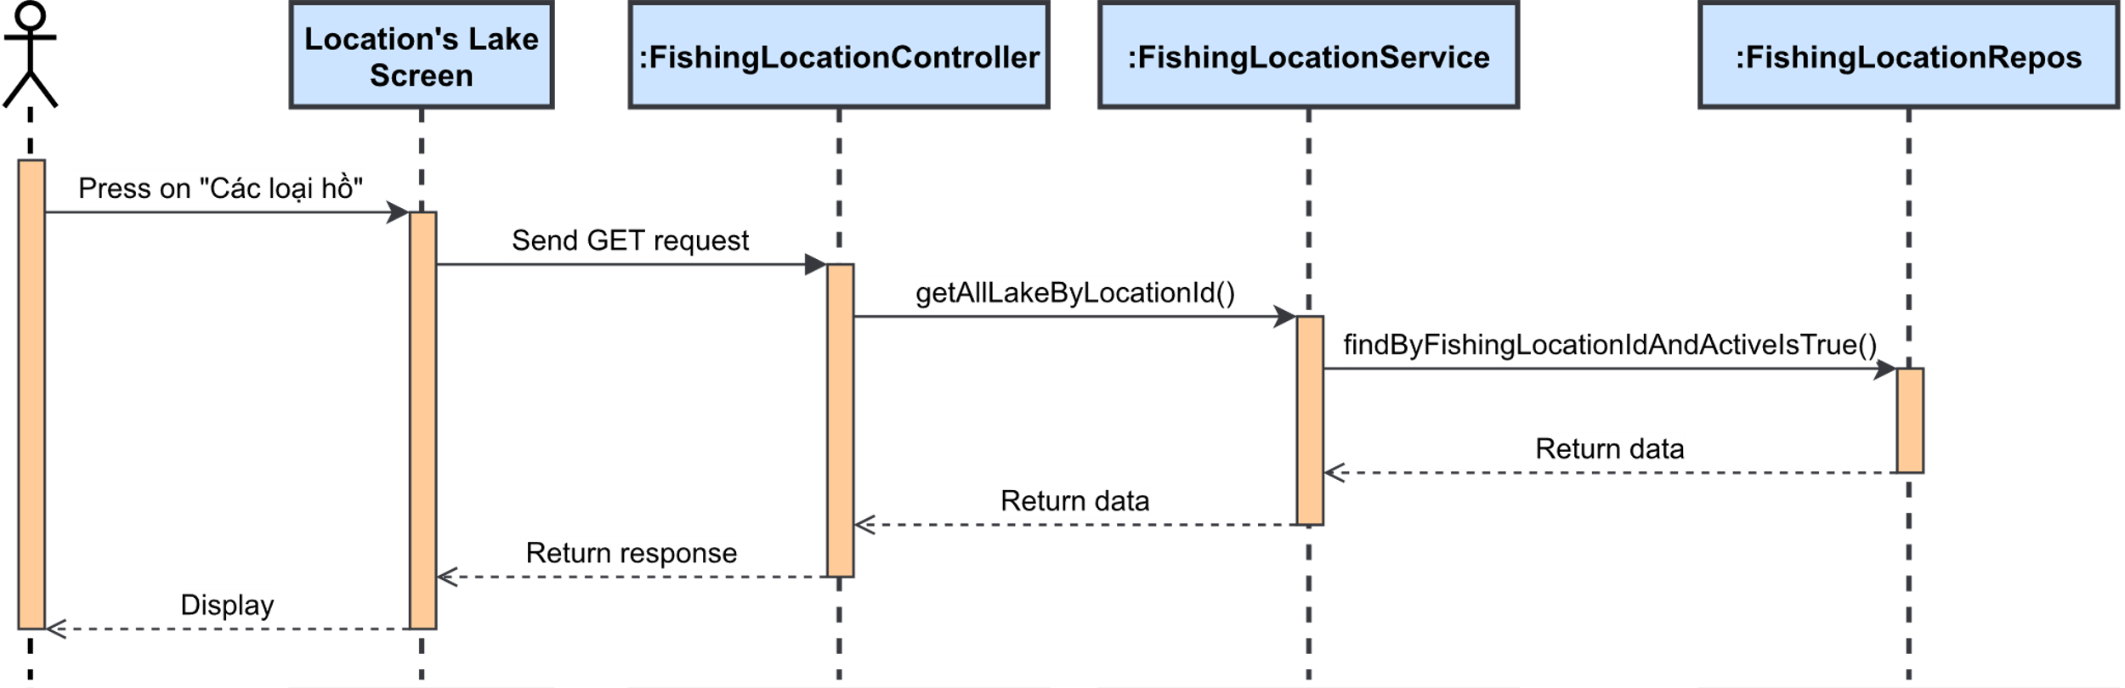

Figure 3.4.2.4. “View lake list” Sequence Diagram

##### 3.4.2.5. View lake details

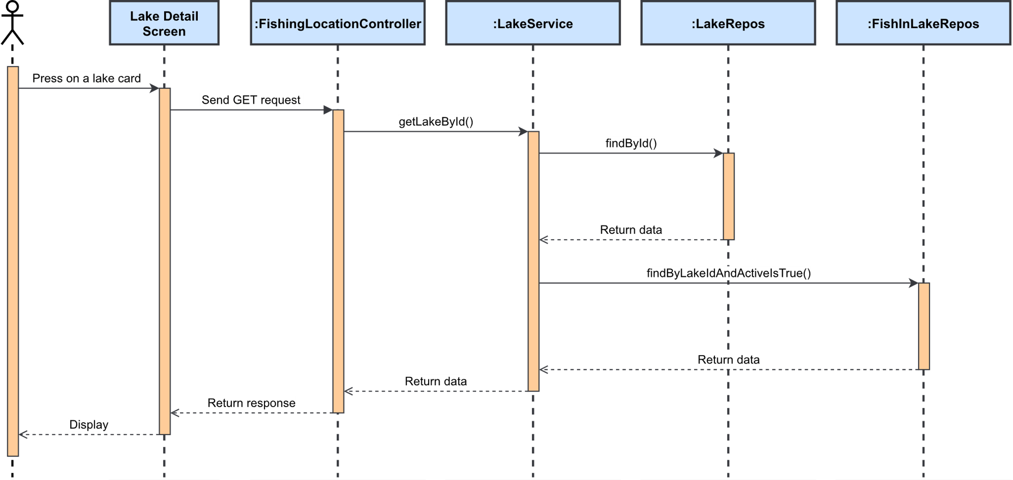

Figure 3.4.2.5. “View lake details” Sequence Diagram

##### 3.4.2.6. Save fishing location

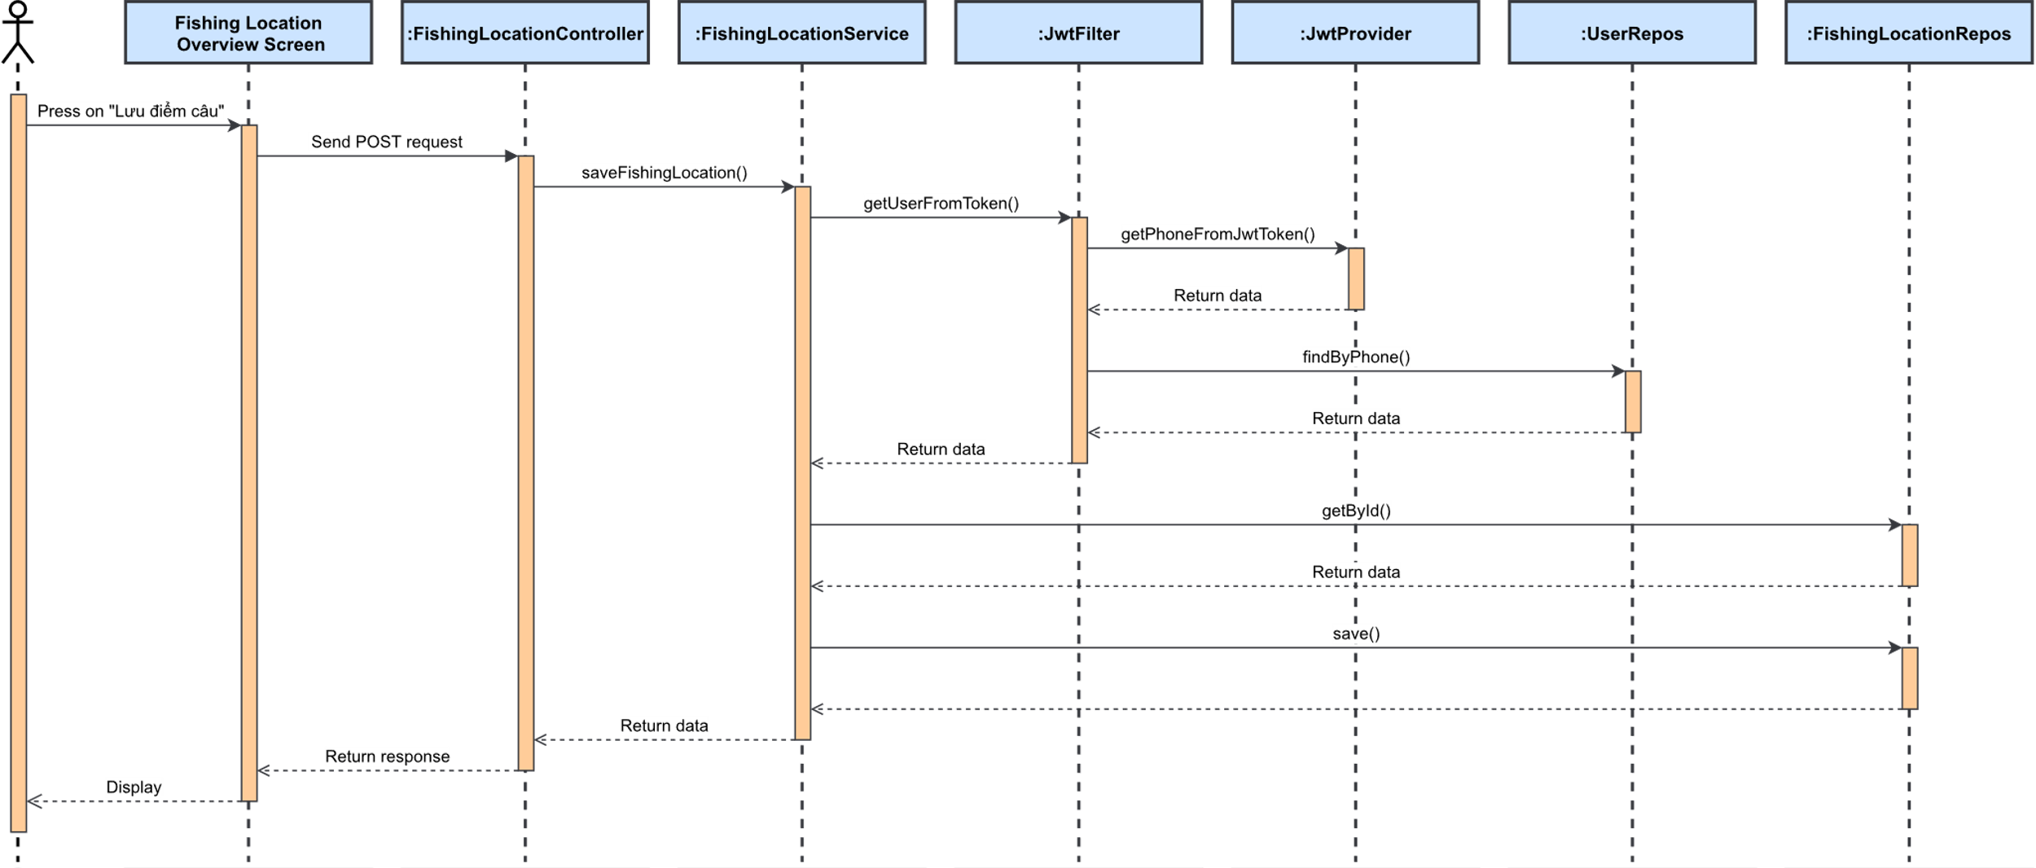

Figure 3.4.2.6. “Save fishing location” Sequence Diagram

##### 3.4.2.7. Report false fishing location information

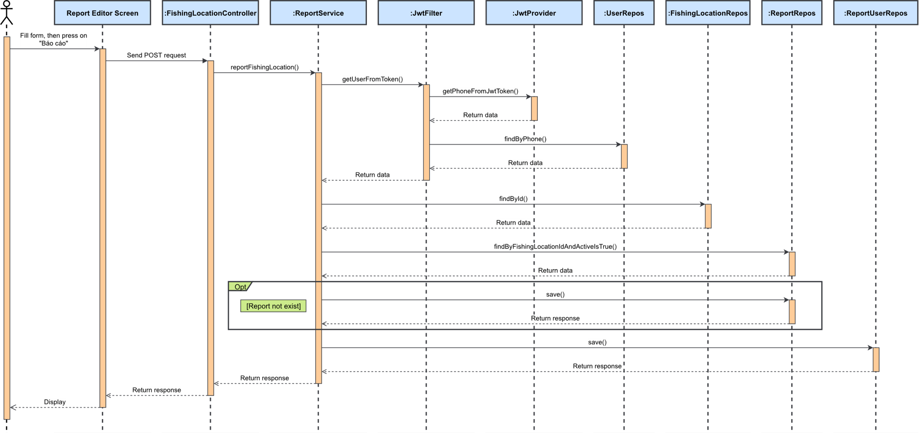

Figure 3.4.2.7. “Report false fishing location information” Sequence Diagram

### 3.5. Feature “Manage fishing location’s reviews”

#### 3.5.1. Class Diagram

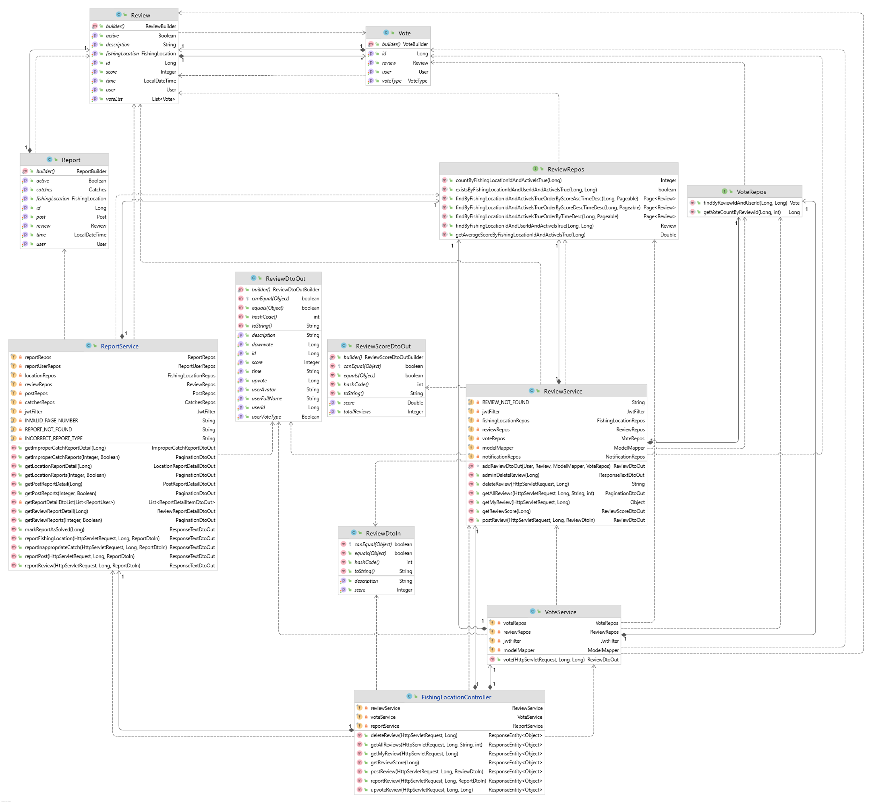

Figure 3.5.1. “Manage fishing location’s reviews” Class Diagram

#### 3.5.2. Sequence Diagram(s)

##### 3.5.2.1. View fishing location’s review

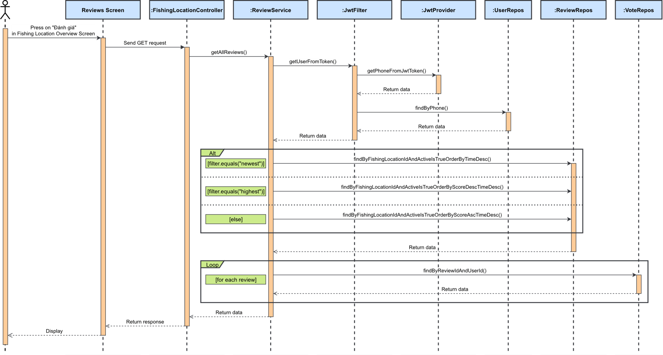

Figure 3.5.2.1. “View fishing location’s review” Sequence Diagram

##### 3.5.2.2. Post personal review

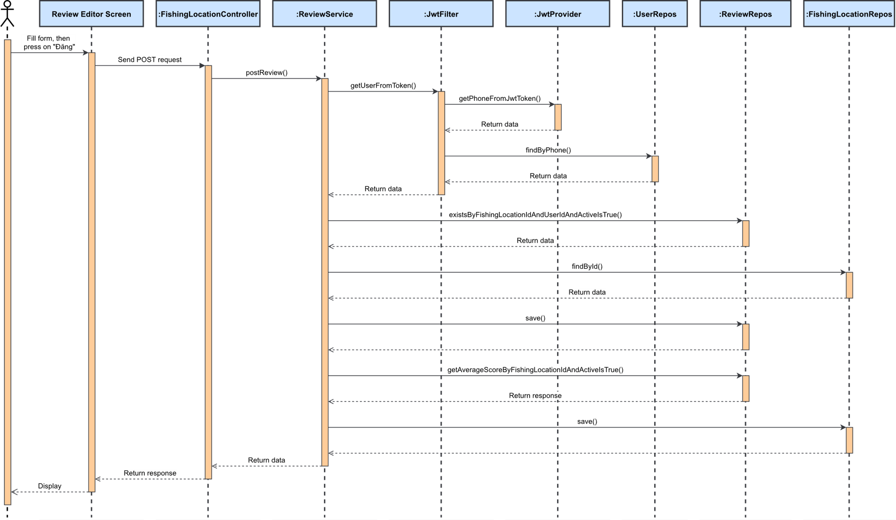

Figure 3.5.2.2. “Post personal review” Sequence Diagram

##### 3.5.2.3. Vote/Downvote review

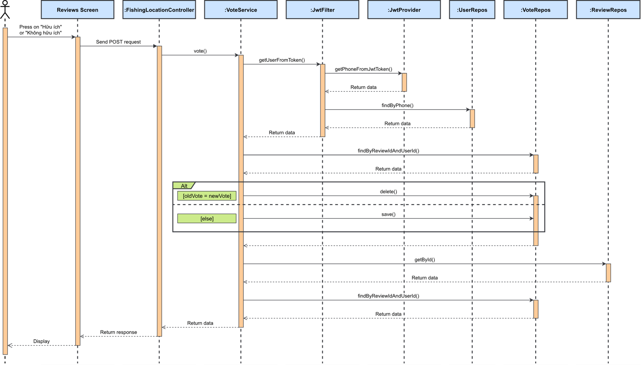

Figure 3.5.2.3. “Vote/Downvote” review” Sequence Diagram

##### 3.5.2.4. Delete personal review

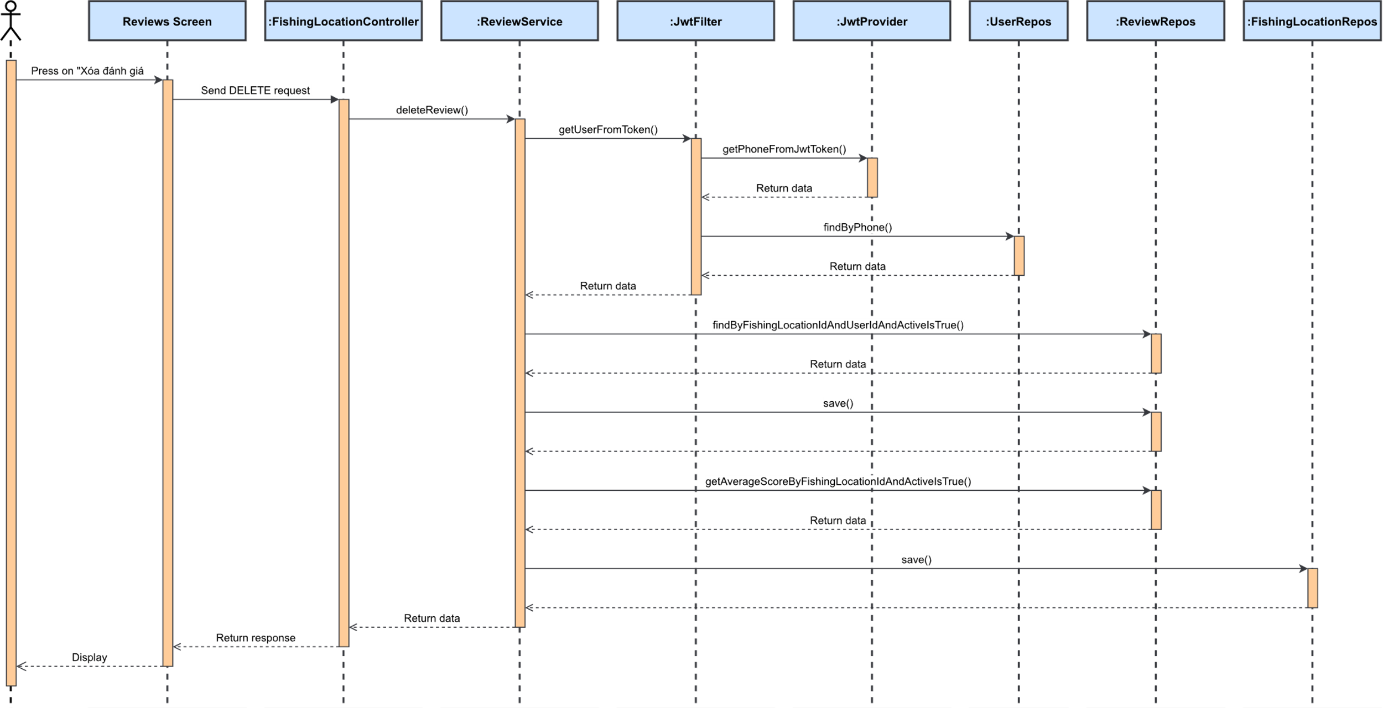

Figure 3.5.2.4. “Delete personal review” Sequence Diagram

##### 3.5.2.5. Report inappropriate review

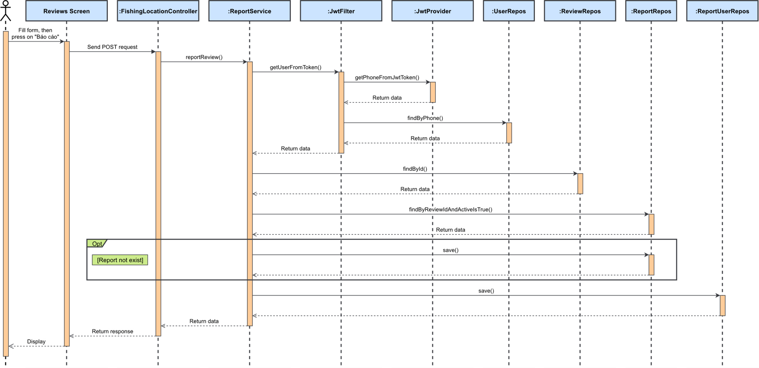

Figure 3.5.2.5. “Report inappropriate review” Sequence Diagram

### 3.6. Feature “Manage check-in”

#### 3.6.1. Class Diagram

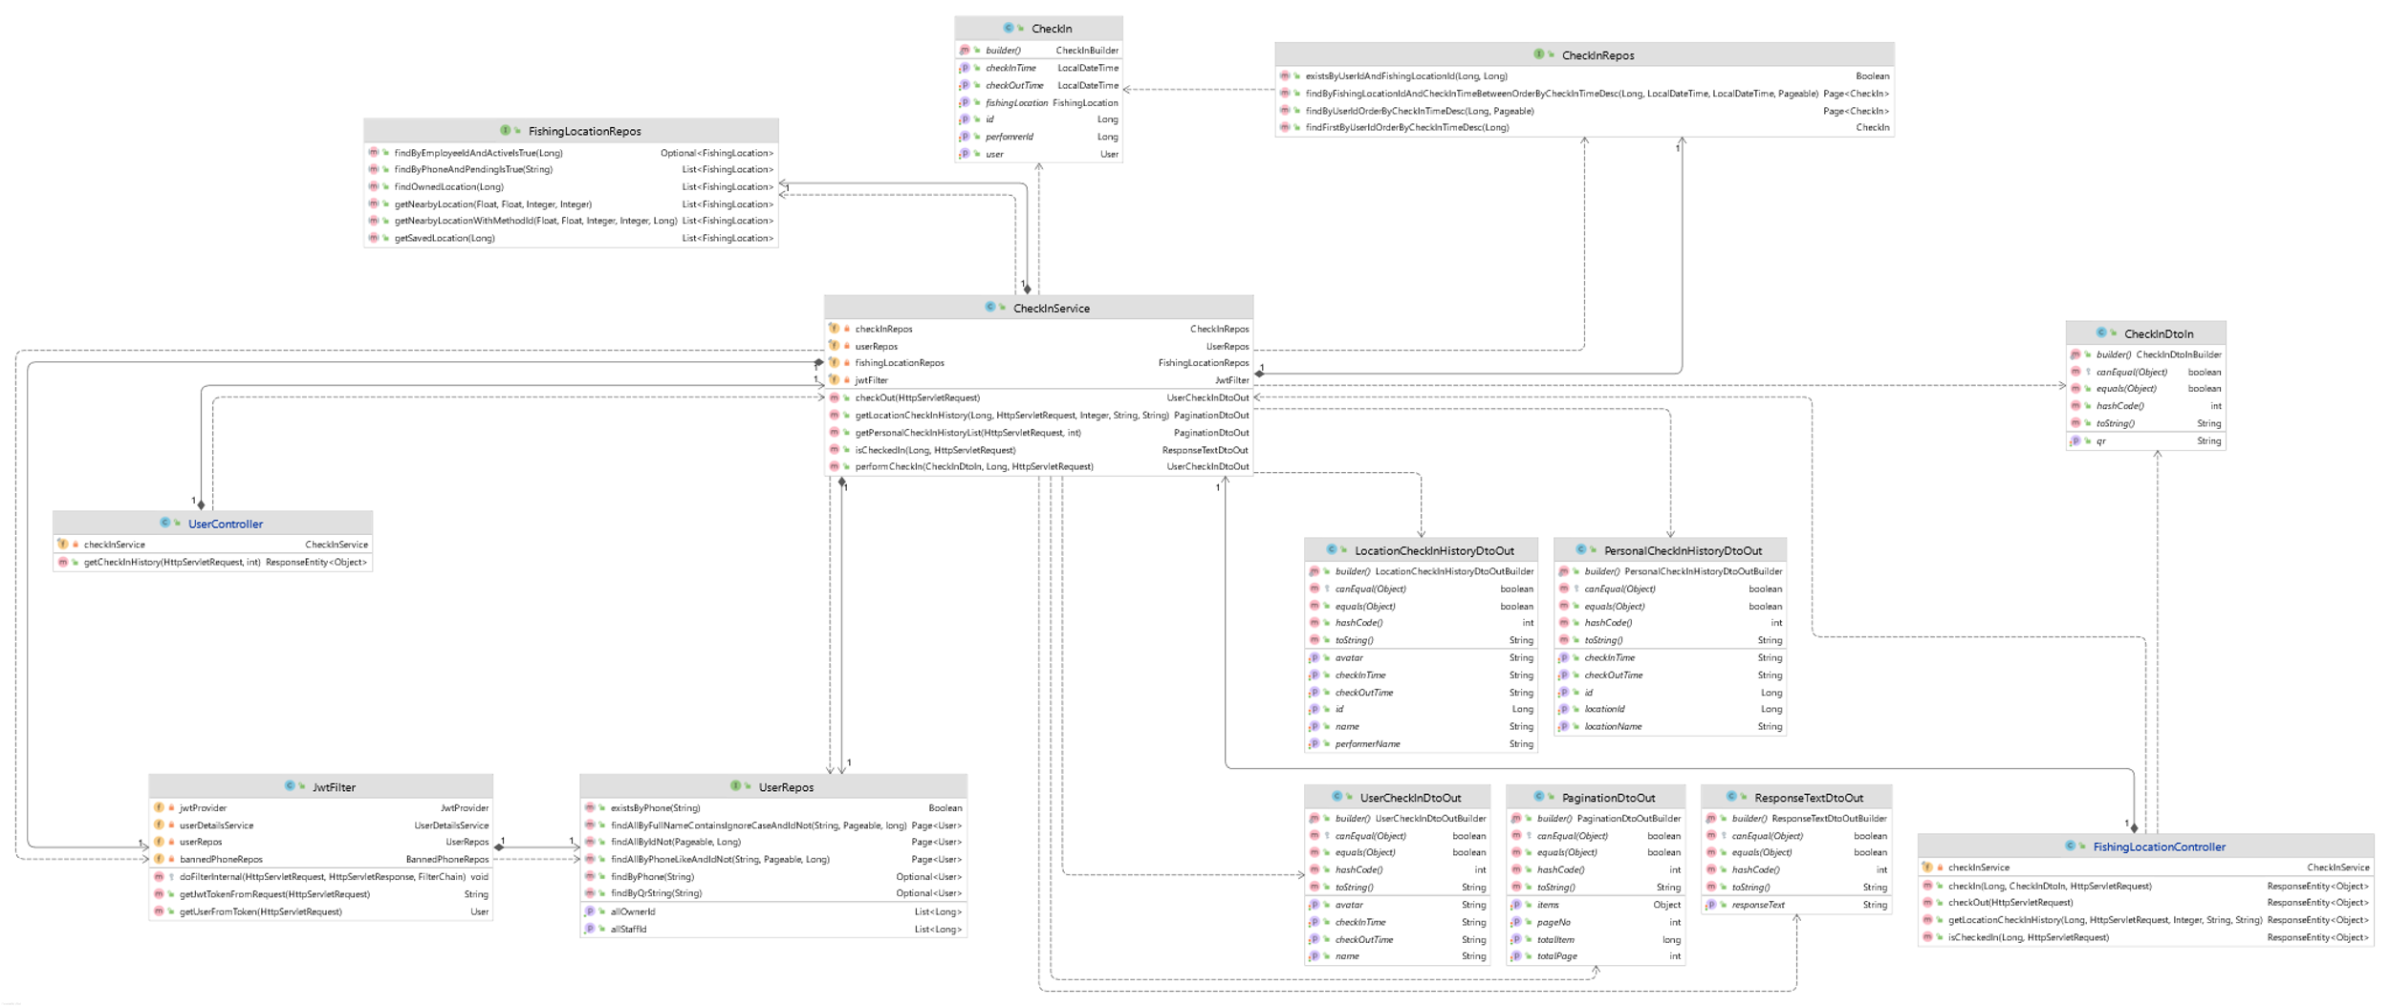

Figure 3.6.1. “Manage check-in” Class Diagram

#### 3.6.2. Sequence Diagram(s)

##### 3.6.2.1. Verify check-in action

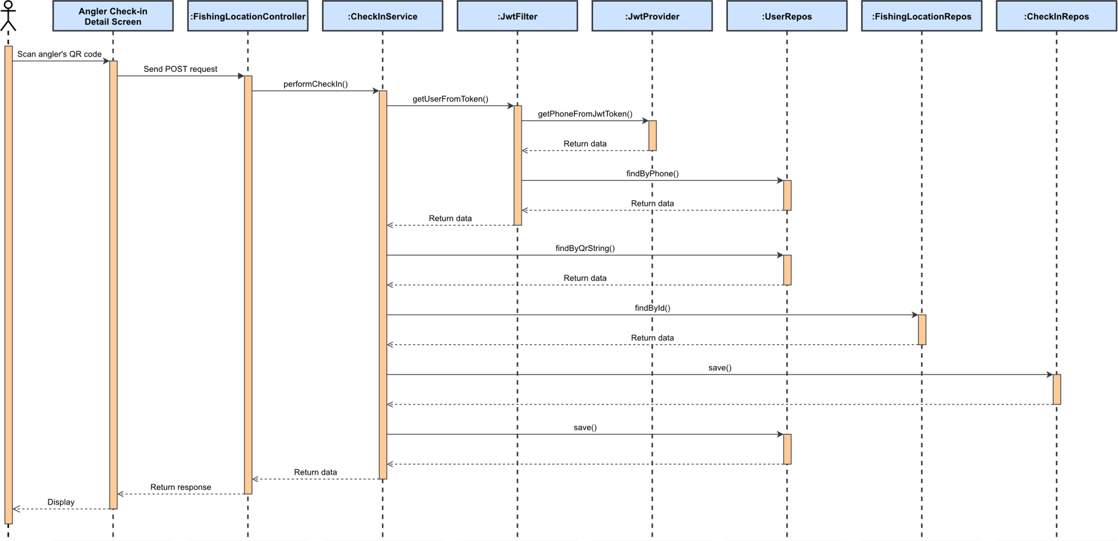

Figure 3.6.2.1. “Verify check-in action” Sequence Diagram

##### 3.6.2.2. View personal check-in history

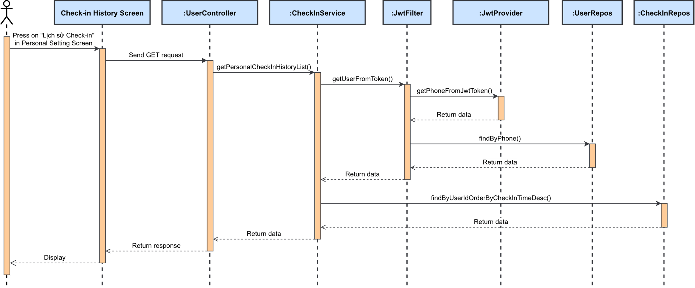

Figure 3.6.2.2. “View personal check-in history” Sequence Diagram

##### 3.6.2.3. View and filter fishing location’s check-in history

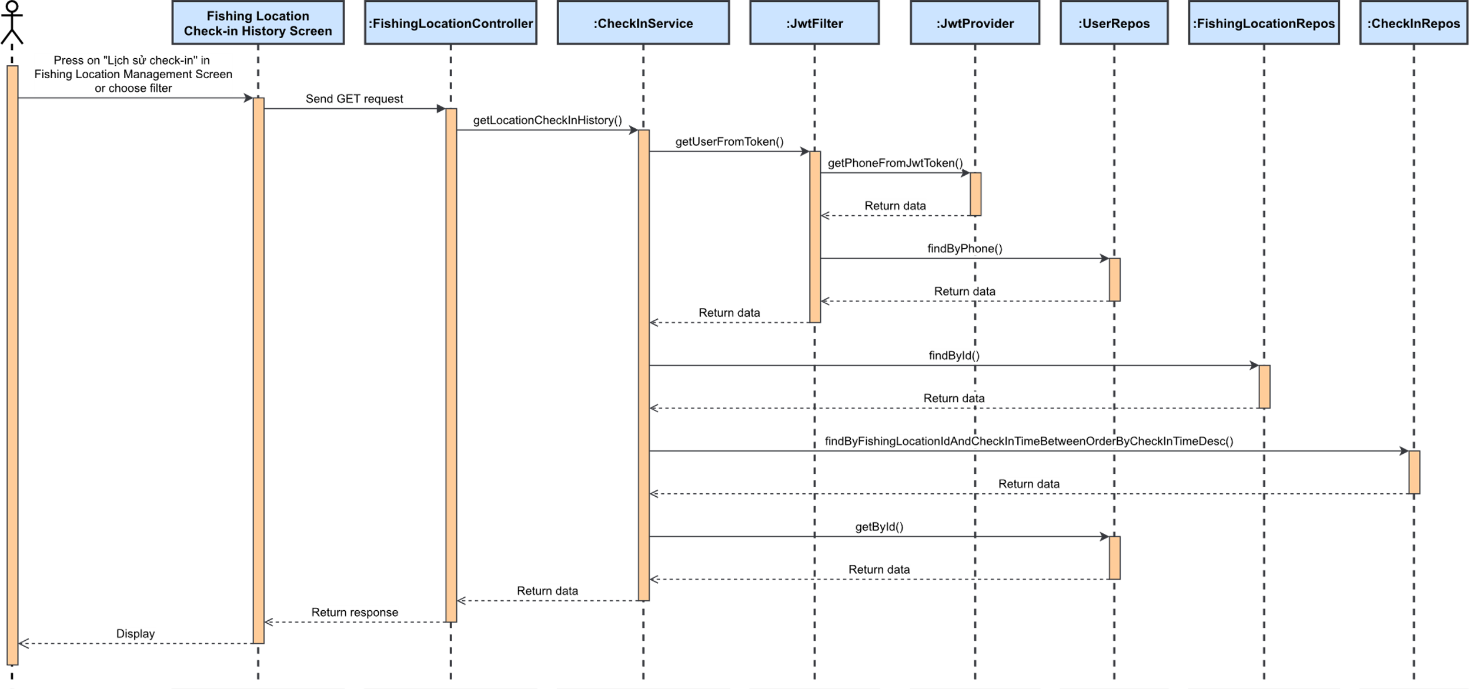

Figure 3.6.2.3. “View and filter fishing location’s check-in history” Sequence Diagram

### 3.7. Feature “Manage catch reports”

#### 3.7.1. Class Diagram

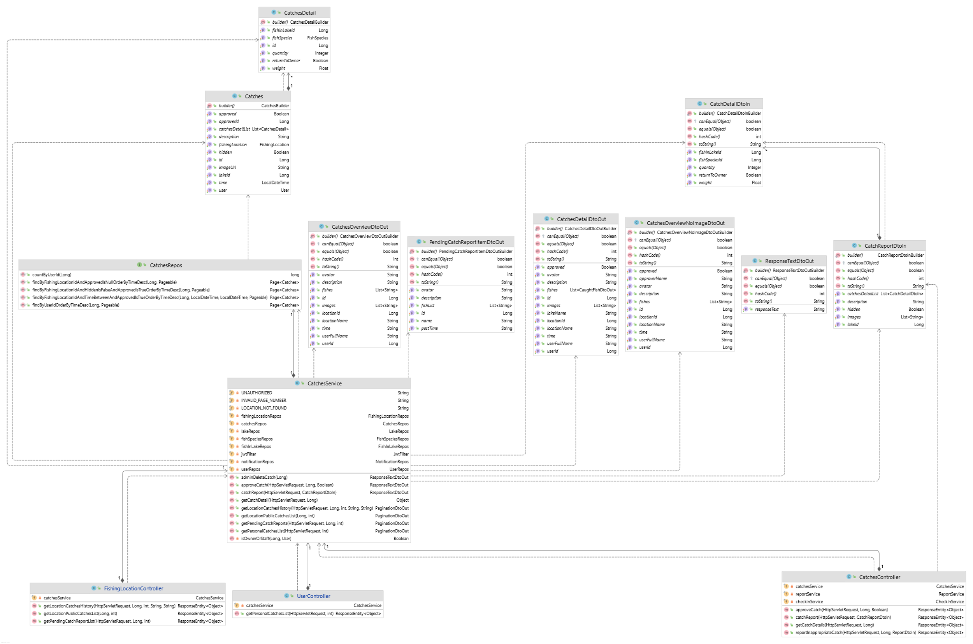

Figure 3.7.1. “Manage catch reports” Class Diagram

#### 3.7.2. Sequence Diagram(s)

##### 3.7.2.1. Catch details reporting

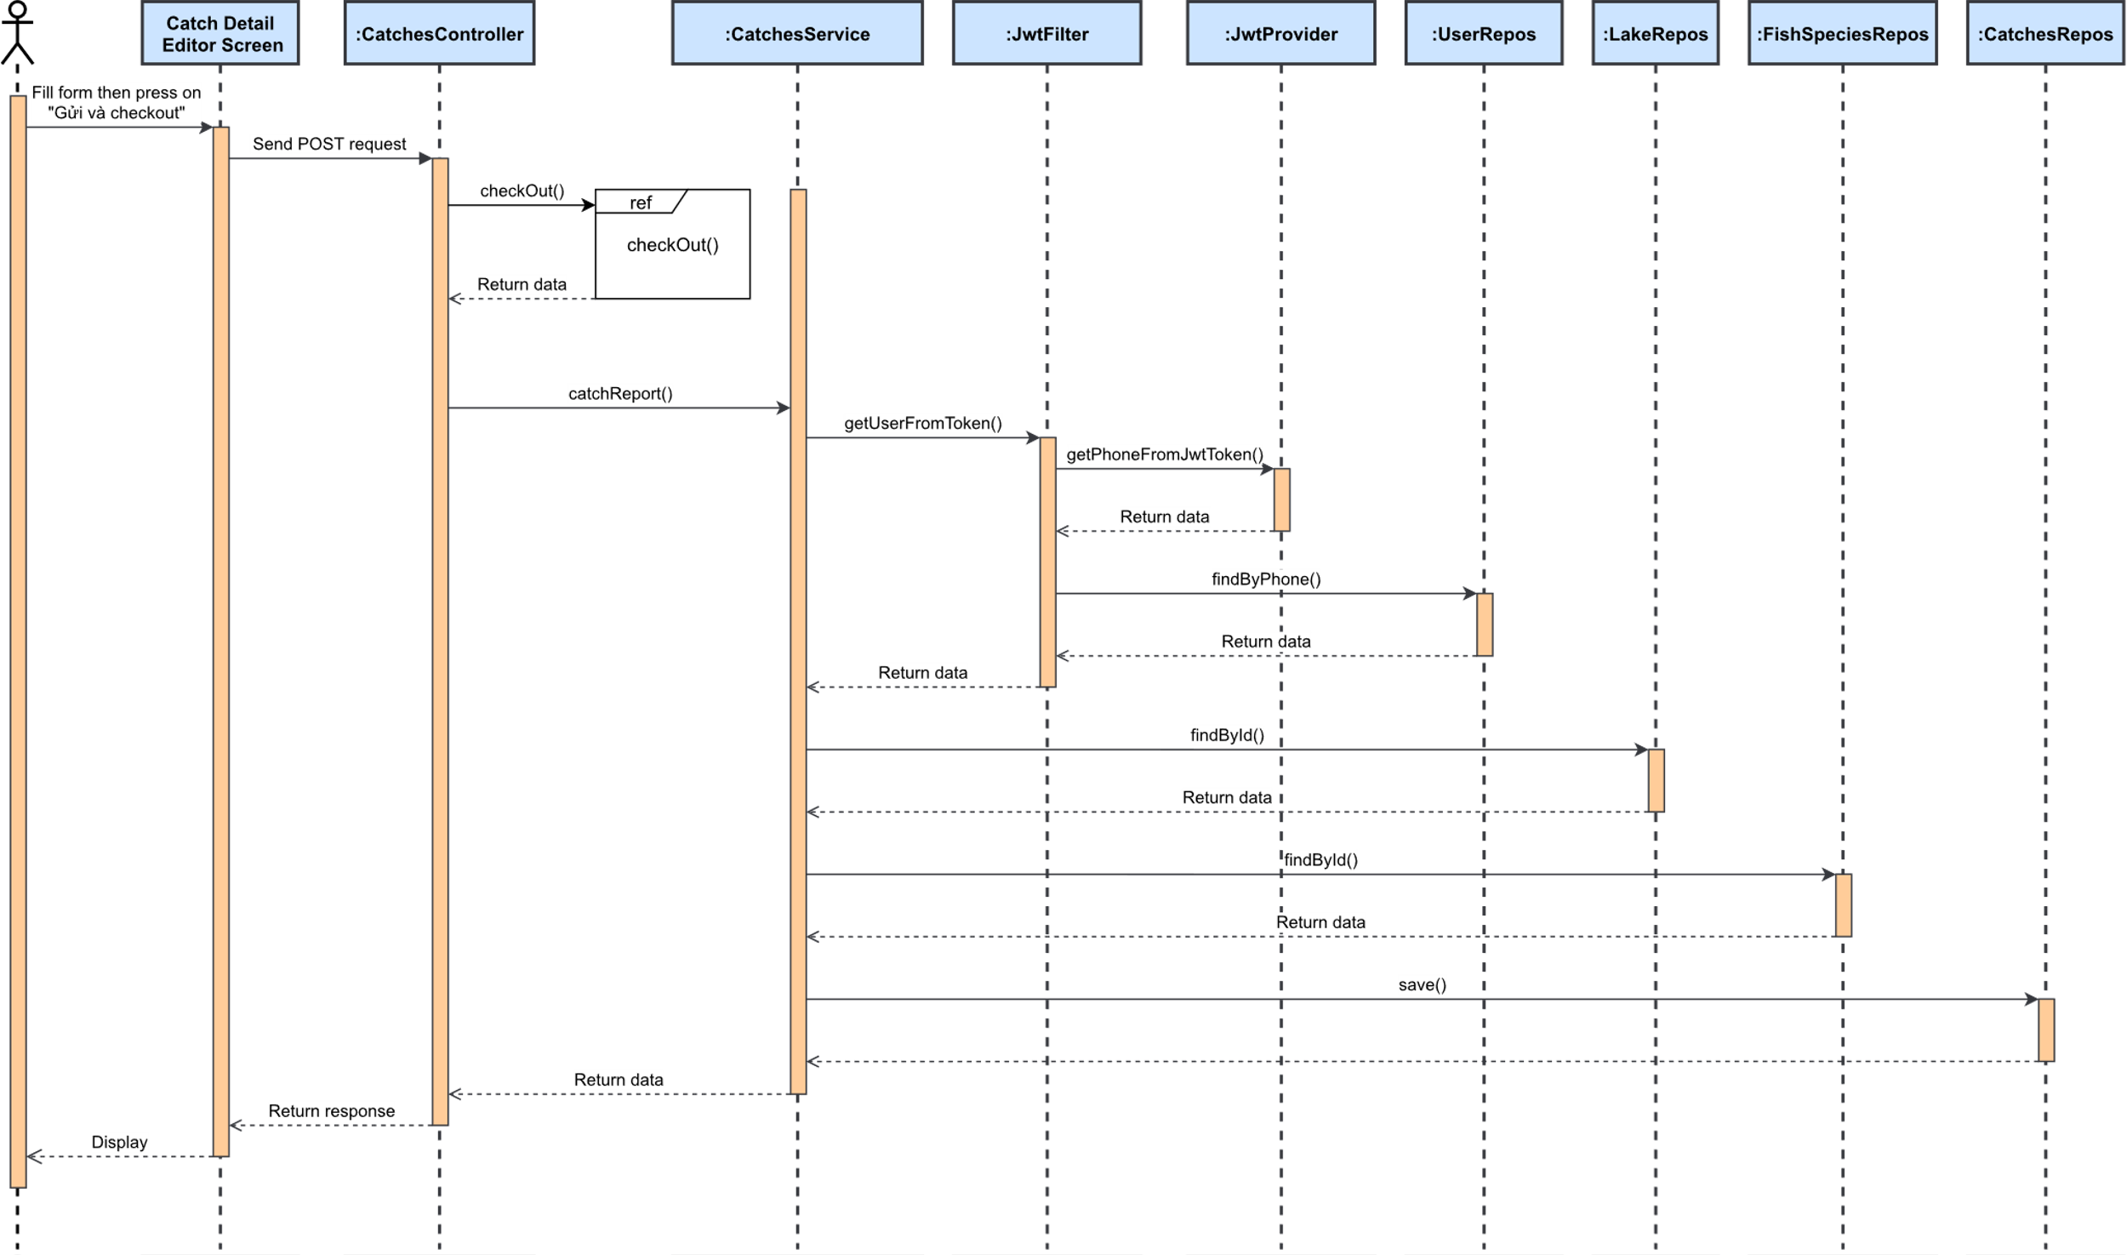

Figure 3.7.2.1. “Catch details reporting” Sequence Diagram

##### 3.7.2.2. View pending catch reports

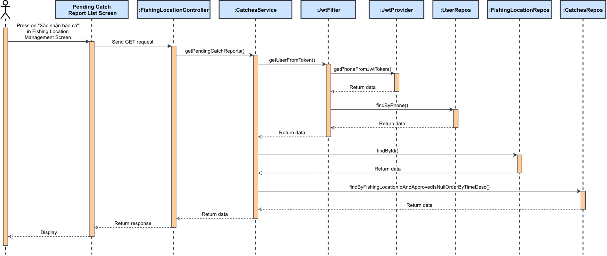

Figure 3.7.2.2. “View pending catch reports” Sequence Diagram

##### 3.7.2.3. Approve/Reject catch detail report

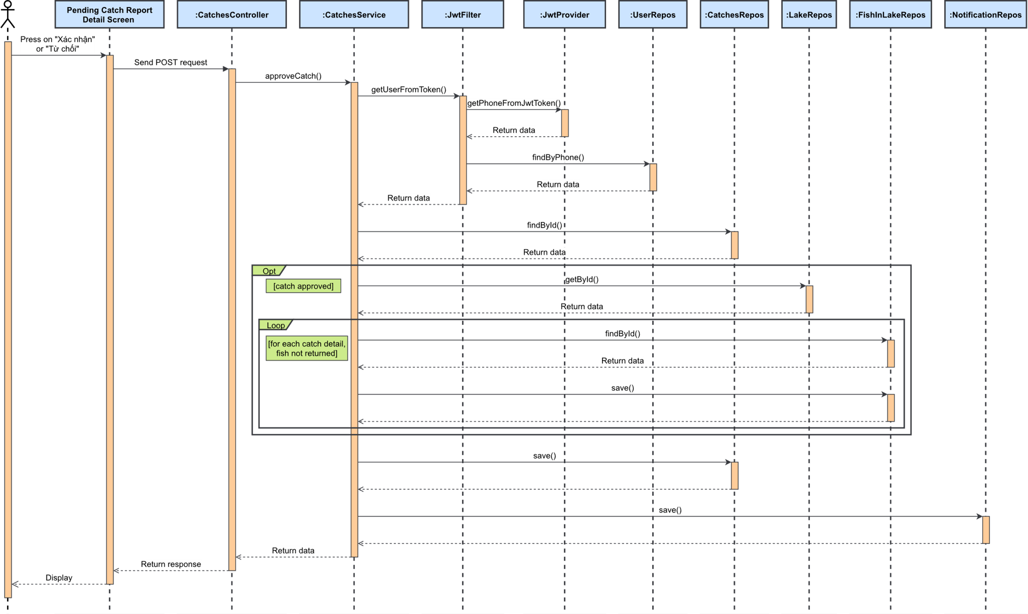

Figure 3.7.2.3. “Approve/Reject catch detail report” Sequence Diagram

##### 3.7.2.4. View personal catch history list

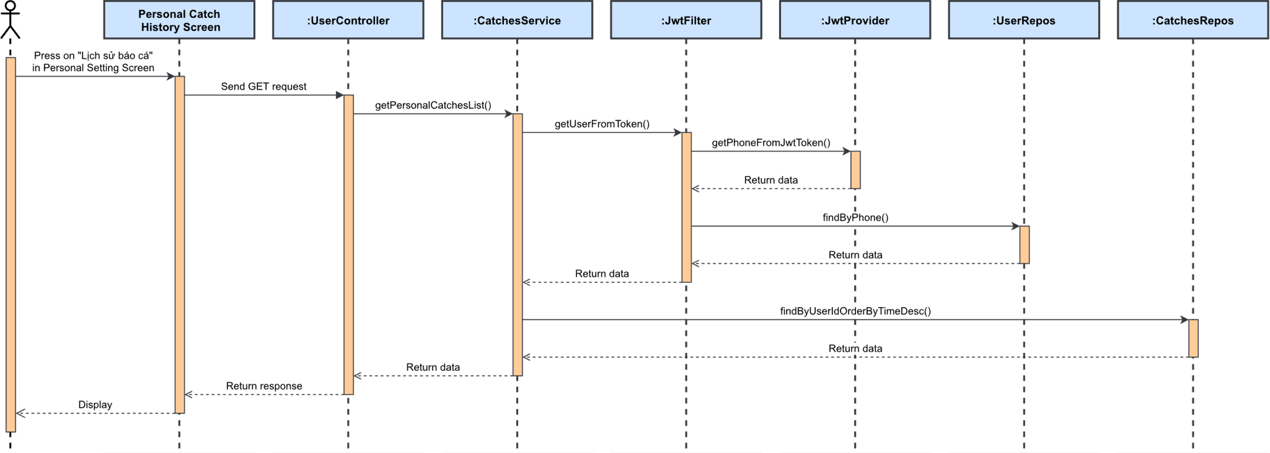

Figure 3.7.2.4. “View personal catch history list” Sequence Diagram

##### 3.7.2.5. View and filter fishing location’s catch history

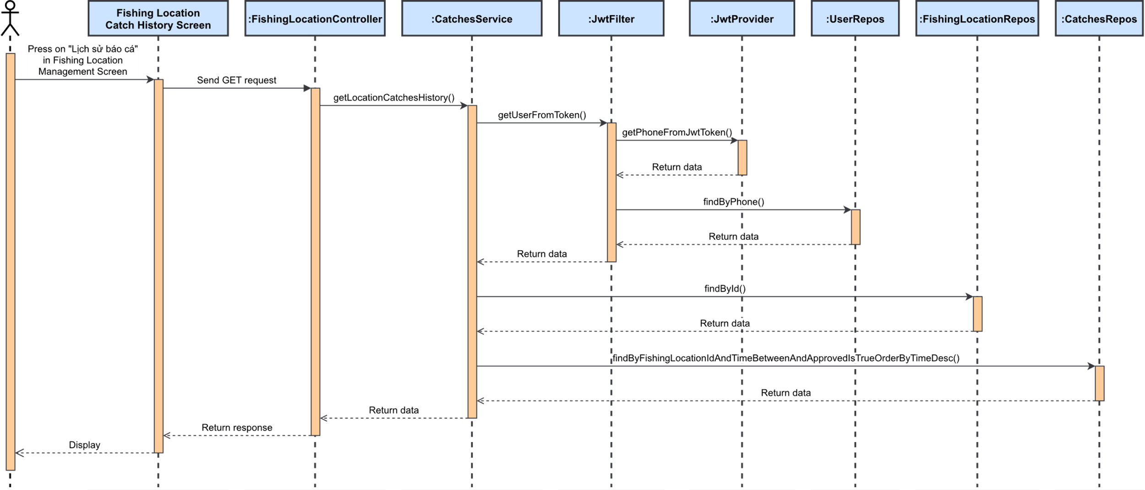

Figure 3.7.2.5. “View and filter fishing location’s catch history” Sequence Diagram

##### 3.7.2.6. View catch history detail

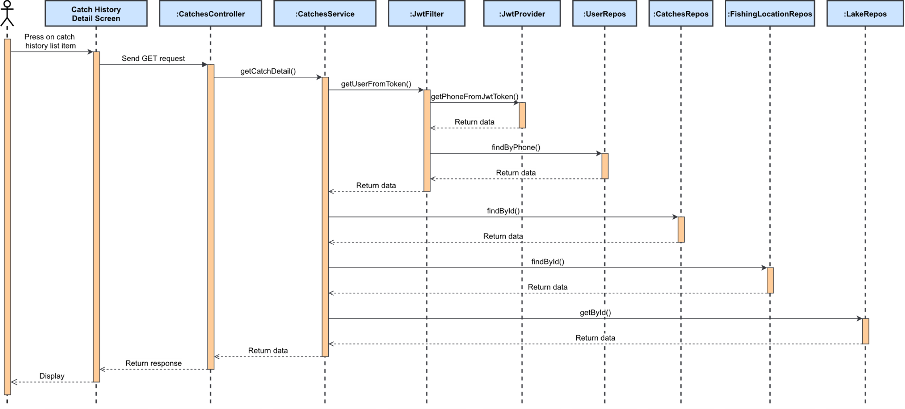

Figure 3.7.2.6. “View catch history detail” Sequence Diagram

##### 3.7.2.7. Report inappropriate catch detail report

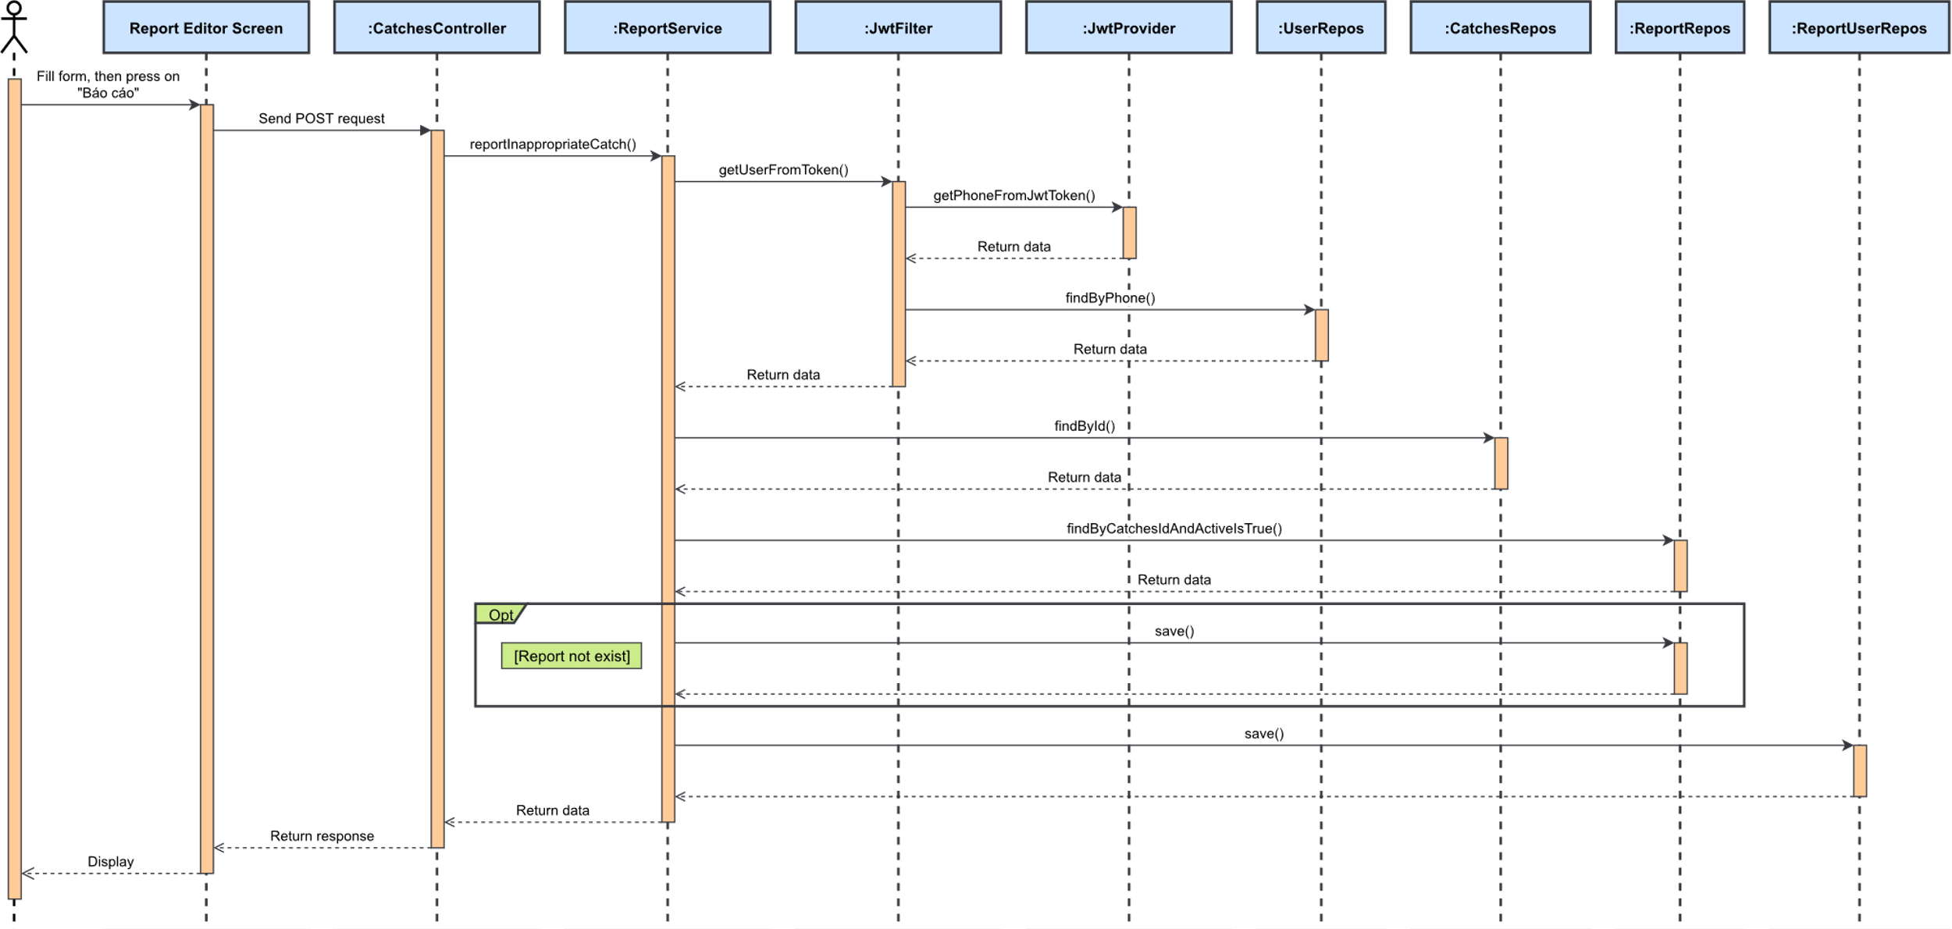

Figure 3.7.2.7. “Report inappropriate catch detail report” Sequence Diagram

##### 3.7.2.8. Check-out

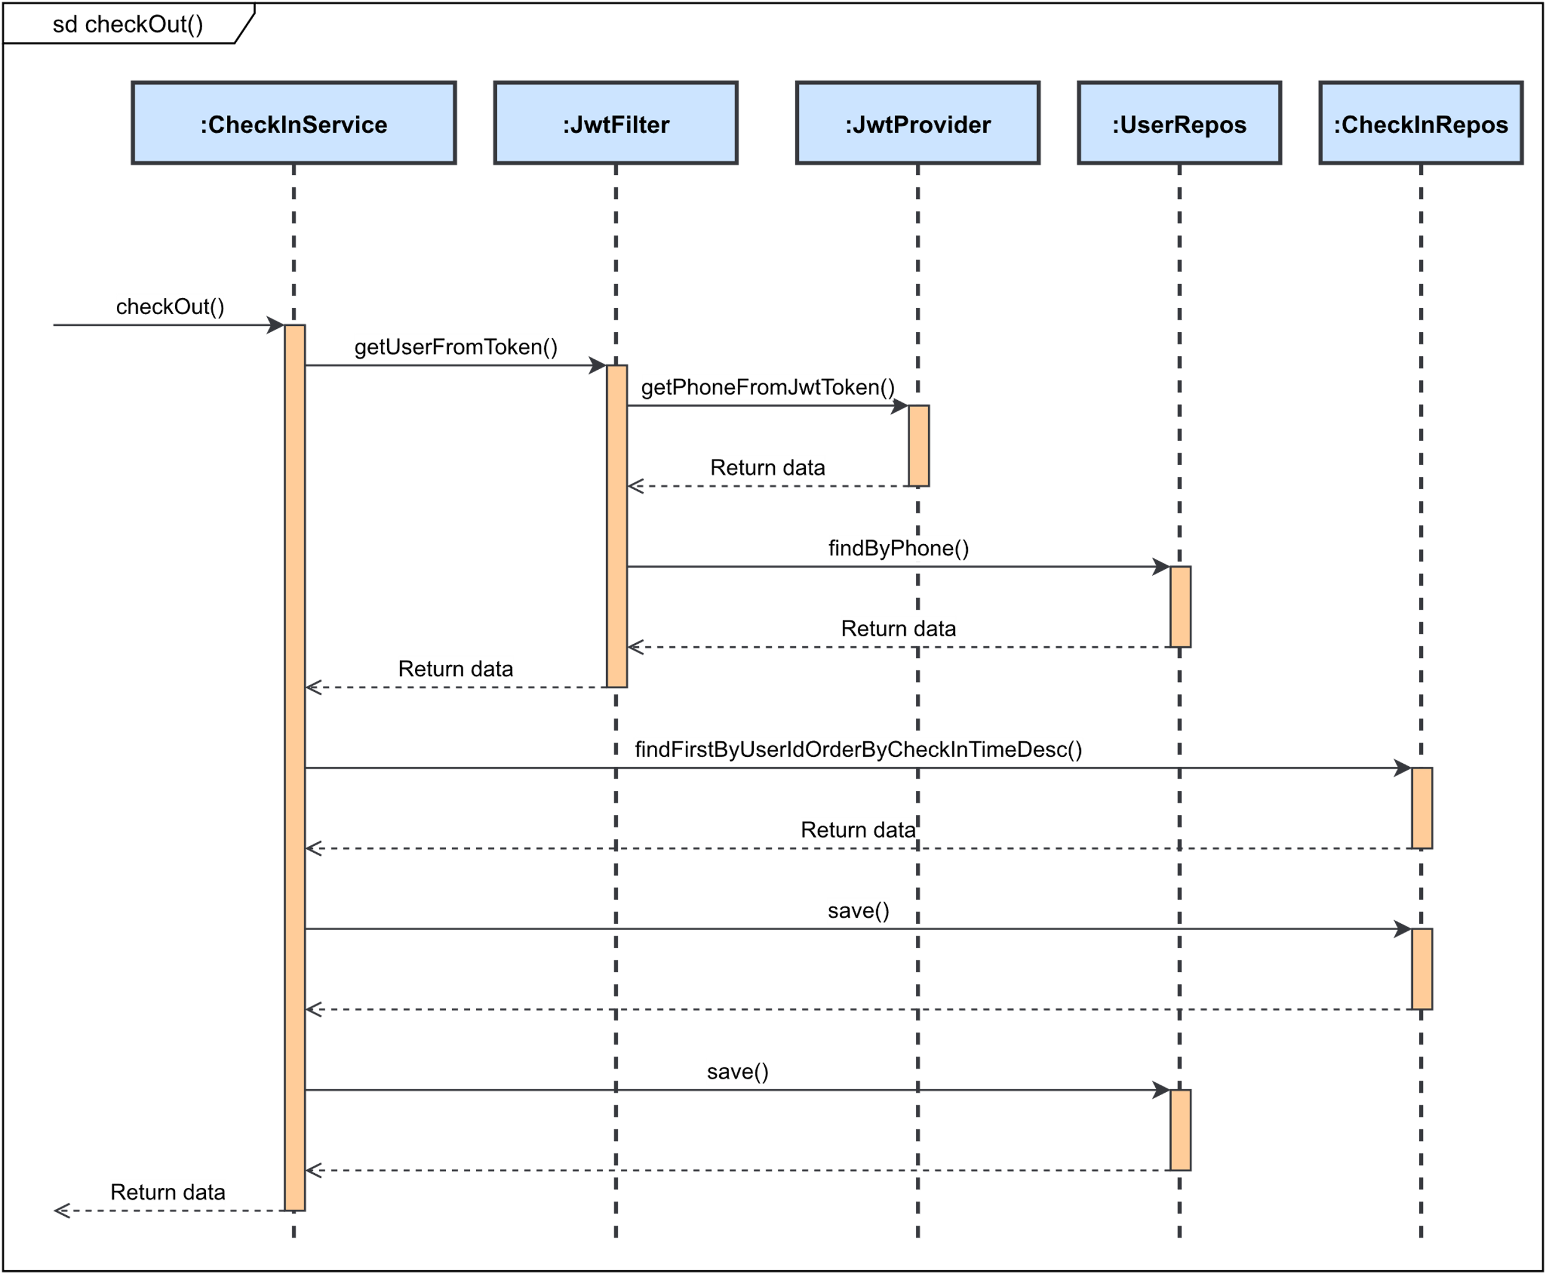

Figure 3.7.2.8. “Check-out” Sequence Diagram

### 3.8. Feature “Manage fishing location’s profile”

#### 3.8.1. Class Diagram

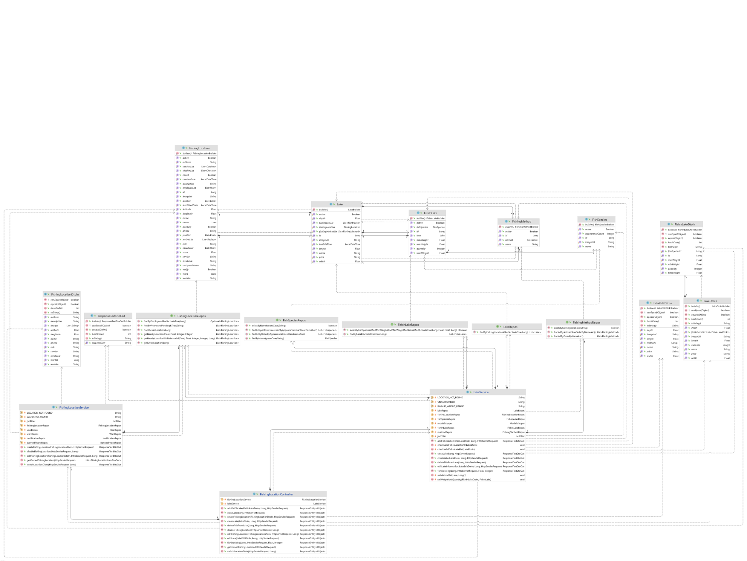

Figure 3.8.1. “Manage fishing location’s profile” Class Diagram

#### 3.8.2. Sequence Diagram(s)

##### 3.8.2.1. Add a fishing location

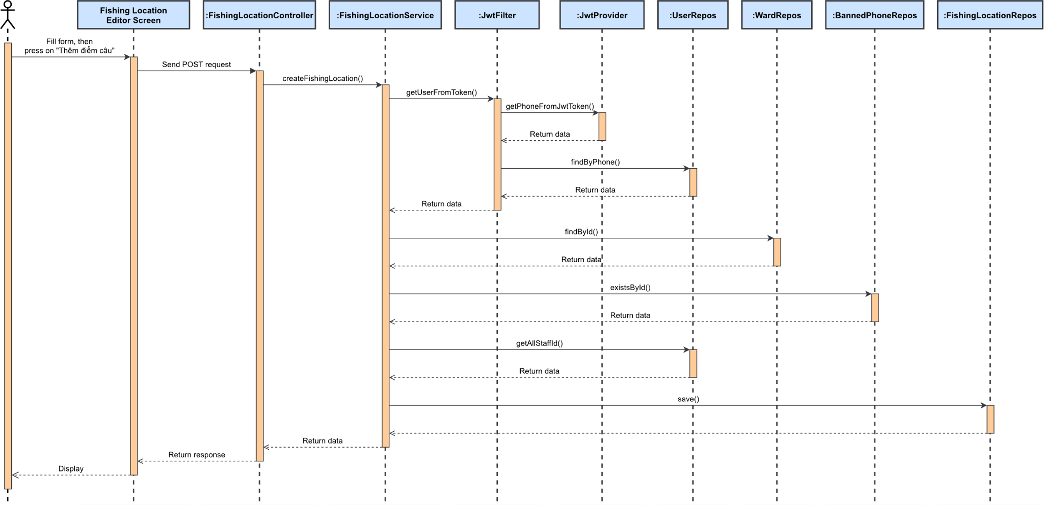

Figure 3.8.2.1. “Add a fishing location” Sequence Diagram

##### 3.8.2.2. Edit fishing location’s overview



Figure 3.8.2.2. “Edit fishing location’s overview” Sequence Diagram

##### 3.8.2.3. Add lake



Figure 3.8.2.3. “Add lake” Sequence Diagram

##### 3.8.2.4. Close lake



Figure 3.8.2.4. “Close lake” Sequence Diagram

##### 3.8.2.5. Edit lake’s profile



Figure 3.8.2.5. “Edit lake’s profile” Sequence Diagram

##### 3.8.2.6. Add fish in lake



Figure 3.8.2.6. “Add fish in lake” Sequence Diagram

##### 3.8.2.7. Stock fish in lake



Figure 3.8.2.7. “Stock fish in lake” Sequence Diagram

##### 3.8.2.8. Delete fish in lake



Figure 3.8.2.8. “Delete fish in lake” Sequence Diagram

##### 3.8.2.9. Temporary close/reopen fishing location



Figure 3.8.2.9. “Temporary close/reopen fishing location” Sequence Diagram

##### 3.8.2.10. Delete fishing location



Figure 3.8.2.10. “Delete fishing location” Sequence Diagram

### 3.9. Feature “Manage system fishing locations”

#### 3.9.1. Class Diagram



Figure 3.9.1. “Manage system fishing locations” Class Diagram

#### 3.9.2. Sequence Diagram(s)

##### 3.9.2.1.Verify/Unverify fishing location



Figure 3.9.2.1. “Verify/Unverify fishing location” Sequence Diagram

##### 3.9.2.2. Search and view system fishing location list



Figure 3.9.2.2. “Search and view system fishing location list” Sequence Diagram

### 3.10. Feature “Receive notification”

#### 3.10.1. Class Diagram



Figure 3.10.1. “Receive notification” Class Diagram

#### 3.10.2. Sequence Diagram(s)

##### 3.10.2.1. View list of notifications



Figure 3.10.2.1. “View list of notifications” Sequence Diagram

### 3.11. Feature “Manage fishing location’s posts”

#### 3.11.1. Class Diagram

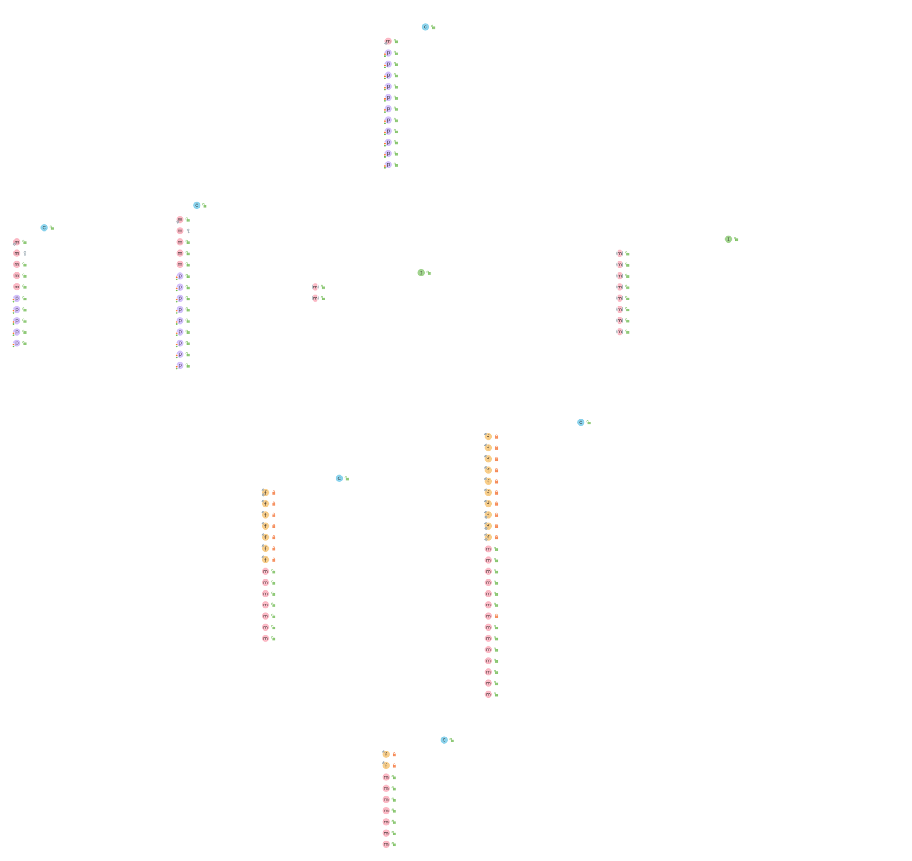

Figure 3.11.1. “Manage fishing location’s posts” Class Diagram

#### 3.11.2. Sequence Diagram(s)

##### 3.11.2.1. View fishing location’s posts



Figure 3.11.2.1. “View fishing location’s posts” Sequence Diagram

##### 3.11.2.2. View public catch details as post



Figure 3.11.2.2. “View public catch details as post” Sequence Diagram

##### 3.11.2.3. Public fishing location’s post



Figure 3.11.2.3. “Public fishing location’s post” Sequence Diagram

##### 3.11.2.4. Edit fishing location’s post



Figure 3.11.2.4. “Edit fishing location’s post” Sequence Diagram

##### 3.11.2.5. Delete fishing location’s post



Figure 3.11.2.5. “Delete fishing location’s post” Sequence Diagram

##### 3.11.2.6. Report fishing location’s post



Figure 3.11.2.6. “Report fishing location’s post” Sequence Diagram

##### 3.11.2.7. Pin/Unpin fishing location’s post



Figure 3.11.2.7. “Pin/Unpin fishing location’s post” Sequence Diagram

### 3.12. Feature “Manage fishing location’s staffs”

#### 3.12.1. Class Diagram

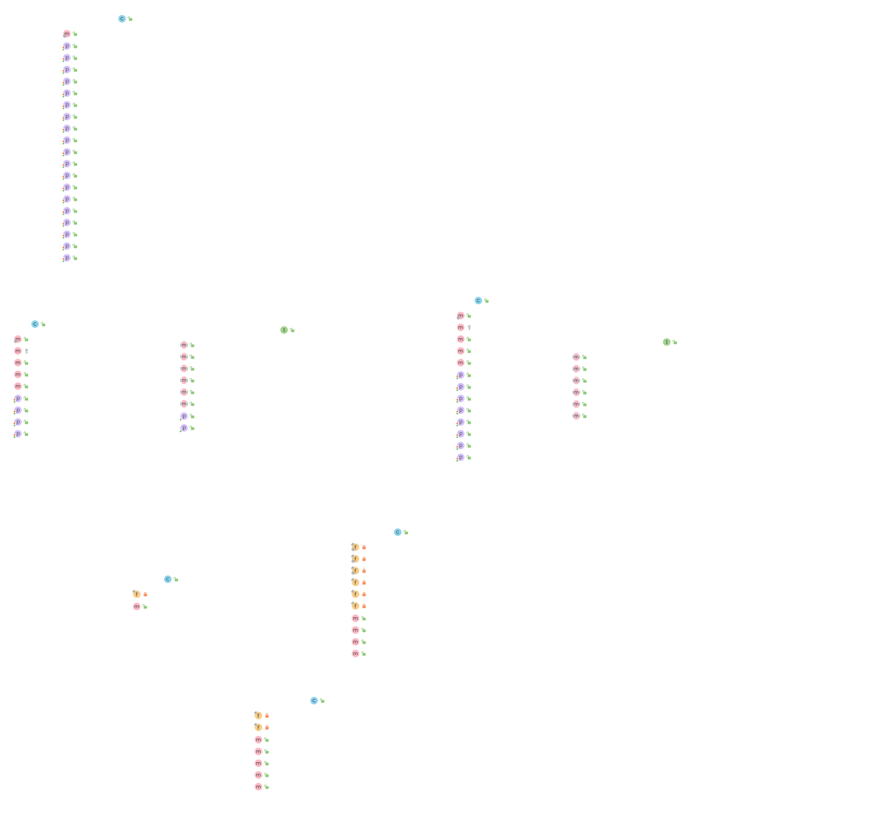

Figure 3.12.1. “Manage fishing location’s staffs” Class Diagram

#### 3.12.2. Sequence Diagram(s)

##### 3.12.2.1. View fishing location’s staff list



Figure 3.12.2.1. “View fishing location’s staff list” Sequence Diagram

##### 3.12.2.2. Add staff to fishing location



Figure 3.12.2.2. “Add staff to fishing location” Sequence Diagram

##### 3.12.2.3. Remove staf from fishing location



Figure 3.12.2.3. “Remove staf from fishing location” Sequence Diagram

### 3.13. Feature “Manage system reports”

#### 3.13.1. Class Diagram



Figure 3.13.1. “Manage system reports” Class Diagram

#### 3.13.2. Sequence Diagram(s)

##### 3.13.2.1. View reports in the system



Figure 3.13.2.1. “View reports in the system” Sequence Diagram

##### 3.13.2.2. View report details



Figure 3.13.2.2. “View report details” Sequence Diagram

##### 3.13.2.3. Mark report as resolved



Figure 3.13.2.3. “Mark report as resolved” Sequence Diagram

##### 3.13.2.4. Remove reported review



Figure 3.13.2.4. “Remove reported review” Sequence Diagram

##### 3.13.2.5. Remove reported post



Figure 3.13.2.5. “Remove reported post” Sequence Diagram

##### 3.13.2.6. Remove reported catch report



Figure 3.13.2.6. “Remove reported catch report” Sequence Diagram

##### 3.13.2.7. Activate/Deactive reported fishing location



Figure 3.13.2.7. “Activate/Deactive reported fishing location” Sequence Diagram

### 3.14. Feature “Manage system fish species”

#### 3.14.1. Class Diagram

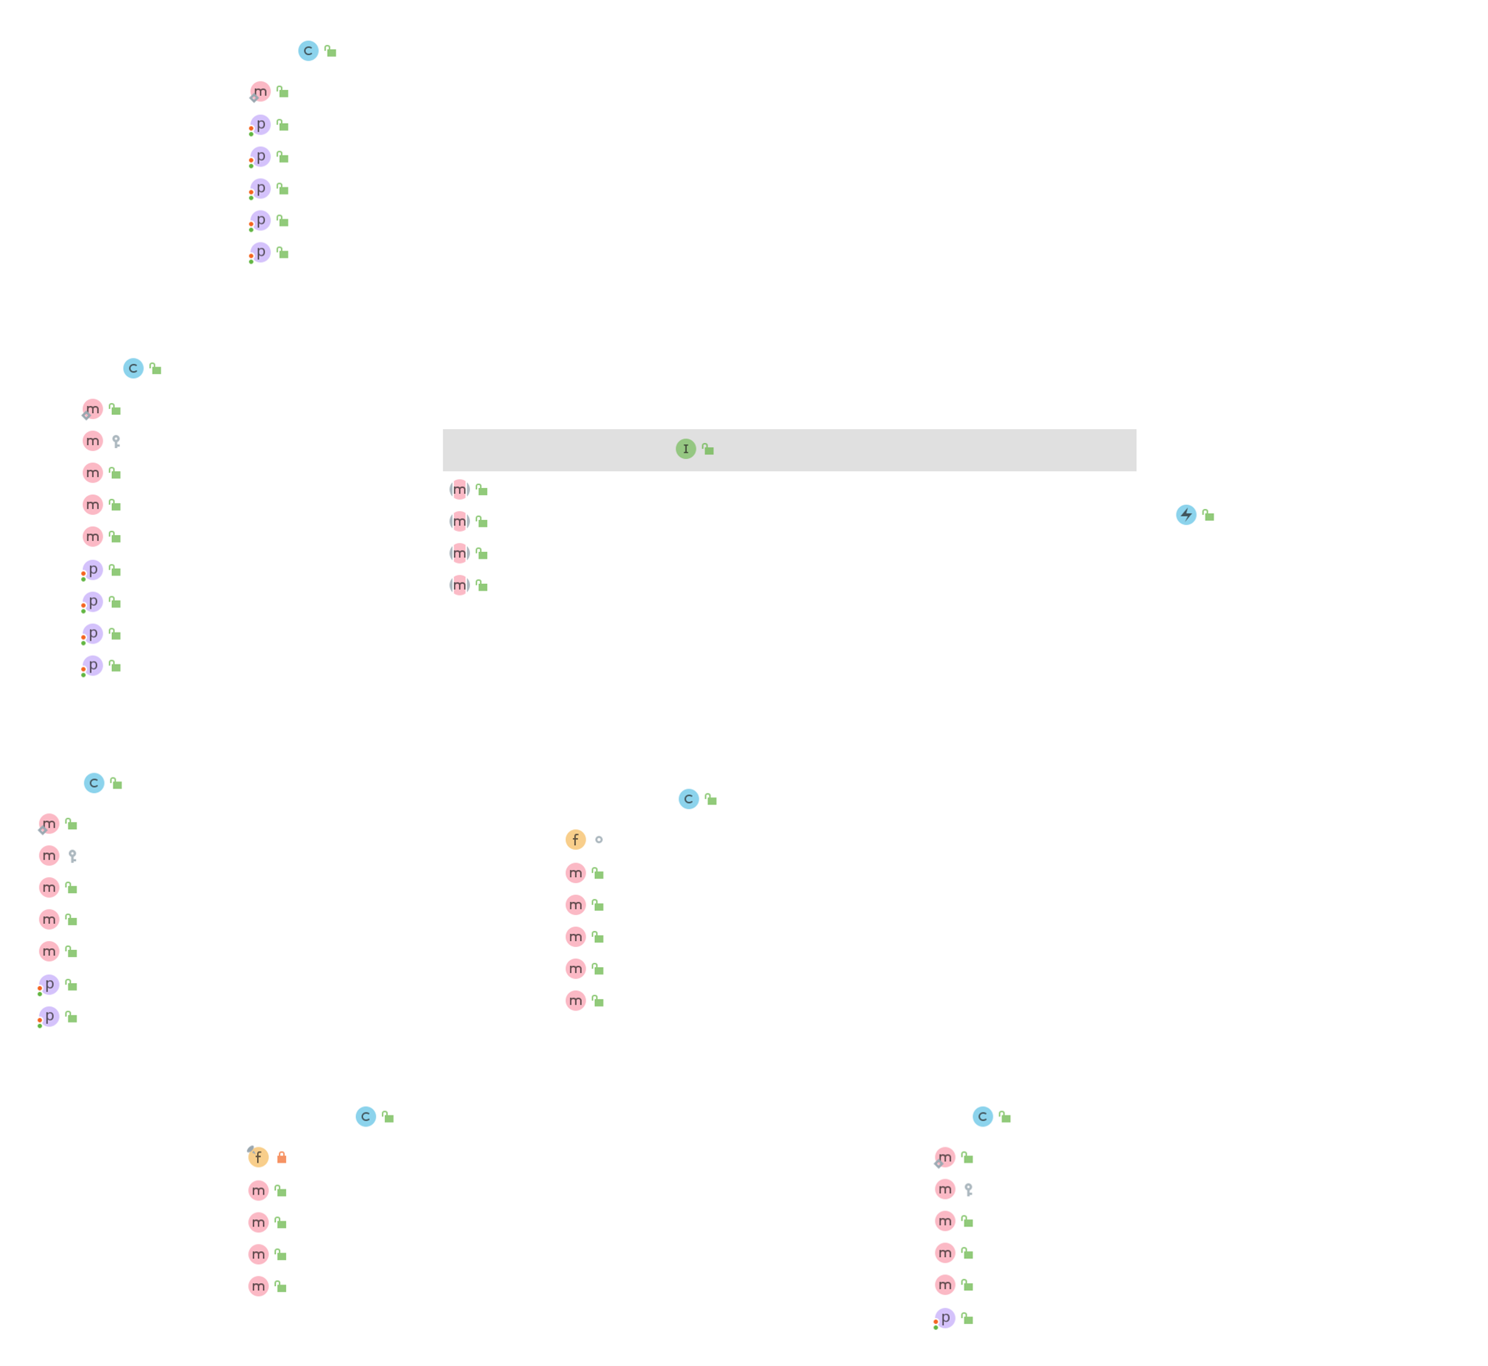

Figure 3.14.1. “Manage system fish species” Class Diagram

#### 3.14.2. Sequence Diagram(s)

##### 3.14.2.1. View system fish species list



Figure 3.14.2.1. “View system fish species list” Sequence Diagram

##### 3.14.2.2. Add new fish species



Figure 3.14.2.2. “Add new fish species” Sequence Diagram

##### 3.14.2.3. Edit fish species information



Figure 3.14.2.3. “Edit fish species information” Sequence Diagram

##### 3.14.2.4. Activate/Deactive fish species



Figure 3.14.2.4. “Activate/Deactivate fish species” Sequence Diagram

### 3.15. Feature “Manage system fishing methods”

#### 3.15.1. Class Diagram

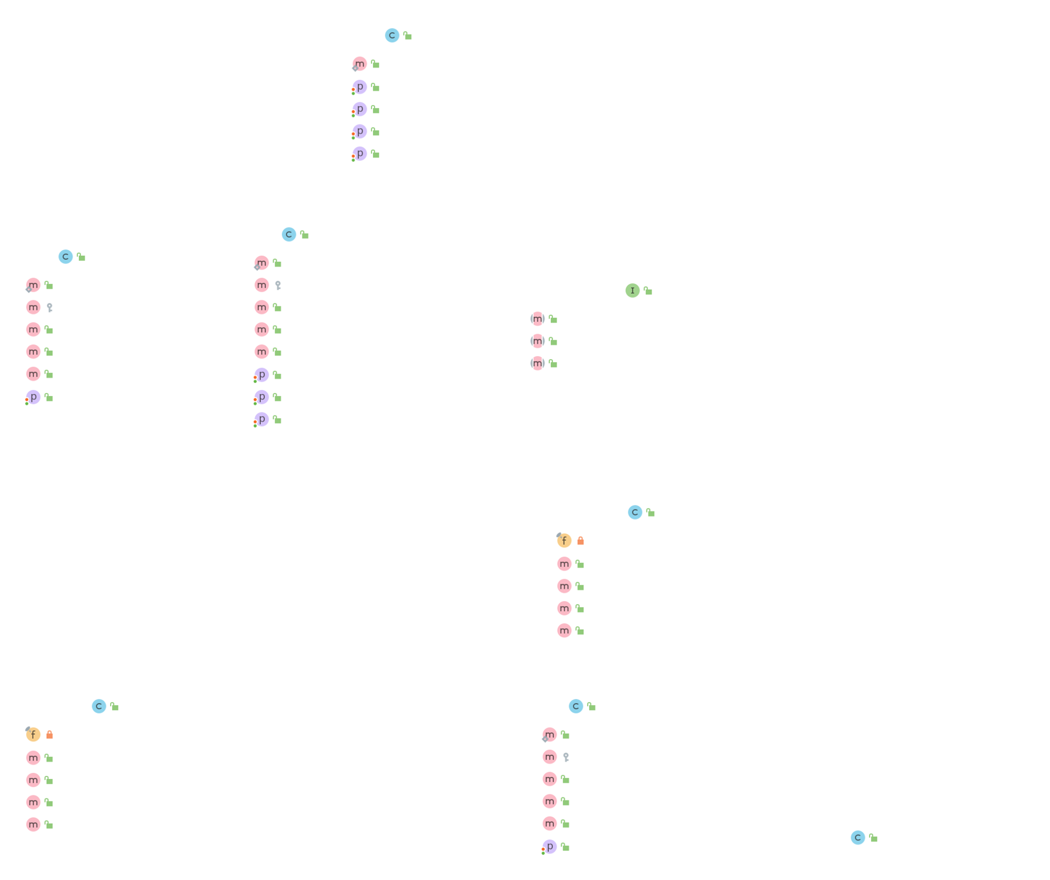

Figure 3.15.1. “Manage system fishing methods” Class Diagram

#### 3.15.2. Sequence Diagram(s)

##### 3.15.2.1. View system fishing method list



Figure 3.15.2.1. “View system fishing method list” Sequence Diagram

##### 3.15.2.2. Add new fishing method



Figure 3.15.2.2. “Add new fishing method” Sequence Diagram

##### 3.15.2.3. Edit fishing method information



Figure 3.15.2.3. “Edit fishing method information” Sequence Diagram

##### 3.15.2.4. Activate/Deactive fishing method



Figure 3.15.2.4. “Activate/Deactive fishing method” Sequence Diagram

### 3.16. Feature “Manage fishing location’s suggestion”

#### 3.16.1. Class Diagram

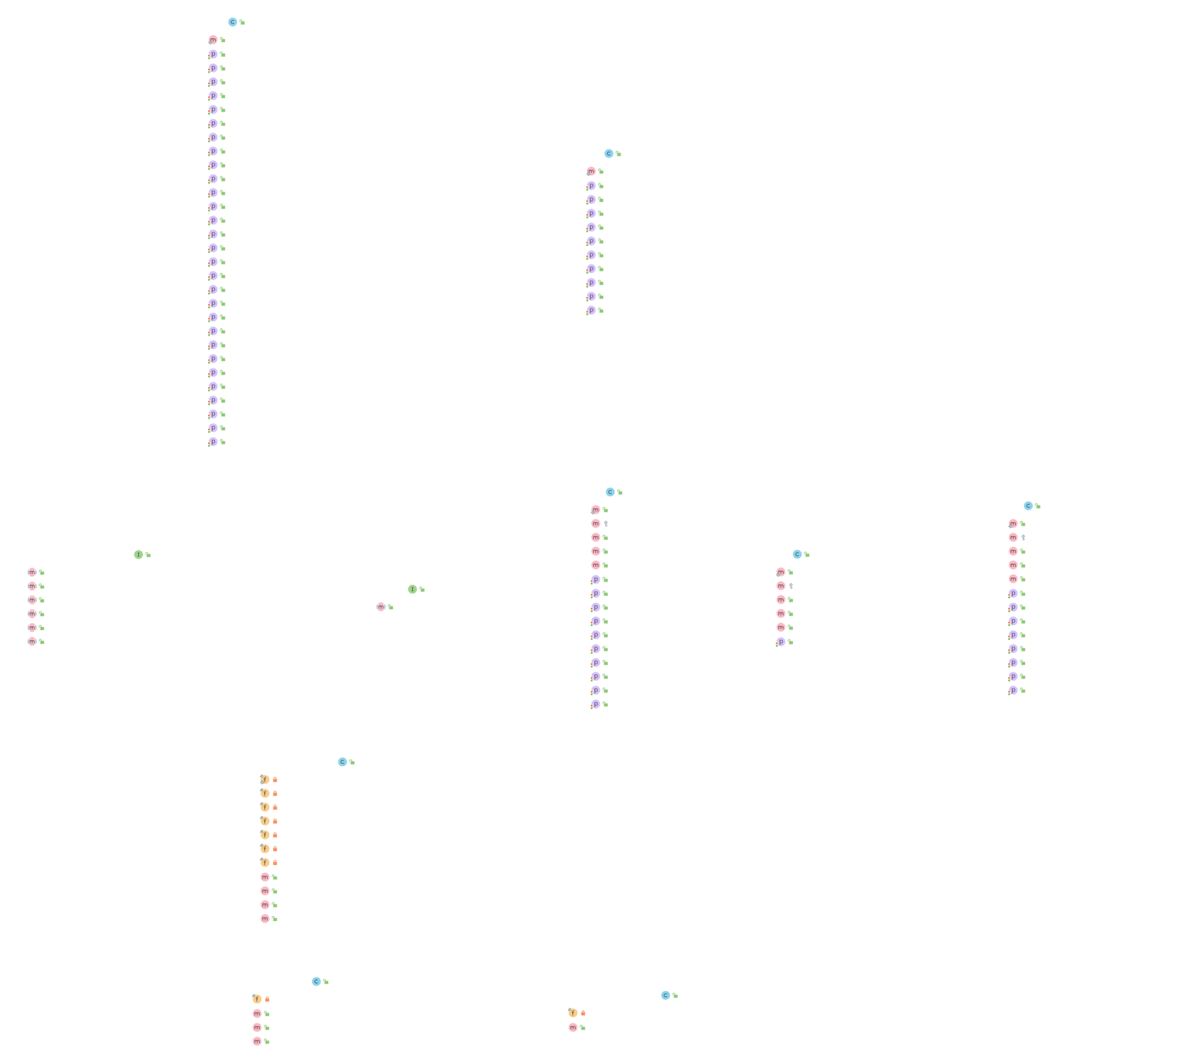

Figure 3.16.1. “Manage fishing location’s suggestion” Class Diagram

#### 3.16.2. Sequence Diagram(s)

##### 3.16.2.1. Suggest fishing location



Figure 3.16.2.1. “Suggest fishing location” Sequence Diagram

##### 3.16.2.2. View list of suggested location



Figure 3.16.2.2. “View list of suggested location” Sequence Diagram

##### 3.16.2.3. Mark helpful suggestion form



Figure 3.16.2.3. “Mark helpful suggestion form” Sequence Diagram

##### 3.16.2.4. Create suggested location



Figure 3.16.2.4. “Create suggested location” Sequence Diagram

### 3.17. Feature “Manage banned phone number”

#### 3.17.1. Class Diagram

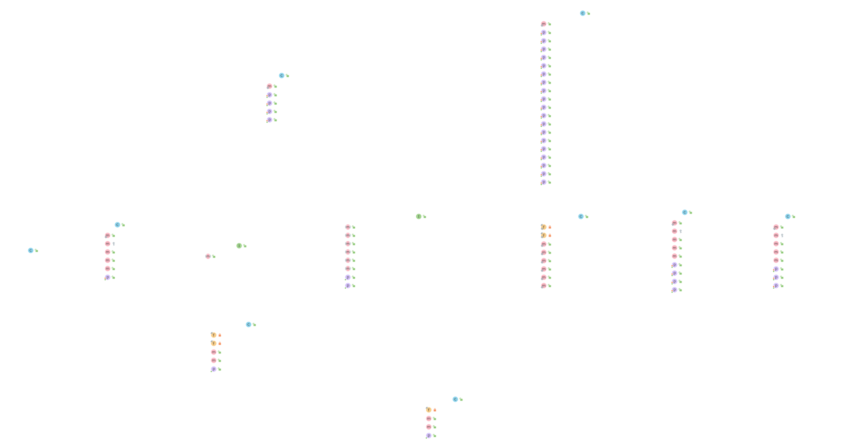

Figure 3.17.1. “Manage banned phone number” Class Diagram

#### 3.17.2. Sequence Diagram(s)

##### 3.17.2.1. View and search banned phone number list



Figure 3.17.2.1. “View and search banned phone number list” Sequence Diagram

##### 3.17.2.2. Ban a phone number



Figure 3.17.2.2. “Ban a phone number” Sequence Diagram

##### 3.17.2.3. Unban a phone number



Figure 3.17.2.3. “Unban a phone number” Sequence Diagram

# V. Software Testing Documentation

## 1. Scope of Testing

* The team will focus mainly on functions that actor “Angler” will be executed.
* There are 4 phases in the testing process: Unit testing, Integration testing, System testing, and Acceptance testing.

|  |  |  |
| --- | --- | --- |
| **Test stages** | **Description** | **Purpose** |
| Unit testing | It is used to test function in backend code, created, and performed in source code by backend developers. | Re-check all requirements and cases that might be happened to a function and check if it can adapt them or not. |
| Integration testing | Group all individual modules and test as a group. It is created and performed by tester team. | To expose defects in the interfaces or defects in the interaction between integrated modules. |
| System testing | It is used to test a complete integrated system. It is created and performed by tester team. | To test overall system and verify all logic and data stream of system. |
| Acceptance testing | It conducted to determine if the requirements of a specification or are met. | Including alpha testing. Supervisor, team members and people who want to use the app can test builded app to detect bug and strange behavior. |

Table 1. Stages of testing

## 2. Test Strategy

### 2.1. Test Model

Our test type is an Interative Model. According to the model of the development process in Agile Model (an interative software development process framework). The Interative Model interates the requirement, design, implementation, testing and deployment phase continuously for each requirement and builds up the system iteratively till it is completely build.

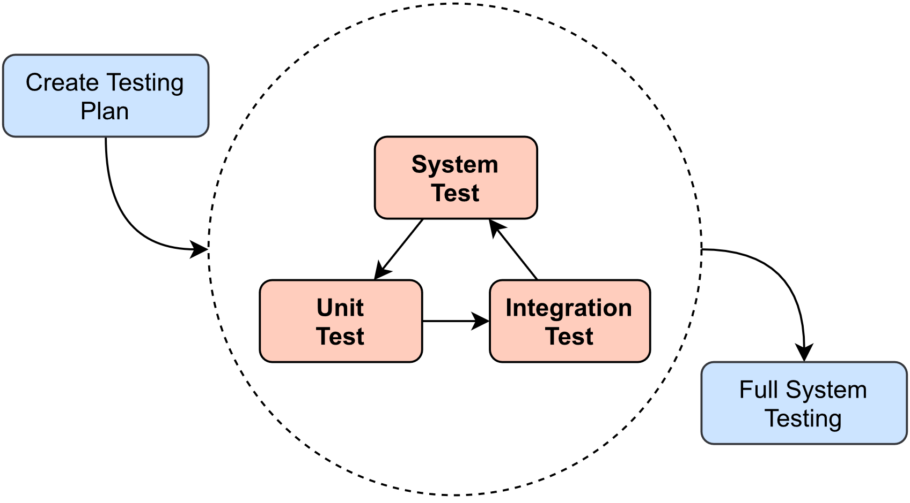

Figure 2.1. Interative Test Model

### 2.2. Testing Types

|  |  |
| --- | --- |
| **Testing Type** | **Description** |
| Functional Testing | * Testing individual methods, functions, model class and library class. * Test case will have to cover all logic branch that function or method could execute with difference data input. Another alternative logic branch should be covered if not, that logic branch should be detected at API testing level. * Implemented function’s error message and database error message will be included in this test. |
| GUI Testing | * GUI testing verifies a user’s interaction with the software. The goal of GUI testing is to ensure that the GUI provides the user with an appropriate access and navigation through the functions of the target-of-test. In addition, GUI testing ensures that the objects within the GUI function as expected and conform to requirement * GUI test will be performed fully on all screens. * This test targets to cover the verification of the overall look and feel of the system including initial position, font, text size, color, focus, initial button, tab order, label, etc. |
| API Testing | * Involves testing APIs directly to determine if they meet expectations for functionality, reliability, performance, and security. API testing will test all of individual implemented API of system API Service. |
| Regression Testing | * The testing is to confirm that the bug was removed including the extent of the impact, when developers fix bug, developers and testers will confirm with each other what is the impacts of fix bug modification, after that all impact unit or function will be retested by developers then testers after that. |
| Acceptance Testing | * This test type will be executed by tester with designed test cases, acceptance test is a test type conducted to determine if the requirements of a specification or contract are met. * It also includes alpha testing; alpha testing takes place at close relation user’s site and are free test to detect bug and strange behavior. By that, development team will improve UX and UI of system. |

Table 2.2. Testing Types

### 2.3. Test Levels

|  |  |  |  |  |
| --- | --- | --- | --- | --- |
| **Type of Tests** | **Test level** | | | |
| **Unit test** | **Integration Test** | **System Test** | **Acceptance Test** |
| Functional Testing | x | x | x |  |
| GUI Testing |  | x | x | x |
| API Testing | x |  | x |  |
| Regression Testing | x | x | x | x |
| Acceptance Testing |  |  |  | x |

Table 2.3. Test Levels

### 2.4. Supporting Tools

|  |  |  |  |  |
| --- | --- | --- | --- | --- |
| **Purpose** | **Type** | **Tool** | **Provider** | **Version** |
| Manage test cases | Software | Microsoft Excel | Microsoft | Professional Plus 2019 |
| Test APIs | Software | Postman[17] | Postman, Inc | Latest |
| Test function | Software | IntelliJ, Visual Studio Code | JetBrains, Microsoft | Latest |
| Execute integration and system test | Hardware | Mi A2  Redmi Note 5  Redmi 5 Plus | Xiaomi | Android 11, 10 |
| Database management | Software | Dbeaver Community[18] | Open source | Latest |
| Manage issues | Website | Github Issues[19] | Github | Latest |

Table 2.4. Supporting Tools

## 3. Test Plan

### 33.1. Human Resources

|  |  |  |
| --- | --- | --- |
| **Member** | **Role** | **Specific Responsibility** |
| AnhLT | Test leader  Tester  Backend developer | * Create test plan, test process, test case. * Create and execute unit test. * Execute test. * Log bug. * Create reports. |
| DatND | Tester  Frontend developer | * Execute test. * Fix bug of frontend features. * Log bug. |
| AnhTD | Backend developer | * Fix bug of backend features. * Log bug. |
| ToanDQ | Frontend developer | * Fix bug of frontend features. * Log bug. |
| DucHM | Frontend developer | * Fix bug of frontend features. * Log bug. |

Table 3.1. Human Resources

### 3.2. Test Milestones

|  |  |  |
| --- | --- | --- |
| **Milestone Tasks** | **Start Date** | **End Date** |
| Create test cases (Iteration 1) | 10/18/2021 | 11/05/2021 |
| Execute Unit test and Integration test (Iteration 1) | 10/18/2021 | 11/05/2021 |
| Create test cases (Iteration 2) | 10/18/2021 | 11/05/2021 |
| Execute Unit test and Integration test (Iteration 2) | 10/18/2021 | 11/05/2021 |
| Update testing document | 11/29/2021 | 12/06/2021 |
| Execute System testing | 11/29/2021 | 12/06/2021 |
| Execute Acceptance testing with fixing bugs | 11/29/2021 | 12/06/2021 |
| Create test reports | 12/06/2021 | 12/06/2021 |

Table 3.2. Test Milestones

## 4. Test Cases

### 4.1. Unit Test

Functional testing will be done on server development side by backend developer, we use Junit Mockito libraries, which have been integrated in Spring Boot. These help to reduce test environment installation and can create function test in the most optimal way. For API testing, we use Postman, one of the most popular API testing platforms today, with a simple, easy-to-use interface, clear, and effective results for each test link.

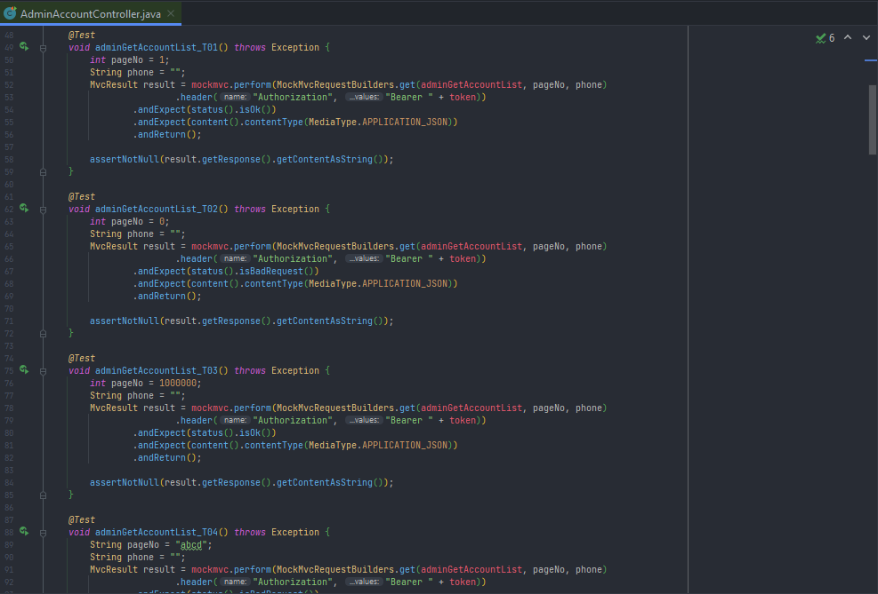

Figure 4.1:1. samples of testing function.

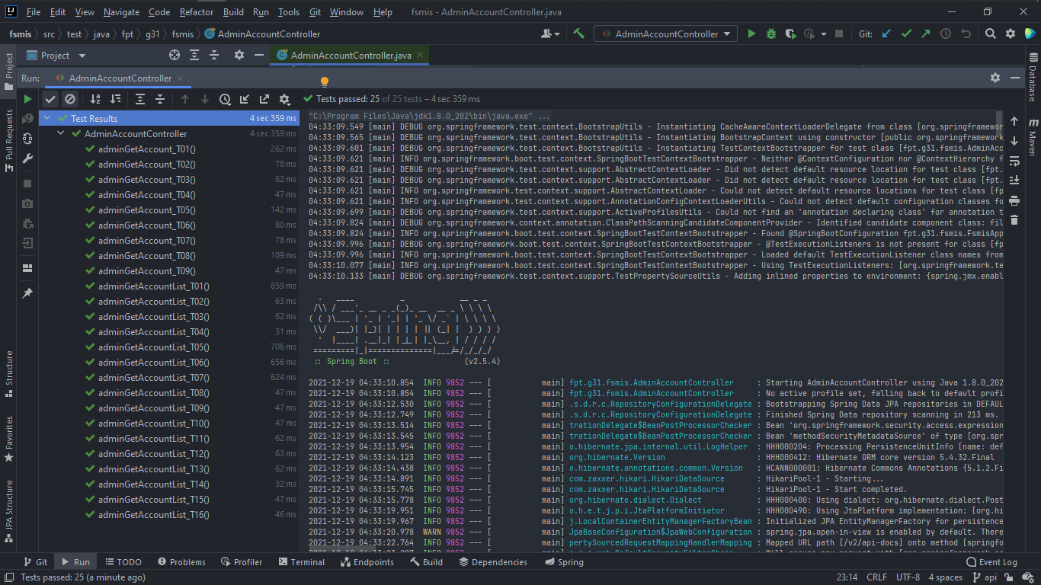

Figure 4.1:2. Running unit test functions

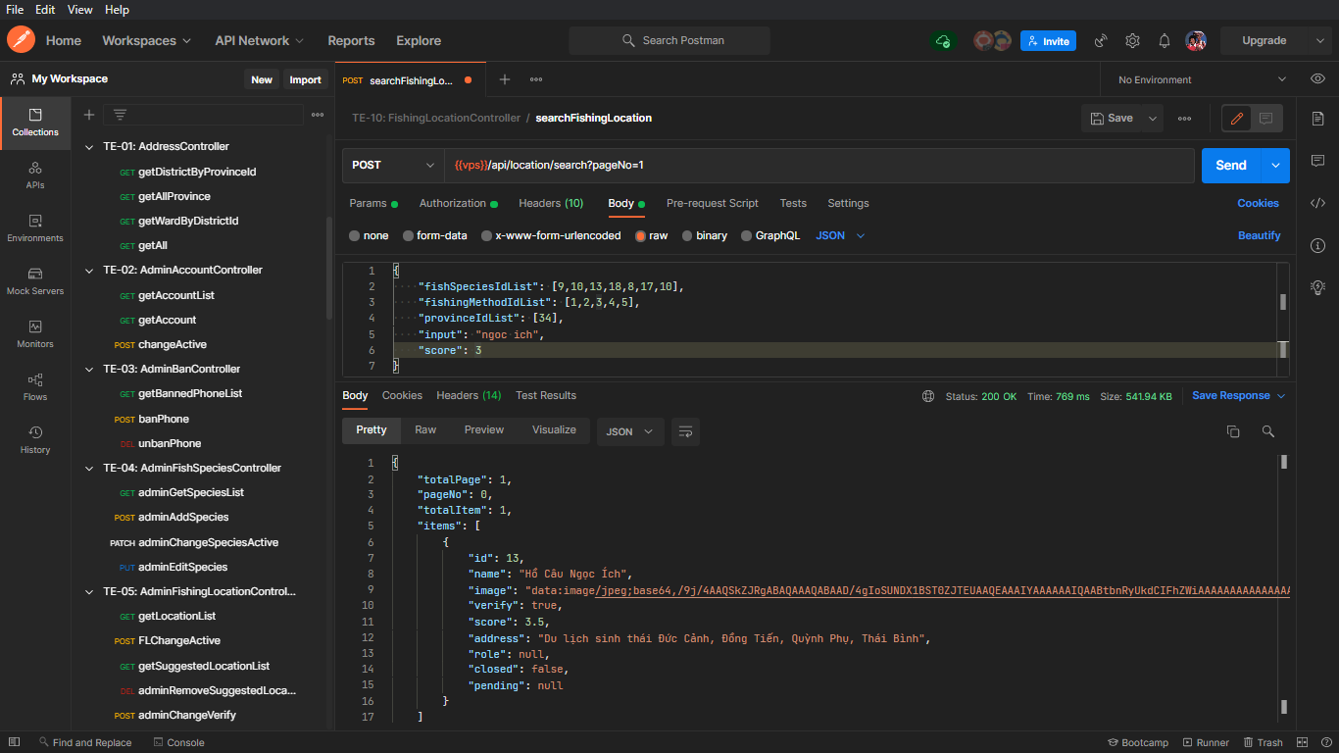

Figure 4.1:3. API testing with Postman Platform

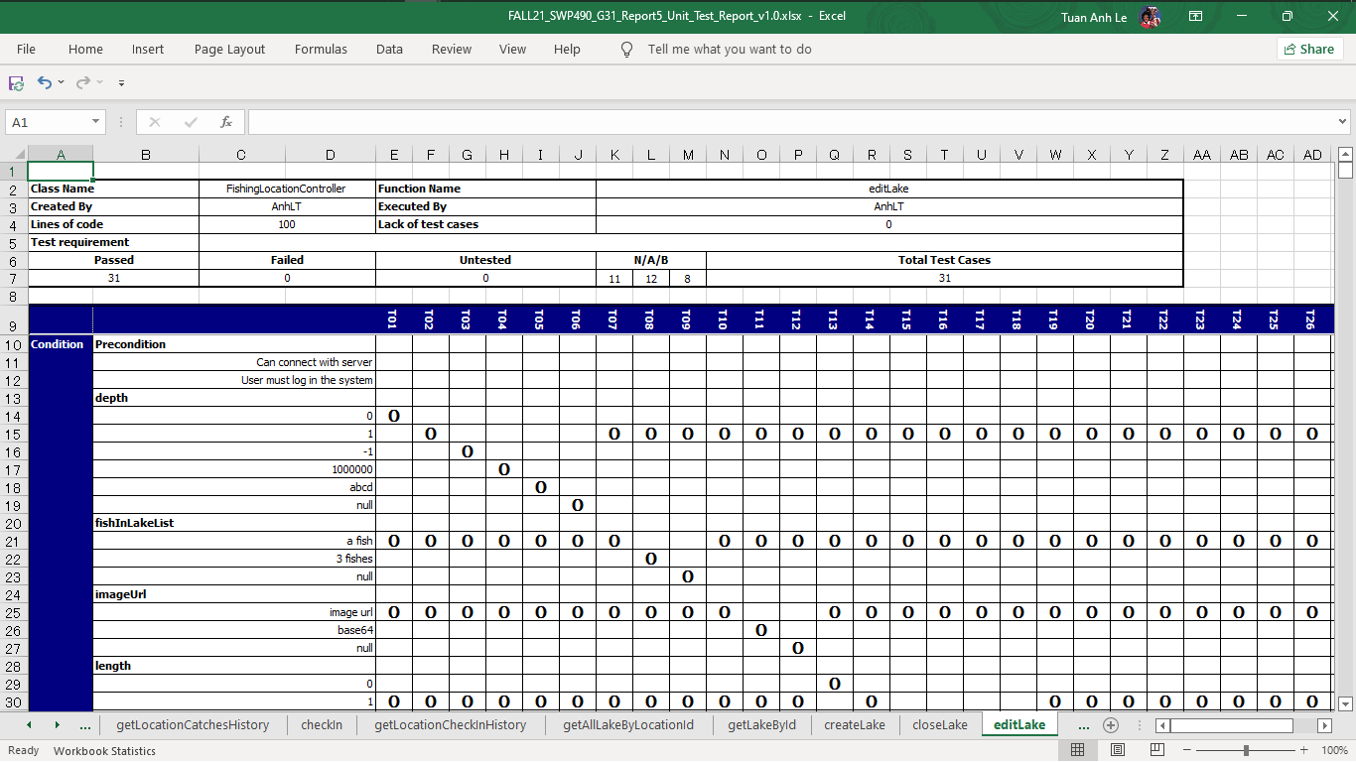

Figure 4.1:4 Functional test tracking

### 4.2. Integration Test

This stage of testing will incorporate the API into the app's interface to test what the data represents to the user. Each test case will clearly record the steps to execute a test case so that bugs or defects can be detected. During testing, if any errors related to UX/UI are discovered, the data representation is incorrect (both user and server side), or maybe the API returns data that is not as expected. Testers will log defect or bug on Github Issues (See 4.4), and track that test case is failed until it will be fixed by developers.

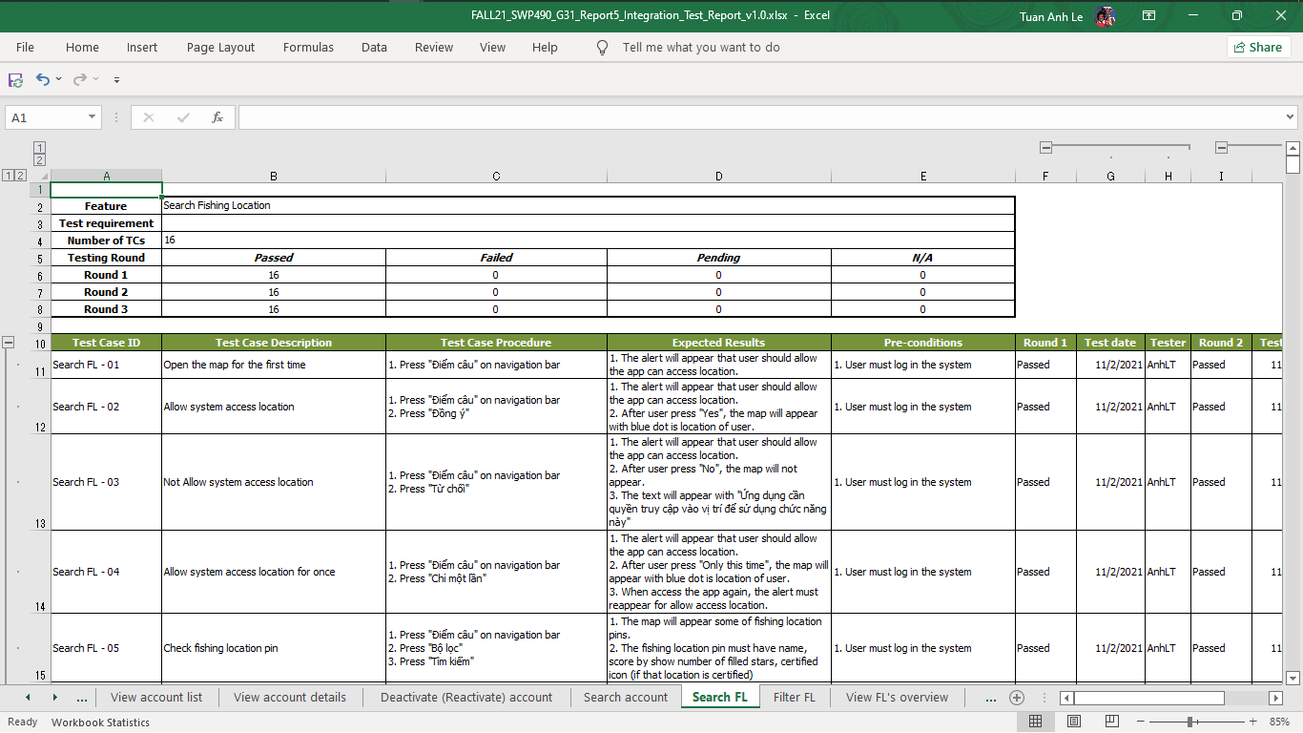

Figure 4.2. Integration test tracking

### 4.3. System Test

This stage of testing is performed after the functions outlined in the requirement are fully implemented. We will practice on a physical phone with Android 10 and 11 operating systems. The goal of this test phase is to test the performance that can be run on the device, and assuming the cases that the user will operate on application. Unlike unit testing and integration testing, if any defect or bug is found, the tester needs to notify the developer to fix it immediately or in the shortest time possible.

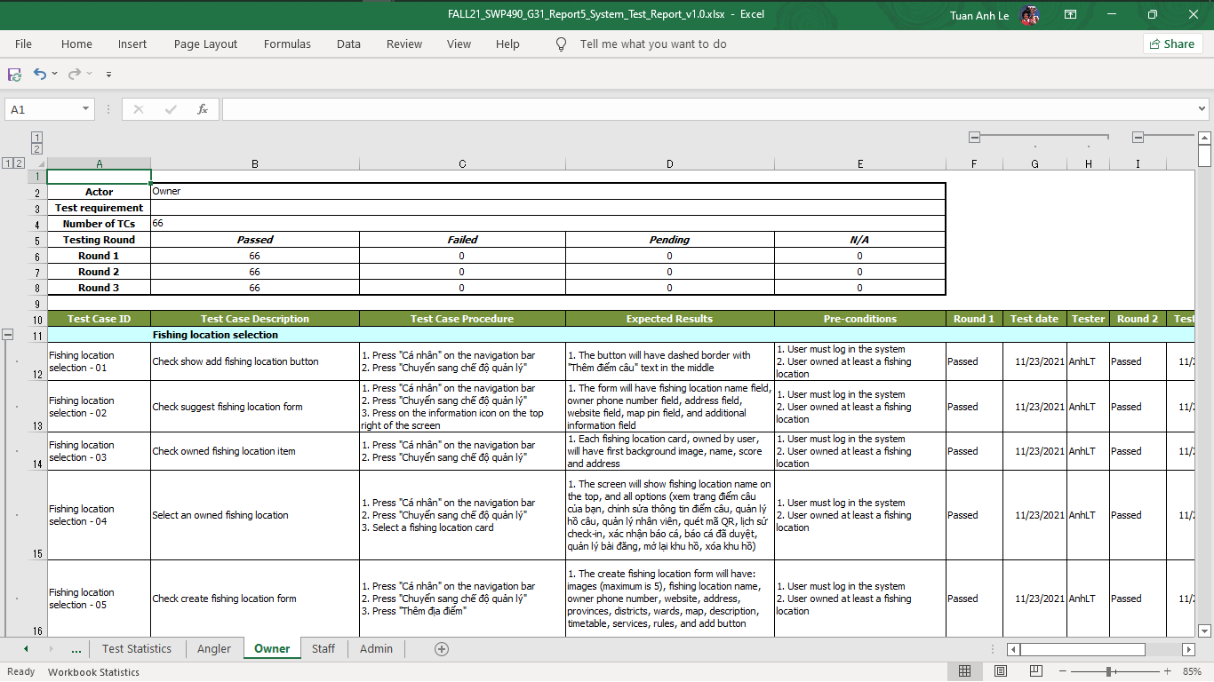

Figure 4.3. System test tracking

### 4.4. Defect & Bug Log

In all the above 3 stage of testings, testers and developers themselves, if a defect or bug is discovered, or there is no time to fix it in the current day, it needs to be recorded so that it can be handled in the future. We use Github Issues, it can create an issue, assign related developers and categories to show how important the issue is to the team. All issues must be clearly described, with pictures attached so that the member who needs to fix the error can see it clearly and unambiguously.

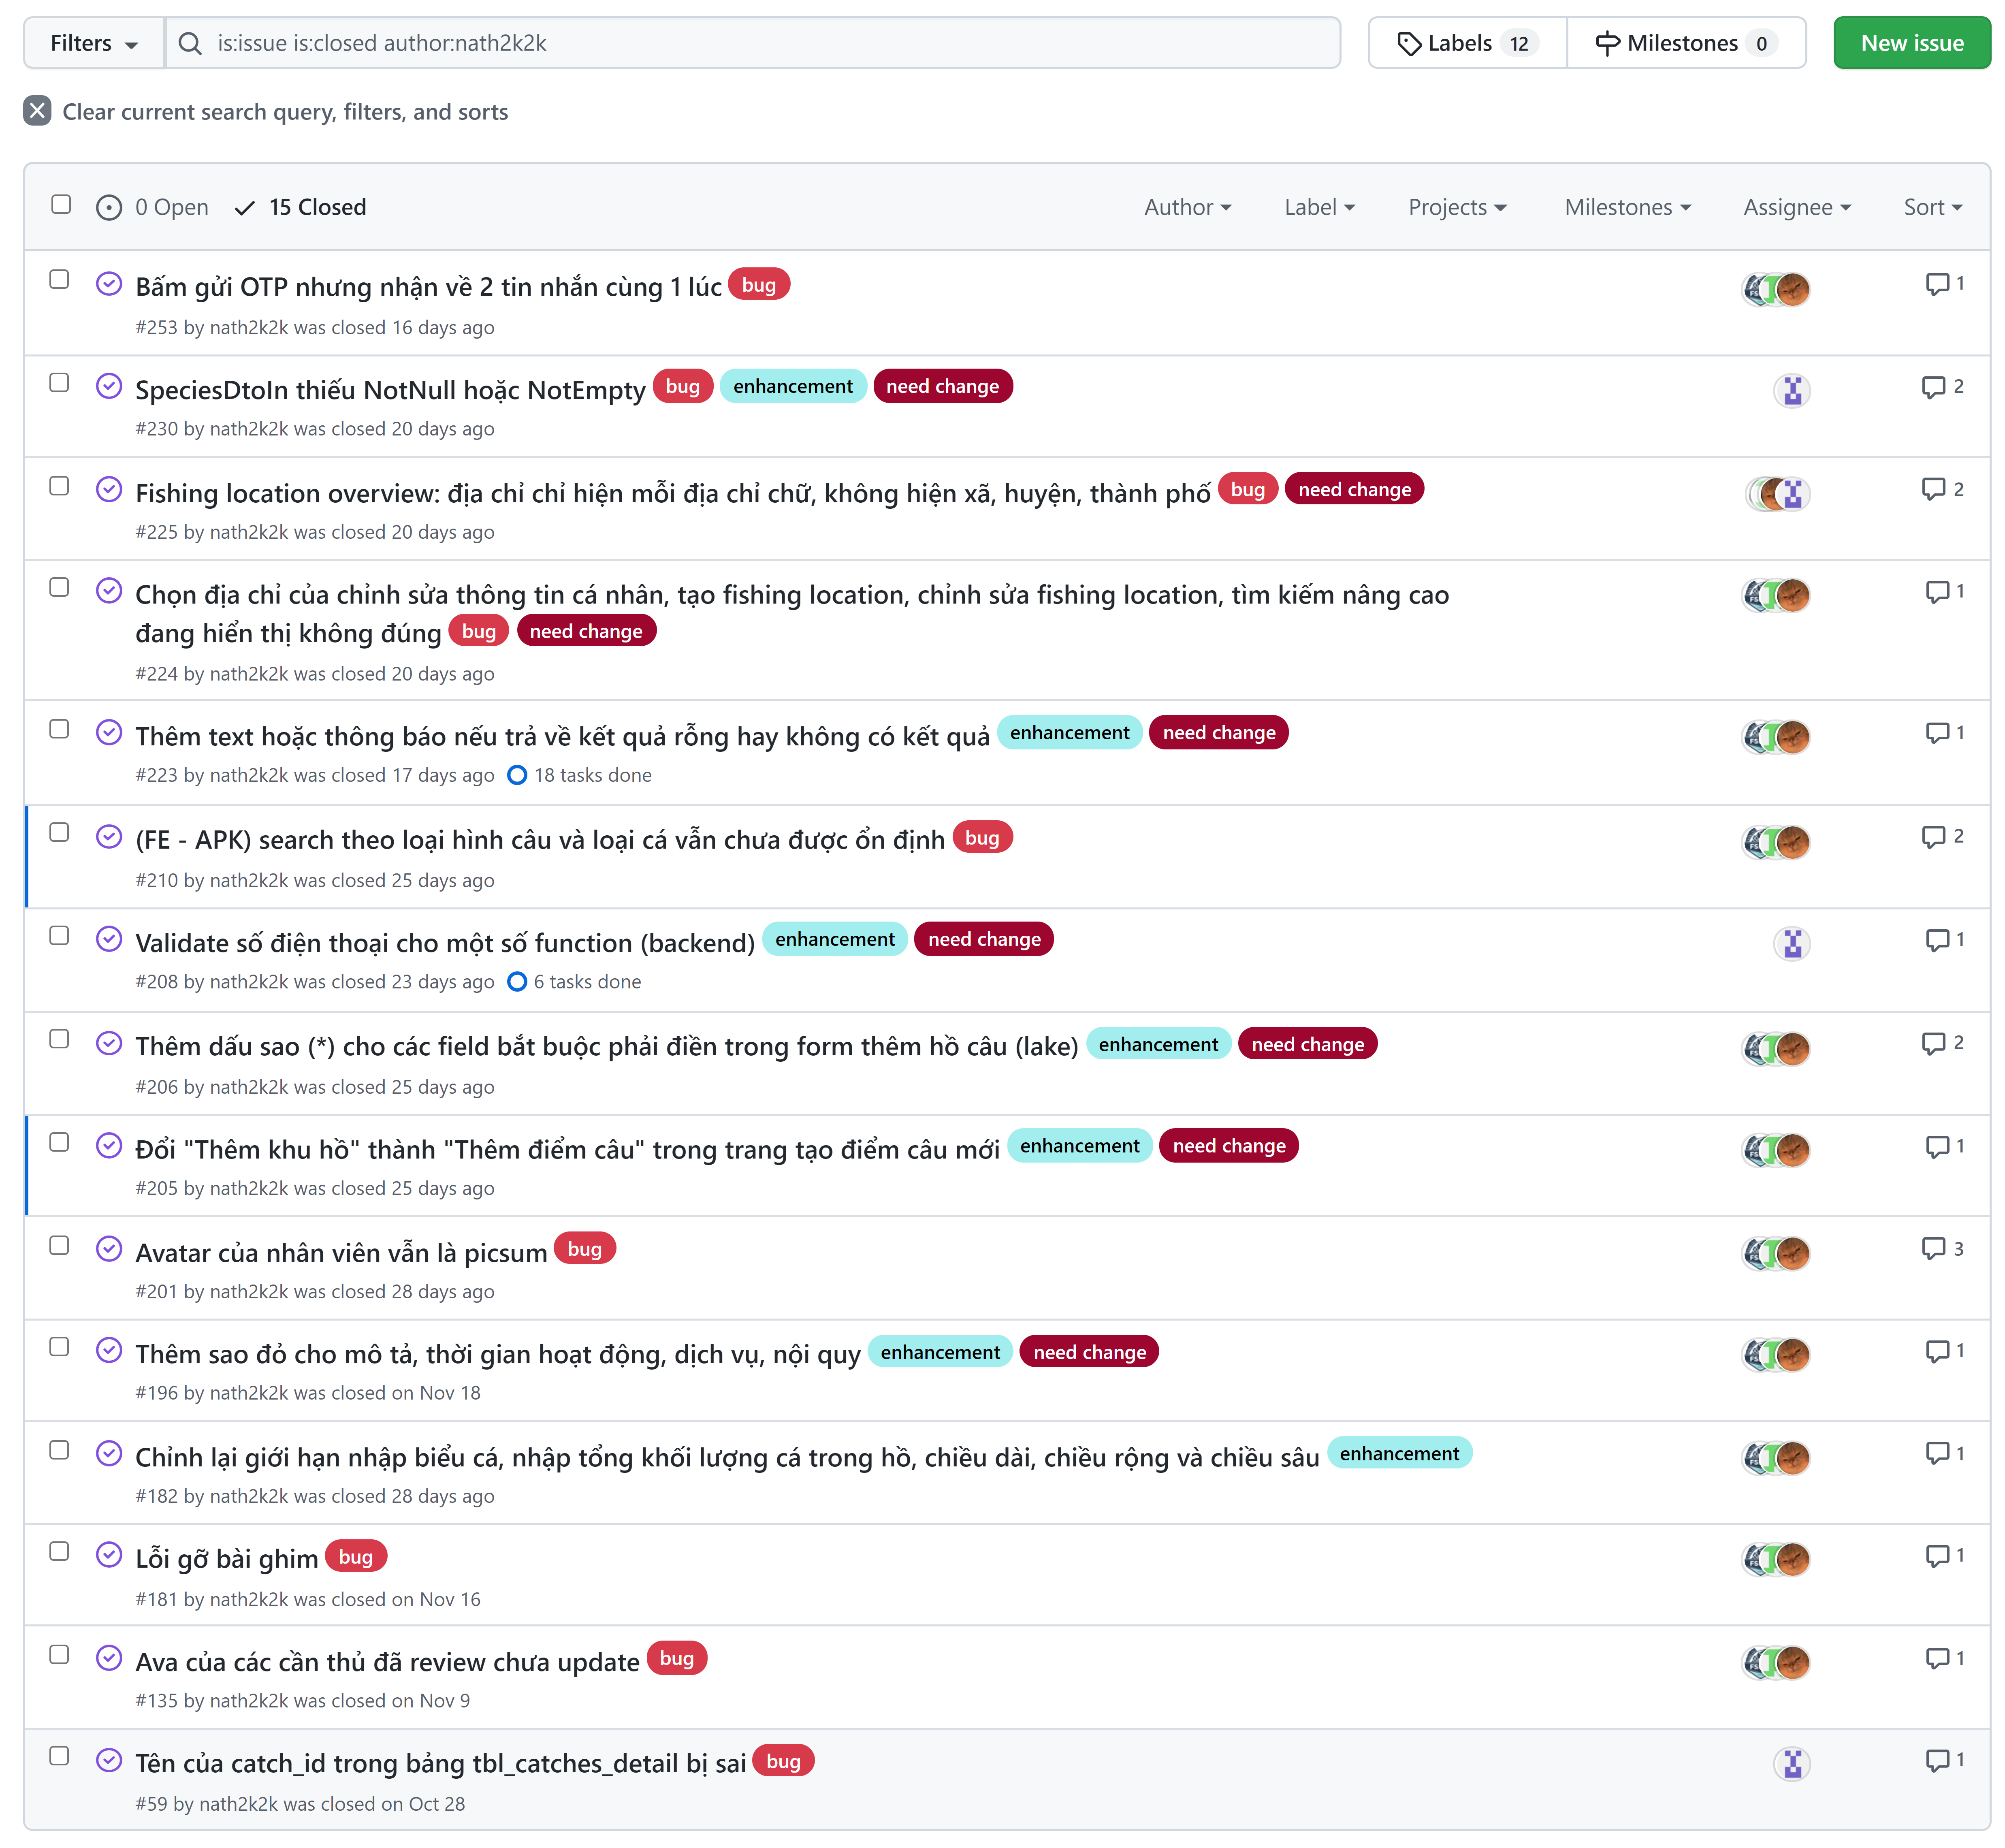

Figure 4.4:1. Defect logs on Github Issues

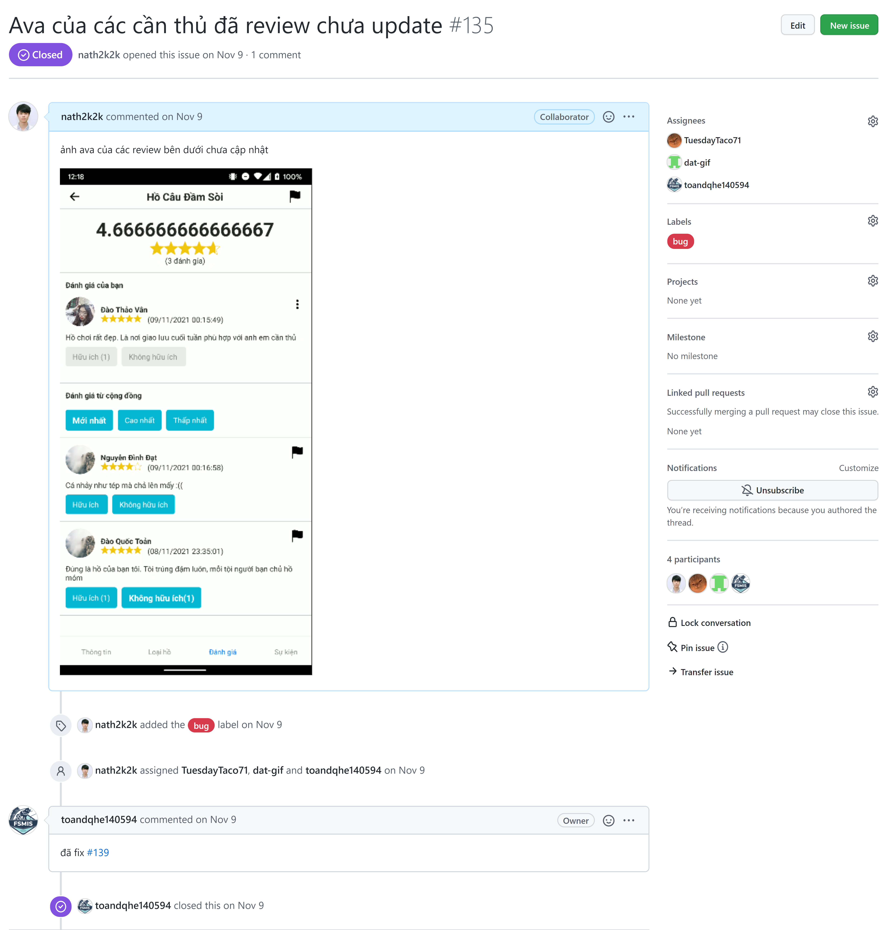

Figure 4.4:2. Defect log details

### 4.5. Acceptance Test

Due to the COVID-19 pandemic, team members were unable to go outside to deliver apps to specific users. So we do alpha testing with our supervisors, family, and friends nearby who are interested in fishing. The purpose of this test is to evaluate the system’s compliance with the business requirements and assess whether it is acceptable for delivery. Our project will use the checklist as a substitute for acceptance testing including items from non-functional requirement specified in Software Requirement Specification.

The content of the checklist is shown in the table below:

|  |  |  |  |
| --- | --- | --- | --- |
| **ID** | **Checklists** | **Yes** | **No** |
| **General** | | | |
| CL-01 | Text on all screens are grammatically correct | x |  |
| CL-02 | All mandatory fields are validated | x |  |
| CL-03 | All error messages are displayed in red colour | x |  |
| **GUI and Usability** | | | |
| CL-04 | Links, buttons, and checkboxes are easily clickable | x |  |
| CL-05 | User interface should be clear and easy to use | x |  |
| CL-06 | The system must be designed so that users can easily familiarize themselves with and use competently functions in a short time | x |  |
| CL-07 | Main functions are organized into navigator for easier access | x |  |
| CL-08 | The maximum steps to complete 1 activity from seeing the screen is 3 | x |  |
| **Security** | | | |
| CL-09 | Using authentication and authorization to access protected resources. | x |  |
| CL-10 | JWT token is used to authenticate user. | x |  |
| CL-11 | Password must be protected and encrypt before store in database. | x |  |
| CL-12 | User's password must be hashed with Bcrypt. | x |  |
| CL-13 | Only send the latest OTP to the user's phone number. | x |  |
| **Performance** | | | |
| CL-14 | In the best condition, the slowest response is not exceeded 5 seconds. | x |  |
| CL-15 | In the best condition, the loading pages time must not exceed 5 seconds. | x |  |
| **Maintaining & Scalability** | | | |
| CL-16 | System logs error reporting to track errors whenever the application happens to crash. | x |  |
| CL-17 | Source code must follow the coding convention to help developers to read, understand, and find it easy to maintain or modify the code. | x |  |
| **Compatibility** | | | |
| CL-18 | The device must be Android 9 or higher. | x |  |
| **Localization** | | | |
| CL-19 | The language is Vietnamese. | x |  |
| CL-20 | The application only accepts Vietnamese phone numer. | x |  |
| CL-21 | The date format in the application must be: dd/MM/yyyy or dd/MM/yyyy HH:mm:ss. | x |  |

Table 4.5. Acceptance Testing Checklist

## 5. Test Reports

### 5.1. Unit Test[20]

|  |  |  |  |  |  |  |  |
| --- | --- | --- | --- | --- | --- | --- | --- |
| **Function code** | **Passed** | **Failed** | **Untested** | **N** | **A** | **B** | **Total Test Cases** |
| getAccountList | 20 | 4 | 0 | 14 | 5 | 5 | 24 |
| getAccount | 6 | 0 | 0 | 2 | 2 | 2 | 6 |
| changeActive | 9 | 0 | 0 | 2 | 3 | 4 | 9 |
| getBannedPhoneList | 1 | 0 | 0 | 1 | 0 | 0 | 1 |
| banPhone | 10 | 0 | 0 | 5 | 4 | 1 | 10 |
| unbanPhone | 7 | 0 | 0 | 1 | 5 | 1 | 7 |
| adminGetSpeciesList | 1 | 0 | 0 | 1 | 0 | 0 | 1 |
| adminAddSpecies | 7 | 3 | 0 | 3 | 6 | 1 | 10 |
| adminChangeSpeciesActive | 9 | 0 | 0 | 4 | 2 | 3 | 9 |
| adminEditSpecies | 12 | 0 | 0 | 2 | 6 | 4 | 12 |
| FLChangeActive | 7 | 0 | 0 | 2 | 3 | 2 | 7 |
| adminChangeVerify | 7 | 0 | 0 | 2 | 3 | 2 | 7 |
| adminGetMethodList | 1 | 0 | 0 | 1 | 0 | 0 | 1 |
| adminAddMethod | 2 | 3 | 0 | 1 | 3 | 1 | 5 |
| adminChangeMethodActive | 7 | 0 | 0 | 2 | 3 | 2 | 7 |
| adminEditMethod | 8 | 3 | 0 | 2 | 7 | 2 | 11 |
| getImproperCatchReportList | 18 | 0 | 0 | 3 | 6 | 9 | 18 |
| getImproperCatchReportDetail | 7 | 0 | 0 | 2 | 3 | 2 | 7 |
| getLocationReports | 18 | 0 | 0 | 3 | 6 | 9 | 18 |
| getLocationReportDetail | 7 | 0 | 0 | 2 | 3 | 2 | 7 |
| getPostReportList | 18 | 0 | 0 | 3 | 6 | 9 | 18 |
| getPostReportDetail | 7 | 0 | 0 | 2 | 3 | 2 | 7 |
| getReviewReportList | 18 | 0 | 0 | 3 | 6 | 9 | 18 |
| getReviewReportDetail | 7 | 0 | 0 | 2 | 3 | 2 | 7 |
| markReportAsSolved | 6 | 0 | 0 | 1 | 3 | 2 | 6 |
| getCatchesDetails | 8 | 0 | 0 | 2 | 3 | 3 | 8 |
| approveCatch | 24 | 0 | 0 | 4 | 16 | 4 | 24 |
| getFishingLocationOverviewById | 7 | 0 | 0 | 1 | 3 | 3 | 7 |
| getLocationCatchesHistory | 20 | 0 | 0 | 9 | 7 | 4 | 20 |
| checkIn | 6 | 0 | 0 | 2 | 2 | 2 | 6 |
| getLocationCheckInHistory | 11 | 2 | 0 | 5 | 7 | 1 | 13 |
| getAllLakeByLocationId | 7 | 0 | 0 | 1 | 3 | 3 | 7 |
| getLakeById | 7 | 0 | 0 | 1 | 3 | 3 | 7 |
| createLake | 28 | 3 | 0 | 11 | 12 | 8 | 31 |
| closeLake | 7 | 0 | 0 | 1 | 3 | 3 | 7 |
| editLake | 31 | 0 | 0 | 11 | 12 | 8 | 31 |
| Get location's post list | 7 | 0 | 0 | 1 | 3 | 3 | 7 |
| createPost | 11 | 3 | 0 | 9 | 5 | 0 | 14 |
| deletePost | 7 | 0 | 0 | 1 | 3 | 3 | 7 |
| editPost | 12 | 2 | 0 | 9 | 5 | 0 | 14 |
| Get location's pinned post | 1 | 0 | 0 | 1 | 0 | 0 | 1 |
| getAllReviews | 6 | 0 | 0 | 4 | 2 | 0 | 6 |
| upvoteReview | 8 | 0 | 0 | 2 | 3 | 3 | 8 |
| getMyReview | 7 | 0 | 0 | 1 | 3 | 3 | 7 |
| deleteReview | 7 | 0 | 0 | 1 | 3 | 3 | 7 |
| postReview | 8 | 0 | 0 | 2 | 6 | 0 | 8 |
| getReviewScore | 7 | 0 | 0 | 1 | 3 | 3 | 7 |
| saveFishingLocation | 7 | 0 | 0 | 1 | 3 | 3 | 7 |
| getStaff | 7 | 0 | 0 | 1 | 3 | 3 | 7 |
| getStaffDetail | 7 | 0 | 0 | 1 | 3 | 3 | 7 |
| addStaff | 7 | 0 | 0 | 1 | 3 | 3 | 7 |
| deleteStaff | 7 | 0 | 0 | 1 | 3 | 3 | 7 |
| createFishingLocation | 16 | 1 | 0 | 8 | 3 | 6 | 17 |
| checkOut | 2 | 0 | 0 | 2 | 0 | 0 | 2 |
| closeFishingLocation | 7 | 0 | 0 | 1 | 3 | 3 | 7 |
| editFishingLocation | 17 | 0 | 0 | 8 | 3 | 6 | 17 |
| getAllLakeWithFishInLake | 7 | 0 | 0 | 1 | 3 | 3 | 7 |
| addFishToLake | 30 | 0 | 0 | 9 | 11 | 10 | 30 |
| fishStocking | 18 | 0 | 0 | 5 | 6 | 7 | 18 |
| getOwnedFishingLocation | 1 | 0 | 0 | 0 | 1 | 0 | 1 |
| getNearBy | 14 | 0 | 0 | 6 | 6 | 2 | 14 |
| switchLocationState | 7 | 0 | 0 | 1 | 3 | 3 | 7 |
| searchFishingLocation | 19 | 1 | 0 | 10 | 6 | 4 | 20 |
| **Sub total** | **630** | **25** | **0** | **202** | **258** | **195** | **655** |

Table 5.1. Unit Test Report

* Test coverage: **100%**
* Test sucessfully coverage: **96.18%**
* Normal case: **30.84%**
* Abnormal case: **39.39%**
* Boundary case: **29.77%**

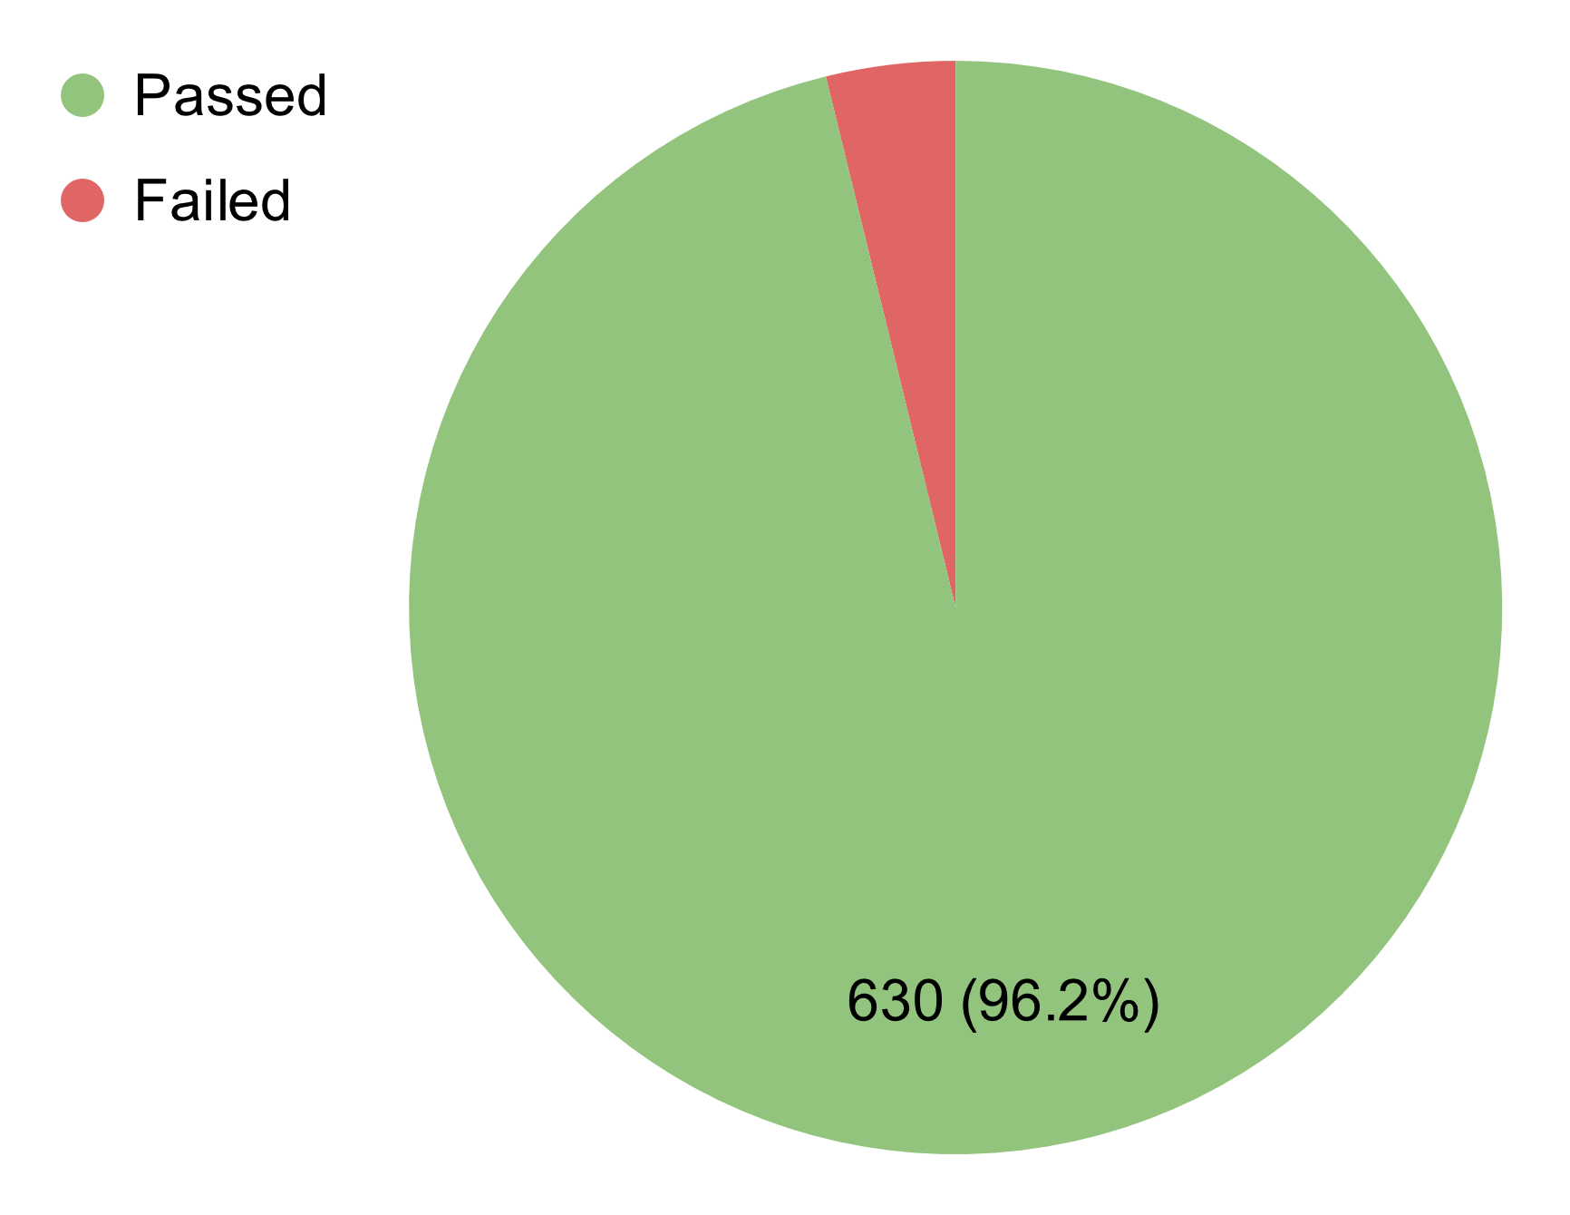 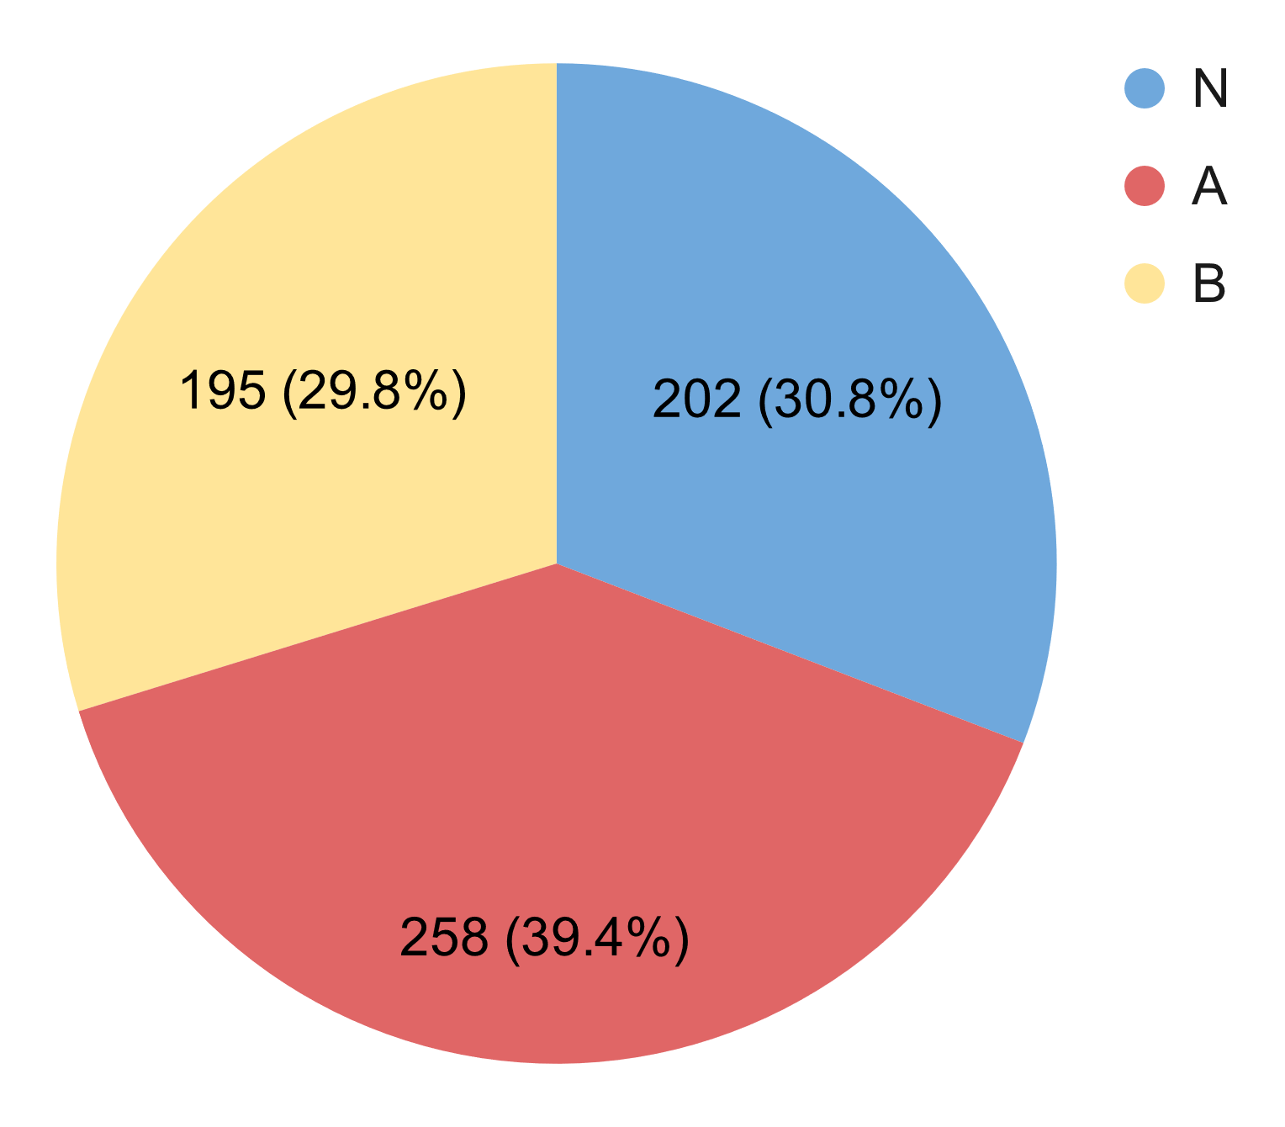

Figure 5.1:1, 5.1:2. Passed Percent & Test Type

### 5.2. Integration Test[21]

|  |  |  |  |  |  |
| --- | --- | --- | --- | --- | --- |
| **Module code** | **Passed** | **Failed** | **Pending** | **N/A** | **Number of test cases** |
| Login | 14 | 0 | 0 | 0 | 14 |
| Register | 22 | 0 | 0 | 0 | 22 |
| Forgot password | 17 | 0 | 0 | 0 | 17 |
| View personal profile | 3 | 0 | 0 | 0 | 3 |
| Edit personal profile | 13 | 1 | 0 | 0 | 14 |
| Change password | 14 | 0 | 0 | 0 | 14 |
| Change phone number | 15 | 0 | 0 | 0 | 15 |
| View account list | 3 | 0 | 0 | 0 | 3 |
| View account details | 2 | 0 | 0 | 0 | 2 |
| Deactivate/Reactivate account | 6 | 0 | 0 | 0 | 6 |
| Search Account | 6 | 0 | 0 | 0 | 6 |
| Search fishing location | 16 | 0 | 0 | 0 | 16 |
| Filter fishing location | 43 | 0 | 0 | 0 | 43 |
| View fishing location's overview | 10 | 0 | 0 | 0 | 10 |
| View lake list | 4 | 0 | 0 | 0 | 4 |
| Save fishing location | 6 | 0 | 0 | 0 | 6 |
| Report fishing location | 4 | 0 | 0 | 0 | 4 |
| View fishing location's reviews | 7 | 0 | 0 | 0 | 7 |
| Post personal review | 11 | 0 | 0 | 0 | 11 |
| Vote/Downvote review | 10 | 0 | 0 | 0 | 10 |
| Delete personal review | 3 | 0 | 0 | 0 | 3 |
| Filter reviews | 7 | 0 | 0 | 0 | 7 |
| Report review | 4 | 0 | 0 | 0 | 4 |
| Verify check-in action | 20 | 0 | 0 | 0 | 20 |
| View personal check-in history | 7 | 0 | 0 | 0 | 7 |
| View fishing location's check-in history | 7 | 0 | 0 | 0 | 7 |
| Filter fishing location's check-in history | 15 | 0 | 0 | 0 | 15 |
| Report catch | 36 | 3 | 0 | 0 | 39 |
| View pending catch reports | 10 | 0 | 0 | 0 | 10 |
| Approve/Reject catch report | 5 | 0 | 0 | 0 | 5 |
| View personal catch history | 11 | 0 | 0 | 0 | 11 |
| View fishing location's catch history | 11 | 0 | 0 | 0 | 11 |
| Filter fishing location's catch history | 15 | 0 | 0 | 0 | 15 |
| Report inappropriate catch | 4 | 0 | 0 | 0 | 4 |
| Add a fishing location | 40 | 5 | 0 | 0 | 45 |
| Edit fishing location's overview | 32 | 5 | 0 | 0 | 37 |
| Add lake | 72 | 1 | 0 | 0 | 73 |
| Close lake | 7 | 0 | 0 | 0 | 7 |
| Edit lake's information | 44 | 0 | 0 | 0 | 44 |
| Add fish in lake | 29 | 0 | 0 | 0 | 29 |
| Stock fish in lake | 10 | 0 | 0 | 0 | 10 |
| Delete fish in lake | 6 | 0 | 0 | 0 | 6 |
| Temporary close/reopen fishing location | 10 | 0 | 0 | 0 | 10 |
| Delete fishing location | 5 | 0 | 0 | 0 | 5 |
| View fishing location's posts | 7 | 0 | 0 | 0 | 7 |
| View lake details | 7 | 0 | 0 | 0 | 7 |
| Suggest fishing location | 9 | 0 | 0 | 0 | 9 |
| **Sub total** | **659** | **15** | **0** | **0** | **674** |

Table 5.2. Integration Test Report

* Test coverage: **100%**
* Test sucessfully coverage: **97.77%**

### 5.3. System Test[22]

|  |  |  |  |  |  |
| --- | --- | --- | --- | --- | --- |
| **Actors and Other functions** | **Passed** | **Failed** | **Pending** | **N/A** | **No. of test cases** |
| Angler | 67 | 0 | 0 | 0 | 67 |
| Owner | 66 | 0 | 0 | 0 | 66 |
| Staff | 33 | 0 | 0 | 0 | 33 |
| Admin | 34 | 0 | 0 | 0 | 34 |
| **Sub total** | **200** | **0** | **0** | **0** | **200** |

Table 5.3. System Test Report

* Test coverage: **100%**
* Test sucessfully coverage: **100%**

# VI. Release Package & User Guides

## 1. Deliverable Packages

|  |  |  |  |  |
| --- | --- | --- | --- | --- |
| **No.** | **Items** | **Sub-Items** | **Type** | **Version** |
| **Code packages** | | | | |
| 1 | Frontend source code | FSMIS_Frontend.zip | .zip | 1.2.5 |
| 2 | Backend source code | FSMIS_Backend.zip | .zip | 1.0.0 |
| **Databases** | | | | |
| 1 | Tables | FSMIS_Database.sql | .sql | 1.0.0 |
| **Documents** | | | | |
| 1 | Final Report | FSMIS_FinalReport.pdf | .pdf | 1.0.0 |
| 2 | Slide | FSMIS_Slide.pdf | .pdf | 1.0.0 |
| 3 | Mockup (Figma) | FSMIS_Mockup.fig | .fig | 1.0.0 |
| 4 | Unit test | FSMIS_UnitTestReport.xlsx | .xlsx | 1.0.0 |
| 5 | Integration test | FSMIS_IntegrationTestReport.xlsx | .xlsx | 1.0.0 |
| 6 | System test | FSMIS_SystemTestReport.xlsx | .xlsx | 1.0.0 |

Table 1. Deliverable Packages

## 2. Installation Guides

### 2.1. Backend Installation

#### 2.1.1. Prerequisite

* Ubuntu[23] or Ubuntu Server[24] (18.04 or higher)
* Twilio Account[25]

#### 2.1.2. Install Java, Maven, & PostgreSQL

##### 2.1.2.1. Java Development Kit version 8

* Run the command to install: $ sudo apt install openjdk-8-jdk
* Confirm Java version:

$ java -version

openJDK version "1.8.0_302"

OpenJDK Runtime Environment (build 1.8.0_302-8u302-b08-0ubuntu2-b08)

OpenJDK 64-Bit Server VM (build 25.302-b08, mixed mode)

##### 2.1.2.2. Apache Maven

* Run the command to install: $ sudo apt install maven
* Confirm Maven version:

$ mvn -version

Apache Maven 3.6.3

##### 2.1.2.3. PostgreSQL 12.9

* Run the command to install: $ sudo apt install postgresql postgresql-contrib
* Change the password of user postgres to 123456:

$ sudo -u postgres psql -c "ALTER USER postgres PASSWORD '123456';"

* Create database name fsmis: $ sudo -u postgres createdb fsmis
* Run this command with FSMIS_DB.sql file to import data into database:

$ sudo -u postgres psql -d fsmis -a -f FSMIS_Database.sql

#### 2.1.2. Configure Twilio

* Unzip FSMIS_BE.zip file, open application.properties located in src/main/resources with text editor and paste all keys from Twilio Console:

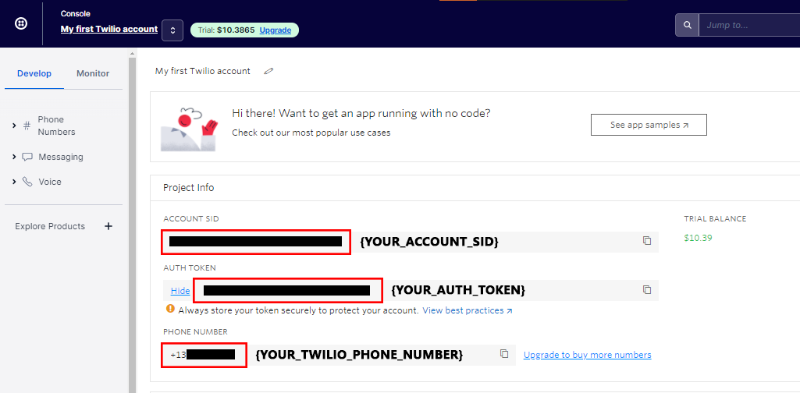

Figure 2.1.2:1. Twilio Console interface with keys

# TWILIO CONFIG

twilio.account_sid={YOUR_ACCOUNT_SID}

twilio.auth_token={YOUR_AUTH_TOKEN}

twilio.trial_number={YOUR_TWILIO_PHONE_NUMBER}

Figure 2.1.2:2. Twilio Configuration in application.properties

#### 2.1.3. Start the build

* In the root directory of source code, run this command to build with Maven:

$ mvn clean install

* After build successfully message appeared, if the fsmis-0.0.1-SNAPSHOT.jar file exists in /target folder. It means the package is ready.

#### 2.1.4. Setup FSMIS service

* Create server with nano (need root permission to create).

$ cd /etc/systemd/system

$ nano fsmis.service

* Copy this configuration, change {YOUR_PATH} to the location of source code folder.

# Example {YOUR-PATH} = /home/ubuntu

[Unit]

Description=FSMIS REST API Service

[Service]

User=root

ExecStart=sudo /usr/bin/java -jar {YOUR-PATH}/FSMIS-BE/target/fsmis-0.0.1-SNAPSHOT.jar

SuccessExitStatus=143

TimeoutStopSec=10

Restart=on-failure

RestartSec=5

[Install]

WantedBy=multi-user.target

* Run these commands one by one to start the service:

$ sudo systemctl daemon-reload

$ sudo systemctl enable fsmis.service

$ sudo systemctl start fsmis

### 2.2. Frontend Installation

#### 2.2.1. Prerequisite

* Expo CLI[26]
* Yarn[27]
* Expo account[28]
* Google Maps API key[29]
* PowerShell[30] (for Windows user only)

#### 2.2.2. Preparation

* If you are using Windows OS, use PowerShell (run as administrator) to run this command, then press “Yes” to change the policy:

Set-ExecutionPolicy -ExecutionPolicy RemoteSigned

##### 2.2.2.1. Install Nodejs, npm, and Yarn

* Download [Nodejs & npm](https://nodejs.org/en/) and install.
* Open the terminal, run npm install --global yarn to install Yarn.

##### 2.2.2.2. Install Expo CLI

* Open the command prompt, run npm install --global expo-cli to install Expo CLI.

##### 2.2.2.3. Sign up for new Expo account

* Go to [Expo Dev](https://expo.dev/signup) to sign up for new Expo account.

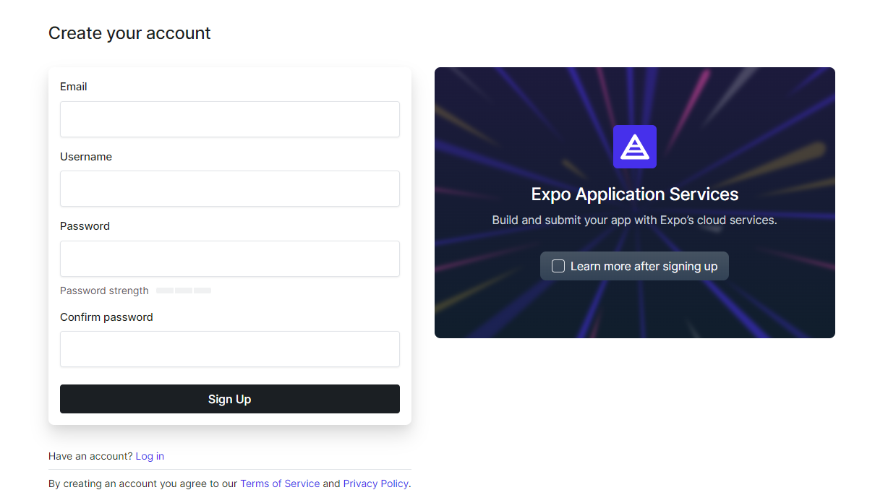

Figure 2.2.2.3. Expo’s sign-up page

* Enter your email address, account username and password, confirm password then press “Sign Up” to create new Expo account.

##### 2.2.2.4. Get Google Maps API key

* Go to [Google Cloud Platform](https://console.cloud.google.com/).

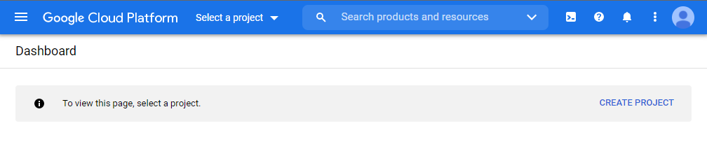

Figure 2.2.2.4:1. Select a project in Google Cloud Platform

* Enter your project name and choose location, then press “CREATE” to create new project.

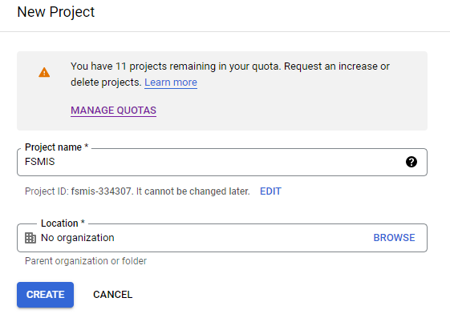

Figure 2.2.2.4:2. New project form

* Go to APIs & Services in your project.

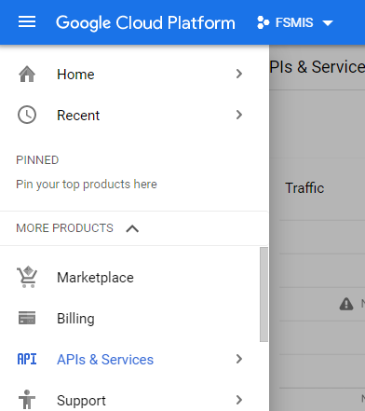

Figure 2.2.2.4:3. Google Cloud Platform Navigation bar, select APIs & Services

* Press “ENABLE API AND SERVICES”.

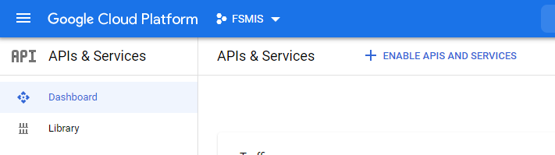

Figure 2.2.2.4:4. APIs & Services

* Enable Maps SDK for Android for your project.

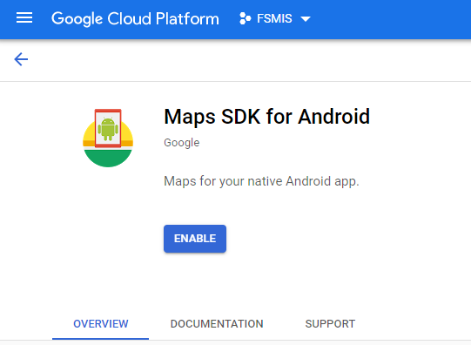

Figure 2.2.2.4:5. Maps SDK for Android

* Go to Google Cloud Credential manager, press “CREATE CREDENTIALS”

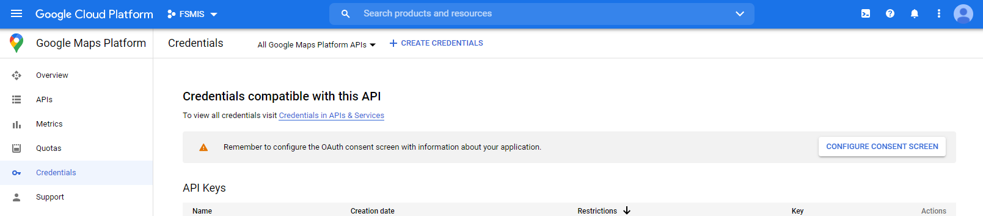

Figure 2.2.2.4:6. Credentials

* Press “API key” to create new API key for your project.

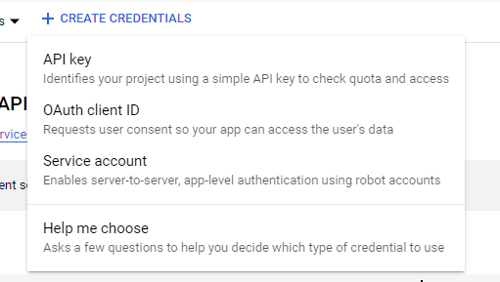

Figure 2.2.2.4:7. Select API key

* Now you have your API key, you can restrict your API key for more privacy.

#### 2.2.3. Setup project

* Open terminal in the folder containing source code. Run yarn install to install necessary dependencies.
* If you haven’t installed Expo CLI, you can run this to get it:

npm install -g expo -cli or yarn global add expo-cli

* If you haven’t created an Expo account before, you’ll be asked to create one when running the build command.

#### 2.2.4. Configure API URL and Google Maps API key

* Open the folder containing source code. Open the .env file in the root directory with a text editor.

APP_NAME=FSMIS

API_URL=

GOOGLE_API_KEY=

* You can paste your backend API URL and your Google Maps API key here.
* **API URL must** end with a / character.
* **Google Maps API key must** have Map SDK for Android enabled.

For example:

APP_NAME=FSMIS

API_URL=127.0.0.1/api/

GOOGLE_API_KEY=AIza****************************TKck

#### 2.2.5. Start the build

* In your root directory of source code, open command prompt and run

expo build:android -t apk

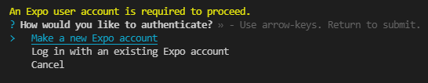

Figure 2.2.5:1. Expo’s authentication

* Log in with your Expo account or create a new one if you haven’t created one yet.
* Since this is the first time we build the project, you will be asked for a keystore. Just choose Generate new keystore

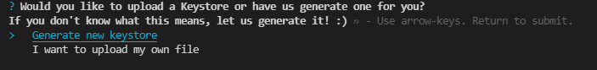

Figure 2.2.5:2. Expo’s Keystore

Now just wait for it to finish building. You can monitor the progress with the URL printed out on the command prompt. Or you can go to the Builds tab on your [Expo Dev](https://expo.dev/) account profile to monitor the build progress

#### 2.2.6. Get the APK file

When the build is finished, you’ll see the URL to your .apk file. Copy and paste the link into your browser to download the file.

Now you can install the app to run locally or remote based on your API URL.

You can always get your .apk file at Projects tab on your [Expo Dev](https://expo.dev/) account profile.

*For more configuration, you can visit the* [*expo documentation*](https://docs.expo.dev/classic/building-standalone-apps/) *site about building a standalone app.*

## 3. User Manual

### 3.1. Overview

This app has been building and developing to provide an easy way for anglers to search for fishing locations and related information, allowing owners and staff to manage fishing locations more efficiently.

### 3.2. Guest

#### 3.2.1. Register

* Open the application
* Press “Đăng ký” at the bottom right corner of the screen, the screen will redirect to the registration screen.
* Enter phone number and password, then press “Tiếp tục”, an OTP code will be sent to the phone number, and the screen will redirect to the OTP validation screen.
* Enter the code and press “Tiếp tục”, the screen will redirect to the registration information screen.
* Enter information and press “Đăng ký” to register the account.

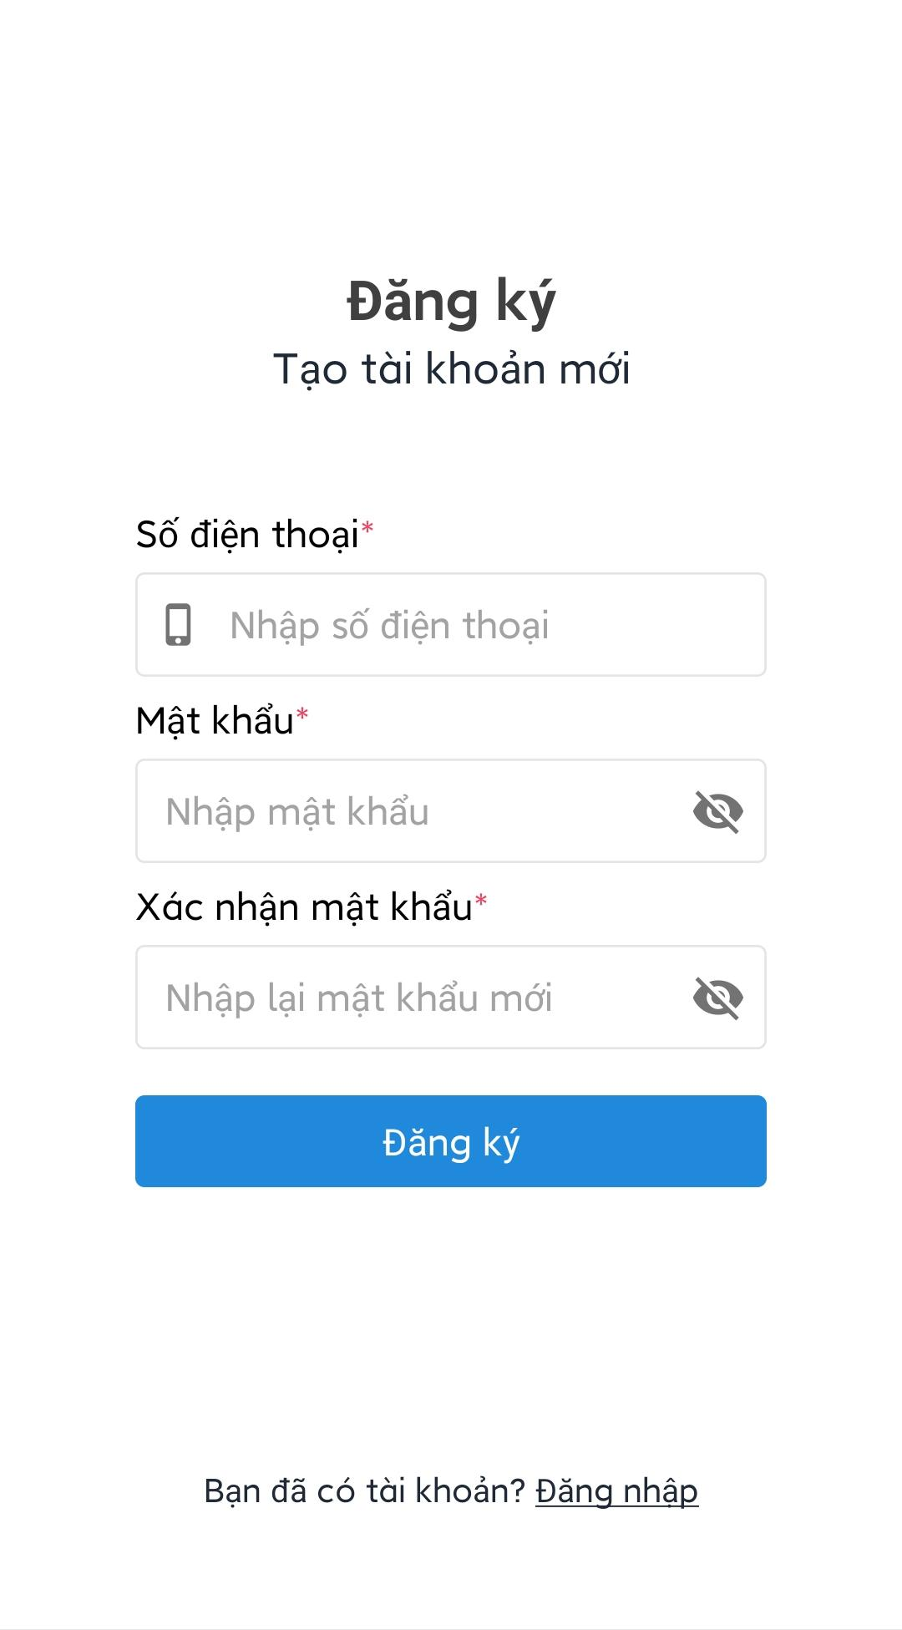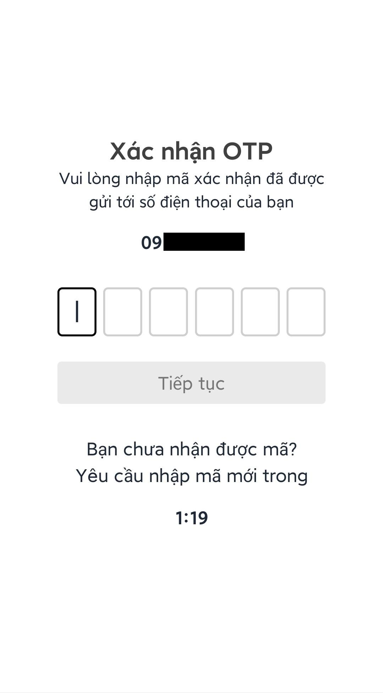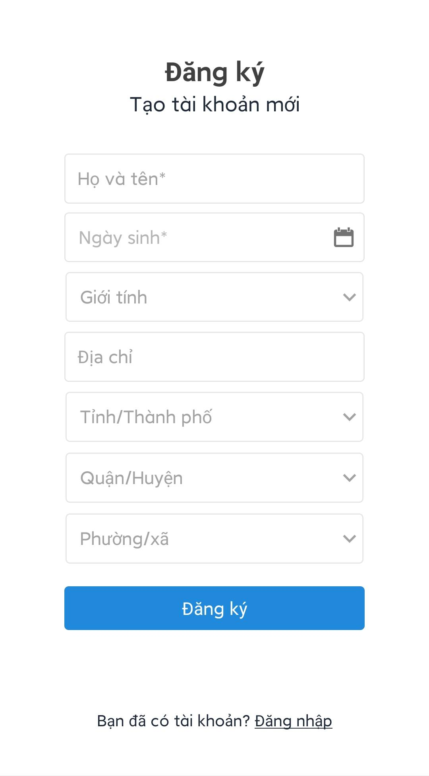

Figure 3.2.1. Register

### 3.3. User

#### 3.3.1. Login

* Open the application.
* Enter user credentials.
* Press “Đăng nhập”, after login successfully the screen will redirect to the main screen.

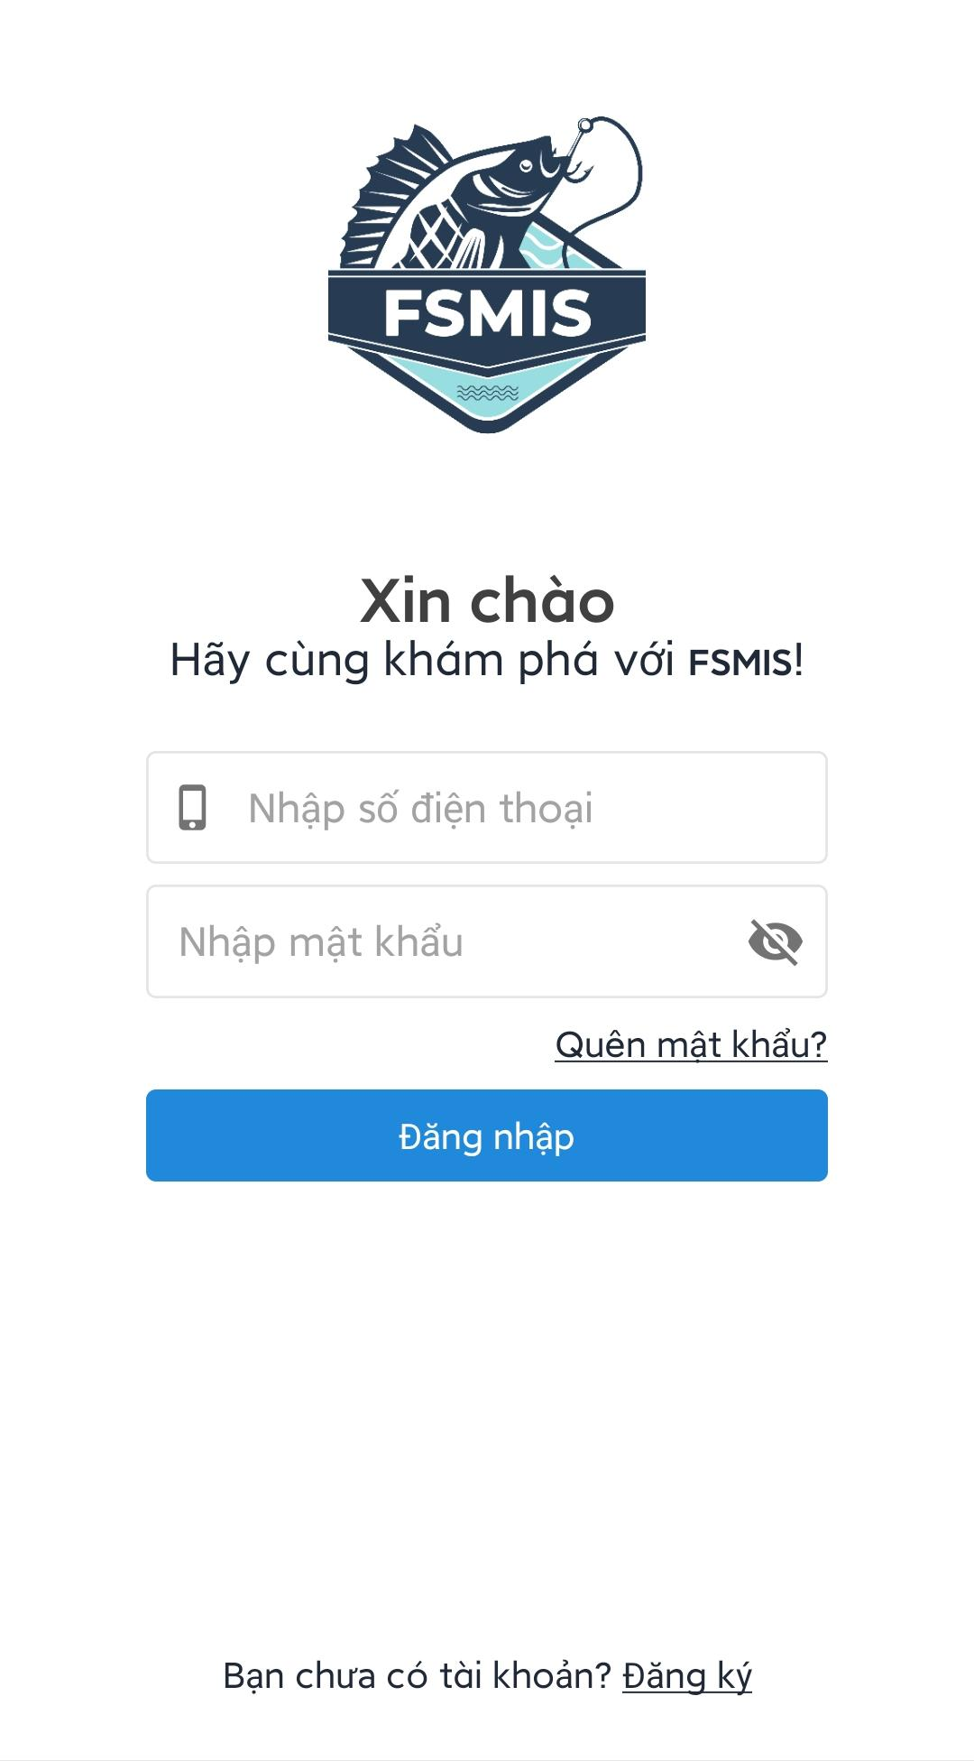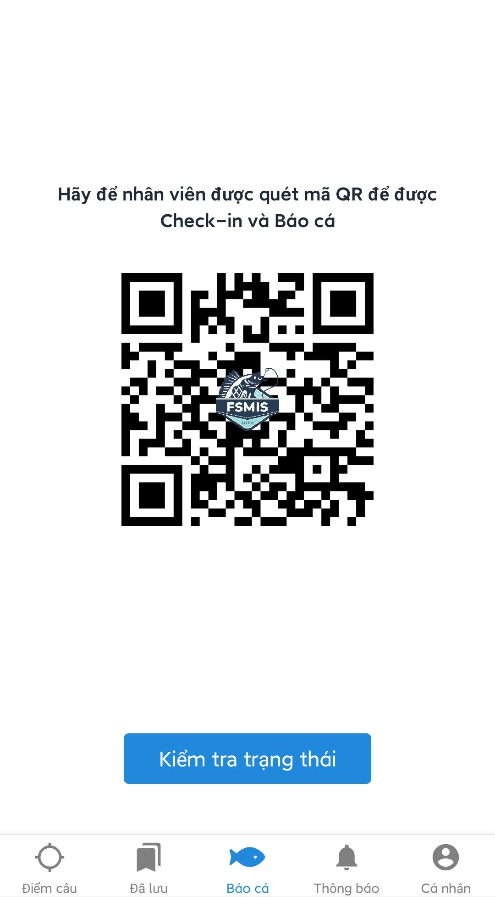

Figure 3.3.1. Login and main screen

#### 3.3.2. Reset password

* Open the application
* Press “Quên mật khẩu” at the middle of the screen, on top of “Đăng nhập” button, the screen will redirect to forgot password screen.
* Enter your phone number then press “Tiếp tục”, an OTP code will be sent to your phone number.
* Enter the code and press “Tiếp tục”, the screen will redirect you to the change password screen.
* Enter a new password, then press “Tiếp tục” to reset the account password.

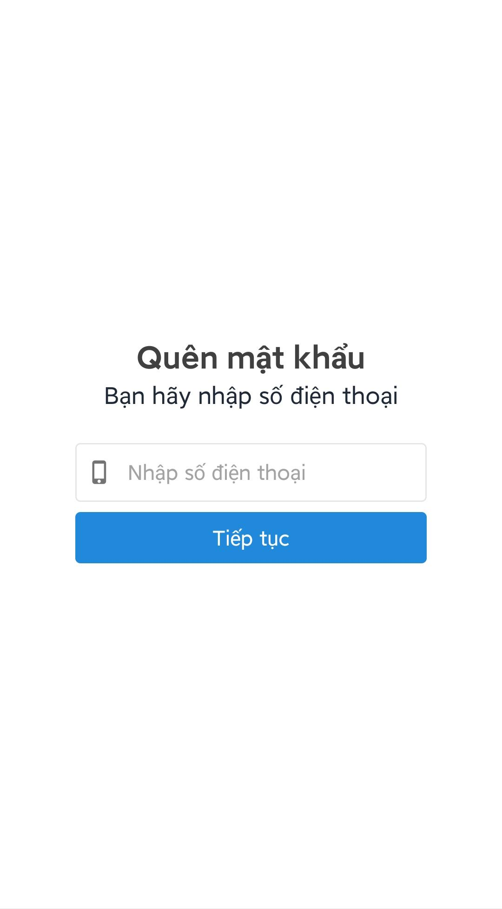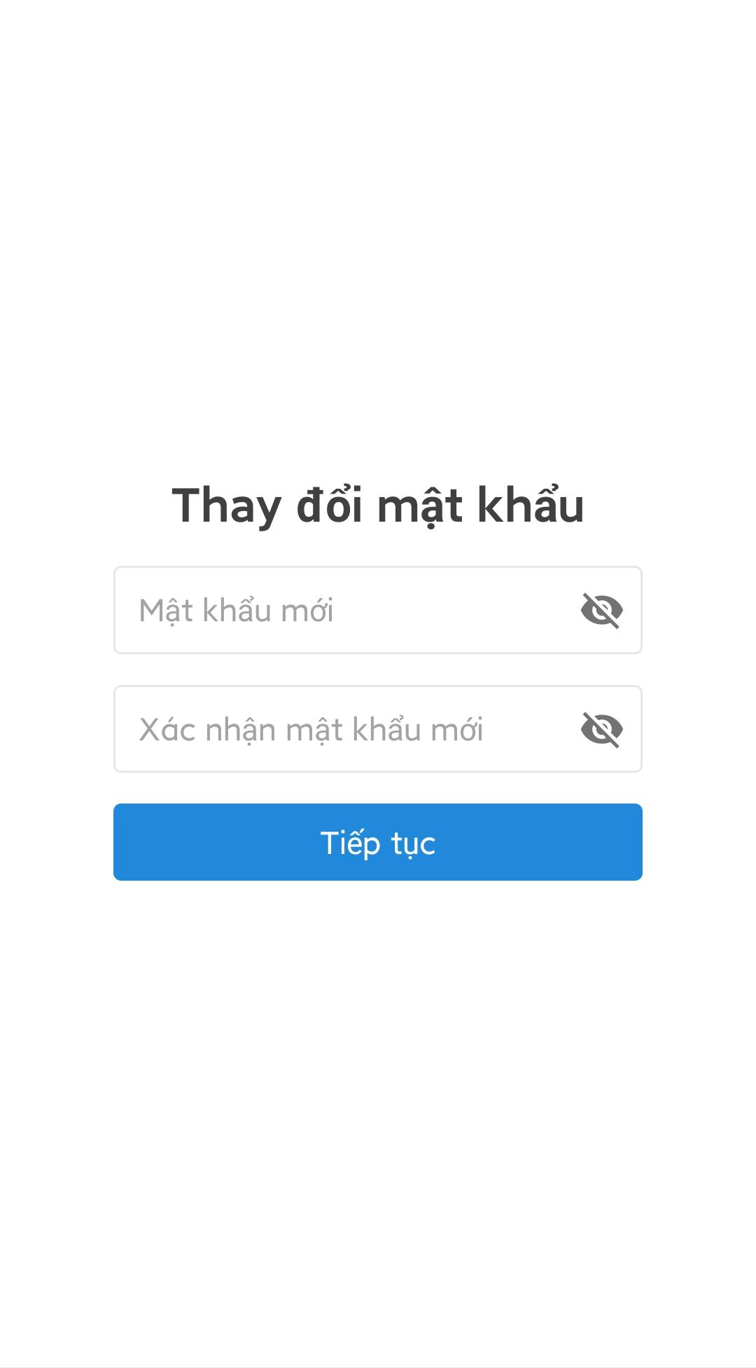

Figure 3.2.3. Reset password

#### 3.3.3. Search fishing location

* Access the main screen.
* Press “Điểm câu” tab at the bottom of the screen. The screen will redirect to the search fishing location screen.

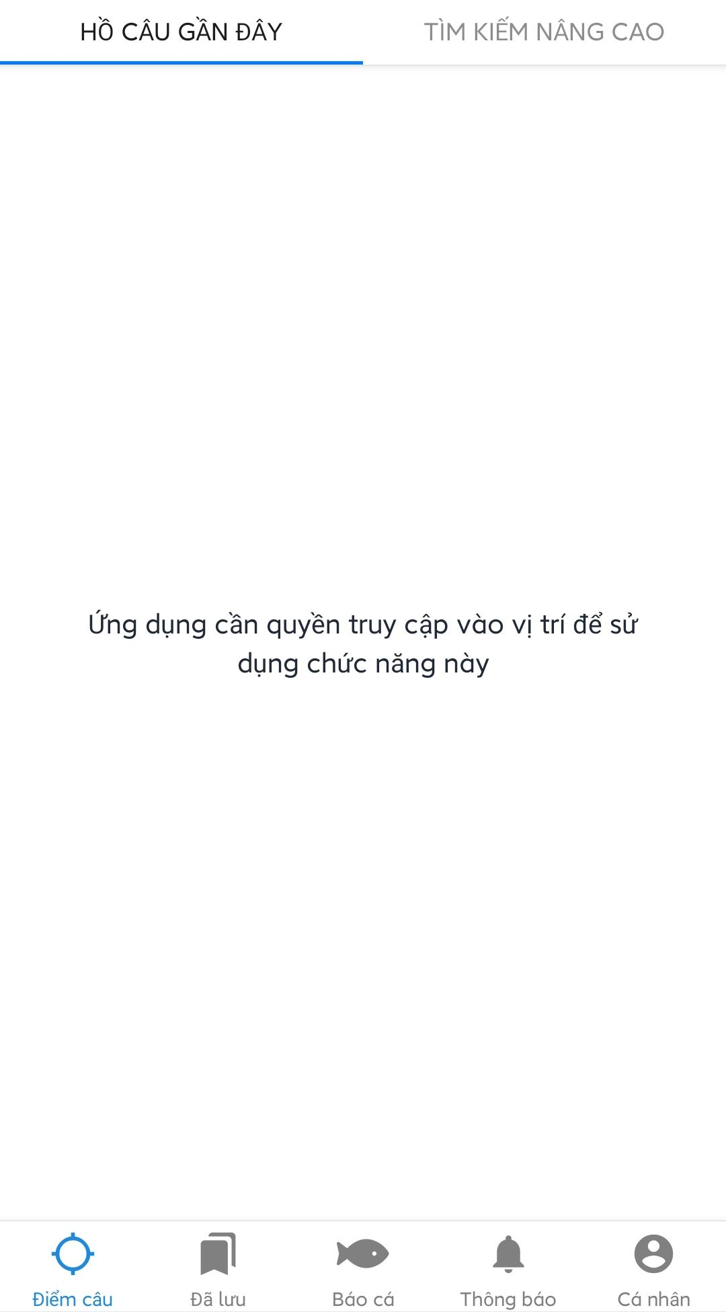

Figure 3.3.3. Go to search fishing location screen

##### 3.3.3.1. View, search and filter nearby fishing locations

* Open “Điểm câu” tab on the main screen.
* Press “Điểm câu gần đây” at the top of the screen
* Grant the application permission to access the user location.
* Press “Bộ lọc” to open filter options. Users can filter fishing locations by fishing method, rating, and radius from user coordinates.
* Press “Tìm kiếm” to search for all matched fishing locations. The application will display all matched locations on the map.
* **Note:** Users can press on a fishing location to view the details screen.

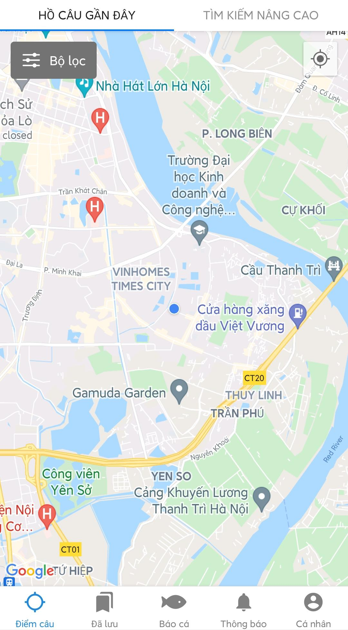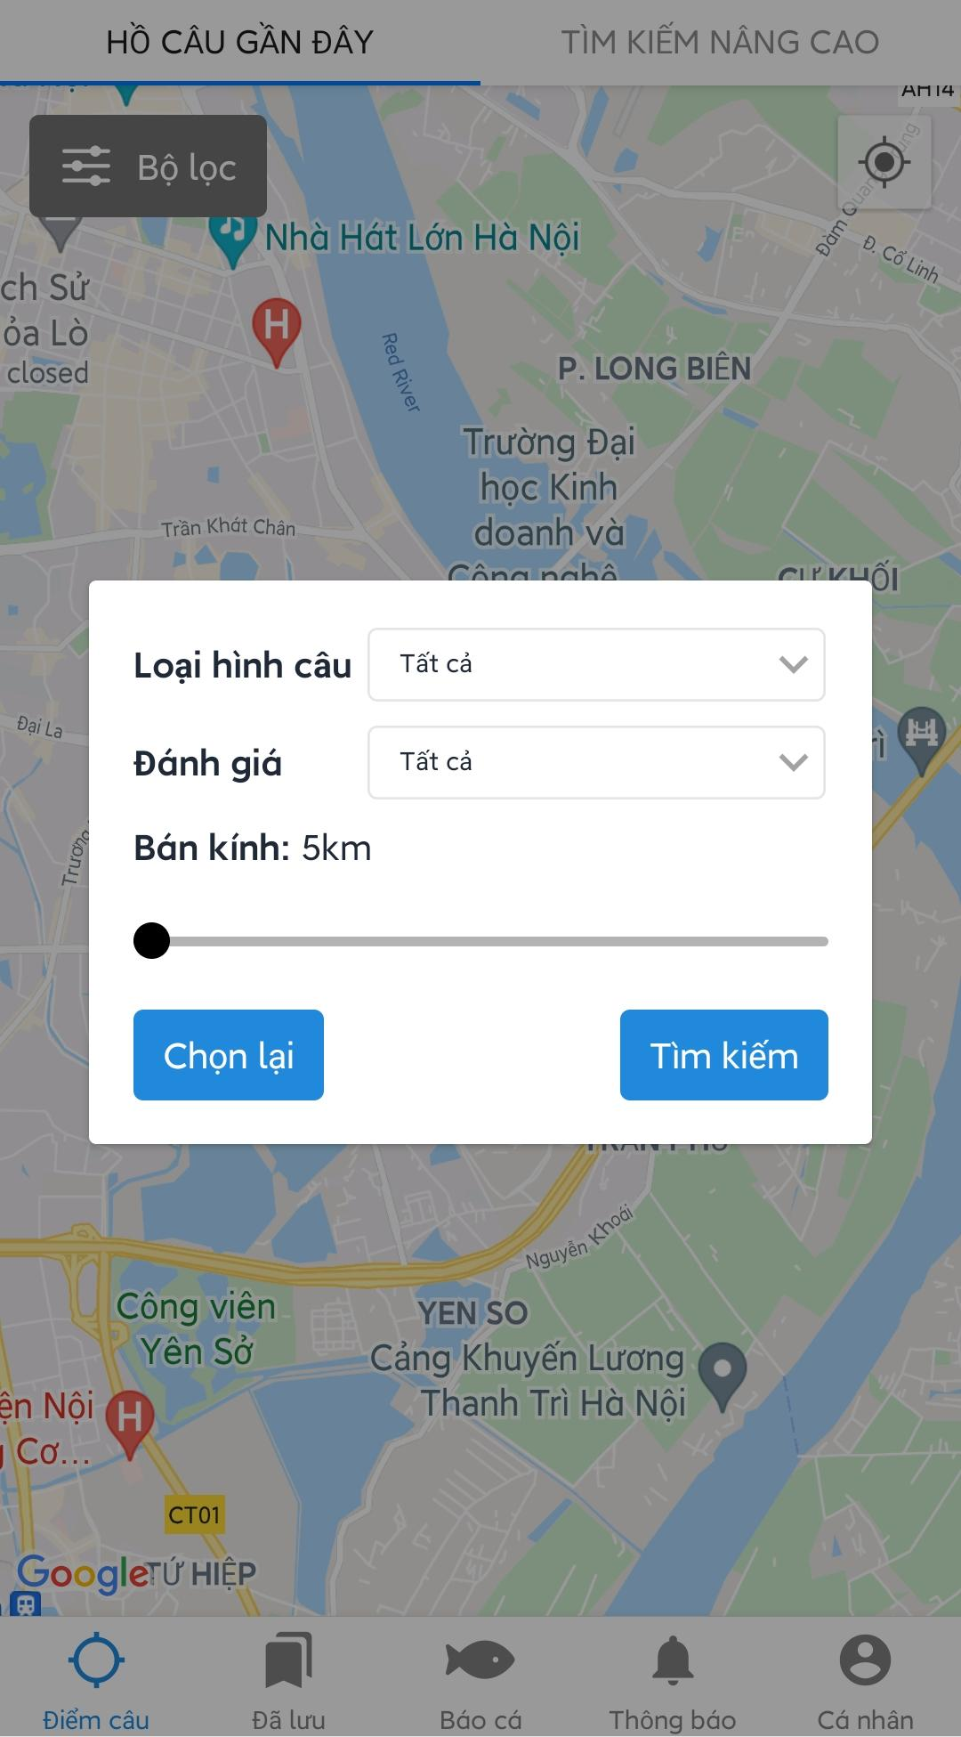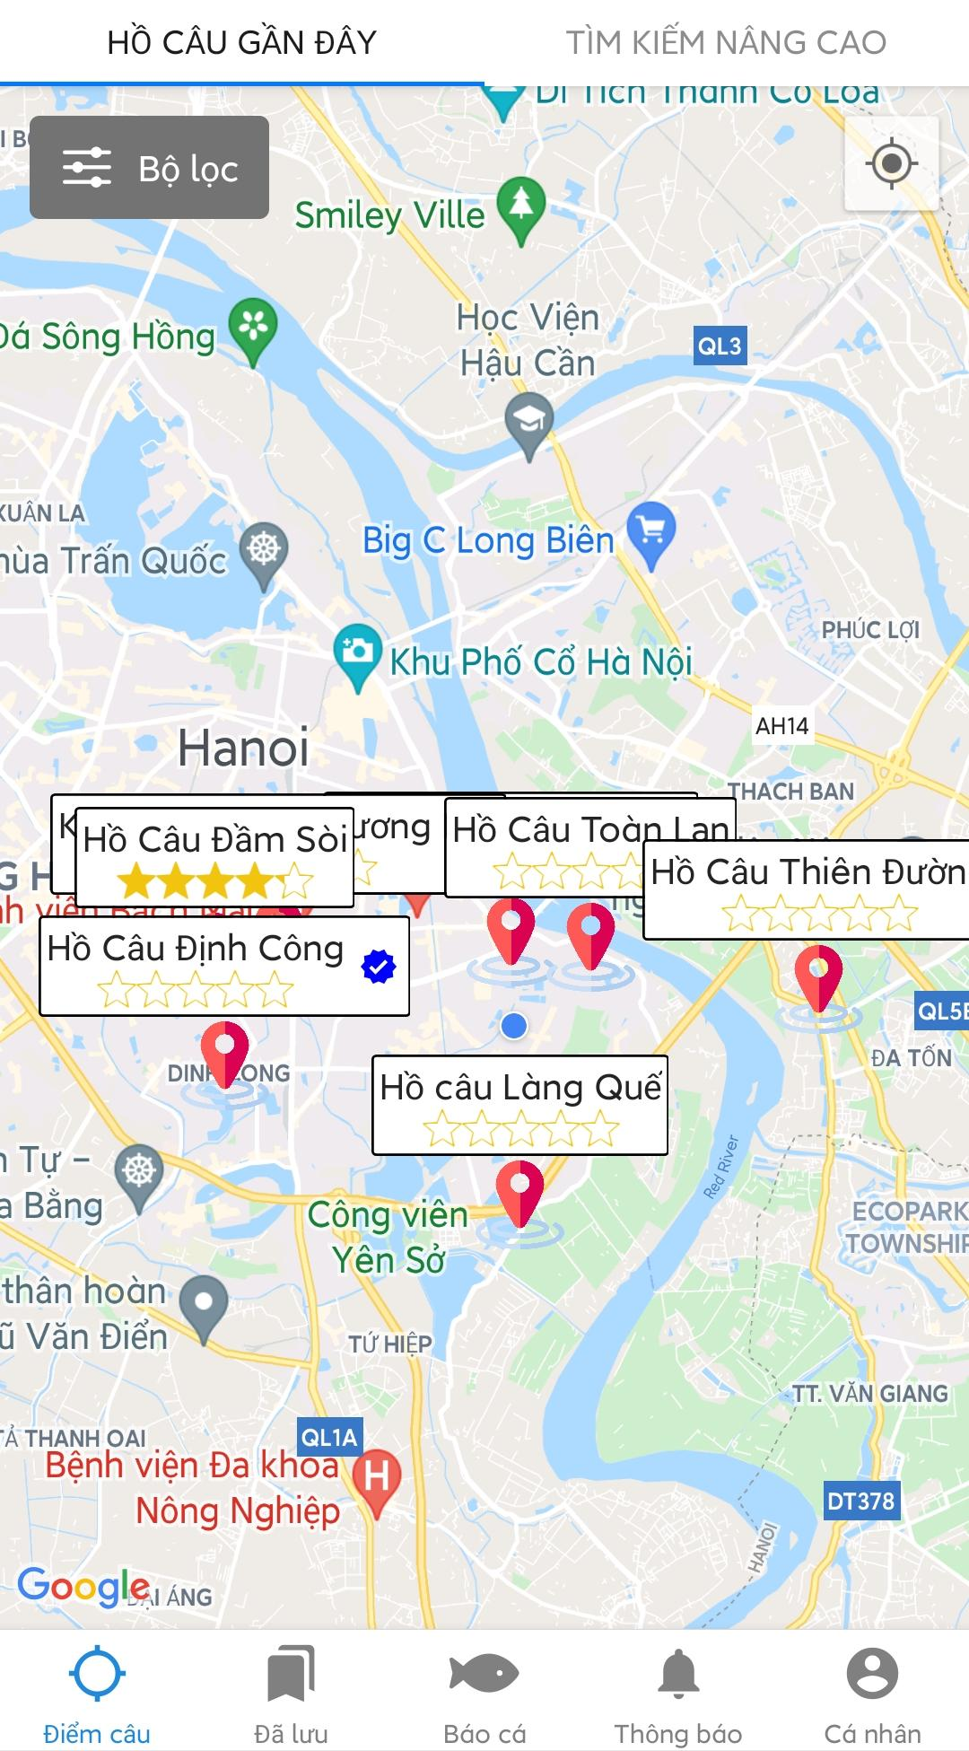

Figure 3.3.3.1: Search nearby fishing location with filter

##### 3.3.3.2. View, search, and filter all fishing locations

* Open “Điểm câu” tab on the main screen.
* Press “Tìm kiếm nâng cao” at the top of the screen to go to the list view screen.
* Press “Tìm kiếm” button to open the advanced search screen.
* Users can search fishing locations by keywords, province, fishing methods, types of fish, and rating.
* After choosing desired search options, press “Tìm kiếm” to search for matched fishing locations. The screen will redirect back to the list view screen and show all matched fishing locations.

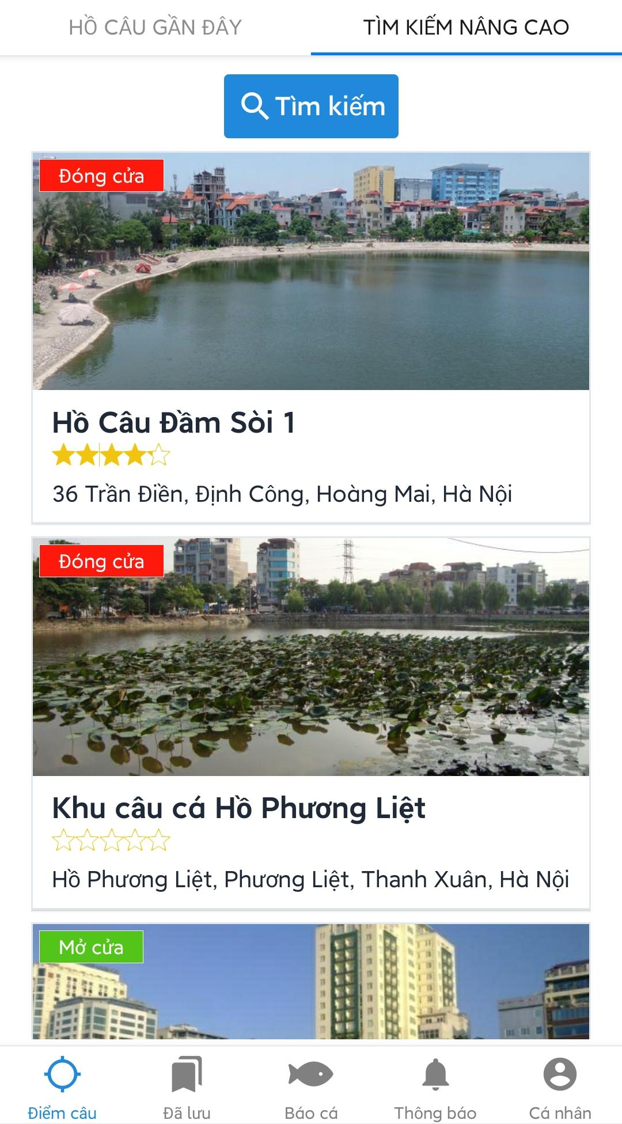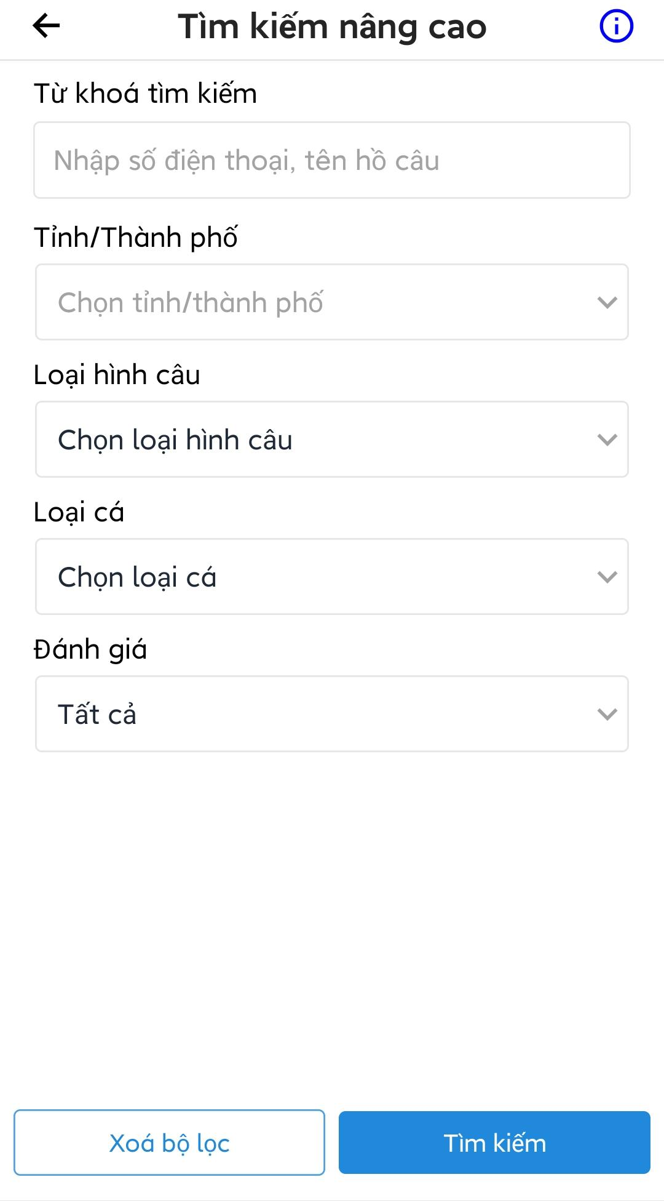

Figure 3.3.3.2. Advanced search

Note:

* Users can press  icon at the header to open suggest new fishing location screen.
* Users can choose multiple fishing methods and types of fishes.

Users can press on a fishing location to open fishing location detail screen.

#### 3.3.4. View fishing location detail

* Press on a fishing location on the map or the list. The application will open fishing location detail screen of the corresponding fishing location.

Note:

* Users can press on  icon at the header to open the report screen.
* Users can swipe right or left to change tab (“Thông tin”, “Loại hồ”, “Đánh giá”, “Sự kiện”).

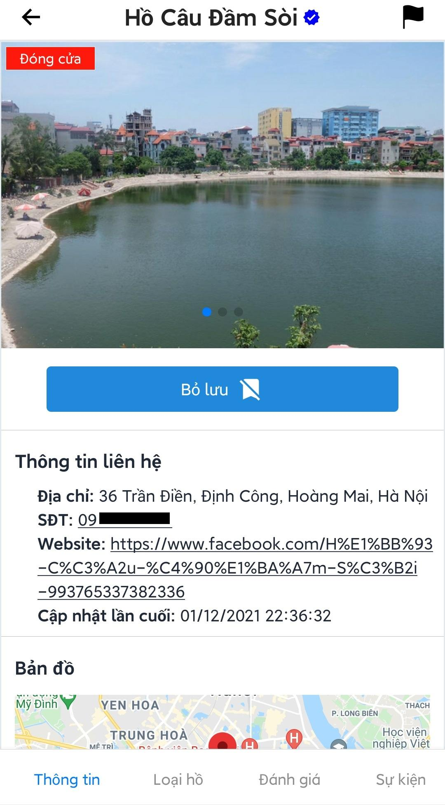

Figure 3.3.4. Fishing location’s details

##### 3.3.4.1. View overview information of the fishing location

* Open the fishing location detail screen.
* Press “Thông tin” tab at the bottom of the screen, the overview information screen will be displayed.

Note:

* Users can press “Lưu”/”Bỏ lưu” button to save or unsave fishing location. (See 3.3.5)
* Users can press 2 buttons at the bottom right corner of the map to open Google Maps to show direction to a fishing location or the position of the fishing location on the map.

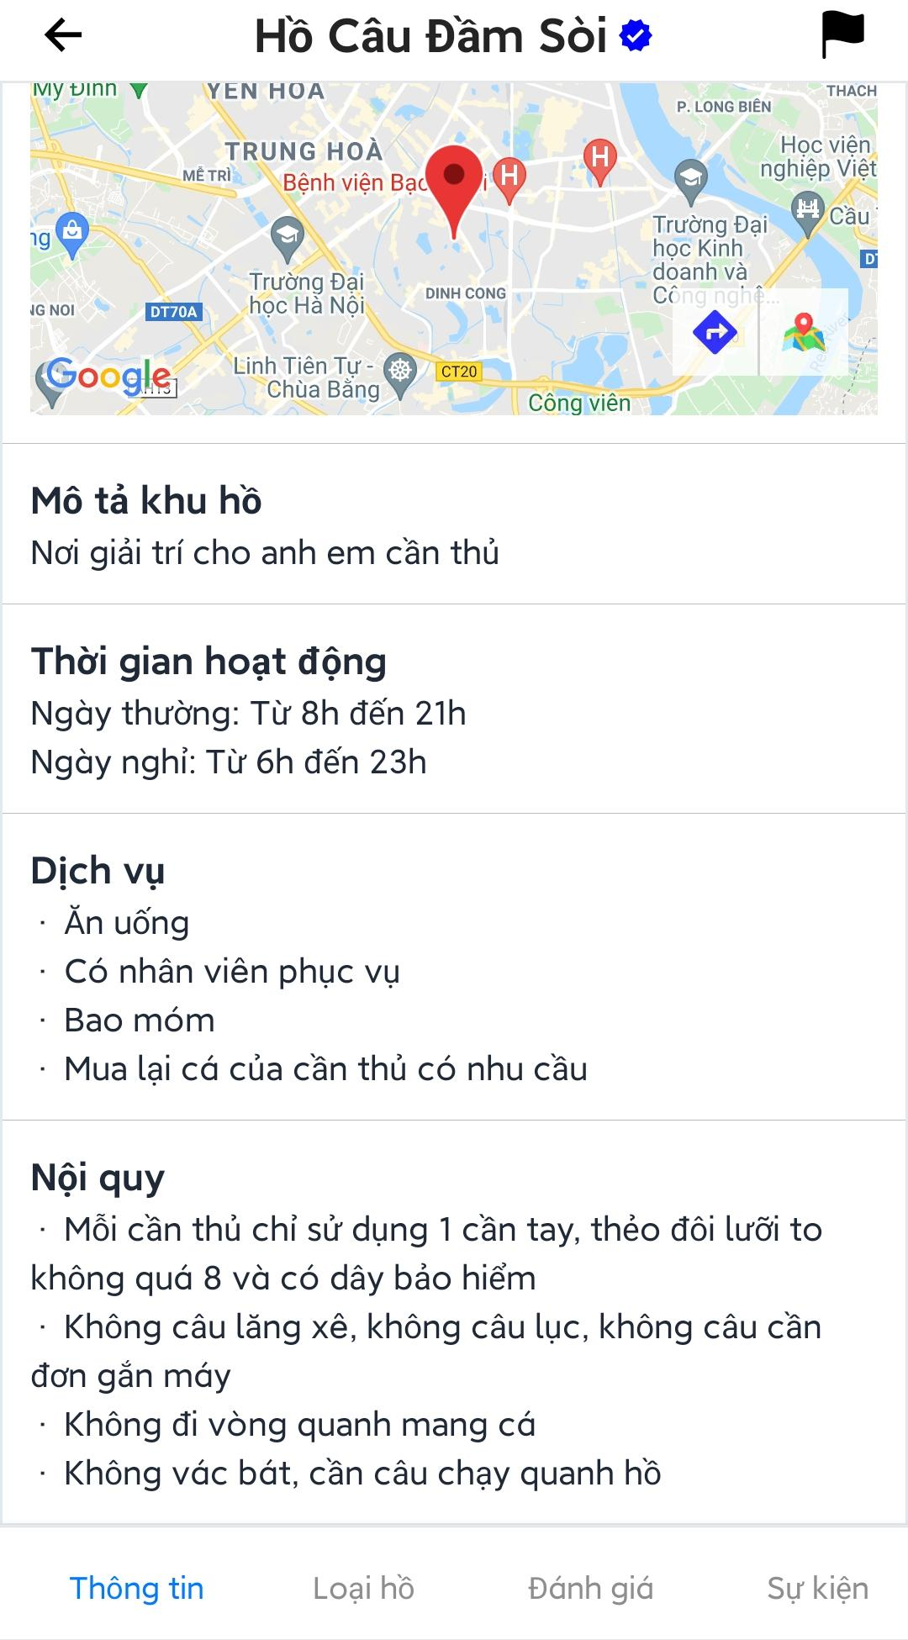

Figure 3.3.4.1. Fishing location’s overview

##### 3.3.4.2. View lake of the fishing location

* Open the fishing location detail screen.
* Press “Loại hồ” tab at the bottom of the screen, list of all lakes of the fishing location will be displayed.
* Press on a lake to open the lake detail screen.

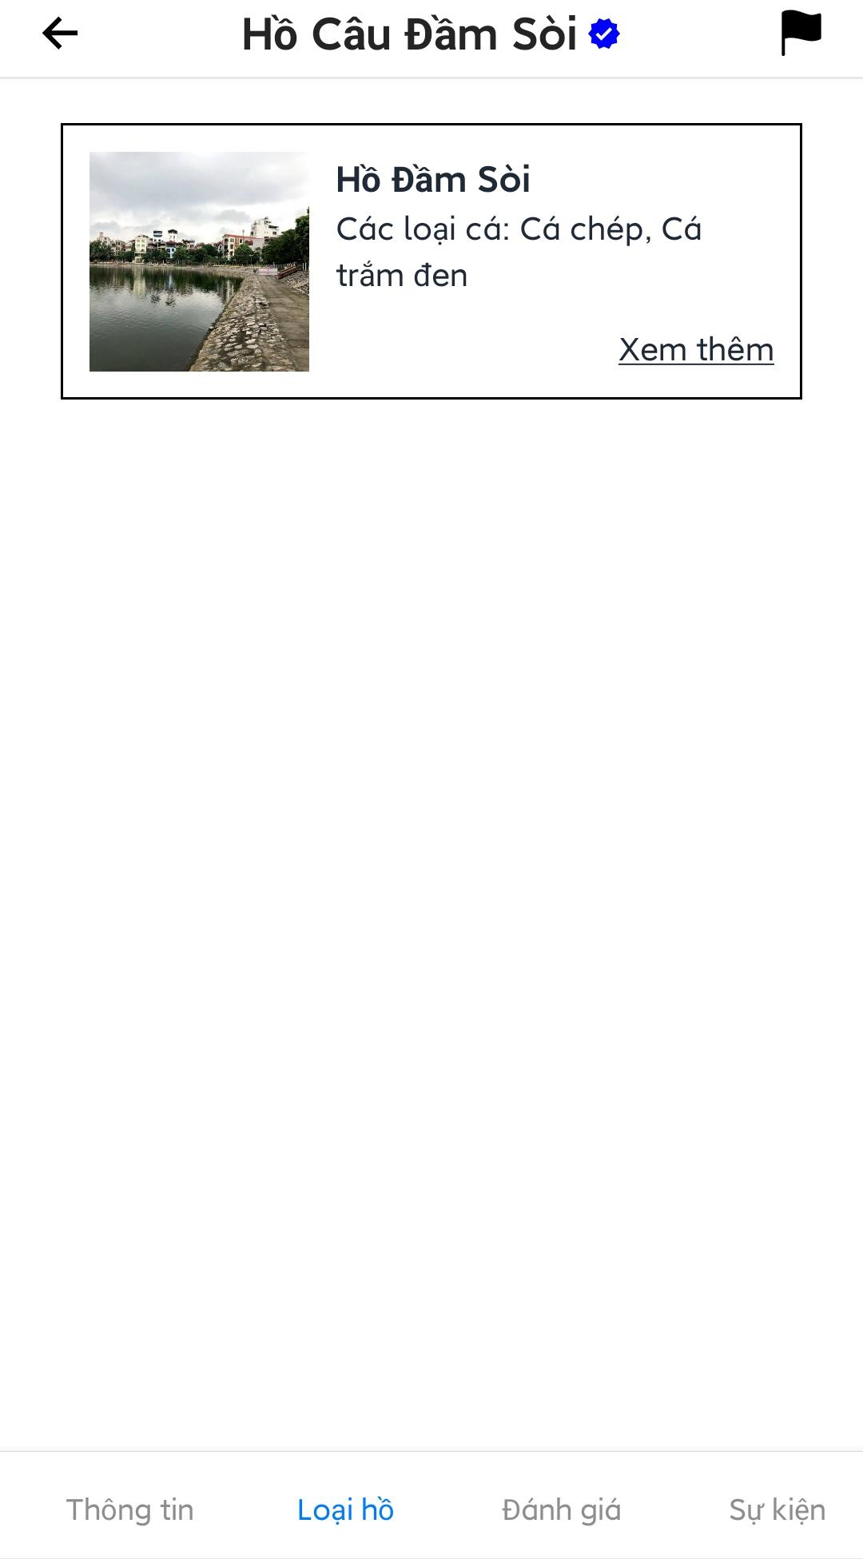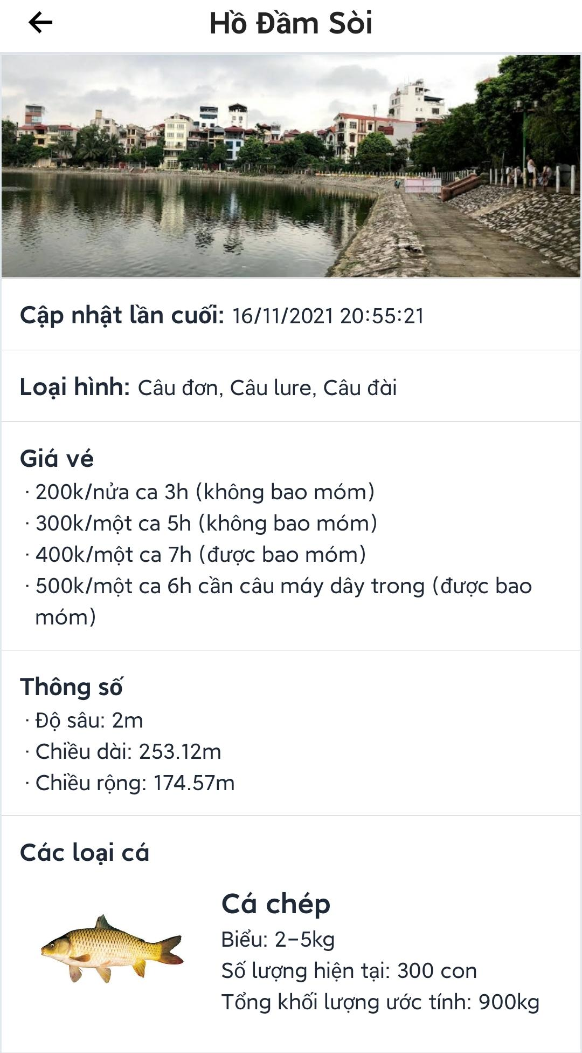

Figure 3.3.4.2. Fishing location’s lake details

##### 3.3.4.3. View list of reviews and post a review

* Open fishing location detail screen
* Press the “Đánh giá” tab at the bottom of the screen. The screen will display review data of the fishing location containing average review score, user personal review, and list of reviews.
* Users can press the “Đăng đánh giá” button to post a review. User can delete personal review to post a new one.
* User can filter the review list by newest, highest/lowest rate.

Note:

* Users can press on the  icon at each of the review to report that review.
* If users haven’t checked in that fishing location, the “Đăng đánh giá” button won’t be shown.

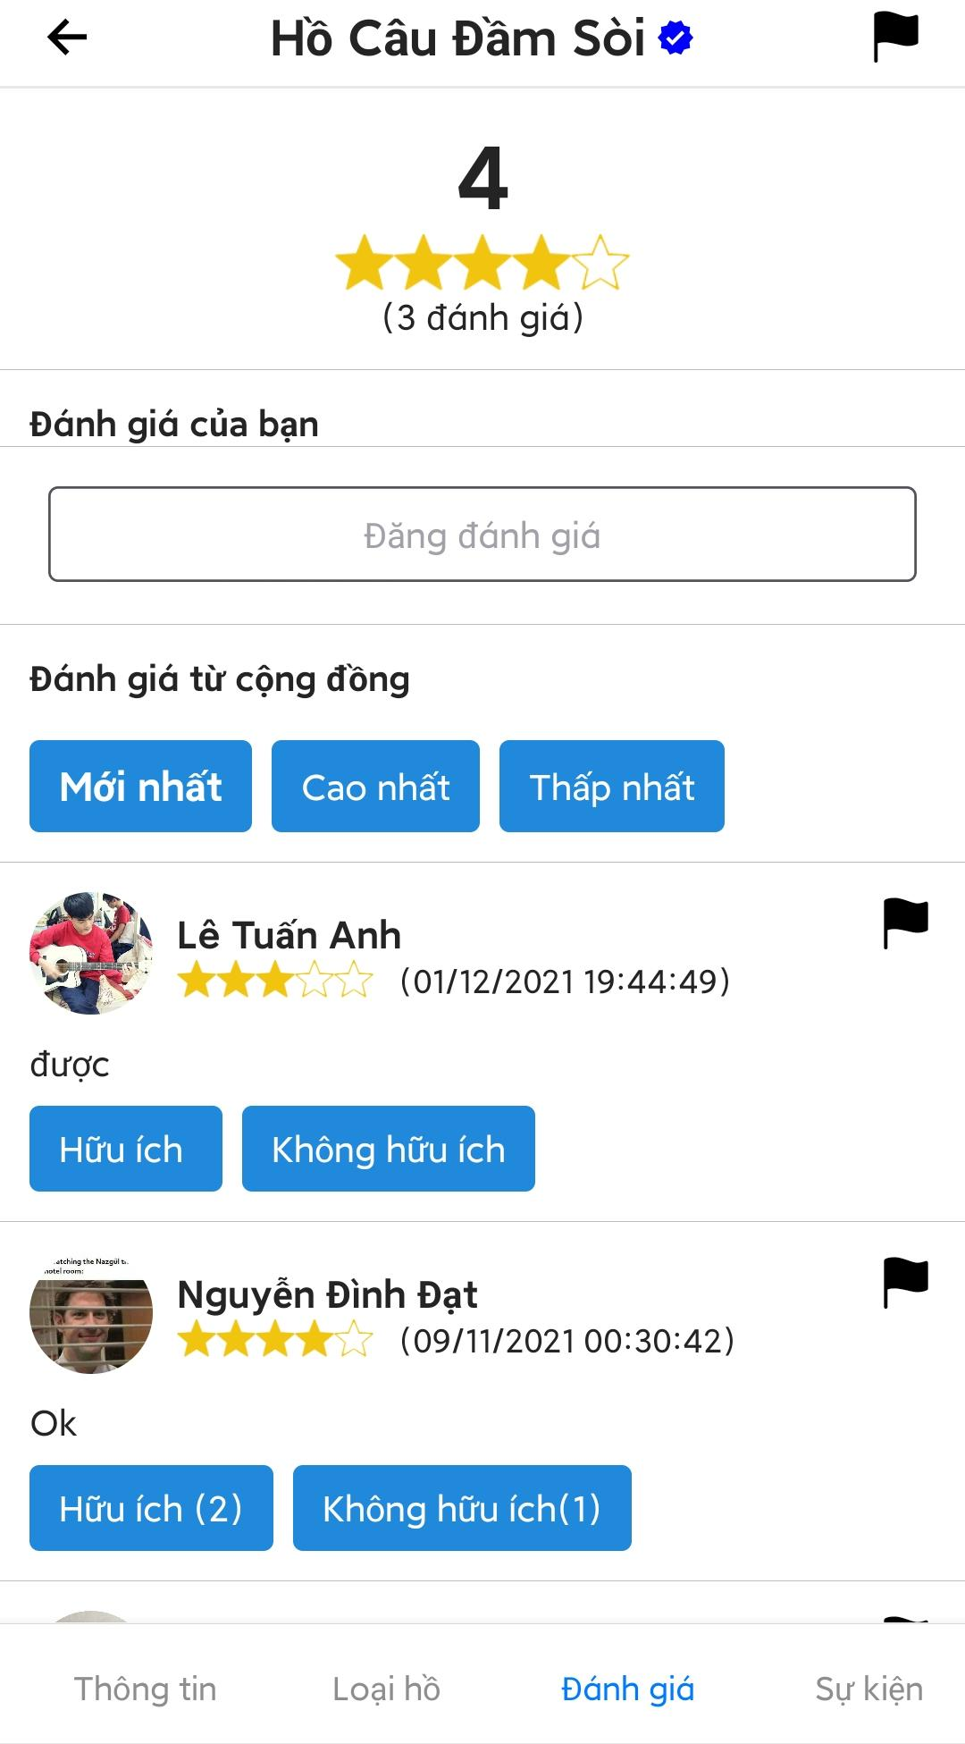

Figure 3.3.4.3. Fishing location’s reviews

###### 3.3.4.3.1. Post a review

* Open the review tab of the fishing location detail.
* Press on the “Đăng đánh giá” button to open write review screen.
* Enter review and choose a score then press “Đăng” to post a review to the fishing location.

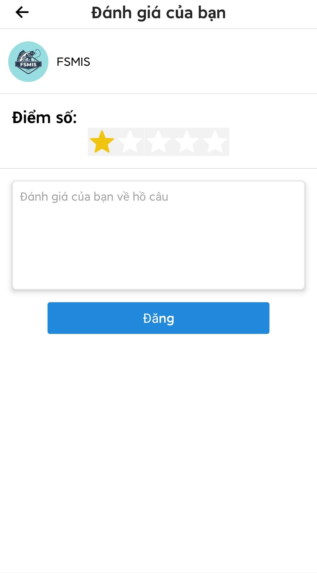

Figure 3.3.4.3.1. Review’s form

##### 3.3.4.4. View posts and catch reports of the fishing location

* Open fishing location detail screen.
* Press the “Sự kiện” tab at the bottom of the screen to view events of the fishing location.
* Users can choose to view posts of the fishing location or catch reports of angler fishing at the fishing location.

Note: User can press on the  icon to report a post or catch report.

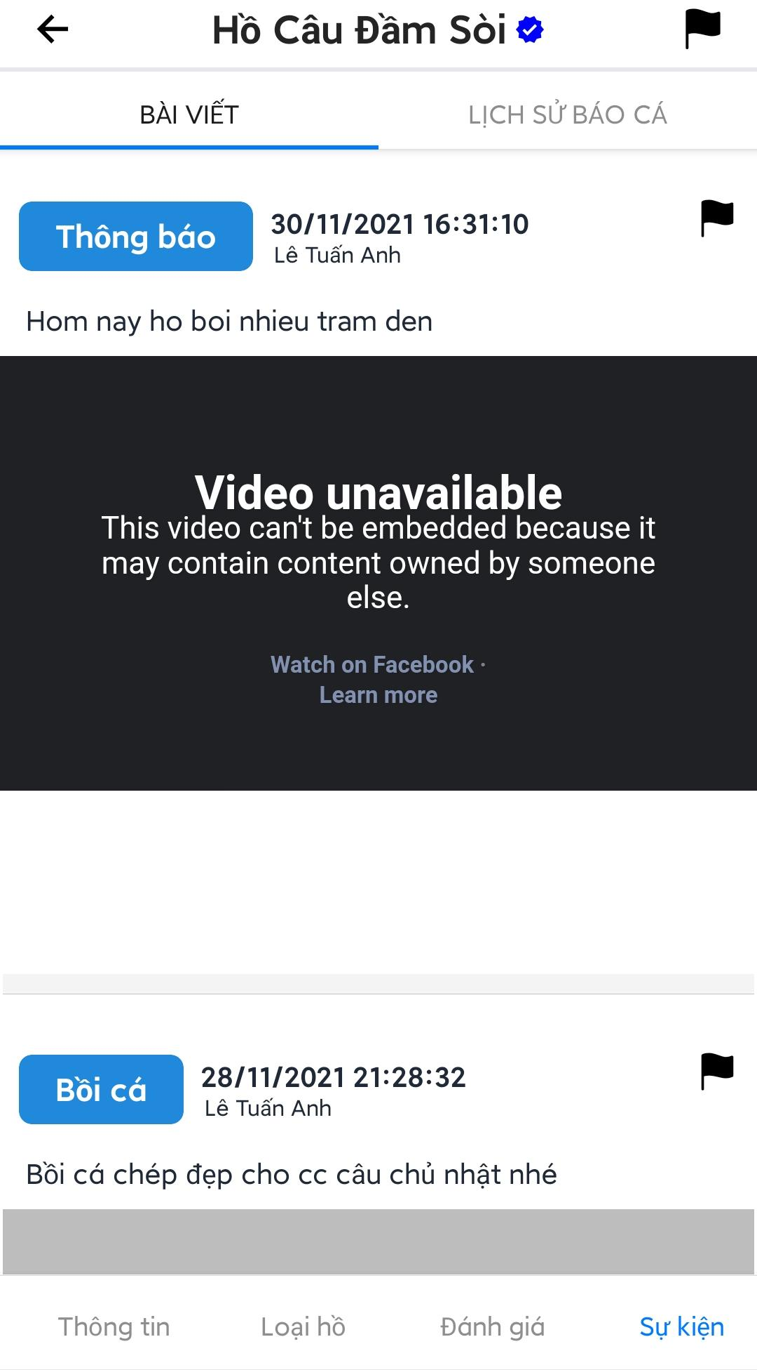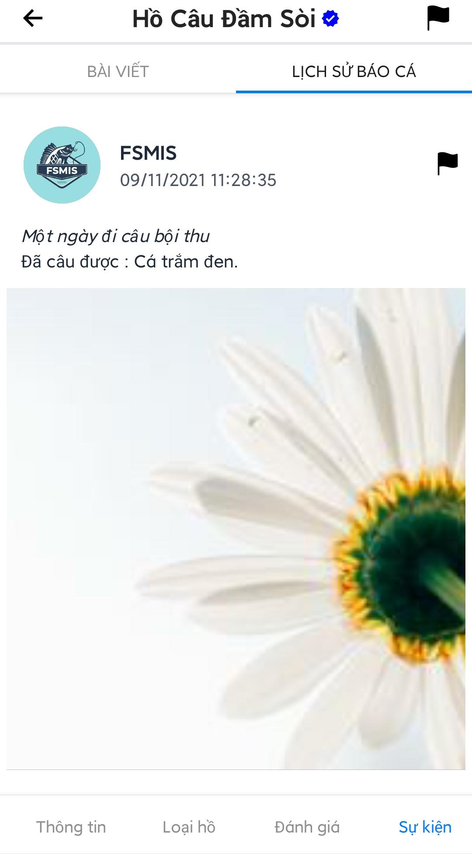

Figure 3.3.4.4. Fishing location’s post and public catch reports

#### 3.3.5. Save/Unsave a fishing location and view saved fishing location list

##### 3.3.5.1. Save/Unsave a fishing location

* Open a fishing location detail screen.
* Press “Lưu điểm câu” to save the fishing location, or press “Bỏ lưu” to unsave the fishing location.

Note: Users can receive notifications about saved fishing locations.

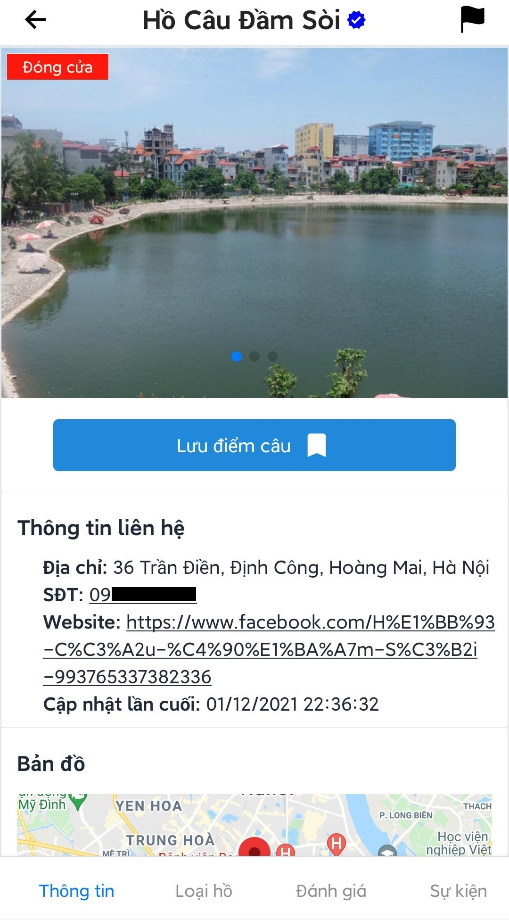

Figure 3.3.5.1. Save/Unsave fishing location

##### 3.3.5.2. View list of saved fishing locations

* Open the main screen.
* Press “Điểm câu” tab to view list of saved fishing locations.

Note: Users can press on a fishing location to open detail screen. (See 3.3.4)

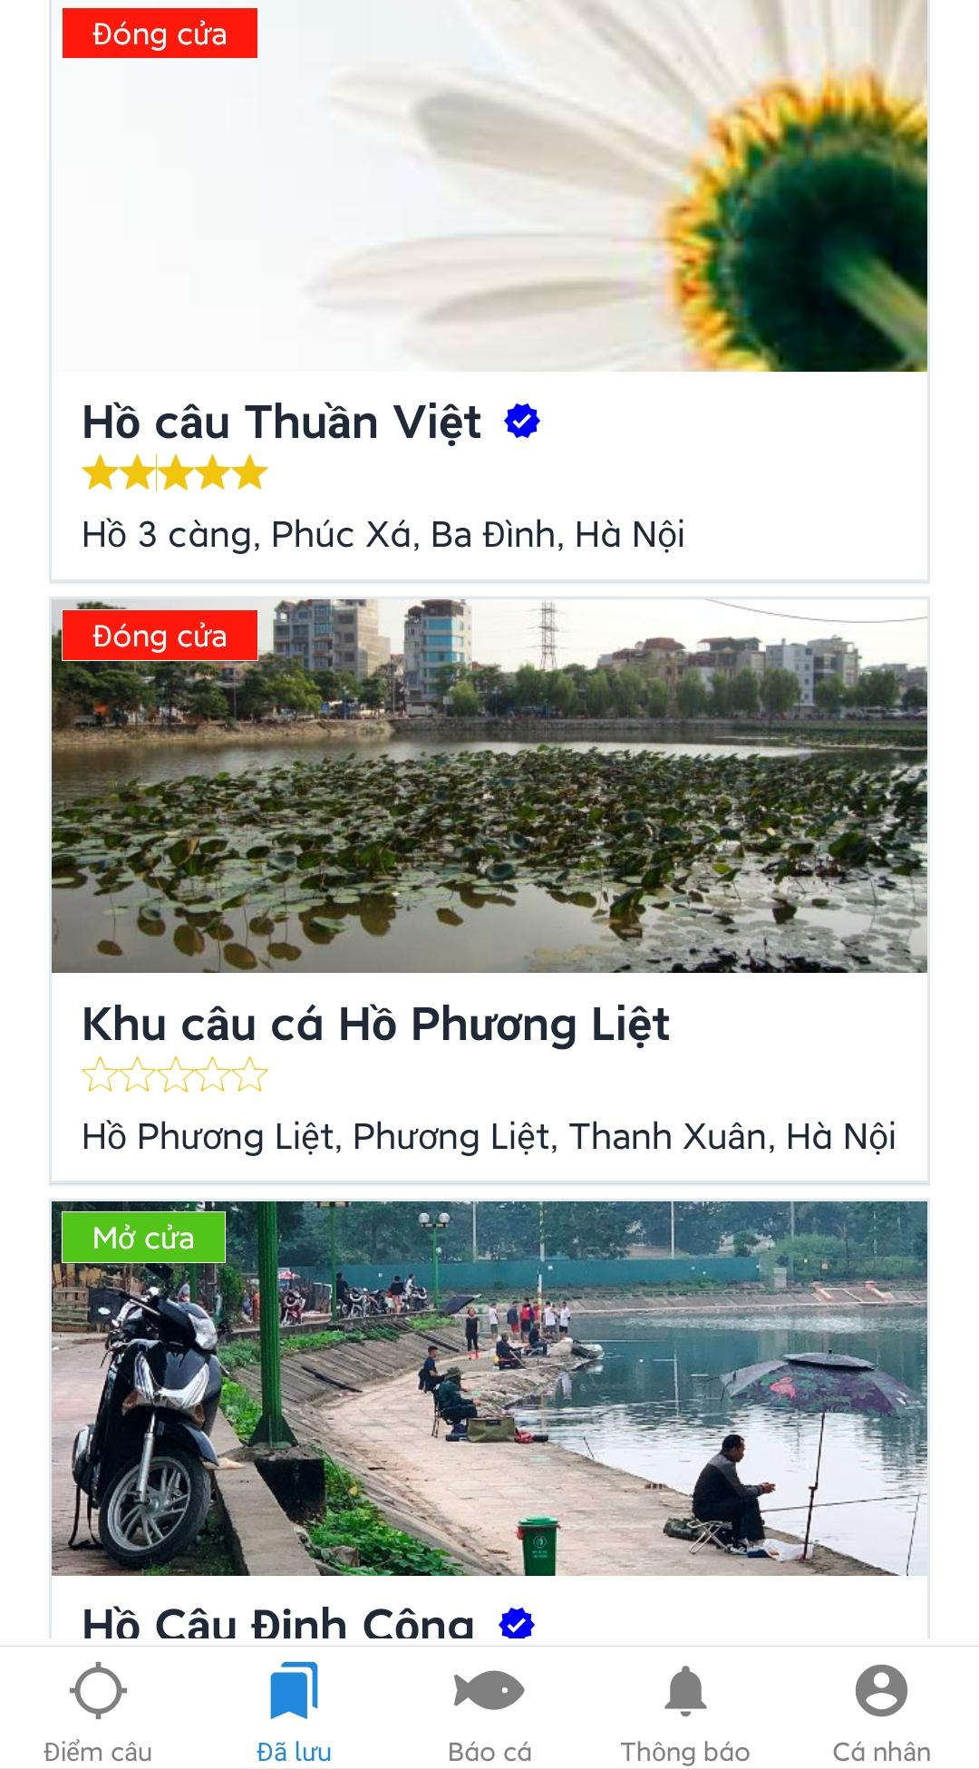

Figure 3.3.5.2. Saved fishing location list

#### 3.3.6. View notifications

* Open the main screen.
* Press “Thông báo” tab at the bottom of the screen, the screen will navigate to list of notifications screen.

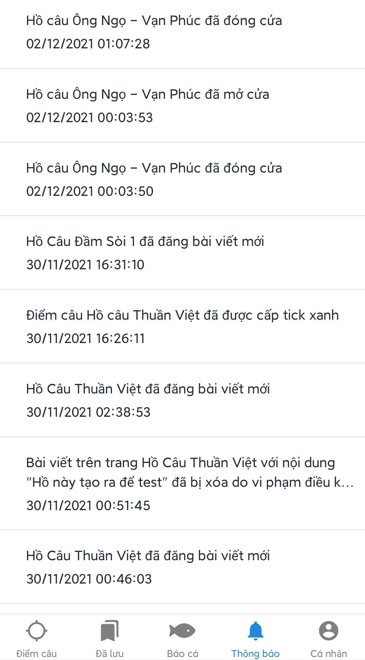

Figure 3.3.6. Notification screen

#### 3.3.7. Write report

* Press the  icon in the location detail screen, on a review, or on a post to open write report screen.
* Fill in the form then press “Báo cáo” to send report to admin.

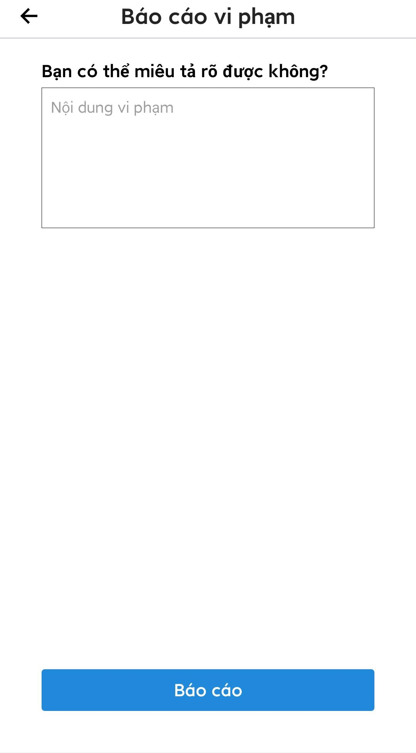

Figure 3.3.7. Report’s form

#### 3.3.8. View personal check-in history

* Open main screen.
* Press “Cá nhân” tab at the bottom of the screen to open the menu screen.
* Press “Lịch sử Check-in”, the screen will navigate to personal check-in history screen.

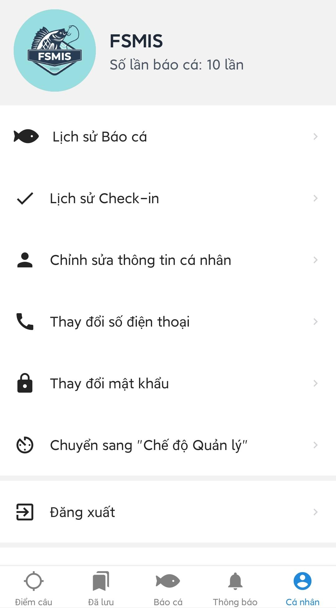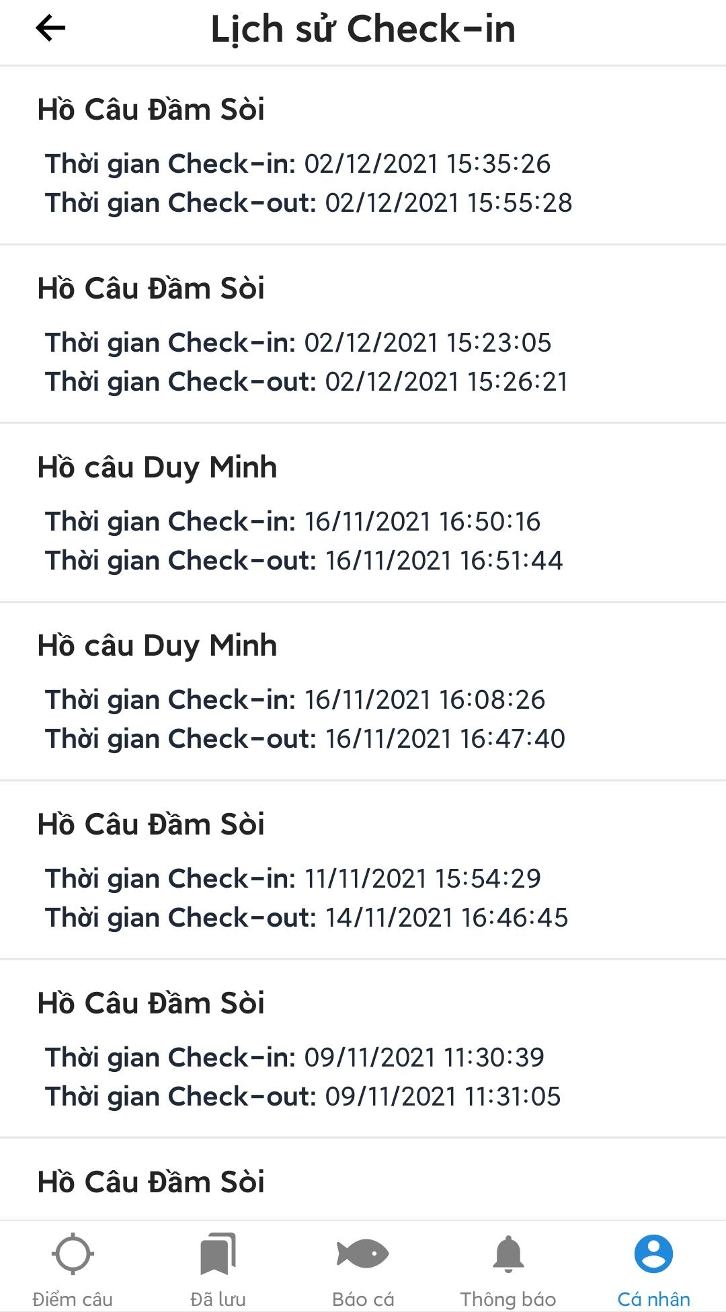

Figure 3.3.8. Personal check-in history

#### 3.3.9. View personal catch reports

* Open the menu screen by pressing the “Cá nhân” tab at the bottom of the main screen.
* Press “Lịch sử báo cá” to view personal catch reports history screen.
* Press on a catch report to view catch report detail.

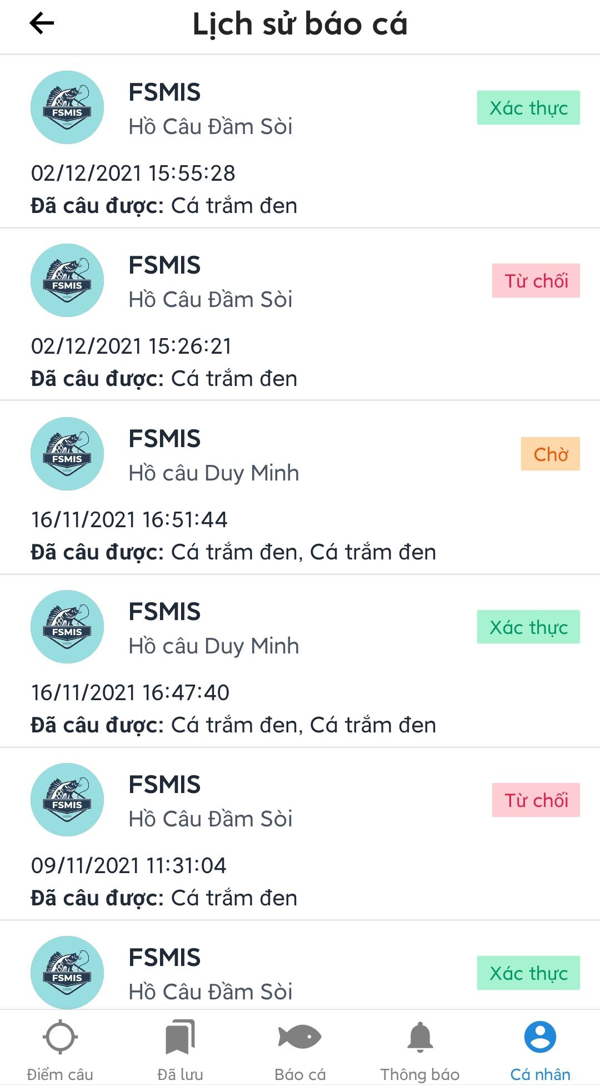

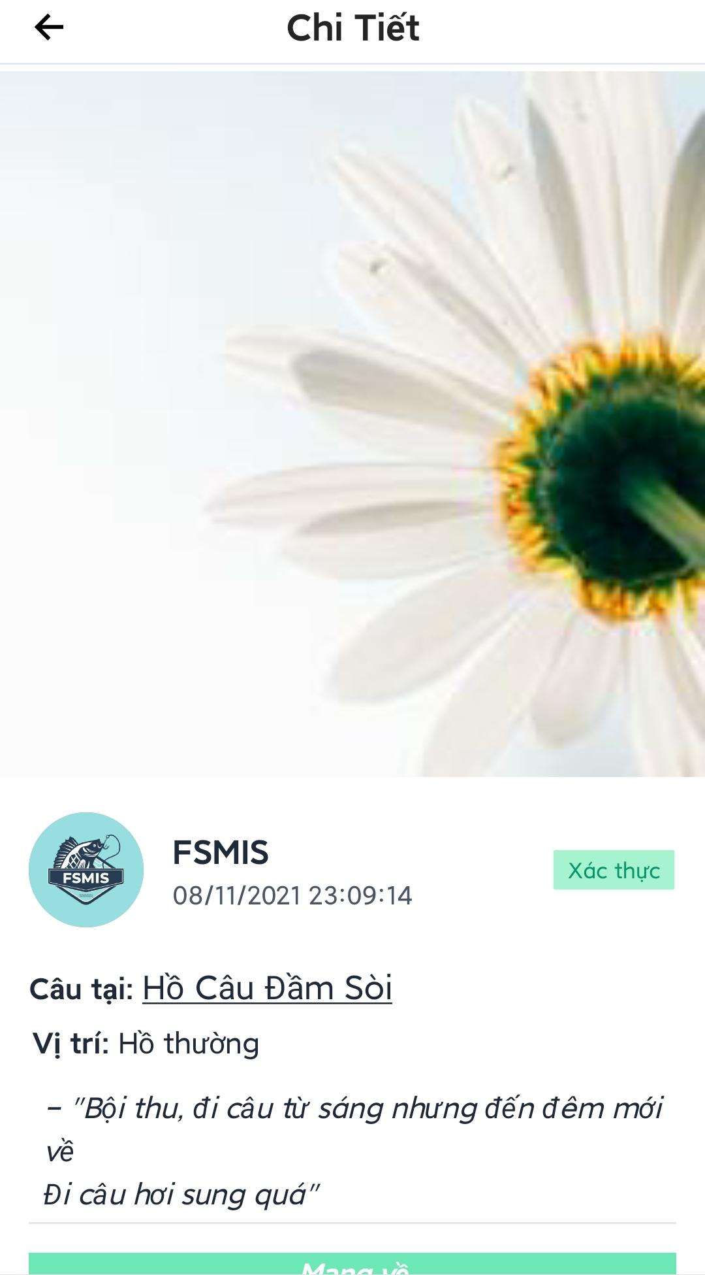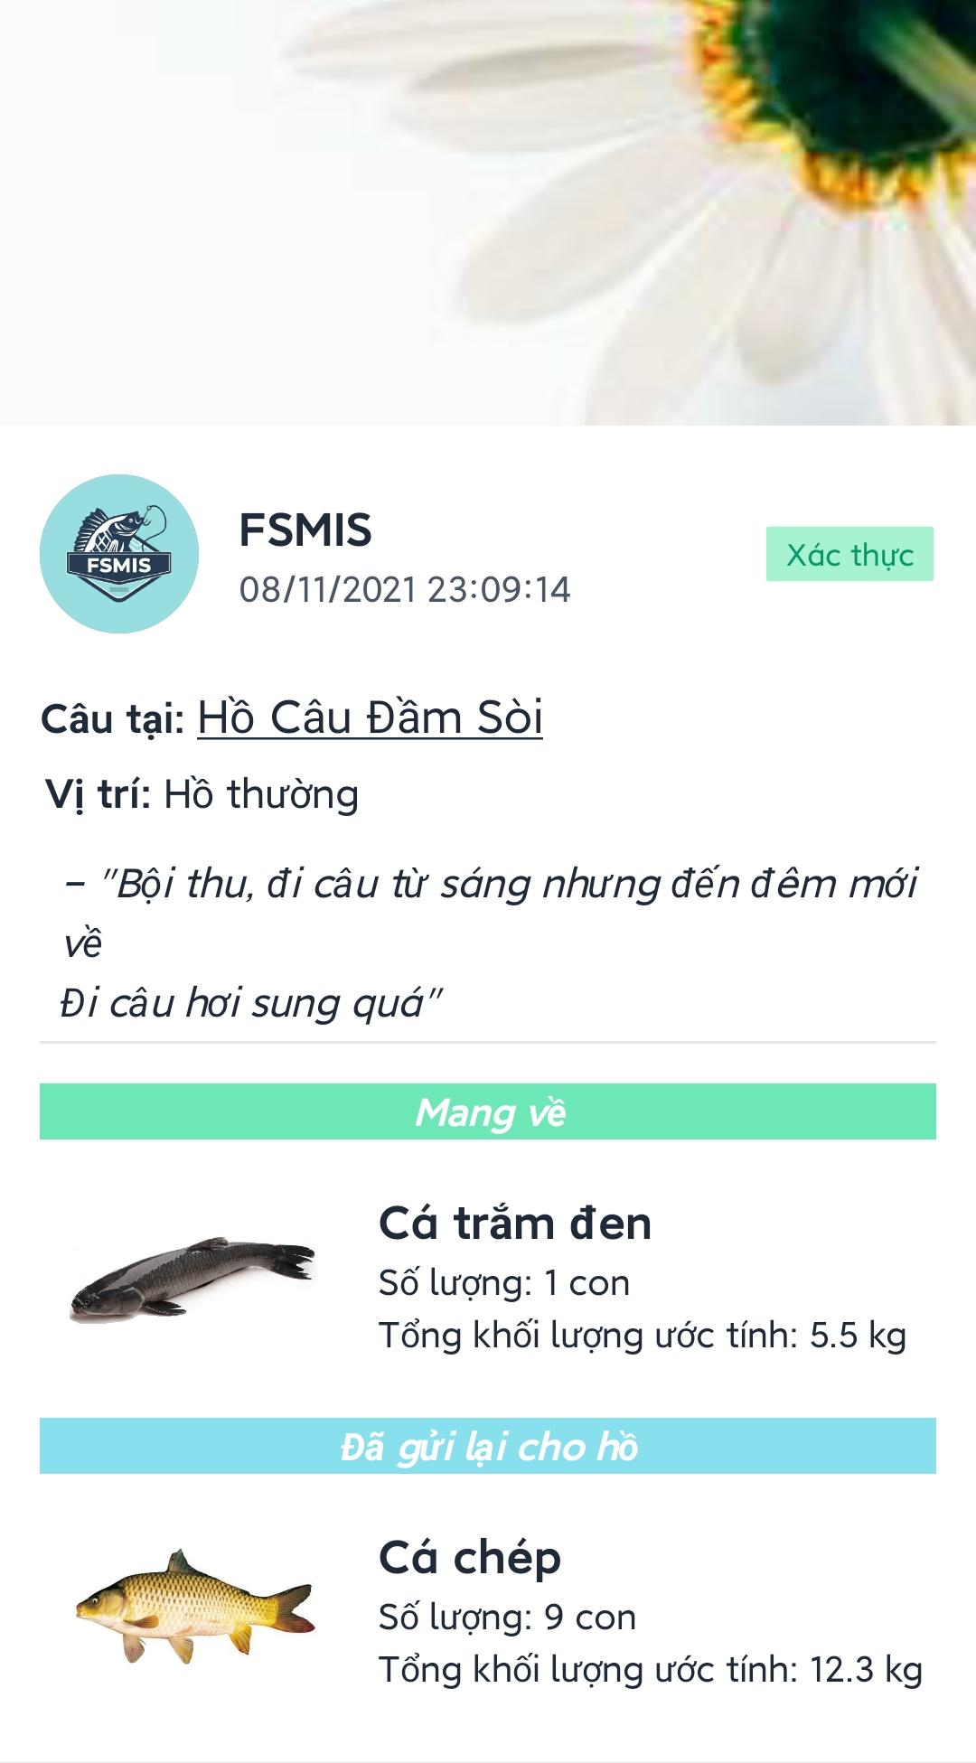

Figure 3.3.9. Personal catch reports

#### 3.3.10. Edit personal information

* Open the personal menu screen by pressing the “Cá nhân” tab at the main screen.
* Press “Chỉnh sửa thông tin cá nhân” to open edit profile screen.
* Users can change profile image by pressing the image to choose an image from user device.
* Edit data in the form then press “Lưu thay đổi” to save new information.

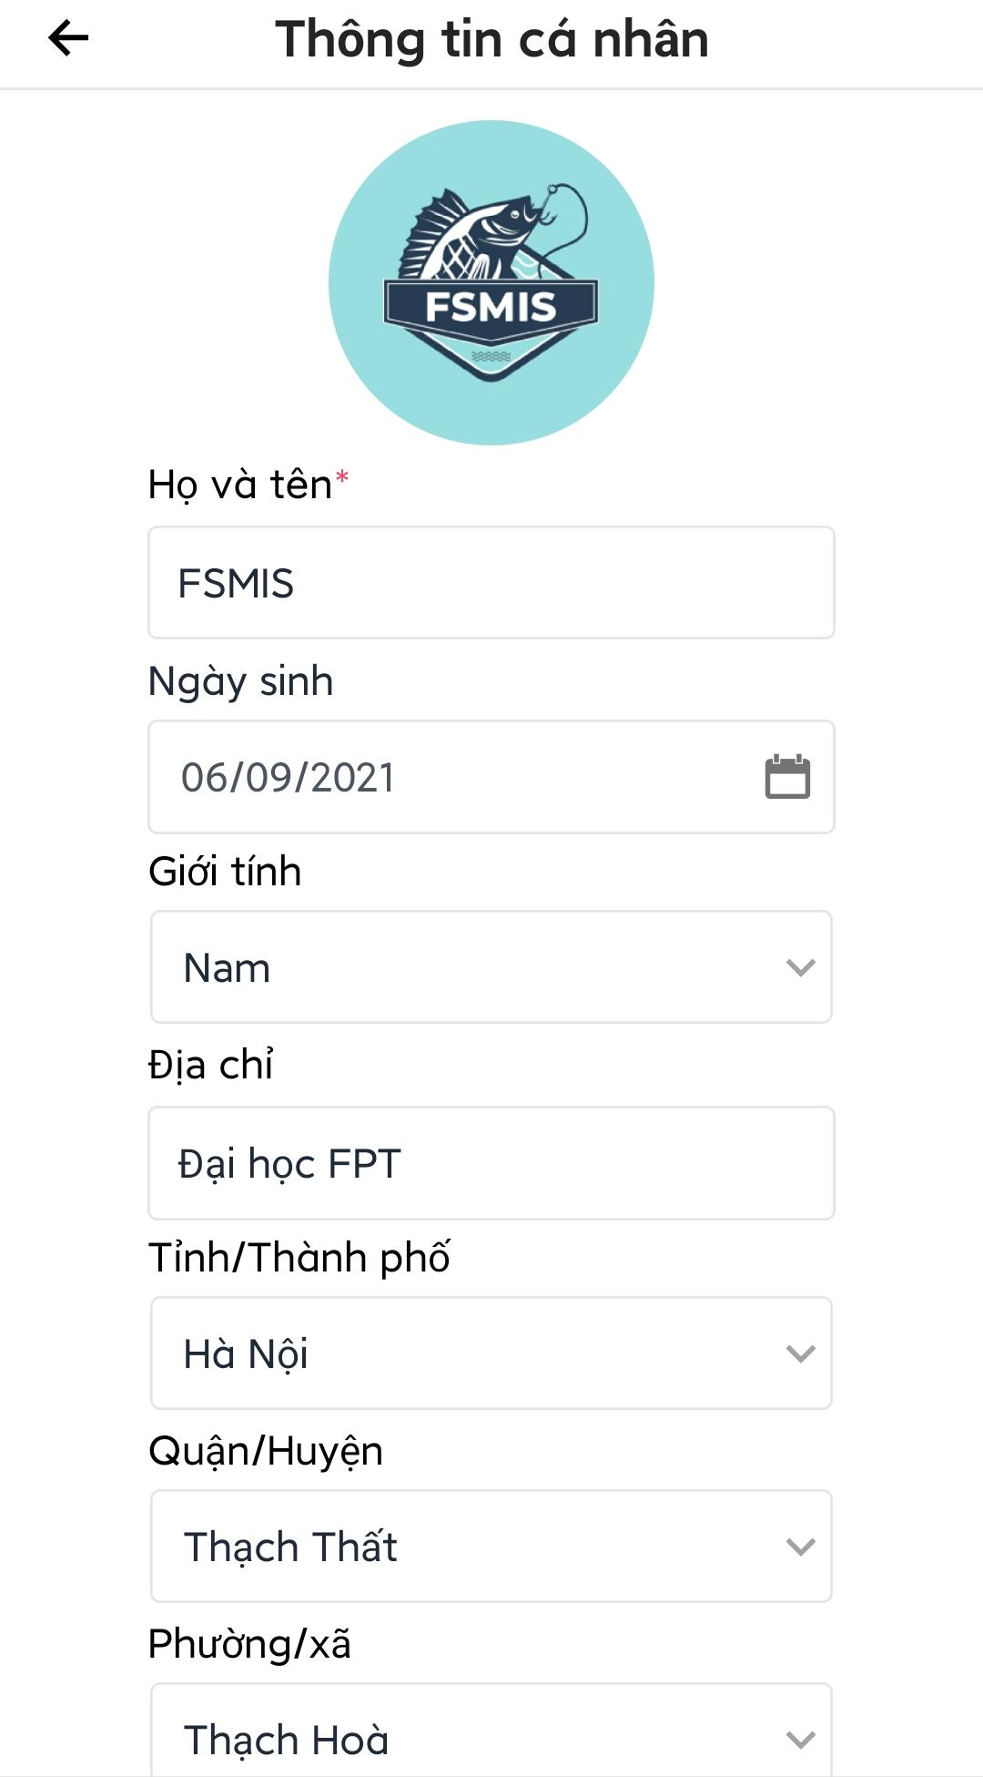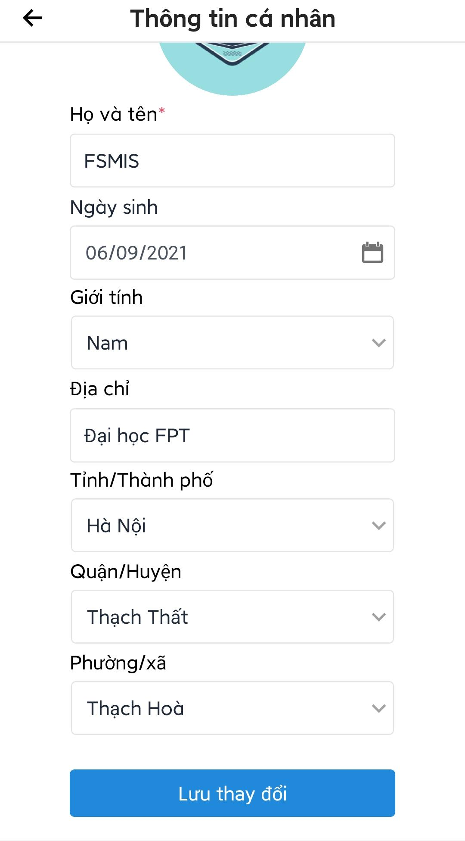

Figure 3.3.10. Edit personal information

#### 3.3.11. Change account phone number

* Open main screen.
* Press “Cá nhân” tab at the bottom of the screen to view the menu screen.
* Press “Thay đổi số điện thoại” to open change phone number screen.
* Enter new phone number and current password then press “Tiếp tục”, an alert will be displayed.
* Press “Xác nhận” on the alert box to confirm the action, an otp code will be sent to the new phone number.
* Enter the otp code and press “Tiếp tục” to change account phone number.

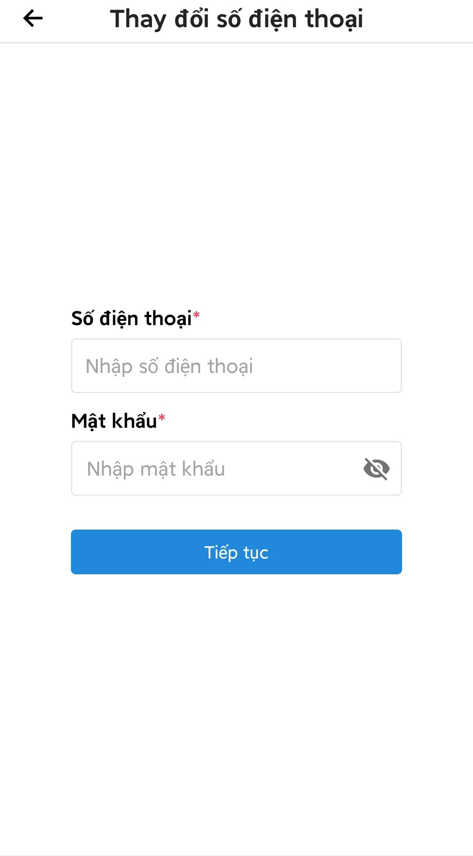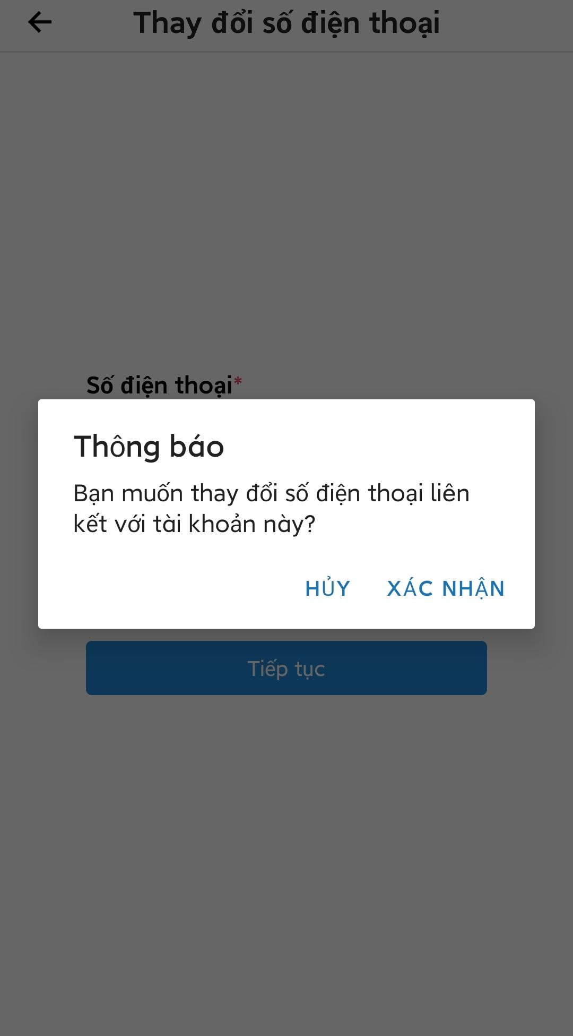

Figure 3.3.11. Change account phone number

#### 3.3.12. Change account password

* Open main screen.
* Press “Cá nhân” tab at the bottom of the screen to view the menu screen.
* Press “Thay đổi mật khẩu” to open change password screen.
* Fill the form and press “Đổi mật khẩu” to change account password.

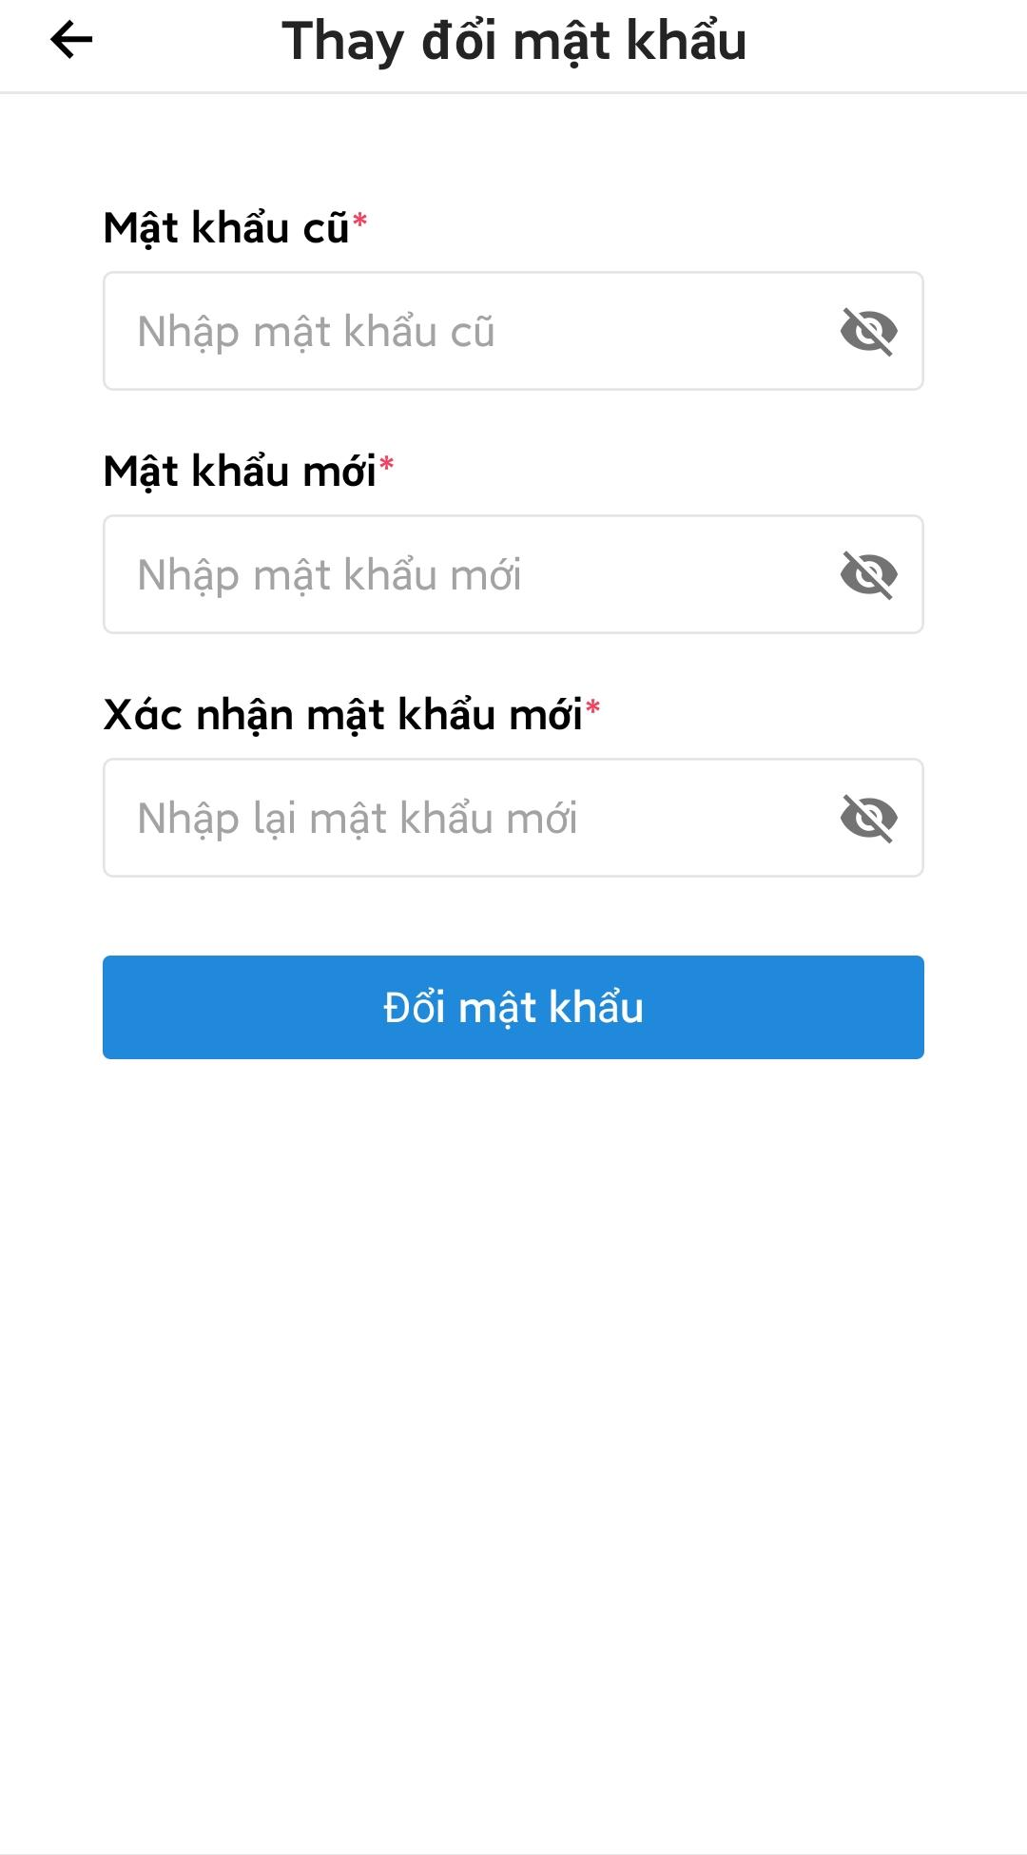

Figure 3.3.12. Change account password

#### 3.3.13. View, create a manageable fishing location

* Press “Chuyển sang ‘Chế độ quản lý’” in the menu screen, a list of manageable fishing locations will be displayed. (fishing location that user own or currently employed)
* Users can press the “Thêm điểm câu” to open create new fishing location screen.
* Enter all required information and press “Thêm điểm câu”, an otp code will be sent to the phone number specified in the form.
* Enter the otp code and press “Tiếp tục” to create a new fishing location.

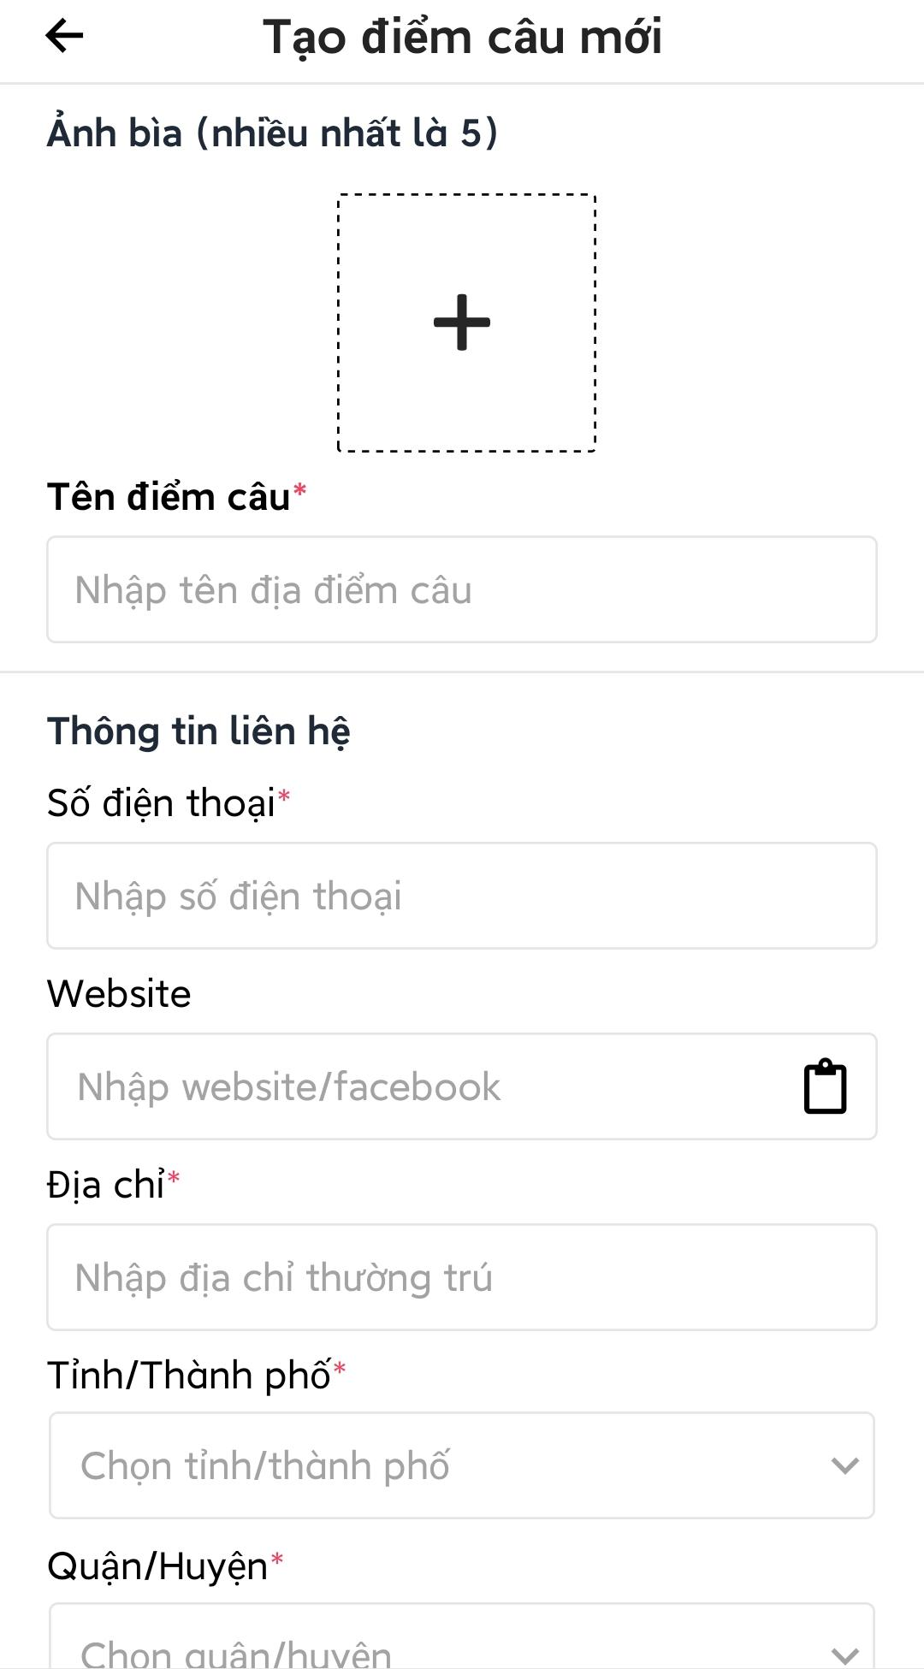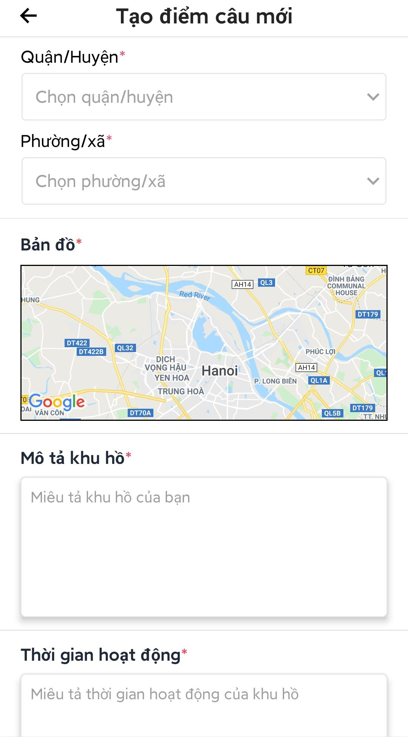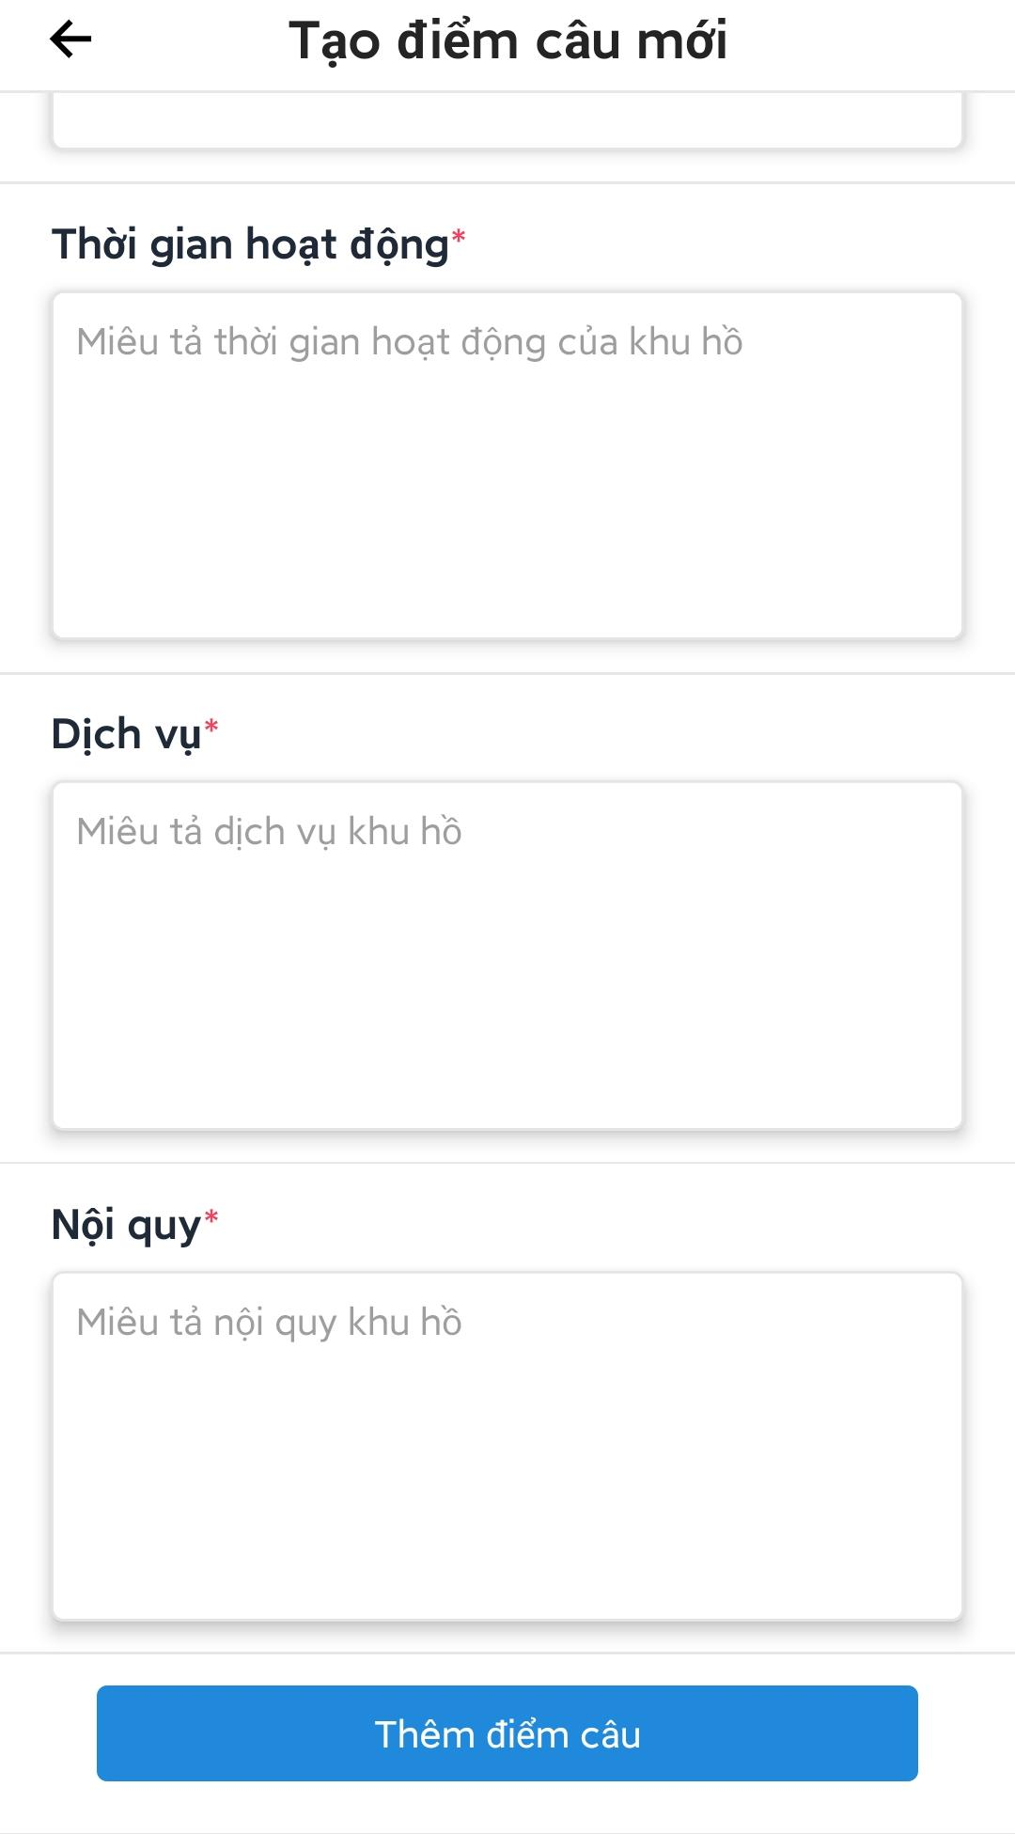

Figure 3.3.13. View, create a fishing location

#### 3.3.14. Manage a fishing location

* Open manageable fishing location list screen.
* Press on a fishing location to open management screen corresponding to that fishing location.

Note:

* User can press “Xem trang điểm câu của bạn” to view location detail screen.
* If user is a staff, the management menu will have less options.

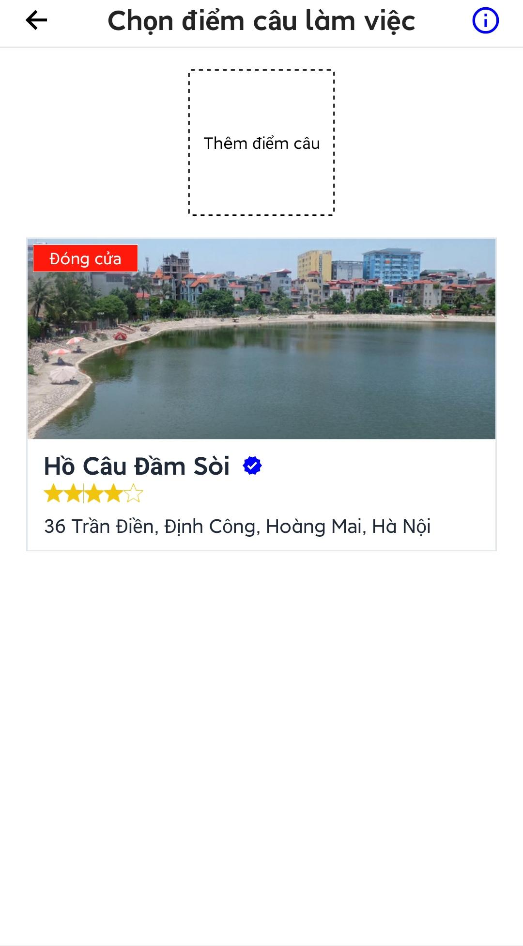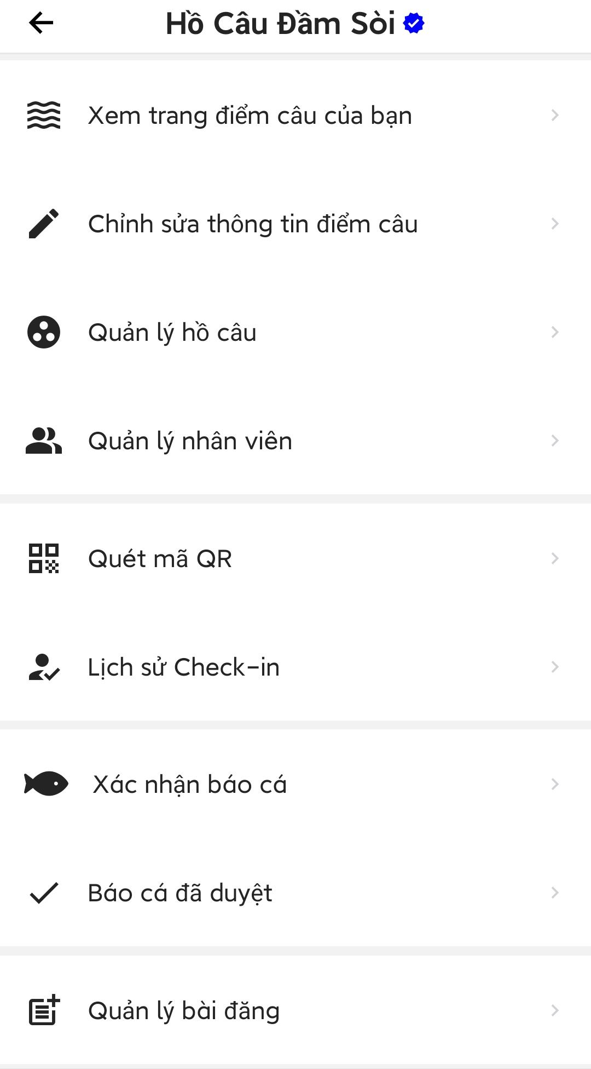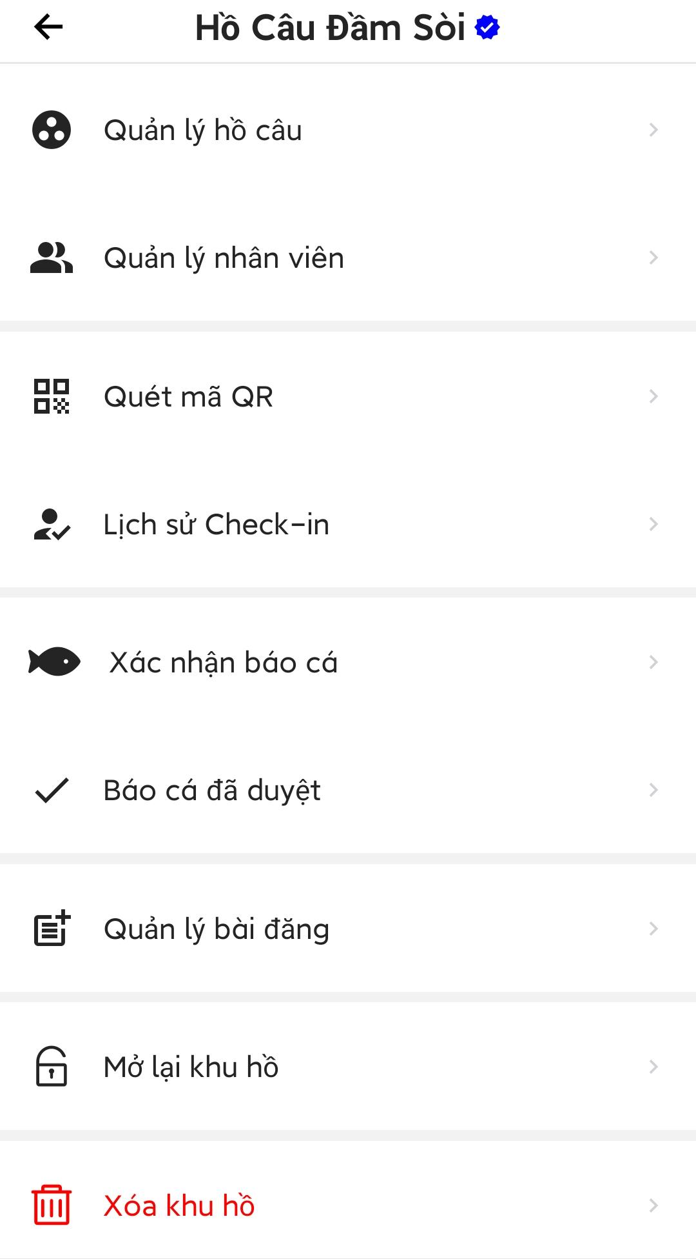

Figure 3.3.14. Manage a fishing location

##### 3.3.14.1. Edit fishing location information

* Open the fishing location management screen.
* Press “Chỉnh sửa thông tin điểm câu” to open edit screen.
* Edit data in the form then press “Lưu thông tin”, if user change phone number of the fishing location, an otp code will be sent to the phone number in the form.
* Enter the otp code then press “Tiếp tục” to save changes.

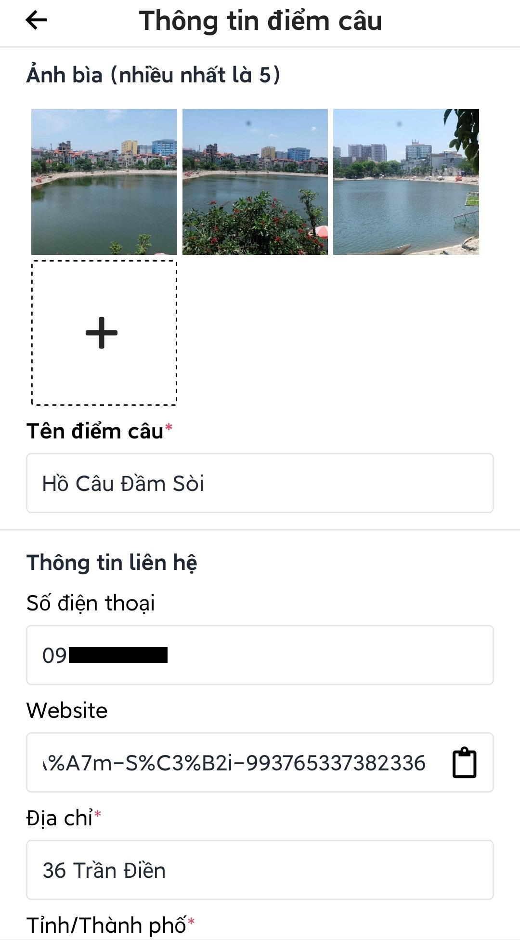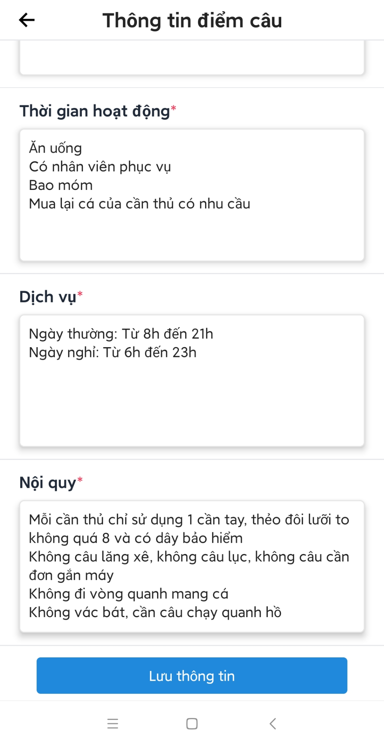

Figure 3.3.14.1. Edit fishing location information

##### 3.3.14.2. Lake management

* Open fishing location management screen.
* Press “Quản lý hồ câu” to open lake management screen.
* Users can press “Thêm hồ câu” to create a new lake at that fishing location.
* Users can press on a lake to view lake detail management screen.

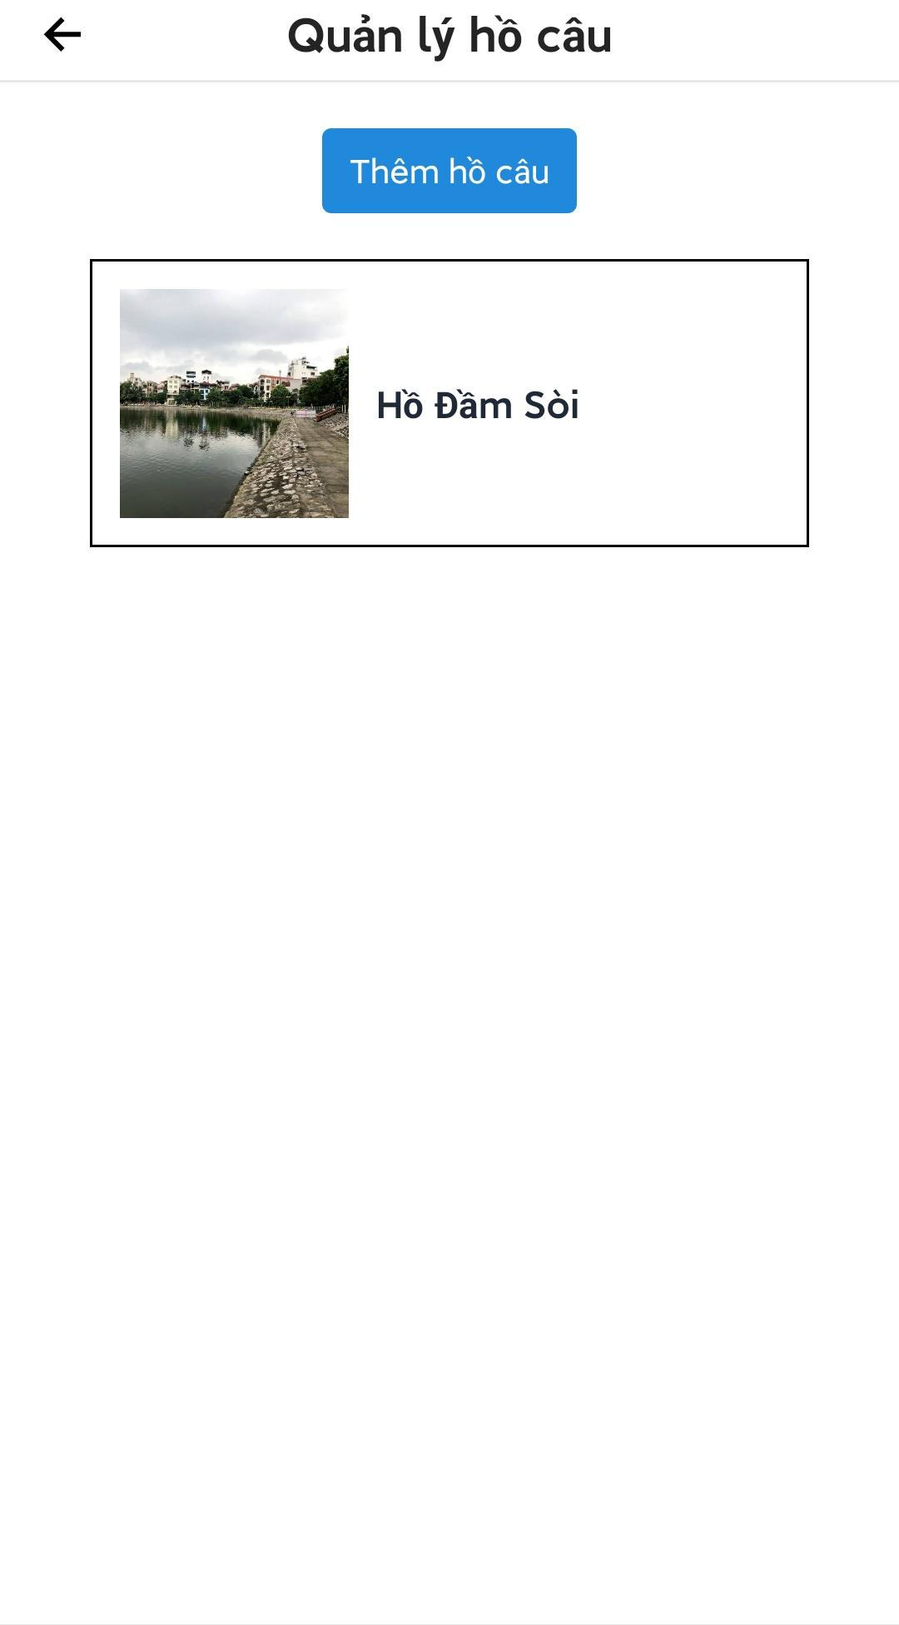

Figure 3.3.14.2. Lake management

###### 3.3.14.2.1. Create new lake

* Open lakes management screen.
* Press “Thêm hồ câu” at the top of the screen, the screen will redirect to create lake screen.
* Fill in the form and press “Thêm hồ câu” to add new lake to fishing location.

Note: Users can add multiple fishes by pressing “Thêm thẻ”.

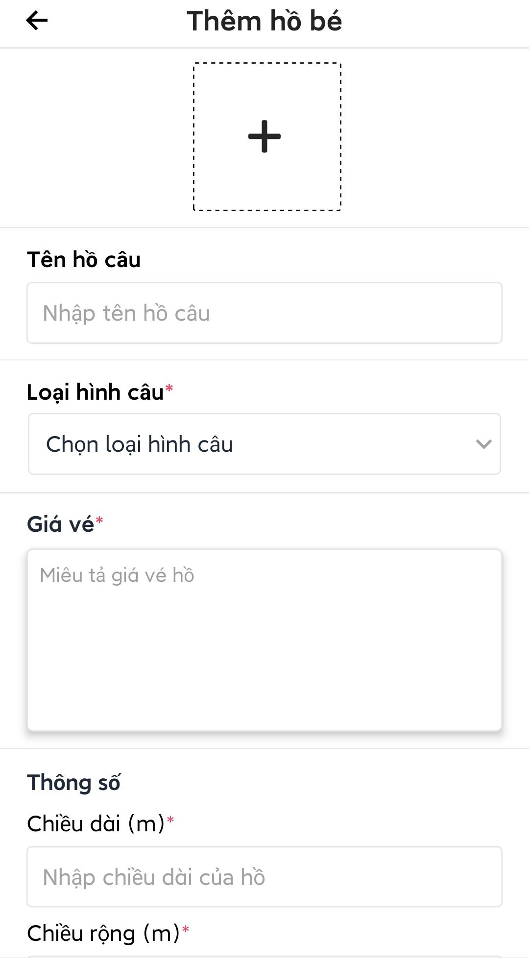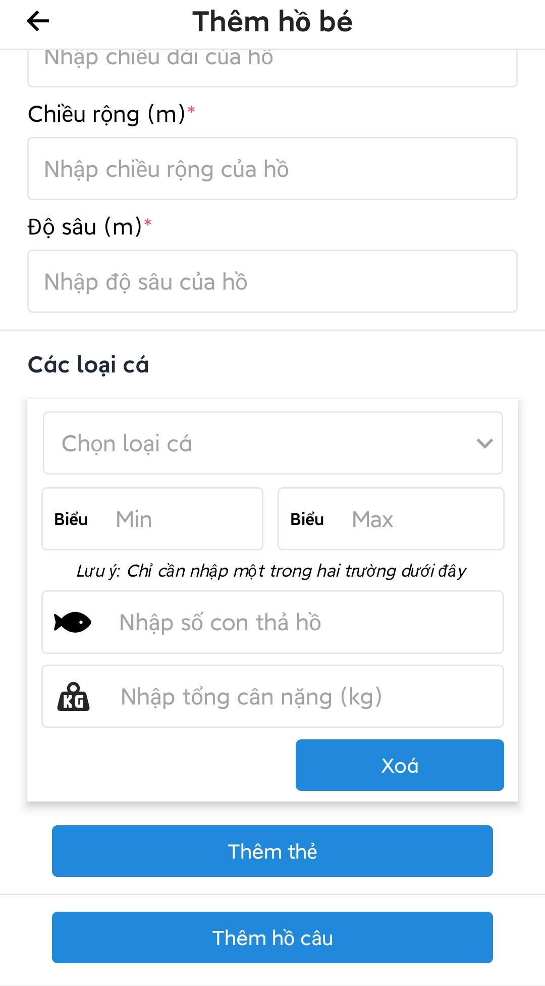

Figure 3.3.14.2.1. Create new lake

###### 3.3.14.2.2. Edit lake information

* Press on a lake in lakes management screen to open detail management screen of that lake.
* Press “Thông tin hồ câu” to open edit screen.
* Edit the form then press “Lưu thông tin hồ câu” to save changes.
* Users can press “Xóa hồ câu” to delete the lake.

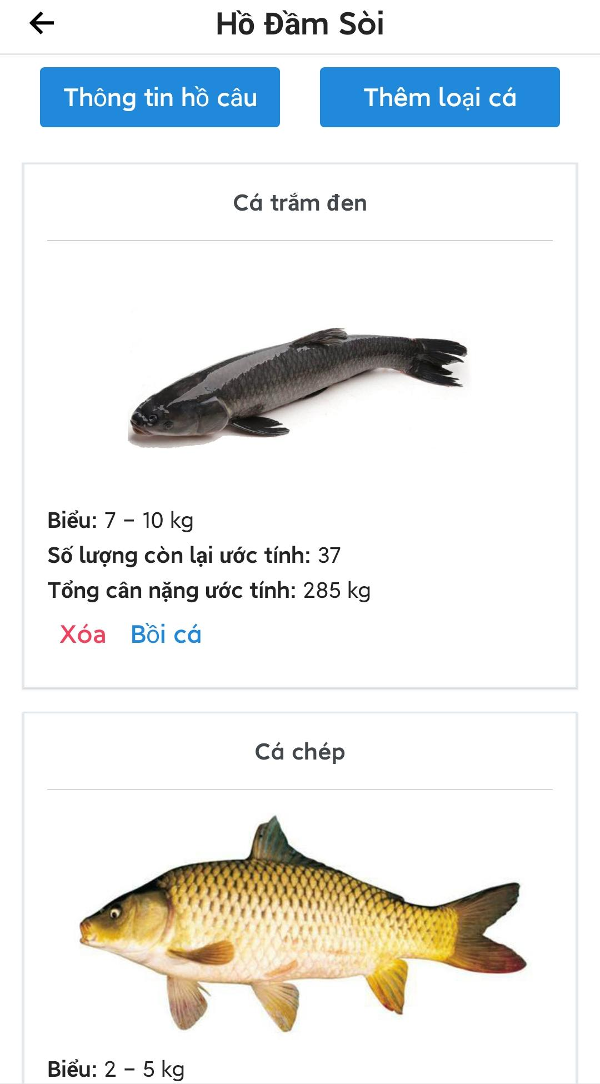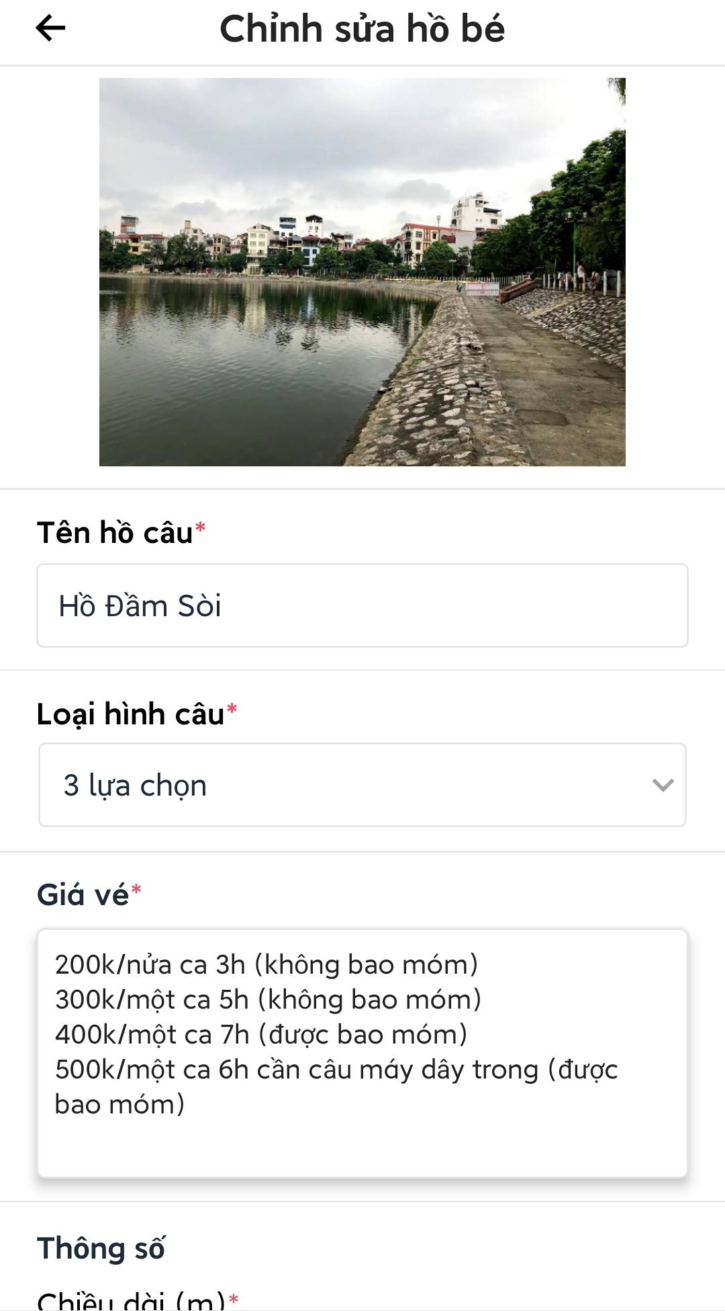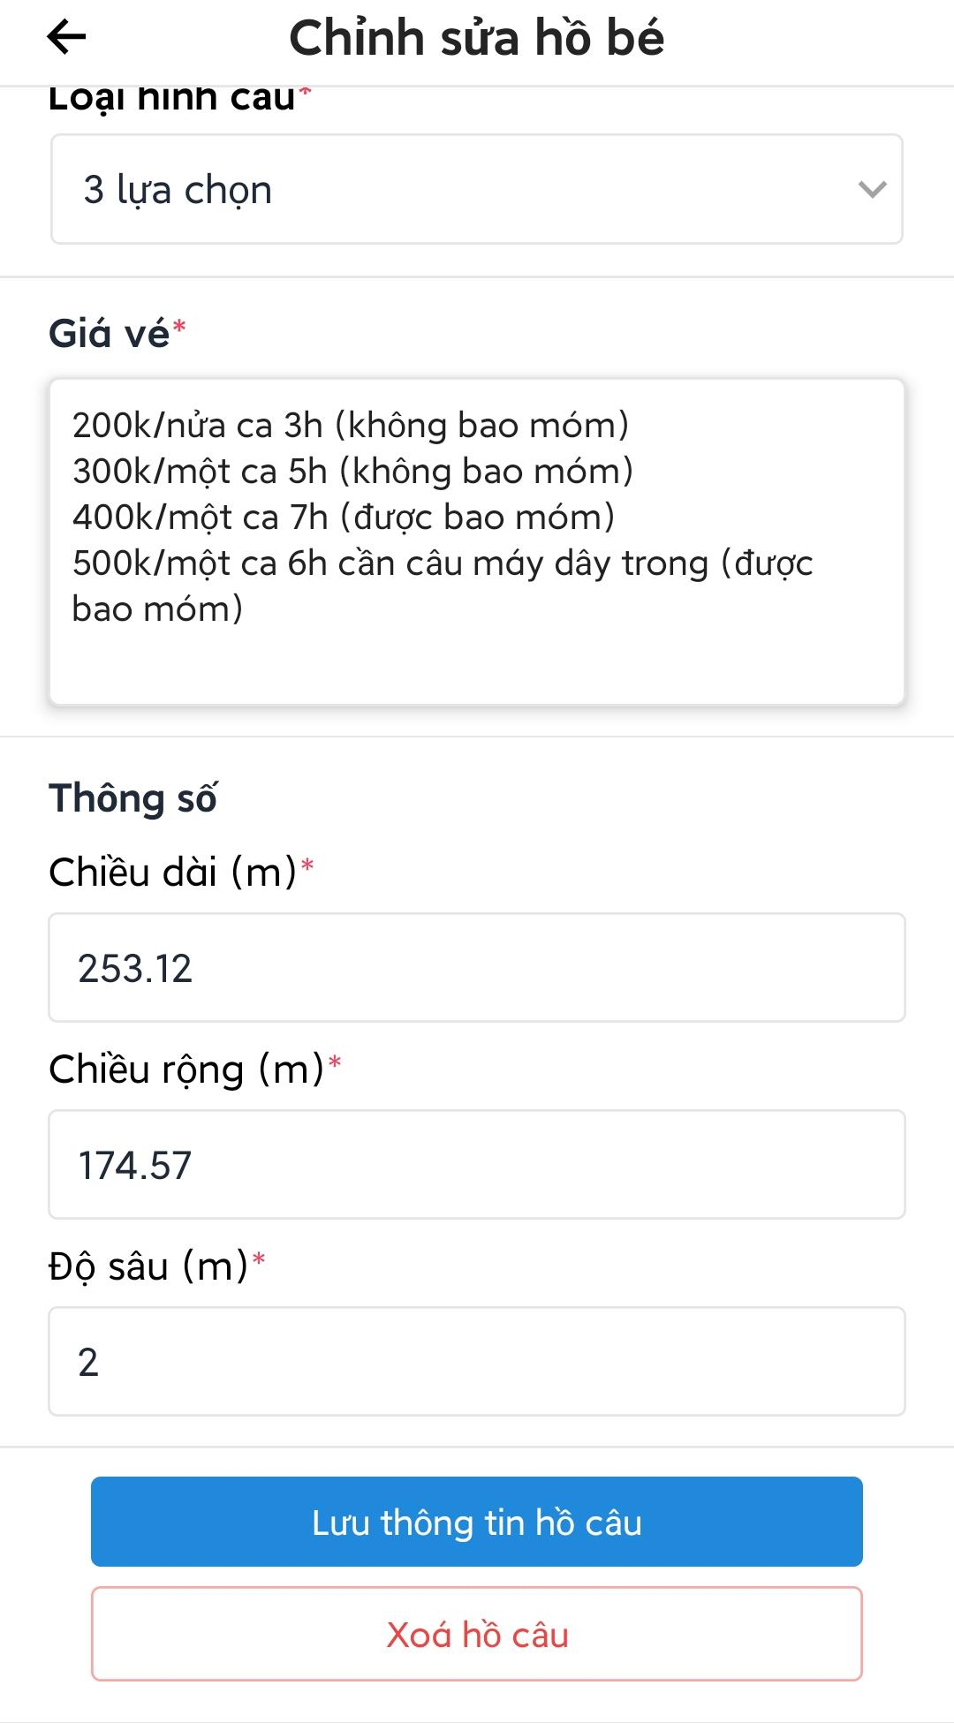

Figure 3.3.14.2.2. Edit lake information

###### 3.3.14.2.3. Edit fishes in lake

* Open lake detail management screen.
* Users can delete fishes by press “Xóa” on each type of fish.
* Users change current amount of a fish in lake by press “Bồi cá” to open an overlay to stock fish, fill in the form then press “Xác nhận” to restock fish in lake.
* Users add more type of fish to the lake by press “Thêm loại cá” to open add fish to lake screen, fill in the form then press “Thêm cá” to add new fish to the lake.

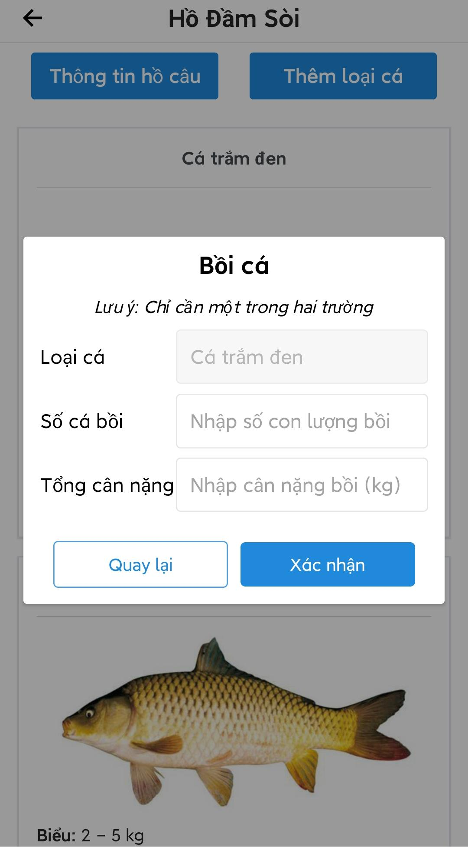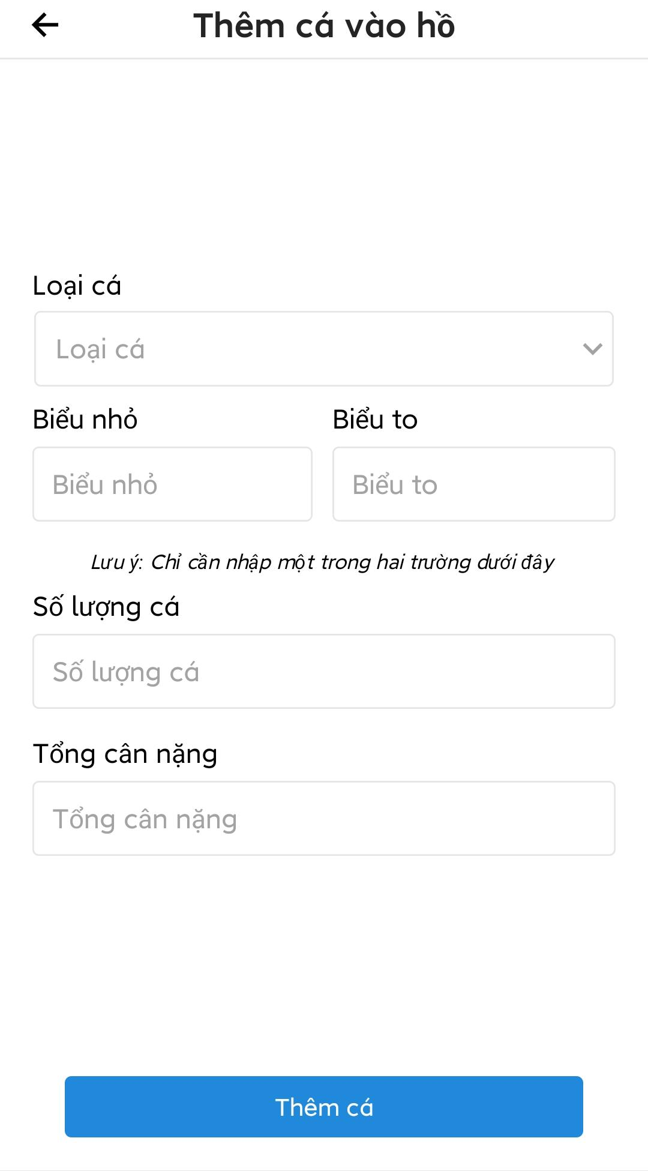

Figure 3.3.14.2.3. Edit fishes in lake

##### 3.3.14.3. Staff management

* Open the location management screen.
* Press “Quản lý nhân viên” to open staff management screen.
* Users can press “Chi tiết” to view staff detail.

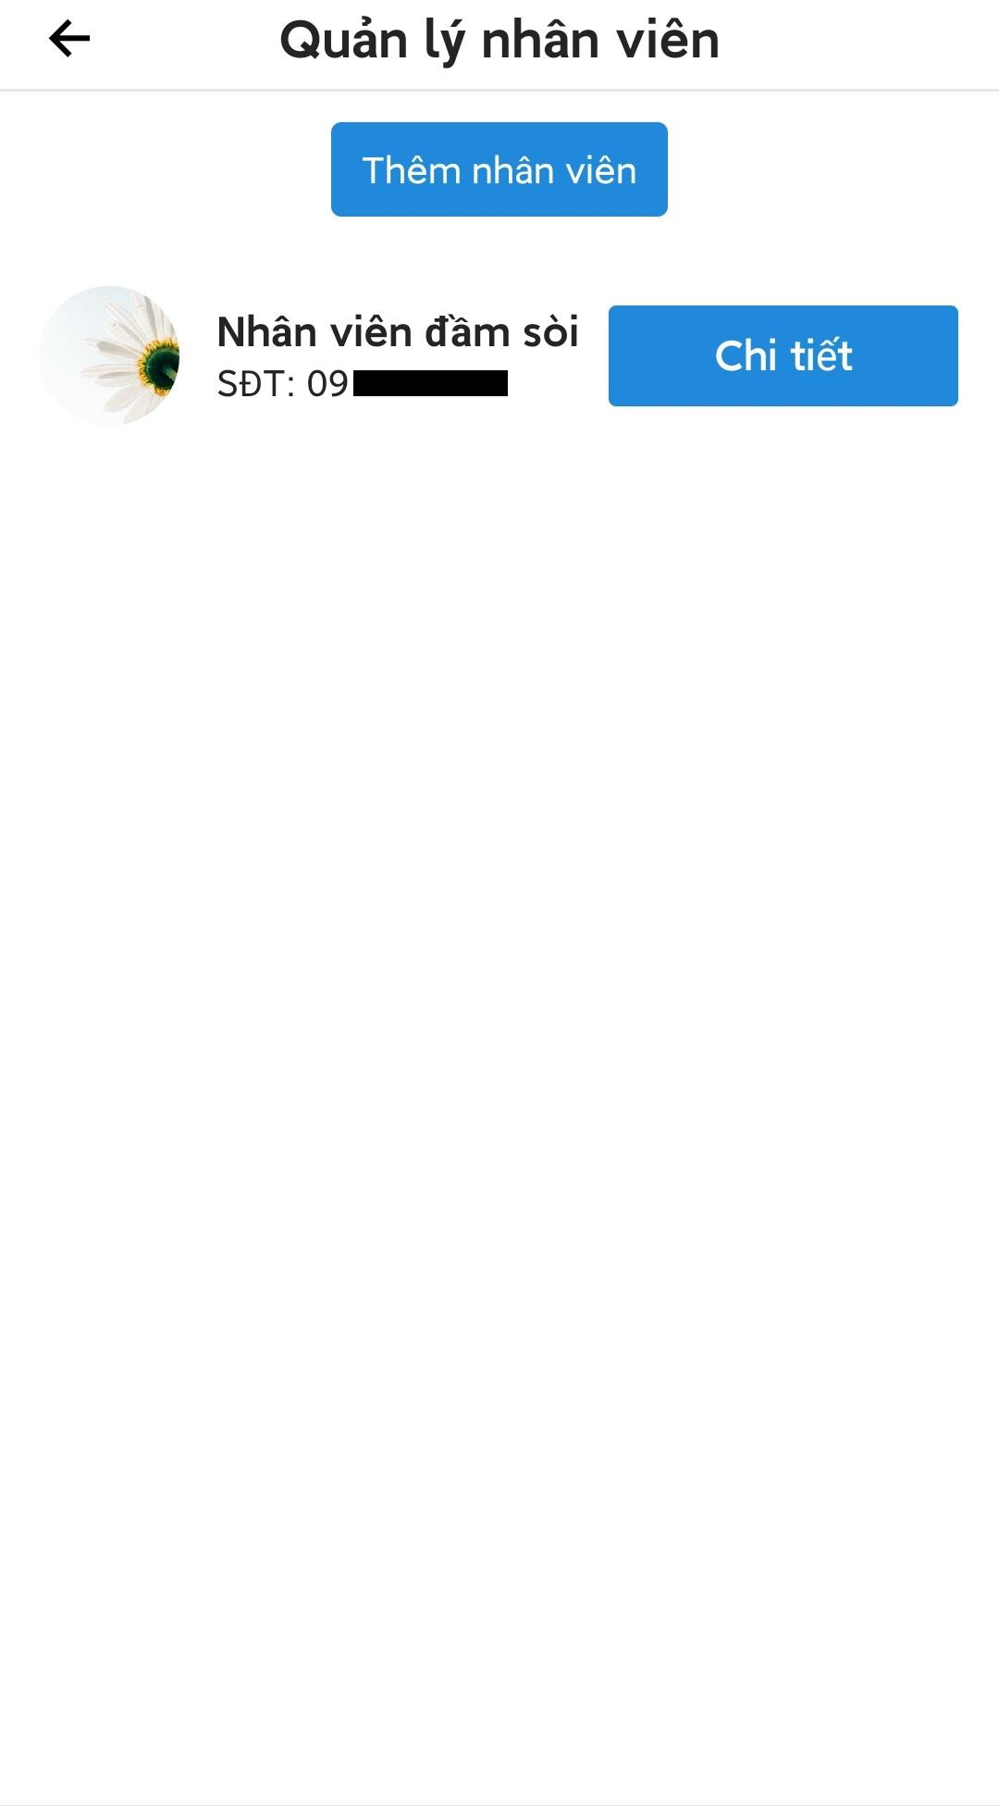

Figure 3.3.14.3. Staff management

###### 3.3.14.3.1. Add new staff

* Open staff management screen.
* Press “Thêm nhân viên” button to open search screen.
* Enter the correct phone number to search for right user.
* Press “Thêm nhân viên” to add new staff to the fishing location.

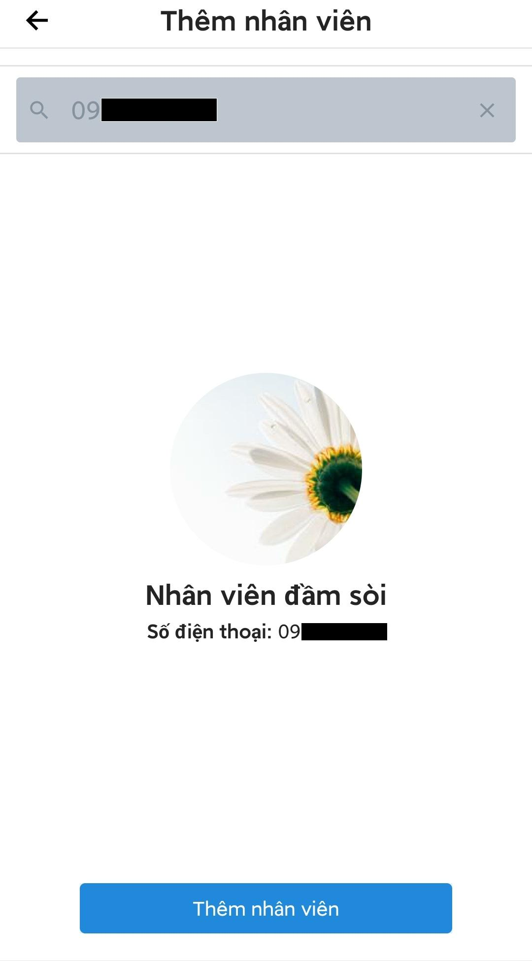

Figure 3.3.14.3.1. Add new staff

###### 3.3.14.3.2. Remove staff

* Open the staff management screen.
* Press “Chi tiết” button on the staff that need to be removed to open staff detail screen.
* Press “Xóa nhân viên” to remove the staff from the fishing location.

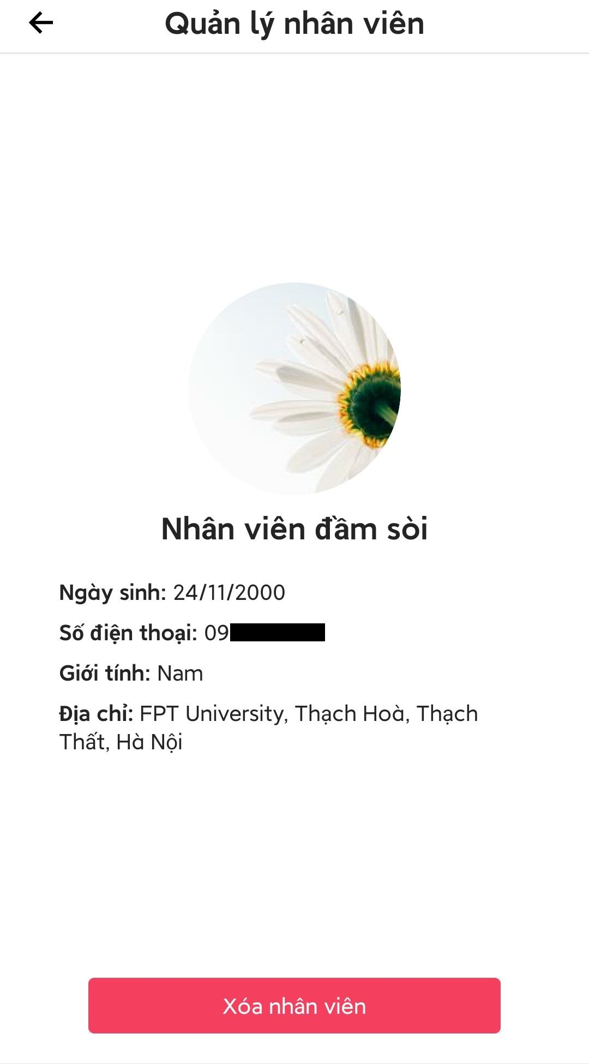

Figure 3.3.14.3.2. Remove staff

##### 3.3.14.4. Check-in an angler at the fishing location

* Open fishing location management screen.
* Press “Quét mã QR” to open scan QR code screen.
* Grant the application permission to access device camera to open the camera.
* Scan an angler QR code (QR code show at the main screen when login to the application) to check-in that angler at the fishing location, a screen will appear to notify that the action is successful.

Note: User can press “Tiếp tục” to go back to scan QR code screen or press “Màn hình quản lý” to go back to management screen.

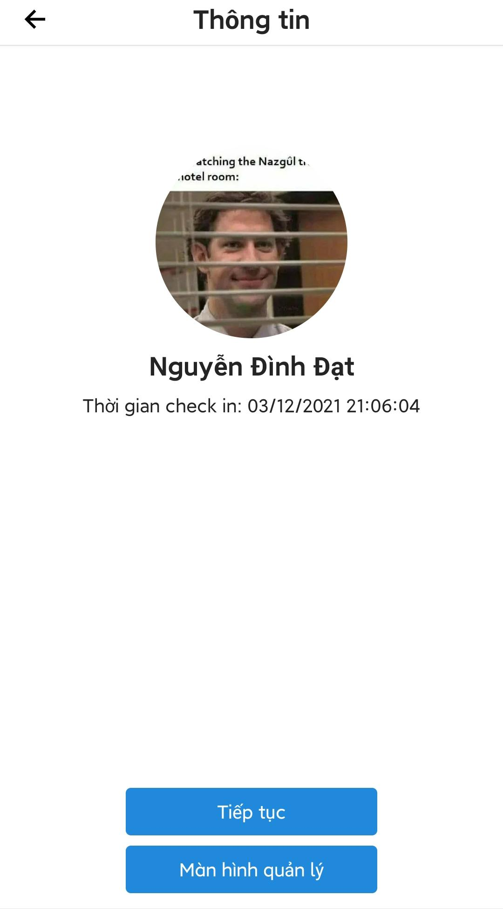

Figure 3.3.14.4. Check-in an angler

##### 3.3.14.5. View check-in history of anglers at the fishing location

* Open the management screen.
* Press “Lịch sử Check-in”, a screen showing check-in history of anglers will be displayed.
* User can filter check-in records by a single date or a range of date.

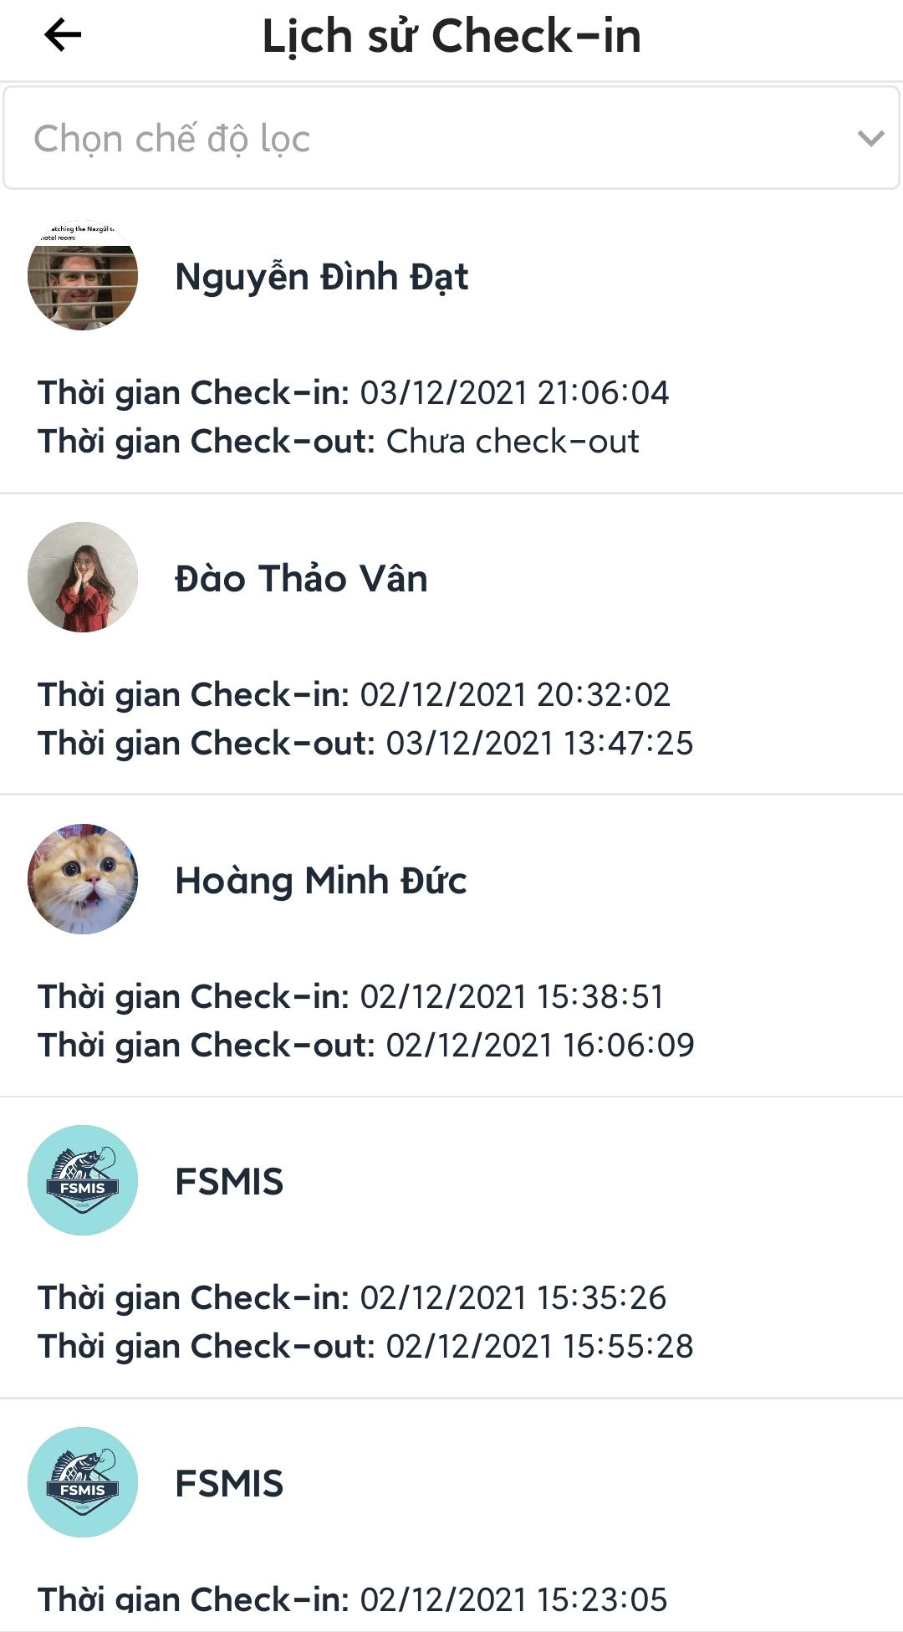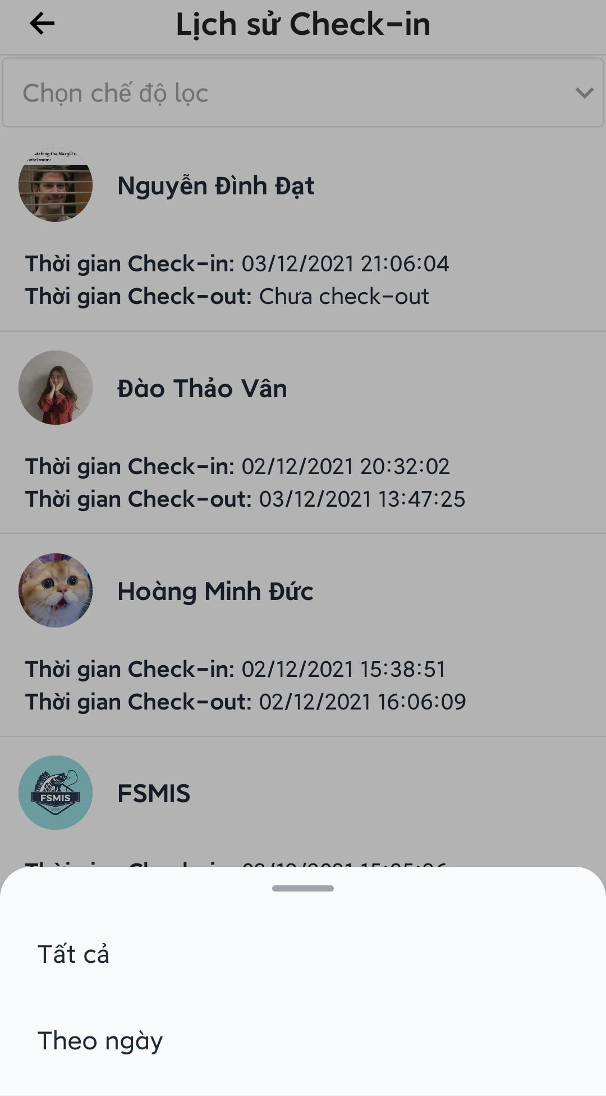

Figure 3.3.14.5. View check-in history of anglers

##### 3.3.14.6. View, verify catch reports

* Open management screen.
* Press “Xác nhận báo cá” to view all pending catch reports.
* Users can press “Đồng ý” to fast accept catch report or press “Chi tiết” to view catch report detail.
* In the detail screen users can press “Từ chối” or “Xác nhận” to verify the catch report.

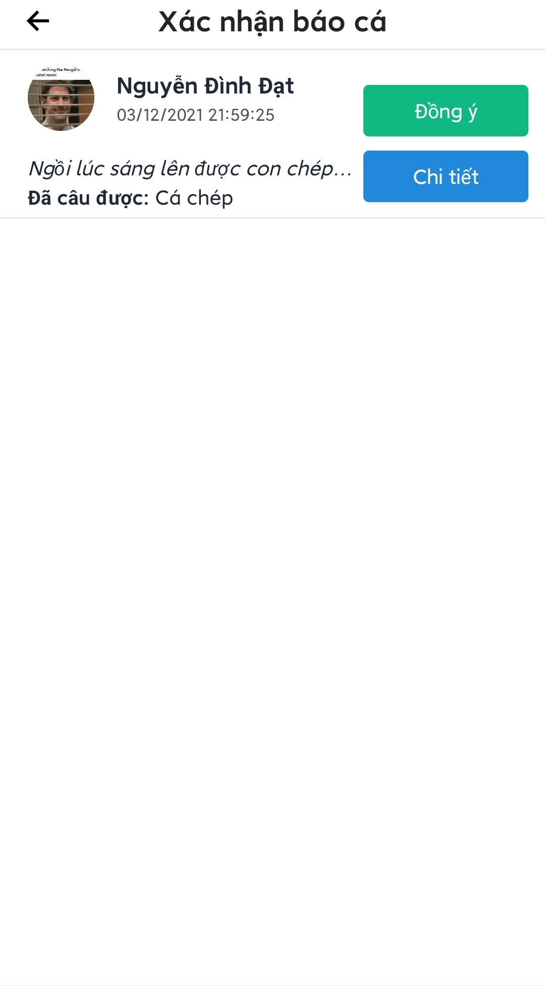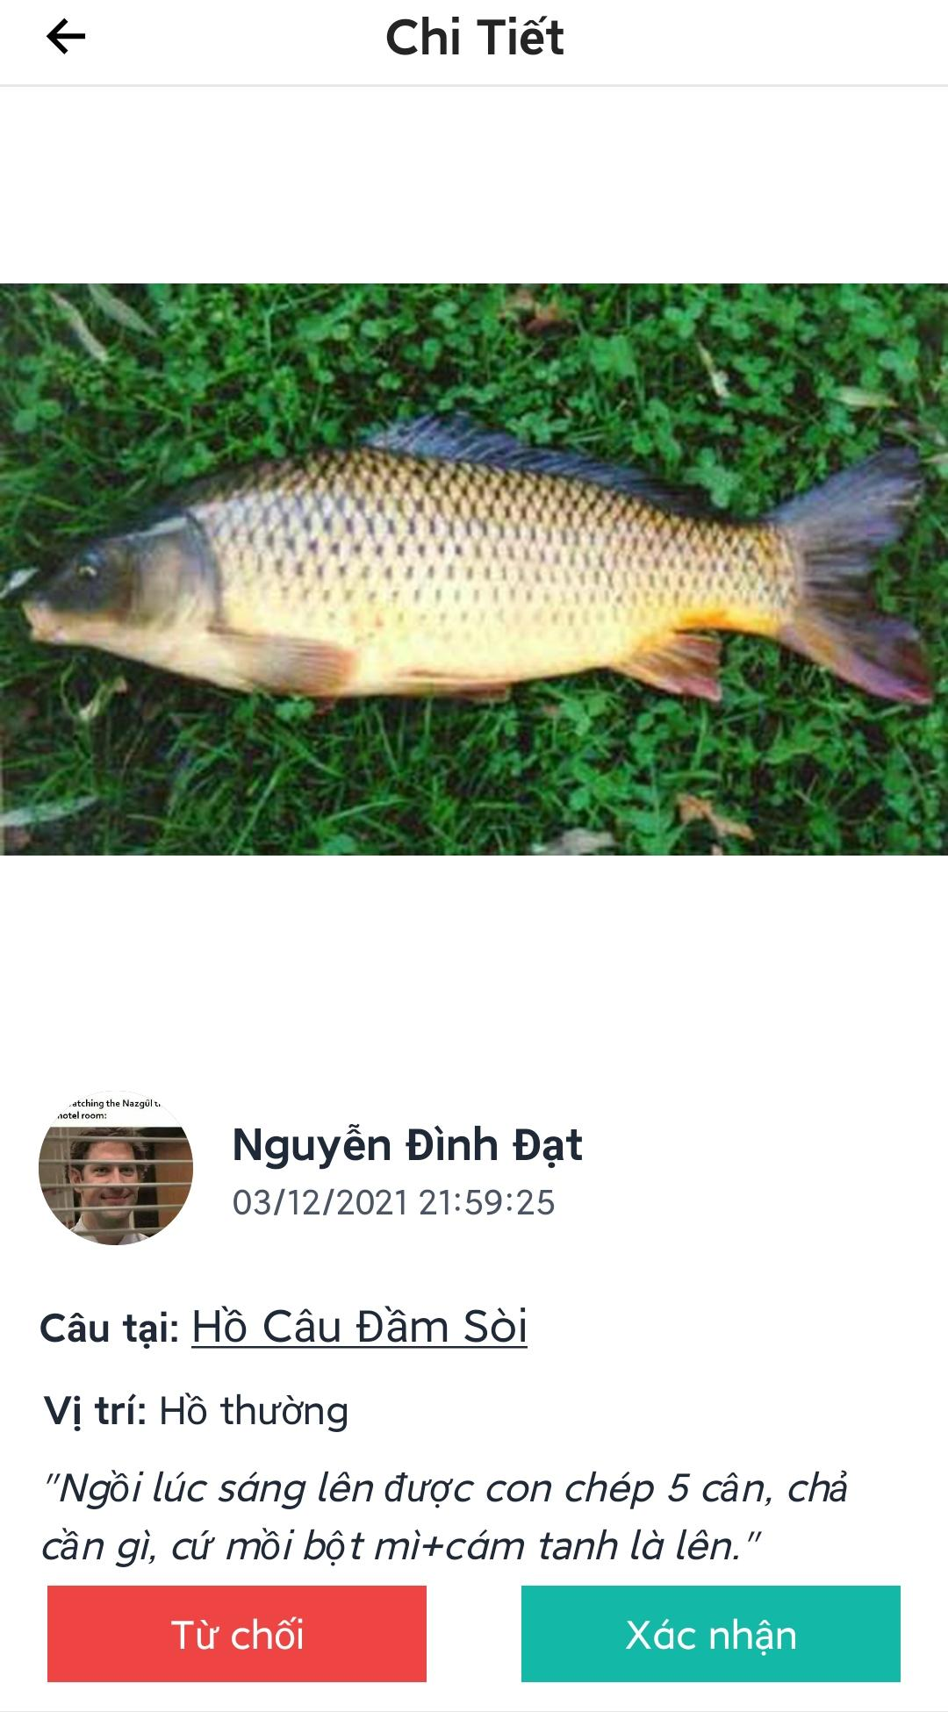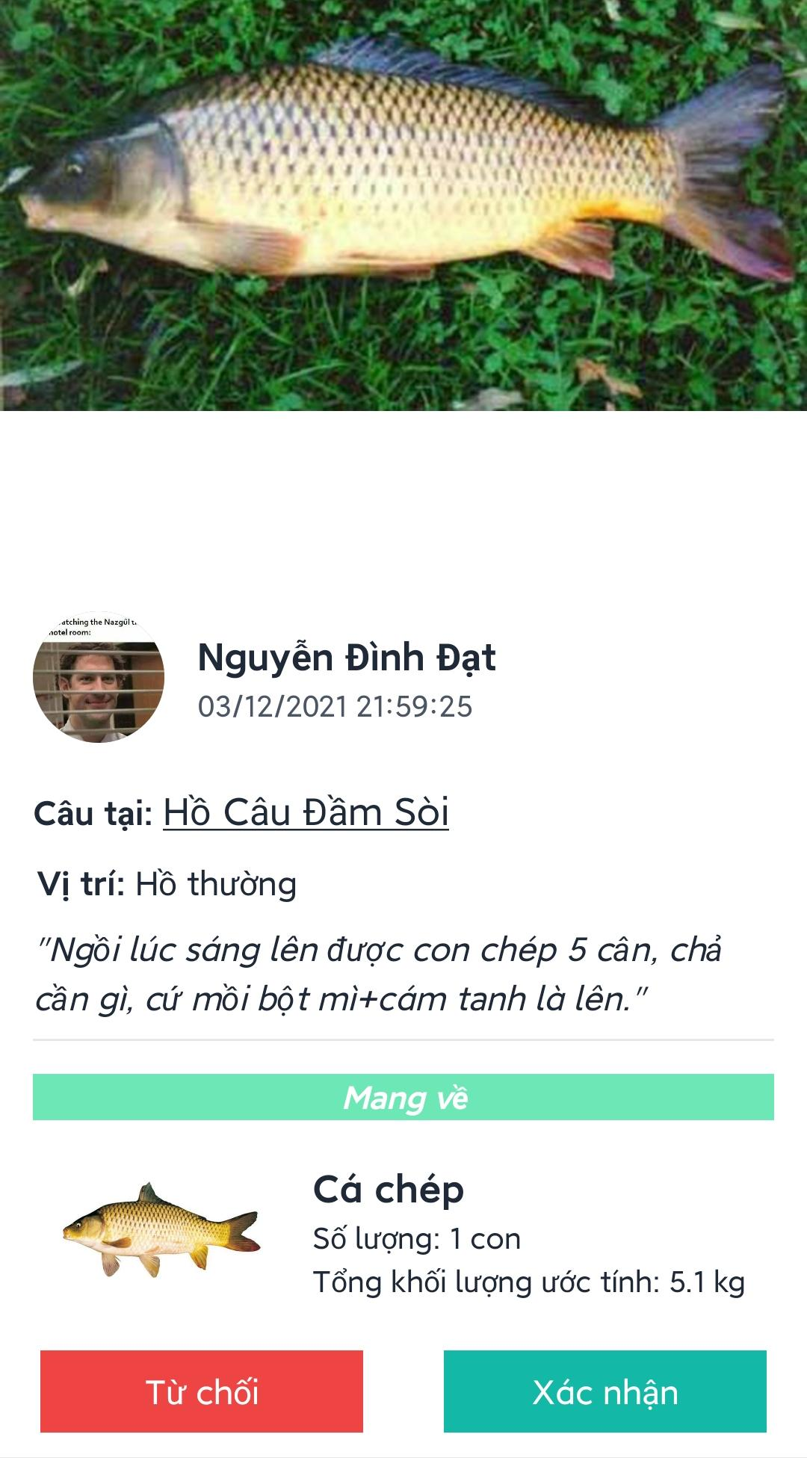

Figure 3.3.14.6. View, verify catch report

##### 3.3.14.7. View verified catch reports

* Open fishing location management screen.
* Press “Báo cá đã duyệt”, a screen showing all previous verified catch reports will be displayed.
* Users can filter the list by a single date or by a range of date.
* User can press on a catch report to view detail.

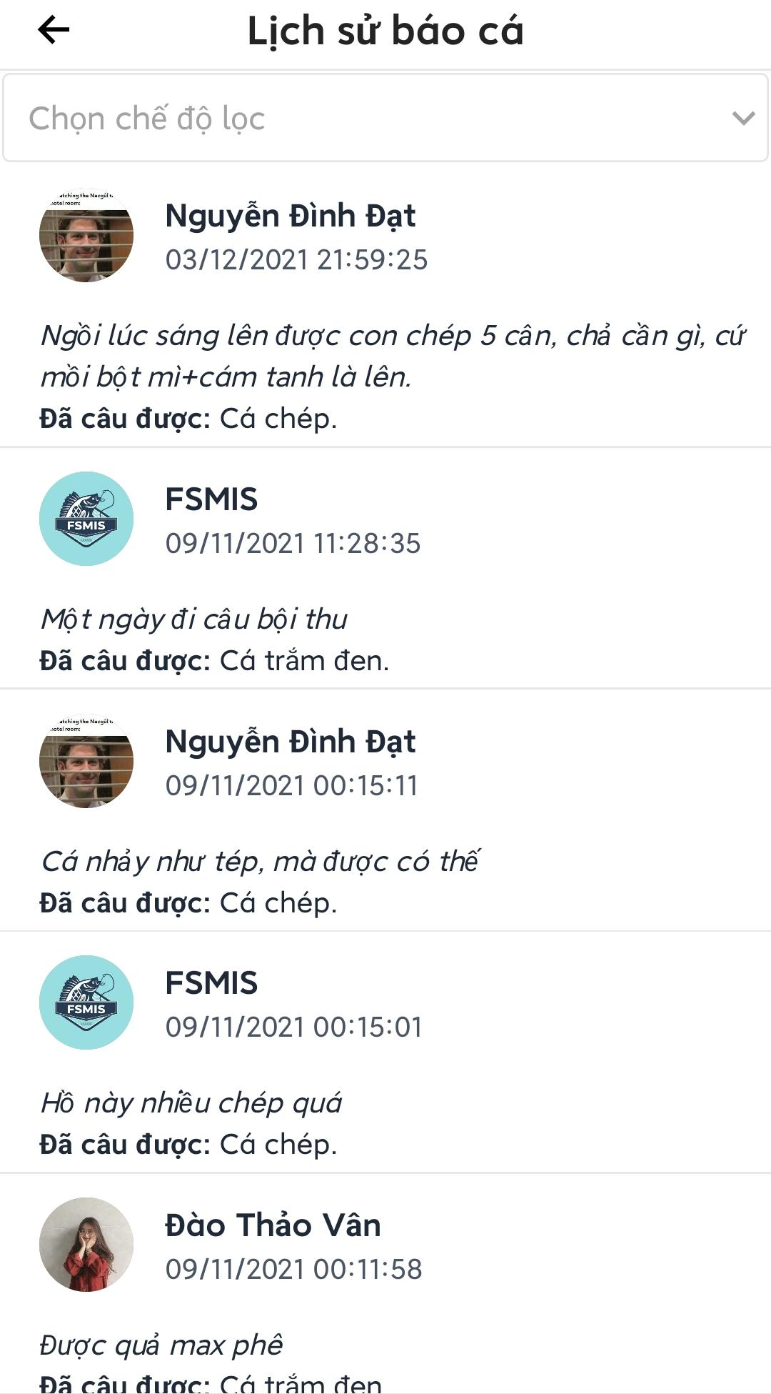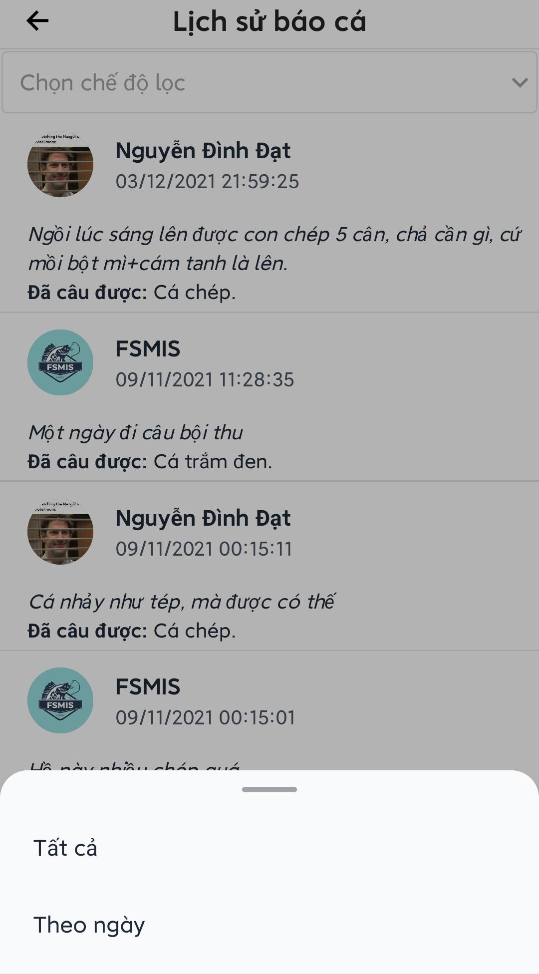

Figure 3.3.14.7. View verified catch reports

##### 3.3.14.8. Post management

* Open fishing location management screen.
* Press “Quản lý bài đăng” to open posts management screen.
* Users can press “Tạo bài viết” to create a new post.
* Users can press  icon to see options for edit posts, delete posts and pin a post.

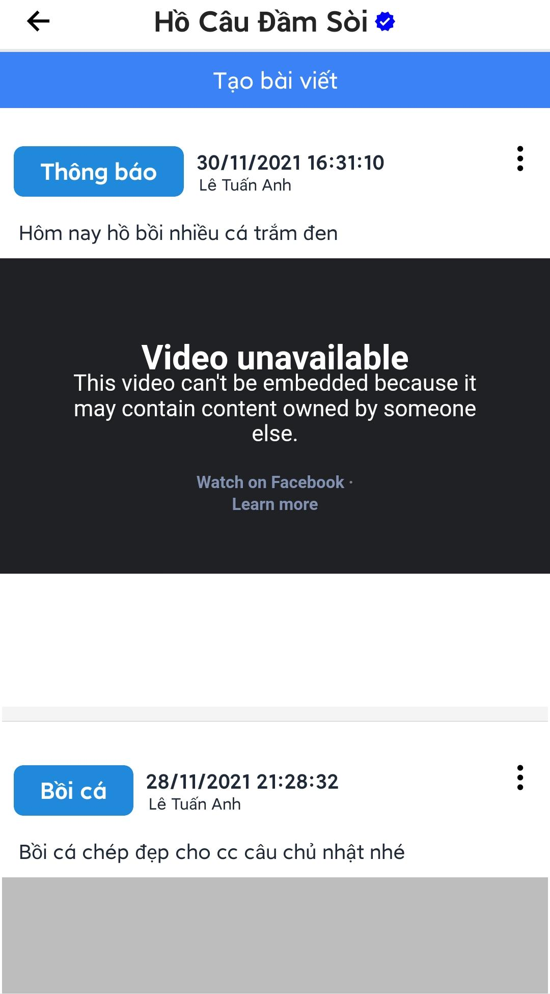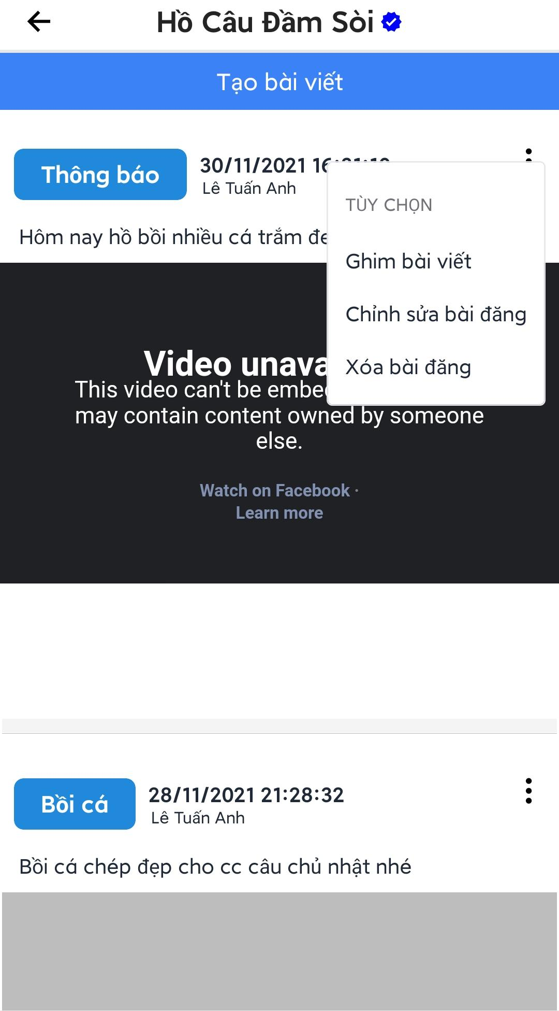

Figure 3.3.14.8. Post management

###### 3.3.14.8.1. Create new post

* Press “Tạo bài viết”, create post screen will appear.
* Users can choose 1 of 3 types of event for post.
* Users can choose to include an image or a video URL to the post.
* Fill the form and press “Đăng” to create a new post.

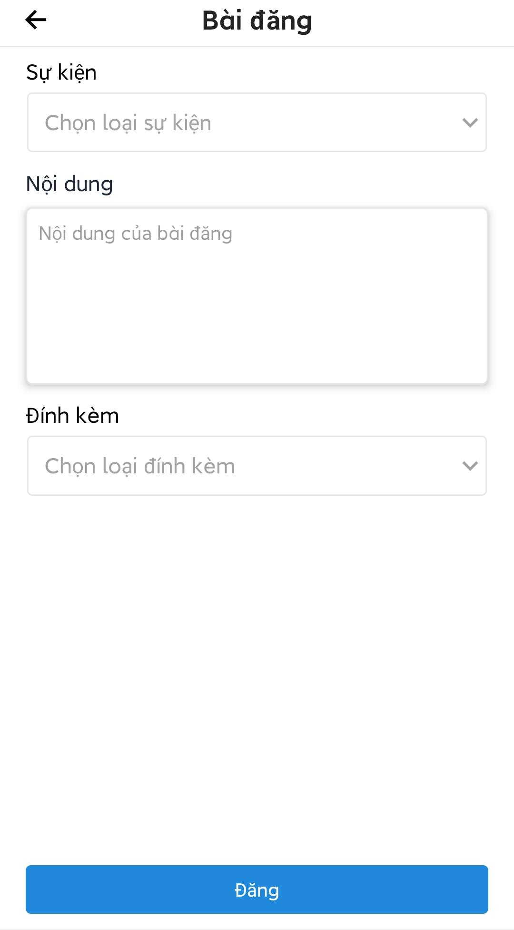

Figure 3.3.14.8.1. Create a new post’s form

###### 3.3.14.8.2. Edit a post

* Press  icon of the post that needs to be edited, edit screen will be displayed.
* Edit the form then press “Đăng” to post the edited post.

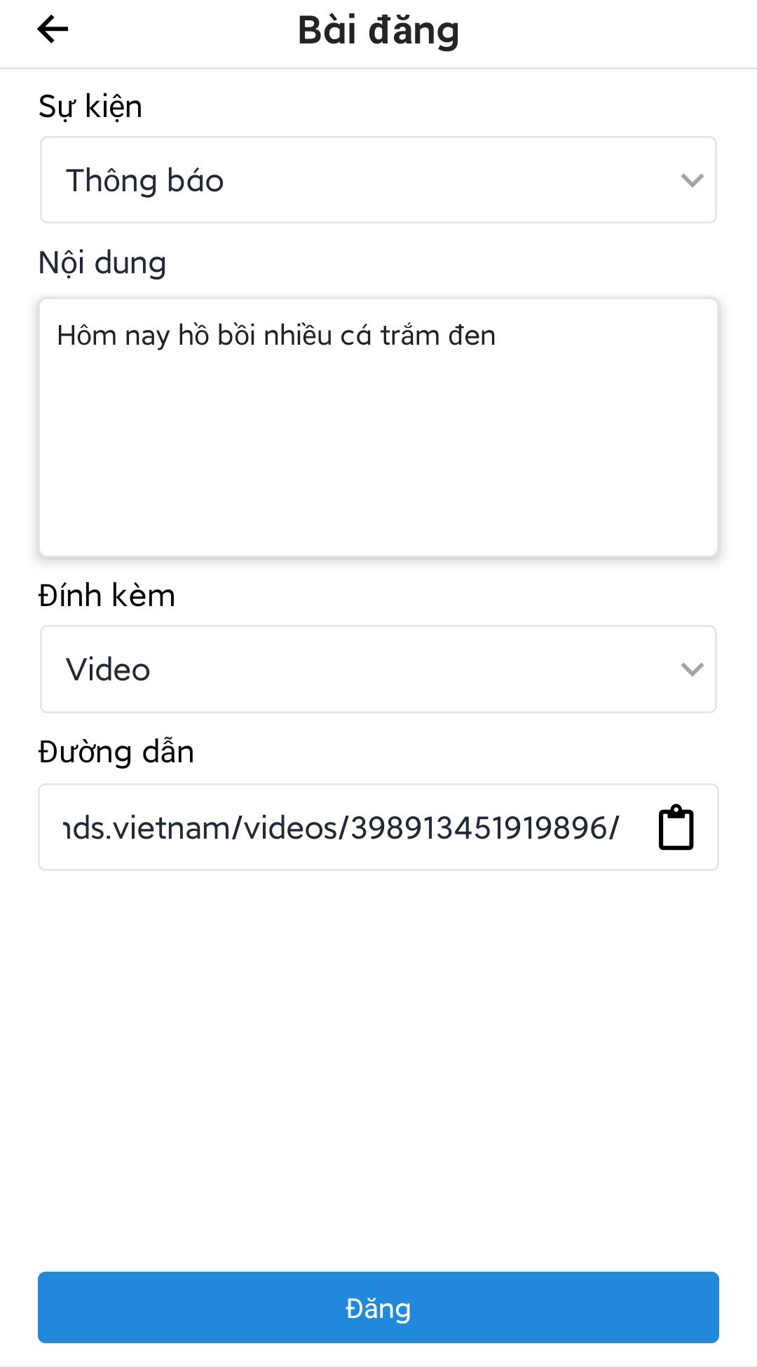

Figure 3.3.14.8.2. Edit a post

###### 3.3.14.8.3. Pin, delete a post

* Press  icon on the post.
* User can press “Ghim bài viết” to pin the post at the top.
* User can press “Xóa bài viết” to delete the post.



Figure 3.3.14.8.3. Pin, delete a post

##### 3.3.14.9. Change opening state of fishing location

* Open fishing location management screen.
* Press “Mở lại khu hồ”/”Đóng cửa khu hồ” on top of the “Xóa khu hồ” menu.
* An alert box will be shown with message corresponding the current state.
* Press “Xác nhận” to change the opening state.

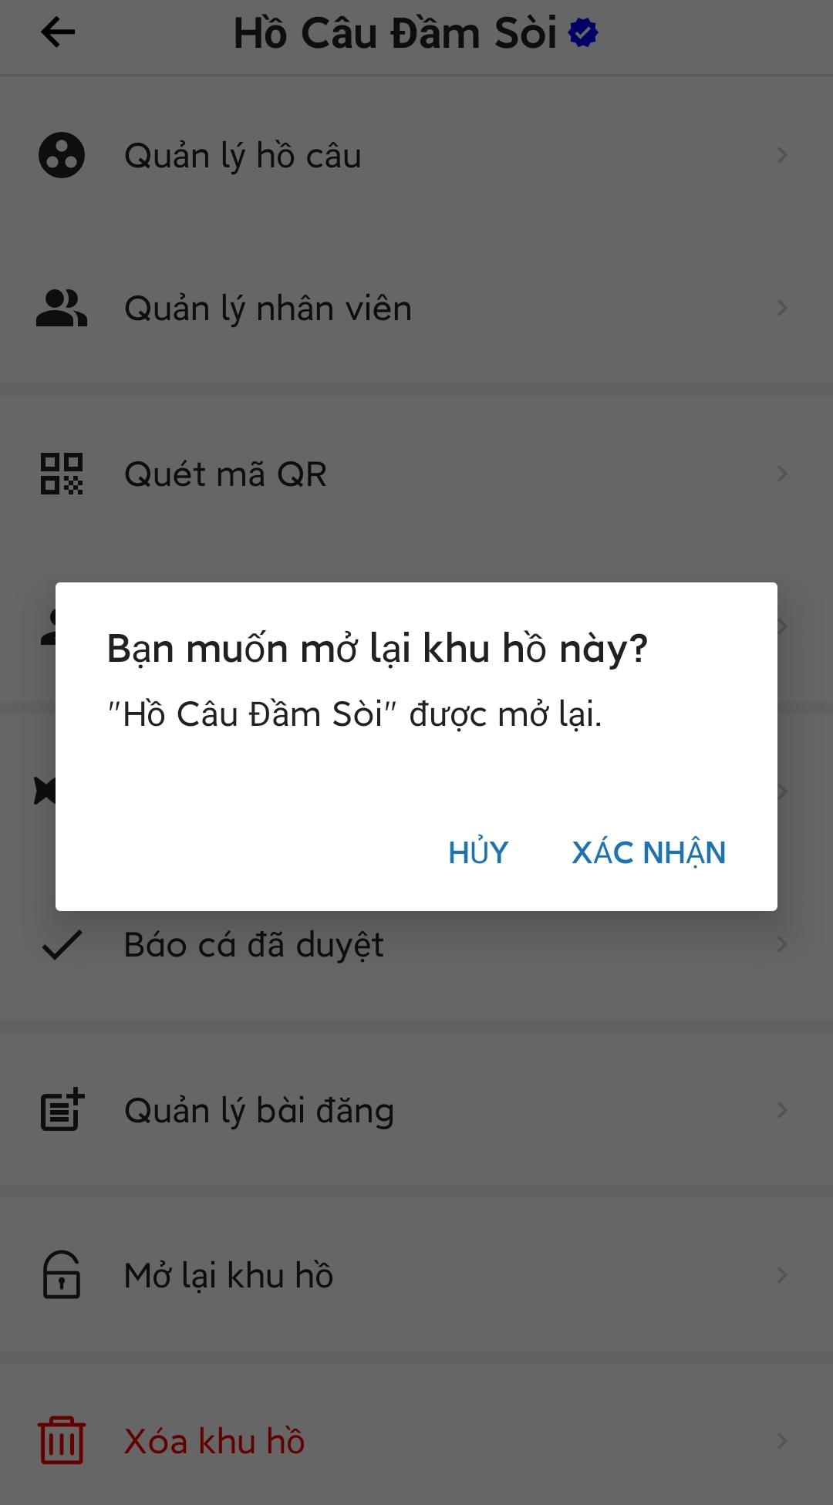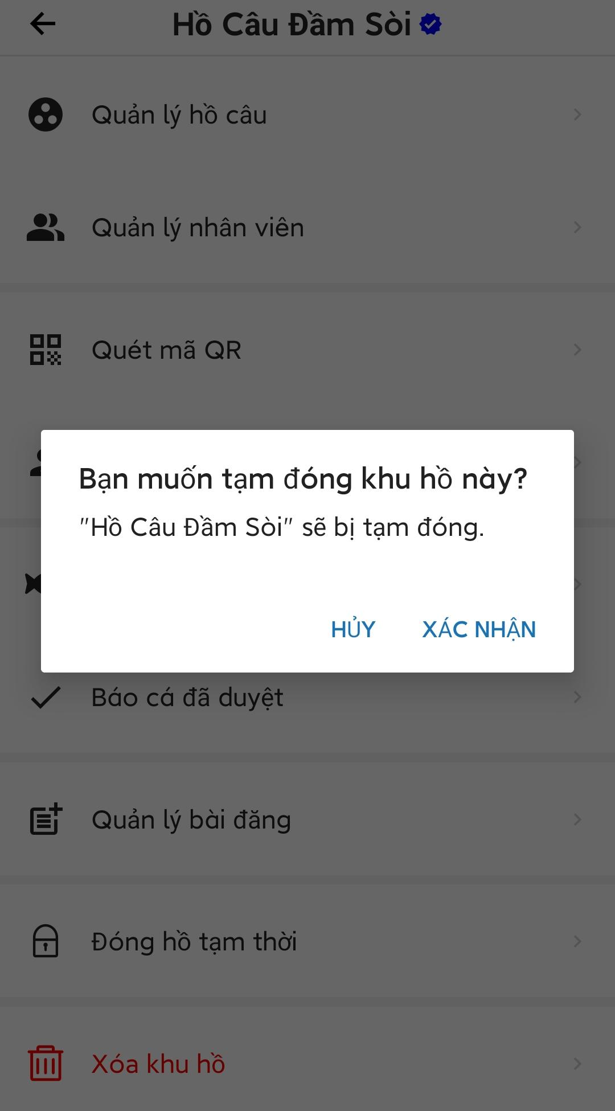

Figure 3.3.14.9. Change opening state of fishing location

##### 3.3.14.10. Delete fishing location

* Open the fishing location management screen.
* Press “Xóa khu hồ”, an alert box will appear.
* Press “Xác nhận” to confirm the action, an OTP code will be sent to the phone number of the fishing location.
* Enter the OTP code and press “Tiếp tục” to delete the fishing location.

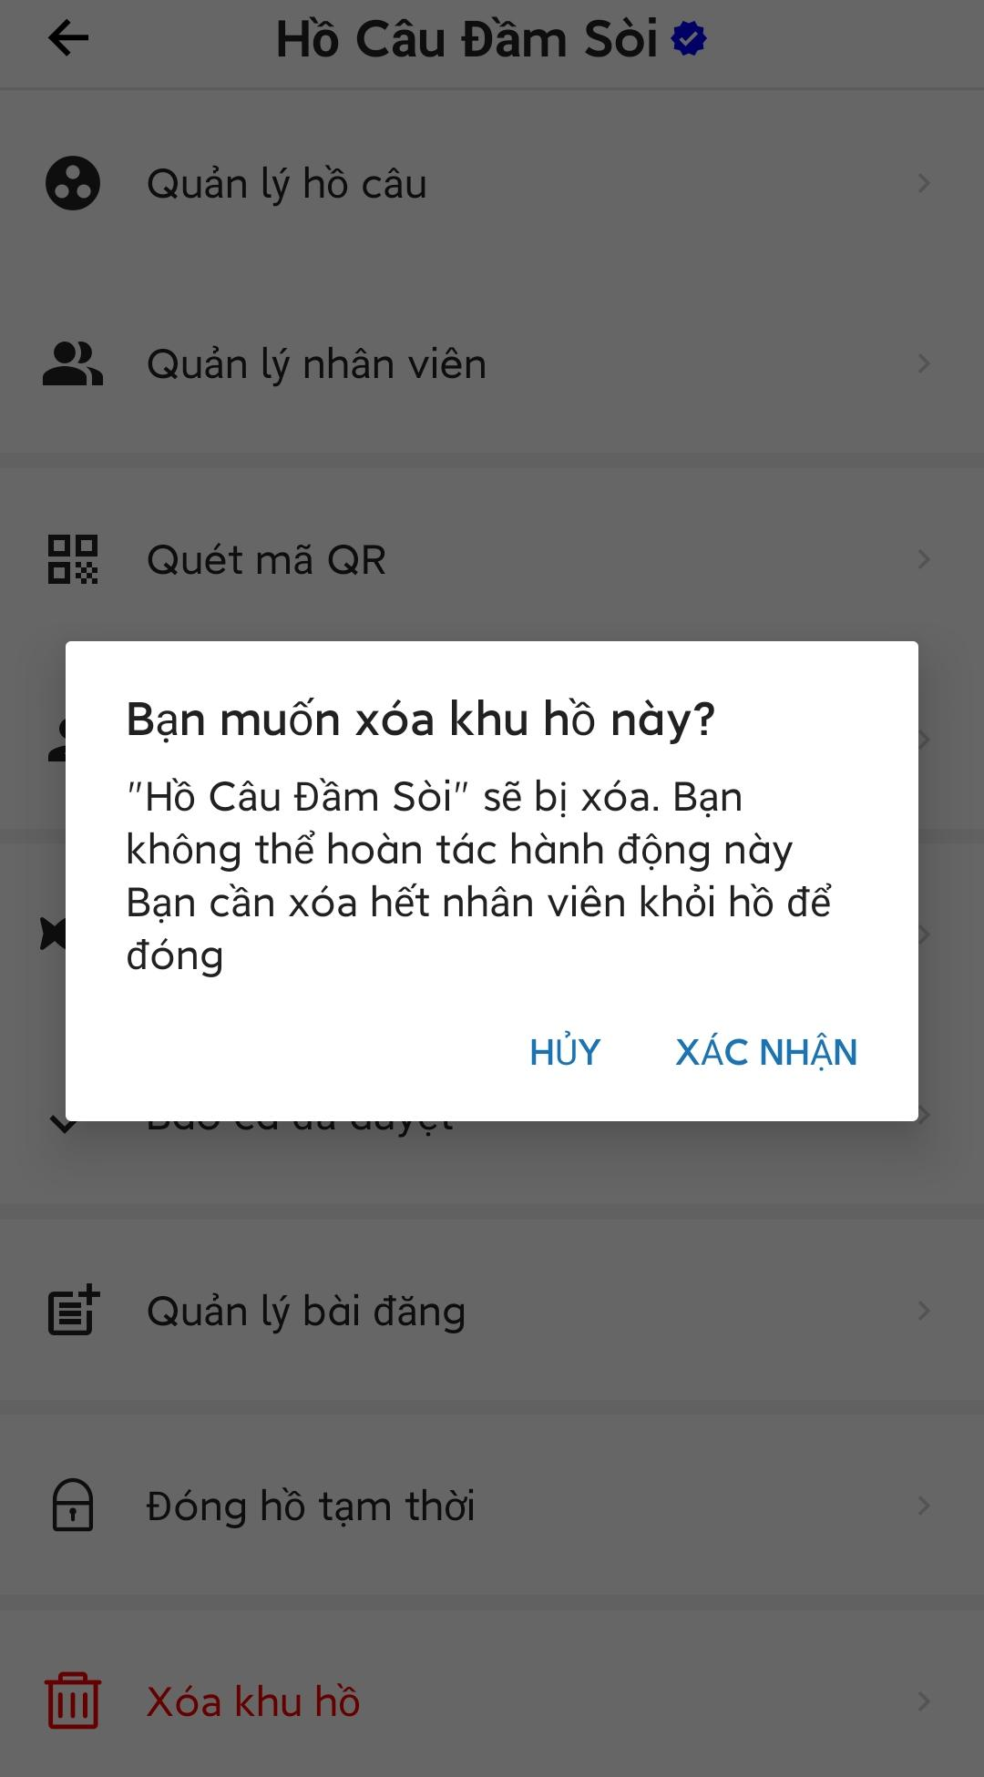

Figure 3.3.14.10. Delete fishing location

#### 3.3.15. Check-out, report catches in a check-in

* Open “Báo cá” tab at the main screen.
* Check-in at a fishing location by letting owner/staffs of the fishing location scan user QR code.
* Press “Kiểm tra trạng thái” to re-check check-in status, if user already checked in a fishing location, the screen would show a screen with fishing location information and 2 buttons to check-out and report catches.
* User can press “Checkout” to check out without report catches.
* User press “Báo kết quả câu” to open report catches screen.
* Fill the form then press “Gửi và checkout” to report catches.

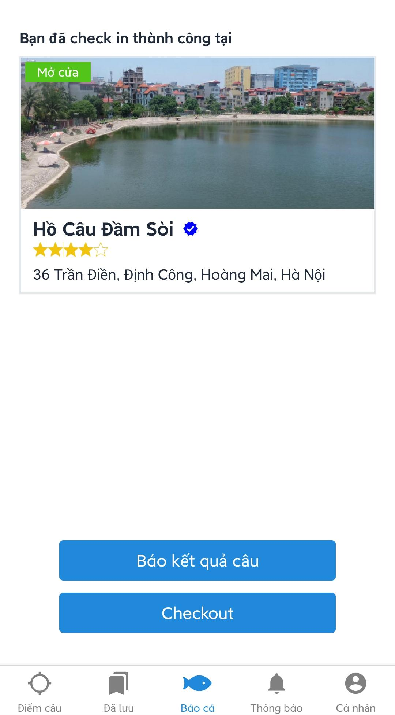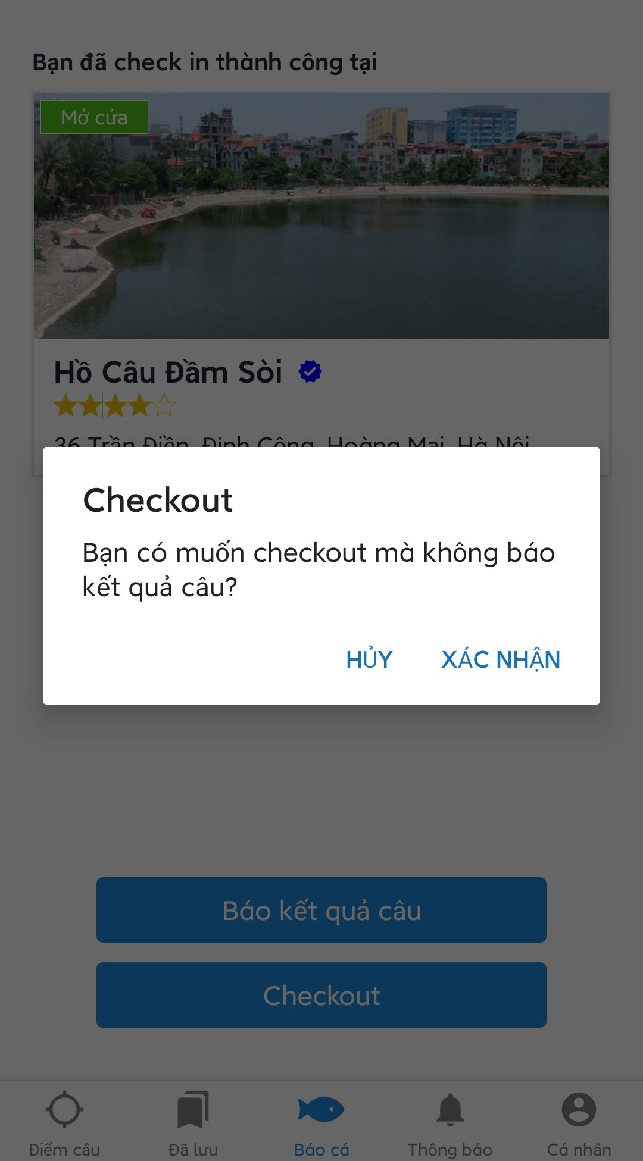

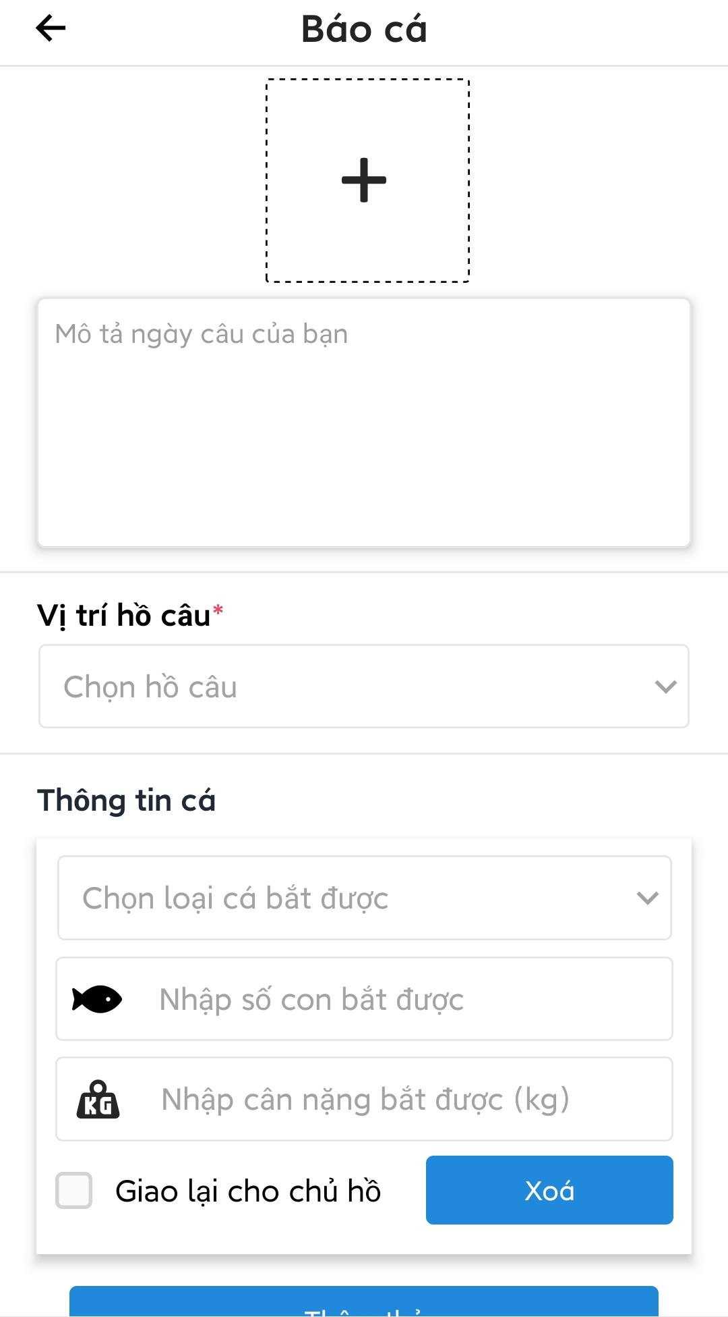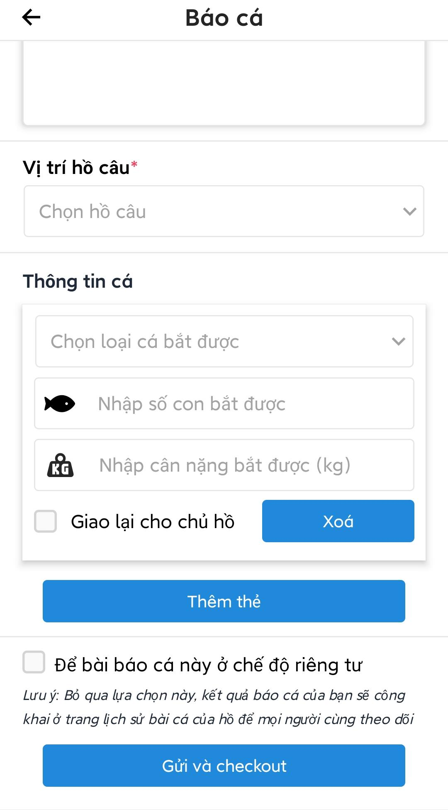

Figure 3.3.15. Check-out, report catches in a check-in

#### 3.3.16. Suggest a fishing location

* Press  icon at the header of advanced search screen or manageable fishing location list screen to open suggestion screen.
* Fill the form then press “Gửi” to send suggestion to admin.



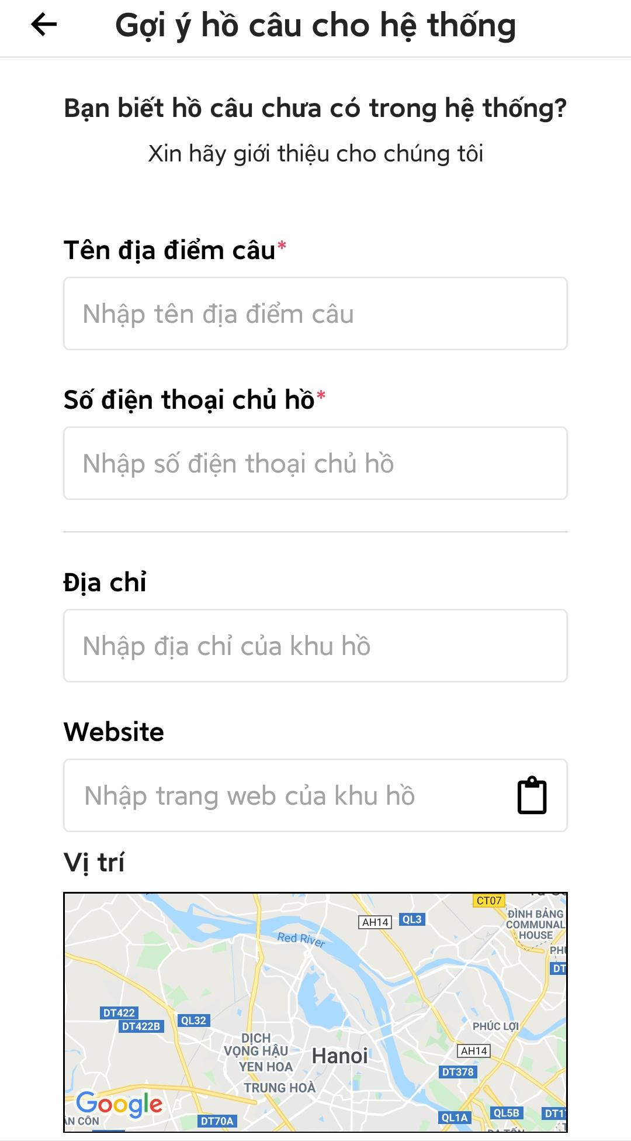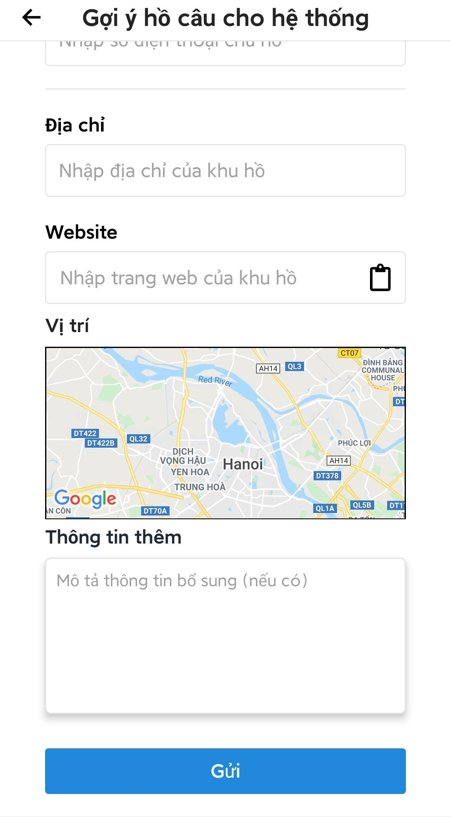

Figure 3.3.16. Suggest a fishing location

#### 3.3.17. Logout

* Open main screen.
* Press “Cá nhân” to open menu screen.
* Press “Đăng xuất” to logout.



Figure 3.3.17. Logout

### 3.4. Admin

* Open the app.
* Login with admin account, the screen will redirect to admin main screen.

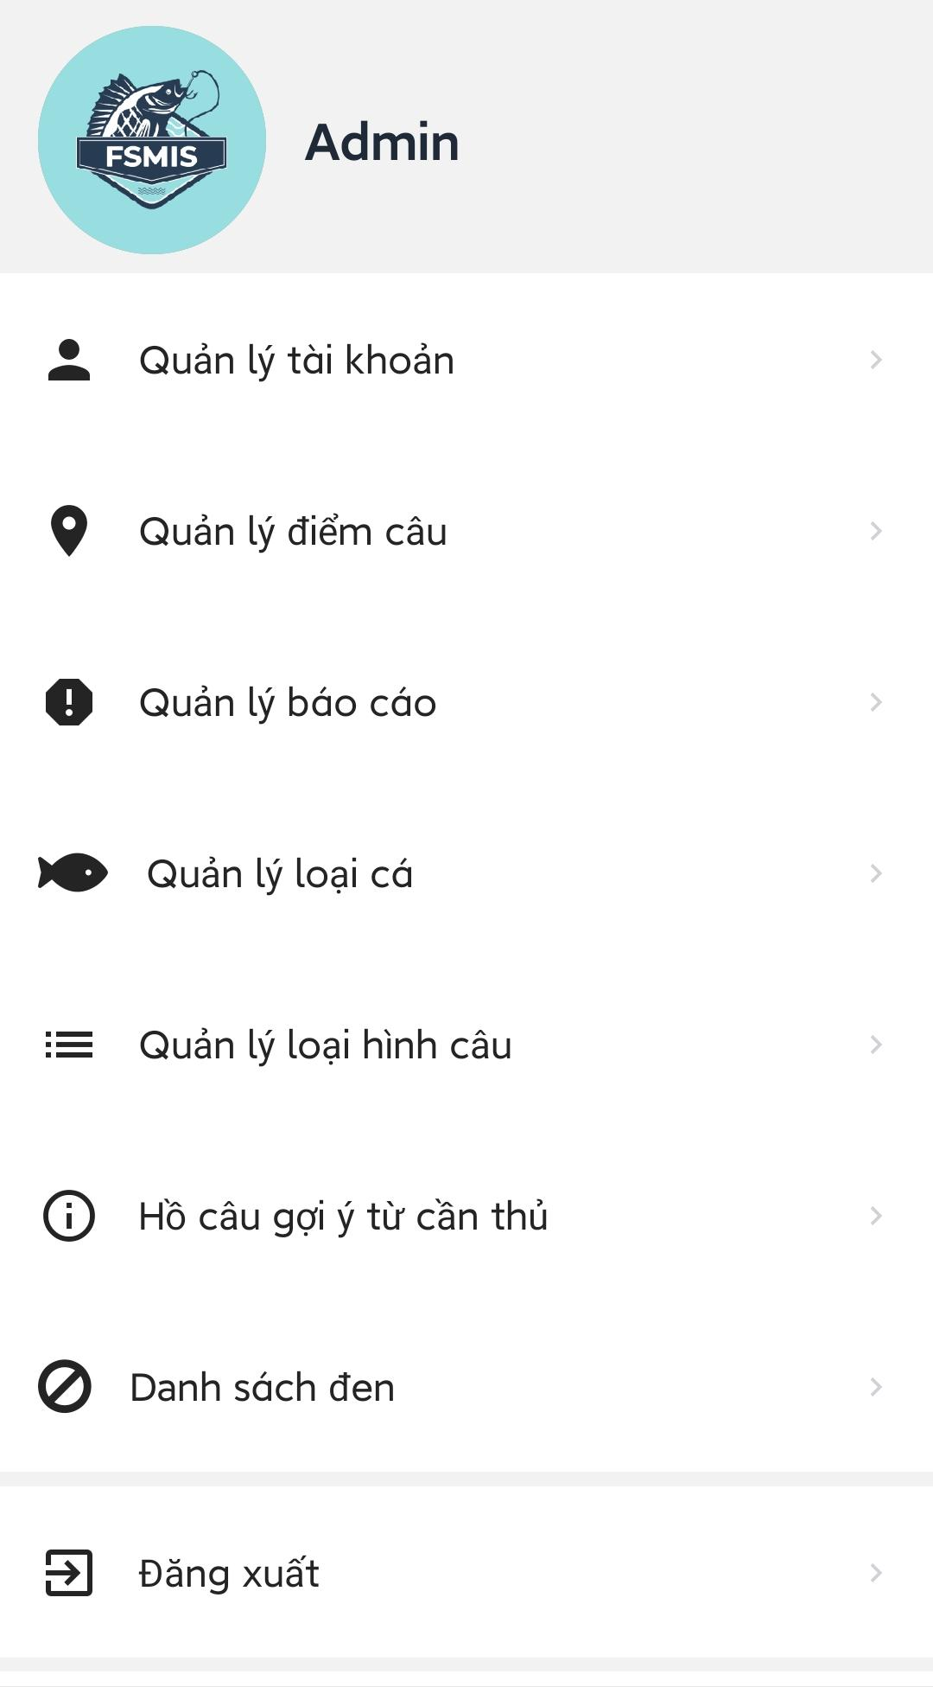

Figure 3.4. Admin login screen

#### 3.4.1. Account management

* Open admin main screen.
* Press “Quản lý tài khoản” to open account management screen.
* Admin can enter keywords to search for some specific accounts.

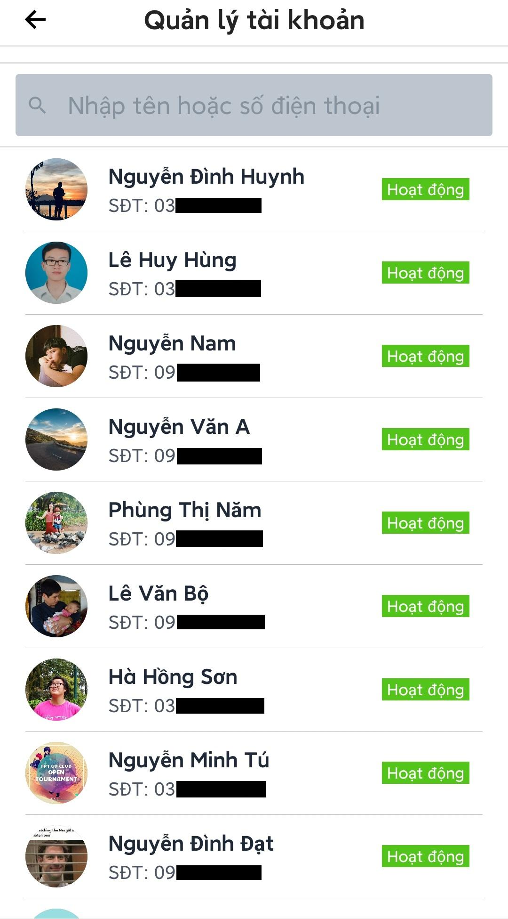

Figure 3.4.1. Account management

##### 3.4.1.1. Search accounts

* Open account management screen.
* Enter keywords to search (Admin can search by name or phone number, the system will search for all accounts with username and phone number that contain the keyword).
* List of matched account will be displayed.

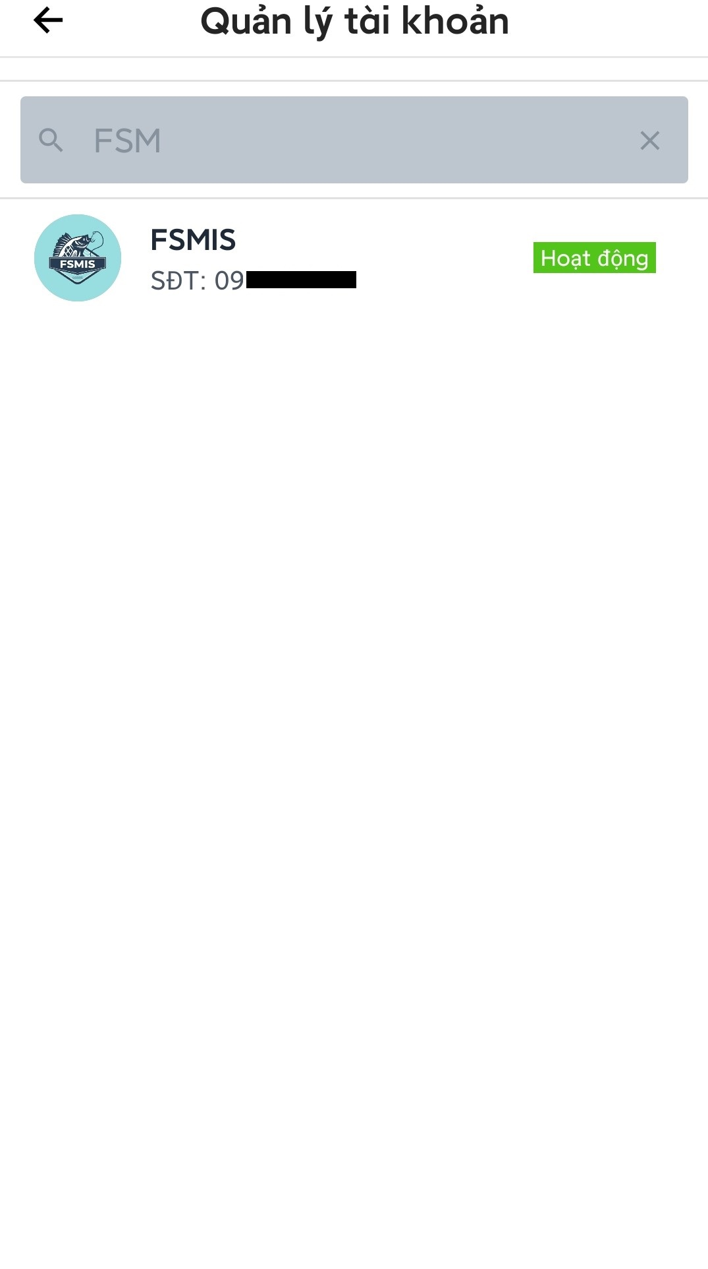

Figure 3.4.1.1. Search accounts

##### 3.4.1.2. Activate/Deactivate an account

* Open account management screen.
* Press on an account to open account detail screen.

Note: the button will change depend on active status of the account.

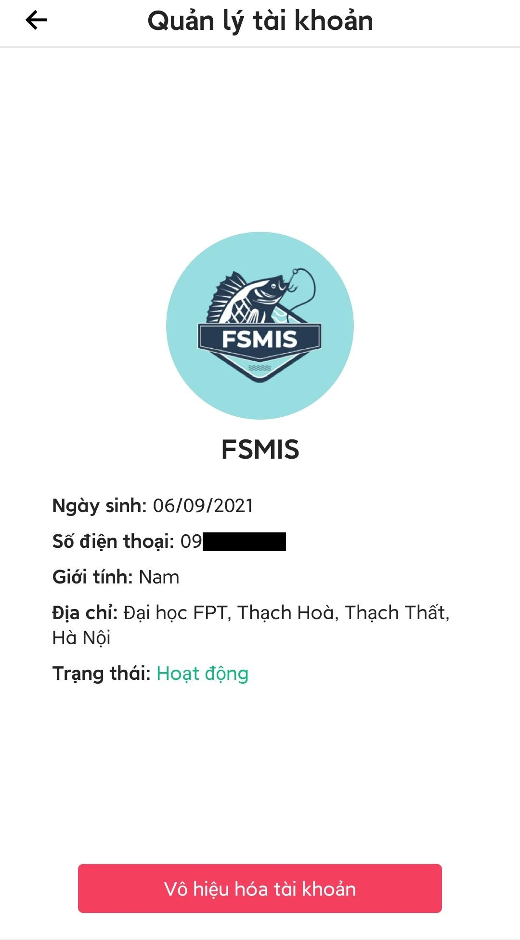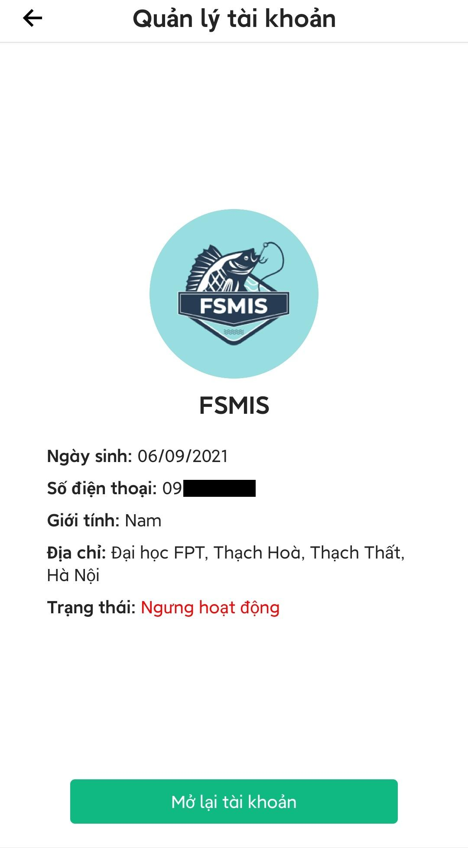

Figure 3.4.1.2. Activate/Deactivate an account

###### 3.4.1.2.1. Deactivate account

* Open account detail screen.
* Press “Vô hiệu hóa tài khoản”, deactivate account screen will be displayed.
* Enter reason and image (optional), then press “Vô hiệu hóa tài khoản”.
* An alert box will appear to confirm the action, press “Xác nhận” to deactivate the account.

Note:

* Account that had been deactivated will be listed in the blacklist.
* Account that had been deactivated won’t be able to participate in the application.

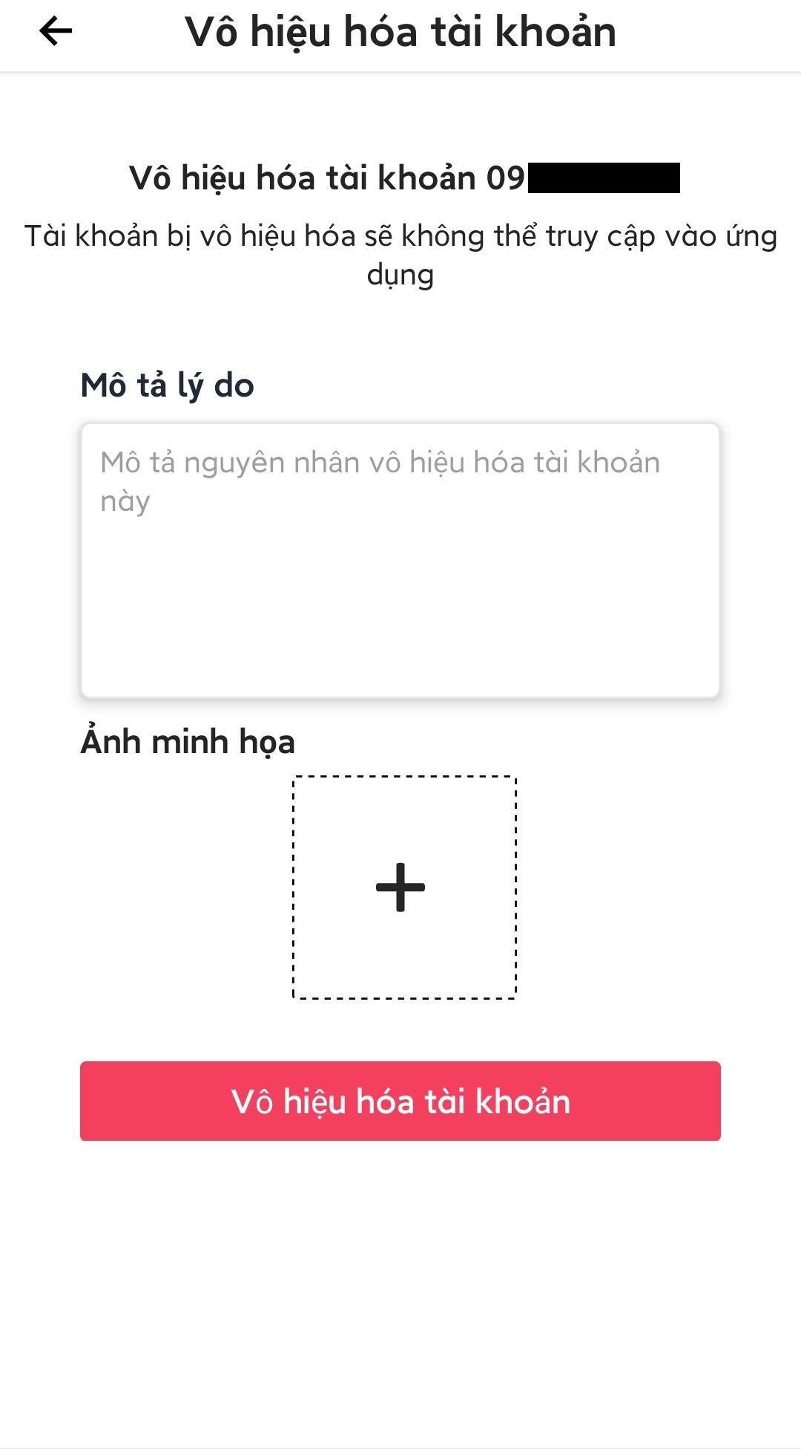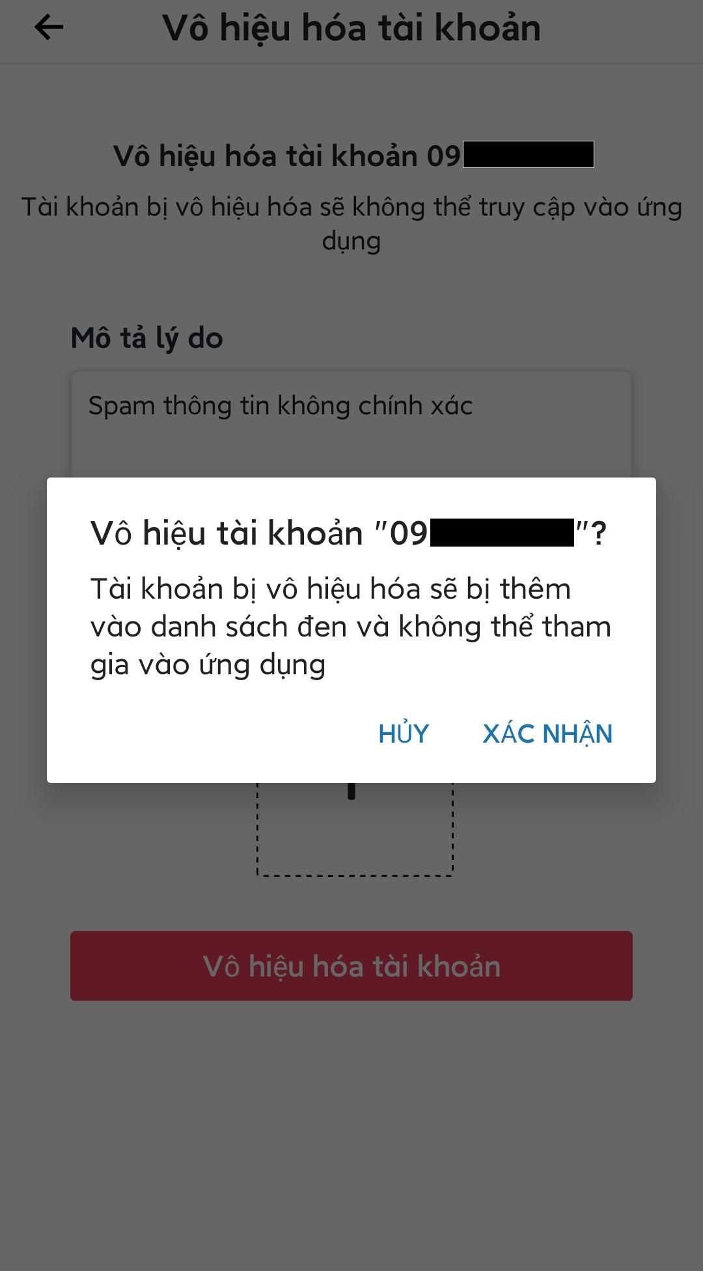

Figure 3.4.1.2.1. Deactivate account

###### 3.4.1.2.2. Activate account

* Open account detail screen.
* Press “Mở lại tài khoản”, an alert box will be displayed to confirm the action.
* Press “Xác nhận” to activate the account.

Note: activate an account will remove that account from the blacklist.

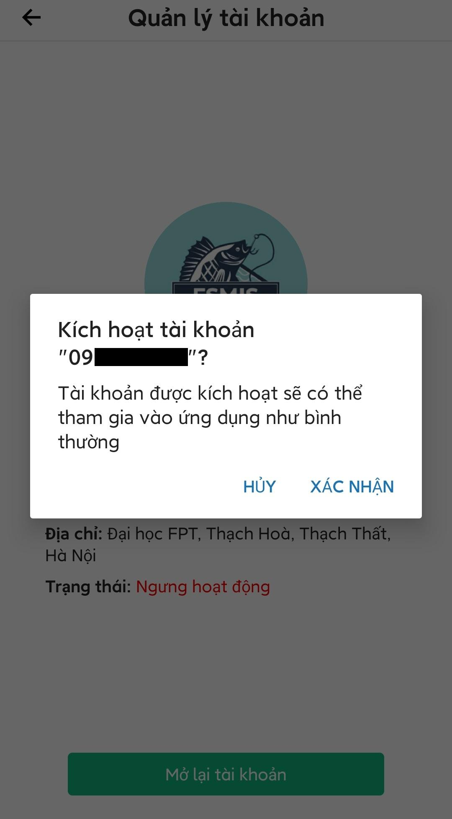

Figure 3.4.1.2.2. Activate Account

#### 3.4.2. Blacklist management

* Open admin main screen.
* Press “Danh sách đen” to open blacklist management screen.
* Admin can search for specific banned phone numbers by entering search keywords.
* Admin can press on a record of banned phone to view detail.

Note: All the phone number in the blacklist won’t be able to participate in the application.

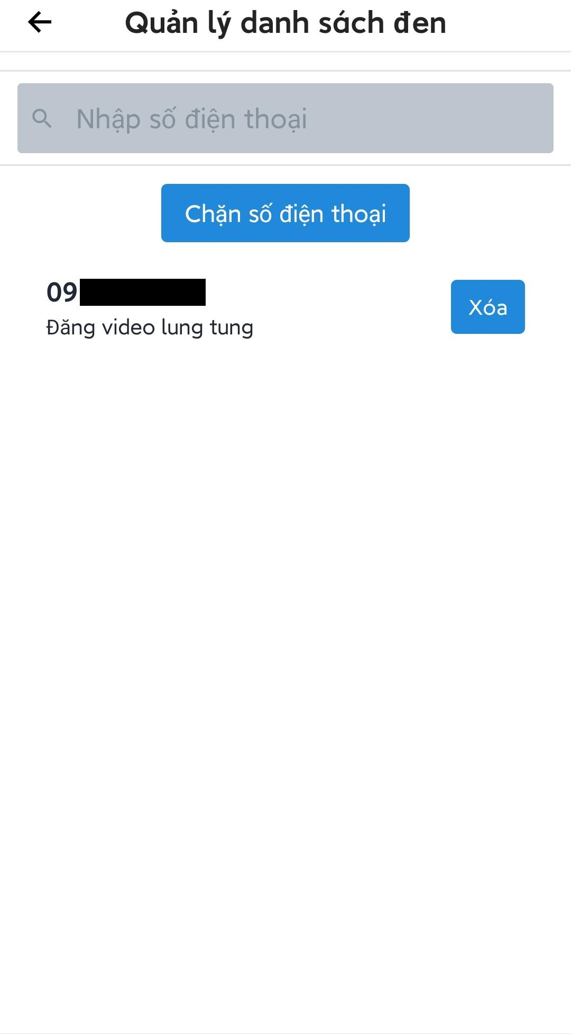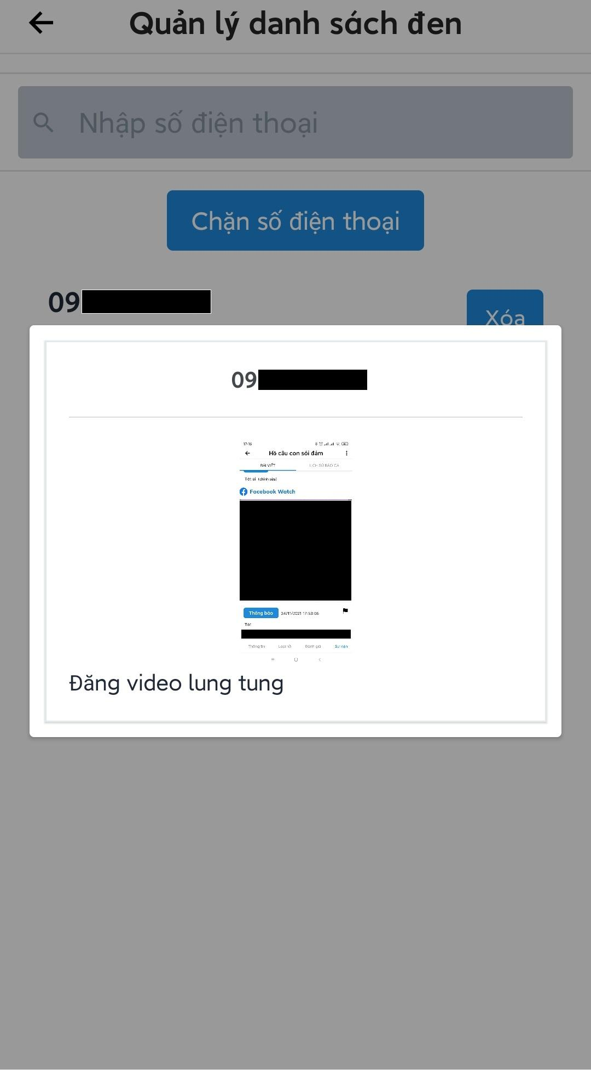

Figure 3.4.2. Blacklist management

##### 3.4.2.1. Remove a phone number from blacklist

* Open blacklist management screen.
* Press “Xóa” on the record that needs to be remove, an alert box will appear to confirm the action.
* Press “Xác nhận” to remove the phone number from the blacklist.

Note: if the phone number that is removed is an account in the system, that account will automatically be activate.

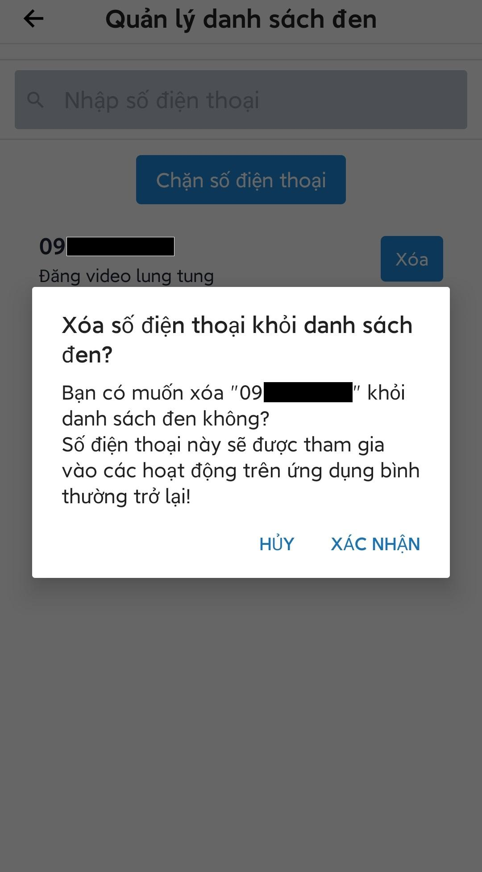

Figure 3.4.2.1. Remove a phone number from blacklist

##### 3.4.2.2. Add a phone number to blacklist

* Open blacklist management screen.
* Press “Chặn số điện thoại” to open screen to add new phone number to blacklist.
* Fill the form then press “Chặn” to add the phone number to blacklist.

Note: If there was an account in the system use the banned phone number, that account will automatically be deactivated.

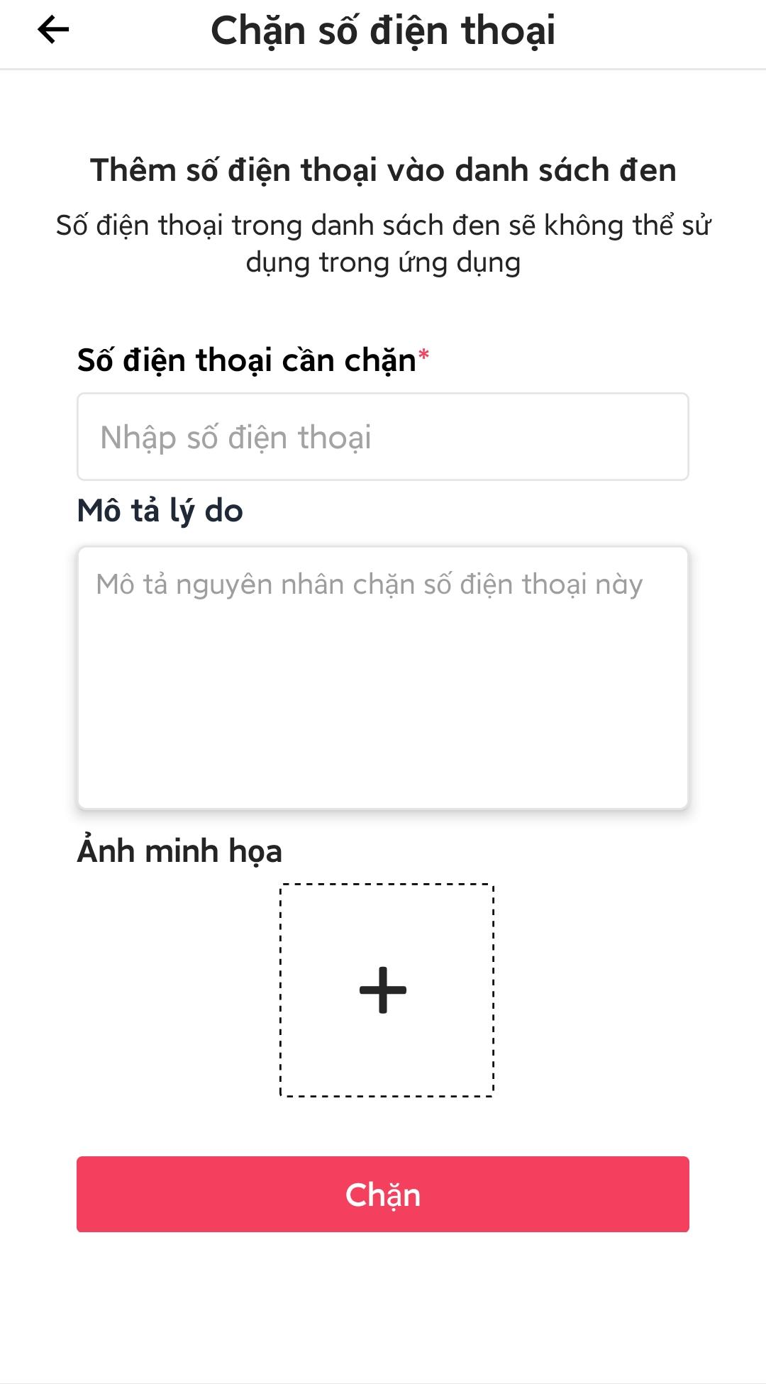

Figure 3.4.2.2. Add a phone number to blacklist

#### 3.4.3. Fishing locations management

* Open the admin main screen.
* Press “Quản lý điểm câu” to open fishing locations management screen.
* Admin can search for fishing locations by name.
* Admin can filter list of fishing locations by active status or verification status.
* Admin can press on a fishing location to view location detail.

Note: Inactive fishing locations have red border, active fishing location have green border.

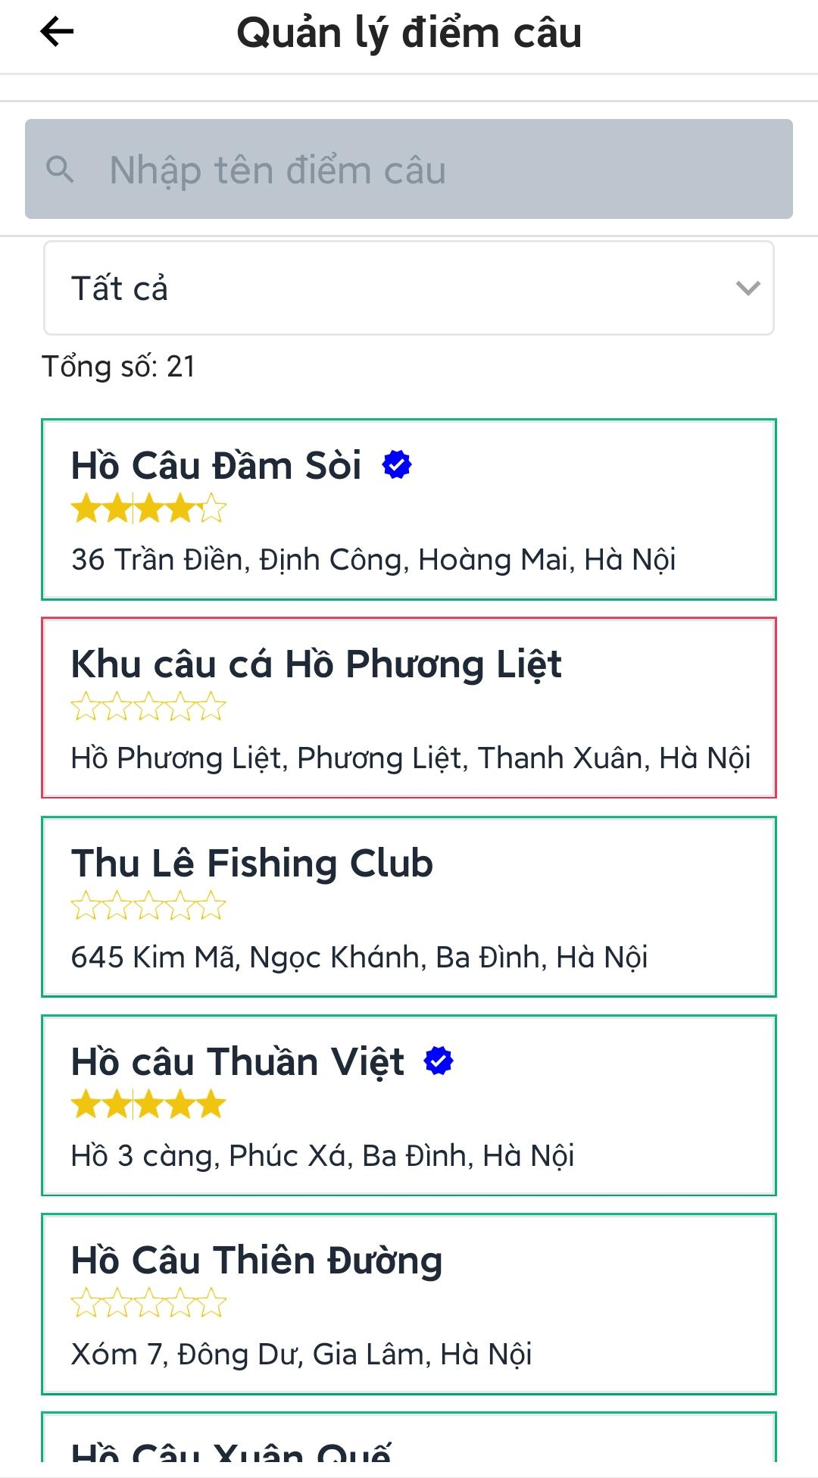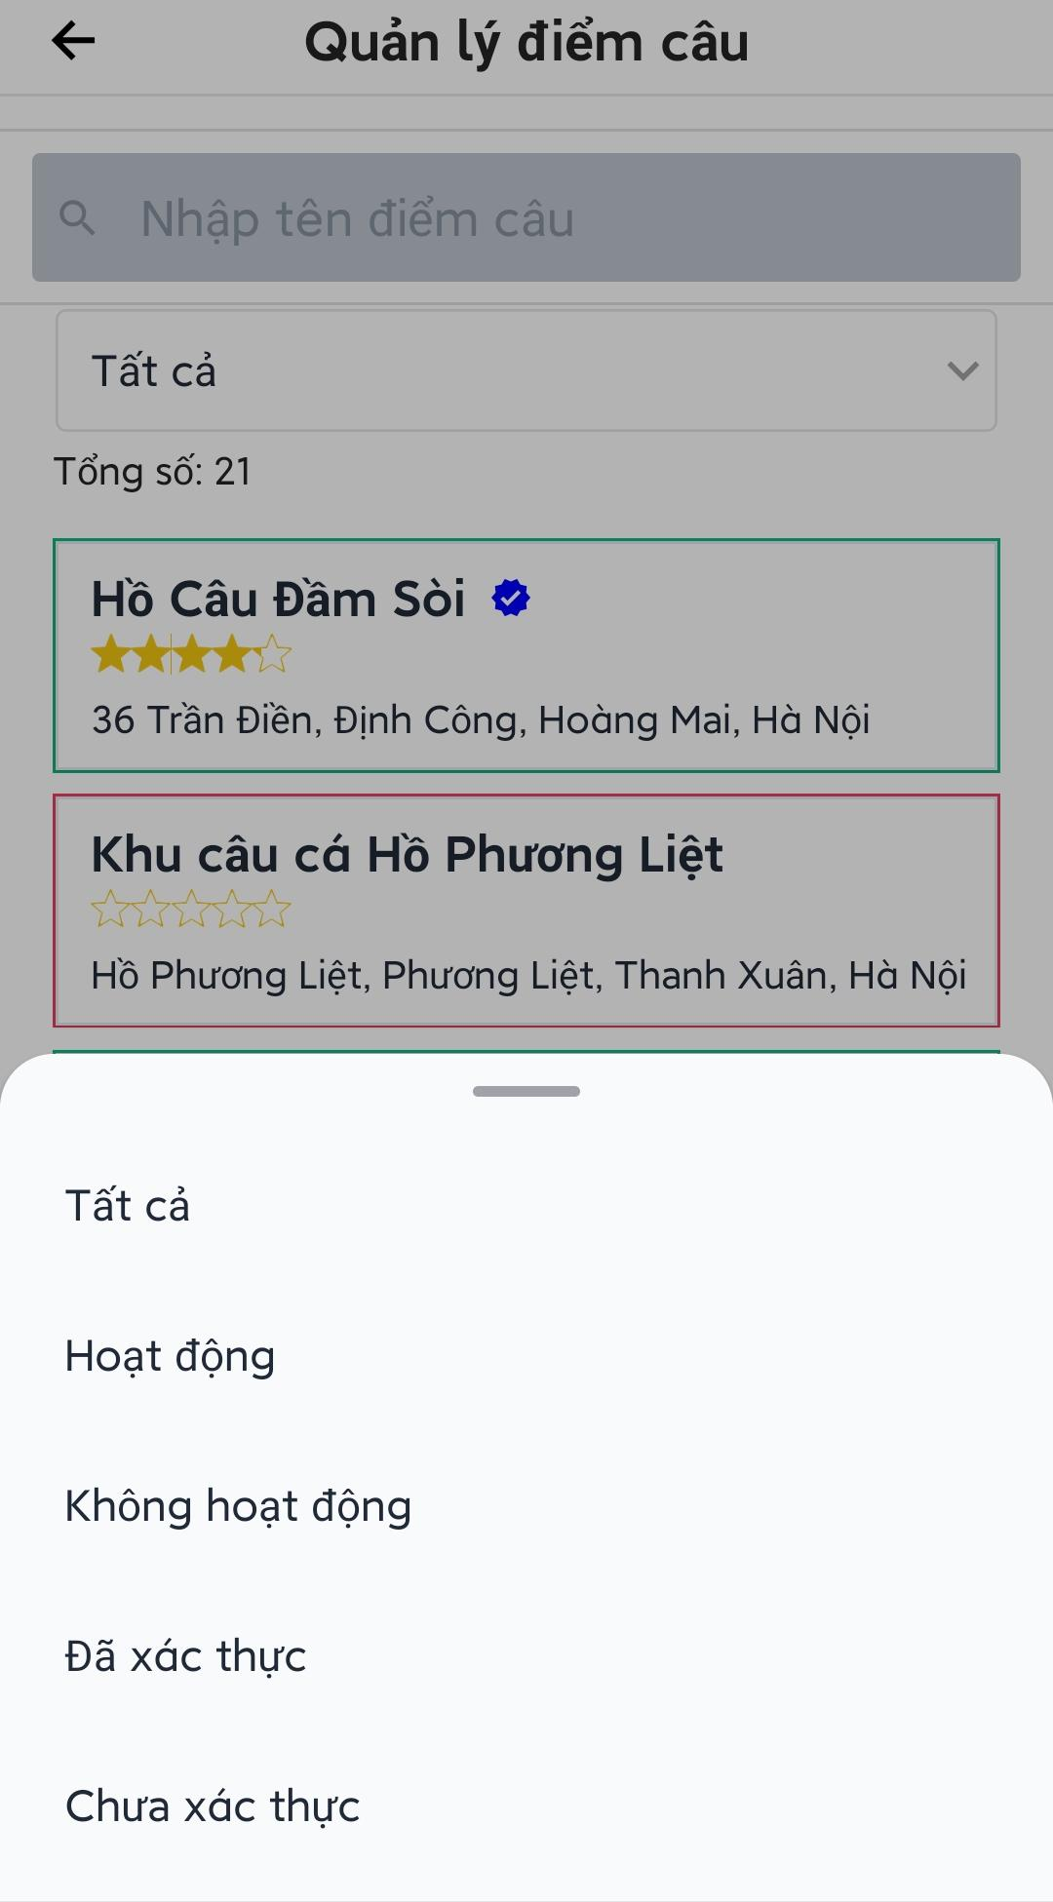

Figure 3.4.3. Fishing location management

##### 3.4.3.1. Activate/Deactivate a fishing location

* Open fishing locations management screen.
* Press on a fishing location to view detail screen.
* Press  icon to show menu options.
* Press “Kích hoạt”/”Vô hiệu hóa” to activate/deactivate the fishing location, an alert box will appear to confirm the action.
* Press “Xác nhận” to confirm the action.

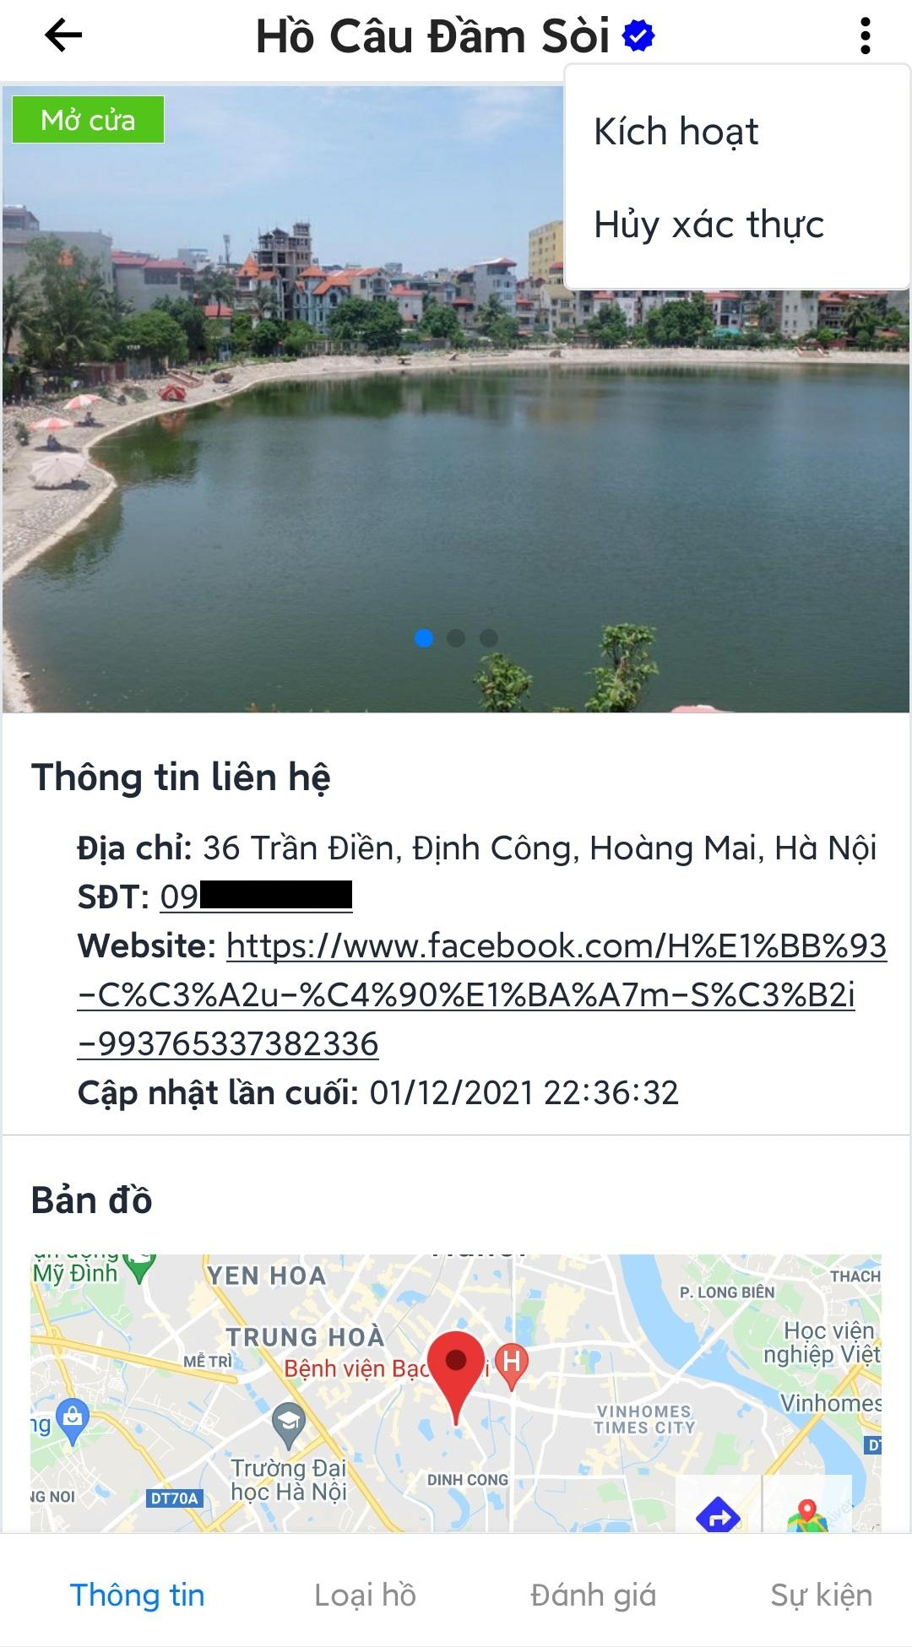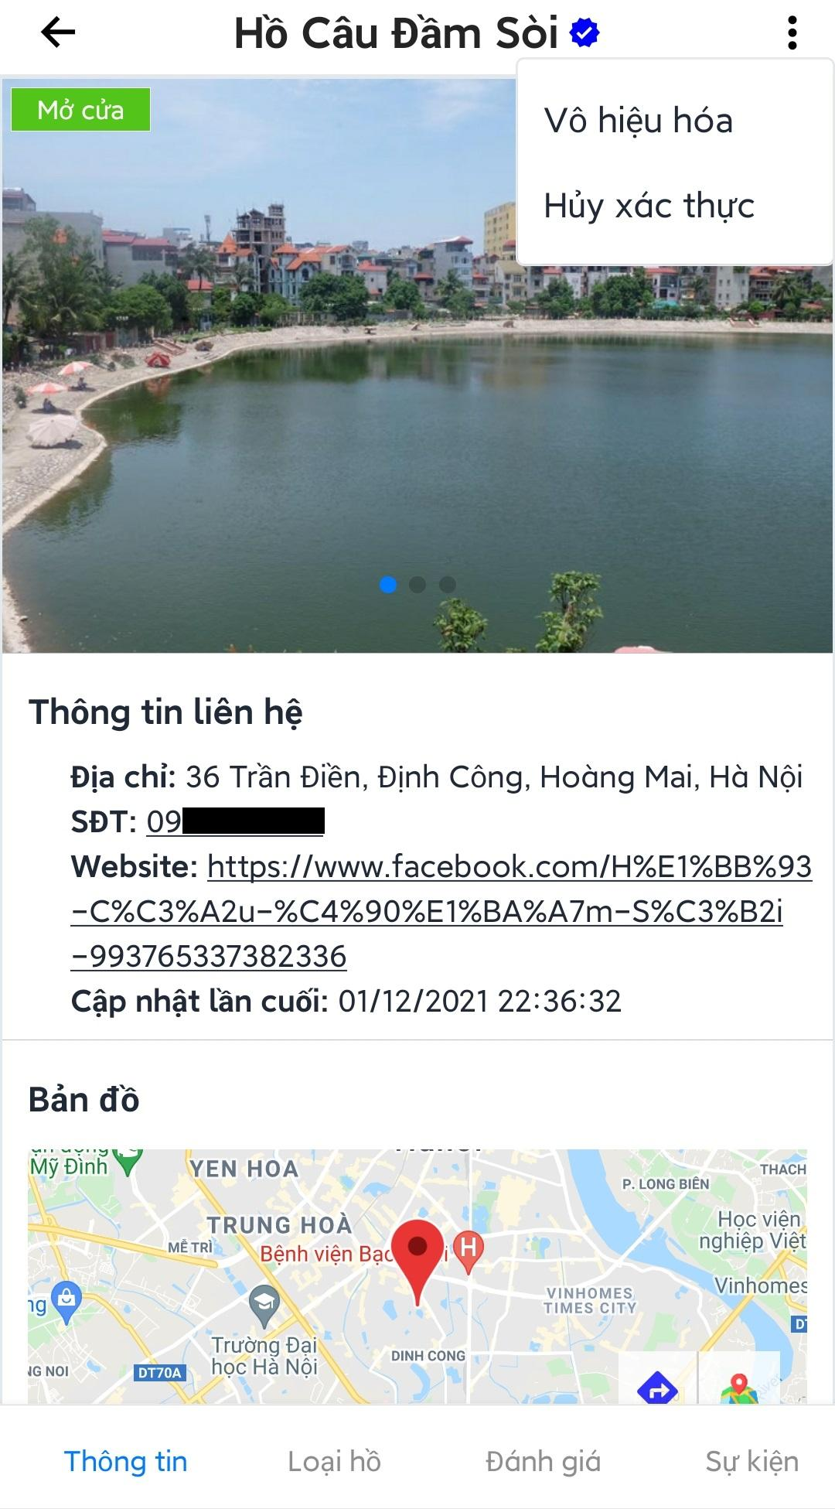

Figure 3.4.3.1. Activate/Deactivate a fishing location

##### 3.4.3.2. Verify/unverified a fishing location

* Open fishing locations management screen.
* Press on a fishing location to view detail screen.
* Press  icon to show menu options.
* Press “Xác thực”/”Hủy xác thực” to verify/unverified the fishing location, an alert box will appear to confirm the action.
* Press “Xác nhận” to confirm the action.

Note: verified fishing location will have  icon next to the name.

#### 3.4.4. Fish management

* Open admin main screen.
* Press “Quản lý loại cá” to open fish management screen.
* Admin can search fish by name.
* Admin can press on a fish to open edit screen.

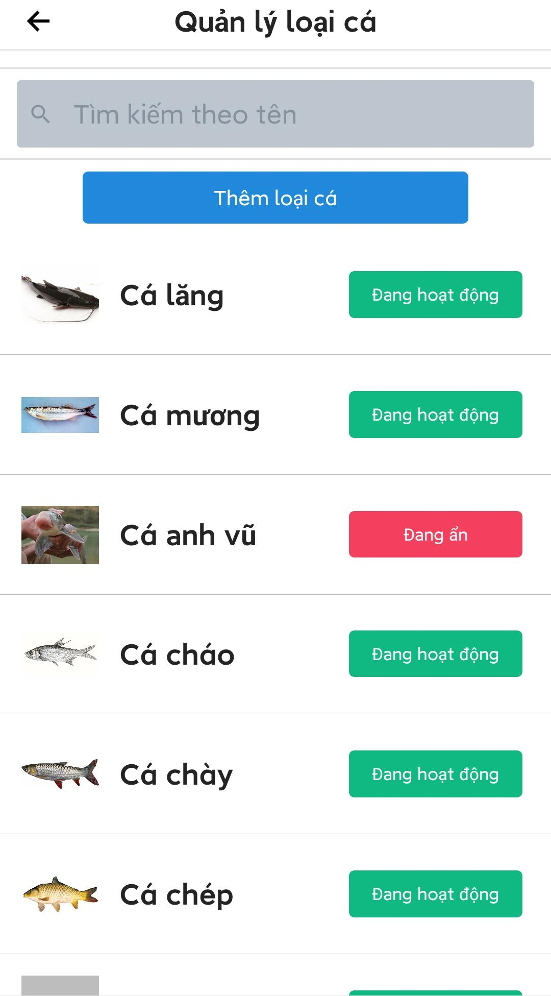

Figure 3.4.4. Fish management

##### 3.4.4.1. Add new fish

* Open fish management screen.
* Press “Thêm loại cá” to open add fish screen.
* Choose image and enter name of the fish.
* Press “Thêm loại cá”.

Note: To change image after choosing, admin need to press and hold on the image till the application show an alert box to delete the current image.

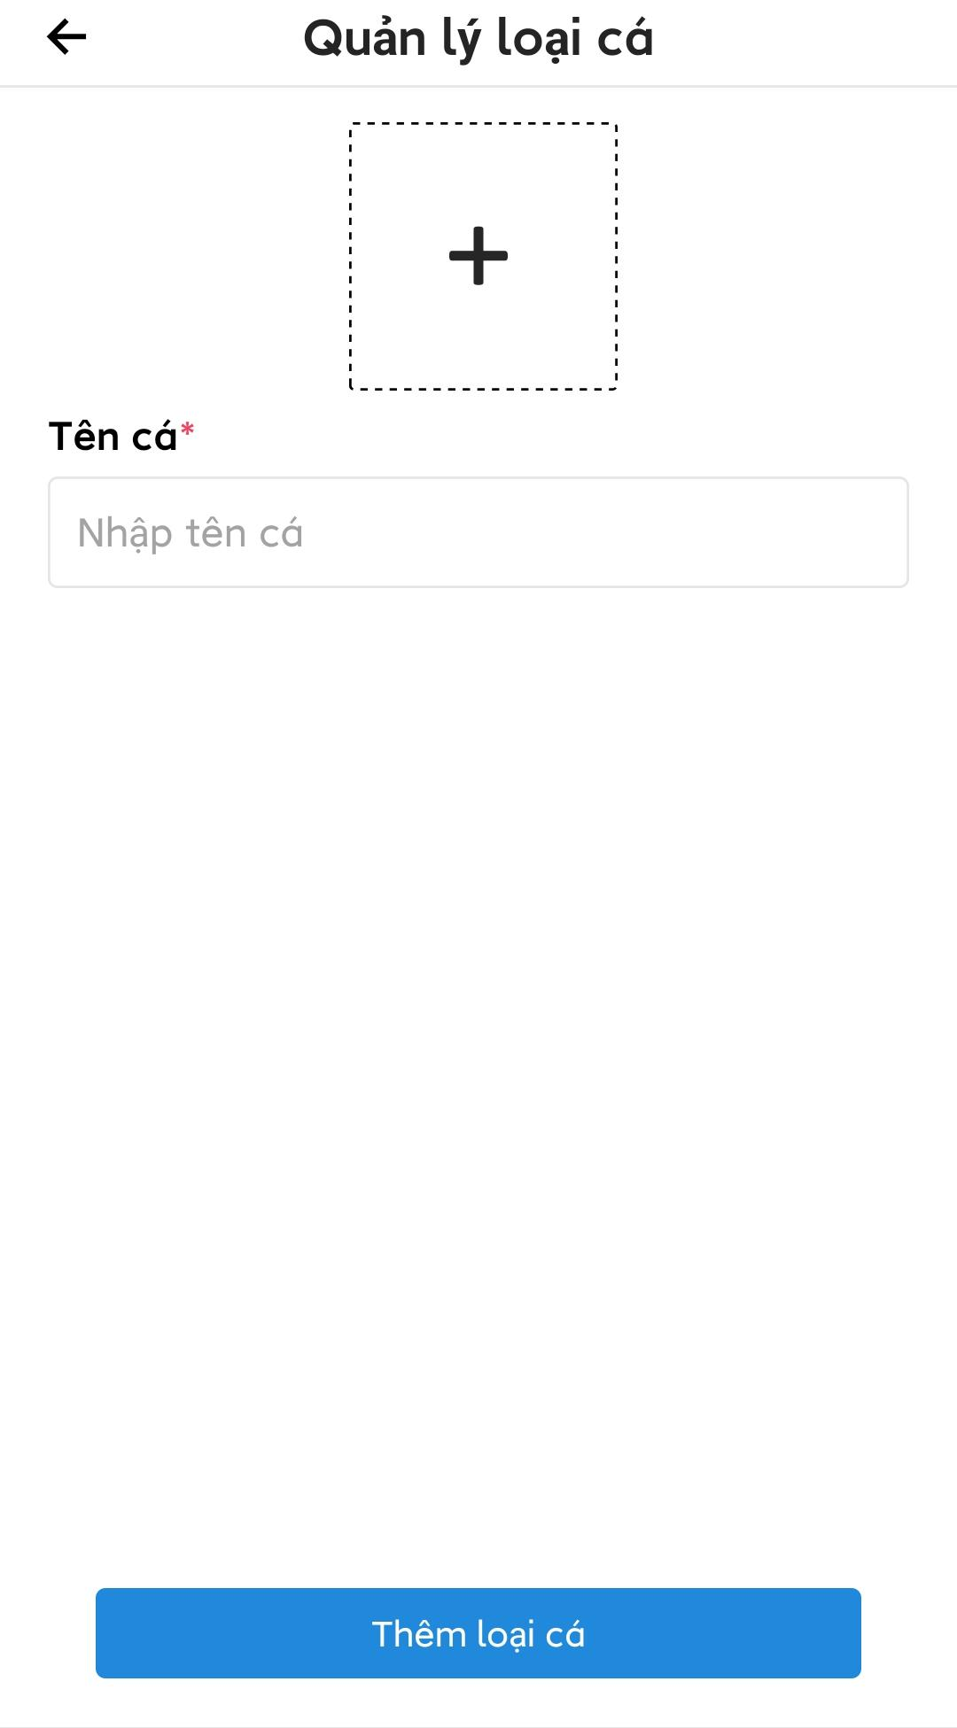

Figure 3.4.4.1. Add new fish

##### 3.4.4.2. Edit a fish species

* Open fish management screen.
* Press on a fish to open edit screen.
* Admin can edit the fish information by change image and name then press “Lưu thay đổi to save changes.
* Admin can change visibility status of the fish by press “Ẩn loại cá này”/”Bỏ ẩn loại cá này” to hide/unhide the fish.

Note: The fish that had been change to hidden status won’t be seen by the user when search or edit fish in lake.

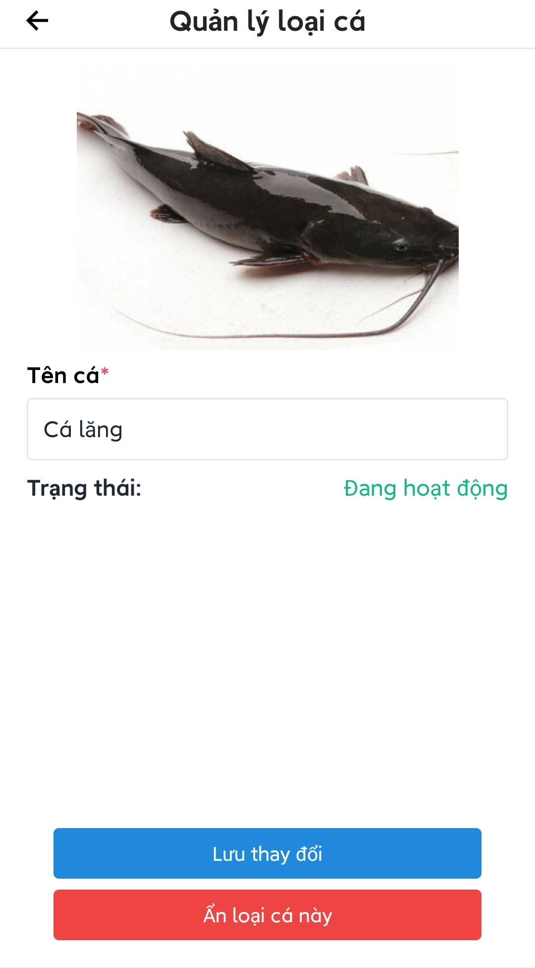

Figure 3.4.4.2. Edit a fish species

#### 3.4.5. Fishing methods management

* Open admin main screen.
* Press “Quản lý loại hình câu” to open fishing methods management screen.
* Admin can search fishing methods by name.

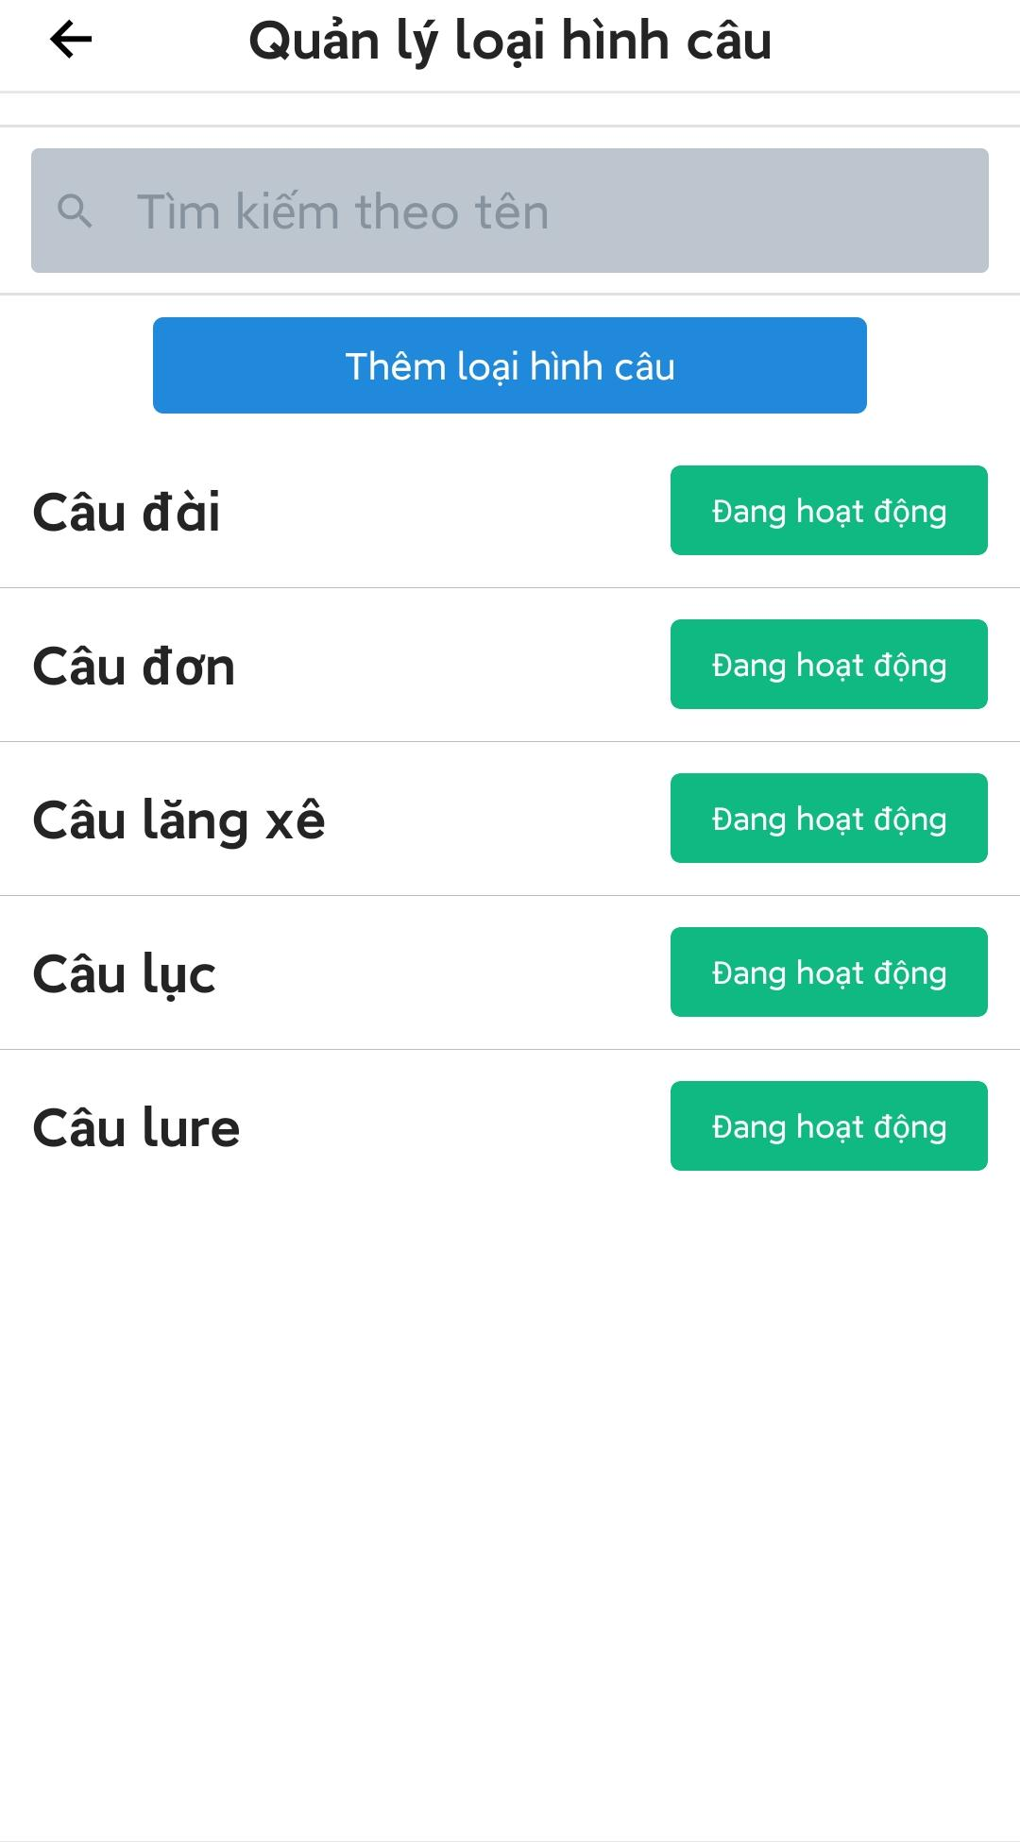

Figure 3.4.5. Fishing methods management

##### 3.4.5.1. Add new fishing method

* Open fishing methods management screen.
* Press “Thêm loại hình câu”, a screen to add new fishing method will be displayed.
* Enter the name of the fishing method.
* Press “Thêm loại hình hình câu” to add new fishing method.

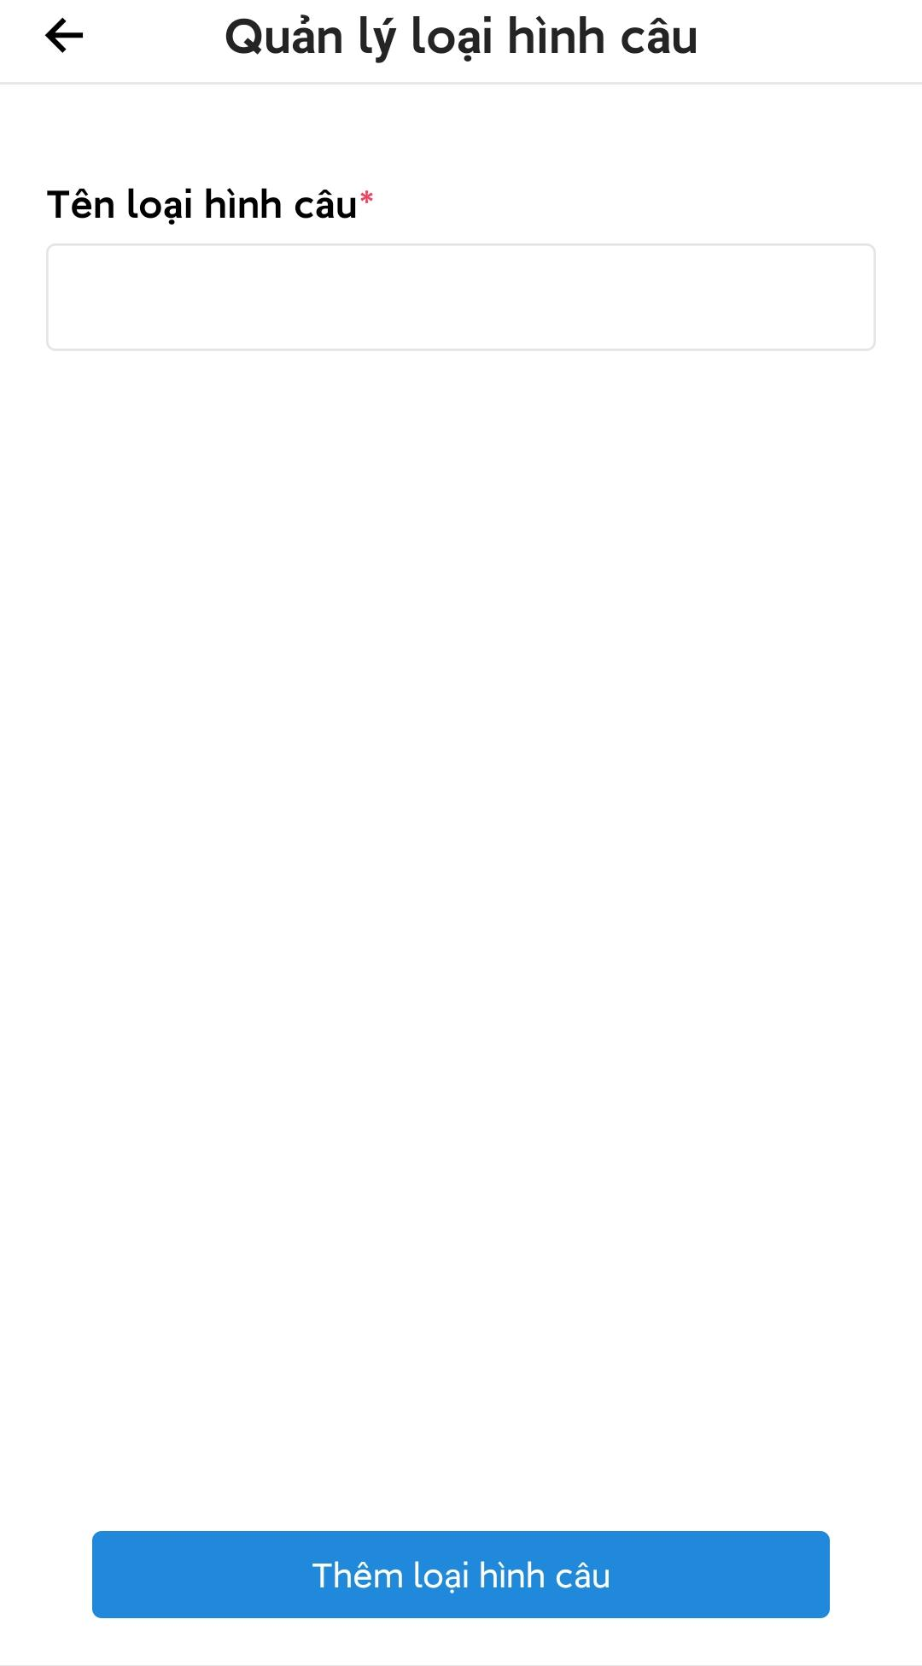

Figure 3.4.5.1. Add new fishing method

##### 3.4.5.2. Edit fishing method

* Open fishing methods management screen.
* Press on a fishing method to open edit screen.
* Admin can change visibility status of the fishing method by press “Ẩn loại hình câu này”/”Bỏ ẩn loại hình câu này” to hide/unhide the fishing method.
* Admin can change fishing method name then press “Lưu thay đổi” to save change.

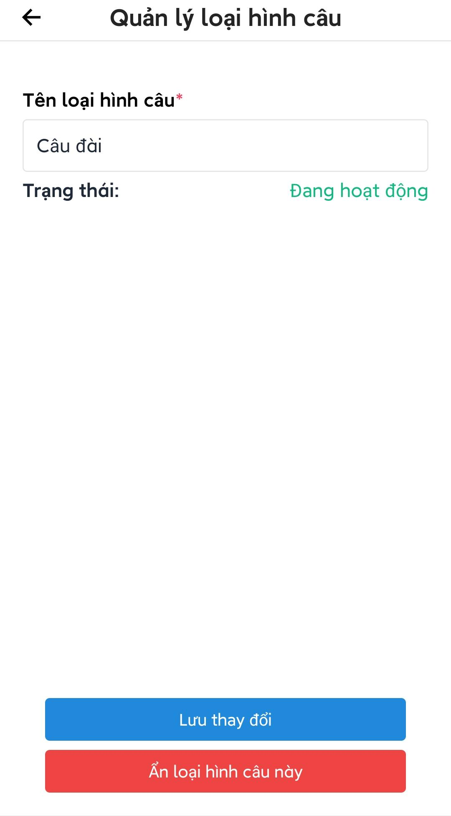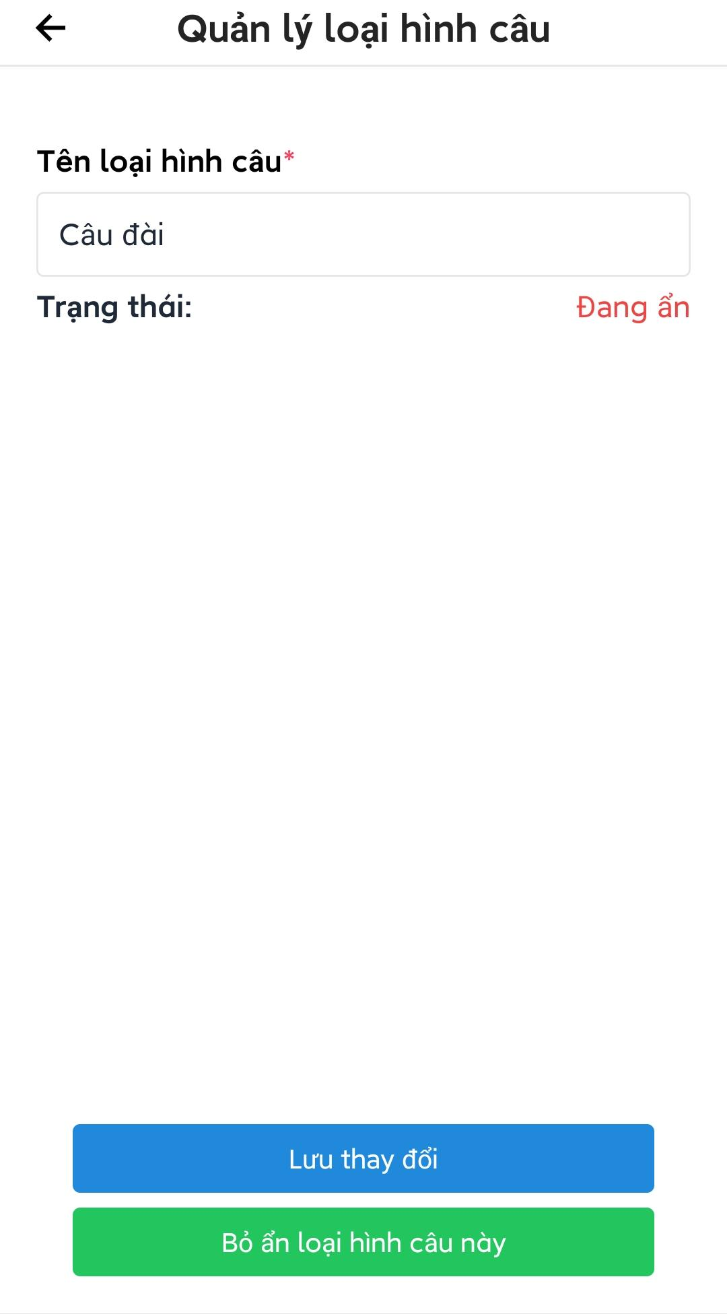

Figure 3.4.5.2. Edit fishing method

#### 3.4.6. Suggested fishing locations management

* Open admin main screen.
* Press “Hồ câu gợi ý từ cần thủ” to view all suggested fishing locations.
* Admin can press on a record to view detail.

Note: Record that marked as helpful will have  icon.

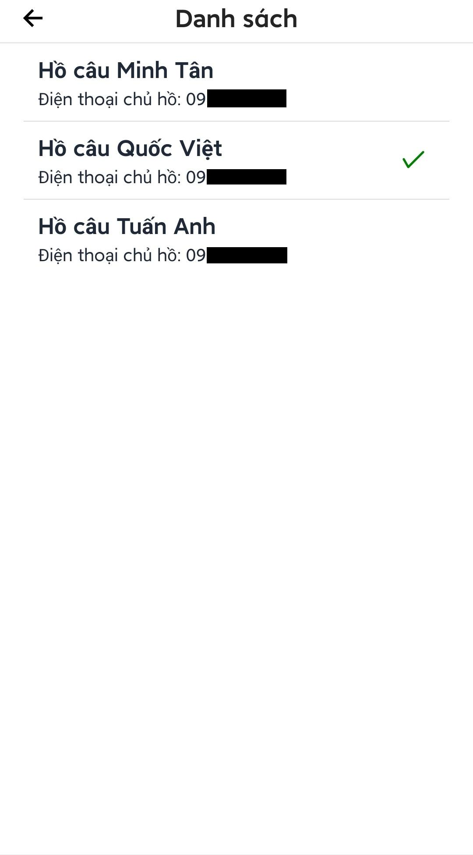

Figure 3.4.6. Suggested fishing locations management

##### 3.4.6.1. Mark suggested location record as helpful

* Open suggested fishing locations management screen.
* Press on a record to view detail.
* Press “Đánh dấu hữu ích”, an alert box will appear to confirm the action.
* Press “Xác nhận” to mark record as helpful, a notification will be sent to the user suggesting the fishing location.

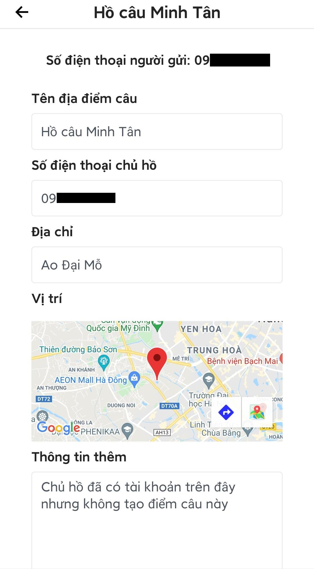

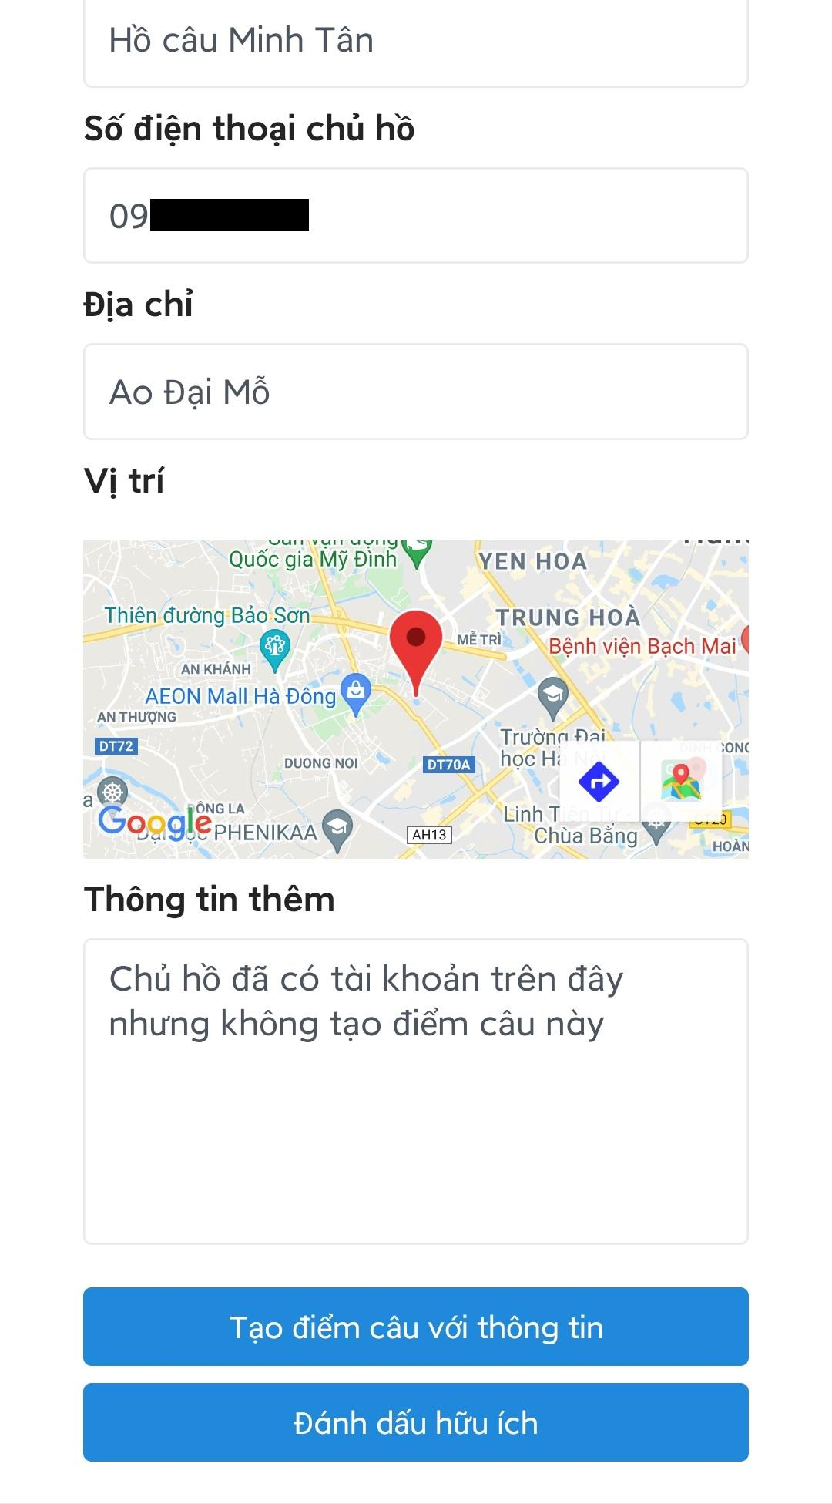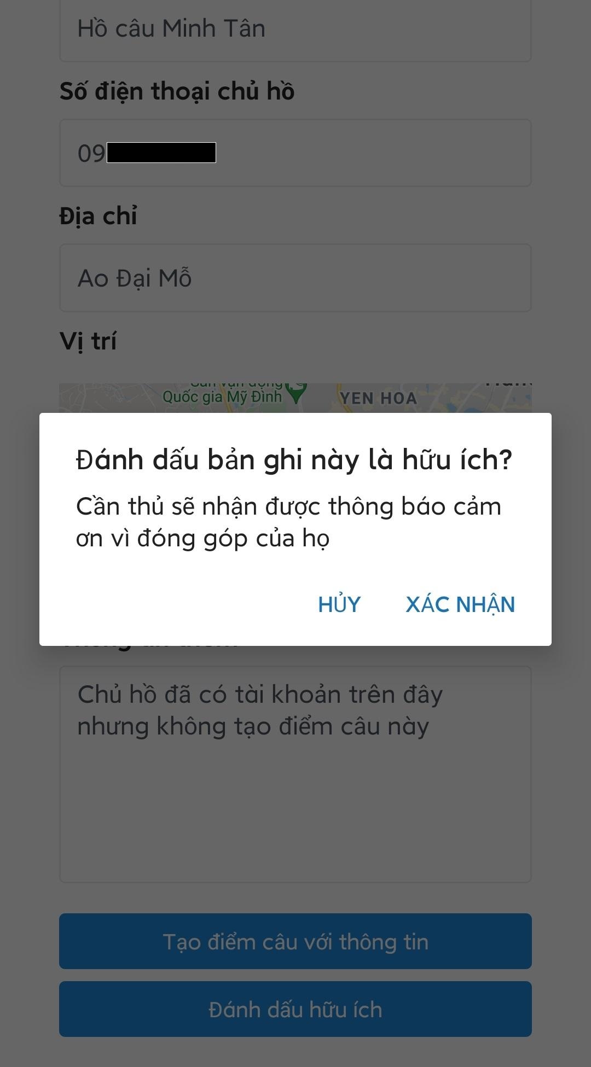

Figure 3.4.6.1. Mark suggested location record as helpful

##### 3.4.6.2. Create new pending fishing location from suggested information

* Open suggested fishing locations management screen.
* Press on a record to view detail.
* Press “Tạo điểm câu với thông tin”, a screen to create new fishing location will appear, the data in the suggested record will be auto filled to the form.
* Enter data to the form.
* Press “Thêm điểm câu” to create a pending fishing location.

Note:

* The pending fishing location will automatically be inactive and will not be visible by users.
* If there was an account with the same phone number with the fishing location, or new account created with the same phone number, the pending fishing location will automatically be assigned to the account.

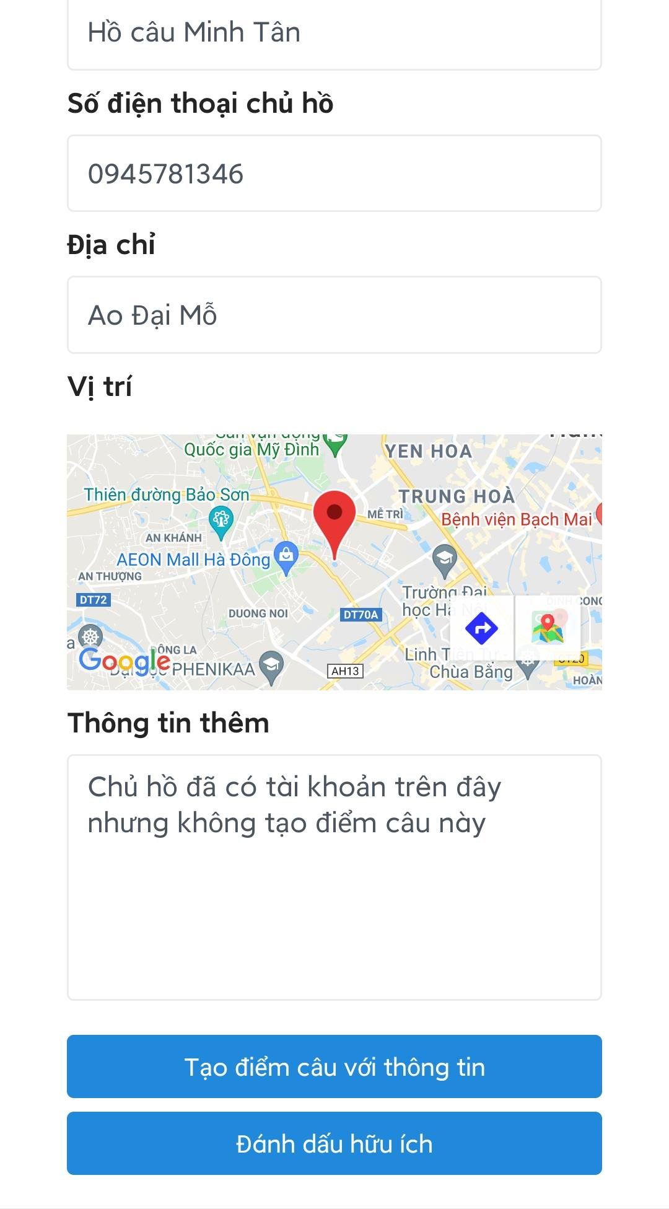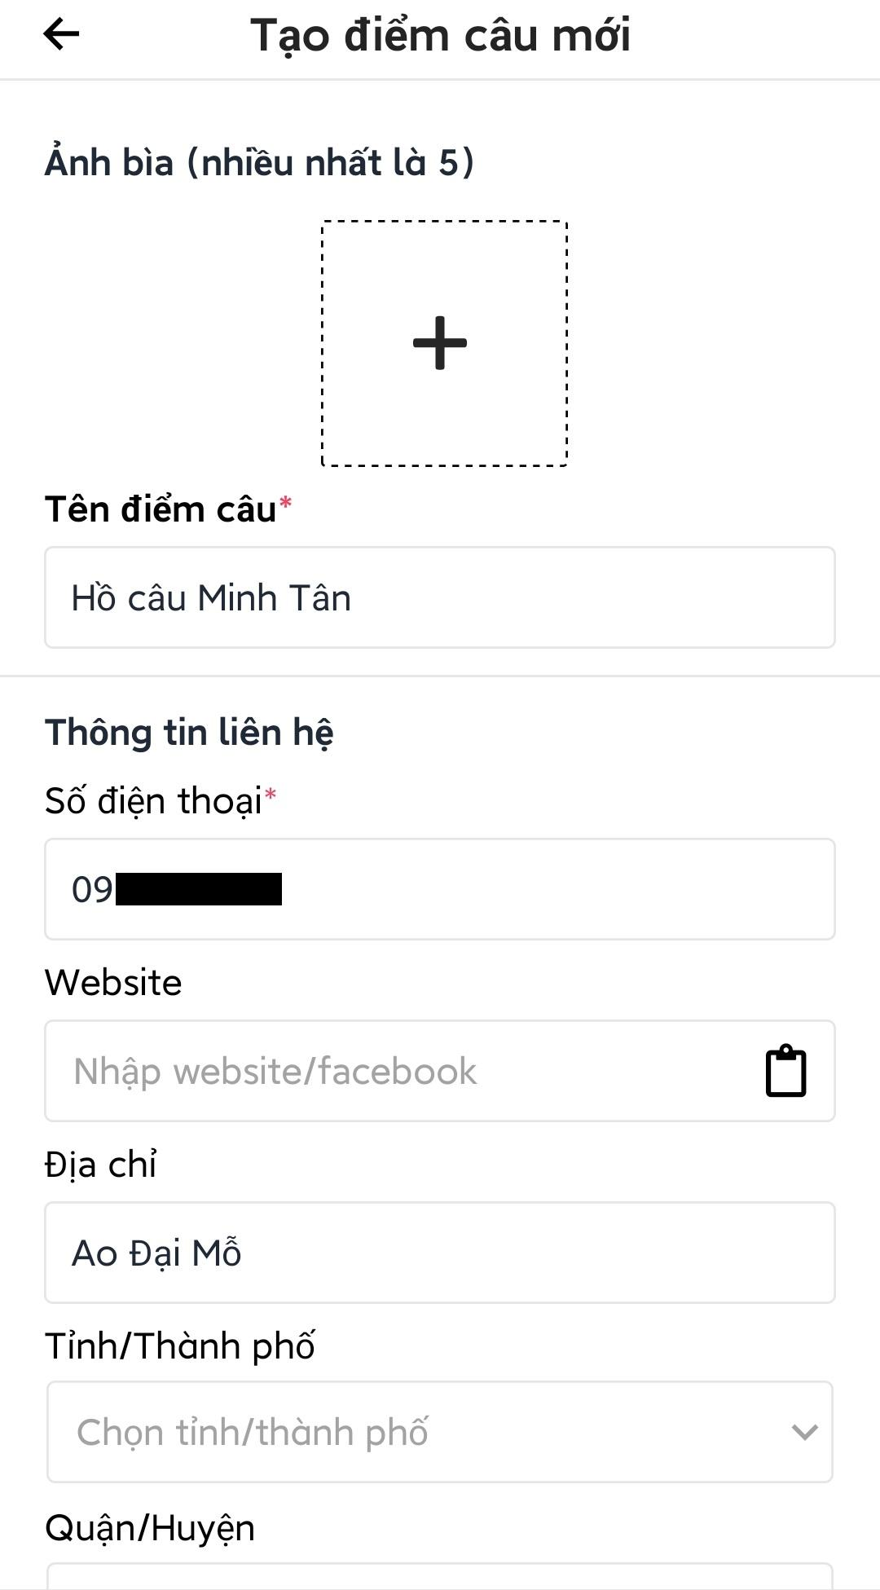



Figure 3.4.6.2. Create new pending fishing location

#### 3.4.7. Reports management

* Open admin main screen.
* Press “Quản lý báo cáo” to open reports management screen.
* Admin can choose between 4 types of report.
* Admin can choose to see resolved or unresolved report.

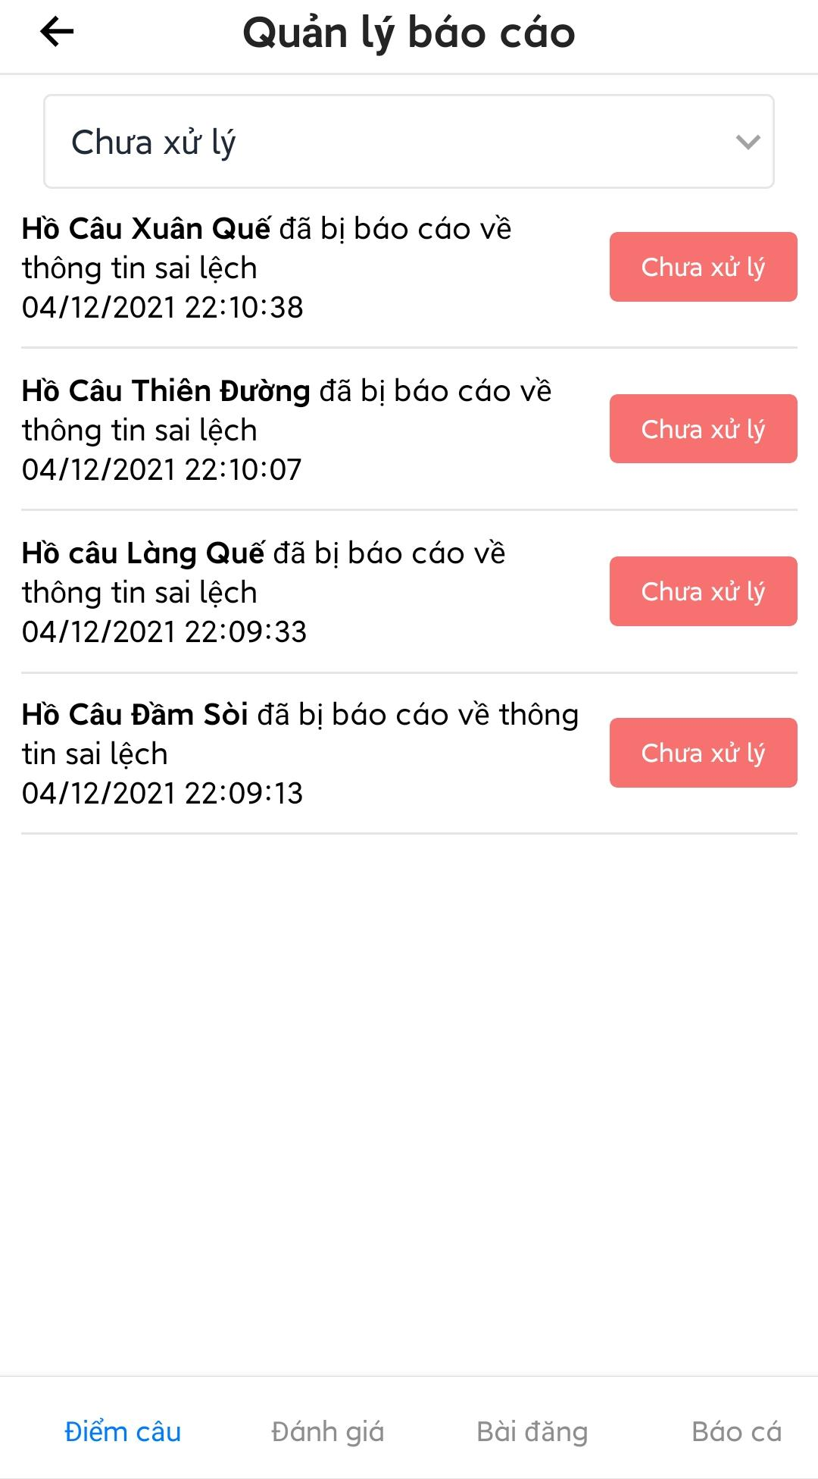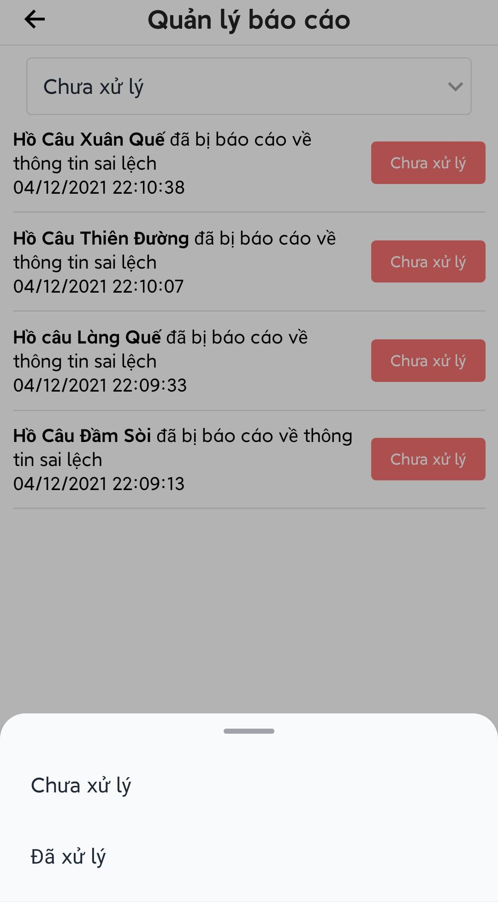

Figure 3.4.7. Reports management

##### 3.4.7.1. Resolve report

Open reports management screen.

Press on an unresolved report to view report detail.

Admin can have actions freely depending on the report.

Press “Đánh dấu đã xử lý”, an alert box will appear to confirm the action.

Press “Xác nhận” to mark the report as resolved.

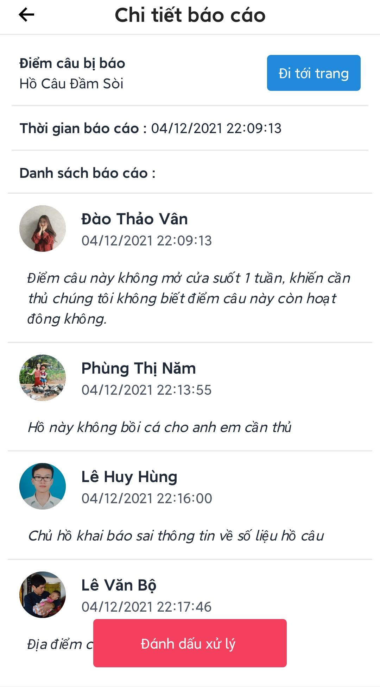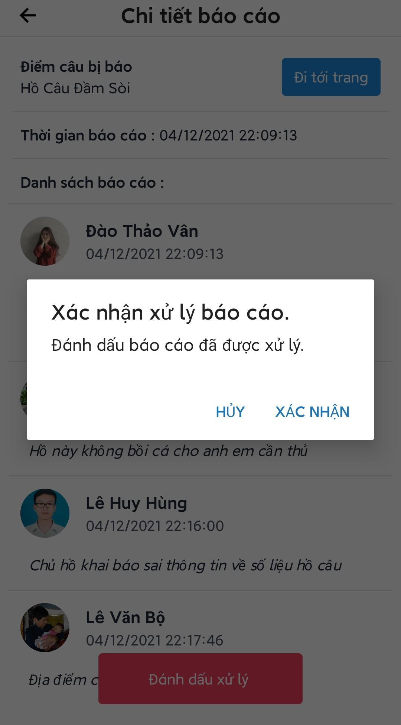

Figure 3.4.7.1. Resolve report

1. [ESLint - Pluggable JavaScript linter](https://eslint.org/)
2. [Prettier · Opinionated Code Formatter](https://prettier.io/)
3. [Java Code Conventions - Oracle](https://www.oracle.com/technetwork/java/codeconventions-150003.pdf)
4. [Snake case | Wikipedia](https://en.wikipedia.org/wiki/Snake_case)
5. [bcrypt - Wikipedia](https://en.wikipedia.org/wiki/Bcrypt)
6. [Expo](https://expo.dev/)
7. [Easy Peasy v5](https://easy-peasy.vercel.app/)
8. [React Native Elements](https://reactnativeelements.com/)
9. [React Navigation](https://reactnavigation.org/)
10. [NativeBase](https://nativebase.io/)
11. [Spring Boot](https://spring.io/projects/spring-boot)
12. [JSON Web Tokens](https://jwt.io/)
13. [Swagger](https://swagger.io/)
14. [Twilio](https://www.twilio.com/)
15. [Nhân Hòa](https://nhanhoa.com/)
16. [GitHub Actions](https://github.com/features/actions)
17. [Postman API Platform](https://www.postman.com/)
18. [DBeaver Community](https://dbeaver.io/)
19. [GitHub Issues · Project planning for developers](https://github.com/features/issues)
20. [FSMIS_UnitTestReport.xlsx | Google Drive](https://docs.google.com/spreadsheets/d/1CQXvedCV2M6DgneRFtlqFfJwEzlq7BvF/edit?usp=sharing&ouid=117694689838249553128&rtpof=true&sd=true)
21. [FSMIS_IntegrationTestReport.xlsx | Google Drive](https://docs.google.com/spreadsheets/d/1q7KM0yVpbsqxVX-vtWePLSaNYiJwlaYN/edit?usp=sharing&ouid=117694689838249553128&rtpof=true&sd=true)
22. [FSMIS_SystemTestReport.xlsx | Google Drive](https://docs.google.com/spreadsheets/d/1YDBLzc6j9_ySipxi3Jea_NK3FXU4TN2q/edit?usp=sharing&ouid=117694689838249553128&rtpof=true&sd=true)
23. [Get Ubuntu | Download](https://ubuntu.com/download)
24. [Get Ubuntu Server | Download](https://ubuntu.com/download/server)
25. [Twilio | Try Twilio Free](https://www.twilio.com/try-twilio)
26. [Installation - Expo Documentation](https://docs.expo.dev/get-started/installation/)
27. [Home | Yarn - Package Manager](https://yarnpkg.com/)
28. [Sign Up - Expo](https://expo.dev/signup)
29. [Get an API Key and Signature |  Maps Static API  |  Google Developers](https://developers.google.com/maps/documentation/maps-static/get-api-key)
30. [Installing PowerShell on Windows - PowerShell | Microsoft Docs](https://docs.microsoft.com/en-us/powershell/scripting/install/installing-powershell-on-windows?view=powershell-7.2)